Special Operations Language Training

Thai

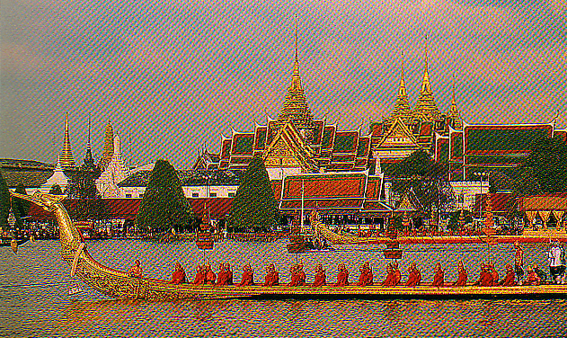

Student

Supplementary Listening Comprehension Workbook

Modules IV-VI

Module 4 Lesson 1

Audio Clip 2

Track 1

Listen to a daily schedule of Thai Privates living in the barracks and answer the following questions.

1. How often is formation scheduled?

_____________________________________________________________________
2. How often do the soldiers have to clean the barrack?

_____________________________________________________________________
3. What time is the walk-through inspection?

_____________________________________________________________________
4. What is the Thai word for ‘reveille’?

_____________________________________________________________________
5. Is there any weapons training scheduled?

_____________________________________________________________________
6. Do the soldiers have to do homework?

_____________________________________________________________________

Track 2

Listen to the following exchanges and write down in English where the activity is taking place.

1. ____________________________
2. ____________________________
3. ____________________________
4. ____________________________
5. ____________________________
6. ____________________________
7. ____________________________
Track 3

Listen to a conversation in which someone is giving directions. Take notes. You may have to listen several times.

A. First, listen once for the general information.
B. Listen again and write down answers to the following questions:

1. Where does the person want to go?

_____________________________________________________________________
2. What are the directions to this place?

_____________________________________________________________________
3. Why does the person have to give up on going to this place?

_____________________________________________________________________
4. Where is the person advised to go and how to get there?

_____________________________________________________________________

Module 4 Lesson 2

Track 4

Listen to the list of capital cities while you look at the country names on the left column. Repeat and write down the names of their capital cities in the space provided. The capital cities will be pronounced in the same order of their country names.

ประเทศ เมืองหลวง

1. ไทย _________
2. ลาว _________
3. เวียดนาม _________
4. กัมพูชา _________
5. มาเลเซีย _________
6. สิงคโปร์ _________
7. อินโดนีเซีย _________
8. พม่า _________
9. อินเดีย _________
10.จีน _________
11.เกาหลีใต้ _________
12.ฟิลิปปินส์ _________
13.ญี่ปุ่น _________
14.ไต้หวัน _________

Track 5

Listen to the following article and answer the questions.

1. อะไรคือเขตแดนระหว่างประเทศไทยและประเทศลาว

_____________________________________________________________________
2. แม่น้ำสายที่สำคัญที่สุดของประเทศไทยชื่ออะไร

_____________________________________________________________________
3. แม่น้ำสายนี้เกิดจากอะไร

_____________________________________________________________________
4. แม่น้ำสายนี้สิ้นสุดที่ไหน

_____________________________________________________________________
Track 6

You are participating in a geography training session about the target region conducted by a native instructor. Before listening to the training material, review the map of Thailand below.

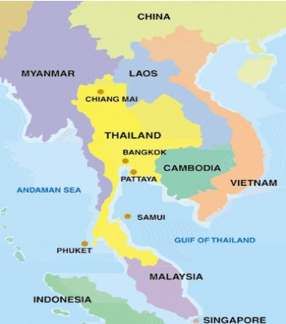

Listen to the passage as many times as you need and choose the correct response.

1. List the names of the countries that border the country.

2. What is the area of the country (in Rai)?

a. 147 million b. 321 million c. 327 million

3. What is the area of the agricultural land in the country?

a. more than half b. less than half c. about one half

4. Which sea has been mentioned?

a. The Andaman Sea b. The Red Sea c. The Mediterranean Sea

5. What climatic zone is the country situated in?

a. Tropic b. Torrid c. Temperate
Module 4 Lesson 3

Track 7

Listen to the following coordinates and write them down, then locate them on the map.

Latitude | Longitude | Province
1.
2.
3.
4.
5.

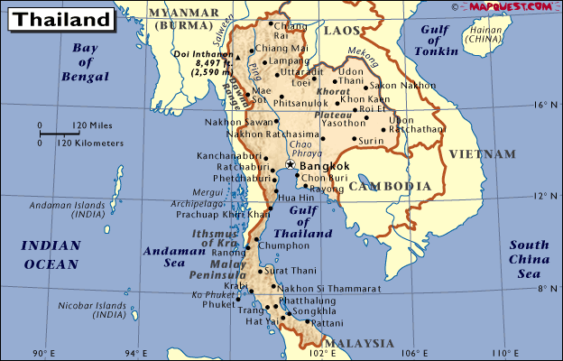

Track 8

Listen to a conversation. A visitor is asking a passer-by for directions to the Weekend Market. Read the statements below and choose the correct response.

According to the passage:

a. The Weekend Market is two bus stops ahead.
b. The Weekend Market is two bus stops back on the left side.
c. The visitor has to go back two bus stops, turn left and walk 150 meters.
d. The visitor has to walk back 150 meters.
Track 9

Listen to a SF team leader who is going to guide a soldier through the field to the meeting point. Then answer the following questions.

1. In what direction does the soldier have to start his travel?

____________________________________________________________________
2. How would he get to the hill?

____________________________________________________________________

3. What can he find in the village?

____________________________________________________________________

4. Where are the two high voltage power posts located?

____________________________________________________________________

5. What is their meeting point?

____________________________________________________________________

Module 4 Lesson 4

Track 10

Listen to the recording and answer the questions.

1. What classes were conducted during Balance Torch 00-3?
_______________________________________________________________
2. What was the purpose of these classes?
_______________________________________________________________

Track 11

Listen to the recording and answer the questions.

1. What training was conducted during the first phase of the Cross Training Exercise?
_______________________________________________________________
2. What training was conducted during the last phase?
_______________________________________________________________

Track 12

Heavy fighting between Myanmar troops and a rebel group spilled into Thailand, killing two civilians and injuring at least 37 Thai soldiers. The Myanmar troops captured 19 soldiers. A Thai detachment is assigned to guard the area and rescue the soldiers. Thai officers are planning this secret mission. Listen to the conversation in the planning and answer the True / False questions.

True or false?

1. The Thai detachment is planning to take over a Myanmar camp. T / F
2. Myanmar soldiers are very alert. T / F
3. A reconnaissance team is not required for this operation. T / F
4. There was no word on casualties from the Thai side. T / F
5. Unit A is trying to convince the Myanmar troops to withdraw from the
mountainous area. T / F
6. Unit C will be responsible for the counter attack. T / F
7. A Thai army helicopters was shot down. T / F
8. Thai used helicopter on a supply mission flight. T / F
9. The operation requires more field radios and night vision devices. T / F
10.The mobilization will begin at dawn. T / F
Module 4 Lesson 5

Track 13

Listen to a segment of a lecture about physical diversity of Thailand. Listen three times, then read the list of the geographical terms. Listen to the recording again and underline those mentioned:

- Alluvial Plain
- Beach
- Coast
- Lake
- Mountain range
- Ocean
- Peninsula
- Plains
- Plateau
- River
- Sea
- Valley

Track 14

Listen to the text about the southern part of Thailand and decide if the statements are true or false.

T / F

1. The distinguishing natural feature of southern Thailand _____
is dense forest.

2. Mountains are located along the coastlines in the western
part of the peninsular. _____

3. The plain occupies a large amount of the whole area. _____

4. The plains in the east coast are wider than the west coast. _____

5. The elevation on the west coast is higher than the east coast. _____

6. Mangrove swamps in the area are diminishing. _____
Track 15

Listen to the travel information and complete the following sentences.

1. The province mentioned is ___________.
a. Saraburi
b. Chonburi
c. Loburi

2. The province is only _______ km from Bangkok.
a. 18
b. 81
c. 87

3. You can take the highway ___________.
a. 34/304
b. 3/34
c. All of the above

4. Motor Way is a new toll-way from __________.
a. Bangkok to Pattaya
b. Bangkok to Chantaburi
c. Bangkok to Phetburi

5. If you prefer to go by bus, you can board the bus at the ________ bus terminal.
a. Ekamai
b. Nonthaburi
c. Pakret

Module 4 Lesson 6

Track 16

Listen to the following article and answer the questions:

1. What kind of climate does Thailand have?
_____________________________________________________________________
2. What is the special characteristic of the climate throughout the country?
_____________________________________________________________________
3. What is the weather in the South and Southeast like?
_____________________________________________________________________
4. What is the average temperature in Thailand?
_____________________________________________________________________
5. What is the average temperature in Bangkok in December?
_____________________________________________________________________
6. What is the average temperature in Bangkok in March and April?
_____________________________________________________________________
7. How many seasons are there in Thailand?
_____________________________________________________________________
8. What are these seasons?
_____________________________________________________________________
9. What is the other name of winter in Thailand?

_____________________________________________________________________

Track 17

Listen to the weather report from the Thai radio and mark the statements below True or False.

1. This forecast is for the central region of Thailand only. ________
2. There will be heavy fog in the morning. ________
3. It will be hot in the middle of the day. ________
4. The highest temperature is between 35º - 39º. ________
5. There will be rain in the eastern part of the country. ________
6. The north wind will be 10-30 km/hr. ________
7. The sea will have small waves. ________
Track 18

Listen to a radio news report about a natural disaster and answer the questions.

1. What kind of disaster was reported here?

_____________________________________________________________________
2. Where did this disaster happen?

_____________________________________________________________________
3. How many children died?

_____________________________________________________________________
4. Were there any survivors?

_____________________________________________________________________
5. How could this disaster have been prevented?

_____________________________________________________________________
6. What caused the disaster?

_____________________________________________________________________
Module 4 Lesson 7

Track 19

Listen to a conversation between Peter and Somsak, and then decide if the following statements are True or False.

1. There is no rail service to Phuket. T / F
2. The coach is always the safest way to travel. T / F
3. Car rental can be very expensive unless you travel in a group. T / F
4. It takes only an hour and ten minutes by air. T / F

Track 20

Listen to a conversation between a mechanic and his regular customer. You will listen three times. Then read the list of the car parts in the table, listen to the recording again and underline those mentioned. (Car parts mentioned in the conversation are not in the same order as they appear in the table.)

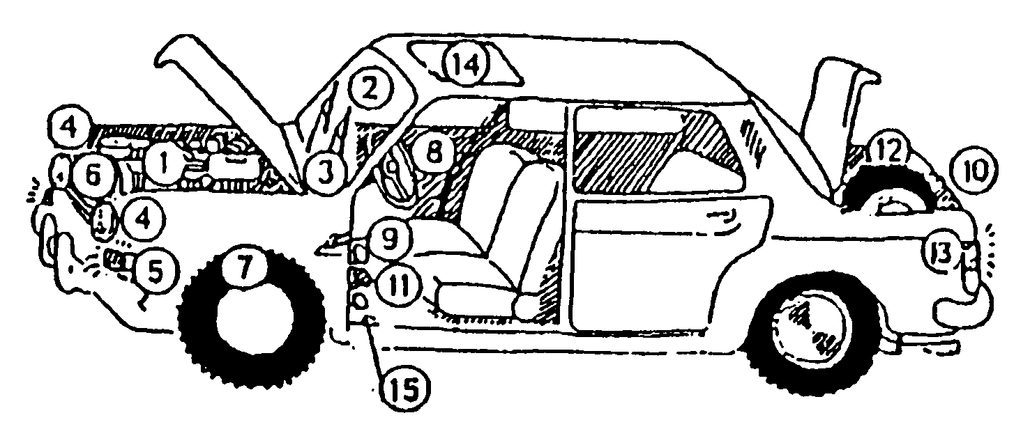

1. เครื่องยนต์ | 2. กระจกหน้ารถ | 3. ที่ปัดน้ำฝน
4. ไฟหน้า | 5. ไฟเลี้ยว | 6. หม้อน้ำ/รังผึ้ง
7. ยาง | 8. เข็มขัดนิรภัย | 9. เกียร์
10.ไฟท้าย | 11.เบรค/ห้ามล้อ | 12.ยางอะไหล่
13.ไฟเบรค | 14.ซันรูฟ/หลังคาเปิดได้ | 15.คลัช

Track 21

Listen to several requests made by military personnel and mark the corresponding illustration for each item.

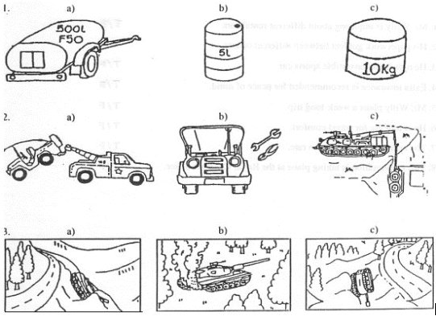

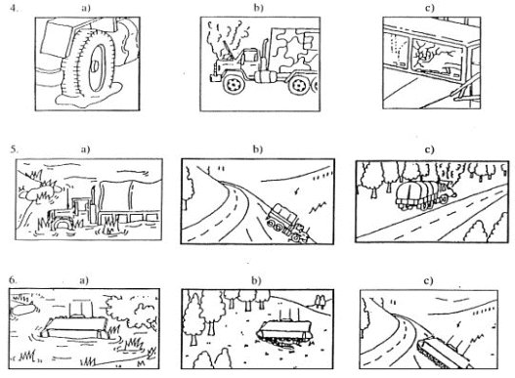
Module 4 Lesson 8

Track 22

Listen to a dialogue between two friends. Both of them are traveling abroad. They are asking each other about their destination, time of departure, airlines, ticket reservation and so on. And then answer the following questions:

1. What is B planning to do in the summer?

_____________________________________________________________________
2. When is A planning to go to the US?

_____________________________________________________________________
3. What causes the delay?

_____________________________________________________________________
4. What suggestion does B make to A concerning the ticket?

_____________________________________________________________________
5. How is he going to reserve the ticket?

_____________________________________________________________________

Track 23

Peter is at the Northern Bus Terminal in Bangkok, trying to book tickets for a trip to the Northeast. Listen to the conversation between Peter and the ticket sales clerk and answer the following questions:

1. When does Peter want to go to Nakhorn Phanom?

_____________________________________________________________________
2. What time does his bus leave?

_____________________________________________________________________
3. How long is the trip?

_____________________________________________________________________
4. How much does his ticket cost?

_____________________________________________________________________
5. What time does the bus arrive in Nakhorn Phanom?

_____________________________________________________________________
Track 24

Listen to the three short conversations. Extract the following information for each situation as applicable.

a. Nature of the problem:
b. Location of the vehicle:
c. Description of the vehicle:
d. Length of wait for the tow truck:
e. Instructions to the driver:
Module 5 Lesson 1

Track 25

Sergeant Prapan was injured during the military training. Sergeant Santi is trying to help him. Listen to their conversation and decide if the statements are true or false.

T / F

1. Sergeant Prapan has pain in his left ankle. ______
2. He is not able to get up. ______
3. Sergeant Santi wraps a bandage around Sergeant ______
Prapan’s ankle.
4. The help will come within five minutes. ______

Track 26

Listen to the instructions given on how to treat a wound. Then choose the appropriate number and write it down in the correct box according to the instruction.

การปฐมพยาบาล
วิธีผายปอด | บาดแผลถูกยิง | การห้ามเลือด

Track 27

Study the pictures below while listening to the instructions on how to perform artificial resuscitation. And then mark the statements True or False.

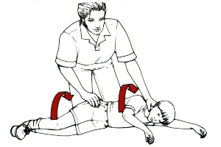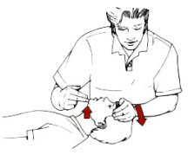

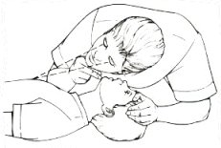

 | T / F
1. The passage describes a CPR procedure.  2. When giving mouth-to-mouth resuscitation, the patient’s head should be held upright.  3. During the procedure, the patient’s nose should be squeezed tight.  4. This is done with three fingers.  5. Mouth-to-mouth and mouth-to-nose procedures have basically the same effect. | _____  _____  _____  _____  _____

Module 5 Lesson 2

Track 28

The following sentences refer to certain parts of the body. Listen to them and write the part of the body to which they refer in the space provided.

Example:
You will hear: ใช้เขียนหนังสือ
You will write: มือ

1.
2.
3.
4.
5.
6.
7.

Track 29

Listen to the recording and check the most appropriate interpretation from the list below.

1. The benefit of doing physical exercise
2. The function of internal organs
3. The blood circulation system

Track 30

Listen to the following announcement and check the most correct answer to the question:

What is the school requirement?

1. The physical exam and chest x-ray.
2. The physical exam.
3. Chest x-ray.
Module 5 Lesson 3

Track 31

Listen to the recording in which people say what is wrong with them and for how long they have felt unwell. Fill in the necessary information in the table below. Names are not mentioned in the same order as they appear in the table.

Name | What’s wrong? | How long
นุชนาถ
สมศักดิ์
ปรีชา
ปรียานุช
มาณวิกา

Track 32

Listen to what Sunee says about her recent health problem and complete the sentences.

- Sunee was suffering from_____________________________________________.
- She decided to see a doctor instead of __________________________________.
- The doctor advised her to do some _____________________________________.

Track 33

Listen to the dialogue once and answer the questions:

1. Where does Somsak work?
_____________________________________________________________________
2. Where was his boss at the time Somsak called?
_____________________________________________________________________
3. What was the reason for the call?
_____________________________________________________________________
4. What was the condition of Somsak’s son?
_____________________________________________________________________
5. What kind of epidemic disease was going around?
_____________________________________________________________________

Module 5 Lesson 4

Track 34

There was an accident on Sukhumvit Road. The police arrived at the scene of the accident and talked to the witness. Listen to their conversation and fill in the missing parts in the following statements:

- The policeman is asking the witness to describe the ________________________.
- The red car was trying to _____________ the other car.
- When the driver of the red car hit the breaks, the car ________________________.
- Both drivers were __________ and one of them was in _____________________.
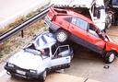

Track 35

Nipa wants to make a doctor’s appointment. Listen to her phone conversation with a clerk at the doctor’s office and decide if the statements are true or false.

T / F

1. Nipa wants to see her doctor tomorrow. ______
2. Her doctor does not have any opening for tomorrow. ______
3. She is suffering from chest pain. ______
4. There is always an exception for emergencies. ______

Track 36

Listen to the following article and write down, in English, four suggestions to help improve your insomnia.

1. _________________________________________________________________
2. _________________________________________________________________
3. _________________________________________________________________
4. _________________________________________________________________
Module 5 Lesson 5

Track 37

Listen to the directions of the medicine and say if the following statements are true or false.

T / F

1. This medicine is for the symptom of a common cold. ____

2. Take 1 pill 2 times daily. ____

3. To be taken after meals and before bedtime. ____

Track 38

You are in a SF Detachment Team preparing for deployment in Thailand. Your team sergeant advises you to get the necessary medicines from the dispensary. Check out different types of medication from the table below as you hear them mentioned in the recording.

ยาแก้ไอ | ยาแก้ท้องเดิน | ผงเกลือแร่
ยาแก้หวัด | ยาแก้อักเสบ | ยาแก้ท้องอืด
ยาแก้เจ็บคอ | ยาระบาย | ครีมทาไฟลวก
ยาแก้ไข้ | พลาสเตอร์ปิดแผล | ยาใส่แผลสด
ยาคลายกล้ามเนื้อ | ยาทำให้น้ำบริสุทธิ์ | ยาแก้คลื่นไส้

Track 39

Peter and Somsak talk about their childhood diseases. Listen to their conversation and decide if the following statements are true or false.

T / F

1. Somsak had chicken pox when he was young. _____
2. The symptom of chicken pox is a red rash on the face. _____
3. Somsak felt tired all the time. _____
4. Somsak was unhappy, and he missed school. _____
5. Somsak slept on a banana leaf. _____
6. Peter remembers well how painful his chicken pox attack was. _____
7. Peter could not sleep because of headaches. _____
Module 5 Lesson 6

Track 40

Somsak gets news that a relative is in the hospital. He calls Daranee to get information to go and visit his relative. Listen to their conversation and decide if the following statements are True or False.

T / F

1. The person who picked up the phone was not Daranee. _____
2. Daranee is Somsak’s cousin. _____
3. Somsak is asking to talk to Daranee’s mother. _____
4. Daranee’s mother has been hospitalized for 2 days. _____
5. They are waiting for the blood test. _____
6. Daranee’s mother is staying in room 51. _____

Track 41

Listen to an article about dental hygiene and complete the following statement:

According to the passage, to keep your teeth healthy, you should:

a. ______________________________
b. ______________________________
c. ______________________________
d. ______________________________

Track 42

Listen to the recording and complete the statements below.

1. The average number of treatments this hospital gives daily is ______________.
2. There are ___________ hospital beds at the present time.
3. The former name of the hospital is __________________________________.
Module 6 Lesson 1

Track 43

Listen to the following paragraph and answer the questions in Thai.

๑. การแสดงที่พูดถึงคืออะไร

_____________________________________________________________________
๒. จิม บริกแมนคือใคร

_____________________________________________________________________
๓. การแสดงครั้งนี้จะมีขึ้นเมื่อไร ที่ไหน

_____________________________________________________________________
๔. จุดประสงค์ของการจัดงานครั้งนี้คืออะไร

_____________________________________________________________________

Track 44

Listen to the following paragraph and answer the questions.

1. What kind of entertainment was mentioned?

_____________________________________________________________________
2. What happened in the year 2515 B.E. and why?

_____________________________________________________________________
3. What did this TV station do to improve this program?

_____________________________________________________________________

Track 45

Listen to the following information and answer the questions.

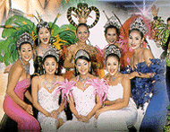

๑. ในเรื่องนี้การแสดงอะไรที่ได้รับความนิยมทั้งในหมู่ชาวไทยและชาวต่างชาติ

_____________________________________________________________________
๒. สาวประเภทสองหมายความว่าอย่างไร

_____________________________________________________________________
๓. ในอดีตสาวประเภทสองเคยถูกมองยังไง แล้วในปัจจุบันล่ะ

_____________________________________________________________________
๔. การแสดงส่วนใหญ่ในปัจจุบันจะเน้นอะไร
_____________________________________________________________________
Module 6 Lesson 2

Track 46

Peter and Somsak talk about their favorite sports. Listen to their conversation and complete the following statements:

1. Somsak has started playing golf ___________________.
2. His _____________ is twenty-four.
3. He usually plays golf at the ___________________.
4. He is a ____________ at the Sports Club.
5. Peter doesn’t know how to play ___________.
6. Peter likes to go to the gym for ____________.
7. Peter likes to watch ______________.

Track 47

Listen to the following newspaper excerpts and match them with the name of the sports given below.

А. boxing B. snooker C. swimming D. golf E. football

Track 48

Listen to the following newspaper excerpts and decide if the following statements are True or False.

1. การแข่งขันฟุตบอลโลกรอบคัดเลือกโซนเอเชียมีขึ้นที่เมืองบังกาลอร์ประเทศเยเมน
2. เป็นการแข่งขันฟุตบอลระหว่างอินเดียกับเยเมน
3. ผลการแข่งขันทั้งสองประเทศเสมอกัน
4. อินเดียได้แต้มนำเป็นอันดับที่ ๑ ในสายคือ ๔ คะแนน
5. สหรัฐอาหรับเอมิเรตส์อยู่ในอันดับที่ ๒ มี ๓ คะแนน
6. บรูไน ดารูสซาลามอยู่ในอันดับที่ ๔ มี ๒ คะแนน
7. สหรัฐอาหรับเอมิเรตส์อยู่ในอันดับที่ ๓ยังไม่มีคะแนนสะสม
8. ในนัดต่อไปสำหรับสายนี้ อินเดียจะพบกับบรูไนวันที่ ๒๖ เมษายน
9. เยเมนจะพบกับบรูไนวันถัดไป
Module 6 Lesson 3

Track 49

Answer the following questions based on the recording about Songkran.

1. What is the occasion for the Songkran festival?

___________________________________________________________________
2. Religiously, what do the Thai people do in the Songkran Festival?

___________________________________________________________________
3. What do the junior family members do in regard to their elderly relatives?

___________________________________________________________________
4. Where is the biggest Songkran celebration held in Thailand?

___________________________________________________________________
5. What does the Songkran Festival consist of?

___________________________________________________________________
6. What do the common Thai people associate with Songkran?

___________________________________________________________________

Track 50

Write the name of the Thai festival for each description you hear in the recording.

1. | 2.
3. | 4.
5. | 6.
7. | 8.
9. | 10.

Track 51

Listen to several short salutations and write down in English what was celebrated.

1. ___________________________________________________________________
2. ___________________________________________________________________
3. ___________________________________________________________________
4. ___________________________________________________________________
5. ___________________________________________________________________
Module 6 Lesson 4

Track 52

John, an American officer, is interested in Buddhism and wants to know more about the religion. Listen to the conversation between John and Sompong, one of his Thai friends, discussing Buddhism and other religions in Thailand. Then provide the answers to the following questions based on the conversation:

1. What is the main religion of the Thai people?

____________________________________________________________
2. State other 3 religions that are practiced in Thailand besides Buddhism.
______________________________________________________________
3. Discuss some outside influences that have impacted Buddhism.
______________________________________________________________
4. Is worshiping a spirit house part of Buddhism’s ritual?
______________________________________________________________

Track 53

Listen to a conversation and answer the following questions in Thai.

1. What religious holidays are mentioned? (Write down at least three holidays)
_____________________________________________________________________
2. What are those rituals practiced by the Thais to observe these holidays?
_____________________________________________________________________

Track 54

Listen to a short paragraph and answer the following questions.

1. What was discovered and where?
_______________________________________________________________
2. What century is the object from?
_______________________________________________________________
3. What does the object signify?
_______________________________________________________________
Module 6 Lesson 5

Track 55

Listen to a passage and answer the questions.

1. What is the name of this festival?
_____________________________________________________________________
2. What is the motive of this festival?
_____________________________________________________________________
3. What are other festivals that have the same motive?
_____________________________________________________________________
4. In what region of Thailand is this festival held?
_____________________________________________________________________
5. Besides entertaining, what does this festival manifest?
_____________________________________________________________________

Track 56

Listen to the recording and answer the questions.

1. What is the name of this Thai King?
____________________________________________________________________
2. What did he do for the good of the country?
____________________________________________________________________
3. Why did the King move the capital from Ayutthaya?
____________________________________________________________________
4. Where did he move?
____________________________________________________________________
Track 57

Listen to an excerpt about the Buddhist Ordination and decide if the following statements are True or False.

1. The ordination of a monk is regarded as an act of a T / F
great merit dedicated to his parents.
2. It is a Thai custom for a young man to enter the T / F
monkhood before marriage.
3. Thai people believe that if a man enters the monkhood T / F
after marriage, his wife is certain to receive half of the
merit instead of his parents.
4. Thai people also believe that if they accumulate a lot T / F
of merit, they will be born in heaven after death.
5. The minimum age for entering the monkhood is 20 years old. T / F
Module 6 Lesson 6

Track 58

Listen to the caption of social activities from local Thai newspapers and write it in English.

(1) ____________________________________________________________
____________________________________________________________
____________________________________________________________
____________________________________________________________

(2) ____________________________________________________________
____________________________________________________________
____________________________________________________________
____________________________________________________________

Track 59

Listen to the excerpt from an article in a Thai military magazine and decide if the statements are True or False.

T/F
1. The recession only affects the poorest people. ___
2. The Government will increase spending to support the military. ___
3. Soldiers are not allowed to supplement their military pay. ___
4. Soldiers can work at a second job with the permission from their
commander. ___
5. Soldiers should not take advantage of their positions to benefit
themselves if they decide to work at a second job after duty hours. ___

Track 60

Listen to the structure of the Thai government and write a summary in English. You may take notes while listening to it.

Summary: ___________________________________________________________
____________________________________________________________________
____________________________________________________________________
____________________________________________________________________
____________________________________________________________________
____________________________________________________________________
Module 6 Lesson 7

Track 61

Listen to the list of various behaviors and mark them as A (acceptable) or U (unacceptable) according to Thai customs. If unacceptable, explain what would be appropriate.

1. ___________________________________________________________________
2. ___________________________________________________________________
3. ___________________________________________________________________
4. ___________________________________________________________________
5. ___________________________________________________________________

Track 62

Listen to the following text and answer the questions below in Thai.

๑. งานที่กล่าวถึงคืองานอะไร

_____________________________________________________________

๒. เขามีงานทั้งหมดกี่วัน

_____________________________________________________________

๓. ในงานนี้ทางวัดจัดให้มีการละเล่นอะไรบ้าง

_____________________________________________________________
Track 63

Many important festivals take place in Thailand. In these festivals, important singers, musicians and actors participate. The following text talks about some of these festivals. Listen to it and answer the following questions in Thai.

๑. งานนี้ใครเป็นผู้จัด

__________________________________________________________

๒. งานนี้จัดให้มีอะไรบ้าง กรุณาบอกมาสามอย่าง

__________________________________________________________

๓. กิจกรรมที่น่าสนใจที่กล่าวถึงคืออะไร

__________________________________________________________

๔. จุดประสงค์ของการจัดกิจกรรมดังกล่าวคืออะไร

__________________________________________________________

