SOLT Serbian Module 5 Lesson 1

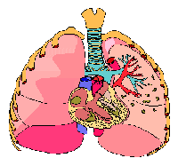

Anatomy

Anatomy Serbian SOLT 1
Objectives Module 5 Lesson 1

During this lesson, the students will be able to accomplish anatomy. Under this Terminal Learning Objective, the students will learn one task: identify parts of the body. At the end of the lesson, the students will be able to:

- Identify parts of the body. This task will include:

- Name main parts of the human body
- Talk about the motor and sensorial organ functions
- Identify internal organs
- Identify external organs

Anatomy Serbian SOLT 1
Introduction Module 5 Lesson 1

The first thing one should know when being injured in a foreign country is to call for help in the event of an emergency. In Serbian, one would say: Зовите доктора! (Get a doctor!) This module will help you to learn the most important medical terms and phrases in Serbian. As a first step in today’s lesson, you will learn to identify basic human anatomy.

Tip of the day
The Serbian names of the fingers are: палац – thumb, кажипрст – index finger, средњи прст – middle finger, домали прст – ring finger, мали прст – little finger.

Exercise 1
Час биологије (A biology class)
Look at the image below and read the parts of the body aloud. Point to your parts of the body and name them using the example below. Example: Ово је моја глава etc.

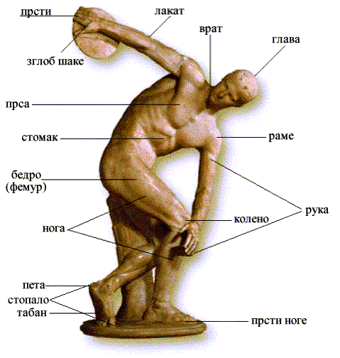

Anatomy Serbian SOLT 1
Introduction Module 5 Lesson 1

Exercise 2
Below are делови главе – the head parts. Work with a partner and name the proper places on the image. The instructor will check your work.

глава око нос обрва уво (ухо) чело образ брада уста усне

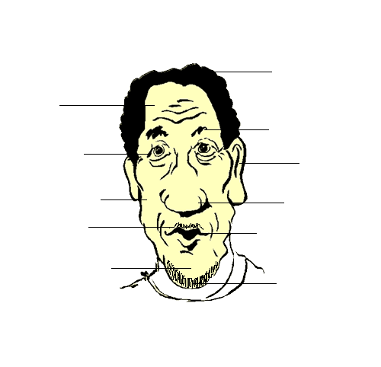

Exercise 3
Point to the parts on your partner’s head and name them using the possessive pronoun as in the example below.

Example: Ово је његово/њено око etc.

Anatomy Serbian SOLT 1
Introduction Module 5 Lesson 1

Exercise 4
Read the names of the internal organs in Serbian and ask each other questions about the position of each organ on the picture.

Example: Где се налази мозак?
Мозак се налази са десне стране.

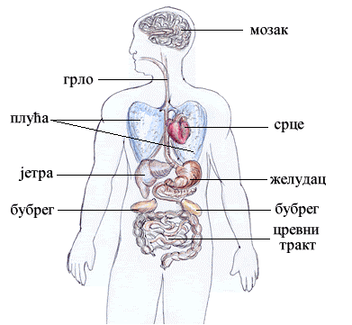

Anatomy Serbian SOLT 1
Introduction Module 5 Lesson 1

Exercise 5
Read the advertisement below and:

- Say what the purpose of the advertisement is.
- Figure out the meaning of the underlined words.

ПРЕСТАНАК ПУШЕЊА ЈЕ ЈЕДНА ОД НАЈБОЉИХ ОДЛУКА КОЈЕ МОЖЕТЕ ДОНЕТИ У КОРИСТ СВОГ ЗДРАВЉА!

1. престанак пушења: a. begin smoking
b. stop smoking
c. continue smoking

2. одлука: а. decision
b. opinion
c. permission

3. корист: a. loss
b. points
c. benefit

4. здравље: a. sickness
b. health
c. depression

Anatomy Serbian SOLT 1
Grammar Notes Module 5 Lesson 1

The numerals Оба and Обе – both

The numeral оба (both) has all three genders: оба or обадва (m), обе or обадве (f), оба or обадва (n). In this lesson you will find several nouns that often call for the numeral both.

Example: оба ува (обадва ува) – both ears
обе руке (обадве руке) – both arms (hands)

The numeral оба/обе is declined as follows:

 | Masculine/Neuter | Feminine
Nom | оба | обе
Gen | обају | обеју
Dat | обема | обема
Acc | оба | обе
Inst | обема | обема

Exercise 1
Use оба or обе where appropriate in the list below. The list specifies the injuries, the body parts and organs affected for each patient. Render it in Serbian for the Serbian medical team.
Patient 1 | both kidneys
Patient 2 | both legs
Patient 3 | both hands
Patient 4 | both ears
Patient 5 | both eyes

Anatomy Serbian SOLT 1
Grammar Notes Module 5 Lesson 1

The Serbian language

For the last four chapters you had the opportunity to listen to and read the true Serbian language which is spoken and written mostly in Serbia. You are familiar with the Cyrillic alphabet, with the ekavian dialect and the да-clause.

However, it was mentioned before that the Cyrillic alphabet is not the only alphabet used in the FRY. Many newspapers, official documents, and traffic directions are written in the Roman Alphabet. Also, in Montenegro for example, the ijekavian dialect is used very often instead of the ekavian dialect. Serbs in Bosnia speak Serbian using the ijekavian dialect and writing in the Roman alphabet. In 2000 the schools in the Republik of Srpska started introducing the Cyrillic alphabet to the children prior to the Roman alphabet, etc.

In our Serbian language course we will continue using the Cyrillic alphabet and ekavian dialect as before. However, from this chapter on, you will have more opportunity to read texts written in the Roman alphabet and texts using the ijekavian dialect. Also, you will see the difference in the sentence structure between the да-clause and the clause that uses mostly the infinitive (Western variant spoken mostly in Croatia).

Some examples are given below for you to compare:

Examples: Cyrillic/ekavian/да-clause

Маја ће да иде следећег лета на море.
Нису хтели да слушају и зато су остали код куће.

Roman/ijekavian/infinitive clause

Maja će ići sljedećeg ljeta na more.
Nisu htjeli slušati i zato su ostali kod kuće.

Anatomy Serbian SOLT 1
Grammar Notes Module 5 Lesson 1

Exercise 2
The following sentences are written using the да form. Rewrite them using the infinitive instead. Follow the example.

Example: Ја ћу да читам.
Ја ћу читати.

1. Јелена је морала јуче да ради.

_______________________________________________________________________

2. Планирали смо да идемо у биоскоп.

_______________________________________________________________________

3. Следеће недеље морамо да спремимо кућу.

_______________________________________________________________________

4. Престаните да пушите и бићете здравији.

_______________________________________________________________________

5. Желели су да купе ново ауто.

_______________________________________________________________________

Anatomy Serbian SOLT 1
Vocabulary Module 5 Lesson 1

бубрег, бубрези | kidney, s
бут, бутови | thigh, s
врат, вратови | neck, s
грло | throat
груди | breast, chest
домали прст, и | ring finger, s
желудац, желуци | stomach, s
живо биће, а | living thing, s
заједнички, а, о (m, f, n) | common
зглоб, зглобови | wrist, s
здравље, а | health
исти, а, о (m, f, n) | same
јетра, е | liver, s
кажипрст, и | index finger, s
колено, а | knee, s
корист, и | benefit, s
кост, кости | bone, s
крвна ћелија, е | blood cell, s
лакат, лактови | elbow, s
личити | to be alike, to resemble
мали прст, и | little finger, s
мешати (impf.) измешати (pf.) | to mix
мишић, и | muscle, s
мозак | brain
нераздвојив, а, о (m, f, n) | inseparable
оба/обе | both
оброк, оброци | meal, s
одлука, е | decision, s
палац, палци | 1. thumb 2. big toe
пета, е | heel, s
плућа | lungs
прерађивати (impf.) прерадити (pf.) | to process
пресађивање, а | transplant, s
пушење, а | smoking
раме, рамена | shoulder, s
слепо црево, а | appendix
средњи прст, и | middle finger, s
срце, а | heart, s
стопало, а | foot, s
трбух, трбуси | tummy, s
фосил, и | fossil, s
црево, црева | intestine, s

Anatomy Serbian SOLT 1
Culture Notes Module 5 Lesson 1

Human Origin

Did you know that the mystery of human origins is the biggest puzzle for people to solve? Here are some explanations:

- The first stage of human origin was the Australopithecines, which appeared during the Pliocene epoch about 4.4 million years ago.
- The second stage was the presence of the Homo habilis, which appeared 2 million years ago in the Southern and Eastern part of Africa. They are known as the first toolmakers.
- The third stage was the Homo erectus, which appeared 1,600,000 years ago. The oldest and most complete homo erectus fossil found was named Turkana boy.
- The fourth stage of human origin was the Homo sapiens, which date back to 100,000. Homo sapiens are also known as Cro-Magnon or Upper Paleolithic peoples.

Anatomy Serbian SOLT 1
Application Activities Module 5 Lesson 1

Activity 1
Work in pairs. Look at the picture below and name as many parts of the body as you can.

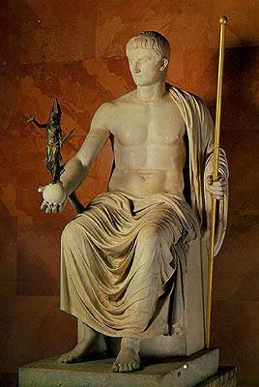

Statue of the Emperor Octavian Augustus
(The Hermitage Museum)

Activity 2
The signs under the pictures below are wrong. Write the correct words under each picture.

нога уста руке

Anatomy Serbian SOLT 1
Application Activities Module 5 Lesson 1

Activity 3
Listen to three descriptions and match them with the pictures below by putting the correct number on the lines provided. Do you recognize these people? Write their names under the picture. Compare your work with a partner.

__________ ___________ __________

Activity 4
Scan the text below and choose the best answer.
Анатомија желуца
Главна функција желуца је да прерађује и преноси храну. После оброка, желудац помаже да се храна измеша и самеље. Желудац може да се подели на три велика дела. То су fundus, corpus и antrum. Fundus и corpus су готово нераздвојиви.

1. The main function of the stomach is: a. to eat food
b. to destroy food
c. to process and transport food

2. These two stomach parts are hardly a. fundus and corpus
separable: b. fundus and antrum
c. antrum and corpus

Anatomy Serbian SOLT 1
Skill Enhancement Activities Module 5 Lesson 1

Activity 1
Listen to the instructor read a list of potential organs needed for the military hospital. Check off those that were needed on the enclosed list below, located next to the illustrations.

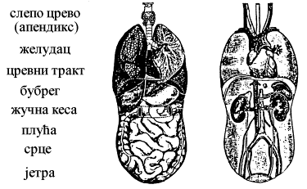

Activity 2
Imagine that your classmates are prospective organ donors. Walk around
the classroom and ask every person what organ he/she is willing to donate. After the
interview, report your findings to the class . Which organ was the most frequently
donated?

Example: 2 особе ће да дају бубрег etc.

Anatomy Serbian SOLT 1
Skill Enhancement Activities Module 5 Lesson 1

Activity 3
На кога личиш? Whom do you resemble?
Ask your partner whom does he/she resemble in their family, and why does he/she think so.
Follow the example below:

Example: На кога ти личиш? Личим на мајку.
Шта имате заједничко? Имамо исте очи и косу.
(What do you have in common?) (We have the same eyes and hair.)

Activity 4
Write a short description of your partner using the previous activity as guidance. Say whom he/she resembles in his/her family. Report your information to the class.

Activity 5
Scan the text below and fill in the missing parts of the statements that follow.

Еволуција
процес у коме се жива бића мењају у току времена
Жива бића се мењају веома полако. Неке промене се могу посматрати директно, али оно што знамо о животу на земљи долази већином од фосила. Фосил је било који траг давно изумрлог организма. Већина фосила је настала од тврдих делова тела. Мекани делови тела се обично распадну.
1. Living things change very ___________.
2. Much of what we know about the history of life on earth comes from the __________.
3. A fossil is any trace of a long-dead ___________.

Anatomy Serbian SOLT 1
Homework Module 5 Lesson 1

Activity 1
Listen to the recording and underline the parts of body that were mentioned.

нос, нога, уста, бедро, грло, колено, прст, рука, раме, желудац, кости, зуби

Activity 2
Read the facts below and decide if the statements are true or false.

- Кости такође производе крвне ћелије и чувају корисне минерале
- Мишићи омогућавају костима да се покрећу
- Најмања кост је у ушима. Највећа кост је у бутинама.
T F

1. Bones manufacture blood cells. _____ _____

2. Muscles prevent bones from moving. _____ _____

3. The smallest bone is in the nose. _____ _____

4. The largest bone is in the thighs. _____ _____

