SOLT Serbian Module 4 Lesson 7

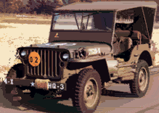

Transportation

Transportation Serbian SOLT 1
Objectives Module 4 Lesson 7

During this lesson, the students will be able to accomplish transportation. Under this Terminal Learning Objective, the students will learn four tasks: identify means of transportation, discuss rental cars, identify military vehicles, discuss motor pool activities. At the end of the lesson, the students will be able to:

- Identify means of transportation. This task will include:

- Identify means of transportation of the TR
- Discuss fees/rates for the different means of transportation
- Compare means of transportation of the TR with the United States

- Discuss rental cars. This task will include:

- Name types of vehicles in the TR
- Identify car model in the TR
- Know the various parts of the car in the TR
- Tell the clerk what type of car you want
- Ask the clerk what type of fuel is required for your car
- Rent a car

- Identify military vehicles. This task will include:

- Name military vehicles
- Identify vehicle parts

- Discuss motor pool activities. This task will include:

- Specify types of vehicles for specific activities
- Discuss vehicle maintenance activities
- Discuss advantages and disadvantages of certain types of military vehicles
- Call a tow truck

Transportation Serbian SOLT 1
Introduction Module 4 Lesson 7

Yugoslavs like to travel. The most popular means of transportation is the railroad and car. Unfortunately, the roads are not as good in the FRY as they are in the United States, and one should take good care when driving on the Yugoslav roads and highways. Air transportation is also popular, however, the prices of air tickets are high and not everyone can afford them. But if one forgets all these details, the traveling in the FRY can be a very pleasant experience thanks to the beautiful scenery that this country has to offer.

Tip of the day
The major ways of transportation in the FRY are: railroads, civil aviation, highways, inland waterways, ports and pipelines.

камион ауто мотор
(truck)

авион Превозна средства воз
(means of transportation)

трамвај аутобус брод
(trolley)

Exercise 1
Listen to what Maria says about her favorite means of transportation, and decide if the statements are true or false.
Transportation Serbian SOLT 1
Introduction Module 4 Lesson 7

Exercise 1 (continued)

T F

1. Maria’s favorite means of transportation are bus and train. _____ _____

2. Maria doesn’t drive her car often. _____ _____

3. Maria goes to work on foot. _____ _____

4. She drives her car, whenever she feels like it. _____ _____

5. The gasoline is not expensive. _____ _____

Tip of the day
If you are at the gas station – (бензинска пумпа или станица) in the FRY, don’t forget that the fluid measures used there are liters and not gallons.

Exercise 2
Где?
горе доле напред иза унутра са стране позади
Read the parts of the car. Ask and answer the questions about the position of these parts using the example given below.

Example: Где се налазе жмигавци?
Жмигавци се налазе напред и позади or са стране.

Transportation Serbian SOLT 1
Introduction Module 4 Lesson 7

Exercise 2 (continued)

Ауто делови (Parts of the car)
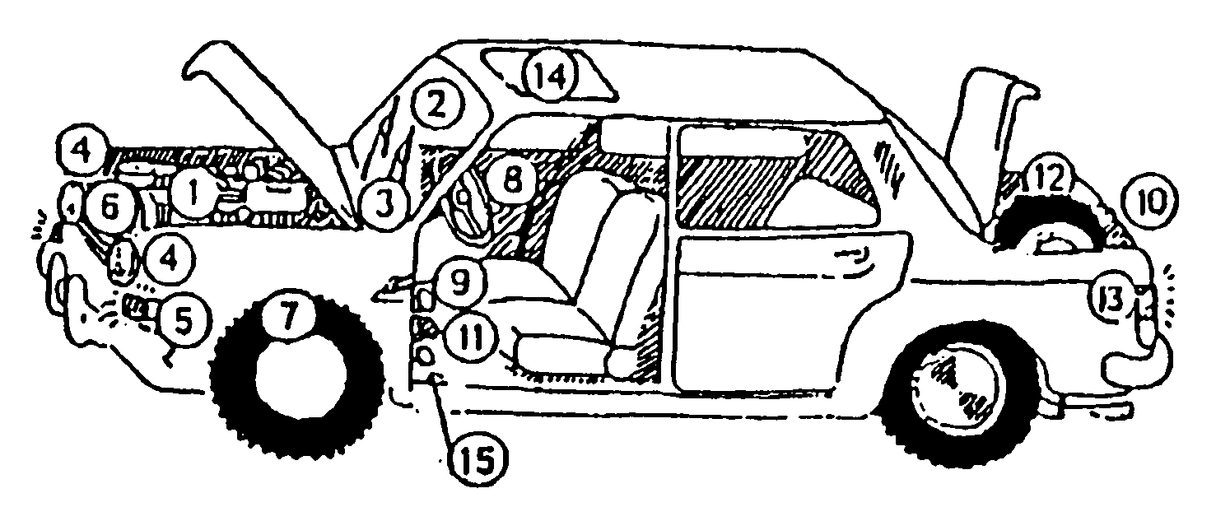

    - хауба 9. гас
    - стакло(шофершајбна) 10. пртљажник (гепек)
    - брисачи 11. кочница
    - фар 12. резервна гума
    - жмигавац 13. жмигавац
    - регистарска таблица 14. кров
    - точак 15. квачило
    - волан

Exercise 3
Када их користимо? When do we use them?
Below is the list of some parts of the car and the description of their usage. Your job is to match the part with its description. Make it as a dialogue with your partner, using the example below.

Example: закочити ауто - кочница
Када користиш кочницу?
Кочницу користим да закочим ауто.

А. дати знак за скретање 1. пртљажник
Б. возити 2. жмигавац
Ц. оставити ствари 3. квачило
Д. обрисати стакло 4. волан
Е. променити брзину 5. брисач
Transportation Serbian SOLT 1
Introduction Module 4 Lesson 7

Tip of the day
Do you recognise these cognates? Here they are: мотор, радиатор, акумулaтор, антифриз, спидометар, таксиметар, цилиндар.

Војна возила

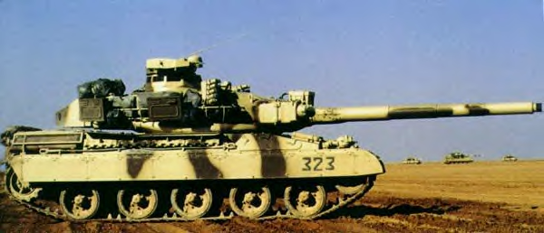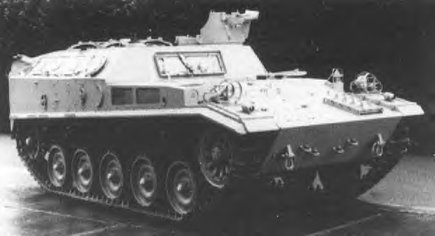

борбени тенк оклопни транспортер
(AMX – 30) (AMX VCI)

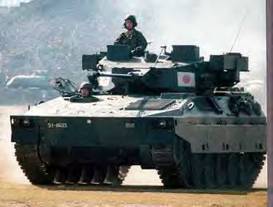
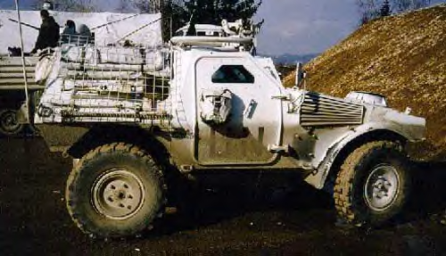
борбено возило пешадије извиђачко оклопно возило
(Type 89) (Panhard VBL)

Transportation Serbian SOLT 1
Introduction Module 4 Lesson 7

Exercise 4
Look at the image below and the list of tank components.

- Working together, find the English equivalents for the Serbian terms
- Label each circle by placing the appropriate number, then read the names of the parts aloud.

1 – точкови 2 – гусенице 3 – оклоп 4 – купола 5 – справа за ноћно навођење 6 – светла 7 – митраљез 8 – улаз 9 – поклопац 10 – антена 11 – топ 12 – средство за осматрање 13 – возачев поклопац 14 – чеони оклоп

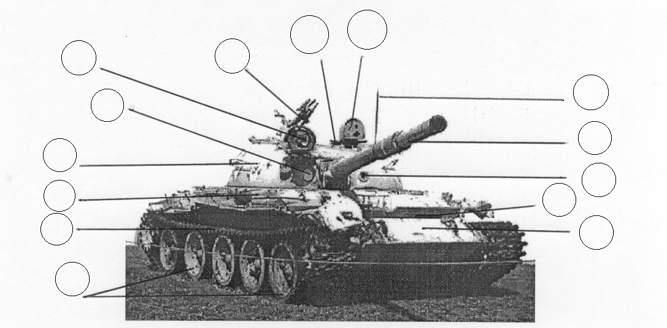

Tip of the day
Возни парк is the Serbian term for the English Motor pool.

Transportation Serbian SOLT 1

Introduction Module 4 Lesson 7

Exercise 5
Look at the rental car price list and answer the questions.

Vozni park - Cenovnik
Tip vozila | Grupa | Po danu  1-3 dana | Po danu  4-7 dana | Preko 7 dana
Fiat UNO | A | 296 | 240 | 150
Fiat Punto | B | 315 | 252 | 180
Opel Corsa | C | 370 | 296 | 210
Seat Ibica 1900 | D | 450 | 360 | 250
Opel Astra  Golf | E | 522 | 495 | 300
Opel Astra  Variant | F | 590 | 472 | 400
Seat Toledo | G | 650 | 522 | 450

1. How much would you pay to rent an Opel Corsa for three days?

2. What is cheaper to rent an Opel Astra for two days or an Opel Corsa for three days?

3. How much would it cost to rent a Fiat Uno for 10 days.

Exercise 6
Marko is traveling from Belgrade to Novi Sad and he wants to rent a car. Listen to the instructor read his conversation with a rent-a-car representative and answer the questions.

1. Какво ауто Марко жели да изнајми?

2. На колико дана Марко изнајмљује ауто?

3. Колико кошта рентање аута по дану?

4. Које ауто је Марко изнајмио?

5. Колико Марко треба да плати изнајмљивање аута на два дана?
Transportation Serbian SOLT 1
Grammar Notes Module 4 Lesson 7

Expression of time in different cases without prepositions

The use of the prepositions in Serbian and English is not identical. The best example of these differences is the expression of time. The time in Serbian can be expressed without prepositions and with prepositions. The following is the expression of time without prepositions and with the genitive, the accusative and the instrumental case.

1. The genitive case without prepositions is used:

a. To express dates:

Она је рођена двадесет првог јануара. She was born on the twenty first of January.

b. With the pronouns сваки, свака, свако – each, every:

Идемо на одмор сваког лета. We go on vacation every summer.

2. The accusative case is used:

a. With the pronouns сваки, свака, свако – each, every (same as the genitive
case):

Идемо на одмор свако лето. We go on vacation every summer.

b. To answer the question Колико?

Колико нисте били код куће? How long weren’t you at home?
Нисмо били задње две године. For the last two years.

3. The instrumental case is used:

a. For the names of days:

Суботом идемо у биоскоп. We go to the movies on Saturdays.
Зором идемо на посао. We go to work at dawn.

Transportation Serbian SOLT 1
Grammar Notes Module 4 Lesson 7

Expressions of time (continued)

b. With the nouns почетак – beginning, крај – end, and other similar nouns:

Почетком године путујемо у Париз.
At the beginning of the year, we are traveling to Paris.

c. I n constructions like the following:

Чекали смо га сатима. We were waiting for him for hours.
Данима је нисмо видели. We didn’t see her for days.

Expressions of time by different cases with prepositions

1. Time can be expressed with the following prepositions + the genitive case:

ОД – since, from,
Учимо Српски од септембра. We are learning Serbian since September.

ДО – till, until, to, by
Требамо да завршимо пројекат до петка.
We should finish the project by Friday.

ПОСЛЕ - after
После предавања идемо у куповину.
After the lecture, we are going shopping.

ПРЕ - before
Пре вечере сам написао писмо.
I wrote a letter before supper.

ЗА ВРЕМЕ – during
То се десило за време другог светског рата.
It happened during World War II.

ОКО – around, about
Око Божића је све весело.
Everything is cheerful around Christmas time.
Transportation Serbian SOLT 1
Grammar Notes Module 4 Lesson 7

Expressing time (continued)

2. Time can be expressed with the following prepositions + the accusative case:

КРОЗ – in, through
Вратићу се кроз недељу дана.
I’ll be back in a week.

ПОД – towards, in
Под старе дане је морао да ради.
He had to work in his old days.

ПРЕД – before, shortly before
Видели смо га пред ручак.
We saw him shortly before lunch.

ЗА – in, for
За два дана ће они да дођу кући.
They will come home in two days.

У – on, at
Школа почиње у уторак.
The school is starting on Tuesday.

НА – on, next, for
На зиму идемо на скијање.
Next winter, we are going skiing.

Мирјана је дошла у Нови Сад само на два дана.
Mirjana came to Novi Sad for two days only.
Transportation Serbian SOLT 1

Grammar Notes Module 4 Lesson 7

Exercise 1
Express the exchanges in Serbian.

1. Marina: Do you need the car every Sunday?
Peter: Not every Sunday, every Saturday.

2. Vesna: How long did you wait for him?
Jelena: We waited for two hours.

3. Mirko: Next summer we are going to Italy.
Slavko: And next winter we are going to France.

4. Vlada: In how many days are your parents coming?
Mira: They are coming in five days.

5. Marija: Did that happen during the lunch hour or after?
Sonja: It happened after the lunch hour.

Сваки, свака, свако (each, every) through cases:

Singular

M F N
Nom. сваки свака свако
Gen. сваког сваке сваког
Dat. сваком свакој сваком
Acc. сваки сваку свако
Inst. сваким сваком сваким

Exercise 2
Fill in the blanks with the proper form of the pronoun сваки, а, о.

1. ________ недеље идемо заједно на ручак.
2. Добили су поклон од _______ пријатеља.
3. Не треба веровати ________ човеку.
4. Разговарали смо са __________ студентом.
5. _________ дан морамо да радимо 8 часова.
6. Купили смо чоколаду _______ детету.
7. _________ године идемо на море у Будву.
8. Од ________ стране смо добили различит одговор.
Transportation Serbian SOLT 1
Vocabulary Module 4 Lesson 7

антена, е | antenna
ауто делови | auto parts
аутоматски мењач | automatic transmission
брисати (impf.) обрисати (pf.) | to wipe
брисач, и | wiper
ветробран, и | windshield, s
возни парк, паркови | motor pool
војно возило, а | military vehicle
волан, волани | steering wheel
гума, е | tire
гусеница, е | caterpillar
дувати (impf.) надувати (pf.) | to blow; to inflate
жмигавац, и | indicator light
за време | during
збуњен, а, о | confused
извиђач, и | scout
камион, и | truck
квачило, а | clutch
клима уређај, и | air condition
корисник, корисници | user
кочити (impf.) закочити (pf.) | to brake, to stop
кочница, е | brake
купола, е | tower
мењач, и | transmission
напред | forward, ahead
оклоп, и | armor
педала за гас | gas pedal
погон на четири точка | four wheel drive
под (temp.) | in
податак, подаци | data
позади | behind, at the back
поклопац, поклопци | hatch
популаран, а, о | popular
пре | before
превозно средство, а | means of transportation
прегледати | to inspect, to check
пред | before, shortly before
предузеће, а | firm
притисак, притисци | pressure
простран, а, о | spacious
Transportation Serbian SOLT 1
Vocabulary Module 4 Lesson 7

пртљажник, пртљажници | trunk
регистарска таблица, е | license plate
резервна гума | spare tire
ручни мењач | standard transmission
сваки, а, о | every, each
сипати (impf.) насути (pf.) | to pour
справа за ноћно навођење | night vision device
средство за осматрање | observation device
стабилан, а, о | stable
точак, точкови | wheel
трамвај, и | street car, trolley
удобан, а, о | comfortable
узрок, ци | cause, s
унутра | inside
фар, фарови | headlight
хауба, е | hood
чеони оклоп | front armor
Transportation Serbian SOLT 1
Culture Notes Module 4 Lesson 7

Public Transportation in the FRY

The public transit system in Yugoslavia is very well developed. The majority of the Yugoslav population lives in cities and relies every day on public transport. The number of privately owned vehicles has dramatically increased in the last few years. In big cities, as in any other metropolitan area of the world, driving is hard due to heavy traffic. Even car owners very often opt for the subway or bus.

Локални возови – suburb trains are not as comfortable as the metro, but still a lot of commuters use them daily.

Аутобус, тролејбус, трамвај - bus, electric bus, street car are the most common means of public transportation. Usually the tickets can be bought either in a kiosk on the street or from the driver on the bus.
Transportation Serbian SOLT 1
Application Activities Module 4 Lesson 7

Activity 1
Work in pairs. Study the map below and answer the questions.

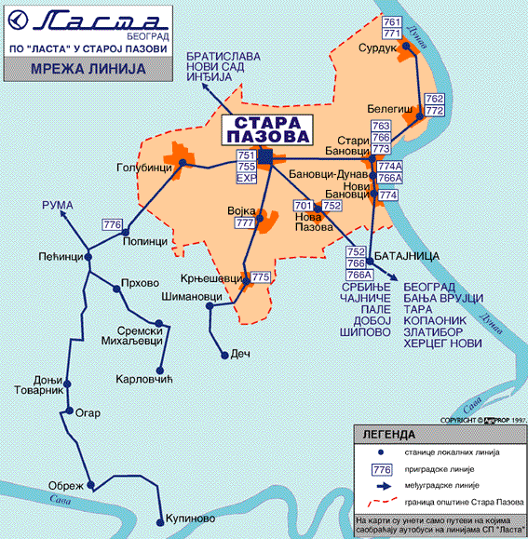

1. Да ли су ово међународне или локалне линије?
2. Која линија иде од Старе Пазове до Нове Пазове?
3. Да ли постоји међународна линија на мапи?
4. Колико станица има од Сурдука до Батајнице? Како се оне зову?
Transportation Serbian SOLT 1
Application Activities Module 4 Lesson 7

Activity 2
You are in Belgrade and want to rent a car to travel to the Adriatic coast. You have a brochure of the VIP rental agency. Read the text below and answer the questions. Compare your work with a partner.



Пружамо услуге изнајмљивања путничких аутомобила са и без возача. Имамо возни парк са аутомобилима марке Пежо (Peugeot): 106 , 206 , 306 , 406 i 806.
У понуди имамо аутомобиле са ручним и аутоматским мењачима.
Возила имају модеран аларм, радио и касетофон и клима уређај.
Нудимо повољне цене и услове.

1. What types of cars does VIP offer for rent?
2. What does each car have?
3. Do the cars have manual or automatic transmission?
Transportation Serbian SOLT 1
Application Activities Module 4 Lesson 7

Activity 3
Now choose between the role of a customer or car rental agency representative and make up a dialogue with your partner following the instructions. You will need to use the map below.

Customer Car rental agency
- Phone the agency, saying the phone - Respond, telling the name of the
number while dialing agency and your name
- Say that you would like to rent a car Ask where he/she lives
and ask for the directions to the agency
- Say that you live in Zvecanska street - Give the directions to the VIP
agency from Zvecanska street
according to the map
- Ask for the office hours - Say that you are open every day
from 8 AM to 9 PM

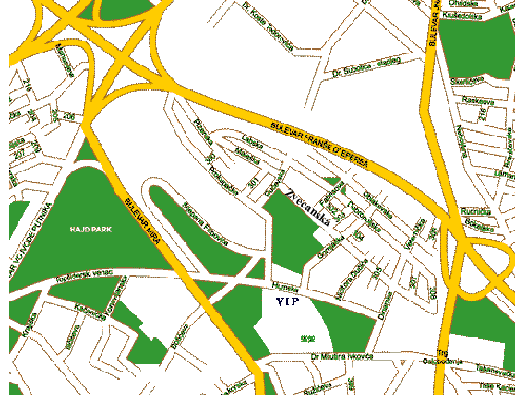

Transportation Serbian SOLT 1
Application Activities Module 4 Lesson 7

Activity 4
You are in the car rental agency. Make up dialogues with your partner. There are no instructions for you. You should be able to create a short conversation using the images and the text below. You can choose between these two situations or make up the situation of your own.

Situation 1. You want to rent a Peugeot 106 for two people
Situation 2. You want to rent a Peugeot for 5 people

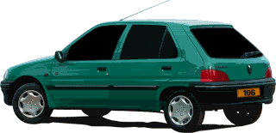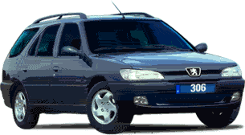

ПЕЖО 306 (караван)
- удобан
- економичан
- за велику породицу
- простран гепек
- широка шофершајбна
- идеалан за дуга путовања
- аутоматски мењач
ПЕЖО 106
- 5 врата
- веома удобан
- економичан
- одличан за малу породицу
- добар на путу
- мало троши
- ручни мењач

Transportation Serbian SOLT 1
Application Activities Module 4 Lesson 7

Activity 5
Use the information from the previous activity and fill out the car rental forms below. Compare them with your partner. Look at the vocabulary list for the unfamiliar words.

ПОДАЦИ

Корисник::
Име и Презиме:
Адреса:
Поштански број и град:
Телефон:

ВОЗАЧКА ДОЗВОЛА

Број дозволе:
Место издавања:
Датум издавања:

ВОЗИЛО

Модел возила:
Датум издавања:
Датум враћања:

Transportation Serbian SOLT 1

Application Activities Module 4 Lesson 7

Activity 6
Scan the text below and fill in the blanks.
Плави воз је био у употреби до маја 1980 године. С плавим возом се возио председник Југославије Јосип Броз Тито. Тито је прешао више од 600.000 километара у плавом возу. Плави воз је направљен у фабрици вагона Гоша, у Смедеревској Паланци и у фабрици Борис Кидрич у Марибору. Тито је путовао у Аустрију, Француску, Немачку, Бугарску, Грчку и многе друге европске земље. Овим возом је путовала и енглеска краљица Елизабета II.

1. The former president of Yugoslavia, Josip Broz Tito, often traveled by ___________.

2. This means of transportation was made by two manufacturers: __________

and ___________.

3. Among the many statesmen who traveled by this _________ was also __________
________________.

Activity 7
Look at the logos and match them with the words below.



1. 3.

2.


А. Авионско предузеће
Б. Железничко транспортно предузеће
Ц. Аутобуско предузеће
Transportation Serbian SOLT 1

Application Activities Module 4 Lesson 7

Activity 8
The following announcement is advertisement for one of the companies mentioned in the previous lesson (Activity 7). Listen to the instructor and guess for the text which company is advertised.

Activity 9
Do the role play with your partner. Read the dialog between Milan and the car mechanic and decide if the statements are true or false.

Милан: Добар дан. Да ли можете да погледате моје ауто.
Механичар: У чему је проблем?
Милан: Нисам сигуран. Брисачи ми добро не раде.
Механичар: Не раде добро јер немате довољно воде. Кад сте
мењали уље задњи пут?
Милан: Пре шест месеци.
Механичар: Требате променити уље. Такође и предња гума нема довољно
притиска. Остали делови су у реду.
Милан: Колико то све кошта?
Механичар: Уље и дување гума је 150 динара.
Милан: Хвала.

T F

1. Milan is at the car service center because his wipers are not _____ _____
working properly.

2. The mechanic thinks that the rear tires don’t have _____ _____
enough pressure.

3. Milan changed the car’s oil 6 months ago. _____ _____

4. The mechanic changed the oil and inflated the tire. _____ _____
Transportation Serbian SOLT 1
Application Activities Module 4 Lesson 7

Activity 10
Choose between the role of a mechanic and a customer and make up a dialogue using the previous activity as a guide. Below are additional expressions and words that can be useful.

заменити/надувати гуму
променити уље
прегледати кочнице/гуме/мотор
насути бензин

Activity 11
Read the characteristics of the military vehicle Thyssen UR-416 and fill in the blank spaces.
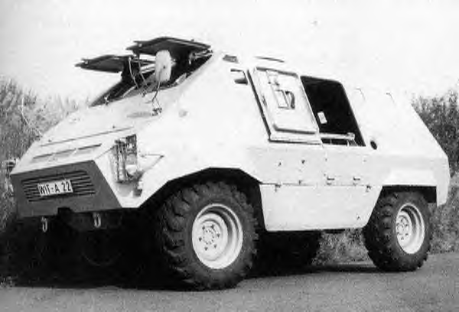

Тактичко-Техничке карактеристике
Посада: | 2+8
Калибар митраљеза: | 7,62 mm
Дужина возила: | 5,1 m
Ширина: | 2,25 m
Висина са куполом: | 2,52 m
Висина тела возила: | 2,25 m
Борбена маса: | 7600 kg
Максимална брзина: | 81 km/h

1. The vehicle’s width is: _______

2. The machine gun caliber is: ________.

3. The height with the tower: _______.

4. The maximum speed: ______

Transportation Serbian SOLT 1
Skill Enhancement Activities Module 4 Lesson 7

Activity 1
Jelena wants to rent a car. Listen to her conversation with the car rental agent and choose the best answer.

1. Jelena wants to rent a car for:

a. three days b. two days c. five days

2. She is particularly interested in:

a. Peugeot b. Mercedes c. Golf

3. The agency has cars that Jelena wants but only in the color:

a. white b. red c. purple

4. Jelena has to return the car:

a. before 10 AM b. before 8 PM c. before 9 PM

5. At the end Jelena:

a. rents the car b. wants to see the car first c. can’t make
a decision

Activity 2
The following reading mentions the names of cars and the most important features people usually look for when buying a new car. Below is a list of the features and cars but not all of them will be mentioned in the reading. Listen carefully to the instructor and mark only those that are mentioned.

Cars Features
Mercedes car price
BMW functionality
Ford slow
Peugeot fast
Golf comfortable
Audi cheap
Opel safe
stable
expensive
Transportation Serbian SOLT 1
Skill Enhancement Activities Module 4 Lesson 7

Activity 3
Scan the text below and answer the questions.

Путнички аутомобили су веома популарни у Југославији. У новије време су постали популарни и каравани. Каравани су удобни, имају доста простора и нарочито су добри за велике породице. Спортски аутомобили су популарни, али их највише воле млади. Спортски аутомобили су скупи и нису тако удобни. У Југославији аутоматски мењач није популаран. Већина аута имају ручни мењач.

1. What is this text about?
2. What three types of the mentioned features are described in the text?
3. Which type of car is the most popular among the young people?
4. What kind of transmission is used in the Yugoslav cars?

Activity 4
Your Serbian counterpart and you are planning a trip to the Adriatic Sea. Look at the photographs of the cars below. The choices might seem obvious. Give your reasons for selecting a particular car.

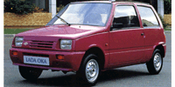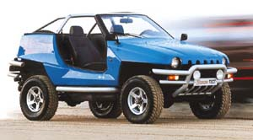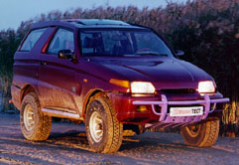

Activity 5
The class should be divided into two groups. The word АУТО should be written on the board. Each group should come up with as many words as possible that have something to do with a car. The instructor will write the associations on the board. The group that comes up with the most words is the winner.
Transportation Serbian SOLT 1
Skill Enhancement Activities Module 4 Lesson 7

Activity 6
What is your dream car? What features are important to you when you are buying a car?
Write your preferences below. Make up at least five sentences. Compare your work with a partner.

________________________________________________________________________________________________________________________________________________________________________________________________________________________________________________________________________________________________________________________________________________________________________

Activity 7
Marko is on the phone with a mechanic but their conversation written below is not in order. Read each statement and number it chronologically from 1 to 10.

A. Жао ми је господине Поповић, али данас немамо времена.
B. Кочнице не раде и ауто троши много бензина.
C. Зовем се Марко, Марко Поповић. Хтео бих да довезем ауто на поправак.
D. Ја не могу сутра. Можда у петак у 10 ујутро?
E. Када могу да дођем?
F. Сутра ујутро.
G. Може. У петак у 10 ујутро.
H. Какав проблем имате са аутом?
I. Добро. Дођите и погледаћемо.
J. Хвала. Довиђења.

Transportation Serbian SOLT 1
Skill Enhancement Activities Module 4 Lesson 7

Activity 8
Work with a partner. Read the ads below together and decide which car of those that are on sale you would buy. Explain your reasons to each other.

ФИАТ
Пунто, 28.000 км, производња 2000, црвене боје, аутоматик, радио и алармни систем. Цена: 10, 000 DM

ФОРД
Форд Ескорт, производња 1992,

ХУНДАИ
Производња 1995, у одличном стању, беле боје. Цена 12,000 DM.

РЕНО
Караван. Производња 1994, 118.000 км, зелена боја. Цена по договору.

Activity 9
Go through the following advertisement, use your knowledge of cognates and decide if the statements are true or false.
PEUGEOT 406 припада линији великих луксузних аутомобила. Ово ауто удовољава жељама и возача и путника. Унутрашњост је комбинација комфора и квалитета. Дизајниран је са лакоћом и може да прелази велика растојања.

T F

1. Peugeot doesn’t belong to the luxurious cars. _____ _____

2. This car is a combination of comfort and luxury. _____ _____

3. Peugeot is designed to easily travel long _____ _____
distances.

Transportation Serbian SOLT 1
Skill Enhancement Activities Module 4 Lesson 7

Activity 10
Look at the text below and fill in the blank spaces with the most suitable words.
Овај оклопни транспортер користи дизел мотор Даимлер Бенц ОМ 366, са снагом од 240 кс (коњских снага) и налази се у предњем делу возила. На крову возила се налази купола са два митраљеза 7,62 мм или топ калибра 20 мм.

1. This armored vehicle is using _____________ motor with the ________ horse power.

2. The motor is located in the _________ part of the vehicle.

3. The tower with two ____________ is located on the _____________.

4. The gun caliber is __________ mm.

Transportation Serbian SOLT 1
Homework Module 4 Lesson 7

Activity 1
Listen to the announcement and choose the correct answers from the list below.

1. The advertised agency offers: a. sea cruises
b. travel to Italy
c. air tickets

2. The agency’s phone number is: a. 011/525-6753
b. 011/523-4553
c. 011/537-6722

Activity 2
Listen to the dialogue and mark if the following statements are true or false.

Т F

1. The customer wants to rent a Renault. _____ _____

2. He needs the car for two days. _____ _____

3. The car rental is 400 din per day. _____ _____

4. The customer wants to make the reservation _____ _____
over the phone.

Activity 3
What is not right to say? Underline the right word.

1. Морам да /оперем / окупам / умијем / ауто.

2. Моје ауто /пије / једе / троши / много бензина.

3. Јуче сам променио уље /у гуми / у ауту / у волану/.

4. Ставили смо кофере /у кров / куполу/ пртљажник.

5. Тенк има /гусенице / гуме / ноге/.

6. Са кочницом / возимо / чистимо / заустављамо/ ауто.
Transportation Serbian SOLT 1
Homework Module 4 Lesson 7

Activity 4
Fill in the the missing words with the proper words in the parenthesis. Be careful! The words are given in a random order.

1. Ваше ауто је готово. Можете одмах да га __________________. (изнајмили)

2. Моје ауто је у квару. Мотор не ____________ добро. (боље)

3. Кад смо путовали у Мађарску _____________ смо Пежоа. (возите)

4. Форд Ескорт је ____________ од Опел Кадета. (гепек)

5. Купили смо ново ауто. Много је __________ од старог аута. (ради)

6. Његово ауто има мали __________ и није ____________. (бржи)
(удобно)

Activity 5
Read the text below and answer the questions.
Перл Харбур, Хаваји, је нападнут око 8 часова ујутро. Била је недеља, 7. децембар 1941. Јапанци су извели напад под вођством адмирала Исороку Јамамото. У нападу је учествовало 353 јапанска авиона.

    - Шта се десило 7. децембра 1941?
    - Кога су напали Јапанци?
    - Ко је предводио Јапанце?
    - Колико авиона је учествовало у нападу?

Transportation Serbian SOLT 1
Homework Module 4 Lesson 7

Activity 6
Study the map below and decide if the statements are true or false.

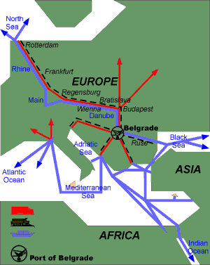

T F

1. Ово је мапа луке Београд. _____ _____

2. Од луке Београд воде путеви у Црно _____ _____
и Медитеранско море.

3. Аутопут од Београда иде до Северног _____ _____
пола.

Activity 7
Write five short sentences using the pronoun сваки, свака, свако. Compare your work with a partner the next day.

1. ______________________________________________________________________

2. ______________________________________________________________________

3. ______________________________________________________________________

4. ______________________________________________________________________

5. ______________________________________________________________________

