SOLT Serbian Module 3 Lesson 6

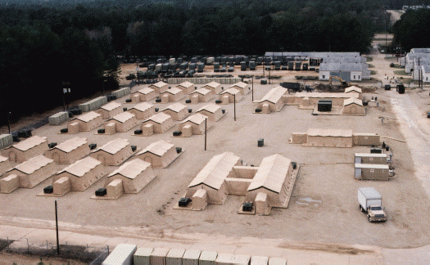

Setting up Base Camp
Setting up Base Camp Serbian SOLT 1
Objectives Module 3 Lesson 6

During this lesson, the students will be able to accomplish Setting up Base Camp. Under this Terminal Learning Objective, the students will learn three tasks: plan to set up a base camp, discuss work attire and get supplies. At the end of the lesson, the students will be able to:

- Plan to set up a base camp. This task will include:

- List all the items for setting up a base camp
- Identify accommodations at a military installation
- Identify one’s surroundings

- Discuss work attire. This task will include:

- Discuss common articles of clothing
- Describe civilian and military clothing
- Discuss preference in style, color and material
- Compare the sizes in the US and the TR
- Describe seasonal clothes
- State clothing needs
- Select weather appropriate clothing

- Get supplies. This task will include:

- Identify supplies
- Select supplies for your mission
- Discuss specific supplies required by team members
- Select supplies for veterinary services
- Ask questions about supplies and where to get them on the post
- Answer questions about supplies and where to get them on the post
- Buy supplies

Setting up Base Camp Serbian SOLT 1
Introduction Module 3 Lesson 6

The building of a suitable base camp could be one of the most important features when being on a mission in the target country. Mines, damaged infrastructure, poor road networks, and poor soil conditions could all affect and limit the potential sites for base camps. Therefore it is necessary to get acquainted with the terms regarding setting up a base camp, learning the names of the items and the camp equipment in the target language. Also it is very important to know how to identify, select and buy supplies and weather appropriate clothing.

Tip of the day
“Наредба командира мора да буде извршена беспрекорно, тачно и на време” - The order given by the commander (chief) must be accomplished implicitly, precisely, and on time.

Exercise 1
Here are the images of some items needed for setting up a base camp. Repeat the words after the instructor. Practice pronouncing the name of each item aloud.
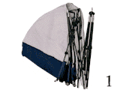

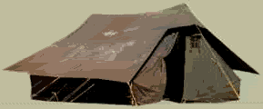

војни шатор шаторски стуб

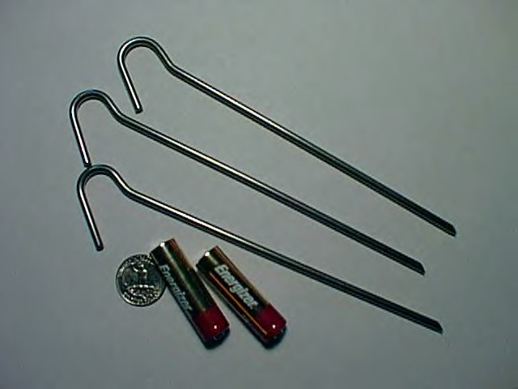
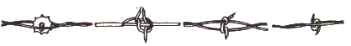

шаторски кочић бодљикава жица

Setting up Base Camp Serbian SOLT 1
Introduction Module 3 Lesson 6

Exercise 1 (continued)

радио | radio
конопац (уже) | rope
алат (алатке) | tool, s
генератор | generator
залихе лекова | medical supplies
залихе хране | food supplies
залихе воде | water supplies
одбрамбено оружје | defense weapon
складиште муниције | ammunition storage
kамиони | trucks

Југословенске војне базе на Косову
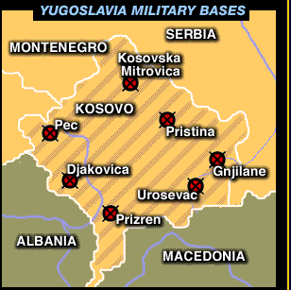

Setting up Base Camp Serbian SOLT 1
Introduction Module 3 Lesson 6

Смештај у војним установама
(The accommodations at a military installation)

Exercise 2
Students work in pairs. Your partner and you are visiting a Yugoslav military installation. Your guide is Captain Мирослав Поповић. He is explaining to you the military life in the Yugoslav army. Read his text below a few times and do the following:

- Find the meaning of the new words that are highlighted
- Answer with true or false
Наши војници живе у војним касарнама. Имају бесплатан смештај, храну, здравствену заштиту и мали месечни џепарац. Сваки војник има петнаест до двадесет дана регуларног одсуства. Војници деле собе у касарнама. Свака соба има до тридесет војника. Они спавају на креветима на спрат. Официри живе у апартманима и имају велике бенефиције. Њихов одмор може да траје и до 30 дана...

B. T F

1. The Yugoslav soldiers live in apartments. _____ _____

2. They get a monthly payment. _____ _____

3. They don’t have any health care provision. _____ _____

4. They sleep in sleeping bags. _____ _____

5. Officers live outside the military installation. _____ _____

6. A Yugoslav soldier can have 15-20 days regular leave. _____ _____

Setting up Base Camp Serbian SOLT 1
Introduction Module 3 Lesson 6

Exercise 3
Students work in pairs. Imagine that your partner is a foreign soldier. He/she wants to know what your military life looks like. Tell him/her the basics of the military accommodations in your unit. Your partner will take notes and report the information to the class.

Tip of the day
The Yugoslavs wear Western-style clothing. There is a difference in clothing and shoe sizes between the US and Yugoslavia.

Exercise 4

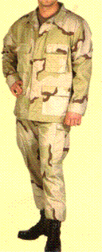
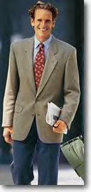
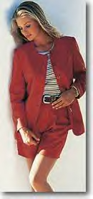
Одећа (clothing) Read a short description under each image of what these people wear and underline all words that you think describe the clothing. Your instructor will help you.
Он носи сако и панталоне. Сако је сиве боје, а панталоне су плаве. Његова кошуља је светло плава. Он такође носи и кравату. Кравата је црвена. Његова величина је 44.
Ово је војна униформа. Војник носи панталоне, јакну и мајицу. Његова мајица је смеђе боје а панталоне и јакна су шарене. На ногама има црне чизме. Униформа је број 44. Чизме су број 43.
Она носи црвени блејзер и црвени шорц. Око појаса има каиш. Њена блуза је бела са пругама. Она носи величину 40.

Setting up Base Camp Serbian SOLT 1
Introduction Module 3 Lesson 6

Exercise 5
У робној кући (In the department store)
Janko is going out tonight with his new girlfriend but he doesn’t want to wear his military uniform. Therefore, he goes to the department store to buy casual clothes for himself. Read his conversation with a salesperson and answer the questions below.

Продавачица: Добар дан. Изволите.
Јанко: Хтео бих да купим панталоне и кошуљу.
Продавачица: Коју величину носите?
Јанко: 44.
Продавачица: Какву боју волите?
Јанко: Волим тамније боје, тамно плаву или смеђу.
Продавачица: Имамо јако лепе панталоне од памука.
Јанко: Да ли могу да их пробам?
Продавачица: Свакако. Кабина је тамо. Имате и огледало.
Јанко: Хтео бих и ципеле.
Продавачица: Ципеле су на другом оделењу.

- What does Janko want to buy?
- What size does he wear?
- What color does he prefer?
- Does the salesperson offer him the shoes as well?

сако кошуља чарапе кравата

каиш мајица блуза

Setting up Base Camp Serbian SOLT 1
Introduction Module 3 Lesson 6

Exercise 6
Look at the clothing and shoe size chart and answer the questions.

ВЕЛИЧИНЕ
Женска гардероба
Америка | 6 |  |  |  | 8 |  |  |  | 10 |  |  |  | 12 |  |  |  | 14 | 16 | 18 |  |  |  | 20 |  |  |  | 22
Југославија | 34 |  |  |  | 36 |  |  |  | 38 |  |  |  | 40 |  |  |  | 42 | 44 | 46 |  |  |  | 48 |  |  |  | 50
Мушка гардероба
Америка |  | 34 |  |  |  | 36 |  |  |  | 38 |  |  |  | 40 |  |  |  |  |  | 42 |  |  |  | 44 |  |  |  | 46
Југославија |  | 44 |  |  |  | 46 |  |  |  | 48 |  |  |  | 50 |  |  |  |  |  | 52 |  |  |  | 54 |  |  |  | 56
Женска обућа
Америка |  |  | 6 |  |  |  | 7 |  |  |  | 8 |  |  |  | 9 |  |  |  |  |  | 10 |  |  |  |  | 11 |  |  |  | 12
Југославија |  |  | 37 |  |  |  | 38 |  |  |  | 39 |  |  |  | 40 |  |  |  |  |  | 41 |  |  |  |  | 42 |  |  |  | 43
Мушка обућа
Америка |  |  |  | 5 |  |  |  | 6 |  |  |  | 7 |  |  |  | 8 |  |  |  |  |  | 9 |  |  | 10 |  |  |  | 11
Југославија |  |  |  | 38 |  |  |  | 39 |  |  |  | 40 |  |  |  | 41 |  |  |  |  |  | 42 |  |  | 43 |  |  |  | 44
- You are in the FR of Yugoslavia and want to buy a pair of shoes. Your American size is 10. What Yugoslav size would you need to buy?
- You are buying a blouse for your wife or a girlfriend. Her American size is 8. What would be her Yugoslav size?
- If your Yugoslav shirt size is 48, what size is it in America?
- Your shoe size is 9.5. What would that be in Yugoslavia?

Expressions

Хтео бих/Желео бих да купим... | I would like to buy…
Носим величину 40. | I wear size 40.
Да ли могу да пробам? | Can I try it on?
Где је мушко/женско/дечије оделење? | Where is the man’s/woman’s/children’s department?
Шта је данас модерно? | What is in style today?
Да ли вам се допада мајица? | Do you like the shirt?
Да ли волите свилу, памук или вуну? | Do you like silk, cotton or wool?
Мајица ми се не допада. | I don’t like the shirt.
Ципеле ми одговарају. | The shoes fit me.
Панталоне ми не одговарају. | The pants don’t fit me.
Шта је на снижењу данас? | What is on sale today?

Setting up Base Camp Serbian SOLT 1
Introduction Module 3 Lesson 6

Tip of the day
“Од вишка глава не боли” – “It will not hurt to bring extra”.

Војна опрема

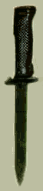

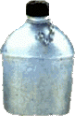
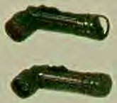

чутурица нож батерија

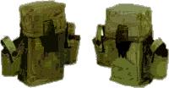

ранац

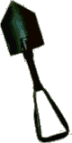

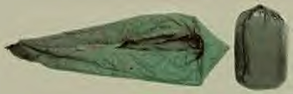

лопата врећа за спавање

Setting up Base Camp Serbian SOLT 1
Introduction Module 3 Lesson 6

Југословенска војна пошта
Here is a layout of the Yugoslav military post.

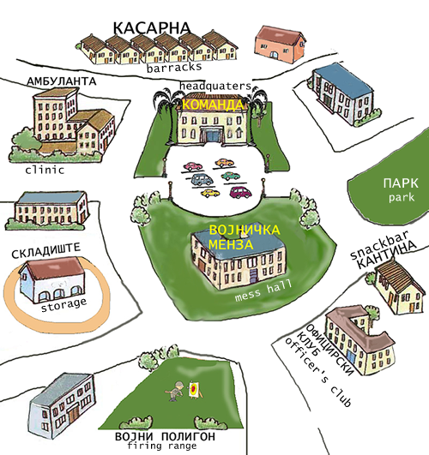

Exercise 7

You are very well familiar with the base where you are stationed. Make a sketch of different services and buildings found on your installation. Compare it with the sketch of the Yugoslav military post.

Setting up Base Camp Serbian SOLT 1
Introduction Module 3 Lesson 6

Exercise 8
Imagine that you are at the Yugoslav military post. Answer the questions by using the Serbian keyword.

- Your friend is lightly injured. Where does he need to go to get medical treatment?

- You would like to buy a pack of cigarettes. Where would you go?

- You will observe the military training tomorrow. Where will this training most likely take place?

- Where would you report a disturbing military message?

- You are looking for Captain Mirkovic. He is on lunch break. Where do you think he is most likely to be found?

Setting up Base Camp Serbian SOLT 1
Grammar Notes Module 3 Lesson 6

Vocabulary supplement

Одећа (Clothing) Направљен/а/о од (made of…)

џемпер (sweater) памук (cotton)
патике (sneakers) кожа (leather)

капа (cap) сомот (velvet)

капут (coat) фротир (terry cloth)

марамица (handkerchief) синтетика (synthetic)

фармерке (jeans) сатен (satin)

одело (suit) најлон (nylon)

рукавице (gloves) рејон (rayon)

купаће гаће (swimming trunks) платно (linen)

пиџама (pyjamas) гума (rubber)

сандале (sandals)

кабаница (rain coat)

спаваћица (nightdress)

купаћи костим (swimsuit)

дугме (button)

крагна (collar)

џеп (pocket)

рукав (sleeve)
излог (store window)
распродаја (sale)
пертле (shoelaces)
мантил (coat)
костим (women’s suit)
тренерка (warm-up suit)
Глаголи (Verbs)
обувати imp. (to put on footwear)
изувати imp. (to take off footwear)
изути pf. (to take off footwear)
облачити imp. (to put on clothing)
обући pf. (to put on clothing/footwear)
пробати pf. (to try on)
пробавати imp. (to try on)

Setting up Base Camp Serbian SOLT 1

Grammar Notes Module 3 Lesson 6

The Conditional

To express the English term “I would like to…” in Serbian you need to use the special form of the verb БИТИ and the Past Participle of the verb желети or хтети. Look at the example:

Ја бих желео/хтео Ми бисмо желели/хтели
Ти би желео/хтео Ви бисте желели/хтели
Он би желео/хтео Они би желели/хтели

Ја бих желео да купим нове ципеле. I would like to buy new shoes.

Past Participle Present

Exercise 1

Шта бисте желели да радите? Write what they would like to do using the examples given.

Example: читати књигу – ја Ја бих желео да читам књигу.

играти спорт - он

слушати музику - Јелена

кувати ручак - она

јести у ресторану - Милан

ићи на излет - они

путовати у Мексико – ми
- возити авион – Владо
- телефонирати – деца
- променити доларе – ја
- плесати са девојком - он

Setting up Base Camp Serbian SOLT 1
Grammar Notes Module 3 Lesson 6

The Expression: Допада ми се/Свиђа ми се (I like it)

The pair допадати се (imp.) and допасти се (pf.) and their synonyms свиђати се (imp.) and свидети се (pf.) are used with the dative form of the pronoun.

Examples:

Како вам се допада Дубровник? How do you like Dubrovnik?

Дубровник ми се много допада. I like Dubrovnik very much.

If you translate the Serbian sentence literally, you can understand this structure perhaps better:

Is Dubrovnik appealing to you?
Dubrovnik is very appealing to me.

Setting up Base Camp Serbian SOLT 1
Vocabulary Module 3 Lesson 6

алат, и | tool, s
амбуланта, е | clinic, s
бенефиција, е | benefit, s
блејзер, и | blazer, s
блуза, е | blouse
бодљикава жица, е | barb wire
величина, е | size
војна база, е | military base
војна пошта, е | military post
војни шатор, и | military tent
врећа за спавање | sleeping bag
генератор, и | generator
гориво, а | fuel, s
залихе воде | water supply
залихе лекова | medical supply
залихе хране | food supply
здравствена заштита | health care
кабина, е | fitting room
каиш, каишеви | belt
камион, и | truck
кантина, е | snackbar
касарна, е | barrack
команда, е | headquarter
конопац, конопци | rope
кошуља, е | shirt
кравата, е | tie
кревет на спрат | bunk bed
лопата, е | shovel
мајица, е | T-shirt
обућа | footwear
одбрамбено оружје, а | defense weapon
оделење, а | department
одећа | clothing
отсуство, а | leave
појас, појасеви | waist
полигон за гађање, и | firing range
ранац, ранци | backpack
резервоар, и | tank, s
робна кућа, е | department store
сако, сакои | jacket (part of suit)

Setting up Base Camp Serbian SOLT 1
Vocabulary Module 3 Lesson 6

сваки, а, о | every
складиште муниције | ammunition storage
смештај, и | lodging
тесан, а, о | too small
униформа, е | uniform, s
чарапа, е | sock, s
чутура, е (чутурица) | flask
џепарац, џепарци | pocket money
шарен, а, о | colorful
шаторски кочић, и | tent peg
шаторски стуб, стубови | tent pole
шорц, шорцеви | shorts

Setting up Base Camp Serbian SOLT 1
Culture Notes Module 3 Lesson 6

Yugoslav Military Post
Military bases in Yugoslavia are not found on tourist or road maps. You will never see signs on the road guiding you to a military installation. You may see a sign Стој! Забрањена зона! – Stop! Prohibited Area! or Прилаз забрањен! - No entry! If you reach such a point and you do not have a reason to be there, you better turn back. No private vehicles are allowed on a military base. Even officers who own cars must keep them outside the base. Normally, only vehicles that belong to the base can enter or exit it. Maps of military installations are not available. Public telephones may or may not be available. Официри - officers do not share the same dining facility with the soldiers. In the официрски клуб - officers' club, officers and civilian employees pay for their meals. The soldiers eat in војничка менза – the mess hall and they don’t pay for their meal. The choice of the food is very modest but the soldiers can buy what they need in the кантина – snackbar. Officers do not share the same living quarters with soldiers. Officers live off base while soldiers live in касарне - barracks on base. They normally have two-level beds. Entertainment there can be телевизор - TV, шах- chess, пинг-понг - ping-pong and sport facilities (basketball, handball).

Setting up Base Camp Serbian SOLT 1
Application Activities Module 3 Lesson 6

Activity 1
Students work in pairs. Ask each other what you are wearing today. Give the name of the clothing, size, color and material of the clothing. Refer to the section of Grammar Notes for the supplementary vocabulary.

Example: Данас носим мајицу. Она је црвена. Њена величина је 40 и направљена је од памука (genitive).

Activity 2
Укуси су различити – Tastes differ
What do you think about the clothes of your classmates? Ask each other questions. You can use the words below to help you express your opinion.

Example: A. Како ти се допада Дејвидова јакна?
Б. Веома је лепа/Није лепа/Не допада ми се...

елегантан, а, о (веома/не баш)
модеран, а, о (веома/не баш)
веома ми се допада
превише дуг, а, о (too long)
превише кратак, а, о (too short)
превише узак, уска, уско (too narrow)
превише широк, а, о (too wide)
Боја ми се не допада.

Activity 3
Students work in pairs. You are in a department store. Your partner is a salesperson. Make up a dialog using the instructions given below. Reverse roles.

Setting up Base Camp Serbian SOLT 1
Application Activities Module 3 Lesson 6

Activity 3 (continued)

- You would like to buy a piece of clothing.
- Tell the salesperson which size you need and what color you prefer.
- Ask for the fitting room and try the merchandise on.
- Say that you don’t like it: it is too narrow/too long etc.
- Ask for another style.
- Say that this one fits you and ask for the price.
- Ask if you can pay with a visa card.

Activity 4
Circulate around the room and interview each other asking questions written below. The questions are about clothing needs. After the interview, report to the class the information that you’ve gotten from one of your classmates.

- Да ли је одећа важна за тебе?
- Да ли је твоја одећа модерна?
- Да ли пратиш моду? (Do you follow clothing trends?)
- Шта највише волиш да носиш?
- Колико трошиш новаца месечно на одећу?
- Шта обично носиш зими (in winter) а шта лети (in summer)?

Activity 5
Scan the following text about color trends and decide if the answers are true or false.
The text is written in the Roman alphabet.

Boja u trendu.
Većina kreatora su svoje kolekcije obojili u zeleno. Zelena se javlja ove sezone u boji masline, dolara ili jelke. Zelena je boja mira i modeli koji je nose ne deluju agresivno. U zelenoj boji su sve vrste materijala svila, vuna, pamuk, pa i koža.

T F
- Green is in trend this season. _____ _____
- Green is very aggressive. _____ _____
- All materials are made in green except leather. _____ _____

Setting up Base Camp Serbian SOLT 1
Application Activities Module 3 Lesson 6

Activity 6
Look at the table of the monthly clothing production from some Serbian factories and answer the questions below.

 | Artikal | Mesečni kapacitet
Fabrika "Beograd" - Beograd | Odelo  Sako  Pantalone | 13.000  7.500  7.500
Fabrika "19. Oktobar" - Lazarevac | Pantalone (teksas)  Jakna | 6.000  2.500
Fabrika "Mladost" - Kovin | Košulje, bluze  Trenerke | 25.000  3.200
Fabrika "Avala" - Aranđelovac | Pantalone | 7.500
Fabrika "Svilajnac" - Svilajnac | Ženski mantil  Muški mantil  Ženski kostim | 1.500  1.500  1.600
1. Which factory has the biggest monthly production capacity?
2. Which factory produces men’s suits?
3. How many jeans are made monthly and where?
4. What kind of clothing does the factory Svilajnac produce?
5. Do any of these factories produce footwear?

Setting up Base Camp Serbian SOLT 1
Application Activities Module 3 Lesson 6

Activity 7
Read the text and answer the questions.
Најтраженији су џемпери, капе, рукавице, фармерке, кошуље и капути. Атекс даје попуст од 20%. Џемпери коштају од 340 до 1.900 динара, женски костими од 1.700 до 3.300 динара. Мушка одела од 3.500 до 6.700 динара. Капути се могу наћи по цени од 3.500 динара. Мушке и женске панталоне коштају између 350 и 1.100 динара.

- Која одећа је поменута (mentioned) овде?
- Ко даје попуст од 20%?
- Која врста одеће је најскупља?
- Која врста одеће је најјефтинија?
- Која одећа је најтраженија?

Activity 8
Captain Mirkovic wants to buy new clothes for himself. Listen to the instructor read his conversation with a salesperson and choose the right answer.

1. Captain Mirkovic wants to buy:

a. a sweater b. a shirt c. pair of pants

2. He prefers:

a. wool b. cotton c. nylon

3. Everything in store is:

a. 30% off b. 20% off c. 10% off

4. Captain Mirkovic

a. likes cotton pants b. doesn’t like cotton pants c. doesn’t care

5. Captain Mirkovic buys

a. new pair of pants b. a new shirt c. nothing

Setting up Base Camp Serbian SOLT 1
Application Activities Module 3 Lesson 6

Activity 9
Captain Rodic received a message from Colonel Simic. Look through the message and guess what Captain Rodic is supposed to do.
Набавити 10 шатора, алат, вреће за спавање, контејнере за воду, лекове и храну. Извршити наредбу одмах

Activity 10
Study the layout of a department store and find the information to the questions written below.

I спрат
козметика/женска и мушка обућа/кожна галантерија/спортска опрема
II спрат
кухињски апарати и сервиси/дечија обућа и одећа/женска одећа/опрема за купатило/
III спрат
мушка одећа/електроника/
IV спрат
намештај/играчке

- Where would you go to buy a new computer?
- You want to buy a present for your girlfriend. Which floor would you go to? Explain your reason?
- A customer wants to buy a pair of sneakers. Where would you direct him/her to go?
- Your toaster is broken. Where can you get a new one: on the second or on the third floor?
- You are planning a camping trip. Where can you buy the camping equipment?
- You just bought a new sofa-bed but you didn’t get the price reduction as you expected. You make your complaint to the salesperson but he/she insists that the price is right. What is his/her reason for this explanation?

Setting up Base Camp Serbian SOLT 1
Application Activities Module 3 Lesson 6

Activity 11
Students work in pairs. You are new on post and don’t know much about the surrounding. Your partner will try to answer all questions that you have. Ask him/her the questions using the words given below. He/she will choose the right possible answer.

Example:

You Your partner
Где могу да набавим цигарете. Можеш да их набавиш у кантини.

1. лек (medicine) а. у складишту
2. вечерати б. у кантини

3. имати вежбу ц. у команди

4. купити хлеб д. у амбуланти

5. набавити скије е. у мензи

6. разговарати са пуковником ф. на војном полигону
Петровићем

Setting up Base Camp Serbian SOLT 1
Skill Enhancement Activities Module 3 Lesson 6

Activity 1
Mira went shopping today. Listen to the instructor read her conversation with Nenad and answer the questions.

- Где је Мира била јутрос?
- Шта је купила?
- Колико пара још има?
- Да ли су паре за њу или за Ненада?
- Шта Мира планира да купи?

Activity 2
Sergeant Stakic has to accomplish a few tasks. Listen to the instructor read the order that he received and figure out what tasks he has to accomplish.

________________________________________________________________________________________________________________________________________________________________________________________________________________________

Activity 3
Listen to the instructor read what Vlado says about the dress code in the military and decide if the answer is true or false.

T F
1. Vlado mentions two kinds of uniform. _____ _____

2. The uniform is made of wool and nylon. _____ _____

3. Vlado only wears a uniform in military school. _____ _____

4. Vlado mentions boots as a part of the uniform. _____ _____

5. He doesn’t like to wear sports clothes. _____ _____

Setting up Base Camp Serbian SOLT 1
Skill Enhancement Activities Module 3 Lesson 6

Activity 4
Students work in pairs. Describe one of the images given below. Your partner should guess which image you are describing. If his/her guess is right, then it is his/her turn to describe another image.


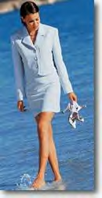
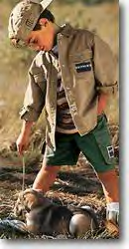
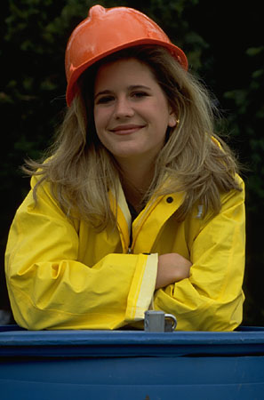

Activity 5
Scan the following text and answer the questions written below.

У улици Бана Милосављевића у недељу увече отворен је први Интернет кафе у Републици Српској. На отварању је владала велика гужва, а млади су највише били заинтересовани за највећу посластицу те вечери - бесплатно крстарење Интернетом. Иначе, десет минута сурфања по Мрежи коштаће једну конвертибилну марку.

What? __________________________________________________________________
Where? _________________________________________________________________

Setting up Base Camp Serbian SOLT 1
Skill Enhancement Activities Module 3 Lesson 6

Activity 6
This short text gives you some information about the Yugoslav military. Read the text and answer the questions.
Официри добиjају одговарајућу плату и бенефиције и живе боље него војници. Висина официрске плате зависи од чина, година рада, брачног стања и броја деце. Лекари, инжењери и техничари са специјалном обуком добиjају екстра плату да остану у војсци.

- What is this text about?
- What factors influence the officer’s salary?
- Which professions are also mentioned here?
- Why do you think these professions get extra pay?

Activity 7
Finish the dialogs by writing the appropriate question or response in the blank spaces provided below.

1. 2.
Жао ми је али немамо каишеве.
Мушка одећа је на другом спрату.

3. 4.
Кошуља је превише скупа.
Ова хаљина? 1000 динара

5. 6.
Не, не желим нове чизме.
Немамо војну униформу број 44.

Setting up Base Camp Serbian SOLT 1
Skill Enhancement Activities Module 3 Lesson 6

Activity 8
Place the terms written below in the proper boxes.

Зимска одећа
Летња одећа
Војна опрема

капут шатор вунене чарапе мантил капа лопата бодљикава жица чутурица костим рукавице
сандале ципеле чизме нож купаће гаће ранац
шорц летње одело кревет на спрат оружје

Activity 9
Look at the images below and do the following exercises:

A. What is happening here? What are the people telling the man at the door? What is his response? Write at least 5 sentences.

_______________________________________________
_______________________________________________
_______________________________________________
_______________________________________________
_______________________________________________
_______________________________________________
_______________________________________________

Setting up Base Camp Serbian SOLT 1
Skill Enhancement Activities Module 3 Lesson 6

Activity 9 (continued)

B. Describe in a few sentences why he is so happy. Use your imagination.

__________________________________________________________________________________________________________________________________________________________________________________________________________________________________________________________________________________________________________________________________________________________________________________________________________________________________________________________________

C. Make up a short dialog between these two people.

__________________________________________________________________________________________________________________________________________________________________________________________________________________________________________________________________________________________________________________________________________________________________________________________________________________________________________________________________________________________________________

Activity 10
Connect the following sentences.

1. Данас је хладније | А. ваша величина?
2. Хоћу да пробам | Б. кабина?
3. Снижене су | Ц. мушке панталоне.
4. Свилене кошуље | Д. него јуче.
5. Која је | Е. се допада ова блуза?
6. Да ли вам | Ф. су веома популарне.
7. Где је | Г. кравате и одела.

Setting up Base Camp Serbian SOLT 1
Homework Module 3 Lesson 6

Activity 1
You will hear some of the new vocabulary words learned today. Listen to the recording and number the words as they are pronounced. Pronounce each word aloud.

залихе воде
конопац (уже)
складиште муниције
генератор
залихе лекова
џепарац
радио
одбрамбено оружје
алат (алатке)
залихе хране
бодљикава жица
камиони
стуб

Activity 2 Шта је данас на снижењу?
Listen to a speaker announcing what is on sale today and write the percentages next to the items announced.

Items | Percentage
Electronics
Men’s/women’s clothing
Furniture
Children’s clothing
House ware

Setting up Base Camp Serbian SOLT 1
Homework Module 3 Lesson 6

Activity 3
Read the letter below and answer the questions.

Драги родитељи,
Стигао сам. Још увек не знам много тога. Добио сам смештај у касарни. У соби нас има 25. Спавамо на креветима на спрат. Једемо у војничкој мензи. Храна ми се не допада. Имамо кантину у бази. Тамо могу да купим све што ми треба. Имамо вежбе сваки дан. Устајем у 5 часова. Увече можемо да гледамо телевизију или да играмо шах. Али ја сам увек уморан.

Ваш Миро

- To whom is this letter written?
- Who is the person that wrote the letter?
- Does he like the food there?
- Write down 5 words that provide us with a clue about the place this letter is written from.

Activity 4
Make a question and answer it using the clues given below. Follow the example.

Example: (он – Париз) Да ли му се допада Париз?
Да, допада му се. or Не, не допада му се.

1. Весна – нова школа (positive answer)
________________________________________________________________________________________________________________________________________________

2. родитељи – хотел (positive answer)
________________________________________________________________________________________________________________________________________________

3. ти – ауто (negative answer)
________________________________________________________________________________________________________________________________________________

4. Милан – стан (negative answer)
________________________________________________________________________________________________________________________________________________

5. ви – Сан Дијего (positive answer)
________________________________________________________________________________________________________________________________________________

Setting up Base Camp Serbian SOLT 1
Homework Module 3 Lesson 6

Activity 5
The following items are needed to establish a base camp. Write down their meaning in Serbian.

1. Tents ________________________________
2. Tent poles ____________________________
3. Tent pegs _____________________________
4. Barbed wire ___________________________
5. Rope _________________________________
6. Tools ________________________________
7. Generator _____________________________
8. Medical supplies _______________________
9. Food supplies __________________________
10.Ammunition storage ____________________

Activity 6
Fill in the blanks with the proper form of the verb given in parentheses. The verbs should be in the present tense unless otherwise directed by the context (e.g. јуче, сутра...)

1. Ја ______________ у Калифорнији. (to live)

2. Јуче _______________. (to work – he)

3. Ја ___________ код куће и ____________ телевизију. (to sit, to watch)

4. Увече _________________ писмо. (to write – she)

5. Он _____________ српски али не баш добро. (to speak)

6. ________ да говорим српски боље. (to wish)

7. ____________ ципеле и капуте. (to put on – we)

8. Она је јутрос ____________ војну униформу. (to wear)

