SOLT Serbian Module 2 Lesson 2



Time and Measurements
Time and Measurements Serbian SOLT 1
Objectives Module 2 Lesson 2

During this lesson, the students will learn about time and measurements. Under this Terminal Learning Objective, the students will learn two tasks: tell time and use metric system. At the end of the lesson, the students will be able to:

- Tell time. This task will include:

- Ask the time
- Use military official time
- Use the 24-hour time system
- Ask and answer questions about the clock/time

- Use metric system. This task will include:

- Use numbers from 101-1,000,000
- Tell distance in the metric system
- Recognize and use metric system weights and measures
- Compare metric system with English system
Time and Measurements Serbian SOLT 1
Introduction Module 2 Lesson 2

When talking about the time don’t be surprised to know that in general typical Yugoslavs are not nearly as rigid as Americans. They regard time as more elastic or flexible. They do not see being on time as an inherently serious matter. As far as personal appointments are concerned, being twenty minutes "late" is culturally acceptable to Yugoslavs. However, business people, especially those who are used to dealing with foreigners, generally conform to the Western concept of time when making and keeping appointments.

Tip of the day
There are two ways of telling time in Serbian: colloquial and official. Colloquial is used every day as in English. Official is used mostly on the radio and TV. The Serbian language doesn’t have equivalents for A.M. and P.M. as in English. The adverbs of time are used to express the periods of the day.

Колико је сати? (What time is it?)
Listen to the instructor read the colloquial time written under each picture, and then repeat the time.

A. B. C.
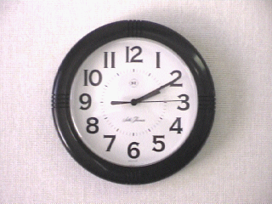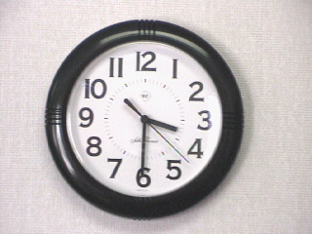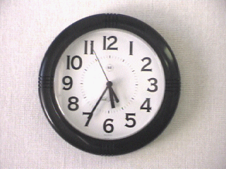

а. два (сата) и десет а. три (сата) и тридесет а.двадесет пет (минута)
(минута) (минута) до шест
б. пола четири б.пет и тридесет пет

D. E. F.
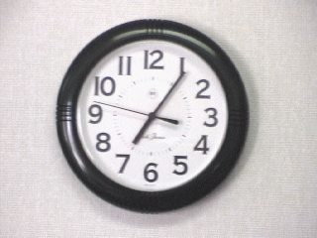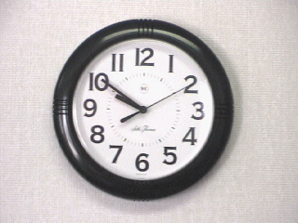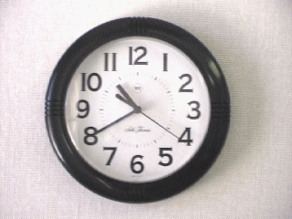

а. седам (сати) и пет а. десет (минута) до а. двадесет (минута) до
(минута) десет једанаест
б. девет (сати) и б. десет (сати) и
педесет (минута) четрдесет (минута)
Time and Measurements Serbian SOLT 1
Introduction Module 2 Lesson 2

Колико је сати? (continued)

G. H. I.
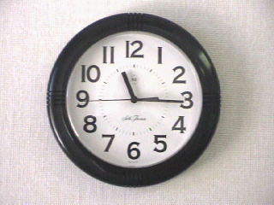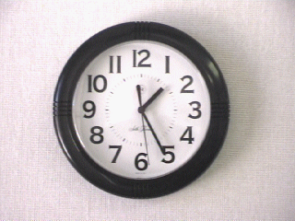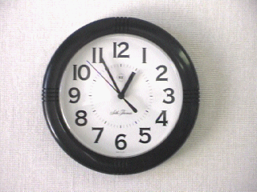

а. једанаест (сати) и а. један (сат) и а. пет (минута) до
петнаест (минута) двадесет пет један
(минута) б. дванаест (сати)
и педесет пет
(минута)

Asking and answering about the time

Колико је сати? What time is it?
Девет је сати. It is nine o’clock.
Када идеш у школу? When do you go to school?
Идем у школу у осам сати ујутро. I go to school at 8 A.M.
У колико сати идеш у школу? At what time do you go to school?

Од када до када?

Од када до када си у школи? From when to when are you in school?

У школи сам од 8 ујутро до 2 попо- I am in school from 8 A.M.
дне. to 2 P.M.

Official Time Colloquial Time

14.00 четрнаест сати два (сата)
14.05 четрнаест сати два и пет
и пет минута
14.15 четрнаест сати два и петнаест
и петнаест минута
14.30 четрнаест сати пола три
и тридесет минута
14.45 четрнаест сати и петнаест до три
четрдесет пет
минута
15.00 петнаест сати три (сата)
Time and Measurements Serbian SOLT 1
Introduction Module 2 Lesson 2

Exercise 1
Work in pairs. Ask your partner for the time. He/she should say the official time first and then colloquial time.
13.00 – 16.00 – 17.00 – 18.00 – 19.00 – 20.00 – 21.00 – 22.00 – 23.00 – 24.00

Adverbs of time
ујутро in the morning
пре подне before noon
у подне at noon
после подне afternoon/in the afternoon
увече in the evening
јуче yesterday
данас today
сутра tomorrow
прекјуче the day before yesterday
јутрос this morning
сутра ујутро tomorrow morning
синоћ last night
прекосутра the day after tomorrow
вечерас this evening

Note: Adverbs of time do not decline

Exercise 2. (Колико је сати?)
Draw the watch hands on the face of each circle according to the written time. Compare your work with your partner.

пет и петнаест осам пола седам

петнаест до три и двадесет пет до седам
осам

Time and Measurements Serbian SOLT 1
Introduction Module 2 Lesson 2

Exercise 3
Please use the appropriate adverbs of time to answer the questions.

1. Када господин Петровић има састанак?

а. 9:00 A.M. _____________________________________________________________

б. 7:30 P.M. _____________________________________________________________

ц. 2:00 P.M. _____________________________________________________________

д. 8:00 A.M. _____________________________________________________________

2. Од када до када они имају предавања?

А. Бранко – 1:00 P.M.– 3:00 P.M.
_______________________________________________________________________

Б. Јелена – 12:00 P.M.– 5:00 P.M.
_______________________________________________________________________

Ц. Марија – 8:30 A.M.– 11:30 A.M.
_______________________________________________________________________

Д. Славко – 4:00 P.M.– 7:30 P.M.
_______________________________________________________________________

Е. Радмила – 11:00 A.M. – 4:30 P.M.
_______________________________________________________________________

Time and Measurements Serbian SOLT 1
Introduction Module 2 Lesson 2

Exercise 4.
Колико је сати? Work with your partner. Ask each other for the time and give the answer.

1. 2. 3. 4. 5.

Exercise 5
Here is Maja’s timetable. Study the table to find out her schedule and to answer the questions.

 | Пон. | Уто. | Среда | Чет. | Пет. | Суб. | Нед.
8.00 | математика
9.00 |  | енглески |  |  | физика
10.00 |  |  |  | хемија
11.00 | Енглески |  | математика
12.00 |  |  |  |  | руски
1.00 |  | кошарка
2.00 | Физика
3.00 |  | хемија
4.00 |  |  | биологија

1. У колико сати Mаја има енглески понедељком?
2. Од када до када Маја има предавања средом?
3. Да ли Маја има предавања суботом и недељом?
4. У колико сати Маја има кошарку у уторак?
5. Шта ради Маја у четвртак у десет?

Time and Measurements Serbian SOLT 1
Introduction Module 2 Lesson 2

Exercise 6. (Jelena’s daily routine)
Read the following text about Jelena’s daily routine. After reading the text, ask your partner questions about Jelena. For example: У колико сати Јелена устаје? He/she should answer them using the time written beside each picture. Reverse the roles.

У кревет идем у једанаест сати. Устајем рано ујутро у седам. Перем зубе и умивам се. Доручкујем обично бутер и мармеладу и пијем млеко или чај. Моја предавања почињу већ у осам и трају до један. После предавања моја другарица Тамара и ја идемо у кафић. Кући идем око три сата.

11 P.M. 7 A.M. 7 - 7:30 A.M. 7:15 A.M.



8 A.M. - 1P.M. 1:15 P.M. 6:00 P.M. 11:30 P.M.



Time and Measurements Serbian SOLT 1
Introduction Module 2 Lesson 2

Ред вожње (Travel timetable)

Exercise 7
Imagine yourself being in the FR of Yugoslavia. You want to know at what time your bus, train or airplane is leaving. How would you ask the questions? Listen first to the instructor read the conversation between a traveler and an information clerk. Look at the text while listening. Answer the questions.

New Words
аутобус, и bus авион, и airplane
на време on time поћи to leave, depart
каснити to be late воз, ови train
за (prep.acc.) to, for

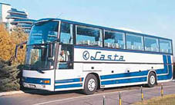
A: Добар дан. Када полази аутобус за Панчево?
B: У девет и педесет.
А: Хвала.
B: Молим.

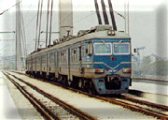
А: Када полази воз за Београд?
B: У осам и десет.
А: Када долази у Београд?
B: У десет часова.

А: Да ли авион из Франкфурта долази на време?
B: Не. Касни 25 минута.

1. What is arriving at 10:00?
2. What will be late?
3. At what time does the bus depart to Pancevo?
4. How many minutes is the flight from Frankfurt late?
5. At what time does the train arrive in Belgrade?
Time and Measurements Serbian SOLT 1
Introduction Module 2 Lesson 2

Exercise 8 (Аутобуска Станица – Bus station)
Work in pairs. Take the role of a traveler being in Belgrade who wants to travel to different destinations in the FR of Yugoslavia. Your partner is an information clerk at the bus station. Ask him/her questions by looking at the bus timetable. Use the previous activity as a model.
*Note that the timetable is written in the Latin (Roman) alphabet and that the official time is used.

Red vožnje (Travel Timetable)

Herceg Novi  22:00 | Podgorica  20:45 | Niš  12:50 | Budva  19:00 | Igalo  6:30 | Novi  Sad  23:00 | Vranje  17:00 | Bar  5:40

Exercise 9
Use the following Belgrade - Frankfurt (Germany) bus schedule to answer the questions.

odlazak (departure) also: polazak svaki dan (every day)
povratak (return) stanica (station)

BEOGRAD - FRANKFURT (via Stuttgart)
odlazak |  |  | stanice | povratak
nedeljom | svaki dan | svaki dan
06.00 | 11.00 | 18.00 | BEOGRAD | 01.30 | 08.00 | 12.00
07.30 | 12.30 | 19.30 | Novi Sad | 00.00 | 06.30 | 10.30
09.00 | 14.00 | 21.00 | Sombor | 22.30 | 05.00 | 09.00
23.00 | 04.00 | 11.00 | MUNCHEN | 08.30 | 15.00 | 19.00
 | 05.45 | 12.45 | Ulm |  | 13.15 | 17.15
 | 07.00 | 14.00 | STUTTGART |  | 12.00 | 16.00
 | 09.00 | 16.00 | Manheim |  | 10.00 | 14.00
 | 10.10 | 17.10 | FRANKFURT |  | 08.45 | 12.45
 |  |  |  | subotom | svaki dan | svaki dan

1. How many stops does the bus make from Belgrade to Frankfurt?
2. Through which cities does the bus travel?
3. Name the Yugoslav cities and the German cities from the schedule.
4. On what day are departures less frequent?
Time and Measurements Serbian SOLT 1
Introduction Module 2 Lesson 2

Exercise 10
Match the days and time on the left with the adverbs of time on the right. Refer to each day pretending that today is Monday morning.

1. уторак 22:00 а. једанаест сати пре подне
2. среда 18:00 б. четири сата поподне
3. четвртак 11:00 ц. десет сати сутра увече
4. петак 6:00 д. дванаест сати у подне
5. субота 16:00 е. шест сати прекосутра увече
6. недеља 12:00 ф. шест сати ујутро

Exercise 11
Work in pairs. Make the timetable for your activities for the next day including the time. Your partner will do the same. Ask each other questions to find out what each of you will be doing the next day and at what time.

Tip of the day
The FR of Yugoslavia uses the metric system in measuring the distance, sizes, weights and temperatures.

Numbers from 101 through 1,000,000
101 сто један 120 сто двадесет 400 четири стотине
102 сто два 130 сто тридесет 500 пет стотина
103 сто три 140 сто четрдесет 600 шест стотина
104 сто четири 150 сто педесет 700 седам стотина
105 сто пет 160 сто шездесет 800 осам стотина
106 сто шест 170 сто седамдесет 900 девет стотина
107 сто седам 180 сто осамдесет 1000 (једна) хиљада
108 сто осам 190 сто деведесет 2000 две хиљаде
109 сто девет 200 *две стотине 3000 три хиљаде
110 сто десет 300 три стотине 4000 четири хиљаде

5000 пет хиљада
10,000 десет хиљада
100,000 сто хиљада
1,000,000 (један) милион

*Note that in everyday speech you will often hear двесто instead of две стотине, тристо instead of три стотине etc.
Time and Measurements Serbian SOLT 1
Introduction Module 2 Lesson 2

Exercise 12 (Телефонски бројеви – Phone numbers)
Work in pairs. Read aloud the numbers with your partner, and then do exercise 1. Ask your partner if the number you are planning to dial is the right one. He/she will respond negatively and give you the right number. Use the model written below.

Model: You: Да ли је то број 072 – 417 – 523?
(нула седамдест два-четристо седамнаест-петсто двадесет три)

Your partner: Није. То је број 072-417-532

1. 053-312-815 2. 011-45-211 3. 079-212-866 4. 071-611-732
5. 032-405-211 6. 033-514-602 7. 021-403-911 8. 052-613-999

Exercise 13
Work in groups of three. Pretend that you have everything. Your partner will ask you if you have such and such items at home. Exaggerate by answering that you have 10 TV’s, 500 cassettes etc.
Time and Measurements Serbian SOLT 1
Introduction Module 2 Lesson 2

Metric System


Before introducing the metric system, the students should bring a meter stick to the classroom. Since the measurements are mostly written in the Latin alphabet, they will be presented here that way.

Удаљеност (distance)

milimetar (mm) = 0.039 inch
centimetar (cm) = 0.39 inch
metar (m) = 39 inches
kilometar (km) = 0.62 miles

70 km
*Beograd *Novi Sad

Колико километара има од Београда до Новог Сада?
Од Београда до Новог Сада има 70 километара.

(How many kilometers is it from Belgrade to Novi Sad?)
(There are 70 kilometers.)

Колика је удаљеност између Београда и Новог Сада?
Удаљеност је 70 километара.
(What is the distance between Belgrade and Novi Sad?)
(The distance is 70 kilometers.)

*prepositions између and од-до ask for the genitive case

1 kilometar 2 kilometra 5 kilometara

Time and Measurements Serbian SOLT 1
Introduction Module 2 Lesson 2

Exercise 14
Study the travel distances between Belgrade and the European cities. Ask your partner to tell you the distance between Belgrade and the particular cities of your choice. Say whether it is close or far (близо – далеко). Reverse the roles.

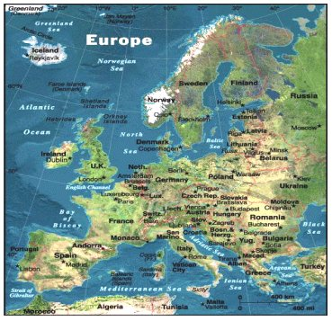

далеко
Amsterdam  is 1774 km | Athens  is 1111 km | Barcelona  is 2074 km | Belgrade  is 0 km | Berlin  is 1829 km | Bern  is 1311 km
Bonn  is 1528 km | Brussels  is 1769 km | Copenhagen  is 1996 km | Dublin  is 2505 km | Helsinki  is 2792 km | Istanbul  is 839 km
Lisbon  is 3341 km | London  is 2073 km | Luxembourg  is 1552 km | Madrid  is 2691 km | Marseilles  is 1573 km | Milan  is 1035 km
Munich  is 967 km | Oslo  is 2584 km | Paris  is 1819 km | Rome  is 1284 km | Stockholm  is 2627 km | Vienna  is 771 km
близо
Time and Measurements Serbian SOLT 1
Introduction Module 2 Lesson 2

Висина (height) 

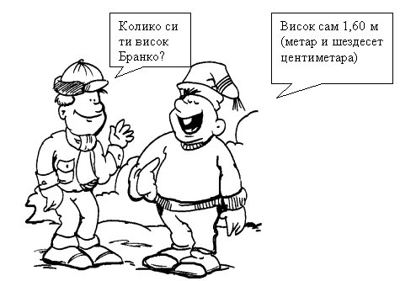

Exercise 15
Ask your partner how tall he/she is. Then walk through the classroom and find out how tall your other classmates are. Take notes. Keep that information for later on.
Дужина – ширина (length –width) 

Колико је дуг орман? Дуг је 2,50 метра (два метра и педесет центиметара).
Колико је широк? Широк је 1 метар.
Time and Measurements Serbian SOLT 1
Introduction Module 2 Lesson 2

Exercise 16
Work in pairs. Go around the classroom and measure as many objects as you can find. Take notes. Report the information to the class. Your report should have the following: the names of your classmates and their heights from the previous lesson, the number, names and measures of the objects you and your partner measured.

Тежина (weight)
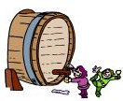
gram (g) = 0.035 ounce
dekagram (dkg) = 0.35 ounce decilitar (dl) = 0.1 quart
kilogram (kg) = 2.2 pounds litar (l) = 1.06 quarts
tona (t) = 2, 200 pounds hektolitar (hl) = 26.5 gallons

1 litar 2 litra 5 litara
1 kilogram 2 kilograma 5 kilograma

Exercise 17
Ask your partner for the weight of the items below. Use the written model.

Колико је…тежак/тешка/тешко? How much does…weigh?

100 g 210 g 120 g
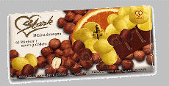

чоколада кекс
Time and Measurements Serbian SOLT 1
Introduction Module 2 Lesson 2

Exercise 17 (continued)

140 g 1kg 100g 50g

   
бомбоњера крекери кафа кикирики
Time and Measurements Serbian SOLT 1
Grammar Notes Module 2 Lesson 2

No new grammar is introduced in this lesson.
Time and Measurements Serbian SOLT 1
Vocabulary Module 2 Lesson 2

авион, и | airplane
аутобус, и | bus
биологија | biology
близо | near, close
бутер | butter
вести | news
вечерас | this evening
висина, е | height
воз, возови | train
временска удаљеност | time distance
далеко | far
данас | today
доручковати | to have a breakfast
дужина, е | length
Жао ми је... | I am sorry
за (preposition) | to, for
између | between
јутрос | this morning
јуче | yesterday
каснити | to be late
кафић, и | café
квиз | quiz
мармелада, е | marmalade
математика | mathematics
млеко, а | milk
на време | on time
напољу | outside
обично | usually
одлазак, одласци | departure
повратак, повратци | return
посао, послови | work, job
после подне | afternoon, in the afternoon
пре подне | before noon
прекјуче | the day before yesterday
прекосутра | the day after tomorrow
Time and Measurements Serbian SOLT 1
Vocabulary Module 2 Lesson 2

рано | early
ред вожње | travel timetable
само | only
сат, и | hour
сат, сатови | clock
сваки дан | every day
серија | series
синоћ | last night
спортски програм | sport broadcast
станица, е | station
степен, и | grade
сутра | tomorrow
сутра ујутро | tomorrow morning
тежина, е | weight
трајати | to last
У подне | at noon
увече | in the evening
удаљеност | distance
ујутро | in the morning
устати | to get up, to stand up
физика | physics
хемија | chemistry
цртани филмови | cartoons
чај, чајеви | tea
час, часови | hour, class
часовник, часовници | clock
ширина, е | width

Time and Measurements Serbian SOLT 1
Culture Notes Module 2 Lesson 2

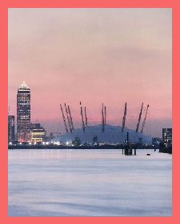

Millennium Dom at Greenwich

GMT

As time pieces became more accurate and communication became global, there needed to be a point from which all other world times were based. Since Great Britain was the world's foremost maritime power when the concept of latitude and longitude came to be, the starting point for designating longitude was the "prime meridian" which is zero degrees and runs through the Royal Greenwich Observatory, in Greenwich, England, just outside London. As a result, when the concept of time zones was introduced, the "starting" point for calculating the different time zones was/is at the Royal Greenwich Observatory. When it is noon at the observatory, it is five hours earlier (under Standard Time) in Washington, D.C.; six hours earlier in Chicago; seven hours earlier in Denver; and, eight hours earlier in Los Angeles.
Unfortunately the earth does not rotate at exactly a constant rate. Due to various scientific reasons and increased accuracy in measuring the earth's rotation, a new time scale, called Coordinated Universal Time (UTC), has been adopted and replaces the term GMT.

Courtesy the U.S. Naval Observatory Website
Time and Measurements Serbian SOLT 1
Application Activities Module 2 Lesson 2

Activity 1
You are invited to a party but the only thing you know is the name of the person who is giving a party. Ask your partner for more information. (Where is the party? At what time does it start? Who is coming?)

Activity 2
Imagine that you got an invitation from your partner but you would rather not go out with him/her. Make excuses giving the time and what you will be doing at that time. Find at least 5 excuses. Use the expression Жао ми је али... (I am sorry but…)

Example: Жао ми је али у 5:00 имам тенис.

Activity 3
Imagine that you are in Europe. You want to travel by train to the different cities. Your partner is a travel agent. Ask him/her for travel and time distance between the cities below. Reverse the roles.

* time distance = vremenska udaljenost * 1 1/2 = jedan i po

From To Distance (km) Time distance
Amsterdam Cologne 262 3 hours

Barcelona Madrid 728 7 hours

Bern Zurich 146 1 1/2 hours

Brussels Paris 336 2 hours

Frankfurt Munich 423 3 ½ hours

Lusanne Paris 521 4 hours
Time and Measurements Serbian SOLT 1
Application Activities Module 2 Lesson 2

Activity 4
You are asked by the policeman (your partner) what you have been doing yesterday between 8 and 10 PM. Do you have an alibi?

Activity 5
Your partner will give you distances and weights in the English system. Compare them with the metric system. Refer to Task 2, if you need help.

Example: 110 miles- Koliko je to kilometara? To je … kilometara.

110 miles 870 miles 1540 miles 217 miles

50 pounds 100 pounds 20 pounds 3 pounds

Time and Measurements Serbian SOLT 1
Skill Enhancement Activities Module 2 Lesson 2

Activity 1
Look at the TV listing below and listen carefully to the TV announcement in Serbian. Write down the time for each broadcast.

спортски програм (sport broadcast)
вести (news)
серија (series)
квиз (quiz program)
цртани филмови (cartoons)
Time

Cartoons

Twenty One

Sport broadcast

Ally McBeal

News

Activity 2
Study the TV listing below and answer the questions.

1. Murphy Brown | 9 AM
2. Jesse | 10 AM
3. Little Bill | 6 PM
4. Who Knows You Best? | 7 PM
5. CNN Special Edition | 10 PM

  - У колико сати почиње Марфи Браун?
  - Која емисија је у седам сати увече?
  - Када почиње Џеси?
  - Шта почиње у шест сати увече?

Time and Measurements Serbian SOLT 1
Skill Enhancement Activities Module 2 Lesson 2

Activity 3
Complete the statements using the words on the right.
1. _________ сте гледали јуче поподне? A. Ко
2. _________ је Марко дошао у Париз? Б. Куда
3. _________ ради твој брат? Ц. Шта
4. _________ година сте живели у Америци? Д. Где
5. _________ путујете у недељу? Е. Чија
6. _________ је ово кућа? Ф. Какав
7. _________ сте видели у биоскопу? Г. Кога
8. _________ су ваши родитељи? Х. Када
9. _________ је Марко студент? И. Колико
10.________ је био данас у посети? Ј. Како

Activity 4
Write down the numbers that you hear from the instructor.
________________________________________________________________________________________________________________________________________________

Activity 5
Match the written time with the numerical.

1. дванаест и десет после подне а. 4.15 PM
2. осам и тридесет пет ујутро b. 7.55 PM
3. једанаест и двадесет пре подне c. 12.10 PM
4. двадесет до једанаест увече d. 10.40 PM
5. четири и петнаест поподне е. 8.35 АМ
6. пола пет ујутро f. 11.20 AM
7. пет до осам увече g. 4.30 AM

Time and Measurements Serbian SOLT 1
Skill Enhancement Activities Module 2 Lesson 2

Activity 6
Imagine that you bought a gift basket for your friend. He/she has the list of items but the weight is written in the English system. Help him/her to translate the English system into the metric system.
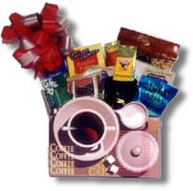

Dark Chocolate (2.5 oz)
Serbian Mild Sausage (9 oz )
Mustard (2 oz)
Walnuts (1.5 oz)
Chocolate Cookies (2 oz)
Crackers (l oz)
Turkish Coffee (1.6 oz)
Fruits (2pounds)

Activity 7
Work in pairs. Study the map of the flights from New York to Paris and find the answers to the questions.

одрасли (adults) најскупљи (the most expensive) најјефтинији (the cheapest)

New York - Paris | Cene |  | Paris - New York | Cene
New York - Paris | Odrasli | Deca | Paris - New York | Odrasli | Deca
Jun. 28 | $499 | $459 | Jun. 30, Jul. 01, 08, 15 | C$460 | C$420
Jun. 30, Jul. 05, 11, 18, 25 | $499 | $459 | Jul. 22, 29, Aug. 05, 12 | C$500 | C$460
Aug. 05, 15, 20, 26 | $499 | $459 | Aug. 19, 26, Sep. 02 | C$500 | C$460
Sep. 03, 09 | $469 | $429 | Sep. 09 | C$430 | C$390

Time and Measurements Serbian SOLT 1
Skill Enhancement Activities Module 2 Lesson 2

Activity 8 (continued)

1. Колико кошта лет за одрасле у аугусту од Њујорка до Париза?
2. Који лет је најјефтинији?
3. Који лет је најскупљи?
4. Колико кошта лет у септембру од Париза до Њујорка за одраслог и једно дете?

Activity 8 (Associations)
Associate the words on the left with those on the right.

1. после подне a. станица
2. математика б. путовање
3. часовник ц. школа
4. авион д. време
5. аутобус е. километар
6. удаљеност ф. Данас

Activity 9
The following reading passage will mention distances, lengths and weights given in the metric system. Listen carefully to the instructor and decide if the answers are true or false. Be careful! The answers are using the English system.

Statements T/F
1. The distance between Novi Sad and Pancevo is 46.6 miles. ______
2. There are 45 miles from Prijedor to Banja Luka. ______
3. Branko is 6 inches tall. ______
4. Ranko has 187 pounds. ______

Time and Measurements Serbian SOLT 1
Homework Module 2 Lesson 2



Activity 1
Listen to the recording of people making bus enquiries. Put the checkmark next to the appropriate words to show when they will be traveling and at what time.

1. Valjevo 2. Beograd

a. Monday morning a. Wednesday at noon
b. Monday afternoon b. Wednesday morning
c. Monday evening c. Wednesday evening
d. 17.30 d. 22.00
е. 18.00 e. 23.50
f. 06.00 f. 07.00

3. Novi Sad 4. Subotica

a. Friday afternoon a. tomorrow morning
b. Friday morning b. Saturday morning
c. Friday evening c. Sunday morning
d. 05. 45 d. 06.00
e. 13.00 e. 08.50
f. 21.30 f. 07.30

Activity 2
Match the Serbian words and expressions with those in English.

1. ујутро a. last night
2. Колико је сати? b. clock
3. сутра ујутро c. in the morning
4. синоћ d. on time
5. часовник e. train
6. на време f. What time is it?
7. воз g. tomorrow morning

Time and Measurements Serbian SOLT 1
Homework Module 2 Lesson 2

Activity 3
Complete the following sentences.

1. Свако јутро устајем у пет _______. 2. Доручкујем и одлазим у ________. 3. Сутра ујутро________ у Суботицу. 4. Тамо _________ моја тетка Рада. 5. Тетка Рада је удата и има једно _______. 6. Данас ______ у пет имам енглески. 7. Остајем на предавању 2 _________.

Activity 4
Circle the numbers that you hear.

180 675 468 980 3067 5300 95 569 777 897 313 517 488 991 908 1533

Activity 5
Write a sentence starting with the words given below. Your instructor will check your work the next day.

1. Време _______________________________________________________________

2. Данас поподне _______________________________________________________

3. Сваки дан ____________________________________________________________

4. Један килограм _______________________________________________________

Activity 6
Fill in the blanks with the proper noun form. Nouns are given in the nominative case.

1. Једна ______ (столица) 2. две _______ (софа) 3. пет ________ (ауто) 4. двесто тридесет три ________ (оловка) 5. седамсто двадесет један ________ (динар)
6. четристо пет _______ (коњ) 7. тринаест ________ (студент) 8. шест ________
(професор) 9. сто четири ________ (шешир) 10. деветсто деведесет девет _____
(година)

Time and Measurements Serbian SOLT 1
Homework Module 2 Lesson 2

Activity 7
Complete the responses in the perfect tense using negative answers.

1. Да ли си био у Београду? _______________________________________________
2. Да ли је она дошла прекјуче? ___________________________________________
3. Да ли су ишли у биоскоп? ______________________________________________
4. Да ли сте дуго путовали? _______________________________________________
5. Да ли је твој брат рођен у мају? __________________________________________
6. Да ли си јуче радила? __________________________________________________
7. Да ли је твоја сестра живела у Русији? ____________________________________
8. Да ли су његови родитељи имали годишњицу брака? _______________________
9. Да ли је авион каснио? _________________________________________________
10.Да ли је време било лепо? ______________________________________________

