SOLT Serbian Module 1 Lesson 4

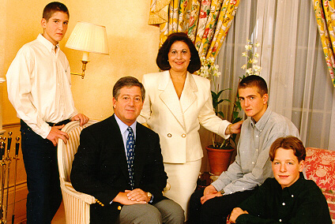

The Family

The Family Serbian SOLT 1
Objective Module 1 Lesson 4

During this lesson, the students will learn about the family. Under this Terminal Learning Objective, the students will learn one task: identify family relationships. At the end of the lesson, the students will be able to:

- Identify family relationships. This task will include:

- Identify family members
- Talk about your family
- Discuss your family tree
- Ask about other family members
- Discuss family events

The Family Serbian SOLT 1
Introduction Module 1 Lesson 4

Each Serbian family has its own patron saint. The слава, or patron saint’s day, is handed down from one generation of males to another. Girls and young women celebrate their father’s слава until they get married, when their husband’s слава becomes their own.

The слава is a three-day holiday when relatives and friends visit a feasting family and celebrate a patron saint with food and music. The guests usually come uninvited, thus showing that they remember the слава of a particular family. The holiday is long enough to allow people to go to more than one feast. The symbols of the слава are the слава bread, the слава candle, a special dessert made of wheat grains, honey and walnuts, and red wine. The tradition is to have a priest come to the feasting house to bless the bread and wine and light the candle, and then the father of the family breaks the bread with his bare hands. A slice of cake must be left over for an unexpected visitor.

Today in urban Serbia, the religious content of the слава is frequently lost. The слава is considered to be a nice opportunity for families and friends to get together.

Tip of the day
Кева and ћале are the popular colloquial terms in Serbia for the English mom and dad. Other words are отац (father), тата (dad), мама (mоm), мајка (mother).

Породица (The family)
The instructor will read a passage for each picture. Listen to it and answer the questions in exercise 1.
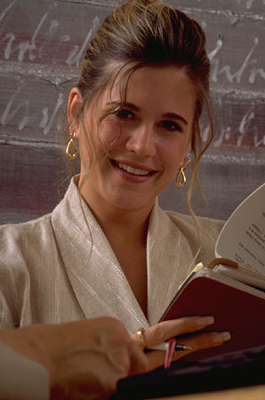
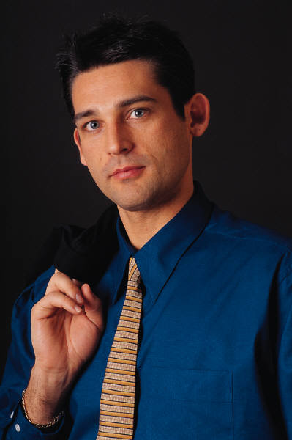

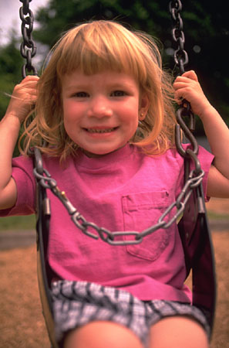
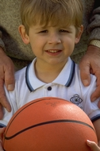

The Family Serbian SOLT 1
Introduction Module 1 Lesson 4

Породица (The family) (continued)
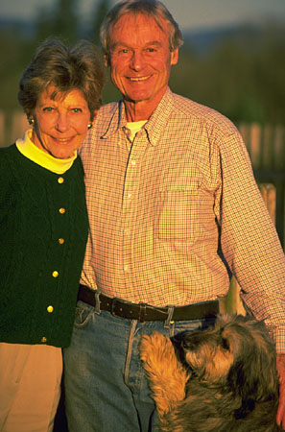

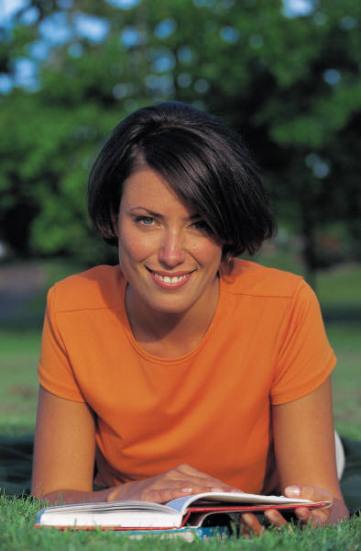
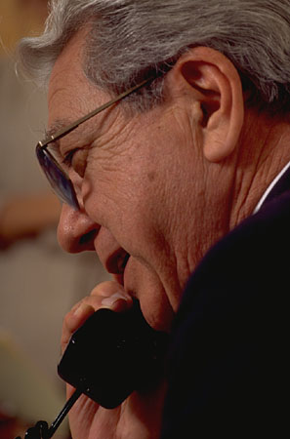
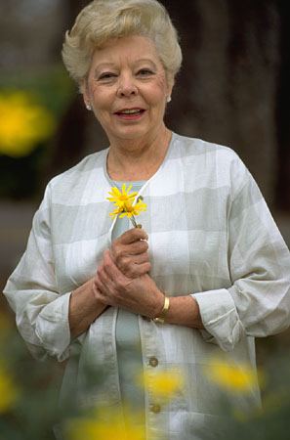

.

Exercise 1

1. Who is speaking?
2. Does she have children?
3. Does she have grandparents?
4. What is her grandmother’s name?
5. Does she have an uncle?
6. What is her brother’s name?

Exercise 2
Use the image below to create your family tree. Start from the bottom of the tree with the oldest family members. Include the names of all your relatives. Please refer to the new words section for more vocabulary. This exercise will be used again later in exercise 9.
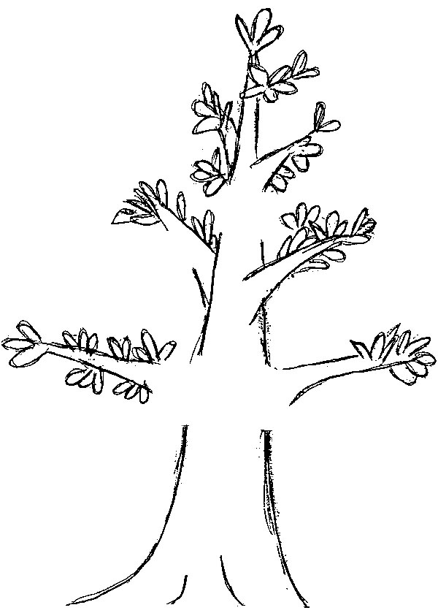

The Family Serbian SOLT 1
Introduction Module 1 Lesson 4

Exercise 3
Find the male and female counterparts.

1. човек ________ 6. ________ кума
2. _______ супруга 7. таст _______
3. отац ________ 8. стриц _______
4. _______ сестра 9. ________ ујна
5. рођак ________ 10.деда _______

Exercise 4 (Talk about the family)
Go back to your family tree and talk about it with your classmate. Tell him/her if you have brothers and sisters, relatives, grandparents. Include the names for each member of the family, then, ask each other questions about the family members.

Да ли имаш брата (сестру, тетку...)?
Како се зову? Да ли имаш деце? Колико имаш деце?

Family Events

венчање медени месец рођендан годишњица

посета излет рођење детета матура

The Family Serbian SOLT 1
Introduction Module 1 Lesson 4

Exercise 5
Read the name of each event and answer the questions:

1. What picture stands for a child’s birth? Write the Serbian term.
2. What is the Serbian term for a wedding?
3. Find the Serbian term for picnic and prom.
4. What picture is showing a visit? Circle it.
5. Find the Serbian terms for honeymoon, anniversary and birthday.

Compare your answers with your classmate.

The Family Serbian SOLT 1
Grammar Notes Module 1 Lesson 4

Verbs: The Infinitive and Present Tense

Look carefully at the following comparison between English and Serbian.

Infinitive: Present Tense:

English Serbian English Serbian

to work радити I work 1. ја радим ми радимо
to write писати You work 2. ти радиш ви радите
to go ићи He works 3. он ради они раде

Two important verb differences could be distinguished between English and Serbian.

1. The English infinitive is recognized by the form to: to work
The Serbian infinitive has a verb stem and the endings –ти or -ћи

Infinitive Verb stem Ending
радити рад - ти

2. In English, there is only the third person singular that has an ending in
the present tense: he works
In Serbian, all personal pronouns have the endings in the present tense. Those endings are: -м –ш –и (sg.) –мо –те –е (pl.) and they are
attached to the verb stem. Remember that there are verbs in
Serbian that have the endings –у and –ају in the 3rd person plural.
ићи – они иду читати – они читају

These verbs are not difficult to recognize:

a. ја радим они раде и - е
б. ја скачем они скачу е - у
ц. Ја читам они читају а – ају

*Note: Personal pronouns are often omitted in Serbian because the verb ending indicates who is performing an action. The present tense in Serbian stands for two English forms:

ја певам I sing/I am singing

The Family Serbian SOLT 1
Grammar Notes Module 1 Lesson 4

Exercise 1
Supply the proper form of the verb радити and the verbs in the brackets.

Example: Шта ради Марко? (Марко) Марко пева. (певати)

1. Милан – учити 4. они - студирати
2. ти – говорити 5. ви - питати
3. деца – спавати 6. она - певати

Exercise 2 (Negatives)
Practice using negatives for the sentences in exercise 6 with a partner.

Positive Negative
Милан учи. Милан не учи.

Exercise 3
Use the same examples from exercise 4 and ask the questions starting with да ли.

The Verb имати (to have) and the Accusative case

Positive

1. имам имамо
2. имаш имате
3. има имају
Negative

1. немам немамо
2. немаш немате
3. нема немају

The Family Serbian SOLT 1
Grammar Notes Module 1 Lesson 4

Many verbs, including the verb имати, require a direct object. The direct object is usually a noun or pronoun that answers the question шта? (what?) for things, or кога? (whom?) for people. In Serbian, the direct object is always in the accusative case.
Example Шта имаш? Имам кишобран. (What do you have?)

Кога имаш? Имам децу. (Whom do you have?)

Here are the accusative case endings compared with the nominative case:

Singular Plural

M F N M F N
N. орман софа ауто ормани софе аута
A. *орман софу ауто ормане софе аута

*Note: If the masculine noun represents humans or animals, the accusative ending is –a:
Имам брата
Имам миша

Exercise 4 (Да/Не)
You want to know if your classmate has the things shown below. He/she should answer with да and не. Refer to the accusative case above to help you with endings.

You: Да ли имаш кишобран? Your partner: Да, имам кишобран.
Не, немам кишобран.

1.  2.  3.  4. 

The Family Serbian SOLT 1
Grammar Notes Module 1 Lesson 4

Exercise 4 (continued)

5.  6.  7. 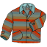 8.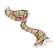

наочаре (pl.) балон (m) оловка (f) софа (f)
књига (f) шал (m) шешир (m) капут (m)

Exercise 5
You want to know what your partner is doing at the moment. Ask him/her questions using the verbs given. He/she should respond by using the nouns below.

Verbs:

1. певати 2 читати 3. гледати 4. питати

You: Шта пишеш? Your partner: Пишем писмо.

1. 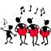 2. 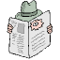 3.  4. 

песма (f) табла (f) новине (pl.) питање (n)

The Family Serbian SOLT 1
Grammar Notes Module 1 Lesson 4

Possessive Adjectives

Possessive adjectives describe possession and they agree with the noun in gender, number and case. Each personal pronoun has its possessive adjective.

Singular Plural

jа мој my ми наш our
ти твој your ви ваш your
он његов his они њихов their
она њен her оне њихов their
оно његов its она њихов their
Ви Ваш your

The following declension of the possessive adjective мој should be used as an example for the declension of all other possessive adjectives.

Singular Plural

M F N M F N

Nominative мој моја моје моји моје моја

Exercise 6 (твој - мој)
Find out if the items belong to your classmate.
You: Да ли је ово твоја књига?  Your partner: Да, то је моја књига.


1. 2. 3. 4. 5. 6. 

The Family Serbian SOLT 1
Grammar Notes Module 1 Lesson 4

Exercise 7
Supply the proper form of the possessive adjective.

1. Да ли је ово _______ мама, Ранко?
2. Да ли су ово ______ хаљине, госпођо Поповић?
3. Да ли су ово ______ шешири, господине Радуловић?
4. Да ли је ово ______ стриц, Јелена?
5. Да ли је ово ______ ауто, пријатељи?

Exercise 8
By asking the question чији? (whose), find out to whom the following items or people belong.

* The question чији? чија? чије? behaves as an adjective.

Чији је ово сат?  Ово је њен сат. (Марија)

1. 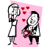 (Марко) 2. 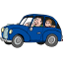 (Јелена и Милан)

3. 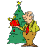 (ја) 4. 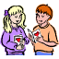 (ми)

5. 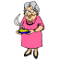(ти) 6.  (она)

ауто деца папир деда родитељи бака

The Family Serbian SOLT 1
Grammar Notes Module 1 Lesson 4

Exercise 9
Fill in the blanks with the question чији.

- То је сат. ______________________ ?
- То је ормар. ____________________ ?
- То је ципела. ___________________ ?
- То је кишобран. _________________ ?
- То су новине. ___________________ ?
- То су књиге. ____________________ ?
- То су родитељи. ________________ ?
- То су деца. _____________________ ?
- То је кревет. ___________________ ?
- То је капут. ____________________ ?

The Family Serbian SOLT 1
Vocabulary Module 1 Lesson 4

баба, е | grandmother
бака, е | grandma
балон, и | balloon
брат, браћа | brother
ваш, а, е | your
венчање, а | wedding
гледати | to look
говорити | to speak
годишњица, е | anniversary
дати | to give
деда, е | grandfather
дете, деца | child
дувати | to blow
зет, зетови | son-in-law
играти | to play
излет, и | picnic
имати | to have
ићи | to go
јести | to eat
капут, и | coat
кђерка, е | daughter
кишобран, и | umbrella
кум, кумови | godfather
кума, е | godmother
мајка, е | mother
матура, е | prom
медени месец | honeymoon
мој, а, е | my
наочале | glasses
наш, а, е | our
новине | newspapers
ногомет | soccer
његов, а, о | his
њен, а, о | her
њихов, а, о | their
одбојка | volleyball
отац, очеви | father
папир, и | paper
певати | to sing
песма, е | song
писати | to write

The Family Serbian SOLT 1
Vocabulary Module 1 Lesson 4

питање, а | question
питати | to ask
пити | to drink
плесати | to dance
поклон | gift
породица, е | family
посета, е | visit
радити | to work
родитељ, и | parent
рођак, рођаци | relative (m)
рођака, е | relative (f)
рођендан, и | birthday
рођење, а | birth
сат, сатови | clock
свекар, свекрови | father-in-law (husband’s father)
свекрва, е | mother-in-law (husband’s mother)
свећа, е | candle
сестра, е | sister
син, синови | son
снаха, е | daughter-in-law
спавати | to sleep
спорт, спортови | sport
студирати | to study
таст, тастови | father-in-law (wife’s father)
ташта, е | mother-in-law (wife’s mother)
твој, а, е | your
тетка, е | aunt
унук, унуци | grandson
унука, е | granddaughter
учити | to learn
чији, а, е | whose
читати | to read
шал, шалови | scarf

The Family Serbian SOLT 1
Culture Notes Module 1 Lesson 4

Crown Prince Aleksandar II Karadjordjevic (the son of King Petar II) and his family: wife Katarina and sons Prince Aleksandar I, Prince Petar and Prince Filip

The History of Kardjordjevic’s

The Karadjordjevic (Karageorgevitch) dynasty is two centuries old. In 1804, a wealthy Serbian clan chief and merchant, Djordje Petrovic - known to his followers as (Karadjordje-Black George, after his dark looks) - led the Serbs in an uprising against the Ottoman Empire that controlled the Balkans. The revolution was successful for a time. Karadjordje established a government in Belgrade and in 1811 was confirmed as the lawful ruler and the right of succession was vested in the family.

19th Century
In 1813 the Turks returned to Belgrade and Karadjordje fled to Austria. His son, Prince Aleksandar, returned to rule Serbia in 1842 but was deposed in 1858. In 1903 the Parliament requested that Prince Petar Karadjordjevic - grandson of Black George - rise to the throne. King Petar I brought democracy and leadership to Serbia. He had John Stuart Mills' essay "On Liberty" translated into Serbian. While the Balkan Wars in 1912 and 1913 resulted in the expansion of Serbia, the annexation by Austria of Bosnia-Herzegovina enraged both neighboring Serbia and the people of Croatia. Nationalist aspirations for independence from Austria finally led to the assassination of Austrian Archduke Franz Ferdinand in Sarajevo, 1914 and within days World War I had begun.

The Family Serbian SOLT 1
Culture Notes Module 1 Lesson 4

Post World War I
Before the end of WW I in 1918, representatives of the three peoples proclaimed by mutual consent a new "Kingdom of the Serbs, Croats and Slovenes" under the Crown of King Petar I. He died three years later. King Aleksandar I, who had acted as Regent for his ailing father since 1914, had earned national fame as a soldier in the Balkan Wars and World War I. In 1922, he married Princess Marija of Romania. They had three sons: Crown Prince Petar, Prince Tomislav and Prince Andrej.

The new kingdom faced many threats. Neighboring states coveted many countries, territories and internal rivalries between the Serbs and Croats. It increased tensions still further. By 1929, it was clear that the King had no option but to impose a Royal dictatorship. However, he did so reluctantly and promised to restore democracy to the newly renamed Kingdom of Yugoslavia once unity had been achieved and bureaucratic corruption expunged. In 1934, he was assassinated in Marseilles by a Macedonian terrorist working in conjunction with Croatian extremists who had Hungarian and Italian support. The French Foreign Minister, Louis Barthou, also died in the attack.

King Aleksandar's son, Crown Prince Petar, was only 11 years old at the time of his death when he became King. Three Regents were appointed. His great-uncle Prince Pavle - married to Princess Olga of the Hellenes (Greece) - became the Prince Regent.

World War II - The Communist Abolition of the Monarchy
By 1941, all but one of theYugoslavs neighbors was under Nazi domination or influence. Despite Prince Pavle's pro-British sentiments, and to avoid bloodshed, he felt obliged to sign a pact with Germany and Italy. Shortly afterwards, on March 27, 1941, Prince Pavle was unseated in a coup and the young King Petar II was declared of age.

Within a week, Germany, Bulgaria, Hungary and Italy invaded. Yugoslavia and the government were forced to surrender. King Peter II, with the Yugoslav Government, made his way via Athens, Jerusalem and Cairo to London where he joined numerous other governments in exile from Nazi occupied Europe.

Yugoslavia was divided to satisfy Italian, Bulgarian, Hungarian and German demands and a puppet Croat state proclaimed. Despite the collapse of the Yugoslavian army, two rival resistance groups to the occupying forces eventually formed. The first was the Royalist Chetniks, led by the loyalist General Draza Mihailovic, Minister for Defense in the exile government. The other was the revolutionary Partisans led by the communist Josip Broz - known to the world later as Tito. A bitter civil war followed.

The Allies, having initially supported Mihailovic, then threw their support behind Tito. The Partisans entered Belgrade in 1944 in the wake of Soviet tank brigades and established a Communist government.

The Family Serbian SOLT 1
Application Activities Module 1 Lesson 4

Activity 1
Here is the photo of the Crown Prince Александар II Карађорђевић and his family. (Please refer to the section Culture Notes to find out more about Prince Aleksandar).
Listen to the description of the photograph and fill in the missing family relations.

On the left: _______: Александар
In the middle: ________: Катарина
Sitting: _____: Александар II, _______
Петар, Филип

Activity 2
Look at the photo again and say how the people on the photo are related to each other. Start from Prince Aleksandar’s II prospective. For example: Принц Петар је његов син After that, start from Princess Katarina’s and Prince Filip’s perspective.

Activity 3
Match the words with the numbers according to the picture. Put the right number to each word. Pay attention to whom the people are standing by.

жена супруг унук мама
родитељи деца деда и бака кђерка
супруга дете човек
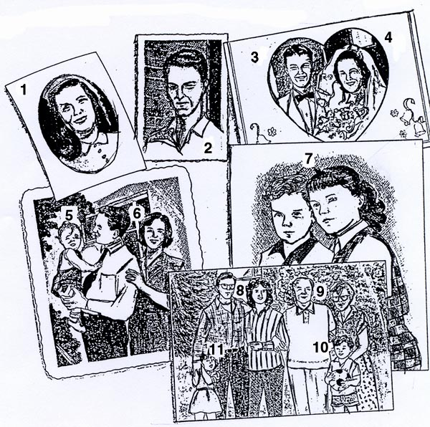

The Family Serbian SOLT 1
Application Activities Module 1 Lesson 4

Activity 4
Work in groups of three. While asking your partner about his/her family, the third member of the team will draw your partner’s family tree. When finished with questions and answers, check the tree for accuracy. Change roles.

Activity 5
Exchange family tree drawings among each other. After looking at the drawing, you will tell all what you know about your partner’s family. The other members of your team will do the same.

Activity 6
Read the passage and pronounce aloud all words that relate to the family members and their relationship.

Моја породица

Ја се зовем Нена Панић. Имам двадесет година. Наша породица је велика. Имам маму и тату. Они су у браку 22 године. Немам брата али имам сестру. Моја мајка има две сестре. Оне су моје тетке. Мој отац има брата и сестру. Његова сестра нема децу. Она је моја тетка. Његов брат је мој стриц. Мој тата нема родитеље. Они су умрли пре две године. Моја мама има старе родитеље. Они су моји деда и бака.

The Family Serbian SOLT 1
Skill Enhancement Activities Module 1 Lesson 4

Activity 1
Listen to the instructor read the following statements and say if they are true or false. Listen again and provide the complete answer where needed.

Example: Statement: Весна има три сина.
You: Не, она има два сина.

Statements: T/F

1. Петар нема родитеље. _____
2. Јелена има деду и баку. _____
3. Бранко и Милена су муж и жена. _____
4. Владо има две кћерке. _____
5. Моја сестра нема децу. _____

Activity 2
Scan the text and answer the questions.

Честитамо нашим драгим родитељима

Годишњицу брака
Мири и Петру Поповићу
Склопили су брак 16. јануара 1948. године и заједно дочекали овај сретан дан.
Ваша захвална деца:
Ирена, Сања и Драгомир
Зет Владимир, снаха Олга
Унуци: Душан, Светлана, Саша и Ана
Ваша захвална деца

1. What family event does this greeting card stand for?
2. How many children do Mira and Petar have?
3. Which sentence is used twice?
4. When did Mira and Petar get married?

The Family Serbian SOLT 1
Skill Enhancement Activities Module 1 Lesson 4

Activity 3
Imagine that your parents or some of your relatives are celebrating a wedding anniversary. Write them an anniversary card using the model in Activity 2.

Activity 4
Match the Serbian terms taken from newspapers with the given English clues.
The Serbian terms are written in the Latin alphabet.

1. Filmski susreti a. murder

2. Muzej jugoslovenske kinoteke b. movies

3. Aforizmi na internetu c. museum

4. Ubistvo u Beogradu d. aphorism

Activity 5
Read the text about Mirko Popovic and answer the questions.

Зовем се Мирко Поповић. Рођен сам 24. 08. 1975. године у Панчеву. Са компјутером сам се први пут срео у средњој школи где сам уписао информатички смер. Сада тренутно радим као програмер у фирми Компус. Живим са родитељима. Имам два брата и једну сестру.

1. Where was Mirko born?
2. What did he start working with in middle school?
3. What is his occupation?
4. What is the name of the company Mirko works for?
5. How many siblings does he have?

The Family Serbian SOLT 1
Skill Enhancement Activities Module 1 Lesson 4

Activity 6
Circle the right answer.

1. (мама) Њена сестра је моја: 3. (деда) Његова жена је моја:

а) ујна a) тетка
b) тетка b) бака
c) сестра c) сестра

2. (тата) Његов брат је мој: 4. (брат) Његова сестра је моја:

a) нећак a) сестра
b) стриц b) брат
c) тетак c) мама

Activity 7
Relationships. The Kennedy clan has been often described as the American equivalent of royalty. Read the description under the group photo. It explains the relationships in the family from President John F. Kennedy’s perspective. Now look at the photo again. Who were these people to John Kennedy Jr.? Rewrite the description from John Kennedy Jr.’s perspective.

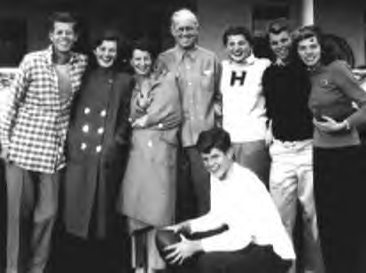
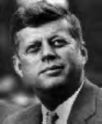

Џон Фицџералд Кенеди

Џон Ф. Кенеди, његова сестра Џин, мајка Роз, отац Џозеф,
сестра Патриша, брат Роберт, брат Едвард

The Family Serbian SOLT 1
Skill Enhancement Activities Module 1 Lesson 4

Activity 8
Look at the photo. This is the family of Robert F. Kennedy. Who were these people to John F. Kennedy, Jr.? Rewrite the description given under the photo from John’s perspective.
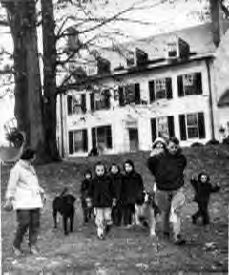

Роберт Кенеди,
његова жена и деца

Activity 9
Choose the identity of the celebrity you like the most. Introduce yourself according to the example.

Example: Зовем се Милан Јанковић.
Живим у Београду.
Ожењен сам и имам једно дете.
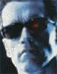



Арнолд Шварценегер Принц Чарлс Бил Клинтон
Лос Анђелес, Лондон, Вашингтон
жена разведен жена
2 сина 2 сина 1 кћерка
2 кћерке

The Family Serbian SOLT 1
Homework Module 1 Lesson 4

Activity 1
1. Can you recognize these cognates? Match each adjective on the left with the noun on the right.

1. Црно а. индустрија
2. амерички б. море
3. аутомобилска ц. партија
4. финансијски д. долар
5. демократска е. проблеми

Activity 2
Transform the sentences using the verb имати.

Ово је сто. Ја имам сто.

А. То је књига. Ви имате __________________.
Б. То је њен кишобран. Она има ________________.
Ц. Ово је њихова софа. Они имају ________________.
Д. То је мој радио. Ја имам ________________.

Activity 3
Write these dialogs in Serbian.
A B
a. Do you have a grandmother, Radmila? a. Do you have children, Ranko?
b. Yes, I do. b. Yes. I have a daughter and a son.
a. What is her name? c. What are their names?
b. Her name is Milica. d. Their names are Slaven and Maja.

__________________________________________________________________
__________________________________________________________________
__________________________________________________________________
__________________________________________________________________
__________________________________________________________________
__________________________________________________________________
__________________________________________________________________

The Family Serbian SOLT 1
Homework Module 1 Lesson 4

Activity 4
Supply the proper form of the present tense.

А. Они __________ филм. (гледати)
Б. Марко _________ задаћу. (писати)
Ц. Ја ____________ проблеме. (имати)
Д. Она _________ наочале. (носити)
Е. Ви ___________ новине. (читати)



Activity 5
Listen to the passage about what people usually do during different family events and then answer the questions.

New Words
играти (to play) пити (to drink)
јести (to eat) плесати (to dance)
спорт, спортови (sport) дувати (to blow)
ногомет (soccer) дати (to give)
одбојка (volleyball) поклон (gift)

1. Which family events are mentioned here? Circle those that apply.
a. a wedding
b. a child’s birth
c. a picnic
d. a birthday
e. a prom

2. What do people do on a birthday?
a. dance
b. eat
c. blow out candles
d. give gifts
e. play basketball

3. When do they play sports?
a. on their birthday
b. on a picnic
c. at a wedding
d. on a honeymoon
The Family Serbian SOLT 1
Homework Module 1 Lesson 4

Activity 6
Think about your family events. Write down what you usually do. Use the words that you learned. Show your work the next day to the instructor.

________________________________________________________________________________________________________________________________________________________________________________________________________________________________________________________________________________________________________________________________________________________________________________________________________________________________________________________________________________________________________________________________________________________________________________________________________________________________________________________________________________________________________________________________________________________________________________________________________________________

Activity 7
Look at the text below and fill in the blanks with the correct adjective endings.

Ово је наш ___ соба. Она је велик ____ . У соби су нов____ столови и мал____ столице. На зиду су леп____ слике и велик ____ сат. На столу су наш____ књиге, и наш____ оловке.

Activity 8
Change the gender of the adjectives and the possessive pronouns.

Example: Наш велики орман. (соба)
Наша велика соба.

1. наш велики разред (школа)
2. твој љубазни стриц (тетка)
3. ваш нови професор (професорка)
4. њен стари друг (другарица)
5. њихов нови сто (столица)
6. наш стари отац (мајка)

