SOLT Serbian Module 1 Lesson 3

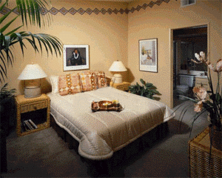

Describing Your Surroundings

Describing Your Surroundings Serbian SOLT 1
Objectives Module 1 Lesson 3

During this lesson, the students will learn about describing surroundings. Under this Terminal Learning Objective, the students will learn three tasks: describe one’s surroundings, identify colors of objects, and express quantities up to 20. At the end of the lesson, the students will be able to:

- Describe one’s surroundings. This task will include:

- Describe sizes, styles, and colors
- Name furniture
- Describe a place or location

- Identify colors of objects. This task will include:

- Name the colors of different objects
- Ask simple questions about objects
- Answer simple questions about objects

- Express quantities up to 20. This task will include:

- Count from 0 to 20
- Number the objects in the classroom
- Tell your age
- Count currency
- Tell your SSN
- Tell your license plate number

Describing Your Surroundings Serbian SOLT 1
Introduction Module 1 Lesson 3

Getting lost in a foreign country is easy to do, so it becomes imperative that you are able to describe your surroundings in the target language. However, it goes far beyond just describing one’s surroundings, for example, you must know the compass directions, be able to read a foreign map, and be able to describe land marks and building structures, all in the target language. Additionally, you must be able to identify colors of objects, and express quantities up to 20. Many of these things you will learn in succeeding lessons, however, now, we will start with describing one’s surroundings.

Tip of the day
The adjectives in Serbian agree with the nouns they modify in gender, number and case.

Шта је то? (What is this?)
Andrew is learning the names of the objects in Serbian. Listen to the pronunciation.

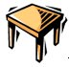 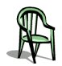
То је сто То је столица
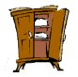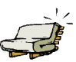
То је софа.
То је ормар.
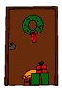
То је прозор. То су врата.

Describing Your Surroundings Serbian SOLT 1
Introduction Module 1 Lesson 3

Exercise 1
Work with your classmate. Ask the question Шта је то? Your partner should give an answer using the objects below. Change the roles.

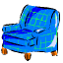

шоља ваза телефон лопта фотеља књига

Exercise 2 (Negatives)
Using the objects from the previous lesson, give negative answers to the question like the following example:

Да ли је то шоља? Не, то није шоља.

Exercise 3
Look around you and name the objects you see. For some of them, you will have to check the dictionary.

Шта је то? Шта је оно?
(What is this?) (What is that?)

То је лампа. Оно је прозор.




Describing Your Surroundings Serbian SOLT 1
Introduction Module 1 Lesson 3

Expressing location

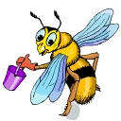
Где је пчела?
(Where is the bee?)

Горе
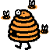
тамо



лево овде десно



доле

Exercise 4
Look at the objects around you and answer the following questions.

1. Шта је лево? _____________________________________________
2. Шта је горе? _____________________________________________
3. Шта је десно? ____________________________________________
4. Шта је тамо? _____________________________________________
5. Шта је доле? _____________________________________________
Describing Your Surroundings Serbian SOLT 1
Introduction Module 1 Lesson 3

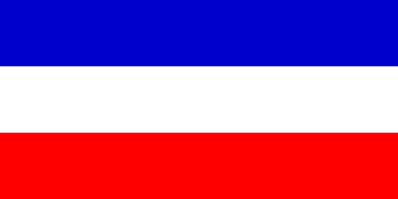

Tip of the day
The flag of the FR of Yugoslavia is blue, white and red.

Exercise 5
Listen to the instructor read the names of colors in Serbian and repeat after listening.

жута роза црвена плава смеђа зелена сива
наранџаста љубичаста

црна бела

Која је то боја? Which color is this?
То је бела боја. This is the white color.
Какве је боје ово ауто? Which color is this car?
Ово ауто је жуте боје. This car is yellow.
Ово ауто је жуто. This car is yellow.

Exercise 6
Ask the question for the color of the items as in the example below. Write your answers.


Example: Какве је боје хаљина?
Хаљина је црвене боје.
Хаљина је црвена.

Describing Your Surroundings Serbian SOLT 1
Introduction Module 1 Lesson 3

Exercise 6 (continued)

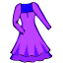

хаљина, шешир, столица, ципела, ормар, фотеља

Exercise 7
Practice with your partner. Ask and answer questions about colors for the objects around you.

Exercise 8
Look at the following chart and write the color for each vehicle name.

Fire engine
Taxi in New York
Police car
Ambulance
Limousine

Describing Your Surroundings Serbian SOLT 1
Introduction Module 1 Lesson 3

Exercise 9 (Plural)
Say what colors the following images are. Below in the box you have only singular.

1. 2.  3. 4.

5. 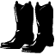 6.  7. 8. 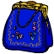

сто, хаљина, шешир, књига, ташна, ципела, чизма, банана,

Exercise 10 (Write the negatives)

Да ли су банане црвене? Не, банане нису црвене. Оне су жуте.

1. Да ли су ципеле црне? (смеђе)
________________________________________________
2. Да ли су прозори сиви? (бели)
________________________________________________
3. Да ли су аута бела? (црвена)
________________________________________________
4. Да ли су софе љубичасте? (наранџасте)
________________________________________________
5. Да ли су шешири жути? (зелени)
________________________________________________

Tip of the day
When counting on their fingers, people in Yugoslavia usually start with the thumb.

Describing Your Surroundings Serbian SOLT 1
Introduction Module 1 Lesson 3

Редни бројеви (Cardinal Numbers)
The instructor will say the numbers from zero to twenty. Listen to the sound of the numbers written below and practice pronouncing them.

нула један два три четири пет шест седам осам девет десет

једанаест шеснаест

дванаест седамнаест

тринаест осамнаест

четрнаест деветнаест

петнаест двадесет

Exercise 11
Count the numbers from 0 to 20 and the other way around. You can practice with your partner. He/she will say one number and you continue with another.

Describing Your Surroundings Serbian SOLT 1
Introduction Module 1 Lesson 3

Exercise 12
Match the numbers with the words on the right.

А. 20 1. дванаест
Б. 18 2. четрнаест
Ц. 12 3. нула
Д. 3 4. двадесет
Е. 14 5. осамнаест
Ф 15 6. једанаест
Г. 11 7. петнаест
Х. 0 8. три

Exercise 13
Listen to the instructor read phrases with numbers and words. Write down the numbers that you hear.

______________________________________________________________________
______________________________________________________________________
______________________________________________________________________
______________________________________________________________________

Exercise 14
The instructor will write the numbers on the board. Each student should say what number is written. Then he/she should come to the board and write the same number in Cyrillic.

Describing Your Surroundings Serbian SOLT 1
Grammar Notes Module 1 Lesson 3

Plural Forms of Nouns

Plural forms in Serbian are more complex than in English. To make your learning of plural forms easier, the new words in the vocabulary list will be given in singular and plural.

The nominative plural endings are:

a. for masculine nouns - i (телефон, телефони/орман, ормани)
b. for feminine nouns - e (шоља, шоље/ књига, књиге)
c. for neuter nouns - a (ауто, аута/ јаје, јаја)

Note: Please remember that masculine nouns ending in consonants:

к, г, х change к into ц (војник, војници/ радник, радници)
г into з (супруг, супрузи)
х into с (орах, ораси)

Exercise 1
Look at the images of the objects. Write the singular and plural forms for each image.

_____________________________________

______________________________________

______________________________________

_________________________________

Describing Your Surroundings Serbian SOLT 1
Grammar Notes Module 1 Lesson 3

Exercise 1 (continued)

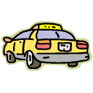 ______________________________________

 _____________________________________

 ______________________________

Adjectives and Question: Какав/Каква/Какво? (What kind of?)

Adjectives are words used to describe things, people or places. In Serbian, they agree with the noun in gender, number and case. The same rule applies for the question: Какав/Каква/Какво. Look the following example.

Singular Plural
M F N M F N
Какав? Каква? Какво? Какви? Какве? Каква?

велик(и) велика велико велики велике велика

Describing Your Surroundings Serbian SOLT 1
Grammar Notes Module 1 Lesson 3

Adjectives and Question: Какав/Каква/Какво? (What kind of?) (continued)

As you can see, the adjectives have different endings for the different genders. Please note that the masculine adjectives can either have no ending in the nominative singular or they can have the ending и. If the masculine adjective has no ending in the nominative singular, we are talking about the so-called non-definite form of adjective. This form is similar to the English indefinite article a:
велик сто - a big table

The -и form is definite and is similar to the English definite article the:
велики сто - the big table

Some masculine adjectives have only -и form in the nominative singular: мали

Example:

Singular

1. Какав је то прозор? What kind of window is this?
То је велики прозор. This is a big window.
2. Каква је то столица? What kind of chair is this?
То је велика столица. This is a big chair.
3. Какво је то ауто? What kind of car is this?
То је велико ауто. This is a big car.

Plural

1. Какви су то прозори? What kind of windows are these?
То су велики прозори. These are big windows.
2. Какве су то столице? What kind of chairs are these?
То су велике столице. These are big chairs.
3. Каква су то аута? What kind of cars are these?
То су велика аута. These are big cars.

Describing Your Surroundings Serbian SOLT 1
Grammar Notes Module 1 Lesson 3

Exercise 2
Here are some adjectives and their opposites. Read each pair aloud. Describe the nouns in the exercise that follows. Remember that the adjectives follow the nouns in gender, case and number.



стар млад

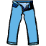

дуг кратак



хладан врућ



мали велик (и)

1. Лопта је _________ а столица је ________________.
2. Човек је _________ а дете је ___________________.
3. Улица је ________ а макарони су ______________.
4. Вода је __________а кафа је __________________.
5. Столице су _____ а ормари су ____________.

Describing Your Surroundings Serbian SOLT 1
Grammar Notes Module 1 Lesson 3

Exercise 3
Form the questions using Какав, ва, во... to the following statements.

Example: Човек је стар. Какав је човек?

1. Књиге су нове. ___________________________________

2. Аута су велика. ___________________________________

3. Орман је стар. ___________________________________

4. Компјутер је велик. _______________________________

5. Улица је дуга. ____________________________________

6. Јаје је мало. ______________________________________

7. Мишеви су мали. _________________________________

The Locative Case and the Prepositions на (on), у (in)

This is the case that is used only with prepositions. When used with the prepositions на and у the locative case answers the question Где? The nouns have the following endings in locative:
M F N

N. Singular ормар шоља ауто
Plural ормари шоље аута

на/у L. Singular ормар-у шољ-и аут-у
Plural ормар-има шољ-ама аут-има

Note: Please note that feminine nouns stems ending in к, г, х usually change into ц, з, с before the locative ending in singular.

N. књига барака снаха
L. књизи бараци снаси

Describing Your Surroundings Serbian SOLT 1
Grammar Notes Module 1 Lesson 3

Exercise 4
Look at the image of a room and say where each object is placed.

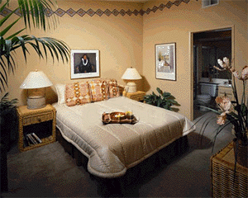

слика јастук
под зид

сточић кревет

1. Где је лампа? _________________________________________
2. Где је слика? _________________________________________
3. Где је кревет? ________________________________________
4. Где су јастуци? _______________________________________
5. Где је под? ___________________________________________

Exercise 5
Find some objects in the classroom. Ask your partner for the location of these objects. The images below can help you with some new words.



табла креда сунђер
компјутер (рачунар)

Describing Your Surroundings Serbian SOLT 1
Grammar Notes Module 1 Lesson 3

Cardinal Numbers

Please remember the following:

1. The number 1 behaves as an adjective. It always agrees with the noun it modifies in number, gender and case.


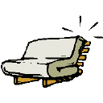
(M) један сто (F) једна софа (N) једно ауто

2. The number 2 has the same form for masculine and neuter nouns but a different form for feminine nouns.

два стола две софе два аута

3. After numbers 2, 3, and 4, masculine and neuter nouns appear in genitive singular, while feminine nouns are in the nominative plural.

4. After numbers 5, 6, 7… the nouns are in genitive plural.

 пет писама
пет столова

Describing Your Surroundings Serbian SOLT 1
Grammar Notes Module 1 Lesson 3

You already know the genitive singular endings. Here is the genitive plural. Refer to the table when practicing numbers.

M F N
Genitive singular стола вазе аута
Genitive plural столова ваза аута

Exercise 6
Look at the objects around you. Name each object using the number 1 (један сто). Do the same by adding adjectives or colors (један црни сто).

Asking the question: Колико? (How many/much?)
*After the question Колико? the noun that follows is in the genitive plural.

Колико је књига на столу? How many books are on the desk?
Шест књига је на столу. Six books are on the desk.

Exercise 7
Make a question for each of the following objects and give an answer.

Example: Колико је овде аута? (8) Овде је осам аута.

1. ормар (7)
___________________________________________________________________________________________________________

2. сто (9)
____________________________________________________________________________________________________________

3. ваза (10)
____________________________________________________________________________________________________________

4. број (1)
____________________________________________________________________________________________________________

5. шоља (11)
____________________________________________________________________________________________________________

Describing Your Surroundings Serbian SOLT 1
Grammar Notes Module 1 Lesson 3

Exercise 8
Write the name of the animal together with the numbers given below. Be careful! The names are in singular.

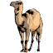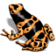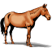
(1) пас (3) птица (2) дева (18) риба (5) жаба (9) коњ

1. __________________________

2. __________________________

3. __________________________

4. __________________________

5. __________________________

6. __________________________

Describing Your Surroundings Serbian SOLT 1
Vocabulary Module 1 Lesson 3

банана, е | banana
бели, а, о | white
боја, е | color
број, бројеви | number
ваза, е | vase
велик, а, о | big
вода, е | water
врућ, а, о | hot
горе | above, up
дева, е | camel
десно | right
доле | down, below
дуг, а, о | long
жаба, е | frog
жут, а, о | yellow
зелен, а, о | green
јаје, а | egg
кафа, е | coffee
колико | How much/how many
коњ, и | horse
кратак, а, о | short
креда | chalk
лево | left
лоптa, е | ball
љубичаст, а, о | purple
мали, а, о | small
миш, мишеви | mouse
млад, а, о | young
наранџасти, а, о | orange
овде | here
орман, и | closet
пас, пси | dog
писмо, а | letter
плав, а, о | blue
прозор, и | window
птица, е | bird
риба, е | fish
рози, а, о | pink
сив, а, о | gray
смеђ, а, е | brown

Describing Your Surroundings Serbian SOLT 1
Vocabulary Module 1 Lesson 3

софа, е | sofa
стар, а, о | old
сто, столови | table, desk
столица, е | chair
сунђер | sponge
табла | board
тамо | there
ташна, е | purse
телефон, и | phone
фотеља, е | armchair
хаљина, е | dress
хладан, а, о | cold
ципела, е | shoe
црвен, а, о | red
црн, а, о | black
чизма, е | boot
шешир, и | hat
шоља, е | cup

Describing Your Surroundings Serbian SOLT 1
Culture Notes Module 1 Lesson 3

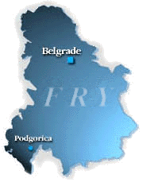

Location of the Federal Republic of Yugoslavia
The Federal Republic of Yugoslavia (FRY), comprising the Republics of Serbia and Montenegro, lies in southeastern Europe, and occupies the heart of the Balkan Peninsula astride the main road, rail and river routes from Western Europe to Asia Minor. The FRY is bordered to the north by Hungary, to the east by Romania and Bulgaria, and by the former Yugoslav republic of Macedonia and Albania to the south; Montenegro, in the southwest, has a coastline on the Adriatic Sea, and the FRY's inland western border is with Bosnia and Herzegovina and with Croatia.

Describing Your Surroundings Serbian SOLT 1
Application Activities Module 1 Lesson 3

Activity 1
Look at the card below and read the Social Security Number.



Activity 2
Here is the picture of an old Serbian bill. Try to find the following information.

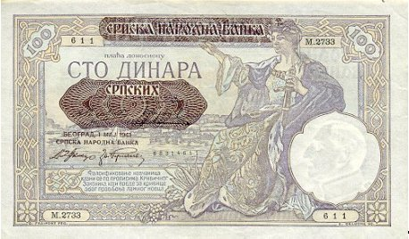

1. When was the bill issued? Include the complete date.
___________________________________________
2. Where was it issued?
___________________________________________
3. What is the amount of the bill?
___________________________________________

Describing Your Surroundings Serbian SOLT 1
Application Activities Module 1 Lesson 3

Activity 3
Some of the colors below have the wrong labels. Write down the correct labels and cross out those that are incorrect. Make statements following the example.

Example: То није црвена боја. То је црна боја.

1. 2. 3. 4. 5. 6.

црвена смеђа плава зелена роза љубичаста

Activity 4
With the help of the list below you and your partner should ask each other where each object is located. Use the prepositions у, на.

Example: Где је ормар?
Ормар је у соби.

софа соба
кревет под
лампа сточић
зид соба
слика зид
креда табла

Activity 5
Imagine you and your partner doing an inventory. You can be the one who is asking questions and he/she should answer them.

Example: Колико је овде столица? Овде је 15 столица.

Describing Your Surroundings Serbian SOLT 1
Application Activities Module 1 Lesson 3

Activity 5 (continued)

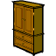

(1) (7) (11) (12) (19)

Activity 6
Look at these pictures of Yugoslav dinars and say how much money each bill is worth.

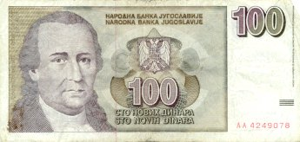

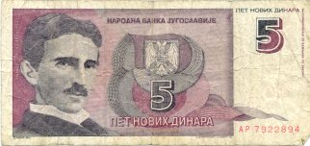

Describing Your Surroundings Serbian SOLT 1
Skill Enhancement Activities Module 1 Lesson 3

Activity 1
Jelena has moved to a new apartment. Listen to what she says about the apartment and do the exercise that follows.

New Words

стан, станови (apartment)
нов, а, о (new)
соба, е (room)
кухиња, е (kitchen)
купатило, а ( bathroom)

1. Jelena’s apartment is:
a. small b. big c. old

2. The apartment has:
a. 2 kitchens b. 2 rooms c. 1 room

3. Jelena has:
- a. 2 lamps b. 1 lamp c. 3 lamps
- a. 4 pictures b. 5 pictures c. 8 pictures
- a. 3 pillows b. 2 pillows c. 5 pillows

Describing Your Surroundings Serbian SOLT 1

Skill Enhancement Activities Module 1 Lesson 3

Activity 2
You will hear cardinal numbers. Find them on the chart below and circle them.

3 | 18 | 11 | 15 | 8 | 19 | 7 | 1 | 12 | 20 | 4 | 13 | 6

Activity 3
Please fill in the missing parts for each sentence written according to the picture.



1. Јелена и Мирко су у __________.

2. Они су _____________________.

3. У учионици је _______ сто и две ______________.

4. _________ је смеђ а столице су _____________.

5. На _________ су књиге.

Describing Your Surroundings Serbian SOLT 1
Skill Enhancement Activities Module 1 Lesson 3

Activity 4
Look at the furniture sale advertisements and find the answers to the questions. Read each advertisement aloud.

Продаја намештаја

1. 2. 3. 4.
Продајем брачни  кревет 190x160.  Тел. 021/31-476 | Продајем писаћи  сто и две лампе.  50 DM  Тел. 021/37-342 | Фотељу, бицикл, гардеробни ормар. Продајем  Тел. 021/37-311 | Продајем нови компјутер. 1000 DM  Тел. 021/31-512

1. What is on sale in the third advertisement?
2. How much is asked for the items in the second advertisement?
3. Which advertisement is selling a computer?
4. What phone number should you call to buy a bed?

Activity 5
What do you think is on sale here?

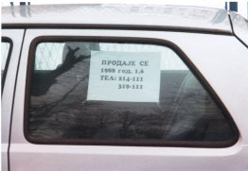

Describing Your Surroundings Serbian SOLT 1
Skill Enhancement Activities Module 1 Lesson 3

Activity 6
You have moved from your current address and you have to apply for the new driver’s license. Tell your classmate the following information and then reverse the roles.

- your name
- your new address
- your new phone number
- your SSN
- your driver’s license number
- your license plate number

Activity 7 (Association)
Match the terms on the left with those on the right.

1. кафа а. жут
2. дан б. хладан
3. сунце ц. црн
4. дете д. врућ
5. вода е. али
6. миш ф. млад

Activity 8
Here are the first names of people and the country of their origin. Write a complete sentence about their nationalities.

1. Џон/Енглеска ____________________________________________________
2. Марко/Италија____________________________________________________
3. Олга/Русија ______________________________________________________
4. Светлана/Југославија ______________________________________________
5. Пјер/Француска __________________________________________________
6. Сабина/Немачка __________________________________________________
7. Коста/Грчка ______________________________________________________
8. Петра/Аустрија ___________________________________________________
9. Ендрју/Канада ____________________________________________________
10.Милош/Румунија _________________________________________________

Describing Your Surroundings Serbian SOLT 1
Homework Module 1 Lesson 3

Activity 1
Put the adjectives in the right form so that they agree with the nouns. Pronounce each adjective together with the noun

А. врућ дани Б. стара ауто Ц. млад студенти Д. кратко дан Е. мала миш

Activity 2
Match the following objects with the proper personal pronoun. Remember that in Serbian, unlike English, objects get their personal pronoun depending on their gender

English Serbian
Example: table – (it) сто – (он)

А. Лампе су на столу. 1. Она је мала.
Б. Кревет је у соби. 2. Оно је старо.
Ц. Ауто је у гаражи. 3. Оне су велике.
Д. Слика је на зиду. 4. Они су велики.
Е. Прозори су отворени. (open) 5. Он је удобан. (comfortable)

Activity 3
Read the following cognates and provide English equivalents.

aрхитектура – скулптура – индустрија – радијатор – регистрација – генератор
продукција – касета – инвентар – продуктивност – термометар - термостат
______________________________________________________________________
______________________________________________________________________
______________________________________________________________________

Activity 4
Listen to the names of colors and circle the one that you hear. Read each color aloud.

А. црвена жута бела
Б. црна бела плава
Ц. смеђа црна роза
Д. бела наранџаста љубичаста
Е. зелена плава смеђа

Describing Your Surroundings Serbian SOLT 1
Homework Module 1 Lesson 3

Activity 5
Match the questions with their answers.

А. Да ли је ово лампа? 1. Да, они су мали.
Б. Какве су боје прозори? 2. Они су бели.
Ц. Да ли су мишеви мали? 3. Не, ово није лампа.
Д. Где су књиге? 4. Да, оне су жуте.
Е. Да ли су банане жуте? 5. Оне су на столу.

Activity 6
Write these sentences in Serbian.

А. What is this? ______________________________________
B. These are books. ___________________________________
A. What type of books? ________________________________
B. The new books. ____________________________________
A. How many books are here? ___________________________
B. Ten. ______________________________________________
A. What color are they? _________________________________
B. They are blue. ______________________________________

Activity 7
Listen to number-word combinations and write them down. Read them several times as fast as you can.
_______________________________________________________________________
_______________________________________________________________________
_______________________________________________________________________
_______________________________________________________________________
_______________________________________________________________________
_______________________________________________________________________
_______________________________________________________________________

Describing Your Surroundings Serbian SOLT 1
Homework Module 1 Lesson 3

Activity 8 (Locative)
Use the locative of the nouns in parenthesis.

1. Маја је у ___________________ (кућа)
2. Књига је на _________________(сто)
3. Ташна је на _________________ (столица)
4. Софа је у ___________________ (соба)
5. Слика је на __________________ (зид)

