SPECIAL OPERATIONS LANGUAGE TRAINING

Serbian

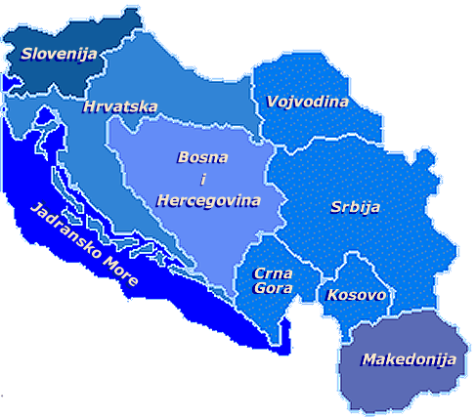

Student

Supplementary Listening Comprehension Workbook
Modules I-III

Module 1 Lesson 1
Audio Clip 1 Track 1

Listen to the Serbian alphabet and its pronunciation. Practice writing the letters until you feel comfortable correlating the sound and the letter.

Аа Бб Вв Гг Дд Ђђ Ее Жж Зз Ии Јј Кк Лл Љљ Мм

Нн Њњ Оо Пп Рр Сс Тт Ћћ Уу Фф Хх Цц Чч Џџ Шш

----------------------------------------------------------------------------------------------------------------------------------------------------------------------------------------------------------------------------------------------------------------------------------------------------------------------------------------------------------------------------------------------------------------------------------------------------------------------------

Track 2

To have a better idea of how letters sound in words, pronounce the following words after listening to them:

Тата-father датум-date
Лекар-doctor радио-radio
Kapetan-captain радар-radar
Џемпер-sweater парк-park
Пасош-passport бомба-bomb
Долар-dollar концерт-concert
Катастрофа-catastrophe војник-soldier

Track 3

Listen to the following geographical names while reading the list written in both the Cyrillic and Latin alphabets.

1. Африка Afrika 8. Москва Moskva
2. Бостон Boston 9. Азија Azija
3. Београд Beograd 10. Индија Indija
4. Панчево Pančevo 11. Америка Amerika
5. Русија Rusija 12. Швајцарска Švajcarska
6. Француска Francuska 13. Флорида Florida
7. Сарајево Sarajevo 14. Лондон London

Module 1 Lesson 2

Track 4

Listen to the Serbian greetings and farewells and practice their pronunciation.

Greetings

Formal Informal
Добро јутро! Good Morning! Здраво Hi/Hello
Добар дан! Good day

Добро вече! Good Evening!

Farewells

Formal Informal
До виђења! Good-bye! Здраво! Bye!
Лаку ноћ! Good night!

Track 5

Listen to the dialog between two friends. Afterwards, answer the questions.

1. How many people are talking? ___________________________________________
2. What are their names? __________________________________________________
3. Who is Гордана? ______________________________________________________
4. To whom is Гордана introduced? _________________________________________

Track 6

Listen as a number of Serbian words are pronounced. Practice saying these words until you feel comfortable with the pronunciation.

- жена 6. чекић (hammer) 11. ђаво
- ћерка 7. чоколада 12. њушка
- шума (forest) 8. школа (school) 13. кашика (spoon)
- џокеј 9. нож (knife) 14. љубав
- човек 10. ћуп 15. четка

Module 1 Lesson 3

Track 7

Редни бројеви (Cardinal Numbers)

Listen to the sound of the numbers written below and practice their pronunciation.

0 1 2 3 4 5 6 7 8 9 10
нула један два три четири пет шест седам осам девет дессет

11 12 13 14 15 16 17
једанаест дванаест тринаест четрнаест петнаест шеснаест седамнаест

18 19 20
осамнаест деветнаест двадесет

Redni Brojevi (Ordinal Numbers)
Listen to the sound of the Ordinal Numbers and practice their pronounciation.

Први(а,о) Други(а,о) Трећи(а,е) Четврти(а,о) Пети(а,о) Шести(а,о)
Седми(а,о) Осми(а,о) Девети(а,о) Десети(а,о

Listen to the following numbers, some are cardinal, some are ordinal. Write a C for cardinal or an O for ordinal in the space provided.

- Пет, 2. Девети, 3. Трећи, 4. Шести, 5. Један,
6. Два, 7. Четири, 8. Седми, 9. Осам, 10. Десет,

Track 8

Jelena has moved to a new apartment. Listen to what she says about the apartment and complete the exercise.

New Words

стан, станови (apartment)
нов, а, о (new)
соба, е (room)
кухиња, е (kitchen)
купатило, а ( bathroom)

1. Jelena’s apartment is:

a. small b. big c. old

2. The apartment has:

a. 2 kitchens b. 2 rooms c. 1 room

3. Jelena has:

a. 2 lamps b. 1 lamp c. 3 lamps
a. 4 pictures b. 5 pictures c. 8 pictures
a. 3 pillows b. 2 pillows c. 5 pillows

Track 9

Listen to number-noun combinations and write them down.

________________________________________________________________________________________________________________________________________________________________________________________________________________________

Module 1 Lesson 4

Track 10

Породица (The family)
Listen to the descriptions that accompany each picture and answer the questions in the exercise.
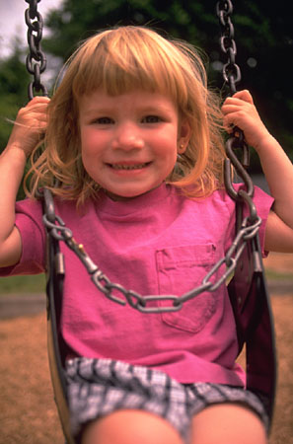

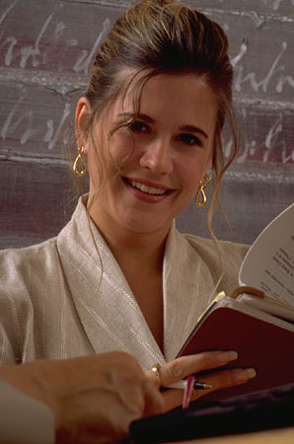


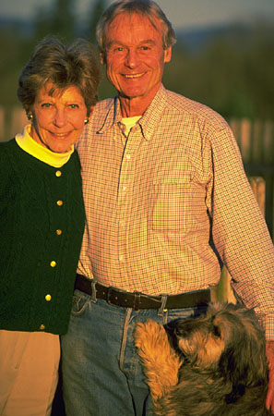

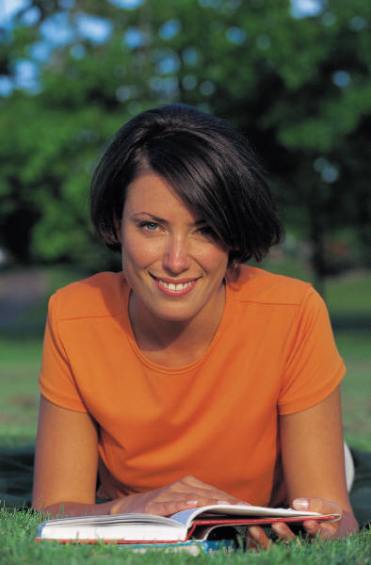
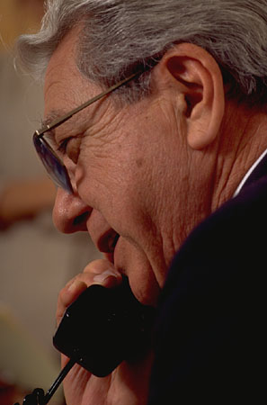
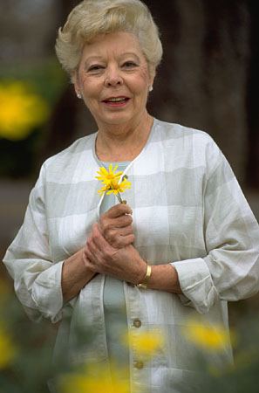

.

1. Who is speaking?
2. Does she have children?
3. Does she have grandparents?
4. What is her grandmother’s name?
5. Does she have an uncle?
6. What is her brother’s name?

Track 11

Listen to the following statements and determine whether they are true or false. Listen again and provide the complete answer where needed.

Example: Statement: Весна има три сина.
You: Не она има два сина.

Statements:
- ______________________________.
- ______________________________.
- ______________________________.
- ______________________________.
- ______________________________.
Track 12

Listen to the passage about what people usually do during different family events and
then, answer the questions.

New Words
Играти (to play) пити (to drink)
Jeсти (to eat) плесати (to dance)
Спорт, спортови (sport) дувати (to blow)
Ногомет (Soccer) дати (to give)
Одбојка (volleyball) поклон (gift)

- Which family events are mentioned here? Circle those that apply.
a. a wedding
b. a child’s birth
- a picnic
- a birthday
- a prom

- What do people do on a birthday?
a dance
- eat
c. blow out candles
- give gifts
- play basketball

Module 1 Lesson 5

Track 13

Listen to the short passage about people and their descriptions, then fill in the tables below with the necessary information.

1. Маја 2. Радмила

Старост (age)___________________ Старост_______________________
Очи___________________________ Очи___________________________
Коса___________________________ Kоса__________________________
Брат___________________________ Брат___________________________
Сестра_________________________ Сестра_________________________

4. Kатарина 4. Весна

Старост_______________________ Старост_______________________
Очи __________________________ Очи__________________________
Коса__________________________ Коса__________________________
Брат__________________________ Брат__________________________
Сестра________________________ Сестра________________________

Track 14

Listen to the short passage about people. Based on the content, determine whether the following statements are true or false.

Statements: T / F

1. Branko is an old man. _______
2. Jelena is not intelligent. _______
3. Radmila is boring. _______
4. Mrs. Peric is not sociable. _______
5. Milan is serious and optimistic. _______

Track 15

Practicing pronunciation. Listen to the following mixture of geographical and biographical names and practice the pronunciation.

Module 1 Lesson 6

Track 16

Listen as the months of the year are spoken aloud. Practice their pronunciation.

Јануар January
Фебруар February
Март March
Април April
Мај May
Јуни June
Јули July
Август August
Септембар September
Октобар October
Новембар November
Децембар December

Track 17
Празници

Jelena and her American friend Ana are talking about holidays. Listen to their conversation and answer the questions in English.

1. When does Jelena’s family celebrate Christmas? _____________________________
2. What is the name for Women’s Day in the FR of Yugoslavia? ___________________
3. In which month is Дан жена celebrated? ___________________________________
4. When was Jelena born? _________________________________________________
5. On what date was Ana born? _____________________________________________

Track 18

How old are they? Listen carefully to the name and the age as it is being pronounced and write the age under each name.

Ненад Радмила Предраг Професор Мила Мој брат

Module 2 Lesson 1

Track 19

Пасош (Passport)
This summer the Петровић’s are planning to visit their relatives in the United States. Since Mrs. Петровић doesn’t have a passport, she is going to apply for one. Listen to the conversation between her and the office clerk. Write down the main points of the discussion.
______________________________________________________
______________________________________________________
______________________________________________________
______________________________________________________________________________________________________________________________________________________________________________________________________________________________________________________________________________

Track 20

Listen to the dialog. Practice it with a colleague. Afterwards, write a short summary of the conversation.
______________________________________________________
______________________________________________________
__________________________________________________________________________________________________________________________________________________________________

Track 21

Listen to a short passage and record the information that is being provided. There are nine important facts altogether.
______________________________________________________
______________________________________________________
__________________________________________________________________________________________________________________________________________________________________

Module 2 Lesson 2
Track 22

Колико је сати? (What time is it?)
Listen to times as they are being read. Place them in the order you hear them.

A. B. C.
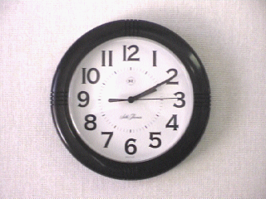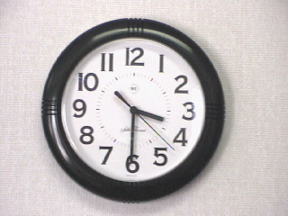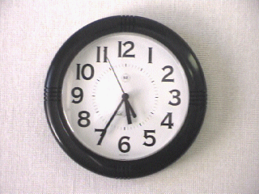

а. два (сата) и десет а. три (сата) и тридесет а.двадесет пет (минута)
(минута) (минута) до шест
б. пола четири б.пет и тридесет пет

D. E. F.
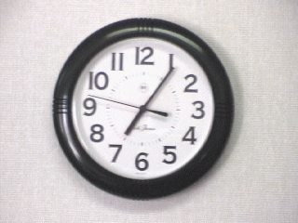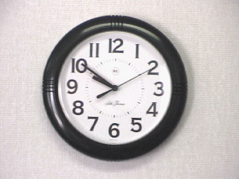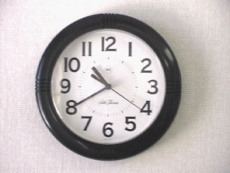

а. седам (сати) и пет а. десет (минута) до а. двадесет (минута) до
(минута) десет једанаест

б. девет (сати) и б. десет (сати) и
педесет (минута) четрдесет (минута)

Track 23

Listen as you will hear a series of numbers read. Write them down as you hear them.
______________________________________________________
______________________________________________________
______________________________________________________
______________________________________________________

Track 24

The following passage will mention distances, lengths and weights given in the metric system. Listen carefully and decide if the answers are true or false. Be careful! The answers are using the English system.

Statements T / F
1. The distance between Novi Sad and Pancevo is 46.6 miles. _________
2. There are 45 miles from Prijedor to Banja Luka. _________
3. Branko is 6 inches tall. _________
4. Branko has 187 pounds. _________

Module 2 Lesson 3

Track 25

Listen to the short exchanges and guess which hobbies are mentioned. Write your answers in English.

1. ____________________________
2. ____________________________
3. ____________________________
4. ____________________________

Track 26

Listen to several people talking about themselves and put a checkmark next to the information they provide.

 | Стефан | Снежана | Александар

Age
Family:

brother
sister

Place
Hobbies:

volleyball
swimming
painting
reading
skiing
diving
chess
cards
tennis
soccer
drawing

Track 27

Listen to what Aleksandar says about his leisure activities and fill in the missing words.

У слободно _____ волим да слушам ______. Обично ______ страну музику. Моја _______ група су Back Street Boys. _____ и да играм _____. Често играм _______ и фудбал. Волим да _____ али немам _________ опрему.
Module 2 Lesson 4
Track 28

Listen to Stefan, Mirjana and Goran talking about their jobs. After listening, choose the correct answer for each question.

1. Who mentions his/her hobbies?

a. Mirjana b. Stefan c. Goran

2. Who earns the most?

a. Goran b. Stefan c. Mirjana

3. Where does Stefan work?

a. Beograd b. Kragujevac c. Nis

4. How old is Mirjana?

a. 35 b. 25 c. 45

5. How much does Goran earn per month?

a. 4200 DIN b. 4000 DIN c. 3000 DIN

6. What is Mirjana’s occupation?

a. doctor b. nurse c. medical technician

Track 29

You have to write a report about people and their earnings. Listen to the passage and write down the earnings that match each name.

Александар_______________ Зоран__________________

Љиљана ________________ Милан_________________

Track 30

Listen to the passage to learn how much money people spend monthly for utilities, then fill in the necessary information in the table provided.

Utilities | Water | Energy | Phone | Gas | Total
Jasna
Marko
Filip
Module 2 Lesson 5
Track 31

Listen to the following military ranks and circle their equivalents in English. Be careful! Not all military ranks written below will be mentioned.

Lieutenant Colonel Major Lieutenant Private First Class
Corporal Sergeant Colonel-General Warrant Officer
Senior Sergeant

Track 32

Listen to the passage concerning people who serve in the army and fill in the information in the table provided below.

 | Раде  Симић | Милан  Станић | Миломир Поповић | Синиша Марковић
Rank
Age
Military: how long
Military branch

Track 33

The following military officers are being promoted to different ranks at different times. Listen to the passage and fill in the information in the table below. Be careful! The names in the table are given in different order than they are introduced in the recording.

 | Ратко П. | Синиша С. | Славко П. | Милан П. | Предраг Р.

Rank

Date

Module 3 Lesson 1
Track 34

Забава (A Party)
Mrs. and Mr. Петровић are planning a dinner party. They will invite their closest friends and relatives. Listen to the conversation a few times and summarize the dialog between Mr. and Mrs. Petrovic.

Track 35

Позив на вечеру (dinner invitation)
While Mrs. Petrovic is busy arranging items in the kitchen, Mr. Petrovic is phoning aunt Kosa and uncle Branko to invite them for dinner. Listen to the conversation and fill in the table with the necessary information.

Who?
When?

Track 36

Listen to Зоран and Маја ordering a meal in a restaurant, then fill in the necessary information in the box provided below.

 | Зоран | Маја
appetizer
main meal
dessert
drinks

Module 3 Lesson 2
Track 37

Mr. Petric is at the reception desk of the Hotel Mediterna. Listen carefully to his conversation with a receptionist and choose the right answers below.

на другом спрату (on the second floor) на трећем спрату (on the third floor)

What does he need? ______________________________________________________
How long does he need the room for? ________________________________________
What else would he like? __________________________________________________

Track 38

Listen to a short passage concerning different types of apartments and houses that certain people rent. Fill in the blanks in the sentences below with the relevant information.

- Ms. Popovic is renting _________ rooms in Novi Sad with a kitchen. Central heating and ________________ are included in the price.
- Radmila is renting __________ apartment with a garage and attic in the city _______.
- Stanko is renting a house in ___________. The house is 200 ___________ large and has ______ floors and _________.
- Mr. Radic is renting a __________ apartment. Utilities are _________ in the rent.

Track 39

Listen to the statements in Serbian and provide their equivalents in English.

_____________________________________________________
_____________________________________________________
_____________________________________________________
_____________________________________________________
_____________________________________________________
_____________________________________________________
_____________________________________________________
_____________________________________________________
_____________________________________________________

Module 3 Lesson 3
Track 40

Новчана уплатница (A money order)
Jelena wants to send a money order. She is at the post office talking to the postal clerk, but she is confused. Listen to her conversation with the clerk and answer the questions.

- Why do you think Jelena is confused?
- Did she get help from the clerk?
- Does the clerk notice that Jelena is confused? Give an example from the text that confirms your answer.

________________________________________________________________________________________________________________________________________________________________________________________________________________________

Track 41

The following people want to send mail. Your task is to listen to the passage and figure out what they are sending, to where, how and to whom.

 | Шта? | Куда? | Како? | Коме?
Мирјана
Славко
Славица
Мирко

Track 42

Mr. Simic is inquiring about postal charges. Listen to the dialog and answer the questions. Use complete sentences.

1. Колико кошта писмо за Енглеску?
________________________________________________________________________

2. А колико кошта препоручено писмо?
________________________________________________________________________

3. А писмо за Америку?
________________________________________________________________________

4. Да ли је то авионско писмо?
________________________________________________________________________
Module 3 Lesson 4
Track 43

You will hear two people in a bank who want to exchange money. Listen carefully and find out how much they want to change, what currency they want, what the exchange rate is and how many dinars they will get in return. Fill in the table below.
1. 2.

Валута?
Колико?
Курс?
Колико динара?

Track 44

Mr. Simic is in the bank. He wants to deposit some money. Listen to the conversation and answer the following questions.

- How much money did Mr. Simic deposit in his account?
- What was the date of his deposit?
- What was his account number?
- How many checks did he deposit?
- Did he have to sign his deposit slip?
________________________________________________________________________________________________________________________________________________________________________________________________________________________

Track 45

Question or request? How good are you in recognizing if someone is asking you something, requesting something from you or just telling you something? Listen to each statement and put the question mark (?), exclamation (!) or period (.) depending on what you hear.

    - _______
    - _______
    - _______
    - _______
    - _______
    - _______
    - _______
    - _______
Module 3 Lesson 5
Track 46

Listen to the following telephone conversation and fill out the message slip with the information you hear.

1. 2.

Who?
When?
Message?

Track 47

Listen to the phone conversation again and answer the questions.

- Где је Миланова мама? _____________________________________________
- Где је Милан и шта ради? ___________________________________________
- Одакле је Миланов пријатељ Влада? __________________________________
- Која је Миланова адреса? ___________________________________________
- Који је његов телефонски број? ______________________________________
- Да ли је Нови Сад далеко од Београда? ________________________________
- Када Милан планира да дође кући? ___________________________________
- С ким Милан живи у стану? _________________________________________

Track 48

Jelena works as a secretary. Yesterday, she received messages for people working in the company. Help her fill out the information in the table below. She needs to know who called, for whom the message is for, what the message is about, and the phone number to call back.

 | Mr. Peric | Marko | Mr. Mirkovic
WHO?
MESSAGE?
PHONE NO.?

Module 3 Lesson 6
Track 49

Mira went shopping today. Listen to her conversation with Nenad and answer the questions.

- Где је Мира била јутрос? _________________________________________
- Шта је купила? _________________________________________________
- Колико пара још има? ____________________________________________
- Да ли су паре за њу или за Ненада? ________________________________
- Шта Мира планира да купи? ______________________________________

Track 50

Listen to what Vlado says about the uniform policy code in the military and decide whether the statements are true or false.

T / F

1. Vlado mentions two kinds of uniform. _____
2. The uniform is made of wool and nylon. _____
3. Vlado wears the uniform only in the military school. _____
4. Vlado mentions boots as a part of the uniform. _____
5. He doesn’t like to wear sport clothes. _____

Track 51

You will hear some of the new vocabulary words that you have recently learned. Listen to the words as they are pronounced and practice writing them.

_____________________________________________________
_____________________________________________________
_____________________________________________________
_____________________________________________________
_____________________________________________________
_____________________________________________________
_____________________________________________________
_____________________________________________________
_____________________________________________________
_____________________________________________________
Module 3 Lesson 7
Track 52

Marko is shopping today at the flea market. There are two situations that you will listen to. Be careful! This is a very colloquial Serbian so listen as many times as you need. After listening, write a short summary of the situations below.

Situation 1 Situation 2

М. Кол’ко су ти фармерке? М. Кол’ко ти је камера?
Т. 250. Т. 500 динара. Права ствар, увоз
М. Превише. из Немачке.
Т. Кол’ко би ти дао? М. Може за 400 динара?
M. 150. Т. 480?
T. Ух, што си леп. М. 400 или не купујем
М. Ено онај тамо продаје за 150 динара. Т. 450?
Т. А ти иди код њега па купи. М. Не може.

Т. Еј бре што си чудан. Нек ти

буде 400.

ко’лко (колико)
бре (colloq.)
чудан (strange)
права ствар (right stuff)

1.____________________________________________________
_____________________________________________________
_____________________________________________________
_____________________________________________________
_____________________________________________________

2.___________________________________________________________
______________________________________________________
______________________________________________________
______________________________________________________
______________________________________________________

Track 53

Listen to the following short conversations and identify the store in which each takes place. (тржница, бувља пијаца, робна кућа, самопослуга)

  - __________________________
  - __________________________
  - __________________________
  - __________________________

Track 54

You are spending a vacation on the Adriatic Sea and you need to know the prices in the food markets. Listen to the announcement and write down the prices next to the products.

млеко ____________ конзервирано воће и поврће ______________

кромпир _________ уље _________________

чоколада __________ грашак ______________

