Special Operations Language Training 1

Korean

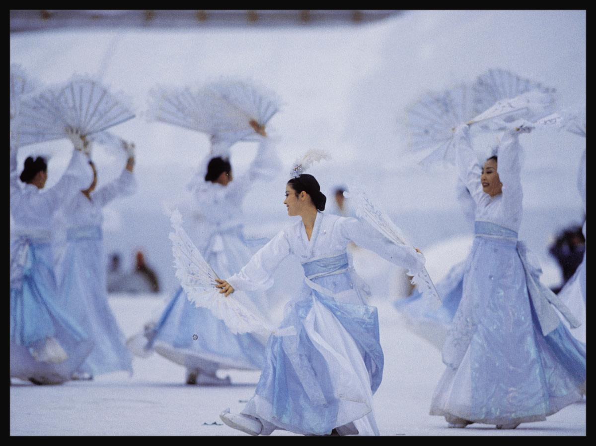

WorkBook
Module 3

Food / Shelter / Daily Life

The US Army John F. Kennedy Special Warfare Center and School
in association with
The University of Arizona, South
Camber
Advanced Computer Learning Company

Module 3 Lesson 1

Audio Clip 3 Track v.1-72

Activity 1
Listen to following five mini-dialogues. Mark the correct statements from each dialogue.

(1) The recipe calls for

(a) barley
(b) flour
(c) rice

(2) The host is offering

(a) a cold drink
(b) hot food
(c) cold food

(3) The customer is asking for

(a) some water
(b) a soft drink
(c) an alcoholic beverage

(4) The recipe calls for

(a) cabbage kimchi
(b) radish kimchi
(c) cucumber kimchi

(5) Mr. 노 comments on

(a) the cafeteria
(b) the service
(c) his favorite meal

Lesson 1

Lesson 1

Audio Clip 3 Track v.1-73

Activity 1
Listen to the following two short dialogues and choose the Korean store they most likely took place in.

(1)

(a) 정육점
(b) 신발가게
(c) 식품점
(d) 옷가게

(2)

(a) 식품점
(b) 정육점
(c) 과일가게
(d) 주유소

Audio Clip 4 Track v.1-74

Activity 1
Listen to the conversation and answer the questions below.

(1) What is Mr. Park ordering?

(a) 김밥, 떡볶이
(b) 간짜장, 짬뽕, 잡채밥, 군만두
(c) 비빔밥, 김치, 잡채
(d) 스테이크, 스프, 샐러드

(2) How much is he paying all together?

(a) 3000원
(b) 4000원
(c) 100원
(d) 16,000원

Lesson 1

Audio Clip 5 Track v.1-75

Activity 1
Listen to the conversation and answer the questions that follow.

(1) How many plates of salad are the speakers going to take?

(a) 10
(b) 11
(c) 12
(d) 13

(2) How many bottles of coke are needed?

(a) 17
(b) 18
(c) 19
(d) 20

Lesson 1

Audio Clip 6 Track v.1-76

Activity 1
Listen to the audio clip and answer the questions below.

(1) What utensils are used for Korean food?

(a) 나이프와 포크
(b) 숫가락과 젖가락
(c) 컵
(d) 국자

(2) What utensils are used for steak?

(a) 접시와 컵
(b) 국자와 주걱
(c) 나이프와 포크
(d) 숫가락과 젖가락

Audio Clip 7 Track v.1-77

Activity 1
Listen to the following note from a Korean wife to her husband and answer the questions below.

(1) What is needed for the party?

(a) 슈퍼마켓
(b) 3병
(c) 소주
(d) 포도주

(2) Why can’t she go to the grocery store?

(a) 차가 없어서
(b) 파티 준비를 해야 하기 때문에
(c) 일을 해야 하기 때문에
(d) 가기 싫어서

Module 3 Lesson 2

Lesson 2

Audio Clip 1 Track v.1-78

Activity 1
Listen to the following three short dialogues and match the names of people with where they live.

최수광 | • | • 왕십리 아파트
박은주 | • | • 오피스텔
김민수 | • | • 망미동 단독주택

Lesson 2

Audio Clip 2 Track v.1-79
Activity 1
Listen to the following dialogue and mark the statements below true or false.

 | Statements | True | False
1 | One person will stay at the hotel.
2 | He wants a non-smoking room.
3 | The hotel rate is 55,000 won.
4 | The room number is 505.
5 | The charge for the room includes breakfast.
6 | The hotel guest wants a 7:30 wake-up call.

Audio Clip 3 Track v.1-80

Activity 1

Listen to the following ad and make a list of features that are available in the rental house, 시골집.

Lesson 2

Audio Clip 4 Track v.1-81

Activity 1
Listen to the following three short dialogues and choose the one that takes place at a real estate office.

Audio Clip 5 Track v.1-82

Activity 1
Listen to the telephone conversation and answer the questions below.

(1) What is the dialogue used for?

(a) 스위트 룸
(b) 호텔예약
(c) 하얏트 호텔
(d) 김철수

(2) When will Mr.Kim stay at the hotel?

(a) 하얏트 호텔
(b) 스위트 룸
(c) 토요일
(d) 금요일

Lesson 2

Audio Clip 6 Track v.1-83

Activity 1
Sergeant Park has been recently transferred to an army post in Kunsan. A friend of his in Seoul, Sergeant Kim, will be moving to the same installation as Sergeant Park shortly. This is a message left on Sergeant Kim’s answering machine by Sergeant Park. Listen to the message first and then answer the following questions.

(1) How far is Sergeant Park’s apartment from the base?

(a) 10 minutes on foot
(b) 10 minutes by bus
(c) 20 minutes on foot
(d) 20 minutes by bus

(2) How much does he pay for the apartment?

(a) 300,000 won deposit for a year
(b) 56,000,000 won deposit for two years
(c) 280,000 won per month
(d) 300,000 won per month

(3) What does Sergeant Park want Sergeant Kim to do?

(a) visit his family
(b) to move into the apartment complex where Sergeant Park lives
(c) to buy a house
(d) to call Sergeant Park

Lesson 2

Audio Clip 7 Track v.1-84

Activity 1
The following is a dialogue between a husband and his wife. They are talking about the cost of utilities. Listen carefully and answer the questions that follow.

(1) Mr. Kim paid the electric bill for the month. How did he pay it?

(a) He paid it with his credit card.
(b) He went to a bank to pay it.
(c) He sent a check for the charges.
(d) He went to a post office to pay it.

(2) How much was the electric bill last month?

(a) 40,000 won
(b) 85,000 won
(c) 80,000 won
(d) 55,000 won

(3) Have they paid the water bill yet?

(a) No, they haven’t received the bill yet.
(b) Yes, Mrs. Kim paid it.
(c) No, but Mr. Kim will pay it today.
(d) Yes, Mr. Kim paid it.

Module 3 Lesson 3

Lesson 3

Audio Clip 1 Track v.1-85

Activity 1
Listen to the following dialogue between a postal clerk and a customer who needs some stamps and answer the questions.

(1) Which postage stamp should you use for a domestic postcard?

(a) 140 won
(b) 170 won
(c) 190 won
(d) 30 won

(2) How many postage stamps is the customer buying?

(a) 20
(b) 30
(c) 50
(d) 140

Lesson 3

Audio Clip 2 Track v.1-86

Activity 1
Listen to the conversation between a postal clerk and a customer and mark the statements as either true or false.

(1) The customer was looking for a mailbox. T______ F______

(2) He wanted stamps for an airmail letter. T______ F______

(3) He had already filled out the necessary form. T______ F______

(4) He forgot to sign the form. T______ F______

(5) The conversation took place at window 3. T______ F______

Module 3 Lesson 4

Lesson 4

Audio Clip 1 Track v.1-87

Activity 1
Listen to the following conversation and answer the questions.

Mr. Youngsu Kang enters a bank and talks to a clerk at a window.

(1) What does he want?

(a) to open an account
(b) to deposit money
(c) to withdraw money
(d) to close an account

(2) How does he want his money?

(a) bank check
(b) all in cash
(c) make a deposit to another account
(d) money order

(3) What did he need to bring to the bank to process this transaction?

(a) money
(b) co-signer
(c) residence card and his seal (stamp)
(d) ATM card

Lesson 4

Audio Clip 2 Track v.1-88

Activity 1
Listen to the following dialogue and answer the questions.

Mr. Brown has just moved to Korea. He will be staying there for a year. He talks with his friend about bank accounts.

(1) What kind of bank account did he open?

(a) 보통예금
(b) 저축예금
(c) 자유예금
(d) 자유저축예금

(2) Select the one that is NOT recorded in the bankbook.

(a) 주소
(b) 날짜
(c) 입금액
(d) 지급액

Lesson 4

Audio Clip 3 Track v.1-89

Activity 1
This is Sungho Hong’s bankbook. Listen to the following questions regarding Mr. Hong’s bankbook and answer them below.

 | 년 월 일 | 적요 | 입금액/지급액 | 잔액 | 취급점
01 | 99-04.01 | 현금 | 500,000 | 500,000 | 거여동
02 | 99-04-25 | 자동이체 | 250,000 | 750,000 | 거여동
03 | 99-05-03 | 현금 | 75,000 | 675,000 | 석촌동
04 | 99-05-25 | 자동이체 | 250,000 | 925,000 | 거여동
05 | 99-05-27 | 현금 | 100,000 | 825,000 | 양재동

(1) What kind of bank account does he have?

(2) What was his bank balance on May 27, 1999?

(3) When did he open the bank account?

(4) When did he withdraw money?

(5) Where is his main bank?

Lesson 4

Audio Clip 4 Track v.1-90

Activity 1
Listen carefully to the dialogue and answer the questions that follow.

(1) “천원 지폐 세장” How much is it?

(a) 2000 원
(b) 1000 원
(c) 3,000 원
(d) 오천원

(2) “백원 동전 일곱개” How much is it?

(a) 700 won
(b) 800 won
(c) 900 won
(d) 70,000 won

Audio Clip 5 Track v.1-91

Activity 1
Listen carefully to the audio clip and answer the questions below.

(1) “십원이 열개 있으면 ” How much is it?

(a) 100 원
(b) 1000 원
(c) 10,000 원
(d) 오백원

(2) “오천원이 두장이면” How much is it?

(a) 500 won
(b) 5,000 won
(c) 20,000 won
(d) 10,000 won

Lesson 4

Audio Clip 6 Track v.1-92

Activity 1
Listen carefully to the dialogue and answer the questions that follow.

(1) What’s the exchange rate today?

(a) 1,000 원
(b) 1,200 원
(c) 1,300 원
(d) 1,500원

(2) How much has it changed by?

(a) 1,000 won
(b) $ 1,000
(c) 1,000,000 won
(d) $ 10,000

Audio Clip 7 Track v.1-93

Activity 1
Listen carefully to the dialogue and answer the questions below.

(1) What’s the exchange rate today?

(a) 1,100 원
(b) 1,200 원
(c) 1,300 원
(d) 1,500원

(2) How much has it changed by?

(a) 5,000 won
(b) $ 5,000
(c) 500,000 won
(d) $ 50,000

Module 3 Lesson 5

Lesson 5

Audio Clip 1 Track v.1-94

Activity 1
Listen to the following Korean expressions to make telephone calls and match them with their English translations.

(1) 전화 왔어요/ 전화 받으세요. | • | • The phone is busy.
(2) 여보세요. | • | • Hello.
(3) 통화중이에요. | • | • May I speak to Mr. Kim please?
(4) 김선생님 바꿔 주세요. | • | • There is a phone call (for you).

Lesson 5

Audio Clip 2 Track v.1-95

Activity 1
Listen to the following telephone conversation and answer the questions.

John is making a phone call to Mary in the U.S.A. through an operator.

(1) What does ‘수신자 부담’ mean?

(a) The caller pays for the call.
(b) The receiver pays for the call.
(c) It is a toll free call.
(d) One does not know who is paying.

(2) In what order did John dial?

(a) 0#620
(b) 0#6209784280
(c) 0#9784280
(d) 0#

Lesson 5

Audio Clip 3 Track v.1-96

Activity 1
Listen to the following short passage and answer the question below.

A person asks the operator for the telephone number of the American Embassy.

What is the phone number of the American Embassy?

(a) 497-4114
(b) 397-3114
(c) 397-4114
(d) 497-4113

Audio Clip 4 Track v.1-97

Activity 1
Listen to the following telephone conversation and answer the questions below.

Saena makes a phone call to Jaeho and finds that he is out.

What is NOT included in the message that Saena left?

(a) her phone number
(b) her name
(c) why she called
(d) asking him to call her back

Lesson 5

Audio Clip 5 Track v.1-98

Activity 1
Listen to the following dialogue and answer the questions below.

Which is correct according to the dialogue?

(a) Dr. Choi has been in the meeting for an hour when Mr. Nah calls.
(b) Mr. Nah tells the secretary that he will make a call later.
(c) Dr. Choi has been waiting for a call from Mr. Nah.
(d) Mr. Nah’s phone number is 322-8148.

Audio Clip 6 Track v.1-99

Activity 1
Listen to the following dialogue and choose the expressions that best complete the conversation.

장승재는 이영국의 전화를 받고 오늘 _____을 같이 하자고 한다. 이영국은 장승재의 사무실 부근으로 와서 열두시경에 _________.

(a) 아침, 전화를 다시 하겠다고 한다.
(b) 점심, 전화를 하기로 한다.
(c) 저녁, 사무실로 오기로 한다.
(d) 모임, 점심을 먹기로 한다.

Lesson 5

Audio Clip 7 Track v.1-100

Activity 1
Listen to the following audio clip and answer the questions that follow.

(1) What is the basic rate to make an international call to the U.S.?

(a) 2,500 won
(b) 860 won

(2) What time of day does the discount rate apply?

(a) It applies from 6:00 pm to 9:00 am the next day.
(b) It applies from 8:00 pm to 6:00 am the next day.
(c) It applies from 9:00 pm to 6:00 am the next day.

Audio Clip 8 Track v.1-101

Activity 1
Listen to the following audio clip and answer the questions that follow.

(1) Can you call the U.S. from this booth?

(a) No, you can not make an international call.
(b) Yes, you can make an international call.

(2)What is the minimum rate for a domestic long-distance call?

(a) 50 won
(b) 200 won

Module 3 Lesson 6

Lesson 6

Audio Clip 1 Track v.1-102

Activity 1
Listen to the following dialogue between a Korean soldier, Corporal Park, and an American soldier, Corporal Brown. Corporal Park visited the American army base in Yongsan while on duty. He arrived there late in the afternoon. He ran into his acquaintance Corporal Brown in the barracks.

(1) What kind of clothing is Corporal Brown wearing?

(a) civilian clothing
(b) military clothing

(2) What clothing would Corporal Park be wearing?

(a) civilian formal clothing
(b) civilian casual clothing
(c) military clothing

Lesson 6

Audio Clip 2 Track v.1-103

Activity 1
Listen to the following dialogue between Kyongsun and a department store clerk and answer the questions below.

(1) What is she looking for?

(a) 셔츠
(b) 바지
(c) 잠바
(d) 치마

(2) What color does she want for her clothes?

(a) 하얀색
(b) 노란색
(c) 빨간색
(d) 검은색

(3) What waist size does she wear?

(a) 25
(b) 26
(c) 27
(d) 28

Audio Clip 3 Track v.1-104

Activity 1
Listen to the following list of items. Choose ten items from the box below that you consider the most important things to take along on a mission. Make a list.

공구, 지도, 손전등, 라디오, 모포, 나침반, 휴지, 배낭, 성냥, 의약품, 칼, 물, 밧줄, 전지, 구급함, 조명탄, 무전기, 폭발물

Lesson 6

Audio Clip 4 Track v.1-105

Activity 1
Listen to the following dialogue and answer the question below.

Where is this dialogue taking place?

(a) at a military base
(b) at a school
(c) at a clothing store
(d) at a grocery store

Audio Clip 5 Track v.1-106

Activity 1
Listen to the following audio clip and answer the questions below.

(1) Where is the 10th company main gate headed?

(a) 서쪽
(b) 동쪽
(c) 남쪽
(d) 북쪽

(2) What is in the center of the 10th company?

(a) 소대 건물
(b) 연병장
(c) 의무대
(d) 부대 정문

(3) Which side are the platoon buildings on?

(a) 남쪽
(b) 동쪽
(c) 북쪽
(d) 서쪽

Lesson 6

Audio Clip 6 Track v.1-107

Activity 1
Listen to the following dialogue and answer the questions below.

(1) Who should set up the tents?

(a) 박상병
(b) 김상사
(c) 텐트병
(d) 민간인

(2) What does Corporal Park bring?

(a) 텐트
(b) 텐트폴
(c) 위장망
(d) 텐트팩

Audio Clip 7 Track v.1-108

Activity 1
Listen to the following dialogue and answer the questions below.

(1) Where should the third platoon reconnoiter?

(a) 1분대
(b) 2분대
(c) 중대장
(d) 365고지

(2) Who should receive the ammunition?

(a) 1분대
(b) 2분대
(c) 중대장
(d) 3분대

Module 3 Lesson 7

Lesson 7

Audio Clip 1 Track v.1-109

Activity 1
Listen to the following conversation between a merchant at a jewelry store and a customer and answer the questions below.

(1) Which jewelry items form a set at this store?

(a) silver necklace, earrings, bracelet
(b) silver necklace, gold ring, earrings
(c) gold ring, earrings, bracelet
(d) earrings, bracelet, silver ring

(2) How much of a discount was the customer given?

(a) 2,000 won
(b) 3,000 won
(c) 5,000 won
(d) 28,000 won

Lesson 7

Audio Clip 2 Track v.1-110

Activity 1
Listen to the following announcement and answer the questions below.

(a) What is this announcement trying to sell?

(b) How much is the item that the announcement is selling?

Audio Clip 3 Track v.1-111

Activity 1
Listen to the following announcement and answer the question below.

(a) What is this announcement trying to sell?

Audio Clip 4 Track v.1-112

Activity 1
Listen to the following statements and write 시장 if the statement describes an outdoor market and 백화점 if the statement refers to a department store. If the statement is about both an outdoor market and a department store, write both 시장 and 백화점.

(Transcript) (Answer)

