Special Operations Language Training 1

Korean

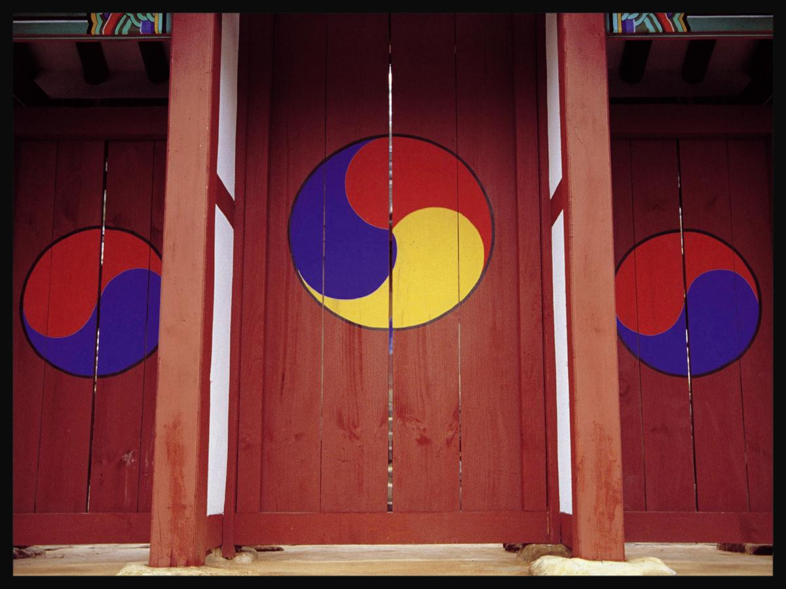

WorkBook
Module 2

Personal Information

The US Army John F. Kennedy Special Warfare Center and School
in association with
The University of Arizona, South
Camber
Advanced Computer Learning Company

Audio Clip 1 Track 41

Activity 1
Listen to the following three short dialogues. Determine if the statement about each is true or false and mark the answer accordingly.

(1)

Their last names are 이 and 최.

(2)

Mr. 최수영 is older than Mr. 김진수.

(3)

박선생 is from 속초.

Module 2 Lesson 1

Lesson 1

Audio Clip 2 Track 42

Activity 1
The following is a list of names of award winning children that are being introduced to the audience. Listen carefully and connect each name with the correct age and grade.

박철수• • 12 • • 초등학교 2학년
이한별• • 7 • • 초등학교 5학년
김경미• • 9 • • 초등학교 6학년
최주원• • 15 • • 중학교 1학년
김지선• • 10 • • 중학교 2학년
노주형• • 8 • • 유치원
정기주• • 13 • • 초등학교 3학년
한보라• • 14 • • 초등학교 1학년
김형국• • 11 • • 초등학교 4학년
차승원• • 5 • • 중학교 3학년

Lesson 1

Audio Clip 3 Track 43

Activity 1
Listen to the following dialogue and answer the questions below.

(1) 이 사람은 자녀가 몇 명 있습니까?

(a) 한 명
(b) 두 명
(c) 세 명
(d) 다섯 명

(2) 이 사람의 큰 딸은 몇 학년입니까?

(a) 유치원
(b) 이학년
(c) 삼학년
(d) 오학년

Lesson 1

Audio Clip 4 Track 44

Activity 1
Listen to the following audio clip and answer the questions below.

(1) 이 사람은 한국에 온 지 얼마나 되었습니까?

(a) 이년
(b) 칠년
(c) 구년
(d) 십년

(2) 이 사람 아내의 고향은 어디입니까?

(a) 시카고
(b) 피닉스
(c) 부산
(d) 서울

(3) 이 사람은 지금 어디에서 살고 있습니까?

(a) 부대 안에 있는 사택에서 살고 있습니다.
(b) 부대 밖에 있는 아파트에서 살고 있습니다.

Lesson 1

Audio Clip 5 Track 45

Activity 1
Listen to the following audio clip and answer the questions below.

(1) How long does Mr. Kim work with this company?

(a) 1
(b) 27
(c) 3
(d) 2

(2) What’s Mr. Kim’s major?

(a) 컴퓨터
(b) 건축
(c) 영문
(d) 경영

(3) Where does he live now?

(a) 송파구
(b) 강남구
(a) 용산구
(b) 서초구

Lesson 1

Module 2 Lesson 2

Audio Clip 1 Track 46

Activity 1
Listen to the following dialogue and answer the questions below.

(1) 윤선생님은 보통 몇 시까지 출근합니까?

(a) 일곱시
(b) 일곱시 반
(c) 여덟시
(d) 여덟시 반

(2) 윤선생님은 왜 일찍 출근합니까?

(a) 의무적으로
(b) 교통 혼잡을 피하기 위해서
(c) 6월달에는 할 일이 많아서
(d) 일찍 퇴근하기 위해서

(3) McDonald씨는 보통 몇 시까지 출근합니까?

(a) 일곱시
(b) 여덟시
(c) 여덟시 반
(d) 아홉시

Lesson 2

Audio Clip 2 Track 47

Activity 1
Listen to the following numbers spoken in Korean and choose the correct Arabic numerals.

(1)
(a) 234
(b) 398
(c) 20987
(d) 23

(2)
(a) 9704
(b) 7644
(c) 790644
(d) 74

(3)
(a) 6,108
(b) 50
(c) 56,189
(d) 509,321

(4)
(a) 197
(b) 2,087
(c) 10
(d) 197,359

(5)
(a) 5,935,738
(b) 5,907
(c) 519
(d) 4,297,000

Lesson 2

Audio Clip 3 Track 48

Activity 1
Listen to the following dialogue and answer the questions below.

(1) When is their morning education time?

(a) 09:30 ~ 10:00
(b) 10:00 ~ 11:30
(c) 11:30 ~ 12:30
(d) 12:30 ~ 13:00

(2) What will they do from13:00?

(a) 오후 교육
(b) 오전 교육
(c) 중식
(d) 집합

Lesson 2

Audio Clip 4 Track 49

Activity 1
Listen to the following numbers spoken in Korean and choose the corresponding Arabic numerals.

(1)
(a) 07:28
(b) 09:28
(c) 19:28
(d) 10:28

(2)
(a) 18:30
(b) 06:30
(c) 02:30
(d) 07:30

(3)
(a) 11:30 AM
(b) 10:30 PM
(c) 11:30 PM
(d) 12:30 PM

(4)
(a) 6:15 AM
(b) 16:15
(c) 9:15 AM
(d) 6:15 PM

Lesson 2

Audio Clip 5 Track 50

Activity 1
Listen to the following dialogue and answer the questions below.

(1) How far is it from Busan to Seoul?

(a) 550 km
(b) 450 km
(c) 300 km
(d) 200 km

(2) Where is the exercise place?

(a) 서울
(b) 부산
(c) 대구
(d) 대전

Lesson 2

Audio Clip 6 Track 51

Activity 1
Listen to the following dialogue and answer the questions below.

(1) What’s Mr. Kim’s weight in pounds?

(a) 150
(b) 178
(c) 160
(d) 170

(2) Whose height is 178cm?

(a) 몸무게
(b) 178
(c) 김철수
(d) 170

Lesson 2

Audio Clip 1 Track 52

Activity 1
Listen to the following people talking about activities while they enjoy their leisure time. What would be their hobbies? Refer to the box below.

(1) 김민기:

(2) 이경미:

(3) 김수철:

(4) 최태룡:

(5) 조민수:

(6) 주철우:

(7) 박경진:

골프, 여행, 바둑, 등산, 스키, 영화보기, 낚시

Module 2 Lesson 3

Lesson 3

Audio Clip 2 Track 53

Activity 1
Listen to the following dialogue and answer the questions below.

(1) What is not Cpt. Kim’s hobby?

(a) 테니스
(b) 여행
(c) 독서
(d) 요리

(2) What subject is Cpt. Kim learning?

(a) 독서
(b) 테니스
(c) 요리
(d) 운전

Audio Clip 3 Track 54

Activity 1
Listen to the following article and answer the questions below.

(1) What is not a traditional Korean game?

(a) 장기
(b) 화투
(c) 체스
(d) 제기차기

(2) What is the traditional Korean game similar to western chess?

(a) 바둑
(b) 윷놀이
(c) 장기
(d) 화투

Lesson 3

Audio Clip 4 Track 55

Activity 1
Listen to the following dialogue and answer the questions below.

(1) What’s Chunsu’s preparation?

(a) 낚시대
(b) 미끼
(c) 점심
(d) 음료수

(2) What are they talking about?

(a) 수영
(b) 테니스
(c) 낚시
(d) 독서

Audio Clip 5 Track 56

Activity 1
Listen to the following statement and answer the questions that follow.

(1) What kind of leisure activity are they talking about?

(a) 수영
(b) 써핑
(c) 항해
(d) 스쿠바 다이빙

(2) What is not necessary for this leisure activity?

(a) 산소통
(b) 오리발
(c) 낙하산
(d) 잠수복

Lesson 3

Audio Clip 1 Track 57

Activity 1
Listen to the following conversation about two people introducing themselves. Pick out the information you need to answer the questions below about each one.

(1) Information about Mr. Seungil Kim (김승일)

김승일의 직업은 무엇입니까?

김승일의 계급은 무엇입니까?

김승일은 부대에서 무슨 일을 합니까?

(2) Information about Mr. Minsu Park

박민수의 직업은 무엇입니까?

박민수의 직장은 어디입니까?

박민수는 직책이 어떻게 됩니까?

Module 2 Lesson 4

Lesson 4

Audio Clip 2 Track 58

Activity 1
Listen to the dialogue and answer the questions that follow.

(1) 민주의 아버지는 어디서 근무하십니까?

(2) 민주 아버지의 직업은 무엇입니까?

(3) 삼우건설에서 근무한 지 얼마나 되었습니까?

Audio Clip 3 Track 59

Activity 1
Listen to the following short statements and fill in the blanks with the appropriate military occupations.

(1) 우소령은 ( )입니다.

(2) 김중위는 ( )입니다.

(3) 서대위는 ( )입니다.

(4) 배대령은 ( )입니다.

Lesson 4

Audio Clip 4 Track 60

Activity 1
Listen to the following seven sentences in Korean. Match each person’s name with his or her profession.

조인숙 • | • 교사
최진선 • | • 위생병
서기원 • | • 장교
안현수 • | • 조종사
정일권 • | • 전기공
임태준 • | • 기술자
한기섭 • | • 하사관

Audio Clip 5 Track 61

Activity 1
Listen to the following mini-dialogues. Stop the audio clip after each dialogue and respond to the questions in writing.

(1)

미세스 윤 딸은 어디서 일합니까?
.

(2)

미세스 박 아들의 직업은 무엇입니까?

Lesson 4

Audio Clip 6 Track 62

Activity 1
Listen to the following dialogue and answer the questions below.

(1) Where does Mr. Lee work?
(2) What is Mr. Lee’s position?
(3) How long has Mr. Lee worked for this company?
(4) What is Mr. Lee’s income?
(5) Is Mr. Lee’s income enough to pay for his living expenses?

Lesson 4

Audio Clip 7 Track 63

Activity 1
Listen to the dialogue and answer the questions below.

(1) What is Jiyoung’s monthly income?

(2) What is Jiyoung’s yearly income?

(3) How much does Jiyoung get paid every two months?

Lesson 4

Audio Clip 8 Track 64

Activity 1
Listen to the following short statements and fill in the blanks with the appropriate military occupations.

(1) What is Major Jang’s position?

(a) 정보 장교
(b) 작전 장교
(c) 중대장
(d) 군수 장교

(2) What is his monthly income?

(a) 삼천만원
(b) 삼십만원
(c) 삼백만원
(d) 300원

(3) What is Major Jang’s yearly income?

(a) 6000원
(b) 육십만원
(c) 육백만원
(d) 6000만원

(4) What percentage does Major Jang get as a bonus?

(a) 오백프로
(b) 사백프로
(c) 이천만원
(d) 삼백만원

Lesson 4

Audio Clip 9 Track 65

Activity 1
Listen to the following seven sentences in Korean. Match the person’s name with their salary.

조인숙 • | • 연봉 3500만원
최진선 • | • 월수입 500만원
서기원 • | • 한달에 1000만원
안현수 • | • 일년에 30,000,000원

Lesson 4

Audio Clip 1 Track 66

Activity 1
Listen to the following article that contains information concerning the military service of a Korean military officer and answer the questions below.

(1) What is this person's name?

(a) 하찬석
(b) 포병
(c) 소대장
(d) 강화도

(2) What school did this person graduate from?

(a) Korea High School
(b) Korea Air Force Academy
(c) Korea University
(d) Korea Military Academy

(3) What rank was this person commissioned as in 1988?

(a) First Lieutenant
(b) Second Lieutenant
(c) Private
(d) Sergeant

Module 2 Lesson 5

Lesson 5

Audio Clip 2 Track 67

Activity 1
Listen to the list of people’s names and ranks. Then, fill in the blanks below.

(1) ______ 김동철

(2) ______ 하수영

(3) _______ 염종석

(4) _______ 강성헌

(5) _______ 조용희

(6) ________ John Moor

(7) ________ Dennis Ray

(8) _______ Jason Terry

(9) ________ Thomas Miller

(10) _______ Bud Walker

Lesson 5

Audio Clip 3 Track 68

Activity 1
Listen to the following statement and answer the questions that follow.

(1) When did Sergeant Lee enter the Army?

(a) 2002 년
(b) 2001 년
(c) 2000 년
(d) 1999 년

(2) What is Sergeant Lee’s branch?

(a) 포병
(b) 위생병
(c) 공병
(d) 보병

(3) What is Sergeant Lee’s position?

(a) 기관총 사수
(b) 기관총 조수
(c) 소총수
(d) 분대장

(4) Where did Sergeant Lee begin Army life?

(a) 경기도
(b) 제주도
(c) 강원도
(d) 충청도

Lesson 5

Audio Clip 4 Track 69

Activity 1
Listen to the following dialogue and answer the questions below.

(1) Where is Lt. Kim from?

(a) 육군본부
(b) 해군 사령부
(c) 항공 사령부
(d) 특수전 사령부

(2) What is the rank of the special operation team leader?

(a) 소위
(b) 중위
(c) 대위
(d) 소령

(3) Who is not a special operation team member?

(a) 무전병
(b) 저격수
(c) 폭파요원
(d) 환경원

Lesson 5

Audio Clip 5 Track 70

Activity 1
Listen to the following statement and answer the questions that follow.

(1) When was Lt. Kim commissioned?

(a) 1999년
(b) 2000년
(c) 2001년
(d) 2002년

(2) What is Lt. Kim’s branch?

(a) 정보
(b) 포병
(c) 기갑
(d) 의무

(3) What is Lt. Kim’s position?

(a) 중대장
(b) 정보장교
(c) 군수장교
(d) 인사장교

(4) How could Lt. Kim be promoted to officer?

(a) 육사
(b) 공사
(c) 해사
(d) R.O.T.C.

Lesson 5



