Special Operations Language Training 1

Korean

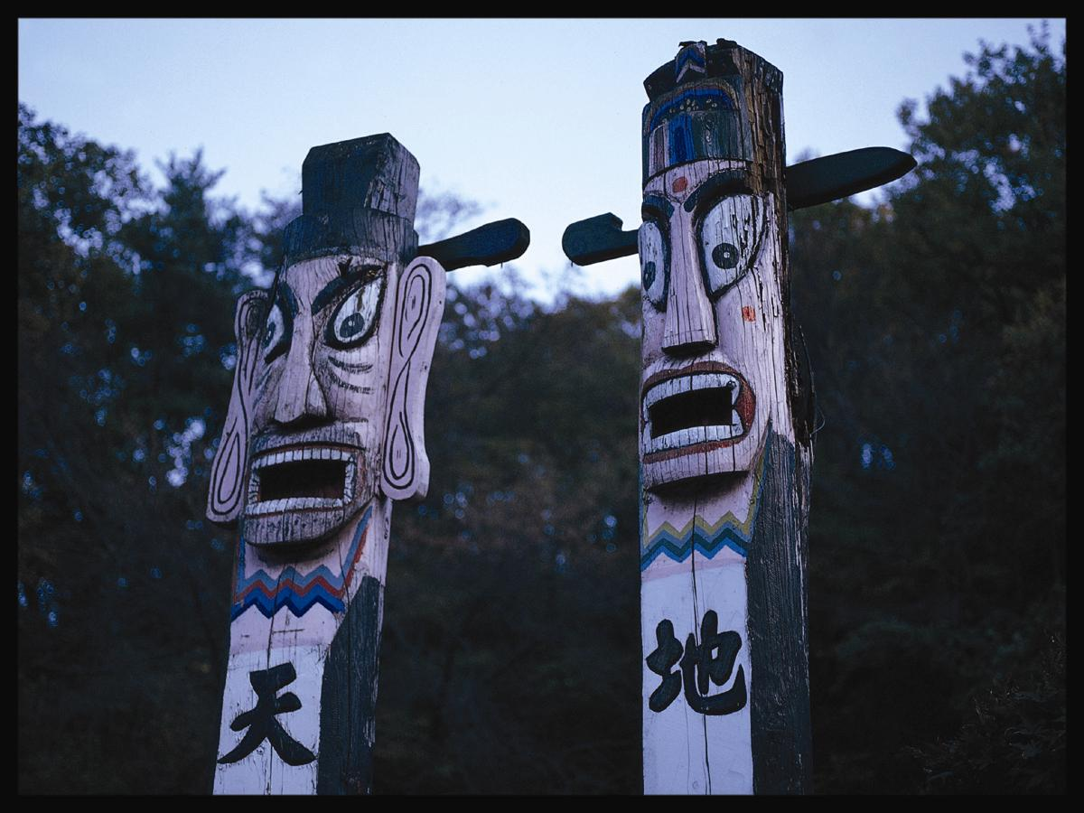

WorkBook
Module 1

Greetings and Introductions

The US Army John F. Kennedy Special Warfare Center and School
in association with
The University of Arizona, South
Camber
Advanced Computer Learning Company

Module 1 Lesson 1

Audio Clip 1 Track 1

Activity 1
Listen to the consonants and vowels of the Korean alphabet and select the correct one from the list.

(1) ㅂ, ㅃ, ㅡ, ㅊ, ㅍ, ㅗ, ㅠ, ㅋ, ㅈ, ㅞ

(2) ㅁ, ㅃ, ㅓ, ㅍ, ㅋ, ㅛ, ㅌ, ㅡ, ㅊ, ㅞ

(3) ㅁ, ㅂ, ㅕ, ㅍ, ㅋ, ㅛ, ㅌ, ㄱ, ㅈ, ㅞ

(4) ㅁ, ㅂ, ㅓ, ㅍ, ㅊ, ㅗ, ㅌ, ㅡ, ㅊ, ㅟ

Audio Clip 2 Track 2

Activity 1
You will hear names of 5 Korean cities. Listen and write them out as dictated.

(1)

(2)

(3)

(4)

(5)

Lesson 1

Lesson 1

Audio Clip 3 Track 3

Activity 1
Listen to the following syllables and write them down.

각, 돋, 맛, 찾, 갑, 역, 삿, 잦, 삽

Audio Clip 4 Track 4

Activity 1
Listen to the following syllables and write them down in Korean.

(1)

(2)

(3)

Audio Clip 5 Track 5

Activity 1
Listen to the syllables and select the one that matches the one being spoken.

1.  (a) 바  (b) 버  (c) 보  (d) 비 | 2.  (a) 감  (b) 갈  (c) 강  (d) 갑 | 3.  (a) 축  (b) 죽  (c) 중  (d) 쭉 | 4.  (a) 지  (b) 주  (c) 쥐  (d) 죄 | 5.  (a) 동  (b) 도  (c) 둥  (d) 돔

Lesson 1
Audio Clip 6 Track 6

Activity 1
Listen to the transcript and fill in the blanks with the appropriate subject marker (S) and object marker (O).

.
(1) 동수(S) 과자(O) 먹어요. (Dong-soo is eating cookies)
(2) 선생님(S) 책(O) 읽어요. (The teacher is reading a book)
(3) 학생(S) 공(O) 차요. (The student is kicking a ball / playing soccer)
(4) 언니(S) 빨래(O) 해요. (My older sister is doing the laundry.)
(5) 고양이(S) 생선(O) 먹어요. (The cat is eating a fish.)

Audio Clip 7 Track 7

Activity 1
Listen to the following words and select the correct English translations from the list below.

(1) gas, piano, hamburger, case, restaurant
(2) café, piano, hamburger, case, restaurant
(3) gas, pizza, hamburger, café, restaurant
(4) café, pizza, hamburger, gas, restaurant

Lesson 2

Module 1 Lesson 2

Audio Clip 1 Track 8

Activity 1
Listen to the following statements. Choose each person’s hometown from the box below and fill in the blanks.

(1) 이경희씨 고향은 ________입니다.
(2) 홍병장 고향은 ________입니다.
(3) 최승규선생 고향은 ________입니다.
(4) 장선생 고향은 _______입니다.
(5) 서일병 고향은 ________입니다.
(6) 김신실씨 고향은 _______입니다.

대구, 부산, 광주, 제주도, 서울, 인천

Audio Clip 2 Track 9

Activity 1
Listen to the short dialogue and select the true statement below.

(a) They have not seen each other for a while.
(b) They are from America.
(c) Their hometown is Seoul.
(d) Mr. Kim is inviting Miss Lee to a dinner.

Audio Clip 3 Track 10

Activity 1

Listen to the short dialogue and choose the true statement below.

(a) They are from the same place.

(b) They are both married.

(c) Both of them happen to have the same surnames.

(d) They are going to lunch together.

Audio Clip 4 Track 11

Activity 1

Listen to the short dialogue and choose the true statement below.

(a) Mr. Park is from 강원도 강릉.

(b) Mr. Park is sending his regards to Mr. Kim.

(c) Mr. Park cannot accept the invitation.

(d) Mr. Park is introducing Mr. Lee to a friend.

Lesson 2

Audio Clip 5 Track 12

Activity 1

Listen to the short dialogue and choose the true statement below.

(a) They are talking about the dinner they are going to have together.

(b) They are talking about Mr. 한.

(c) They are asking each other about their hometown.

(d) They have the same first names.

Audio Clip 6 Track 13

Activity 1

Listen to the following conversation between friends and choose the true statement below.

(a) This conversation deals with friends having lunch

(b) A person is declining a dinner offer from a friend

(c) Friends are discussing news in their hometown

(d) All of the above

Audio Clip 7 Track 14

Activity 1

Listen to the following conversation between friends and choose the true statement below.

(a) They are at a post office

(b) Miss Park and Miss Choi are exchanging greetings

(c) Miss Park is introduced to Mr. Kim

(d) Miss Park can not accept the invitation

Lesson 2

Module 1 Lesson 3

Audio Clip 1 Track 15

Activity 1
Listen to the following number-noun combinations and write the numbers you hear below.

Audio Clip 2 Track 16

Activity 1
Listen to the following list of names and ages. Write the correct age for each person in the box below.

김복남 |  | 정지나
최진원 |  | 한태순
박수미 |  | 성다솜
이한솔 |  | 김한석

Lesson 3

Audio Clip 3 Track 17

Activity 1
First, study the vocabulary items below. Then, listen to the audio clip carefully and answer the questions that follow.

종각 | Bell House
서점 | bookstore
은행 | bank
백화점 | department store

*It would be helpful to draw a simple map on a piece of paper as you listen to the dialogue.

(1) Where is the speaker located?

(a) 명동
(b) 종로
(c) 왕십리
(d) 잠실

(2) Where is the speaker located?

(a) in front of a bookstore
(b) at the back of the Bell House (종각)
(c) in front of the Bell House (종각)
(d) inside the department store

(3) How many stories high is the Bell House building?

(a) 3 stories
(b) 10 stories
(c) 2 stories
(d) 5 stories

Lesson 3

Audio Clip 4 Track 18

Activity 1
Listen to the following audio clip and choose the correct answers for the questions below.

(1) Where is the speaker?

(a) in a shoe store
(b) in a fruit shop
(c) in a sports store
(d) in a bank

(2) 딸기는 무슨 색입니까?

(a) 빨간색입니다.
(b) 노랑색입니다.
(c) 고동색입니다.
(d) 흰색입니다.

(3) 포도는 무슨 색입니까?

(a) 빨간색입니다.
(b) 파란색입니다.
(c) 보라색입니다.
(d) 고동색입니다.

Audio Clip 5 Track 19

Activity 1
Listen to the following audio clip and write down the English names of the colors.

(1)

(2)

(3)

(4)

(5)

Lesson 3

Audio Clip 6 Track 20

Activity 1
Listen to the audio clip and write down the names of the items being described.

(1)

(2)

(3)

(4)

Audio Clip 7 Track 21

Activity 1
Listen to the conversation between a taxi driver and a police officer. Answer the question below.

What is the taxi driver’s license number?

Lesson 3

Module 1 Lesson 4

Audio Clip 1 Track 22

Activity 1
Listen to the following description of a family. Write down all the family members mentioned in Korean.

Audio Clip 2 Track 23

Activity 1
Listen to the following dialogue and answer the questions below.

(1) Who is 조부모님?

(a) parents
(b) grandparents
(c) uncles
(d) sisters

(2) According to the dialogue, is 정순미’s grandfather still alive?

(a) yes, he is alive
(b) no, he has passed away
(c) don’t know

(3) According to the dialogue, who lives with 정순미’s parents?

(a) her grandmother
(b) her brother
(c) her grandfather
(d) her uncle

(4) Where does 정순미’s grandmother live?

(a) 부산
(b) 마산
(c) 미국
(d) 서울

Lesson 4

Audio Clip 3 Track 24

Activity 1
Listen to the following short passage that contains information concerning a man’s family and answer the questions that follow.

(1) How many brother(s) and sister(s) does he have?

(a) two brothers
(b) three sisters
(c) one brother and one sister
(d) three brothers and one sister

(2) What is his father's occupation?

(a) policeman
(b) high school teacher
(c) businessman
(d) dentist

(3) Where are his parents living?

(a) 서울
(b) 마산
(c) 제주도
(d) 부산

Lesson 4

Audio Clip 4 Track 25

Activity 1
Listen to the dialogue and answer the following questions.

(1) Who lives in New York?

(a) Michael’s parents
(b) Michael’s mother
(c) Michael’s sister
(d) Michael’s professor

(2) Where does Michael’s mother work?

(a) City Hall
(b) department store
(c) university
(d) home

Audio Clip 5 Track 26

Activity 1
Listen to the following audio clip and answer the questions below.

(1) How many people are there in Seung-Hoon’s family?

(a) 셋
(b) 넷
(c) 다섯
(d) 아홉

(2) When does the entire family gather?

(a) 설
(b) 생일
(c) 크리스마스
(d) 휴가

Lesson 4

Audio Clip 6 Track 27

Activity 1
Listen to the following audio clip and answer the questions that follow.

1. How many are in the speaker’s family?

(a) 셋
(b) 넷
(c) 다섯
(d) 둘

2. Whose birthday is it?

(a) older brother, Bok-Nam
(b) younger brother, Bok-Nam
(c) older sister Seung-Hyun
(d) younger sister Seung-Hyun

Lesson 4



Module 1 Lesson5

Audio Clip 1 Track 28

Activity 1
Listen to the audio clip and write appropriate expressions next to the illustrations.

(1) | 
(2) | 
(3) | 
(4) | 
(5) | 
(6) | 

Lesson 5

Audio Clip 2 Track 29

Activity 1
Listen to the following dialogue and mark the statements true or false.

 |  | True | False
(1) | 잭슨씨는 흑인입니다.
(2) | 잭슨씨는 키가 큽니다.
(3) | 잭슨씨는 날씬합니다.
(4) | 잭슨씨는 피부가 흰 편입니다.
(5) | 잭슨씨는 키가 190센티미터쯤 됩니다.

Audio Clip 3 Track 30

Activity 1
Listen to the following dialogue and answer the questions below. Speaker A and speaker B are driving in the countryside.

(1) What is speaker A excited about?

(a) the traffic
(b) mountains and flowers
(c) the color of river
(d) blue sky

(2) What is the name of the yellow flowers?

(a) 개나리
(b) 진달래
(c) 장미
(d) 연꽃

(3) According to the dialogue, what season is it?

(a) Spring
(b) Summer
(c) Fall
(d) Winter

Lesson 5

Audio Clip 4 Track 31

Activity 1
Listen to the following conversation and mark the proper emotional state of the speakers.

(a) happy
(b) irritated
(c) exclamatory
(d) concerned

Audio Clip 5 Track 32

Activity 1
Listen to the following conversation and mark the proper emotional state of the speakers.

(a) happy
(b) irritated
(c) exclamatory
(d) concerned

Lesson 5

Audio Clip 6 Track 33

Activity 1
Listen to the description of Sujin and answer the following question.

1. Which statement is the best description of Sujin?

(a) She has long, black hair
(b) She has blue eyes and wears glasses
(c) She has short, straight hair
(d) She is tall

Audio Clip 7 Track 34

Activity 1
Listen to the description of Sujin and answer the following question.

1. Select the illustration that best fits the description.
(a)  (b)  (c) (d) 

Lesson 5

Module 1 Lesson 6

Audio Clip 1 Track 35

Activity 1
Listen to the following Native-Korean numbers and write them down in Arabic numbers.

(1)
(2)
(3)
(4)
(5)

Audio Clip 2 Track 36

Activity 1
Listen to the following conversation and answer the questions.

(1) How many people are there in this family?

(a) 10
(b) 4
(c) 12
(d) 1

(2) How many brothers does this person have?

(a) 1
(b) 3
(c) 5
(d) none

(3) How old is this person’s mother?
(a) 40
(b) 35
(c) 60
(d) 80

Lesson 6

Audio Clip 3 Track 37

Activity 1
Listen to the transcript as the ages of the following people are announced. Fill in the blanks as you hear them.

이름 | 나이
김호석
이샛별
최진환
차석호
노용준
최진
강원태
이해린
김성수
김해진

Lesson 6

Audio Clip 4 Track 38

Activity 1
Listen to the following report and answer the questions.

1. What did this person do last Saturday?

(a) he went shopping
(b) he went to get a haircut
(c) he met his friend
(d) he went out for a drink

2. Where did he go?

(a) 남대문
(b) 이태원
(c) 동대문
(d) 롯데 백화점

3. What kind of money did he use?

(a) American dollars
(b) Korean won
(c) Japanese yen
(d) Italian lira

Lesson 6

Audio Clip 5 Track 39

Activity 1
Listen to the following dialogue between Mr. Baker and Sumi and answer the question.

According to the dialogue, when will they go to the concert?

(a) Wednesday evening
(b) Sometime next week
(c) Friday evening
(d) Sunday evening

Audio Clip 6 Track 40

Activity 1
Listen to the conversation between a customer and a salesperson. Answer the following questions.

1. What is the final negotiated price for the bag?

(a) 75dollars (X)
(b) 80dollars
(c) 85dollars
(d) 70dollars

Lesson 6

