INTRODUCTION
CULTURAL
NOTES
APPLICATION
ACTIVITIES
SKILL ENHANCEMENT
HOMEWORK
GRAMMAR NOTES
VOCABULARY
Armed Forces
Lesson Objectives

At the end of the lesson, the students will be able to:

1. Identify Military Ranks and Titles
• Recognize military ranks
• Identify military insignias
• Compare military insignias
• Address Korean officers and enlisted personnel
by appropriate rank and protocol
• Compare military ranks
• Identify the ranks and specialties of a SF team

2. Identify Military Specialties
• Recognize military specialties
• Describe activities of different military specialties
• Request information about the MOS of the Korean
team members
• Provide information about the MOS of the U.S. team
members

3. Discuss the Branches of the Armed Forces
• Identify branches of services
• Identify the branch insignia of the Armed Forces
• Talk about the organization and formation of the
Armed Forces
• Discuss the differences between the U.S. and
Korean military insignias and their functions
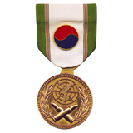
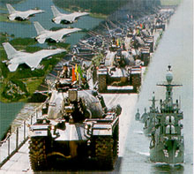
pages 186-219
pages 220-221

Pages 222-223
pages 226-231

pages 224-225

pages 232-234

pages 235-238

INTRODUCTION
Korean Military Ranks and Insignias / Compare Military Insignias

Enlisted (사병)

Private  이등병 |  | When South Korea's national defense guard was founded, enlisted ranks were divided into Private and Private First Class. These terms have been used ever since.
Private  First Class  일병 | 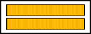
Corporal/  Specialist  상병 | 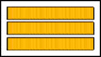 | In 1962, enlisted ranks were divided into four, and those who were in the upper rank of the enlisted were called Corporal.
Sergeant  병장 | 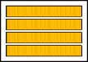 | The term Sergeant was used to signify the head of the enlisted ranks.

Non-commissioned Officer (부사관)
In 1996, the Non-commissioned Officers' insignias were revised. In the past, the Non-commissioned Officers’ insignias were placed on top of the enlisted soldiers’ insignias, causing them to look too big. So, to arouse their pride and to make the insignias of the officers unique, they added the Mugunghwa sign.

Staff Sergeant  하사 | Sergeant First Class  중사 | Master Sergeant  상사 | Sergeant Major  원사
 |  |  | 

INTRODUCTION
Company Grade Officer (위관급 장교)
The Company Grade Officers’ rhombus symbolizes the officers' strong will to protect the nation, and is expressed in the shape of a strong, unbreakable diamond.

2nd Lieutenant  소위 | 1st Lieutenant  중위 | Captain  대위
 | 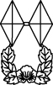 | 

Field Grade Officer (영관급 장교)
The Field Grade Officers' bamboo symbolizes the ever greenness of the four seasons, strong spirit, and fidelity.

Major  소령 | Lieutenant Colonel  중령 | Colonel  대령
 |  | 

INTRODUCTION
General (장성)

Brigadier General  준장 | Major General  소장
 | 
Lieutenant General  중장 | General  대장
 | 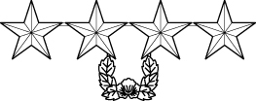

INTRODUCTION

Exercise 1

Match each insignia with the corresponding Korean rank.

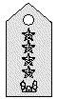 | • |  | • 소장
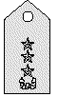 | • |  | • 대장
 | • |  | • 준장
 | • |  | • 중장

INTRODUCTION

Exercise 2

Match each insignia with the corresponding Korean rank.

 | • |  | • 소위
 | • |  | • 대령
 | • |  | • 중위
 | • |  | • 소령
 | • |  | • 중령
 | • |  | • 대위

INTRODUCTION

Exercise 3

Match each insignia with the corresponding Korean rank.

 | • |  | • 중사
 | • |  | • 하사
 | • |  | • 상사

Exercise 4

Match each insignia with the corresponding Korean rank.

 | • |  | • 일병
 | • |  | • 병장
 | • |  | • 이병
 | • |  | • 상병

INTRODUCTION
Military Insignias of the U.S. Forces

The following tables show the military insignias of the American enlisted personnel, officers, and warrant officers.

Enlisted Personnel
Rank Level | Army |  | Navy / Coast Guard |  | Air Force
E-1 | Private | (no insignia) | Seaman Recruit (SR) |  | Airman Basic | (no insignia)
E-2 | Private |  | Seaman Apprentice (SA) |  | Airman
E-3 | Private First Class |  | Seaman (SN) |  | Airman First Class
E-4 | Specialist, Fourth Class | 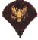
E-4 | Corporal |  | Petty Officer Third Class (PO3) |  | Senior Airman | 
E-5 | Sergeant |  | Petty Officer Second Class (PO2) |  | Staff Sergeant | 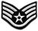
E-6 | Staff Sergeant |  | Petty Officer First Class (PO1) |  | Technical Sergeant | 
E-7 | Sergeant First Class |  | Chief Petty Officer (CPO) |  | Master Sergeant | 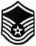

INTRODUCTION
E-8 | Master Sergeant |  |  |  | Senior Master Sergeant
E-8 | First Sergeant |  | Senior Chief Petty Officer (SCPO) |  | Senior Master Sergeant  with first sergeant status
E-9 | Sergeant Major | <> |  |  | Chief Master Sergeant
E-9 | Command Sergeant Major |  | Master Chief Petty Officer (MCPO) |  | Chief Master Sergeant  with first sergeant status
E-9 (special) | Command Sergeant Major of the Army |  | Master Chief Petty Officer of the Navy (MCPON) |  | Chief Master Sergeant of the Air Force

INTRODUCTION
Officers
Rank Level | Army |  | Navy / Coast Guard |  | Air Force
O-1 | Second Lieutenant (2LT) |  | Ensign (ENS) |  | Second Lieutenant (2Lt)
O-2 | First Lieutenant (1LT) |  | Lieutenant, Junior Grade (LTJG) |  | First Lieutenant (1Lt)
O-3 | Captain (CPT) |  | Lieutenant (LT) |  | Captain (Capt)
O-4 | Major (MAJ) |  | Lieutenant Commander (LCDR) |  | Major (Maj)
O-5 | Lieutenant Colonel (LTC) |  | Commander (CDR) |  | Lieutenant Colonel (LtCol) | 
O-6 | Colonel (COL) |  | Captain (CAPT) |  | Colonel (Col)
O-7 | Brigadier General (BG) |  | Rear Admiral, Lower Half (RDML) |  | Brigadier General (BGen)
O-8 | Major General (MG) |  | Rear Admiral, Upper Half (RADM) |  | Major General (MGen)
O-9 | Lieutenant General (LTG) |  | Vice Admiral (VADM) |  | Lieutenant General (LtGen)
O-10 | General (GEN) |  | Admiral (ADM) |  | General (Gen)
(special) | General of the Army | 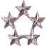 | Fleet Admiral (FADM) |  | General of the Air Force

INTRODUCTION
Warrant Officers
Rank Level | Army |  | Navy / Coast Guard
WO-1 | Warrant Officer (WO1) |  | Warrant Officer (W-1)* | 
WO-2 | Chief Warrant Officer (CW2) |  | Chief Warrant Officer (W-2) | 
WO-3 | Chief Warrant Officer (CW3) |  | Chief Warrant Officer (W-3) | 
WO-4 | Chief Warrant Officer (CW4) |  | Chief Warrant Officer (W-4) | 
WO-5 | Chief Warrant Officer (CW5)

Address Korean Officers and Enlisted Personnel by Appropriate Rank and Protocol

When addressing a person of a higher rank, “–님” should be added to the end of the rank to give respect. Blunt or informal form should be used when addressing a person of a lower rank.
Read the dialogue below and answer the question that follows.

A: 김중위님, 중대장님께서 찾으십니다.
B: 알았어. 지금 곧 가도록 하지.
참, 이병장, 본부 전화번호가 몇 번이지?
A: 123-4567입니다.

Dialogue 1 Exercise

1. Who is looking for First Lieutenant Kim?
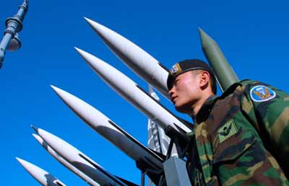
Lesson Dialogue 1 – Address Korean Officers and Enlisted Personnel
INTRODUCTION
Comparing Military Ranks

The following table shows the army ranks for both South and North Korea.

South Korea | North Korea | English Equivalents
대장 | 대장 | General
(None) | 상장 | (None)
중장 | 중장 | Lt. General
소장 | 소장 | Maj. General
준장 | (None) | Brigadier General
대령 | 대좌 | Colonel
(None) | 상좌 | (None)
중령 | 중좌 | Lt. Colonel
소령 | 소좌 | Major
대위 | 대위 | Captain
(None) | 상위 | Senior Lieutenant
중위 | 중위 | First Lieutenant
소위 | 소위 | Second Lieutenant
상사 | 특무상사 | Master Sergeant
중사 | 상사 | Sergeant First Class
하사 | 중사 | Staff Sergeant
병장 | 하사 | Sergeant
상(등)병 | 상등병 | Specialist/Corporal
일(등)병 | (None) | Private First Class
이(등)병 | 전사 | Private

INTRODUCTION
한국군 계급 비교 (Korean Military Rank Comparison Chart)

구분  계급 | 육 군  (ARMY) | 해 군  (NAVY) | 공 군  (AIR FORCE) | 해 병 대  (MARINE CORPS)
대 장 | GENERAL | ADMIRAL | GENERAL | NONE
중 장 | LIEUTENANT  GENERAL | VICE  ADMIRAL | LIEUTENANT  GENERAL | LIEUTENANT  GENERAL
소 장 | MAJOR  GENERAL | REAR ADMIRAL  UPPER HALF | MAJOR  GENERAL | MAJOR  GENERAL
준 장 | BRIGADIER  GENERAL | REAR ADMIRAL  LOWER HALF | BRIGADIER  GENERAL | BRIGADIER  GENERAL
대 령 | COLONEL | CAPTAIN | COLONEL | COLONEL
중 령 | LIEUTENANT  COLONEL | COMMANDER | LIEUTENANT  COLONEL | LIEUTENANT  COLONEL
소 령 | MAJOR | LIEUTENANT  COMMANDER | MAJOR | MAJOR
대 위 | CAPTAIN | LIEUTENANT | CAPTAIN | CAPTAIN
중 위 | FIRST  LIEUTENANT | LIEUTENANT  JUNIOR GRADE | FIRST  LIEUTENANT | FIRST  LIEUTENANT
소 위 | SECOND  LIEUTENANT | ENSIGN | SECOND  LIEUTENANT | SECOND  LIEUTENANT
준 위 | WARRANT  OFFICER | WARRANT  OFFICER | WARRANT  OFFICER | WARRANT  OFFICER
원 사 | COMMAND  SERGEANT MAJOR | MASTER CHIEF  PETTY OFFICER | CHIEF MASTER  SERGEANT | MASTER GUNNERY  SERGEANT
상 사 | MASTER  SERGEANT | SENIOR CHIEF  PETTY OFFICER | SENIOR MASTER  SERGEANT | MASTER  SERGEANT
중 사 | SERSEANT  FIRST CLASS | CHIEF PETTY  OFFICER | MASTER  SERGEANT | GUNNNERY  SERGEANT
하 사 | STAFF  SERGEANT | PETTY OFFICER  SECOND CLASS | TECHNICAL  SERGEANT | STAFF  SERGEANT
병 장 | SERGEANT | PETTY OFFICER  SECOND CLASS | STAFF  SERGEANT | SERGEANT
상 병 | CORPORAL | PETTY OFFICER  THIRD CLASS | SENIOR  AIRMAN | CORPORAL
일 병 | PRIVATE  FIRST CLASS | SEAMAN | AIRMAN  FIRST CLASS | LANCE  CORPORAL
이 병 | PRIVATE | SEAMAN  APPRENTICE | AIRMAN | PRIVATE  FIRST CLASS

INTRODUCTION

Sergeant Smith is asking Lieutenant Kim about the Special Forces in Korea. Read the dialogue below and answer the question that follows.

Sergeant Smith : 김중위님은 소속이 어디시죠?
Lieutenant Kim : 네 특수전 사령부에서 근무 합니다.
Sergeant Smith : 특전사 팀장 계급은 무엇 입니까?
Lieutenant Kim : 대위 입니다.
Sergeant Smith : 팀에 무전병과 저격수 등도 있나요?
Lieutenant Kim : 그럼요, 그외에도 정보, 폭파
요원도 있습니다.

Scenario 2 Exercise

1. What is the SF’s team leader’s rank?

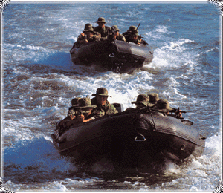
특전사 구성 비교 (U.S. & Korean Special Forces Team Composition)

미군 (U.S.) | 한국군 (Korean)
12명 (12 man team) | 13명 (13 man team)
팀장 – 대위(Team Ldr-Captain)  부팀장 – 준위(Asst. Team Ldr-WO)  작전 1 (Operations NCO)  정보 1 (Intelligence NCO)  무기 2 (Weapons NCO)  공병 2 (Engineer NCO)  의무 2 (Medical NCO)  통신 2 (Communications NCO) | 팀장 – 대위 (Team Ldr-Captain)  부팀장 – 중위 (Asst. Team Ldr-1LT)  선임부사관 – 상사 (Team NCO-MSG)  작전 1 (Operations NCO)  정보 1 (Intelligence NCO)  무기 2 (Weapons NCO)  공병 2 (Engineer NCO)  의무 2 (Medical NCO)  통신 2 (Communications NCO)

Lesson Scenario 2 – Identify Ranks and Specialties of a SF Team

INTRODUCTION

Exercise 5

Write down the English equivalents for the following Korean ranks.

(1) 대장

(2) 중장

(3) 소장

(4) 준장

(5) 대령

(6) 중령

(7) 소령

(8) 대위

(9) 중위

(10) 소위

Exercise 6

Write down the Korean equivalents for the following American ranks.

(1) Master Sergeant

(2) Sergeant First Class

(3) Staff Sergeant

(4) Sergeant

(5) Specialist/Corporal

(6) Private First Class

(7) Private

INTRODUCTION

Exercise 7

Answer the questions below regarding proper forms of address.

(1) How would Sergeant Park address Lieutenant Jin, who is Sergeant Park’s platoon leader?

(2) How would Sergeant Park address Lieutenant Jin, who visited him from another unit on business?

(3) How would Corporal Kang address Captain Ku, who is Corporal Kang’s company leader?

(4) How would Corporal Kang address Captain Ku, who visited him from another unit on business?

(5) How would Lieutenant Jin address Sergeant Kyongho Park (박경호)?

(6) How would Mr. Suh, who is a civilian, address Major Lee?

(7) How would Major Lee address Mr. Wooseong Suh, who is a civilian (서우성)?

(8) How would Staff Sergeant Choi address Staff Sergeant Kim?

Captain Kim meets Sergeant Lee at a church. Read the dialogue below and answer the question that follows.

A: 이병장은 군종병이라며 무슨 일들을 하나?
B: 네, 저는 군목님을 도와 드리고 있습니다.
A: 김대위님은 무슨 일을 하십니까?
B: 응, 난 대대 정보 장교야.

Scenario 3 Exercise

1. What is Captain Kim’s branch?


Lesson Scenario 3 – Different Military Specialties

INTRODUCTION
Read the short dialogue below and answer the question that follows.

A: 김병장은 직책이 무엇 입니까?
B: 저는 보병 소총수 입니다.

Dialogue 4 Exercise

1. What is Sgt. Kim’s duty position?


Read the short dialogue below and answer the question that follows.

A: 스미스 중사의 직책이 뭡니까?
B: 저는 정보분석관 입니다.
A: 어떤 일들을 하십니까?
B: 분석한 정보를 대대본부에 보고합니다.

Dialogue 5 Exercise

1. What is SFC Smith’s duty position?



Exercise 8

This following is a short autobiography about Sergeant Sungo Jin’s military service. Read it carefully and answer the questions below.

저는 진승오 병장입니다. 1997년에 보병 소총수로 입대하였습니다. 강원도에서 병영 생활을 시작하였지만, 지금은 서울로 전출 중입니다.

Lesson Dialogue 4 – Request Information about MOS
Lesson Dialogue 5 – Provide Information about MOS
INTRODUCTION

Continue…

(1) 진병장은 언제 입대하였습니까?

(a) 1997 년
(b) 1998 년
(c) 1999 년
(d) 2000 년

(2) 진병장의 병과는 무엇입니까?

(a) 포병
(b) 위생병
(c) 공병
(d) 보병

(3) 진병장의 직책은 무엇입니까?

(a) 기관총 사수
(b) 기관총 조수
(c) 소총수
(d) 분대장

(4) 진병장은 어디에서 군대 생활을 시작하였습니까?

(a) 경기도
(b) 제주도
(c) 강원도
(d) 충청도

(5) 진병장은 지금 어디서 근무하고 있습니까?

(a) 서울
(b) 부산
(c) 광주
(d) 강릉

INTRODUCTION

Exercise 9

The following is a short autobiography about Specialist Soohyon Hwang’s military service. Read it carefully and answer the questions below.

저는 황수현 상병입니다. 1998년 공군으로 입대하여 제주도 한라산의 관제탑에서 근무 중입니다. 2000년 8월달에 제대할 예정입니다.

(1) 황상병은 언제 입대하였습니까?
(a) 1997년
(b) 1998년
(c) 1999년
(d) 2000년

(2) 황상병은 육해공군 중 어디에 속합니까?
(a) 육군
(b) 해군
(c) 공군
(d) 해병대

(3) 황상병은 어디에서 근무합니까?
(a) 경기도 강화도
(b) 제주도 해안초소
(c) 제주도 한라산
(d) 서울 수방사

(4) 황상병은 어떤 일을 합니까?
(a) 관제탑 근무
(b) 의무대에서 근무
(c) 공병대에서 근무
(d) 헌병으로 근무

(5) 황상병은 언제 제대할 예정입니까?
(a) 1999년 5월
(b) 2000년 5월
(c) 1999년 8월
(d) 2000년 8월

INTRODUCTION

Exercise 10

The following is a short autobiography about First Lt. Byonghee Lee’s military service. Read it carefully and answer the questions below.

저는 이병희 중위입니다. 병과는 공병대이고 직책은 소대장입니다. R.O.T.C. 출신이며, 1998년 임관하였습니다.

(1) 이중위는 언제 소위로 임관하였습니까?

(a) 1996년
(b) 1997년
(c) 1998년
(d) 1999년

(2) 이중위의 병과는 무엇입니까?

(a) 공병대
(b) 포병대
(c) 기갑부대
(d) 의무대

(3) 이중위의 직책은 무엇입니까?

(a) 중대장
(b) 소대장
(c) 분대장
(d) 연대장

(4) 이중위는 어떤 과정을 걸쳐 소위가 되었습니까?

(a) 육사
(b) 공사
(c) 해사
(d) R.O.T.C.
INTRODUCTION
Read the dialogue below and answer the question that follows.

A: 이대위님은 소속군이 어디입니까?
B: 네, 전 공군입니다.
A: 스미스 중사님은 소속군이 어디입니까?
B: 네, 전 육군입니다.

Dialogue 6 Exercise

1. Which branch of the armed services does Captain Lee belong to?

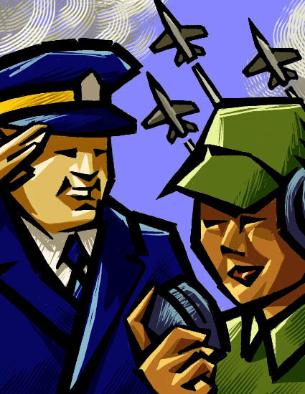

Tip of the Day

Korean Military Forces

According to the data published in 1998, the manpower and units of the Korean military forces are as follows:

1. Ground Forces
* Manpower: 560,000 soldiers (including 140,000 conscripts)
* Units
Active Component
- 3 Armies
- 11 Corps Headquarters
- 3 Mechanized Divisions
- 19 Infantry Divisions
- 2 Independent Infantry Brigades
- 7 Special Forces Brigades
- 3 Counter-infiltration Brigades
- 3 ADA Brigades
- 3 ADA Battalions with I-Hawk missiles
- 2 ADA Battalions with Nike Hercules missiles
- 3 SSM Battalions
- 1 Aviation Command



Lesson Dialogue 6 – Identify Branches of The Armed Services
INTRODUCTION

Tip of the Day (Continued)

Reserve Component
-1 Army Headquarters
- 23 Infantry Divisions

2. Naval forces
* Manpower: 35,000 sailors (including 10,000 conscripts)
* Vessels
- 14 diesel submarines
- 5 destroyers
- 33 frigates
- 11 missile patrol boats
- 90 patrol boats
- 16 amphibious warfare ships
- 14 mine countermeasure ships
- 13 support ships
* Naval Air
- 23 fixed wing
- 47 helicopters

3. Air Forces
* Manpower: 52,000 airmen
* Units
- 10 fighter-bomber squadrons
- 4 fighter squadrons
- 1 recon squadron
- 2 transport wings

4. Marine Forces
* Manpower: 25,000 (including 9,000 conscripts)
* Units
- 2 Divisions
- 1 Separate Brigade
- Support Units

INTRODUCTION
Identify the Branch Insignia of the Armed Forces
육군 휘장 (Army) 공군 휘장 (Air Force)

해군 휘장 (Navy) 해병대 휘장 (Marines)

Identify Branches of Services in Korea

Distinction | Branch Marks | Branch Mascot | Explanation
Infantry  보병 | 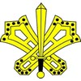 |  | - Infantry is represented with sword and shield, the basic weapon of ancient warriors.
Artillery  포병 | 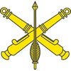 | 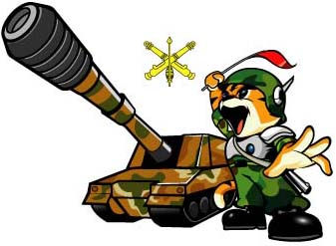 | - Two cannons in cross formation with an arrow down the middle represent artillery.
Armor  기갑 |  | 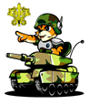 | - The horseshoe is added to the infantry logo to represent the speed of the cavalry.

INTRODUCTION

Intelligence  정보 | 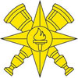 |  | - The torch represents the ancient signal fires that were used to communicate warnings. The circle represents the earth. The four compass points represent the spread of information. The telescope represents intelligence observation.
Ordnance  병기 | 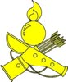 |  | - Ordnance is represented with ancient weapons like the bow and arrow.
Quarter Master  병참 | 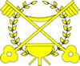 |  | - The keys represent the supply control system.
Transportation  수송 | 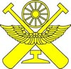 | 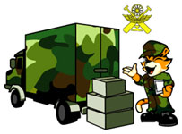 | - This logo represents the 5 major transportation means: land route, water way, railroad, air, and oil pipeline.

INTRODUCTION

Adjutant  부관 |  | 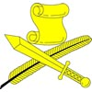 |  |  | -The scroll and quill writing brush represent administration, and the sword represents the army
Military  Police  헌병 | 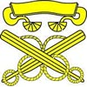 |  | 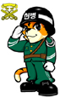 |  | -The two hexagonal clubs that cross represent jail and punishment, and the belt represents judicial power.
Accounting  경리 |  |  |  |  | -The diamond represents the national treasury of Korea. The ancient money and abacus represent finance.

INTRODUCTION

Troop Information Education  정훈 |  | 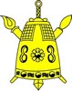 |  | -The bell represents freedom, the signal fire represents democracy, and the brush represents education. The sword represents justice.
Medical  의무 |  |  | 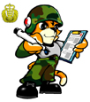 | -This symbol, with two snakes twined around a staff and spreaded wings surrounding the staff, represents the ancient god’s angel’s staff. The symbol is commonly used to represent medical art.
Judge  Advocate  General  법무 | 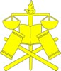 |  | 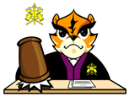 | -The Laurel crown represents justice and peace. The code of law and the scale represent justice. The hammer represents the court.
Chaplain  군목 | 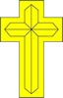 |  | 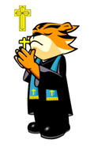 | -The cross symbolizes faith, charity, and service of Christ.

INTRODUCTION

Priest  신부 | 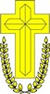 |  | 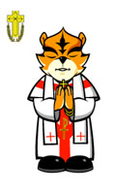 |  | -This cross represents the resurrection of mankind, and the hemp represents the spirit of martyrdom.
Monk  군승 |  |  | 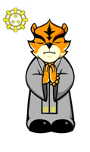 |  | -The logo represents Paljungdo (8 right ways in Buddhism) and Sambo (3 elements of Buddhism).
Inspector  General  감찰 |  | 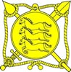 |  | -The ancient horse plate represents the authority of the inspector. The brush represents the commander’s assistant. The sword symbolizes the power to punish evil.
Band  군악 |  | 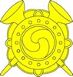 |  | -The ancient trumpet and drum symbolize victory.

INTRODUCTION
Unit Symbols of the Korean Army (육군 병과)

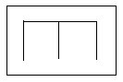 | 공병 | Military Engineer
 | 보병 | Infantry
 | 산악보병 | Mountain Infantry
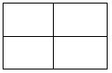 | 위생병 | Medical Corps
 | 통신병 | Signal
 | 포병 | Artillery
 | 공수부대 | Airborne Troops

INTRODUCTION

Exercise 11

Match each branch insignia with the corresponding Korean word.

 | • |  | • 보병
 | • |  | • 위생병
 | • |  | • 통신병
 | • |  | • 공수부대
 | • |  | • 포병
 | • |  | • 공병
 | • |  | • 산악보병

INTRODUCTION
Talk about the Organization and Formation of the Armed Forces

In English:
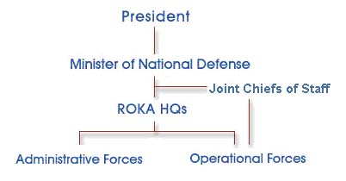

In Korean:
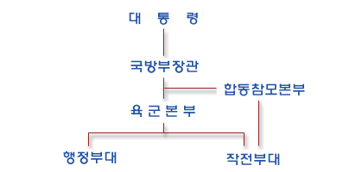

INTRODUCTION
In English:
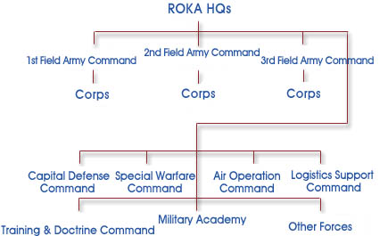

In Korean:
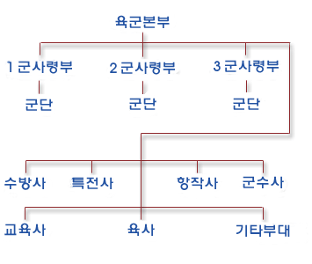

INTRODUCTION

Tip of the Day

Minimum Military Service Period for Promotion

The following tables indicate the minimum military service period for promotion.

Minimum Military Service Period for Enlisted Personnel

입영 => 이병 | 2 months
이병 => 일병 | 4 months
일병 => 상병 | 6 months
상병 => 병장 | 8 months
병장 => 전역 | 6 months

Minimum Military Service Period for Officers

소위 => 중위 | 1 year
중위 => 대위 | 3 years
대위 => 소령 | 5 - 7 years
소령 => 중령 | 6 years
중령 => 대령 | 7 years
대령 => 준장 | 6 years
준장 => 소장 | 2 years
소장 => 중장 | 3 years
중장 => 대장 | 3 years

INTRODUCTION
Mr. Hangi Chu (주한기) and Mr. Suwhan Kang (강수환) are talking about the military jobs they’ve had during their military service. Read the dialogue below and answer the questions that follow.

A: 주한기씨는 군대 갔다 왔습니까?
B: 예, 강원도 15사단에 있었습니다.
A: 거기서 무슨 일을 하셨습니까?
B: 주로 DMZ 철책 근무를 하였습니다.
그렇지만 제대하기 6개월 전 부대가
이동하여 기관총 사수로도 있었습니다.
강수환씨는 군대 어디 갔다 왔습니까?
A: 저는 공군으로 있었습니다.
용문산 관제탑에서 근무했습니다.

Scenario 7 Exercise

1. Did Mr. Hangi Chu finish his military service?

2. What did Mr. Chu do at the 15th Infantry Division?


Exercise 12

Captain Mingi Suh (서민기) calls the Support Unit that handles billeting and asks whether an apartment is available in the residential barracks. Sergeant Jin answers the phone. Sergeant Sugil Jin (진수길) asks his name and rank, as well as other pertinent information (number of children, date required, etc.) needed to put him on the waiting list. The Captain responds using the appropriate form of politeness. With a partner, act out this scenario. Reverse roles so both of you can practice.

Example:

A: 계급과 성함이 무엇입니까?
B: 저는 서민기 대위입니다.

Lesson Scenario 7 – Military Job
INTRODUCTION

Exercise 13

The students will stay in the same pair groupings as the last activity. The situation is that PFC Sungho Shin (신승호) is requesting a military discount for the train fare from Seoul to Pusan. The person at the window asks his name and rank and requests to see some ID to confirm his military status. PFC Shin has forgotten his ID card, but has his leave orders. He must convince the clerk he is who he says. Act out this situation with your partner. Reverse roles so both of you can practice.

Example:

A: 이름과 계급이 무엇입니까?
B: 저는 신승호 중사입니다.

Tip of theDay

United States Forces in Korea (USFK)

HYPERLINK "http://www.korea.army.mil/50anniv\\index.htm" INCLUDEPICTURE "http://www.korea.army.mil/seal.jpg" \* MERGEFORMATINET 

The United States forces have been stationed in Korea since 1945. According to the data published in 1998, the manpower and units of the U.S. forces are as follows:

Manpower
* Ground Forces: 27,460 soldiers
* Air Forces: 8,660 airmen

Units
* 1 x Army Headquarters
* 1 x Infantry Division
* 1 x Air Force Headquarters
* 2 x Fighter Wings
* 1 x Special Operations Squadron

INTRODUCTION

Exercise 14

The class will work as a group, with the instructor as the facilitator. The situation is that Captain Yang, who is in the Air Force, and First Lieutenant Cho, who is a Marine, will be joining the team for training. The class leader will introduce them to the team and the class members will take turns asking simple questions about their background. They are in civilian clothing, so it’s impossible to determine any information about them from their attire. Two students will assume the role of Yang and Cho. After ten minutes, the activity will start over with a new “Yang” and “Cho” until all students have had the opportunity to both ask and respond to questions concerning rank, background, and branch of service. Make sure that appropriate levels of politeness and tact are used during the questioning process. You don’t want them to think that they’re being interrogated!

Exercise 15

The class will work together as a group. Two students will play the roles of Mr. Mingi Kim (김민기) and Mr. Yongsu Lee (이용수), who are going to join the team temporarily as observers. They are cost analysts. They want to see if the training justifies the cost. They’re a bit skeptical. You must persuade them that the training is well worth the cost. In their introductions to the team, they state that they had previously served in the military. The plan is to ask them about their military service, in hopes that they’ll realize how crucial their training was to their success. The rest of the class will play the roles of the team. They will ask simple questions to get the two gentlemen to reminisce about their military days. After ten minutes, two new students will play the roles of Mr. Kim and Mr. Lee. Continue until everyone gets the chance to ask and respond to simple questions about ranks, branches of service, etc.

GRAMMAR NOTES
1. Negated Sentences: -지 않다

The verb ending, -지 않다, attached at the end of the stem, makes the sentence negative.

배가 고프지 않아요 I am not hungry.

술을 마시지 않았어요 I didn't drink.

지하철을 기다리는 사람이 많지 않습니다
There are not many people waiting for the train.

지난 주말에 산에 가지 않았어요 I didn't go hiking last weekend.

Exercise 1

Convert the following sentences into negatives using “-지 않다.”

(1) 담배를 피워요.

(2) 음식이 내 입에 맞아요.

(3) 아버지는 집에 계세요.

(4) 영화를 봤어요.

(5) 약속을 잊어버렸어요.

2. -보다 (than)

- 보다 indicates the object of a comparison.

지하철이 버스보다 빨라요.
Subway trains are faster than buses.

김경호씨가 강철민씨보다 더 커요.
Mr. Kyongho Kim is taller than Mr. Cholmin Kang.

이것이 저것보다 더 비싸요.
This one is more expensive than that one.

GRAMMAR NOTES
3. –어도 되다 (May I - / You may -)

By attaching “-어도 되다” to the end of the verb stem in an interrogative sentence, you can ask for permission very politely. By attaching it to the end of the verb stem in a predicative sentence, you can give permission very politely.

집에 가도 됩니까?
Can I go home?

네, 집에 가도 되요.
Yes, you can go home.

이 물 마셔도 되요?
Can I drink this water?

네, 마셔도 되요.
Yes, you can drink.

Exercise 2

Ask permission to do the following actions.

(1) to ask

(2) to open the window

(3) to smoke

(4) to cut the grass

(5) to turn off the air conditioner
VOCABULARY
군계급 (Military Ranks)
고급장교 senior officer
대령 Colonel
대위 Captain
대장 General
부사관 Non-commissioned officer
병장 Sergeant
사병 Enlisted personnel
상(등)병 Specialist/Corporal
상사 Master Sergeant
생도 cadet
소대장 platoon leader
소령 Major
소위 Second Lieutenant
소장 Maj. General
영관급 field grade officer
위관급 company grade officer
이(등)병 Private
장교 officer
장성 General
준장 Brigadier General
중령 Lt. Colonel
일(등)병 Private First Class
중사 Sergeant First Class
중위 First Lieutenant
중장 Lt. General
하사 Staff Sergeant

군사용어 (Military Terms)
관제탑 control towel
복무기간 service period
-사단 -th division
소속 one’s regiment
육군사관학교 the Korean Military Academy
육사 Abbreviated name for the Korean Military Academy
지도자 leader
직책 position
진급 promotion
진급 대상자 people eligible for a promotion
진급 심사 promotion inquiry
최저 복무 기한 minimum service period

군직책 / 주특기 (Military Titles / Specialties)
군목 chaplain in the army
무전병 communication sergeant
저격수 sniper
폭파 요원 demolition specialist
(군사) 주특기 (military) specialty

VOCABULARY
Branches of Armed Forces
공군 Air Force
육군 army
해군 navy
병과 army branch
정보 intelligence
포병 artillery

동사 (Verbs)
임관하다 to be commissioned
보장하다 to guarantee
성장하다 to grow
요구하다 to demand
창설하다 to find

유용한 단어 (Useful Words)
능력 ability
역할 role
강인한 strong
동북쪽 northeastern
미래사회 future society
민족 nation
반세기 half a century
발전 prosperity
사고력 mental quality
업적 achievement
역사 history
창의적 creativity
체력 physical ability
탁월한 excellent

CULTURAL
NOTES

- Military Service

The Korean constitution specifies that military
service is a mandatory obligation of every Korean
male. After taking a physical examination to determine whether a person is fit for military service, both physically and mentally, Korean men enter the military normally between the ages of 20 and 25. The active service period prescribed by law is 26 months.



2. The Korean Army Emblem

The picture to the left is the emblem of the Korean army. The Taeguk () and the Korean national flower, the Rose of Sharon, in the center symbolize the Republic of Korea and patriotism. The circle symbolizes the strong unity of the Korean Army. The leaves of the Rose of Sharon symbolize the persistent history and development of Korea. The knot at the bottom symbolizes the solidarity of civilians, the government, and the Army.

3. The Korean Air Force Insignia

The image to the right represents the insignia of the
Korean Air Force. The eagle represents the
brave and progressive energy of the Air Force.
The star symbolizes the military and the importance of national defense. The laurel tree is the symbol of victory. The rose of Sharon, which is the national flower of Korea, symbolizes the Koreans’ love of country.


CULTURAL
NOTES

4. Military Assistance of Civilians

Korean military units have provided extensive assistance to the civilian sector whenever needed. One of the most common forms of assistance is helping farmers in planting and harvesting rice. For example, in 1987, 561,000 military personnel helped plant the crop and 392,000 military personnel helped in the harvest. Moreover, for such natural disasters as typhoons and floods, and for huge man-made calamities, millions of personnel from active units and the Homeland Reserve Force have provided assistance.


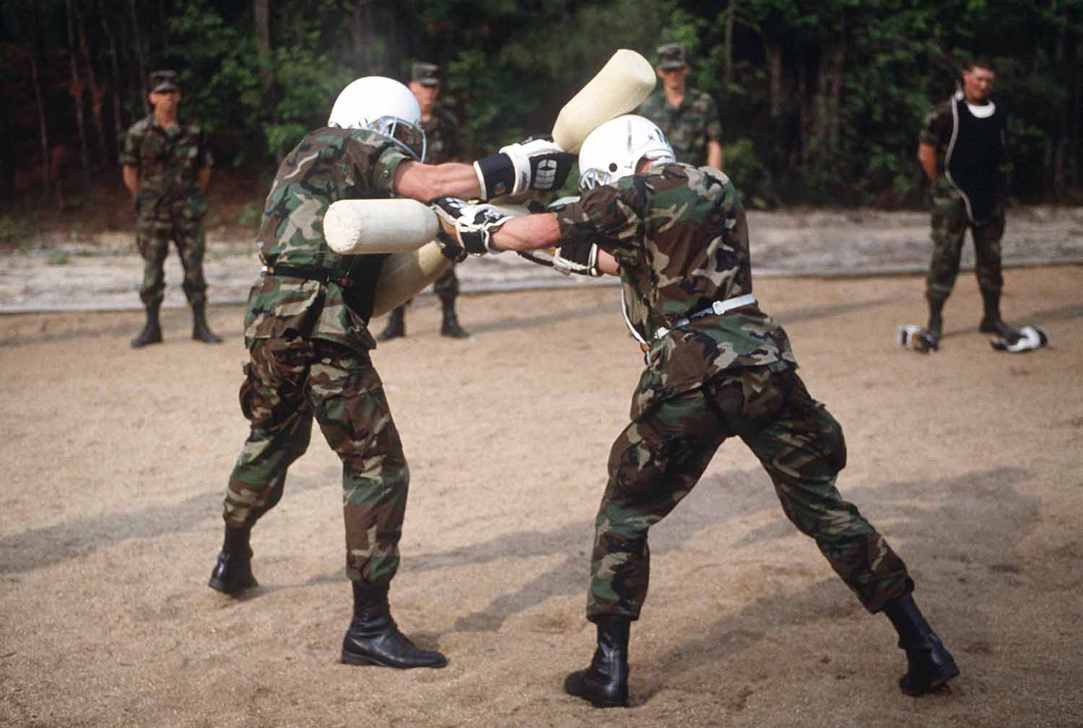
APPLICATION ACTIVITIES
The class will work together as a group. Each student will assume a military rank of the instructor’s choice. Each student will then create a mini-autobiography about themselves (using their assumed identities). The situation is that they are attending a social engagement. Their task is to meet as many people as possible at the function. Afterwards, they will write as much information as they were able to elicit on note cards. When they are finished, each student will go to the front of the class and present their findings. Discuss, as a class, if the information is correct.

Example:
저는 김동식 하사입니다.
Write the appropriate American rank title, found in the box below, next to each Korean army rank insignia.

(1) 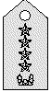

(2) 

(3)
(4) 

Second Lieutenant
Major General
Lieutenant General
General
Private First Class
Sergeant
Sergeant First Class
Master Sergeant/ First Sergeant
Brigadier General
Activity 1
Activity 2
APPLICATION
ACTIVITIES

(5)
(6) 

(7)

(8)

(9) 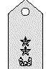

APPLICATION ACTIVITIES
Write the correct forms of address for the following sentences. Note: A is highest in rank.

(1) A: (Sergeant Park), 고향이 어디인가?

(2) A: (Captain Cho), 같이 점심 식사하러 갈까?

(3) A: (Staff Sergeant Lee), 언제 군에 입대했지?

(4) A: (Major Mun), 언제 결혼했나?

Write the correct forms of address for the following sentences. Note: A is lowest in rank.

(1) A: (Specialist Kim), 전화 왔습니다.
(2) A: (First Lieutenant Chu), 이건 어떻게 사용하는 겁니까?
(3) A: (Major Park), 임무를 다 마쳤습니다.
The class will work together as a group. Each student will have five minutes to prepare a short autobiography. Afterwards, they will take turns introducing themselves to the class. Make sure to mention your branch, position, and rank. Tell the class what your duties are. The other students may ask questions.

Activity 3
Activity 4
Activity 5
APPLICATION
ACTIVITIES
Write down the correct branches, in Korean, for each of the symbols.






Match the Korean branch names to the English branch names.

포병 | • | • Military Engineers
산악보병 | • | • Infantry
보병 | • | • Mountain Infantry
공병 | • | • Medical Corps
통신병 | • | • Signal
공수부대 | • | • Artillery
위생병 | • | • Airborne Troops

Activity 6
Activity 7
APPLICATION ACTIVITIES
If “Person A” is asking “Person B” the following questions, who is senior in rank? Write your answers below. Be prepared to discuss them in class.

(1) A: 김하사, 지금 몇 시인가?

(2) A: 이병장님, 근무 시간입니다.

(3) A: 소대장님, 이것은 무엇입니까?

(4) A: 차중위, 소대 인원이 몇 명인가?

(5) A: 강중령님은 어디에 사십니까?

(6) A: 최소령은 언제 결혼했지?
Read the following article about the military service of a Korean officer and answer the questions below.

나는 하찬석 중위입니다. 내 병과는 포병대이고, 직책은 소대장입니다. 내 부대는 강화도에 주둔하고 있습니다. 육군사관학교를 졸업하였으며, 1998년 소위로 임관하였습니다.

(1) What is this person's name?

(2) What is this person's rank?

(3) Where is this person's unit located?

(4) What school did this person graduate from?

(5) What rank was this person commissioned as in 1988?
Activity 8
Activity 9
APPLICATION
ACTIVITIES
The class should divide into pairs. Each pair of students should answer the following questions using the table below, which shows the years that Colonel Park was promoted in rank.

소위 | 1980
중위 | 1981
대위 | 1984
소령 | 1990
중령 | 1996
대령 | (Current)

(1) 백대령은 언제 소위로 임관하였습니까?

(2) 백대령은 언제 중위로 승진하였습니까?

(3) 백대령이 중위에서 대위로 승진하기까지 몇 년 걸렸습니까?

(4) 백대령은 입대한지 얼마만에 소령이 되었습니까?

(5) 대령의 최저 복무 기간이 6년이라면, 백대령은 언제쯤 준장 진급 심사를 받게 될까요?
Activity 10
SKILL ENHANCEMENT
The class should divide into pairs. Each student will look at one of the following charts. Then, they will ask and answer questions to fill in the blanks. Compare your charts when you are finished. Finally, using your completed charts, answer the given questions that follow.

Student A

South Korea | North Korea | English Equivalent
 | 대장 | General
(None) | 상장 | (None)
 | 중장 | Lt. General
 | 소장 | Maj. General
 | (None) | Brigadier General
대령 | 대좌
(None) | 상좌 | (None)
중령 | 중좌
소령 | 소좌
대위 |  | Captain
(None) |  | Senior Lieutenant
중위 |  | First Lieutenant
소위 |  | Second Lieutenant
 | 특무상사 | Master Sergeant
 | 상사 | Sergeant First Class
 | 중사 | Staff Sergeant
 | 하사 | Sergeant
상등병 |  | Corporal/Specialist
일등병 | (None) | Private First Class
이등병 |  | Private

Activity 1
SKILL ENHANCEMENT
Student B

South Korea | North Korea | English Equivalent
대장 |  | General
(None) |  | (None)
중장 |  | Lt. General
소장 |  | Maj. General
준장 | (None) | Brigadier General
 | 대좌 | Colonel
(None) | 상좌 | (None)
 | 중좌 | Lt. Colonel
 | 소좌 | Major
대위 | 대위
(None) | 상위
중위 | 중위
소위 | 소위
상사 |  | Master Sergeant
중사 |  | Sergeant First Class
하사 |  | Staff Sergeant
병장 |  | Sergeant
 | 상등병 | Corporal/Specialist
 | (None) | Private First Class
 | 전사 | Private

SKILL ENHANCEMENT
(1) 남한의 대령과 일치하는 북한의 계급은 무엇입니까?

(2) 남한의 상사와 일치하는 북한의 계급은 무엇입니까?

(3) 남한의 병장과 일치하는 북한의 계급은 무엇입니까?

(4) 북한의 전사와 일하치는 미국의 계급은 무엇입니까?

(5) 미국의Sergeant와 일치하는 북한의 계급은 무엇입니까?

(6) 미국의Major와 일치하는 남한의 계급은 무엇입니까?
The class will work together as a group. The instructor will describe the roles and functions of a branch and the class will have to determine which branch he/she is depicting. Listen for key words! The following examples are sample descriptions.

(1) 무전기를 메고 다닙니다.

(2) 다리를 놓습니다.

(3) 부상자를 응급치료합니다.

(4) 부대 이름이 알파 부라보 등으로 나갑니다.

(5) 수송 임무를 담당합니다.
Activity 2
HOMEWORK

1. Listen to the list of names and ranks. Then, write the ranks of the people in the blanks given below.
(Listen to the homework audio CD Track 40 - M2L5HW1)

(1) _____ 김동철

(2) _____ 하수영

(3) ______ 염종석

(4) ______ 강성헌

(5) ______ 조용희

(6) ______ John Moor

(7) ______ Dennis Ray

(8) ______ Jason Terry

(9) ______ Thomas Miller

(10) _____ Bud Walker

2. Write down the full list of Korean military ranks from the lowest to the highest.

3. If A is higher in rank than B, how would A address B and how would B address A? Fill in the second chart with the appropriate forms of address.

 | A |  | B
 | 이름 | 계급 | 이름 | 계급
1 | 이경호 | 병장 | 진정태 | 일병
2 | 최주영 | 하사 | 박동권 | 병장
3 | 김영준 | 중위 | 조동호 | 소위
4 | 백광철 | 소령 | 전영선 | 중위
5 | 정성균 | 대령 | 설형진 | 소령

HOMEWORK

Continue…

 | A가 B를 부를 때 | B가 A를 부를 때
1
2
3
4
5

4. Convert the following sentences into negatives using “-지 않다.”

(1) 소대장은 화가 났어요.

(2) 잘 들려요.

(3) 중대장 컴퓨터가 잘 작동해요.

(4) 호랑이는 풀을 먹어요.

(5) 요즈음은 친구를 자주 만나요.

5. Write the branch of each soldier below according to his activities.

(1) 도하 작전시 다리를 놓거나, 도로 붕괴 시 도로를 닦는다.

(2) 환자를 치료하고, 위생 및 방독 등의 제반 의료 행위를 한다.

(3) 무전기를 휴대하고, 각 부대간의 통신 연락을 책임진다.

(4) 접전지 적군의 위치를 파악하여 포 지원 사격을 가한다.

(5) 낙하산 낙하를 통한 침투 임무를 수행한다.

HOMEWORK

6. Read the following notes and decide which military branch they pertain to. Write your answers accordingly.

(1) 오늘은 105mm곡사포 사격 연습이 예정되어 있지.

(2) 중요한 임무를 열거하자면 특히 지뢰, 폭파, 도하, 조립교, 급수, 장애물 운용 등에 중점을 두어 훈련을 하게 됩니다.

(3) 정비대에서는 일년 몇차례 군단 검열에 앞서 먼저 일선 부대 장비 검열을 갑니다.

(4) 저는 M60사수인데, 훈련 시 항상 제일 무거운 기관소총을 메고 다녀야 하지요.

- The following table shows the name, rank, unit, and location of each soldier. Review it carefully and answer the questions below.

이름 | 계급 | 부대 | 위치
오동진 | 상병 | 공수부대 | 경기도 포천
임경수 | 병장 | 수색대 | 강원도 철원
이진만 | 일병 | 헌병대 | 충청도 대전
주윤성 | 이병 | 해병대 | 제주도 제주
조현영 | 상병 | 공군 | 경기도 용문산
이동진 | 병장 | 카츄사 | 경기도 동두천

(1) 오동진 상병의 부대는 무엇이며, 위치는 어디입니까?

(2) 수색대에 있는 사람은 누구이며, 계급과 부대 위치는 어디입니까?

(3) 경기도 동두천에서 근무하는 사람은 누구이며, 계급과 부대는 무엇입니까?

(4) 공군으로 근무하는 사람은 누구이며, 계급과 부대 위치를 말하시오.

(5) 임경수 병장의 부대는 무엇이면, 위치는 어디입니까?

(6) 헌병대에 있는 사람의 이름, 계급, 부대위치를 말하시오.

HOMEWORK

8. How would you ask for permission to do the following actions? Write your answers below, using the verb ending “-어도 되다”.

(1) 잠을 자다.

(2) 퇴근하다.

(3) 군사 주특기를 바꾸다.

(4) TV를 보다.

(5) 히터를 켜다.

9. Listen to the following dialogues and write the MOS and branches of the speakers.
(Listen to the homework audio CD Track 41 - M2L5HW9)

A:
B:

Answer:___________________

A:
B:

Answer:____________________

