INTRODUCTION
CULTURAL
NOTES
APPLICATION
ACTIVITIES
SKILL ENHANCEMENT
INTEGRATION
HOMEWORK
GRAMMAR NOTES
VOCABULARY
Time and Measurement
Lesson Objectives

At the end of this lesson, the students will be able to tell time and use the metric system.

Tell Time

• Tell official military time
• Use the 12-hour system for telling time
• Ask questions about clock times
• Answer questions about clock times

Use Metric System

• Tell distance using the metric system
• Use numbers from 101 ~ 1,000,000
• Compare the metric system with the English system
• Recognize and use the Metric system of weights and measures
• Recognize types of packaging used in Korean markets
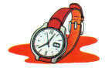
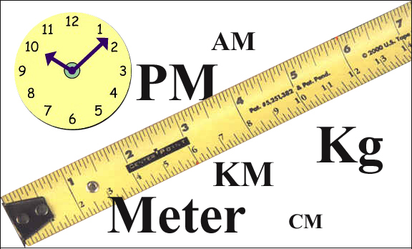
pages 54-73
pages 74-76

Pages 77
pages 80-87

pages 78-79

pages 88-92

pages 93-96

INTRODUCTION
Tip of the Day

Different Ways of Telling Time

There are many different ways of telling time in Korean. The most common way is in the order of the hour (시) and then the minute (분). Civilians use Native-Korean numbers to tell hours and Sino-Korean numbers to tell minutes and seconds. For example, 5:10 is 다섯시 십분 and 12:47 is열두시 사십칠분.

Tell Official Military Time
To record or indicate official times such as the military and transportation schedule times, the 24- hour system is used instead of the 12-hour system. When stating the official time, Sino-Korean numbers, rather than Native-Korean numbers should be used.

Example:
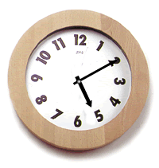
5:10 a.m. (0510) “공오시 십분”
5:10 p.m. (1710) “십칠시 십분”

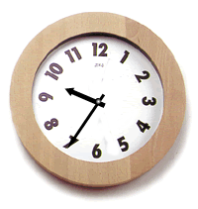
9:35 a.m. (0935) “공구시 삼십오분”
9:35 p.m. (2135) “이십일시 삼십오분”

INTRODUCTION

Use the 12-hour System for Telling Time

As in the USA, the 12-hour system is commonly used in Korea. The word to indicate the AM hours is “오전”and the word for PM hours is “오후”. For example, 2:40 AM is 오전 두 시 사십 분 and 2:40 PM is 오후 두시 사십분. However, in everyday life, the word 새벽 (dawn) can be also used for the hours before dawn, instead of 오전. For example, 4:00 AM is 새벽 네시. Likewise, for the hours during the daytime, the word 낮 (daytime) can be used. 저녁 (evening) is used for hours in the evening, instead of 오후. For example, 1:00 PM is 낮 한시 and 8:00 PM is 저녁 여덟시. For the hours close to midnight, the word 밤 (night) can be used. For example, 11:00 PM is 밤 열한시.

Examples:

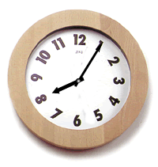
AM

오전 여덟시 오분 or 아침 여덟시 오분

PM

저녁 여덟시 오분 or 밤 여덟시 오분

INTRODUCTION
Ask Questions about Clock Times

Although it is not required, Korean use “지금” (now) often when asking questions about clock times.
Examples:

지금 몇시 입니까? What time is it?
지금 시간이 어떻게 됩니까? What time is it?

Read the short dialogue below and answer the question that follows.
SFC Smith : 임대위님, 지금 몇시 입니까?
Capt. Im : 오전 열한시 십육분 입니다.
SFC Smith : 네, 감사합니다.

Dialogue1 Exercise
1. What time is it?

Read the short dialogue below and answer the question that follows.
A Lady : 실례합니다. 지금 시간이 어떻게 됐나요?
SFC Smith : 네, 일곱시 삼십분 입니다.
A Lady : 네, 감사합니다.

Dialogue 2 Exercise
1. What time is it?

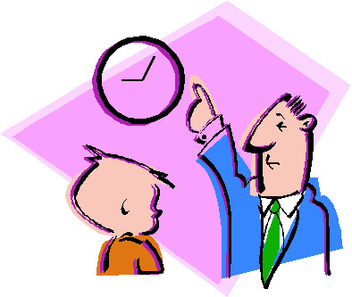
Lesson Dialogue 2 – Answer Questions about Clock Time

Lesson Dialogue 1 – Ask Questions about Clock Times

INTRODUCTION

Exercise 1

Pair up with a classmate. Then, ask and answer questions about clock times.

(1) It’s 2:35am (Official Military Time)
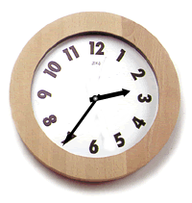

(2) It’s 2:35pm (Official Military Time)

(3) It’s 2:35am (12-hour System)

(4) It’s 2:35pm (12-hour System)

INTRODUCTION

Continue…

(5) It’s 6:34pm (12-hour System)
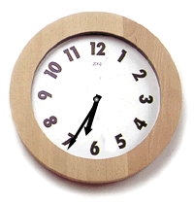

(6) It’s 6:34am (12-hour System)

(7) It’s 6:34pm (Official Military Time)

(8) It’s 6:34pm (Official Military Time)

INTRODUCTION

Exercise 2

You have an appointment and notice that your watch has stopped. It is very important that you be punctual. You see a passerby who looks friendly and is about the same age as you are. Ask him/her for the time along with the appropriate greetings and expressions of gratitude. Act out the scenario with a partner, using the English cues below, and switch roles so you can both practice. Try to use both am and pm expressions.

A: Request the time using the appropriate level of politeness.
B: Respond with an appropriate answer.
A: Thank him/her with an appropriate expression of gratitude.

Exercise 3

Work together with a partner. You are at a work-related conference. You have to leave at a specific time to meet your spouse for lunch. You do NOT want to be late! The person who is sitting beside you is a stranger who is older. Ask the time very formally. Practice several of these encounters with a partner, emphasizing the different times of day and levels of familiarity. Exchange roles.

English Cues:
A: Request the time using the appropriate level of politeness.
B: Respond with an appropriate answer.
A: Thank him/her with an appropriate expression of gratitude.

Exercise 4

Work together with a partner. You are at a conference with a colleague whom you are somewhat acquainted with. Therefore, you can be either formal or informal. The conference is getting boring, and you really want to leave. The clock on the wall isn’t correct. Ask your acquaintance for the time. Switch roles so you can both practice.

English Cues:
A: Ask for the time using either formal or informal speech.
B: Respond with a plausible answer.
A: Thank him/her with an appropriate expression of gratitude.

INTRODUCTION

Exercise 5

Work together with a partner. You are in Korean language class. Use the English cues below to act out the following scenarios in Korean. Change roles so you can both practice.

(1) English Cues:
A: Ask for the time using the appropriate level of politeness.
B: Respond using the same form.

Example:
A: 지금 몇 시야?
B: 지금 오전 아홉시 삼십분이야.

(2) English Cues:
A: Ask what time the class begins.
B: Respond using the same form.

Example:
A: 수업이 몇 시에 시작해?
B: 열시에 시작해.

(3) English Cues:
A: Ask what time the class ends.
B: Respond using the same form.

Example:
A: 수업이 몇 시에 끝나?
B: 오후 세시에 끝나.

INTRODUCTION

Tip of the Day

Reading Large Numbers

While large numbers are written in Arabic form in Korea, as they are in the USA, they are read quite differently. In the USA, there is not a single word to say 10,000, instead we read it as “ten thousand.” In Korea, there is a single word for 10,000. That word is “만”. Therefore, 20,000 would be pronounced as “이만”. Let’s take a look at some examples below for clarification.

Numbers | Explanation of Pronunciation | Pronounciation
10,000 | 1 (일) + 10000 (만) | (일)만
20,000 | 2 (이) + 10000 (만) | 이만
100,000 | 10 (십) + 10000 (만) | 십만
1,000,000 | 100 (백) + 10000 (만) | 백만
10,000,000 | 1000 (천) + 10000 (만) | 천만

Tell Distance using the Metric System

Like many countries around the world, Koreans use the metric system, kilometers instead of miles, when indicating distance (거리) and speed (속도).

Conversions:
America | Korea
0.394 inches | 1 centimeter
3.28 feet | 1 meter
1.09 yards | 1 meter
0.62 miles | 1 kilometer

INTRODUCTION
Read the short dialogue below and answer the question that follows
SFC Smith: 임대위님, 서울에서 평택까지 거리가 얼마나되요?
Capt. Im: 네, 한 백 킬로미터쯤 될거에요.
SFC Smith: 그럼 차로 한시간쯤 걸리겠네요.

Dialogue 3 Exercise
1. What is the distance between Seoul and Pyong-Tak?

Use Numbers from 101 ~ 1,000,000

Both pure Korean words and Sino-Korean words are used for the numbers from 1 to 99. However, for the numbers 100 and above, only Sino-Korean words are used.

Knowing high numbers in Korean is particularly important since the smallest Korean monetary note, “the Won” (원), starts from 1,000.

Numbers | Korean
101 | 백일
102 | 백이
103 | 백삼
1,000 | 천
10,000 | 만
100,000 | 십만
1,000,000 | 백만
397 | 삼백구십칠
4150 | 사천백오십
19,268 | (일)만구천이백육십팔
624,936 | 육십이만 사천구백삼십육
7,814,650 | 칠백팔십일만 사천육백오십

Lesson Dialogue 3 – Tell Distance using the Metric System

INTRODUCTION
Compare the Metric System with the English System
Recognize and Use the Metric System (weights and measures)

Linear Measurements

U.S. | Korea
1 inch (in) | 25.3995 millimeters (mm)
1 foot (ft) | 30.479 centimeters (cm)
1 yard (yd) | 0.9144 meters (m)
1 mile | 1.6093 kilometers (km)
1 league | 4.8279 kilometers

Square Measures

U.S. | Korea
1 square inch | 6.4516 sq centimeters
1 sq foot | 929.030 sq centimeters
1 sq yard | 0.836 sq meters
1 acre | 0.405 hectáreas
1 sq mile | 2.599 sq kilometers

Weight

U.S. | Korea
1 ounce (oz) | 28.35 grams (g)
1 pound (lb) | 0.454 kilograms (kg)

Temperature Equivalents
Koreans use Centigrade/Celcius to indicate temperature.

Fahrenheit (F): U.S. | Centigrade (C): Korea
212 degrees (boiling point) | 100 degrees (boiling point)
32 degrees (freezing point) | 0 degrees (freezing point)

Changing Fahrenheit to Centigrade: (F-32) X 5/9 = C
Changing Centigrade to Fahrenheit: (C × 9/5) + 32 = F

INTRODUCTION
Recognize Types of Packaging used in Korean Markets

Like many other industrial nations, Koreans use various plastic or paper based packaging. These types of packaging are a particular concern for many environmentalists in Korea, because Korea is one the most densely populated countries per landmass in the world.

Regulations on the Use of Disposable Products

In order to prevent environmental pollution and to lessen fiscal waste, the government published a set of regulations prohibiting the use of wooden chopsticks in public restaurants in 1998. The restaurants have to provide either plastic or steel chopsticks that will be later washed and re-used. The government is also recommending that restaurants use recyclable dishes and bowls. Since the summer of 1999, customers have had to pay for the plastic and paper bags that are used for packaging at stores. Since then, more people take baskets when they go shopping.

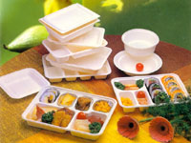

Exercise 6

Work together in pairs. One student will look at the list of names in Table A and ask the other student questions about someone’s height or weight in both the American and Korean measuring systems. Looking at Table B below, that student will respond appropriately. Reverse roles so you can both practice.

Example:

A: 이동진씨는 미국식으로 하면 몸무게가 얼마나 됩니까?
B: 백칠십이 파운드입니다.

A: 이동진씨는 한국식으로 하면 키는 얼마나 됩니까?
B: 백칠십오 센티미터입니다.

INTRODUCTION

Continue…

Table A:
Name
Sarah Eliot
Joe Stuart
Tom Miller
이동진
조수미
황수철

Table B:
Name | American |  | Korean
Name | Height | Weight | Height | Weight
Sarah Eliot | 5 ft 3 in | 160 lb | 159.6 cm | 73 kg
Joe Stuart | 6 ft 2 in | 185 lb | 187.4 cm | 84 kg
Tom Miller | 5 ft 9 in | 178 lb | 175.2 cm | 81 kg
이동진 | 5 ft 9 in | 172 lb | 175 cm | 78 kg
조수미 | 5 ft 3 in | 139 lb | 160 cm | 63 kg
황수철 | 6 ft | 187 lb | 183 cm | 85 kg

INTRODUCTION

Exercise 7

Work together in pairs. SOF soldiers are always interested in weather, since it often affects their mission. The following table provides the weather forecast on May 3, 2000 for major cities in Korea. Student A asks about the temperature of a city from the table. Student B gives the temperature in Centigrade. Then, student A asks what the temperature is in Fahrenheit and student B answers appropriately. This exercise can be repeated until the information in the table is exhausted.

Example:
A: 서울/경기 지방의 오늘 최고기온이 몇 도예요?
B: 섭씨 영상25도 예요.
A: 그러면 화씨로 바꾸면 어떻게 되죠?
B: 화씨로는 77도예요.
지역구분 | 최고  기온(섭씨) | 최고  기온(화씨) | 상태 | 내일
서울/경기 | 25º C | 77º F
강원영서 | 24 º C | 75º F
강원영동 | 25 º C | 77º F
울릉도/독도 | 24 º C | 75º F
충청북도 | 26 º C | 79º F
충청남도 | 26 º C | 79º F
전라북도 | 26 º C | 79º F
전라남도 | 26 º C | 79º F
제주도 | 23 º C | 73º F
경상북도 | 27 º C | 81º F

INTRODUCTION

Exercise 8

The following chart indicates the daily schedule of Mr. Sung-whan Choi (최승환). Referring to the chart, answer the following questions.

6:00 AM. | 기상, 운동
7:00 AM. | 아침 식사, 출근
8:10 AM. | 회사 도착
9:00 AM.- 10:30 AM. | 회의
12:30 PM-1:20 PM. | 점심 식사
6:00 PM | 퇴근
7:00 PM | 귀가
7:30 PM. – 8:00 PM. | 저녁 식사
9:00 PM. – 10:00 PM. | 영어 학원
11:00 PM. | 취침

(1) What time does he get up?

(a) 여섯시
(b) 여섯시 반
(c) 일곱시
(d) 일곱시 반

(2) What time does he get to work?

(a) 여덟시 십분
(b) 여덟시 반
(c) 아홉시
(d) 아홉시 반

(3) When is his meeting?

(a) 8:00 am – 9:00 am
(b) 8:30 am – 10:00 am
(c) 9:00 am – 10:30 am
(d) 9:30 am – 11:00 am
INTRODUCTION
(4) When is his lunch time?

(a) 12:00 pm – 1:00 pm
(b) 12:10 pm – 1:30 pm
(c) 12:30 pm – 1:20 pm
(d) 12:30 pm – 1:40 pm
(5) What time does he leave his office?

(a) 여섯시
(b) 여섯시 반
(c) 일곱시
(d) 일곱시 반

(6) What does he do after dinner?

(a) TV를 본다.
(b) 영어 학원에 간다.
(c) 도서관에 간다.
(d) 운동을 한다.

(7) When does he go to bed?

(a) 열시
(b) 열시 반
(c) 열한시
(d) 열한시 반

INTRODUCTION

Exercise 9

The following chart contains the schedule for the Korean class. Answer the following questions regarding the schedule.

Time | Class
8:00 AM - 9:50 AM | 복습
9:00 AM - 10:50 AM | 본문 공부
11:00 AM - 11:50 AM | 이야기 읽기
12:00 PM - 1:00 PM | 점심 시간
1:00 PM - 2:50 PM | 대화 연습
3:00 PM - 3:50 PM | 연습 문제

(1) 몇 시에 수업이 시작됩니까?
(a) 여덟시
(b) 여덟시 반
(c) 아홉시
(d) 아홉시 반

(2) 아홉시부터 열시 오십분까지 무엇을 합니까?
(a) 복습
(b) 본문 공부
(c) 이야기 읽기
(d) 대화 연습

(3) 열한시부터 열한시 오십분까지 무엇을 합니까?
(a) 복습
(b) 본문 공부
(c) 이야기 읽기
(d) 대화 연습

(4) 점심시간은 언제입니까?
(a) 열한시 반부터 열두시 반까지
(b) 열두시부터 한시까지
(c) 열두시 반부터 한시 반까지
(d) 한시부터 두시까지

(5) 한시부터 두시 오십분까지 무엇을 합니까?
(a) 복습
(b) 본문 공부
(c) 이야기 읽기
(d) 대화 연습

INTRODUCTION

Exercise 10

The following table gives the distances from Seoul to the other cities. Read the schedule and provide the correct responses to the questions.

평양 | 372 km
부산 | 445 km
광주 | 320 km
청진 | 768 km

(1) 서울에서 평양까지 거리가 얼마나 됩니까?

(2) 서울에서 부산까지 거리가 얼마나 됩니까?

(3) 서울에서 광주까지 거리가 얼마나 됩니까?

(4) 서울에서 청진까지 거리가 얼마나 됩니까?

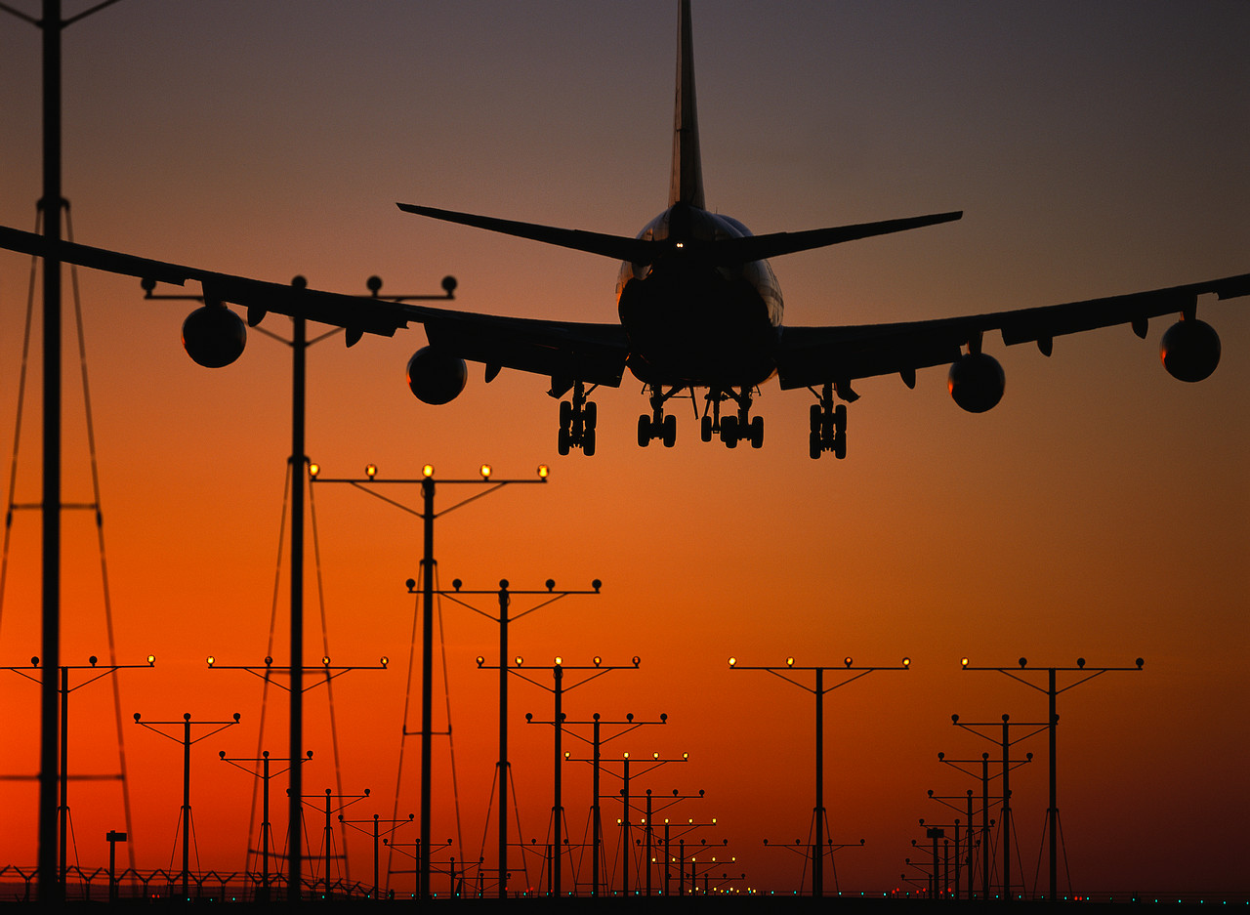
INTRODUCTION

Exercise 11

The bus schedule on the next page provides information concerning transportation from 부산 and 대구 to some other major cities. After carefully reviewing the schedule, provide the correct responses to the questions.

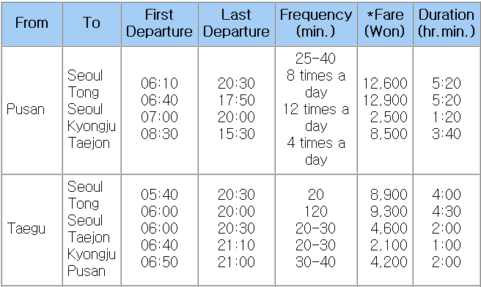

(1) 부산에서 서울까지 시간이 얼마나 걸립니까?

(2) 부산에서 서울까지 요금이 얼마입니까?

(3) 부산에서 경주까지 시간이 얼마나 걸립니까?

(4) 부산에서 경주까지 요금이 얼마입니까?

(5) 대구에서 동서울까지 시간이 얼마나 걸립니까?

(6) 대구에서 동서울까지 요금이 얼마입니까?

(7) 대구에서 대전까지 시간이 얼마나 걸립니까?

(8) 대구에서 대전까지 요금이 얼마입니까?

INTRODUCTION

Exercise 12

This table below represents a listing of selected clothing items and prices. Analyze the information provided and give the appropriate responses to the following questions in Korean.

구두 | 45,000원
장갑 | 23,000원
모자 | 16,000원
바지 | 38,000원
양복 | 110,000원

(1) 구두는 얼마입니까?

(2) 장갑은 얼마입니까?

(3) 모자는 얼마입니까?

(4) 바지는 얼마입니까?

(5) 양복은 얼마입니까?


INTRODUCTION

Exercise 13

You have been provided with a restaurant menu in Korean. Scan the listing of food items and the corresponding prices. Answer the questions below in Korean.

메뉴

김치찌개 3200 원
불고기 4500 원
갈비 5000 원
비빔밥 3500 원
냉면 4000 원

(1) 김치찌개는 얼마입니까?

(2) 불고기는 얼마입니까?

(3) 갈비는 얼마입니까?

(4) 비빔밥은 얼마입니까?

(5) 냉면은 얼마입니까?

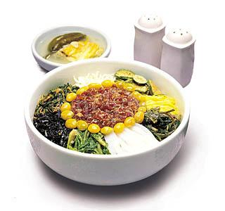
GRAMMAR NOTES
1. How to Express a Large Quantity: 많다

The verb “많다” is used to express a large quantity of objects or persons (a lot of, many, or much):

여기 많습니다.
시간 많습니다.
돈이 많습니다.
사람이 많아요.

Exercise 1

Respond to the following sentences by asking questions about quantity using the verb 많다.

(1) 학생이 있습니다.

(2) 시간 있어요.

(3) 커피 있어요.

(4) 사과 있어요.

(5) 장교가 있어요.

2. Future-Tense Marker -겠-

When attached to a verb stem, -겠- indicates the future tense. Sometimes, it also expresses intention or will.

교육을 받겠다
저녁에 가겠습니다.
다섯 시까지 오겠습니다.

GRAMMAR NOTES
3. Dependent Noun -때

때 as an independent noun means opportunity or chance, but as a dependent noun, -때 cannot be used by itself. It always follows a time noun such as 점심, 고등학교, 크리스마스 and so on.

점심 때
고등학교 때
크리스마스 때
저녁 때

4. -야/아야/어야 하다 = Have to
-야/아야/어야하다 is used to indicate the necessity of things to be done.

Vowel sound endings + | - 야 하다
[ㅏ, ㅑ, ㅗ, ㅛ] vowels + consonant sound endings + | - 아야 하다
The other sound vowels + consonant sound endings + | - 어야 하다

일요일에는 교회에 가야 합니다.
(You have to go to church on Sunday.)
시계를 사야 합니다.
(You have to buy a watch.)
공을 받아야 합니다.
(You have to catch the ball.)
이름과 생년월일을 적어야 합니다.
(You have to write down your name and date of birth.)
하루에 한 알씩 먹어야 합니다.
(You have to take a pill a day.)

GRAMMAR NOTES

Exercise 2

1. With the template below, write sentences in Korean using the given English phrases.

저는 이번 주말에 ________________야 합니다.

(1) to wash the car

(2) to go hiking

(3) to repair the bike

(4) to cut the grass

(5) to watch the football game

(6) to sleep for 10 hours

(7) to read a book

2. Convert the following statements into sentences that indicate the obligation of an action using -어/아야 하다.

(1) 동생을 돌보다.

(2) 학교에 갑니다.

(3) 이 사람을 찾습니다.

(4) 지금 가다.

(5) 공부를 해.

(6) 여기서 기다려요.

(7) 책을 읽다.

(8) 영화관에서 만나요.

VOCABULARY
시간 (time)
교대 shift
일정 schedule
자유시간 free time
저녁 evening
저녁식사 dinner
점심시간 lunch hour
점호 inspection
정오 noon

미터법 (metric system)
거리 distance
대형 large size
바구니 basket
속도 speed
킬로미터 kilometer

동사 (verb)
끝나다 to finish
많다 to be a lot
발표하다 to announce
사용하다 to use
시작하다 to begin
실시하다 to execute
지불하다 to pay
취침하다 to go to bed
퇴근하다 to get off work
힘들다 to be hard

유용한 단어 (useful words)
늦게 late
대학병원 university hospital
보통 usually, normally
봉지 bag
비닐봉지 plastic bag
사무실 office
예절 manner
교육 education
운동 exercise
정신교육 moral (spiritual) education
차 car
충 loyalty
할인매장 discount store
환경오염 environmental pollution
회의 meeting
효 filial piety

CULTURAL NOTES

1. Telling the Time “Counterclockwise”

The counterclockwise method is commonly used when the minute hand is at any point between 40 and 59 minutes after a particular hour. For example, for 10:55, saying "5 minutes to 11" is more common than saying "55 minutes after 10". So, when it is 40 minutes or more past any particular hour, you can say, "- 시 -분 전". (The word 전 means "before.")

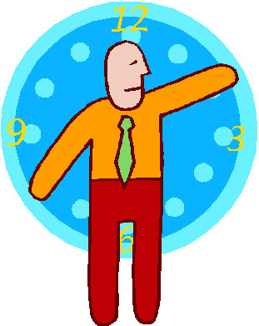

2. Korean Workdays

Koreans work five and a half days per week, Monday through Friday and a half-day (morning hours) on Saturday. Downtown Seoul is, therefore, most crowded on Saturday afternoons. The number of work hours is "officially" the same as in America, but the general working habits of both white-collar and blue-collar workers is to put in one or two hours more than the "official" eight hours. For that reason, the evening rush hours are later than in America, 5-7 PM, rather than 5-6 PM.

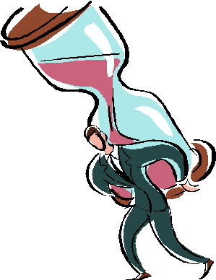
CULTURAL
NOTES

3. Time (시간)

In general, Korean attitudes towards time are similar to the Western norms. Despite this attitude and the type of behavior it entails, on a personal basis, the typical Korean is not nearly as time-bound as Americans or other Westerners. They regard time as more elastic or flexible. They do not see being on time as an inherently serious matter. Intentions take precedence over time.

As far as personal appointments are concerned, being thirty minutes "late" is culturally acceptable to Koreans. However, businesspeople, especially those who are used to dealing with foreigners, generally conform to the Western concept of time when making and keeping appointments.

Koreans still tend to blur private and public time. Their concept of time is rather work oriented, so they do not automatically keep track of the hours they toil, as Westerners are apt to do. Employees do not dash for the door at the official quitting time. However, the attitude toward 시간 is changing more among the younger generation and they are becoming increasingly interested in having a personal life away from their workplaces.

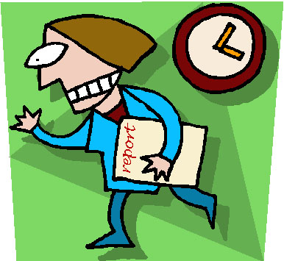
APPLICATION ACTIVITIES
The clocks below indicate specific times. Use the appropriate Korean numbering system to convey the correct time in Korean.

(1) 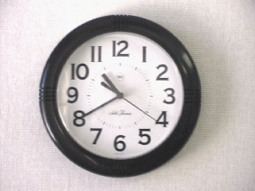AM (Answer):
(2) 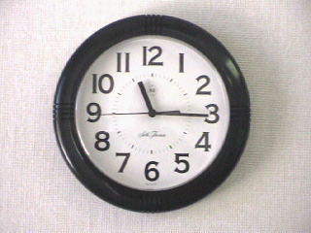PM (Answer):
(3) 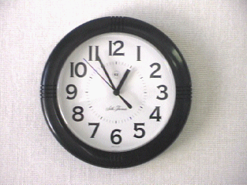AM (Answer):
(4) 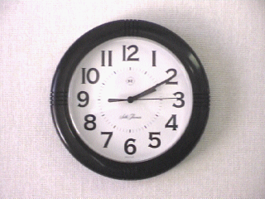PM (Answer):
(5) 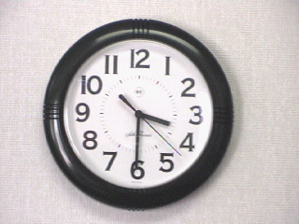 PM (Answer):
(6) 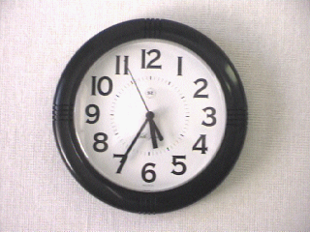 AM (Answer):
(7) 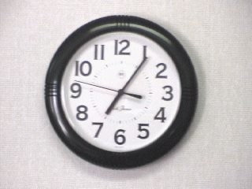 PM (Answer):
(8) 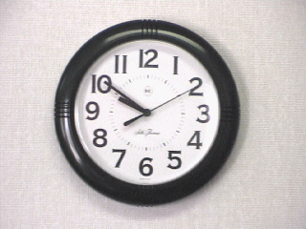 AM (Answer):

Activity 1
Activity 2

APPLICATION
ACTIVITIES

Work together in pairs. The setting is that students are reading a training schedule to determine the various starting times of activities. Students will take turns asking and responding to questions relating to the activity, such as the time allowed to accomplish it, and any equipment that may be necessary to complete it.

Example:

A: 훈련이 몇 시부터 시작합니까?
B: 오전 여덟시부터요.

Activity | Beginning time
훈련 | 오전 여덟시
공부 | 오후 네시 반
강의 | 오전 열시
영화 | 오후 일곱시
음악회 | 오후 여섯시 이십분

Use the appropriate Korean numbering system to convey the time expressions below.

(1) 2:15 AM

(2) 10:45 PM

(3) 7:00 AM

(4) 11:27 PM

(5) 5:05 AM

Activity 3
APPLICATION ACTIVITIES
Work together in pairs. The setting is that students are reading a training schedule to determine the various completion times of activities. Students will take turns asking and responding to questions relating to the activity, the time allowed to accomplish it and any required equipment necessary to complete it.

Example:

A: 훈련이 몇 시에 끝납니까?
B: 정오에 끝납니다./ 낮 열두시에 끝납니다.

Activity | Ending Time
훈련 | 12:00 PM
공부 | 4:50 PM
강의 | 11:15 AM
영화 | 9:00 AM
음악회 | 7:30 PM

Use the appropriate Korean numbering method to convey the correct times using the 12-hour system.

(1) 8:59 AM.

(2) 4:13 PM.

(3) 1:20 PM.

(4) 11:25 AM.

(5) 7:00 PM.

Activity 4
Activity 5
APPLICATION
ACTIVITIES
Work together in pairs. The setting is that students are examining the personal training schedule of Private Kim below. Students will take turns asking and responding to questions to determine the full range of his activities.

Example:

A: 아침에 몇 시에 기상합니까?
오전에는 무슨 일을 합니까?
아침 식사는 몇 시에 합니까?
점심 식사는 몇 시에 합니까?
오후에는 무슨 일을 합니까?
체력 단련 운동은 몇 시에 시작합니까?
체력 단련 운동은 몇 시에 끝납니까?
저녁 식사는 몇 시에 합니까?
저녁에는 무엇을 합니까?
일과 정리는 몇 시에 합니까?
몇 시에 취침합니까?

0600 | 기상
0620 | 점오
0700 | 아침 식사
0800 - 1150 | 오전 일과
1200 – 1300 | 점심 식사
1300 – 1600 | 오후일과
1600 – 1700 | 체력 단련 운동
1800 | 저녁 식사
1900 – 2030 | 자유시간
2030 – 2130 | 일과 정리
2130 | 점오
2200 | 취침

Activity 6
APPLICATION ACTIVITIES
Use the appropriate Korean numbering method in order to convey the correct times using the 24-hour system.

Example:

오전 아홉시 십분 - 공구시 십분

(1) 밤 한시

(2) 오전 열시 이십분

(3) 낮 세시

(4) 저녁 일곱시 십칠분

(5) 오후 두시 반

(6) 새벽 여섯시 십분전

(7) 밤 열두시

(8) 정오

(9) 낮 한시 십오분전

(10) 자정

Activity 7
APPLICATION
ACTIVITIES
The class will be divided into two groups. Students will alternate in asking and providing the time using the appropriate system. Also, write the questions and answers in the spaces provided below.

Example:

3:20 PM – 1520 hrs
Group A : 오후 세시 이십분
Group B : 십오시 이십분

(1) 8:45 PM – 2045 hrs
Group A :
Group B :

(2) 2:10 PM – 1410 hrs
Group A :
Group B :

(3) 10:00 AM- 1000 hrs
Group A :
Group B :

(4) 5:25 PM – 1725 hrs
Group A :
Group B :

(5) 9:30 PM- 2130 hrs
Group A :
Group B :

(6) 5:45 AM- 0545 hrs
Group A :
Group B :

(7) 12:00 PM- 1200 hrs
Group A :
Group B :

(8) 11:13 AM- 1130 hrs
Group A :
Group B :

Activity 8
APPLICATION ACTIVITIES
(9) 11:30 PM- 2330 hrs
Group A :
Group B :

(10) 7:50 AM- 0750 hrs
Group A :
Group B :
Work together in pairs. The first student will read one of the following times out loud in Korean. His partner will then respond in English. Students can alternate turns.

(1) 정오

(2) 저녁 여덟시 십오분 전

(3) 새벽 세시

(4) 자정

(5) 아침 일곱시 반

(6) 오전 열시 이십분 전

(7) 오후 한시 반

(8) 낮 두시 십오분

(9) 새벽 네시 오십분

(10) 오후 다섯시 오분
Activity 9
APPLICATION
ACTIVITIES
Work together in pairs. Students will practice the pronunciation of the number sets in both Native-Korean and Sino-Korean by alternating turns.

(1) 234

(2) 7633

(3) 50,189

(4) 196,356

(5) 852,761

(6) 4,934,625

(7) 1,673,822

(8) 6,264,900

Students will develop their listening skills by distinguishing between three, three-digit numbers. The instructor will read one three-digit number from each grouping, and students should circle the one that they hear from each set.

(1) 243 254 876
(2) 653 832 634
(3) 986 587 108
(4) 754 492 263
(5) 104 363 827
Work together in pairs. Students will ask and respond to questions concerning their height and weight in both the American and Korean metric systems.

Example:

제 키는 5피트 8인치이고 몸무게는 165 파운드입니다. 한국식으로 하면 키는 176 센티이고 몸무게는 75 키로입니다
Activity 10
Activity 11
Activity 12
SKILL ENHANCEMENT

Chart A is the schedule of a businessman and Chart B is the schedule of a soldier. After reviewing the charts below, answer the following comprehension questions.
(1) 회사원은 몇 시에 점심을 먹습니까?

(2) 군인은 몇 시에 취침합니까?

(3) 군인은 오후 네시와 다섯시 사이에 무엇을 합니까?

(4) 회사원은 저녁 아홉시부터 열시까지 무엇을 합니까?

(5) 회사원은 오전시간에 무엇을 합니까?

Activity 1

Chart A
6:00 AM | 기상, 운동
7:00 AM | 아침식사, 출근
8:10 AM | 회사 도착
9:00 AM – 10:30 AM | 회의
12:30 PM – 1:20 PM | 점심 식사
6:00 PM | 퇴근
7:00 PM | 귀가
7:30 PM – 8:00 PM | 저녁 식사
9:00 PM – 10:00 PM | 영어 공부
11:00 PM | 취침

Chart B
06:00 | 기상
06:20 | 점오
07:00 | 아침 식사
08:00 – 11:50 | 오전 일과
12:00 – 13:00 | 점심 식사
13:00 – 16:00 | 오후 일과
16:00 – 17:00 | 체력 단련 운동
18:00 | 저녁 식사
19:00 – 20:30 | 자유 시간
20:30 – 21:30 | 일과 정리
21:30 | 점오
22:00 | 취침

SKILL ENHANCEMENT
INTEGRATION
The class will be divided into two groups. Each group will be provided with a train schedule. Groups will alternate in asking and answering questions in order to complete their table with the information received from the other group. After completing their table, each group will answer the following questions.
Student A

열차번호 | 열차등급 | 시발역 |  | 광주 | 종착역
0382 | 무궁화 | 목포 | 22:40
0383 | 무궁화 | 부산 | 21:40
1204 | 도시통근 | 광주 | 05:35
 |  |  |  | 06:40 | 목포 | 08:29
 |  |  |  | 07:56 | 순천 | 10:33
 | 새마을 | 광주 | 09:00

Student B

열차번호 | 열차등급 | 시발역 |  | 광주 | 종착역
 |  |  |  | 00:07 | 부산 | 06:15
 |  |  |  | 03:50 | 목포 | 05:13
 |  |  |  | 05:35 | 대전 | 09:34
1556 | 도시통근 | 광주 | 06:40
1560 | 무궁화 | 목포 | 06:10
0142 |  |  |  | 09:00 | 서울 | 13:08

(1) 0382호 기차를 타면 목포에서 부산까지 시간이 얼마나 걸립니까?

(2) 무궁화호 기차를 타면 부산에서 광주까지 시간이 얼마나 걸립니까?

(3) 도시통근 기차를 타면 광주에서 대전까지 시간이 얼마나 걸립니까?

(4) 1560호 기차를 타면 목포에서 순천까지 시간이 얼마나 걸립니까?

(5) 새마을호 기차를 타면 광주에서 서울까지 시간이 얼마나 걸립니까?
Activity 2
SKILL ENHANCEMENT
Pair Work: Role-playing

One student will assume the role of a clerk at the train ticket office, and the other will assume the role of the customer. Ask and respond to questions concerning the train schedules from the previous activity. Change roles and repeat the activity.
The class will be divided into two groups. Each will have a list of cities and their distances (in Kilometers) from either 김포 or 평양 airport. Groups will alternate in asking and answering questions in order to complete their table with the information received from the other group.

Example:

A: 김포공항에서 뉴욕까지는 거리가 얼마나 됩니까?
B: 만 칠천이백킬로미터입니다.

Group A:

김포공항  부터 | ____ 까지 | Km | 평양공항  부터 | ____ 까지 | Km
 | 뉴욕 | 17,200 |  | 뉴욕
 | 도꾜 | 1,578 |  | 도꾜
 | 런던 | 19,725 |  | 런던
 | 로마 | 14,597 |  | 로마
 | 로스엔젤레스 |  |  | 로스엔젤레스 | 12,229
 | 마닐라 |  |  | 마닐라 | 3,156
 | 모스코우 |  |  | 모스코우 | 9,863
 | 방콕 |  |  | 방콕 | 3,945
 | 뻬이징 | 1,184 |  | 뻬이징
 | 베를린 | 15,788 |  | 베를린
 | 샌프란시스코 | 11,598 |  | 샌프란시스코
 | 워싱톤 디시 | 16,726 |  | 워싱턴 디시
 | 타이뻬이 |  |  | 타이뻬이 | 1,815
 | 텔아비브 |  |  | 텔아비브 | 11,598
 | 파리 |  |  | 파리 | 13,414
 | 홍콩 |  |  | 홍콩 | 1,973

Activity 3
SKILL ENHANCEMENT
INTEGRATION
Group B:

김포공항  부터 | ____ 까지 | Km | 평양공항  부터 | ____ 까지 | Km
 | 뉴욕 |  |  | 뉴욕 | 17,437
 | 도꾜 |  |  | 도꾜 | 1,736
 | 런던 |  |  | 런던 | 14,203
 | 로마 |  |  | 로마 | 14,992
 | 로스엔젤레스 | 11,992 |  | 로스엔젤레스
 | 마닐라 | 2,907 |  | 마닐라
 | 모스코우 | 10,257 |  | 모스코우
 | 방콕 | 3,550 |  | 방콕
 | 뻬이징 |  |  | 뻬이징 | 1,026
 | 베를린 |  |  | 베를린 | 12,236
 | 샌프란시스코 |  |  | 샌프란시스코 | 11,835
 | 워싱톤 디시 |  |  | 워싱턴 디시 | 16,769
 | 타이뻬이 | 1,736 |  | 타이뻬이
 | 텔아비브 | 11,835 |  | 텔아비브
 | 파리 | 18,936 |  | 파리
 | 홍콩 | 1,815 |  | 홍콩

SKILL ENHANCEMENT
Pairs will use the following table, which shows the train fares between Seoul and Pusan, to answer the questions below in Korean.
(1) 어른 두 명 어린이 한 명이 새마을호를 탔을 때 기본 요금은 얼마입니까?

(2) 어른 한 명이 무궁화호를 탔을 때 특실 할인 요금은 얼마입니까?

(3) 어른 한 명 어린이 두 명이 무궁화호를 탔을 때 입석 할증 요금은 얼마입니까?

(4) 어른 한 명 어린이 한 명이 새마을호 할인 특실 표를 끊었다면 얼마를 지불해야 합니까?

(5) 어른 두 명이 무궁화호 할인 일반실 표를 끊었다면 얼마를 지불해야 합니까?

Group Work: Role-playing

One student in each group will play the clerk at the train ticket office and the rest of the group will play the customers. The customers will ask and answer questions about ticket fares for different trains and buy tickets. Be creative. After five minutes, the retiring clerk will appoint a new clerk and the activity will continue until all the students have had a chance to play the clerk.
Activity 4
HOMEWORK

1. Use the 12-hour system to respond (in Korean) to the questions below using the times provided.

(1) 오늘 수업이 몇 시에 시작합니까? (9:00 am)

(2) 오늘 수업이 몇 시에 끝납니까? (4:00 pm)

(3) 병기대 훈련이 오늘 몇 시에 시작됩니까? (9:30 am)

(4) 병기대 훈련이 오늘 몇 시에 끝납니까? (5:30 pm)

(5) 의무대 훈련이 오늘 몇 시부터 있습니까? (9:15 am)

(6) 의무대 훈련이 오늘 몇 시에 끝납니까? (3:10 pm)

(7) 폭파대 훈련은 오늘 언제 시작해요? (9:40 am)

(8) 폭파대 훈련은 오늘 언제 끝나요? (3:50 pm)

(9) 오늘 통신병 훈련이 언제부터 있지요? (12:05 pm)

(10) 오늘 통신병 훈련이 언제 끝나지요? (2:25 pm)

2. Listen to the following dialogue and answer the questions below.
(Listen to the homework audio CD Track 34 - M2L2HW2)

(1) What time does Mr. Youn go to the office?

(a) 일곱시
(b) 일곱시 반
(c) 여덟시
(d) 여덟시 반

(2) Why does Mr. Youn go to the office early?

(a) 의무적으로
(b) 교통 혼잡을 피하기 위해서
(c) 6월달에는 할 일이 많아서
(d) 일찍 퇴근하기 위해서

HOMEWORK

Continue...

(3) What time does Mr. Macdonald go to the office?

(a) 일곱시
(b) 여덟시
(c) 여덟시 반
(d) 아홉시

3. Read the following dialogue and select the appropriate sentence to fill in the blank.

A: 김경호씨, 수업이 몇 시부터 시작하죠?
B: 오전 아홉시부터요.
A: 실례지만, 지금 몇 시예요?
B: 여덟시 사십분이요.
A: 그럼 _______________.
B: 네, 거의 다 되었어요.

(a) 한 시간 정도 시간이 남았군요
(b) 이십분 정도 남았군요.
(c) 바로 시작하겠군요
(d) 제가 좀 늦었군요

4. Read the following dialogue and answer the questions below.

A: 실례지만 지금 몇 시예요?
B: 열한시 사십오분이에요.
A: 벌써 점심 시간이네요.
B: 몇 시부터가 점심 시간이에요?
A: 정오부터예요.
B: 그럼 십오분전이네요. 점심 시간이 몇 시까지예요?
A: 한시 반까지인데, 보통 한시 십분 전쯤까지 돌아와요. 오늘 함께 식사 하실래요?
B: 그러죠.
A: 그럼 십오분 뒤에 같이 나갈까요?
B: 네, 그렇게 해요.

HOMEWORK

Continue...

(1) 점심 시간은 몇 시부터 몇 시까지입니까?

(a) 열두시부터 한시까지
(b) 열두시부터 한시 반까지
(c) 열두시 반부터 한시 반까지
(d) 열두시부터 열두시 오십분까지

(2) 이 두 사람은 몇 시에 같이 식사하러 가기로 했습니까?

(a) 열한시 사십오분
(b) 열두시
(c) 열두시 십오분
(d) 열두시 반

5. Listen to the following numbers read in Korean and write them down in Arabic form.
(Listen to the homework audio CD Track 35 - M2L2HW5)

(1)

(2)

(3)

(4)

(5)

HOMEWORK

6. Look at the price for each item below and answer the following questions.

구두 | 43000원
모자 | 4500원
장갑 | 3000 원
넥타이 | 25000원
지갑 | 10000원
셔츠 | 32500원
바지 | 55000원

(1) 구두는 얼마입니까?
(2) 모자는얼마입니까?
(3) 장갑은얼마입니까?
(4) 넥타이는얼마입니까?
(5) 지갑은얼마입니까?
(6) 셔츠는얼마입니까?
(7) 바지는얼마입니까?

7. The following table shows the distances from Seoul to other major cities of the world. Review it carefully and answer the following questions.

로스엔젤레스 | 12229 km
뉴욕 | 17200 km
런던 | 19725 km
뻬이징 | 1184 km
파리 | 13414 km

(1) 서울에서 로스엔젤레스까지의 거리는 얼마입니까?

(2) 서울에서 뉴욕까지의거리는 얼마입니까?

(3) 서울에서 런던까지의거리는 얼마입니까?

(4) 서울에서 뻬이징까지의거리는 얼마입니까?

(5) 서울에서 파리까지의거리는 얼마입니까?

