INTRODUCTION
APPLICATION
ACTIVITIES
SKILL ENHANCEMENT
INTEGRATION
HOMEWORK
GRAMMAR NOTES
VOCABULARY
CULTURAL NOTES
Calendar
Lesson Objectives

At the end of this lesson, the student will be able to talk about family activities and events.

Express Numbers 21-100
• Provide your home address
• Provide the age of your family members
• Request the price of merchandise
• Buy merchandise

Identify Days of the Week
• Recognize days of the week
• Pronounce days of the week
• Name different activities you perform on different days of the week

Identify Months
• Recognize months
•Pronounce months
•Provide you and your family member’s birthdays
•Discuss military activities for the month

Recognize Dates
• Write the dates for personal / military activities
• Identify the dates of the Korean holidays
• Talk about specific holiday activities
• Identify important family dates

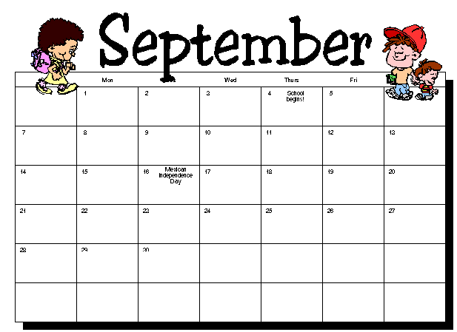
pages 226-242
pages 243-244

Pages 245-246
pages 249-256

pages 247-248

pages 257-260

pages 261-265

INTRODUCTION
Tip of the Day

Numbers 21 – 100

 | Native-Korean | Sino-Korean
21 | 스물 하나 | 이십일
22 | 스물 둘 | 이십이
23 | 스물 셋 | 이십삼
24 | 스물 넷 | 이십사
25 | 스물 다섯 | 이십오
30 | 서른 | 삼십
40 | 마흔 | 사십
50 | 쉰 | 오십
60 | 예순 | 육십
70 | 일흔 | 칠십
80 | 여든 | 팔십
90 | 아흔 | 구십
100 | 백 | 백

INTRODUCTION

Exercise 1

Repeat after your instructor to practice the pronunciation of the following Sino-Korean numbers.

(1) 31

(2) 40

(3) 25

(4) 78

(5) 22

Exercise 2

Listen to the instructor as the following Native-Korean numbers are pronounced. Write them down in Arabic form.

(1) __________________________
(2) __________________________
(3) __________________________
(4) __________________________
(5) __________________________

INTRODUCTION

Mr. Kim is Korean and Mr. McGuire is American. Mr. Kim has a special occasion and invites Mr. McGuire to his house. Read the dialogue below and answer the question that follows.

Kim: McGuire씨, 이번 주 일요일에 뭐 하세요?
McGuire: 일요일에는 교회에 가요.
Kim: 이번 주 일요일 저녁에 저희 집에 오세요.
McGuire: 왜요?
Kim: 제 아기의 백일파티가 있어요.
McGuire: 그래요? 축하해요. 댁이 어디세요?
Kim: 잠실이에요.
McGuire: 주소를 가르쳐 주세요.
Kim: 서울시 송파구 잠실 2동 127번지예요.
McGuire: 김동현씨는 자제분이 어떻게 되세요?
Kim: 딸이 하나 아들이 하나 있어요.
McGuire: 나이가 몇 살이에요?
Kim: 딸은 여덟 살이고 아들은 백일 되었어요. McGuire씨는요?
McGuire: 저는 딸이 둘 있는데, 스물 여섯살과 스무살이에요.

Scenario1 Exercise

1. Why does Mr. Kim invite Mr. McGuire to his house?

Lesson Scenario 1 – Baby’s 100th Day Party
INTRODUCTION

Exercise 3

The situation is that you are having an informal discussion with your counterpart after work. The subject of families comes up. You’re interested in whether he has children of the same age as you. Ask your partner about his/her family members and their ages. Afterwards, reverse roles so both partners can practice.

Example:

A: 가족이 어떻게 되십니까?
B: 어머니와 동생 둘이 있어요.
A: 어머니께서는 연세가 어떻게 되십니까?
B: 올해 예순이십니다.
A: 동생들은요?
B: 여동생은 열 다섯, 남동생은 열 일곱이에요.

Exercise 4

The situation is that you took your family to the Air Show on Korean Army Day. Your three children, a son who is 9 and two daughters that are 7 and 4, your parents, and your wife will all attend. While waiting for the show to begin, you meet your counterpart with his family. Introduce your family to him. He asks questions about your family and you tell him their names and ages. He then introduces you to his family members.

Example:

A: 제 가족을 소개합니다. 제 부모님, 아내, 제 아이들입니다.
B: 자제분 나이가 몇 살입니까?
A: 아들이 아홉 살, 딸이 일곱 살, 네 살입니다.

INTRODUCTION

Exercise 5

The situation is that you are discussing going out to dinner with your counterpart. He agrees to pick you up at your house, as he knows the city you live in is better. However, he doesn’t know exactly where you live. Provide him with your address. Your partner will play the role of your counterpart.

Exercise 5a

This is a continuation of the previous activity. The situation is that the dinner plans you both agreed on fell through, because your counterpart’s car is still in the shop. So, he asks if you can meet him at his place. You agree and ask him for his address.

Hint: Make up a Korean address from the box below.

서울시 종로구 낙원동 13-5번지
서울시 영등포구 여의도동 은하아파트 C 동 513호
부산 광역시 중구 중앙동 49-1번지
대전 광역시 대덕구 문평동 미성아파트 3동 110호
전라북도 전주시 완산구 경원동 경원아파트 2동 312호
제주도 제주시 삼도2동 17-9번지
경기도 부천시 소사구 송내동 16-8번지
강원도 동해시 천곡동 721번지

INTRODUCTION

Speaker A is visiting Korea on a business trip. He heard that there are many great markets with good prices in Korea. Read the dialogue below and answer the question that follows.

A: 이 전자시계 미국 달러로 얼마예요?
B: 미화로 40불이에요.
A: 너무 비싸요. 그것 보다 더 싼 것을 보여 주세요.
B: 27불 짜리, 20불 짜리가 있어요.
A: 20불 짜리로 좀 보여 주세요.
B: 예, 여기 있어요.

Scenario2 Exercise

1. What does speaker A want?
a. A hand bag
b. An electric watch
c. A suit


Exercise 6

The situation is that you are at a department store in the home electronics department. Your partner will play the role of the salesperson. You are interested in the prices of different items, because you want to see if they are cheaper in the department store or at the PX. Ask about the prices of the different merchandise. Your partner will respond accordingly. Afterwards, change roles and repeat the activity.

LG 냉장고  840,000원  (팔십만원) | GE 냉장고  2,600,000원  (이백 육십만원) | AEG 세탁기  1,280,000원  (백이십팔만원) | LG 선풍기  58,000원  (오만 팔천원) | GE 가스 레인지  1,600,000원  (백육십만원)

Example:
A: LG 냉장고가 얼마예요?
B: 팔십만원이에요.
Lesson Scenario 2 – The Price of Merchandise
INTRODUCTION

Exercise 7

The situation is that your wife asked you to pick up some fruit on the way home from work. You are at a fruit stand. Your partner will play the role of the vendor. Ask the price for the various fruits. Using the price table below, your partner responds appropriately. Afterwards, change roles.

Example:
A: 사과가 얼마예요?
B: 한 개에 오백원이에요.

 | Name | Price per Item
 | 바나나 | 900원
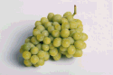 | 포도 | 800원
 | 사과 | 200원
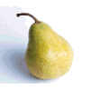 | 배 | 300원
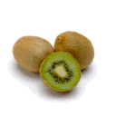 | 키위 | 350원
 | 오렌지 | 500원

INTRODUCTION

Exercise 8

The situation is that you and your counterpart are going shopping. He forgot his glasses at home and he asks you to read the price tags for him. Help him out by reading the prices in Korean. Afterwards, exchange roles and repeat the activity.

 | 피망 (200원) | 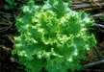 | 상추 (400원)
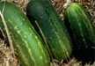 | 오이 (50원) |  | 고추 (510원)
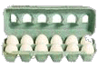 | 계란 (920원) |  | 쇠고기 (1000원)
 | 파인애플 (800원) |  | 마늘 (70원)
 | 생선 (780원) |  | 딸기 (630원)

INTRODUCTION
Tip of the Day

Exercise 9

The class will work together in two groups. The situation is that you are attending a garage sale. This is a “special” sale, because any item you want is available. The issue, of course, is the price. One student from each group will act as the vendor, the other students will act as prospective customers. Using the vocabulary that you know, see what you can buy. After ten minutes, the vendor will change. The activity will continue until all students have played the role of the vendor.

Example:

A: 이것 얼마예요?
B: 컵이요? 한 개에 칠백원이에요.

INTRODUCTION

날짜 (date) / 요일 (day)

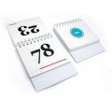 | 오늘 날짜가 무엇 입니까?  오늘은 2004년 5월 3일 입니다.  오늘은 무슨 요일 입니까 ?  오늘은 월요일 입니다.

계절 Season
봄 spring
여름 summer
가을 autumn / fall
겨울 winter

Days of the Week

일요일 | Sunday
월요일 | Monday
화요일 | Tuesday
수요일 | Wednesday
목요일 | Thursday
금요일 | Friday
토요일 | Saturday

INTRODUCTION

Exercise 10

Listen as your instructor pronounces the different days of the week and write them in English.

(1) 일요일
(2) 목요일
(3) 월요일
(4) 토요일

Exercise 11

The situation is that you just came out of the field after a long exercise. You’re disoriented. You see your counterpart and he asks you how it went. You say fine. You wish him a nice weekend. And he replies, “It’s not time for the weekend yet!” You’re puzzled. Your partner plays the role of your counterpart.
You ask…
(1) what day today is.
(2) what day tomorrow is.
(3) what day the day after tomorrow is.

He answers surprised. You laugh and say that you’re just joking. Reverse roles so that both students can practice.

INTRODUCTION

Exercise 12

The situation is that you’re setting up your schedule for the week and your counterpart walks in. He wants to know what your week looks like, so you decide to explain your entire schedule to him. He asks you about specific days and you reiterate. Below is your agenda for the week. Reverse roles so both partners can practice.

월요일 | 화요일 | 수요일 | 목요일 | 금요일 | 토요일 | 일요일
영어 학원에 갑니다. | 영화구경을 합니다. | 헬스센터에 가서 운동을 합니다. | 음악회에 갑니다. | 친구를 만납니다. | 데이트를 합니다. | 등산을 합니다.

Exercise 13

This is a continuation of the previous activity. The pair groupings remain the same. The situation is that you have both discussed your upcoming work schedules and are coordinating things that you want to do together each day. Using the table below, the pair will come up with a joint schedule showing the activities that they will do together.

월요일
화요일
수요일
목요일
금요일
토요일
일요일

INTRODUCTION
Tip of the Day

Month Names

1월/일월 | January
2월/이월 | February
3월/삼월 | March
4월/사월 | April
5월/오월 | May
6월/유월 | June
7월/칠월 | July
8월/팔월 | August
9월/구월 | September
10월/시월 | October
11월/십일월 | November
12월/십이월 | December

INTRODUCTION

Exercise 14

Listen to the instructor as the Korean months are pronounced. Write them down in English as you hear them.

(1) 삼월
(2) 오월
(3) 시월
(4) 일월
(5) 십이월
(6) 이월
(7) 십일월
(8) 유월
(9) 팔월
(10) 칠월

Exercise 15

The class will divide into pairs. One student in each pair will be female and the other will be male. Take turns converting the following sentences in the correct gender specific forms. Reverse roles so both people can practice.

(1) My older sister's birthday is June 24th.

(2) My parents celebrate their birthdays by the lunar calendar.

(3) My older brother's birthday is October 3rd.

(4) My birthday is November 16th.

(5) My grandfather's birthday is March 28th by the lunar calendar.

INTRODUCTION

Exercise 16

The situation is that you and your counterpart are discussing family issues. Ask each other your family member’s names, their ages, and their birthdays. Record each other’s information in the following table.

Example:

가족이 어떻게 되십니까? 성함이 어떻게 됩니까? 연세가 어떻게 됩니까?
생일은 언제입니까?

Title | Name | Age | Birthday

Exercise 17

The situation is that you and your counterpart are discussing Korean holidays. You ask your partner when he/she celebrates family events such as 백일, 돌, 약혼식, 결혼식, 부모님의 환갑, and 진갑. Your partner should respond using their personal information or made up information. Reverse roles so that both partners can practice.

Example:

A: 아버님 환갑이 언제십니까?
B: 5월 9일이십니다.

INTRODUCTION

Exercise 18

The situation is that in an earlier discussion you talked about family events. Ask your partner what holiday that his/her family celebrates is his/her favorite. Also ask what he/she does on that holiday. Write the information below. Exchange roles so your partner can record your information. Afterwards, each pair will report their findings to the class. The instructor will record the information on the board and the class will discuss the most popular holiday and activities.

INTRODUCTION

Discuss Military Activities for the Month

 |  |  | 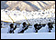
4월, 전술훈련  (April, tactics training) | 7월, 전투수영  (July, combat diving) | 9월, 을지 훈련  (September, UFL training) | 12월 동계훈련  (December, cold weather training)

Write the Dates for Personal / Military Activities

 생일: Birthday |   결혼 기념일:  Wedding Anniversary |   현충일: Memorial Day |   국군의 날 : Armed Forces Day
FEB. 4th | MAY 20th | JUNE 6th | OCT. 1st

Holiday Activities

Youngja (영자) talks about her plans for the coming Full-Moon Day.

추석에 우리집 식구 모두는 할아버님 댁에 갑니다. 교통이 혼잡하지만 기분은 좋습니다. 저녁에 도착하면 대가족이 모여 식사를 할 겁니다. 그리고 할아버지, 할머니에게 선물을 드릴 겁니다. 추석에는 맛있는 음식이 너무 많아 배탈이 나기 쉽습니다. 추석 날 밤에는 식구들과 달맞이를 가서 소원을 빌겁니다. 추석은 모든 식구들을 만나서 재미있게 지낼 수 있는 날 입니다.

GRAMMAR NOTES

1. Coordinate Connectives and Conjunctions -고

Two clauses can be connected by attaching -고 to the verb stem of the first clause.

제 성은 김입니다 (My family name is Kim.) +
제 이름은 미연입니다 (My given name is Miyon.)

= 제 성은 김이고, 제 이름은 미연입니다.

Exercise 1

Combine the following two sentences using "-고".
(1) 저는 김지연입니다. 제 동생은 김미연입니다.

(2) Johnson씨는 미국 사람입니다. 김철민씨는 한국 사람입니다.

(3) 저는 군인입니다. 송창우씨는 민간인입니다.

2. The use of -씩

The word "-씩" is often used in a sentence stating or questioning how much things cost. It is hard to translate into English, but basically means so much money per item / unit.

책 한 권에 20불씩 (20 dollars per book)
사과 한 개에 500원씩 (apples, 500 won each)
GRAMMAR NOTES

Exercise 2

How do you say the following expressions in Korean?

(1) 5 dollars per piece

(2) 50 dollars per book

(3) 2 dollars per bottle

3. Comparative -보다 (더)

-보다 (더) is attached to the thing compared to and usually precedes the subject for comparison. The word 더 (more) may follow -보다 for emphasis.
For example, A is cheaper than B = B +보다 precedes A.

사과보다 배가 더 비싸다. (Pears are more expensive than apples.)
배보다 사과가 더 싸다. (Apples are cheaper than pears.)

4. The use of –짜리

The word -짜리 indicates the value of the item it refers to. For example, "1불 짜리 동전" means "a one-dollar coin" and "10불 짜리 모자" means "a 10-dollar hat”.

VOCABULARY

연휴 / 명절 (Holidays / Family Dates)
구정 Lunar New Year’s Day
대보름 Full Moon Day
설 New Year’s Day
세배 traditional deep bow
세뱃돈 New Year’s gift of money
차례 ancestral rites
현충일 the Memorial Day
추석 Full Moon Day
환갑잔치 60th birthday celebration (party)
명절 national holidays, festive days
추수감사절 Thanksgiving
기념일 a day of remembrance
돌 first birthday
백일 100th Day
생신 birthday (honorific)
생일 birthday
약혼식 wedding engagement ceremony
결혼식 wedding ceremony
계획 plan

시간 (Time)
양력 solar calendar
음력 lunar calendar
요일 day of the week
밤 night
보름달 full moon
주중 during the weekdays
아침식사 breakfast
오후 afternoon
저녁 evening
주 week
주말 weekend

사람 (People)
딸 daughter
아내 wife
식구 family
자제분 children (honorific)
아기 baby

군사용어 (Military Terms)
국군 the National Armed Forces
동계 the winter season
을지 Ulji
전술 tactics
전투 combat, battle
훈련 exercise, drill, training

VOCABULARY

식품 (Food)
떡국 rice cake soup
고기 meat
복숭아 peach

동사 (Verbs)
가다 to go
먹다 to eat
비싸다 to be expensive
싸다 to be cheap
세다 to celebrate
등산하다 to climb a mountain
맛있다 to be delicious
보러가다 to go to see
퇴근하다 to get off work

유용한 단어 (Useful Words)
-날 a day, a date, time
댁 house (honorific)
-보다 rather than
-불 dollar
-쯤 approximately
-초 beginning
왜 why
일찍 early
주로 mainly
우리 our
큰 big
근교 suburb
대부분 almost
미국달러/ 미화 American dollar
소풍 picnic
수영 swimming
연세 age (honorific)
경사 happy event
교회 church
전자시계 digital watch
집안 household
주소 address
파티 party
잔치 party
공연 performance

CULTURAL NOTES

Family Celebrated Holidays

100th Day (백일)

Previously in Korea, infant mortality was high because of a variety of disease and other health problems. Therefore, it was customary for families to wait until the hundredth day to officially celebrate the birth of a new child with a big party. Relatives and close friends were invited to participate in the happy event. The meaning of this day has slightly changed in the modern day, but Baek-il is still celebrated as one of the most important family events.



New Year's Day (설)

The first day of the first lunar month has traditionally been the biggest holiday. The entire family gathers together and, dressed in their best clothes, observes the ancestral rites. After the ceremonies, they enjoy a feast and younger members of the family make a deep traditional bow called Saebae (세배) to their elders. The elders give well wishing remarks and money called Saebatdon (세뱃돈) in return. Traditionally in Korea, everyone becomes one year older on the Lunar New Year's Day.

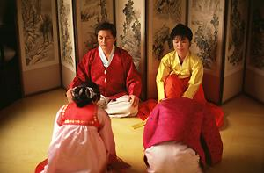
CULTURAL NOTES

Full Moon Day (추석)

Chusuk is the Korean name for the Harvest Moon Festival. It is on August 15th on the Lunar calendar and is one of Korea's most celebrated holidays. People usually get together with family members and hold special rituals to honor and give thanks to their ancestors for the harvest. People also enjoy foods taken from the fall harvest. Songpyun (송편), the half-moon shaped rice cake and cooked new crop are Chusuk's special dishes. Songpyun is usually stuffed with chestnut paste, fruit, brown sugar, and sesame seeds.
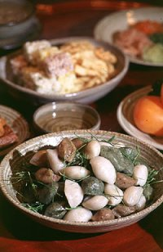
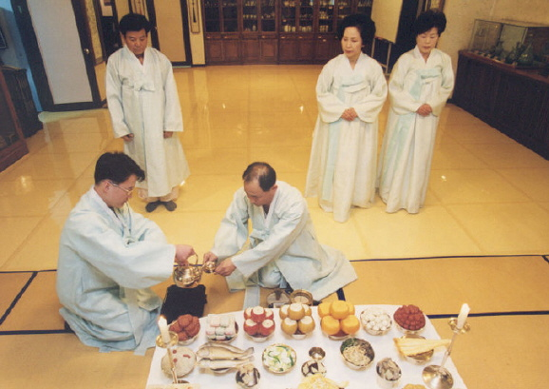
APPLICATION
ACTIVITIES

Match the following Native-Korean numbers with their corresponding Sino-Korean numbers.

스물일곱 | • | • 삼십오
아흔셋 | • | • 이십칠
일흔여덟 | • | • 삼십일
서른하나 | • | • 구십삼
예순둘 | • | • 사십
쉰여섯 | • | • 육십이
마흔 | • | • 육십삼
아흔일곱 | • | • 칠십팔
서른다섯 | • | • 구십칠
예순셋 | • | • 오십육

Follow along with your instructor as he/she reads the following dialogue and answer the questions.

A: William 상병님 가족은 언제 모두 모이세요?
B: 추수감사절에 모여요.
추수감사절에는 형제들이 모두 부모님 집에서 만나지요.
A: 추수감사절에 무엇을 하세요?
B: 가족이 함께 식사를 해요.
칠면조 고기와 호박 파이가 맛있어요.
A: 김대위님 가족은 언제 모두 모이세요?
B: 추석에 모여요. 추석은 한국의 추수감사절이에요.

Activity 1
Activity 2
APPLICATION ACTIVITIES

(1) What are they talking about?

(a) their family members’ birthdays
(b) their family-celebrated holidays
(c) their jobs
(d) their food preferences

(2) What is the most celebrated holiday for William’s family?

(a) Thanksgiving
(b) Christmas
(c) New Year’s Day
(d) his birthday

(3) What holiday does Kim’s family celebrate the most?

(a) 크리스마스
(b) 설
(c) 추석
(d) 단오

(4) According to the dialogue, what does William do on this holiday?

(a) he watches the full moon
(b) he has dinner with his family
(c) he goes out with his friends
(d) he celebrates alone

(5) What is the special food that the William’s family eats on this holiday?

(a) 송편
(b) 떡국
(c) 생일케익
(d) 칠면조 고기
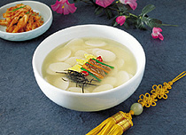
APPLICATION
ACTIVITIES

Complete the following interviews by writing in the appropriate questions.

(1) A: _____________________?
B: 제 이름은 김철수입니다.

(2) A: ______________________?
B: 서울시 반포동 32번지에서 살아요.

(3) A ______________________?
B: 올해 스물 여섯입니다.

(4) A: _______________________?
B: 제 생일은 4월 19일입니다.

(5) A: _________________________?
B: 제 아버지는 올해 사십 구세이십니다.

The situation is that you are at a department store to buy clothing for your family. The department is having a sale. Your partner will play the salesperson. The sale prices are located in the following ad. Ask about specific items and whether they’re still available. Also, decide what you will buy and thank him for his assistance. Reverse roles so that both partners can practice.

Activity 3
Activity 4
APPLICATION ACTIVITIES

알뜰 바겐 세일

캐쥬얼 의류
바지………………… 95,000원
원피스…………………125,000원
청바지………………… 27,000원
반바지…………………15,500원
니트 T …………………75,000원
정장
상의………………… 135,000원
하의………………… 88,000원

잠옷, 내의
남녀 잠옷………………… 30 % 세일
백양 내의………………… 2,000원

Referring to the previous ad, write the prices of each item.

Item | Price
Blue jeans
Shorts
Underwear
Dress
Jacket
Casual pants
Dress pants

Activity 4a
APPLICATION
ACTIVITIES

In pairs, review the following article, which contains information on Korean celebratory events. Afterwards, answer the question regarding the text. Be prepared to support your answer in class.

설날에는 떡국을 먹고 어른들께 세배를 드린다. 또한 가족들과 윷놀이를 즐긴다. 추석에는 송편을 먹고 보름달을 보면서 소원을 빈다. 이두 명절이 한국에서 가장 큰 명절이다. 이때 교통이 엄청 복잡하다.

(1) Why is there heavy traffic on celebratory days?

Complete the following exchanges by writing in the missing words from the box below. You may use words more than once.

(1) A: _____하십니까?
B:_____, ______하세요?

(2) A: 제 _____은 존 맥스웰입니다. ______뵙겠습니다.
B: 반갑습니다. 저__ 김인경입니다. 여기 서울에서 _______?

(3) A: 네, 반포에 ______.
B: 저는 한남동에서 살아요.

(4) A: 선생님 ______번호는 _______ 되십니까?
B: 597_____ 0763입니다. 선생님 전화번화는요?

(5) A: 624___1359입니다.
B: 그럼 또 _____. 안녕히 ______.

(6) A: 네, 안녕히 _______. 또 뵙겠습니다.

살아요, 가세요, 에, 뵙지요, 는, 처음, 안녕, 네, 안녕, 사세요? 전화, 어떻게, 계세요

Activity 5
Activity 6
APPLICATION ACTIVITIES

Listen to the instructor as the ages of the following people are read. Fill in the blanks as you hear them.

이름 | 나이
김호석
이샛별
최진환
차석호
노용준
최진
강원태
이해린
김성수
김해진

The situation is that you are discussing whether your counterpart has plans for the weekend. Ask what he/she usually does on Friday night, Saturday, and Sunday. Then, using the expression "주말에는 무엇을 합니까?" ask what he/she likes to do on the weekends. Also, ask about his/her specific plans for this coming weekend. Change roles and repeat the activity.

Activity 7
Activity 8
APPLICATION
ACTIVITIES

The class will be divided into two groups for this activity. Group together the items from the box below that are related to each Korean holiday and write them next to the name of the holiday in the following table. If one item applies to more than one holiday, write that item next to all the holidays it applies to. Discuss where and why things go together. Each group will share their findings with the class.

신정
추석
광복절
구정

세배, 양력 1월1일, 차례, 한복, 태극기 계양, 보름달, 송편, 떡국, 음력8월15일, 음력 1월1일, 양력 8월15일, 널뛰기, 윷놀이, 세뱃돈, 귀향, 한국의 독립기념일

This is a continuation of the previous activity. The groups will remain the same. Write the appropriate expressions from the box below next to their corresponding occasions in the following table. Some expressions may relate to more than one occasion.

생일
추석
손님
설날
약혼
결혼기념일
승진

달구경, 맥주파티, 외식, 반지, 장미꽃, 떡국, 미역국, 송편, 어서 오세요, 새해 복 많이 받으세요, 축하합니다, 또 오세요, 세배

Activity 9
Activity 10
APPLICATION ACTIVITIES

Working in pairs, partners will take turns saying what is customary and appropriate for each event that is listed below. They will match them accordingly. If you end up with two "un-matchables" start again.

설날 | • | • 생일을 축하합니다.
회갑잔치 | • | • 신랑 신부의 행운을 위해 축배!
성탄절 | • | • 수고 많이 하셨습니다.
추석 | • | • 새해 복 많이 받으세요.
20년 근속 | • | • 메리 크리스마스
결혼식 | • | • 만수무강 하십시오.
생일 | • | • 달구경 합시다.

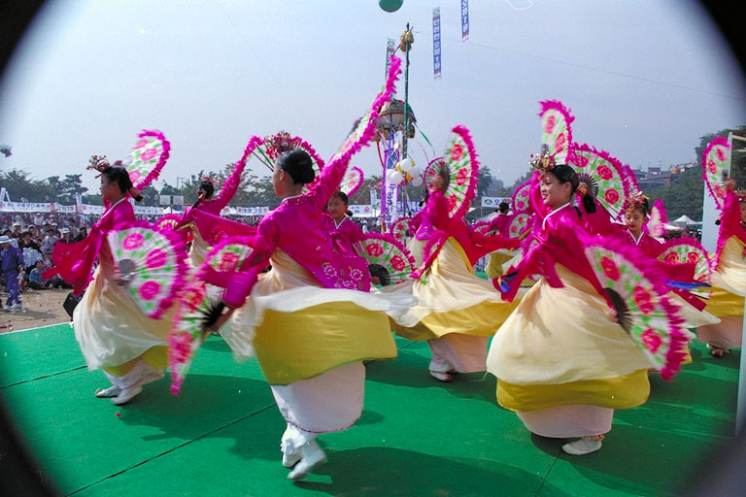
Activity 11
SKILL ENHANCEMENT
INTEGRATION

The class will be divided into groups of three students. The situation is that you are a military policeman who has taken information from two witnesses. Take information from your partners about their names, addresses, and telephone numbers and report the information to the class. Use the following statements as examples.

Example:
그분의 성함은 ____________입니다.
그분의 주소는 _____________입니다.
그분의 전화번호는 _________________입니다.

Now give information about yourself. Keep in mind the level of speech for the strangers and yourself. Change roles so that all the students can elicit and provide information.

Read the following conversation and answer the questions.

A: 어서오세요. 뭘 찾으세요?
B: 지난 주에 전투화를 주문했어요. 사이즈가 275mm예요.
A: 언제 주문하셨어요?
B: 금요일에요.
A: 이름이 어떻게 되세요?
B: 이건영이에요.
A: 이건영씨요. 아, 죄송해요. 아직 안 왔어요.
B: 언제 오면 되요?
A: 이번 주 금요일에 오세요.

Activity 1
Activity 2
SKILL ENHANCEMENT

(1) According to the sales clerk…

(a) they could not repair the boots
(b) they do not have the boots
(c) they ordered the wrong size
(d) they ordered the wrong color
(2) When did speaker B order the boots?

(a) last Wednesday
(b) last Sunday
(c) last Friday
(d) last Monday

(3) What does the sales clerk suggest 이건영to do?

(a) forget about the boots
(b) buy them somewhere else
(c) get a different color
(d) come back on Friday

Follow along with your instructor as he/she reads the following short report and answer the questions.

지난 7월 10일 토요일에 이태원에 가서 양복과 구두를 샀습니다. 양복은 고동색이고 구두는 검정색입니다. 모자도 하나 샀는데 모자의 색깔이 좋습니다. 양복은 미화로 150불이고 구두는 78불입니다.

(1) What did this person do last Saturday?
(a) he went shopping
(b) he went to cut his hair
(c) he met his friend
(d) he went out for a drink

(2) Where did he go?
(a) 남대문
(b) 이태원
(c) 동대문
(d) 롯데 백화점

Activity 3
SKILL ENHANCEMENT
INTEGRATION

(3) What kind of money did he use?
(a) American dollars
(b) Korean won
(c) Japanese yen
(d) Italian lira

(4) Which of the following items didn’t he buy?
(a) a pair of shoes
(b) a suit
(c) a hat
(d) a bag

(5) What color was the suit?
(a) black
(b) gray
(c) brown
(d) blue

The situation is that you’re trying to enhance your political acumen. In pairs, look at the chart below with the portraits of past Korean presidents on it. Ask your partner when each president was born, where he’s from, and the years he served as president. Your partner should then look at the chart below and answer your questions. Switch roles so you can both practice asking and answering questions.

Example:

이승만 대통령은 몇 년에 태어났습니까?
이승만 대통령은 몇 년부터 몇 년까지 대통령이었습니까?
이승만 대통령의 생일은 언제입니까?
이승만 대통령의 고향은 어디입니까?

Activity 4
SKILL ENHANCEMENT

Photo | Name | Date of Birth | Hometown | Years Served
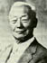 | 이승만 | 1875년 4월18일 | 황해도 평산 | 1948 – 1960(1,2,3)
 | 윤보선 | 1897년 8월 26일 | 충청남도  아산 | 1960 – 1962(4)
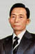 | 박정희 | 1917년 4월 9일 | 경상북도 구미 | 1963 – 1979(5,6,7,8,9)
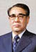 | 최규하 | 1919년 7월16일 | 강원도 원주 | 1979 – 1980(10)
 | 전두환 | 1931년 1월18일 | 경상남도  합천 | 1980 – 1988(11,12)
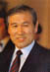 | 노태우 | 1932년 12월4일 | 경상북도 대구 | 1988 – 1993(13)
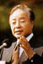 | 김영삼 | 1927년12월20일 | 경상남도 거제 | 1993 – 1998(14)
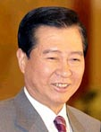 | 김대중 | 1926 년 1 월 6 일 | 전라남도 신안 | 1998 – 2003(15)
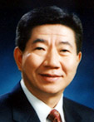 | 노무현 | 1946 년 8 월 6 일 | 경상남도 김해 | 2003 – 현재(16)  present

HOMEWORK

1. Read the following numbers aloud in Native-Korean and write them in the blanks below.

(1) 25 Answer:

(2) 67 Answer:

(3) 38 Answer:

(4) 44 Answer:

(5) 59 Answer:

(6) 72 Answer:

(7) 91 Answer:

(8) 83 Answer:

(9) 26 Answer:

(10) 60 Answer:

2. Read the following numbers aloud in Sino-Korean and write them in the blanks below.

(1) 34 Answer:

(2) 52 Answer:

(3) 89 Answer:

(4) 23 Answer:

(5) 97 Answer:

(6) 21 Answer:

(7) 48 Answer:

(8) 65 Answer:

(9) 76 Answer:

(10) 100 Answer:

HOMEWORK

3. Read the following dialogue and select the appropriate response to fill in the blank.

A: 이 전자시계 미국 달러로 얼마예요?
B: 미화로 40불이에요.
A: 너무 비싸요. 그것 보다 더 싼 것을 보여 주세요.
B: _________가 있어요.
A: 좀 보여 주세요.
B: 예, 여기 있어요.

(a) 오십불짜리
(b) 육십불짜리
(c) 이십불짜리
(d) 팔십불짜리

4. Looking at the calendar below, answer the following questions in Korean.

January
Sunday | Monday | Tuesday | Wednesday | Thursday | Friday | Saturday
 |  | 1 | 2 | 3 | 4 | 5
6 | 7 | 8 | 9 | 10 | 11 | 12
13 | 14 | 15 | 16 | 17 | 18 | 19
20 | 21 | 22 | 23 | 24 | 25 | 26
27 | 28 | 29 | 30 | 31

(1) What day of the week is Jan. 3rd?

(2) What day of the week is Jan. 26th?

(3) What day of the week is Jan. 7th?

(4) What date is the third 금요일 on the calendar above?

(5) What date is the first 화요일on the calendar above?

HOMEWORK

5. Referring to the example below, write how the dates are read in Korean.
Example: June 6th -- 6월 6일/유월 육일

(1) March 30th Answer:

(2) December 1st Answer:

(3) July 25th Answer:

(4) January 15th Answer:

(5) October 8th Answer:

6. Listen to the following dialogue between Mr. Baker and Sumi and answer the question.
(Listen to the homework audio CD Track 26 - M1L6HW6)

According to the dialogue, when will they go to the concert?

(a) Wednesday evening
(b) Sometime next week
(c) Friday evening
(d) Sunday evening

HOMEWORK

7. Listen to the audio clip and answer the following question.
(Listen to the homework audio CD Track 27 - M1L6HW7)

What is not mentioned in the passage above?

(a) the origin of Chusuk
(b) the brightness of the full moon on Chusuk
(c) the ritual on the morning of Chusuk
(d) the traffic jams on Chusak

8. Listen to the audio clip and answer the following question.
(Listen to the homework audio CD Track 28 - M1L6HW8)

According to the passage, why are Korean children so happy on the Lunar New Year’s Day?

(a) 맛있는 음식이 많아서
(b) 세뱃돈을 받아서
(c) 가족들이 한데 모여서
(d) 떡국을 먹게 되어서

9. Read the following dialogue and choose the appropriate answer for the question below.

Mrs. 장정미’s colleague just found out that she has children. She asks the ages of Mrs. 장’s children.

A: 장정미씨, 자제분이 어떻게 되세요?
B: 딸이 하나, 아들이 둘 있어요.
A: 따님이 몇 살이에요?
B: 두 살이에요.
A: 아드님들은 나이가 어떻게 돼요?
B: 큰 아이가 아홉 살, 작은 아이가 다섯 살이에요.

장정미씨의 자제분은 어떻게 됩니까?

(a) 삼남입니다.
(b) 열 살입니다.
(c) 이남 일녀입니다.
(d) 네, 결혼했습니다.

HOMEWORK

Student Notes :

