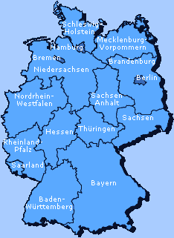

Geography
At the end of this lesson you will be able identify the different German states and the countries surrounding Germany. In order to achieve this objective you will:

Recognize the German States and Their Locations

- Recognize the states’ locations, their capitals, major cities, and regions
within the states
- Describe their areas and borders
- Brief about Germany
- Describe the geography of Germany
- Talk about the location of military installations in Germany
- Identify the national flag of the country

Identify Nationalities

- Identify languages in the world countries
- Identify different ethnic groups
- Describe demographic composition

Features of Germany

You are planning a short vacation somewhere in Germany and have asked one of your German counterparts to describe some of the various landscapes, since you can’t decide. He gives you a quick description of Germany’s geography. Where will you decide to go?

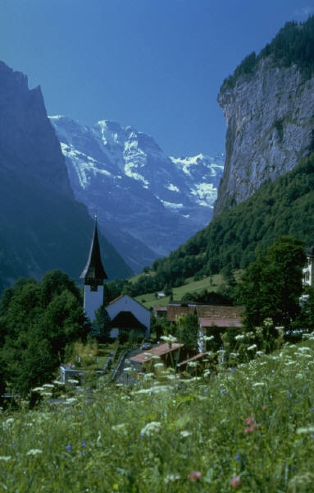

Deutschland hat sechzehn Bundesländer. Die Hauptstadt von Deutschland ist Berlin. In jedem Bundesland gibt es sehr schöne Landschaften.

Im Norden ist die Nordsee mit der schönen Insel Sylt. Das Land ist flach. Die Bundesländer dort sind Schleswig-Holstein, Hamburg und Bremen.

In der Mitte von Deutschland gibt es viele Berge. Besonders schön ist der Teutoburger Wald und der Hunsrück. Weiter südlich gibt es natürlich den berühmten Schwarzwald im Westen und den Bayrischen Wald. Einige Bundesländer dort sind Sachsen-Anhalt, Thüringen, Hessen und Nordrhein-Westfalen.

Im südlichen Teil von Deutschland liegt Bayern. Deutschlands höchster Berg, die Zugspitze, ist in den Bayrischen Alpen.

Der wichtigste und berühmteste Fluss in Deutschland ist der Rhein.
Die 16 deutschen Bundesländer und ihre Landeshauptstädte

(The 16 German Federal States and their Capitals)

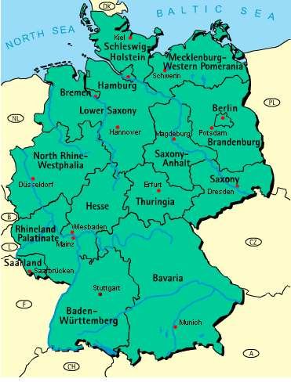
© www.germany-tourism.de/ Map in English

Germany is located in Central Europe, north of Austria and Switzerland and south of Denmark; it also borders on the North Sea and the Baltic Sea between the Netherlands and Poland. Roughly the size of Montana, re-unified Germany has an area of 357,021 square kilometers. Extending 853 kilometers from its northern border with Denmark to the Alps in the south, it is the sixth largest country in Europe. From the Belgian-German border in the west to the Polish frontier in the east, Germany measures approximately 650 kilometers.

The territory of former East Germany accounts for almost one-third of united Germany's territory and one-fifth of its population. In 1990, shortly before re-unification with West Germany, East Germany divided its administrative districts into five new states so they could legally join the federal union of German States. In 1993, after a hotly debated and close vote, the enlarged “Bundestag”, the lower house of Germany's parliament, voted to transfer the capital residence from “Bonn am Rhein”, a relatively small western city, back to the historic capital city of Berlin, which is now a city-state in the east surrounded by the state of Brandenburg.

Germany – Quick Facts and Figures

Germany is the most populous democracy in Europe and about the size of Montana.

Offizieller Name: Bundesrepublik Deutschland (Federal Republic of Germany)
(Official Name)

Hauptstadt: Berlin
(Capital)

Nachbarländer: Dänemark (Denmark), Polen (Poland), Tschechien (Czech
(Bordering countries) Republic), Österreich (Austria), Schweiz (Switzerland), Frankreich (France), Luxemburg (Luxembourg), Belgien (Belgium), die Niederlande (Netherlands)
Flagge: 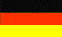
(Flag)
Klima: Kühles Klima mit reichlich Regen und Bewölkung. Niedrigere Temperaturen mit Schnee im Osten und im Süden. Neigt zu raschen Wetteränderungen.
(Climate) (Cool climate with abundant rainfall and overcast. Lower temperatures
with snowfall in east and south. Prone to rapid weather variations.)

Sprachen: Deutsch (German)
(Languages)

Breitengrad/Längengrad: 51° 00'N, 9° 00'E
(Latitude/Longitude)

Offizielle Währung: der Euro
(Official Currency)

Religionen: Hauptsächlich evangelisch (66%) und katholisch (27%)
(Religions) (mostly Protestant (66%) and Catholic (27%))

Bevölkerung: 83,251,851 (July 2002)
(Population)

Fläche: 357,021 km²
(Area)

Geographie: Norddeutschland ist flach, während die Mitte und der Westen hügelig sind. Der Südwesten dagegen ist sehr bergig. Deutschlands größte Flüsse: Donau, Elbe, Ems, Main, Rhein und Weser.
(Geography) (Germany is flat in the north, hilly in the central and western part of the country, and mountainous in the southwest. Major rivers include the Danube (Donau), Elbe, Ems, Main, Rhine (Rhein), and Weser.)

Bundesländer: 16 Bundesländer
(States) 16 Federal States
Recognize the German States and their Locations

Exercise 1 (Pair Exercise)

Using the German map on this page, write down all 16 Federal States in alphabetical order. Also, include each state’s capital and borders. Then ask your partner questions regarding the names of the different states.

Beispiele: Nennen Sie ein Bundesland mit dem Anfangsbuchstaben B.
(Name a federal state that begins with the letter B.)

Wie heißt die Hauptstadt von diesem Bundesland?
(What’s the capital of this state?)

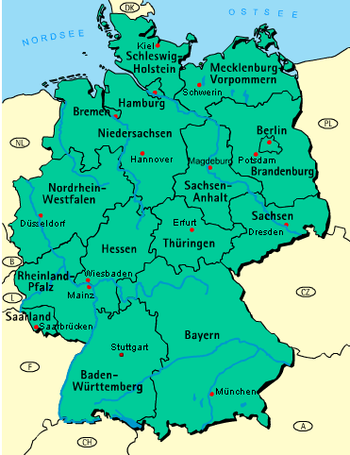
Exercise 2

Search the table below for the following German states and their capitals:

Baden Württemberg Thüringen Erfurt
Saarland Sachsen Anhalt Hannover
Hessen Rheinland Pfalz Potsdam
Bayern Bremen Saarbrücken
Mecklenburg Vorpommern Hamburg Wiesbaden
Sachsen Brandenburg Mainz
Berlin Magdeburg München
Niedersachsen Kiel Dresden
Schleswig Holstein Schwerin Stuttgart
Nordrhein Westfalen Düsseldorf

E | N | G | L | Ö | S | A | J | E | A | L | M | D | R | E | S | D | E | N | E | R
U | L | A | S | B | O | A | P | H | R | Z | E | S | M | M | A | Z | Y | Z | O | Q
A | V | E | N | U | X | W | O | O | F | I | C | C | S | A | A | R | L | A | N | D
N | E | U | W | D | I | E | T | J | A | U | K | H | I | G | H | B | O | H | M | E
O | E | Ö | R | Ü | I | N | S | U | N | F | L | L | N | D | A | R | Y | I | N | E
R | A | I | B | S | R | E | D | O | G | N | E | E | I | E | N | E | B | B | I | C
D | H | E | S | S | E | N | A | L | I | N | N | S | G | B | N | C | Ö | A | E | P
R | O | H | M | E | I | F | M | C | R | G | B | W | S | U | O | Y | E | D | D | R
H | H | O | Ü | L | E | N | Z | E | R | S | U | I | A | R | V | C | S | E | E | H
E | D | I | N | D | A | N | Y | U | D | A | R | G | C | G | E | W | C | N | R | E
I | A | N | C | O | M | A | B | B | S | C | G | H | H | E | R | I | H | W | S | I
N | B | E | H | R | B | M | S | R | A | H | V | O | S | O | R | E | W | Ü | A | N
W | K | Ä | E | F | A | N | T | A | A | S | O | L | E | S | I | S | E | R | C | L
E | Ö | I | N | H | I | W | H | N | R | E | R | S | N | T | Ö | B | R | T | H | A
S | E | W | E | L | F | N | Ü | D | B | N | P | T | W | U | S | A | I | T | S | N
T | V | Ö | R | L | Z | T | R | E | R | A | O | E | M | T | P | D | N | E | E | D
F | A | E | S | N | R | R | I | N | Ü | N | M | I | N | T | G | E | U | M | N | P
A | B | D | I | U | S | R | N | B | C | H | M | N | Ä | G | R | N | E | B | K | F
L | Ü | A | F | H | C | Ä | G | U | K | A | E | S | C | A | Ü | R | D | E | V | A
E | M | R | W | A | U | P | E | R | E | L | R | O | U | R | B | O | N | R | Ä | L
N | E | U | D | E | F | Ä | N | G | N | T | N | U | I | T | W | H | S | G | S | Z

Answer Key:
E | N | G | L | Ö | S | A | J | E | A | L | M | D | R | E | S | D | E | N | E | R
U | L | A | S | B | O | A | P | H | R | Z | E | S | M | M | A | Z | Y | Z | O | Q
A | V | E | N | U | X | W | O | O | F | I | C | C | S | A | A | R | L | A | N | D
N | E | U | W | D | I | E | T | J | A | U | K | H | I | G | H | B | O | H | M | E
O | E | Ö | R | Ü | I | N | S | U | N | F | L | L | N | D | A | R | Y | I | N | E
R | A | I | B | S | R | E | D | O | G | N | E | E | I | E | N | E | B | B | I | C
D | H | E | S | S | E | N | A | L | I | N | N | S | G | B | N | C | Ö | A | E | P
R | O | H | M | E | I | F | M | C | R | G | B | W | S | U | O | Y | E | D | D | R
H | H | O | Ü | L | E | N | Z | E | R | S | U | I | A | R | V | C | S | E | E | H
E | D | I | N | D | A | N | Y | U | D | A | R | G | C | G | E | W | C | N | R | E
I | A | N | C | O | M | A | B | B | S | C | G | H | H | E | R | I | H | W | S | I
N | B | E | H | R | B | M | S | R | A | H | V | O | S | O | R | E | W | Ü | A | N
W | K | Ä | E | F | A | N | T | A | A | S | O | L | E | S | I | S | E | R | C | L
E | Ö | I | N | H | I | W | H | N | R | E | R | S | N | T | Ö | B | R | T | H | A
S | E | W | E | L | F | N | Ü | D | B | N | P | T | W | U | S | A | I | T | S | N
T | V | Ö | R | L | Z | T | R | E | R | A | O | E | M | T | P | D | N | E | E | D
F | A | E | S | N | R | R | I | N | Ü | N | M | I | N | T | G | E | U | M | N | P
A | B | D | I | U | S | R | N | B | C | H | M | N | Ä | G | R | N | E | B | K | F
L | Ü | A | F | H | C | Ä | G | U | K | A | E | S | C | A | Ü | R | D | E | V | A
E | M | R | W | A | U | P | E | R | E | L | R | O | U | R | B | O | N | R | Ä | L
N | E | U | D | E | F | Ä | N | G | N | T | N | U | I | T | W | H | S | G | S | Z

Exercise 3 (Group Exercise)
 Tip of the Day
In Germany there are generally four administrative levels of government: federal, state, district, and municipal. The status of cities like Hamburg and Bremen (the historic Free Hanseatic Cities of Hamburg and Bremen) as well as the capital Berlin is a special one. They are “city states” and thus combine state, district and municipal authorities.

The class is split into two teams. The instructor will give each team ten questions regarding the location of certain German states. The teams have 10 minutes to write down the answers to each of the questions. Once the time is up, the two teams will compare their answers.

NOTE: There might be more than one possible answer for each of the questions.

Questions/clues:
1. Ein Bundesland im Süden Deutschlands.
2. Ein Bundesland nördlich von Sachsen-Anhalt.
3. Ein Bundesland im Westen Deutschlands.
4. Ein Bundesland mitten in Brandenburg.
5. Das nördlichste Bundesland Deutschlands.
6. Ein Bundesland mitten in Deutschland.
7. Ein Bundesland östlich von Niedersachsen.
8. Ein Bundesland zwischen Niedersachsen und Brandenburg.
9. Das größte deutsche Bundesland.
10. Ein sehr kleines Bundesland im Westen Deutschlands.
Note to the Instructor: Give each of the teams a flashcard with the above questions.

Exercise 4

Study the map of Germany below and, in German, fill in the missing bordering countries.

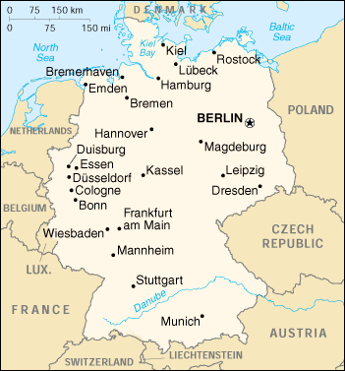

Answer Key:
Dänemark
Die Niederlande
Belgien
Luxemburg
Frankreich
Polen
Tschechien
Österreich
Schweiz
Dänemark

Note to the Instructor: Compile a list of the European countries bordering Germany’s neighbors (the ones that haven’t been covered in this lesson) for your students to learn.

Exercise 5 (Pair Exercise)

Practice the following role-play with your partner in German. Reverse roles.

A: Wo bist du denn her ?
B: Ich bin aus . . . (name the German state or bordering country).
A: Wie lange wohnst du denn schon in (. . .) ?
B: Ich wohne schon seit (…) in (…) .
A: Wo genau liegt eigentlich (…)?
B: Es liegt nördlich/südlich/östlich/westlich von (…).
Scan this chart and familiarize yourself with German geography, then follow the instructions for Exercise 6 on the next page.

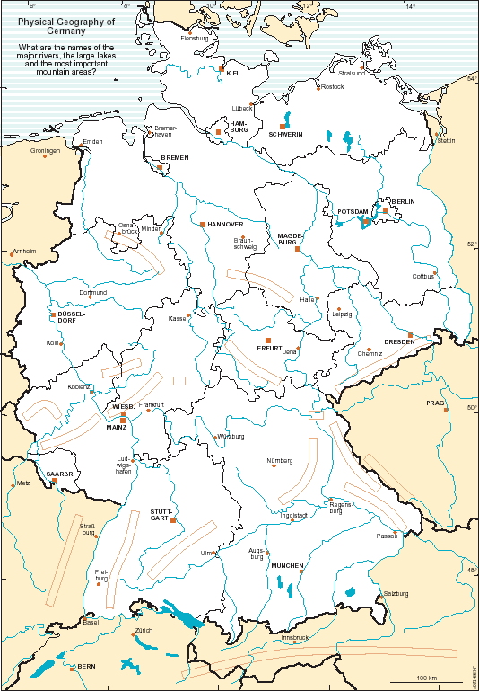
Die physische Geographie Deutschlands
(Germany’s physical geography)
1
2
3
4
5
6
7
A
B
C
E
D
F

G
H
I
J
K
L
M
20
21
24
23
25
26
27
28
29
22
Exercise 6 (Pair Exercise)

It is important to know the physical geography of the region/country you are in for a military purpose. Below is a list of the seven most important lakes, thirteen most important mountain ranges and forests, and ten most important rivers. With the help of a fellow student, choose the correct names for each of the different terrain features on the map on the previous page. Learn them, since your instructor will ask you about them the next day.

Lakes: Mountain ranges and forests:

Bodensee Teutoburger Wald Hunsrück
Schweriner See Pfälzer Wald Erzgebirge
Ammersee Schwarzwald Bayrischer Wald
Müritzer See Eifel Harz
Starnberger See Schwäbische Alb Taunus
Plauer See Fränkische Alb Thüringer Wald
Chiemsee Westerwald

Rivers:

Fulda
Isar
Main
Weser
Ems
Mosel
Donau
Rhein
Neckar
Elbe

Answer Key:
Lakes:
1. Schweriner See, 2. Plauer See, 3. Müritzer See, 4. Bodensee, 5. Ammersee,
6. Starnberger See, 7. Chiemsee,
Mountain ranges and forests:
A. Fränkische Alb, B. Pfälzer Wald, C. Bayrischer Wald, D. Schwäbische Alb,
E. Schwarzwald, F. Teutoburger Wald, G. Harz, H. Thüringer Wald, I. Erzgebirge,
J. Hunsrück, K. Taunus, L. Eifel, M. Westerwald
Rivers:
20. Isar, 21. Donau, 22. Neckar, 23. Rhein, 24. Main, 25. Mosel, 26. Fulda, 27. Elbe, 28. Ems, 29. Weser

Exercise 7 (Pair Exercise)
Tip of the Day
There are an estimated 125,000,000 people in Germany, Austria, Switzerland, Liechtenstein, Belgium, Russia, Romania, Hungary, the Czech Republic, Slovenia, Brazil, Argentina, South Africa, Chile, Puerto Rico, the USA, and Australia and who speak German as a native tongue.

Ask and answer questions about the physical geography of Germany.

Beispiele: Welche Seen liegen im Süden Deutschlands?
Im Süden Deutschlands liegen . . .

Welche Gebirge und Wälder liegen im Süd-Westen Deutschlands?
Im Süd-Westen Deutschlands liegen . . .

Without going back to the Quick Facts, write a short German summary of the things you have learned about Germany and its geography so far. Brief the rest of the class.

________________________________________________________________________

________________________________________________________________________

________________________________________________________________________

________________________________________________________________________

________________________________________________________________________

________________________________________________________________________

________________________________________________________________________

________________________________________________________________________

________________________________________________________________________

________________________________________________________________________

________________________________________________________________________

________________________________________________________________________

Exercise 8 (Pair Exercise)

Ask and answer questions about German military installations and their locations.

Beispiele: Nennen Sie einen Standort in . . . .
Wie viele Standorte des Heeres gibt es in . . .?
Nennen Sie die größten Heeresstandorte in . . .?
Was ist die Landeshauptstadt von . . .?
Nennen Sie einen Fluss, eine Bergkette, oder einen Wald in . . . .

Military Installations of the German “Heer”
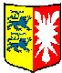
Schleswig-Holstein
Insgesamt 26 Standorte
Größte Standorte: Schleswig, Neumünster, Kiel

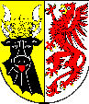
Mecklenburg-Vorpommern
Insgesamt 6 Standorte
Größte Standorte: Neubrandenburg, Schwerin, Eggesin

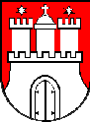
Hamburg
Insgesamt 14 Dienststellen

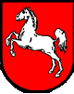
Niedersachsen
Insgesamt 16 Standorte
Größte Standorte: Hannover, Hildesheim, Münster, Oldenburg
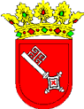

Bremen
Insgesamt 5 Dienststellen

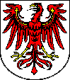
Brandenburg
Insgesamt 6 Standorte
Größte Standorte: Storkow

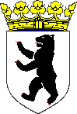
Berlin
Insgesamt 22 Dienststellen

Military installations of the German “Heer” (continued)

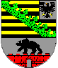
Sachsen-Anhalt
Insgesamt 4 Standorte
Größte Standorte: Havelberg

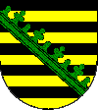
Sachsen
Insgesamt 7 Standorte
Größte Standorte: Dresden, Leipzig, Frankenberg

Thüringen
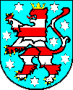
Insgesamt 6 Standorte
Größte Standorte: Erfurt, Gera

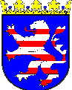
Hessen
Insgesamt 11 Standorte
Größte Standorte: Fritzlar, Neustadt

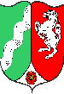
Nordrhein-Westfalen
Insgesamt 16 Standorte
Größte Standorte: Münster, Köln, Ahlen, Hilden, Bonn, Rheinbach, Düsseldorf

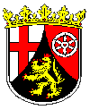
Rheinland-Pfalz
Insgesamt 9 Standorte
Größte Standorte: Mainz, Koblenz

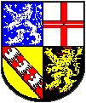
Saarland
Insgesamt 3 Standorte
Größter Standort: Saarlouis

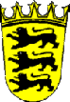
Baden-Württemberg
Insgesamt 15 Standorte
Größte Standorte: Calw, Müllheim, Ellwangen

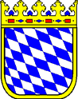
Bayern
Insgesamt 72 Standorte
Größte Standorte: München, Amberg, Veitshöchheim, Regensburg, Bogen, Ingolstadt, Bad Reichenhall
Exercise 9

Study the map below and complete the following tasks:

- Highlight the borders of the following German-speaking countries:
A. Bundesrepublik Deutschland
B. Österreich
C. Schweiz

- Label the neighboring European countries.

- Sketch and label the following rivers:
A. Rhein
B. Ems
C. Donau
- Sketch and label the following geographic features:
A. Bodensee
B. Schwarzwald
C. Teutoburger Wald
D. Bayrischer Wald
E. Thüringer Wald
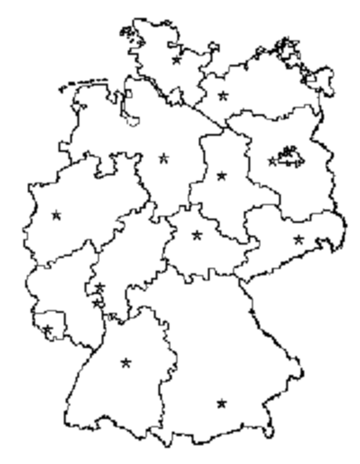
Answer Key:
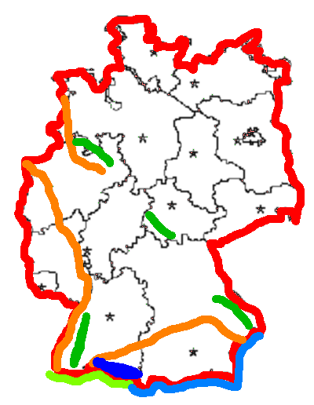
Polen
Tschechische Republik
Österreich
Schweiz
Frankreich
Luxemburg
Belgien
Die Niederlande
Rhein
Ems
Donau
Schwarzwald
Bayrischer Wald
Teutoburger Wald
Thüringer Wald

Exercise 10

Your instructor will name 15 German cities. Listen carefully and circle the mentioned locations on the map below. Indicate in which state the different cities are located. Compare your answers with those of your classmates.

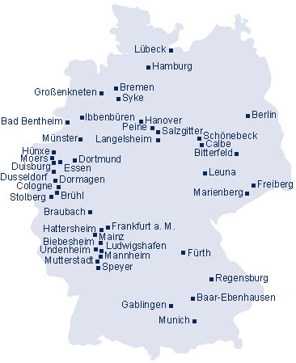

Note to the Instructor:
Choose the names of 15 German cities from the map above and read them to the students.

Adverbs of Degree and Manner

You have already learned about adverbs of time and place. Another category deals with adverbs of manner. As you already know, German adverbs do not have specific endings and their word order also varies. Adverbs usually follow the verbs or nouns they modify but precede any adjectives they modify. Adverbs of time usually come before adverbs of manner, which can be followed by adverbs of place. If there are two time or manner elements, then go from the specific to the general.
Beispiel: Er ist heute (time) schnell (manner) in den Wald (place) gerannt.

NOTE: A useful rule of thumb for general sequence is: Time – Cause – Manner - Place

Some common German adverbs of manner;

anders (different)
beinahe (almost)
besonders (especially)
fast (almost)
ganz (quite)
gern (gladly)
genug (enough)
hoffentlich (hopefully)
kaum (hardly)
langsam (slowly)
leider (unfortunately)
leise (quietly)
natürlich (naturally)
pünktlich (on time)
schnell (fast, quick)
schwer (heavy, difficult)
schwierig (difficult)
sehr (very)
sicher (certainly)
überdies (moreover)
vielleicht (maybe)
wirklich (really, indeed)
ziemlich (rather, pretty)

Exercise 1

Read the following sentences and mark the word order as correct or incorrect. Correct the sentences if necessary.

1. Die Hausaufgaben sind sehr schwierig heute. C IC
________________________________________________________________________
2. Wir gehen über Weihnachten gerne nach Hause. C IC
________________________________________________________________________
3. Pünktlich sie kommt Montags nie. C IC
________________________________________________________________________
4. Er kommt abends gewöhnlich um 8 Uhr nach Hause. C IC
________________________________________________________________________
Answer Key:
1. IC – Die Hausaufgaben sind heute sehr schwierig.
2. C
3. IC – Sie kommt Montags nie pünktlich.
4. C

Exercise 2

Study the following sentence elements and put them into the correct order according to the adverb rule.

1. vielleicht / er / kommt / nach Hause
____________________________________________________________
2. besonders / freue / ich / mich / Geburtstag / auf / meinen
____________________________________________________________
3. Sie / ist / gefahren / schnell / sehr
____________________________________________________________
4. Nie / pünktlich / komme / ich / zum / Unterricht
____________________________________________________________

Answer Key:
1. Vielleicht kommt er nach Hause.
2. Ich freue mich besonders auf meinen Geburtstag.
3. Sie ist sehr schnell gefahren.
4. Ich komme nie pünktlich zum Unterricht.

Baden-Württemberg | Baden-Württemberg
Bayern | Bavaria
bedeutend | important
Belgien | Belgium
Berg, der die Berge | mountain
Berlin | Berlin
Bevölkerung, die (-en) | population
bilden | to form
Binnenwasserstraße, die (-n) | inland waterway
Brandenburg | Brandenburg
Bremen | Bremen
Bundesland, das (-länder) | federal state
Bundesrepublik Deutschland | Federal Republic of Germany
Dänemark | Denmark
Dienststelle, die (-n) | department, agency
flach | flat
Fläche, die (-n) | area
Flagge, die; die Fahne (-n) | flag
fließen | to flow
Fluss, der die Flüsse | river
Frankreich | France
Geographie, die | geography
grenzen an | to border
Hamburg | Hamburg
Hauptstadt, die die Hauptstädte | capital
Hessen | Hesse
Klima, das | climate
Landeshauptstadt, die (-städte) | state capital
Luxemburg | Luxembourg
Mecklenburg-Vorpommern | Mecklenburg-Western Pomerania
münden, fließen | to flow (into)
Nachbarland, das die Nachbarländer | neighboring country
Nebenfluss, der die Nebenflüsse | tributary
Niederlande, die | Netherlands
Niedersachsen | Lower Saxony
Norden, der | North
Nordrhein-Westfalen | North Rhine-Westphalia
Osten, der | East
Österreich | Austria
Polen | Poland
Rheinland-Pfalz | Rhineland-Palatine
Saarland | Saarland
Sachsen | Saxony
Sachsen-Anhalt | Saxony-Anhalt
Schleswig-Holstein | Schleswig-Holstein
Schweiz, die | Switzerland
See, der die Seen | lake
Standort, der die Standorte | location, garrison
Süden, der | South
Thüringen | Thuringia
Tschechien | Czech Republic
Wald, der die Wälder | forest
Welt, die | world
Westen, der | East
Wirtschaft, die die Wirtschaften | economy

Supplemental Vocabulary

Güter, die | goods
Bezug auf, in | in reference to
ausbilden | to train, to educate
betragen | amount to
berühmt | famous
Dialekt, der | dialect
eigentlich | actually
Einwohner, der (die) | citizen
Ersatzteil, das die Ersatzteile | replacement/spare part
evangelisch | Protestant/Lutheran
gewöhnlich | usually
Insel, die (-n) | island
katholisch | Catholic
Landschaft, die (-en) | landscape
Manöver, das | manouver
natürlich | naturally, certainly
nennen | name
sprengen | to blast, to detonate, to blow sth. up
umfassen | to cover, comprise, surround, enclose
umgeben sein | to be surrounded
um…herum | around
umgeben | surround
Unterbringung, die | accommodation
verlegen | move, transfer
hauptsächlich | mainly
unterteilen | to divide

Germany’s natural regions

Germany can be divided into five natural regions. The largest consists of a part of the great plain that extends across Europe from the Netherlands to the Ural Mountains in Russia. The North German Plain is largely flat, but in the east there are chains of small hills consisting of glacial deposits. In the west there are areas of marshes along the coasts with sandy heath and moorlands inland.

Farther south a complex region of hills and valleys forms the Mid-German Uplands. These hills are partially of volcanic origin. The major ranges of hills in the west are the Eifel, Hunsruck, Westerwald, Taunus, and Hardt mountains, which are located on both sides of the Rhine River. In the center are the Harz Mountains and the Thüringer Wald, and in the east the Erzgebirge, which form part of the border with Czechoslovakia. The western hills are not very high, but the Brocken in the Harz reaches 3,747 ft (1,142 m) and the Fichtelberg in the Erzgebirge reaches 3,980 ft (1,213 m).

South of the Mid-German Uplands a region of plateau and lowlands stretches across the country. It contains a chain of hills known as the Swabian and Franconian Jura, which extends from southwest to northeast. These hills are formed from limestone and present steep sharp slopes to the north. To the west, the Black Forest (Schwarzwald), follows a north-south direction. The Rhine River flows through a deep, densely forested valley to its west. Its highest summit is the Feldberg at 4,898 ft (1,493 m). This region of southern Germany also contains a central area of plains and low hills crossed by the Neckar and Main rivers, both tributaries of the Rhine. To the east, the Bohemian Forest forms part of the border with Czechoslovakia. It rises to more than 4,700 ft (1,430 m).

The two southern regions consist of the Bavarian Alps and the Bavarian Plateau. The plateau contains small hills and valleys formed by the tributaries of the Danube River, which borders on the north. The Bavarian Alps contain the highest mountain in Germany, the Zugspitze at 9,721 ft (2,963 m), and form a region of great natural beauty.

Most of Germany's rivers flow northward to the North Sea. The longest is the Rhine, 820 miles (1,320 km) long--with its tributaries, the Main, Neckar, and Mosel Rivers, followed by the Elbe, Weser, and Ems. The Oder flows to the Baltic Sea, and the Danube, with its tributaries, the Iller, Lech, and Isar rivers, flows to the Black Sea. Most of these are navigable and are connected by a system of canals that cross Germany from east to west.

There are a few lakes, such as Lake Constance (Bodensee), which form part of the border with Switzerland and Austria. North of the Alps there is a chain of small lakes, including the Chiemsee, Ammersee, and Starnberger See, or Würmsee. In the north, the Muritzer-see and Schwerinersee are the largest of a group of small lakes between the Oder and Elbe rivers. South of Berlin, there are small lakes formed by the Spree and Havel rivers.

There are several islands along the German North Sea coast. The East Frisian Islands are a continuation of the string of islands that stretches along the coast of The Netherlands, and the North Frisian Islands are located to the south of the Danish border. The main island is Sylt, which is connected by a causeway with the mainland. Between the two groups of islands is the small rocky island of Helgoland. The Baltic coast has few islands, the largest being the flat island of Rügen.

History of the Federal States

For most of its history, Germany had been divided into a large number of more or less independent states. Most of the states as we know them today were established after 1945, and they have largely retained their ethnic traditions and characteristics, together with some of the old boundaries. Until Germany was reunited in 1990, the Federal Republic (founded in 1949) consisted of eleven states, which had evolved out of the three “Western” occupation zones after World War II.

In the Soviet-occupied zone, which later became the German Democratic Republic (GDR), five democratic states were likewise formed after the end of the war, but these were soon replaced by a centralized administration. After the first free election in the former GDR on March 18, 1990, five new states were created with boundaries largely conforming to those of the period prior to 1952. On October 3, 1990 the German Democratic Republic was reunited with the Federal Republic, creating Europe’s largest economy and most populous nation. The states of Mecklenburg-Western Pomerania, Saxony-Anhalt, Brandenburg, Saxony, and Thuringia became part of the 16 Federal States of the Federal Republic of Germany.

Germany’s former and new capital - Berlin

Germany’s capital and its largest city is Berlin. Its population is approximately 3.5 million people and it covers about 883 km². After World War II, Berlin became a divided city. In 1949 the eastern part of Berlin, the sector controlled by the Soviet Union, became the capital of the German Democratic Republic (East Germany). West Berlin was turned into a city-state and remained occupied by the Western allied powers USA, Britain, and France. It became politically closely connected with (but was never fully a part of) Western Germany, and kept a special “Four Powers” status until reunification.

In 1961, in order to stop its citizens from escaping to the more prosperous West, East Germany constructed a barrier of barbed wire and concrete around West Berlin, which come to be known as the “Berlin Wall.” During the next 30 years, more than 70 East Germans were killed climbing the wall while trying to reach the West. More than 100 people were injured and at least 3,000 were captured.

With the collapse of Communism in the Soviet Union, reunification of East and West Germany, and also of East and West Berlin, became possible. Berlin once again became the capital of a united Germany.

For further information in English on Germany, go to: www.germany-tourism.de, or www.howtogermany.com

German Dialects

The German you are learning here is the so-called Hochdeutsch, but up to 50% of all Germans, especially in the country, do not speak Hochdeutsch at home. They speak one of the many German dialects.

A very general overview of the main dialect families is:

- Niederdeutsch (Low German/Plattdeutsch), including: Northern Lower Saxon, Westphalian, Eastphalian, Brandenburgian, East Pommeranian, Mecklenburgian, etc. For the English speaker, these are often surprisingly easy to understand.

- Mitteldeutsch (Middle German), spoken in the center of Germany to Luxembourg) eastward into present-day Poland and the region of Silesia (Schlesien).

- Fränkisch (Frankish)
Frankish dialect is spoken along Germany's Main River to the Moselle River.

- Alemannisch (Alemannic) is spoken in Switzerland north along the Rhine, to the city of Karlsruhe in Germany. It includes Alsatian, Swabian, Low and High Alemannic, and Schwyzertüütsch.

- Bairisch-Österreichisch (Bavarian-Austrian) extends over a large area, from Bavaria into Austria.

Although most Germans have learned Hochdeutsch in school, the differences between the dialects are so extreme that native German dialect speakers may not understand each other. For example, a farmer in the Bavarian woods, and a worker from Cologne will have difficulty knowing what the other is talking about. According to one poll, the dialects most disliked in Germany are “Sächsisch,” 50%, “Berlinerisch” 24%, “Bairisch” 19%, “Schwäbisch“ 14%, “Thüringisch” 13%, and “Hessisch”11%. If you are interested, there is a very comprehensive website on German dialects available at http://www.ex.ac.uk/~pjoyce/dialects/diagen.html.

In general, the local dialects are much more colorful than Hochdeutsch, and can often be quite playful. Dialects have the humor many people think is missing in the “high” and “official” Hochdeutsch, and this humor can often be vulgar. Pennsylvania Dutch is actually just another southern German dialect, developed over the centuries, and mixed with a few American words.
Recognize the German States and their Locations

Activity 1 (Pair Activity)

Study the pictures of the two German Federal States below, then ask (one student) and answer (the other student) the following questions on the first state in German. Change roles with the second state.

1. Wie heißt dieses Bundesland?
2. Was ist die Hauptstadt von diesem Bundesland?
3. Welches sind seine Nachbarstaaten?
4. Welches sind seine geographischen Hauptmerkmale?
5. Wie viele militärische Standorte gibt es in diesem Bundesland?
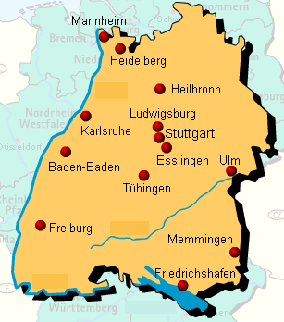

______________________________
______________________________
______________________________
______________________________
______________________________
______________________________
______________________________
______________________________
______________________________
______________________________
______________________________
______________________________
______________________________

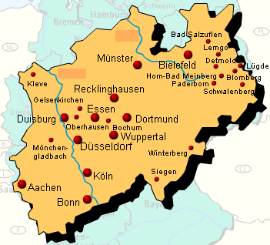

______________________________
______________________________
______________________________
______________________________
______________________________
______________________________
______________________________
______________________________
______________________________
______________________________
______________________________
______________________________

Answer Key:
A.
1. Baden-Württemberg
2. Stuttgart
3. Bayern, Hessen, Rheinland-Pfalz
4. Donau, Neckar, Schwarzwald, Schwäbische Alb
5. 15 Standorte
B.
1. Nordrhein-Westfalen
2. Düsseldorf
3. Niedersachsen, Hessen, Rheinland-Pfalz
4. Ems, Rhein, Teuteburger Wald
5. 16 Standorte

Activity 2 (Pair Activity)

Using Activity 1 as an example, describe a Federal State to your partner, mentioning everything except the name of the state. Describe it in as much detail as possible so your partner can guess its name.

Activity 3

Imagine that you are stationed in Germany, and you took part in a combined exercise in one of the neighboring countries. The instructor will ask each student where the exercise took place and where the country is in relation to Germany as well as to other countries. The instructor will also ask about the length of the exercise.

NOTE: Write down your classmates’ answers for Activity 4.

Note to the Instructor:
“Wo fand das Manöver statt?”
“Wie lange dauerte das Manöver?”

Activity 4

Using your classmates’ answers from Activity 3, report to the instructor the location and duration of the exercise one of your classmates participated in.
Activity 5 (Group Activity)

The class is divided into two groups. Each group assigns each group member a particular piece of information to memorize about Germany. Once as many facts as possible have been memorized, the first group pretends to be briefing a group of soldiers that have just arrived in Germany. Switch roles. Each group may also ask the briefing group questions about points they might have left out.

Activity 6 (Group Activity)

The class is split up into two teams. The instructor will then ask 20 questions regarding the physical geography of Germany. The group that can answer the most questions in the fastest time wins.

Sample Questions:
“Welcher See beginnt mit dem Buchstaben M?”
“Welches ist der größte deutsche See?“
Note to the Instructor:
Prepare 20 questions following the sample questions above.

Activity 7 (Reading Comprehension)

Read the following text and fill in the blanks with the words from the jumble box. Compare your answers with those of the class. Ask questions related to the reading to your classmates and discuss the answers.

Der _________ ist mit 1320 Kilometern der längste Fluss Deutschlands. Er fließt durch die _____________, Österreich, Liechtenstein, _______________, _______________ und die _________________, bis er in die Nordsee mündet. Er bildet sich in den Schweizer Alpen aus dem Vorderrhein und dem Hinterrhein. Der Rhein bildet insgesamt eine _________ von zirka 220.150 Quadratkilometern. Seine größten Nebenflüsse sind die Aare (Schweiz), der ____________, der_________, die Lahn, die Ill (Frankreich), die ___________, die Ruhr und die Lippe. Der Rhein ist eine der wirtschaftlich bedeutendsten ______________________ der Welt.

Fläche Main Rhein Deutschland Mosel
Binnenwasserstraße Schweiz Neckar Frankreich Niederlande

Answer Key:
Der Rhein ist mit 1320 Kilometern der längste Fluss Deutschlands. Er fließt durch die Schweiz, Österreich, Liechtenstein, Frankreich, Deutschland und die Niederlande, bis er in die Nordsee mündet. Er bildet sich in den Schweizer Alpen aus dem Vorderrhein und dem Hinterrhein. Der Rhein bildet insgesamt eine Fläche von zirka 220.150 Quadratkilometern. Seine größten Nebenflüsse sind die Aare (Schweiz), der Neckar, der Main, die Lahn, die Ill (Frankreich), die Mosel, die Ruhr und die Lippe. Der Rhein ist eine der wirtschaftlich bedeutendsten Binnenwasserstraßen der Welt.
Note to the Instructor:
The order of the countries and rivers may vary.

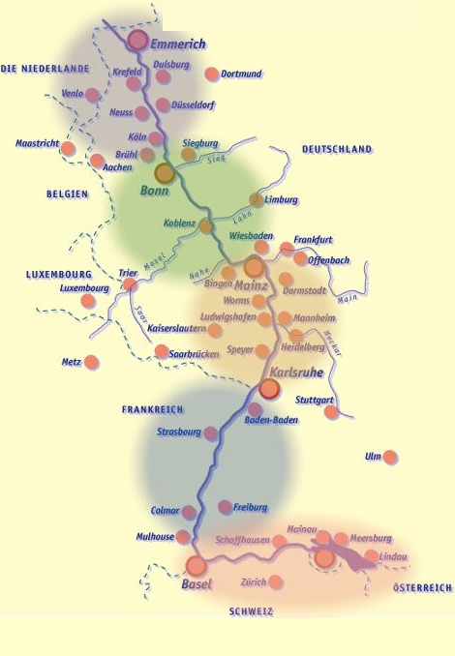
© http://www.rheintourismus.de/
Activity 8

Your instructor will ask you a question regarding German military installations. Using the map below, answer his/her question by naming at least one large German military installation in the state mentioned.

Beispiel: Welche größeren Standorte gibt es in Bayern?
Ein größerer Standort des Heeres in Bayern ist Ingolstadt.

Activity 9

The map below shows the active aircraft operating US Air Force and US Army bases/posts in Germany. Use the map to ask each other questions about the locations of the different bases. Use the following questions as guidelines for your German questions.

- Name a state in which US Air Force and Army bases/posts are located.
- How many bases/posts are located in ________________?
- At the border of which country(ies) does the base/post in ______________ lie?
- Which state(s) has/have the least installations?

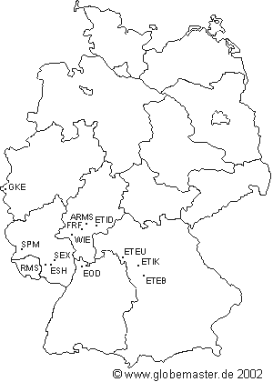

NOTE: Discuss with your instructor why most US military installations in Germany are located in Southern Germany.

Activity 10

Your instructor will read to you some facts about Germany. Some of them might be wrong. Listen carefully and mark the answer as true or false. Once you have marked all the answers, correct the false answers on the lines provided, and discuss them in class.

1. True False ________________________________________________
2. True False ________________________________________________
3. True False ________________________________________________
4. True False ________________________________________________
5. True False ________________________________________________
6. True False ________________________________________________
7. True False ________________________________________________
8. True False ________________________________________________

Reading Key:
1. Das Erzgebirge liegt im Osten Deutschlands.
2. Die Hauptstadt Deutschlands ist Bonn.
3. Deutschland hat 11 Bundesländer.
4. Deutschland grenzt im Westen an Frankreich.
5. Der Rhein fließt nur durch ein einziges Bundesland.
6. Bayern hat die meisten Bundeswehrstandorte in Deutschland.
7. In Sachsen hat die Bundeswehr überhaupt keine Standorte.
8. Nordrhein-Westfalen hat insgesamt 7 große Standorte.
Answer Key:
1T, 2F, 3F, 4T, 5F, 6T, 7F, 8T

Exercise 11 (Group Exercise)

In the Introduction section, you have learned to describe a country’s geography. Now, imagine that you have just arrived at a German military installation and you want to brief your German counterparts about the geography of your home state. Without mentioning the name of the state, describe its geography in as much detail as possible, so that your German counterparts (your classmates) can guess the state.

Recognize the German States and their Locations

Activity 1 (Pair Activity)

Without looking them up, list all 16 German Federal States and their state capitals, if applicable. One student will name a state and the other will name the state’s capital. You also may reverse roles. (Write down their German names.)

1. ________________________________ ________________________________
2. ________________________________ ________________________________
3. ________________________________ ________________________________
4. ________________________________ ________________________________
5. ________________________________ ________________________________
6. ________________________________ ________________________________
7. ________________________________ ________________________________
8. ________________________________ ________________________________
9. ________________________________ ________________________________
10. ________________________________ ________________________________
11. ________________________________ ________________________________
12. ________________________________ ________________________________
13. ________________________________ ________________________________
14. ________________________________ ________________________________
15. ________________________________ ________________________________
16. ________________________________ ________________________________

Answer Key:
1. Schleswig-Holstein (Kiel), 2. Mecklenburg Vorpommern (Schwerin), 3. Hamburg,
4. Bremen, 5. Berlin, 6. Niedersachsen (Hannover), 7. Brandenburg (Potsdam),
8. Sachsen-Anhalt (Magdeburg), 9. Nordrhein-Westfalen (Düsseldorf), 10. Thüringen (Erfurt), 11. Sachsen (Dresden), 12. Hessen (Wiesbaden), 13. Rheinland-Pfalz (Mainz), 14. Saarland (Saarbrücken), 15. Baden-Württemberg (Stuttgart), 16. Bayern (München)
Activity 2 (Pair Activity)
Without looking them up, list all 9 countries bordering Germany (write down their German names). Then, turn to your neighbor, and alternate telling each other their location in relationship to Germany.

1. ________________________________________________________________
2. ________________________________________________________________
3. ________________________________________________________________
4. ________________________________________________________________
5. ________________________________________________________________
6. ________________________________________________________________
7. ________________________________________________________________
8. ________________________________________________________________
9. ________________________________________________________________

Answer Key:
1. Dänemark, 2. Polen, 3. Tschechische Republik, 4. Österreich, 5. Schweiz,
6. Frankreich, 7. Luxemburg, 8. Belgien, 9. die Niederlande

Activity 3 (Group Exercise)

The instructor will begin by asking the first student “Was ist die Landeshauptstadt von (insert Federal State)?” The student will answer and add some geographical characteristics of it. Then turn to the next student and ask him/her the same question, using a different state. Continue until each state has been covered.

Activity 4 (Pair Activity)

Ask your partner the following question: “In welchem Bundesland liegt . . .(name of the city)?” He or she will answer the question and ask you the same question about another city from the map below. Ask your partner about the location of at least six cities.

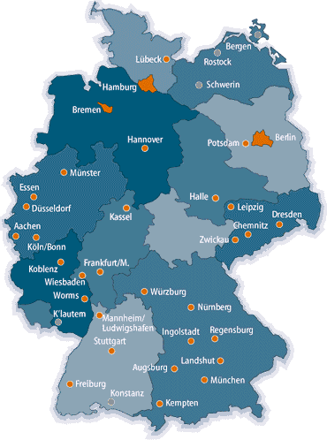

Activity 5 (Pair Activity)

Imagine that you are the sponsor for a US soldier who will be arriving in Germany shortly. He or she (your partner) will ask you the questions below in English. Answer in German in as much detail as possible. Compare the answers with those of your peers.

- What does the physical geography of Germany look like?
- Tell me something about religion in Germany.
- How many German states are there, and what is special (besonders) about three of them?
- How many countries are bordering Germany?
- What is the population size of Germany?

Activity 6 (Pair Activity)

Imagine that your commander (your partner) has just arrived in Germany and that you have to brief him about the physical geography of Germany. Three different types of exercises are planned and you will have to recommend the best location (federal state and lake or mountain range) for the exercise. Brief the class.

1st exercise involves diving
2nd exercise involves mountain climbing
3rd exercise involves skiing

Since more than one state is suitable for the above activities, you will be able to switch roles and name different locations.

Activity 7 (Pair Activity)

Below are two descriptions of German military installations. Each of you chooses one of the locations and studies it carefully. You will then pretend that you are stationed at this particular installation, and you will tell your partner all the details without looking at the description below.

1. Diez (Freiherr-vom-Stein-Kaserne)
- Transportbataillon 370
→ Transportiert Bundeswehrgüter: Ausrüstung, Ersatzteile, Munition, Fahrzeuge, Post
- Größe der Kaserne: 289.000m²
- Unterbringung für 1.500 Soldaten
- Bildet Soldaten zu Transportsoldaten aus
- Bevölkerung von Diez: 10.000
Activity 7 (continued)

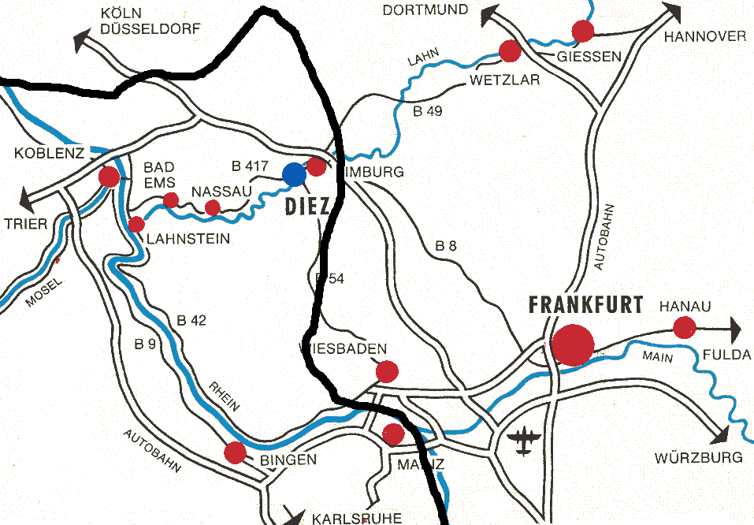

HESSEN

2. Emmerich (Moritz-von-Nassau-Kaserne)
- Größe: 329.000m²
- Unterbringung für 1.200 Soldaten
- Stabsgebäude, Unterkunftsgebäude, Sporthalle, Technischer Bereich, Ausbildungsstätten
- Ausbildungseinrichtungen: 2 Übungsplätze, Schießanlage, Wasserübungsplatz, Sprengbunker
- Bevölkerung Emmrichs: fast 30.000 Einwohner

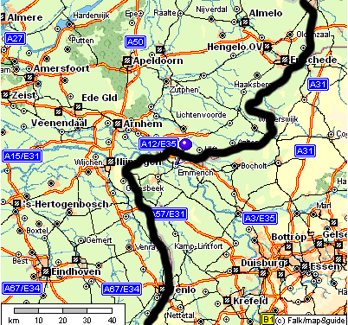
DIE NIEDERLANDE
Activity 8 (Pair Activity)

Imagine that you have to explain to another soldier how to get from one German city to another. Make sure to mention the rivers, mountain, forests, and cities he or she will be driving through or crossing on the way. Reverse roles. (You may use the physical geography map from the introduction, if necessary.)

- Von Nürnberg nach Magdeburg
- Von Dortmund nach Bremen
- Von Freiburg nach Augsburg
- Von Regensburg nach Frankfurt

Activity 9

Your instructor will give you some information about Germany’s capital Berlin. Listen carefully and answer the questions below in German. Discuss your answers with those of your classmates.
1. Welche drei besonderen Faktoren kann man in Bezug auf den Status von Berlin nennen?
______________________________________________
2. Welche Bundesländer liegen um Berlin herum?
______________________________________________
3. Wie groß ist die Fläche von Berlin in Quadratkilometern?
______________________________________________
4. Welche drei deutschen Städte sind zusammen genauso groß wie Berlin?
______________________________________________
5. Wie viele Einwohner hat Berlin?
______________________________________________
6. Welche Stadt war die offizielle Hauptstadt der Bundesrepublik Deutschland von 1945 bis 1991?
______________________________________________
7. How many large rivers and lakes are in Berlin?
______________________________________________

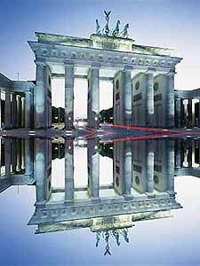

Reading Key:
Berlin ist erstens die Hauptstadt Deutschlands, zweitens ein Bundesland, und außerdem die größte Stadt des Landes. Berlin ist umgeben vom Bundesland Brandenburg und hat eine Fläche von 891 Quadratkilometern. Das ist eine Fläche so groß wie München, Stuttgart und Frankfurt zusammen. Die Einwohnerzahl beträgt zirka 3,39 Millionen. Berlin war von 1871 bis 1945 Hauptstadt des Deutschen Reiches. Nach 1945 wurde die Hauptstadt nach Bonn verlegt, bis in 1991 Berlin wieder den Titel der Hauptstadt erhielt. In Berlin fließen drei große Flüsse: die Havel, die Spree und die Panke. Außerdem gibt es auch drei Seen in Berlin: der große Wannsee, der Tegeler See und der Müggelsee.
Answer Key:
1. Berlin ist die Hauptstadt, ein Bundesland und die größte Stadt Deutschlands.
2. Das Land Brandenburg
3. 891 Quadratkilometer
4. München, Stuttgart und Frankfurt zusammen
5. 3,39 Millionen Einwohner
6. Bonn
7. 3 Flüsse und drei Seen

Activity 10 (Group Activity)

Split the class into two groups. Each group brainstorms about all the facts learned about the 16 federal states – past and present. Then, each group gives a brief presentation on the information that has been put together.

Activity 11

Match the German adverbs on the left with their English equivalents on the right and create a sentence using it.

fast difficult
langsam fast
pünktlich quite
vielleicht almost
wirklich certainly
ziemlich quietly
ganz moreover
kaum naturally
anders enough
gern very
hoffentlich unfortunately
schwierig heavy
leise almost
sicher slowly
überdies maybe
beinahe really
sehr on time
schnell especially
natürlich hopefully
leider different
besonders gladly
schwer hardly
genug rather, pretty

---------------------------------------------------------------------------------------------------------

Answer Key:

fast difficult
langsam fast
pünktlich quite
vielleicht almost
wirklich certainly
ziemlich quietly
ganz moreover
kaum naturally
anders enough
gern very
hoffentlich unfortunately
schwierig heavy
leise almost
sicher slowly
überdies maybe
beinahe really
sehr on time
schnell especially
natürlich hopefully
leider different
besonders gladly
schwer hardly
genug rather, pretty

Activity 1

Go on a scavenger hunt. If you have studied this lesson carefully, you will be able to answer the following questions. If you need help with this task, search for your answer in the Introduction section. Be ready to discuss your answers in class tomorrow.

1. Welches ist das nördlichste deutsche Bundesland?
_____________________________________________________________
2. Wie heißt die Hauptstadt von Bayern?
_____________________________________________________________
3. Wie heißt die Hauptstadt von Deutschland?
_____________________________________________________________
4. Welches Bundesland (abgesehen von den Stadtstaaten) hat die kleinste Fläche?
_____________________________________________________________
5. Welches Bundesland hat die größte Fläche?
_____________________________________________________________
6. Was ist “Rhineland Palatine” auf deutsch?
_____________________________________________________________
7. Was ist die Hauptstadt von Hessen?
_____________________________________________________________
8. Von welchem Bundesland ist Dresden die Hauptstadt?
_____________________________________________________________
9. Von welchem Bundesland ist Berlin rings herum umgeben?
_____________________________________________________________
10. Wie heißt die Hauptstadt von Niedersachsen?
_____________________________________________________________
Answer Key:
1. Schleswig Holstein, 2. München, 3. Berlin, 4. Saarland, 5. Bayern, 6. Rheinland-Pfalz, 7. Wiesbaden, 8. Sachsen, 9. Bundesland Brandenburg, 10. Hannover

Activity 2 (Reading Comprehension)

The paragraph below contains six mistakes. Find the mistakes and correct them in German. Be ready to explain your correction in class tomorrow.

Die Bundesrepublik Deutschland umfaßt eine Fläche von 300,520 Quadratkilometer und die Einwohnerzahl liegt ungefähr bei 83 Millionen. Die Landessprache ist Deutsch aber es gibt viele Dialekte in den verschiedenen Regionen. Die Bevölkerung ist hauptsächlich katholisch. Im Norden Deutschlands gibt es sehr viele Berge und man kann dort gut Skifahren. Der Süden Deutschlands ist eher flach. Die Bundesrepulik Deutschland ist in 15 Bundesländer unterteilt. Drei Bundesländer sind Städte. Die kleinste der drei Städte ist Berlin, welches außerdem die Hauptstadt Deutschlands ist.

1. ______________________________________________________________________
2. ______________________________________________________________________
3. ______________________________________________________________________
4. ______________________________________________________________________
5. ______________________________________________________________________
6. ______________________________________________________________________

Answer Key:
1. Die Bundesrepublik Deutschland umfaßt eine Fläche von 351.021 Quadratkilometern.
2. Die Bevölkerung ist hauptsächlich evangelisch.
3. Der Norden Deutschlands ist sehr flach.
4. Der Süden Deutschlands ist sehr bergig.
5. Die Bundesrepublik Deutschland ist in 16 Bundesländer unterteilt.
6. Berlin ist die größte der drei Städte und die größte Stadt des Landes.
 Activity 3

The following song is the anthem of one of Germany’s states. Listen carefully and determine which state is mentioned. Write down its German name.

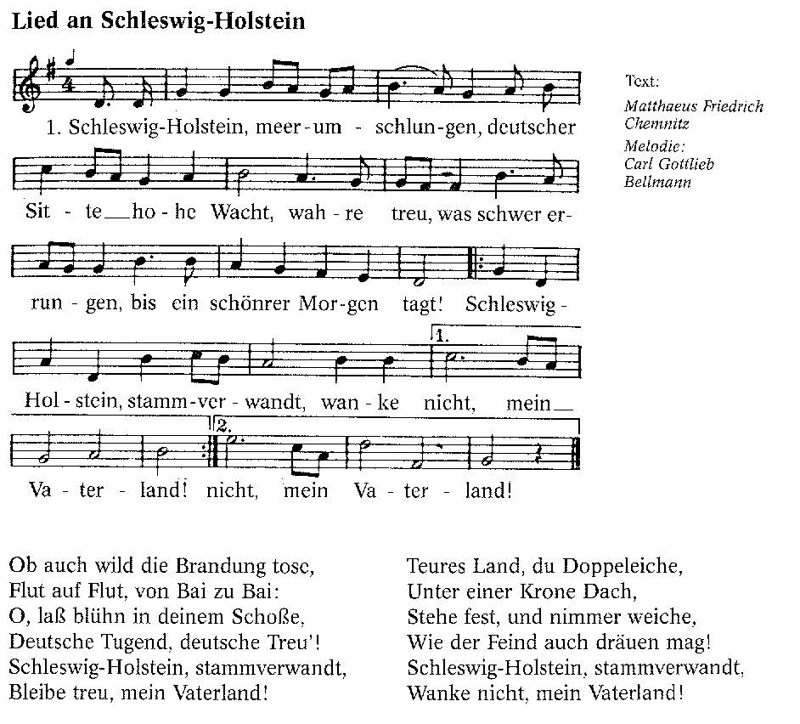
© http://www.shantychor-hornblower.de

Worte: Matthias Friedrich Chemnitz (1844)
Weise: Karl Gottlieb Bellmann (1844)

NOTE: The song is from the middle of the 19th century. The pathos (passion) of the words is representative of European Nationalism, typical of this era.

Answer Key: Schleswig-Holstein

Activity 4

Your instructor will assign a federal state to each of you. Go to a German search engine like www.yahoo.de and find out as much information about the state as possible. Give a 5-minute presentation in German on the state you researched.

Activity 5

Listen to the instructor read the exercise and report what you heard.

1. Die deutsche Wirtschaft ist die größte Europas und die fünftgrößte der Welt.

2. Dänemark grenzt an Deutschland, aber die Grenze ist nur 50 Kilometer lang.

3. Der Standort der deutschen Fallschirmjägerschule befindet sich in Altenstadt, bei München.

4. Deutschland hat eine Insel in der Nordsee. Sie heißt Helgoland.

5. Die Autobahn bildet ein bedeutendes Transportnetz für das deutsche Heer.
Answer Key:

- The German economy is the biggest in Europe and the 5th biggest in the world.
- Denmark borders on Germany, but the border is only 50 kilometers long.
- The location of the German airborne school is located in Altenstadt by Munich.
- Germany has an island in the North Sea. It’s called Helgoland.
- The German interstate highway forms a transport net for the German army.

