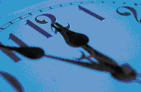

Time and Measurement

At the end of this lesson you will be able to tell the time in German and use metric measurements. In order to achieve this objective you will:

Tell Time

- Use the official military time
- Use the 12-hour system for telling time
- Ask/answer questions about time

Use the Metric System

- Tell the distance in the metric system
- Use numbers from 101 through 1,000,000
- Compare the metric system with US system
- Recognize and use the metric system of weights and measurements
- Recognize types of packaging used in Germany

Train Travel

You are waiting for your wife at the train station in Stuttgart. You haven’t seen her for two weeks since she was visiting a friend in Frankfurt.

Jim Jones: Entschuldigen Sie bitte! Können Sie mir sagen, wann der Zug aus Frankfurt ankommt?
Ein Herr: Ja, gerne. Er kommt um 21.24 Uhr an.
Jim: Es ist jetzt 5 Minuten vor 9 Uhr. Ich habe noch Zeit Blumen zu kaufen.
Der Herr: Das ist nett, junger Mann. Kommt Ihre Frau?
Jim: Ja, ich freue mich sehr. Es sind 404 km von Frankfurt nach Stuttgart.
Der Herr: Das stimmt. Zählen Sie die Stunden?
Jim: Ich warte schon 1.209.600 Sekunden.
Der Herr: Sie zählen die Sekunden!? Wie viele Stunden sind das?
Jim: Das sind 336 Stunden oder 14 Tage!
Der Herr: Eine lange Zeit für ein junges Paar.
Jim: Ja! Ich muss jetzt gehen. Vielen Dank!

Military Time and the German 24-Hour Time System

Although the two systems are very similar, there is still a slight difference. The differences are that the German system does not use zeros in front of any numbers, and it uses a colon or a period between the hour and minute sections. The announcement of the time is always followed by the word “Uhr” (o’clock). Further, since full stops (periods) are used, the time is not seen in hundreds, like the military time, but rather in tens. See the following table for examples.

U.S. Civilian Time |  | U.S. Military Time |  | German Time
12:00 am |  | 0000 |  | 24.00 Uhr
1:00 am |  | 0100 |  | 1.00 Uhr
2:00 am |  | 0200 |  | 2.00 Uhr
3:00 am |  | 0300 |  | 3.00 Uhr
4:00 am |  | 0400 |  | 4.00 Uhr
5:00 am |  | 0500 |  | 5.00 Uhr
6:00 am |  | 0600 |  | 6.00 Uhr
7:00 am |  | 0700 |  | 7.00 Uhr
8:00 am |  | 0800 |  | 8.00 Uhr
9:00 am |  | 0900 |  | 9.00 Uhr
10:00 am |  | 1000 |  | 10.00 Uhr
11:00 am |  | 1100 |  | 11.00 Uhr
12:00 pm |  | 1200 |  | 12.00 Uhr
1:00 pm |  | 1300 |  | 13.00 Uhr
2:00 pm |  | 1400 |  | 14.00 Uhr
3:00 pm |  | 1500 |  | 15.00 Uhr
4:00 pm |  | 1600 |  | 16.00 Uhr
5:00 pm |  | 1700 |  | 17.00 Uhr
6:00 pm |  | 1800 |  | 18.00 Uhr
7:00 pm |  | 1900 |  | 19.00 Uhr
8:00 pm |  | 2000 |  | 20.00 Uhr
9:00 pm |  | 2100 |  | 21.00 Uhr
10:00 pm |  | 2200 |  | 22.00 Uhr
11:00 pm |  | 2300 |  | 23.00 Uhr

When expressing the number of minutes after an hour in the German 24-hour system, you add the number of minutes after the word "Uhr" in spoken German. In written German however, the word "Uhr" comes after the minutes.
Tip of the Day
Just like the German monetary writing style, Germans use commas instead of periods when writing out units of measurement. Therefore, the American 1.52 meters would be 1,52 Meter in German (ein Meter fünfundzwanzig!).

Symbol | Unit
t | Tonne | 1000 kg
kg | Kilogramm
g | Gramm | 0,001 kg
mg | Milligramm | 0,001 g

Symbol | Unit
km | Kilometer | 1000 m
m | Meter
dm | Dezimeter | 0,1 m
cm | Zentimeter | 0,01 m
mm | Millimeter | 0,001 m

Symbol | Unit
hl | Hektoliter | 100 l
1 | Liter
ml | Milliliter | 0,001 l

The following conversion chart might make it easier for you to “think metric”.

METRIC CONVERSION CHART
inches  feet  yards  miles  ounces  pounds  short tons  fluid ounces  pints, US  quarts, US  gallons, US | Multiply by:  25  30  0.9  1.6  28  0.45  0.9  30  0.47  0.95  3.8 | millimeters  centimeters  meters  kilometers  grams  kilograms  metric tons  milliliters  liters  liters  liters

-simple brain teasers-

1. How many centimeters are in a yard?
2. If a person weighs 200 pounds, then how many kilograms is that?
3. How many kilometers is 10 miles?
4. How many liters are in a gallon?
5. How many grams is 10 ounces?
Answer Key: 1. 90. 2. 90. 3. 16. 4. 3.8 5. 280.

The Counting Continues...

You have already learned the German numbers 0 through 100. Now apply your current knowledge of the number system to build the numbers 101 through 1,000,000.

101 | 200 | 300 | 400 | 500
einhundertundeins | zweihundert | dreihundert | vierhundert | CONTINUE
Continue the numbers 500 through 900 with the knowledge you have already acquired.

1.000 | 2.000 | 3.000
eintausend | zweitausend | CONTINUE
Continue the numbers 3.000 through 9.000.

10.000 | 20.000 | 30.000
zehntausend | zwanzigtausend | CONTINUE
Continue the numbers 30.000 through 90.000.

100.000 | 200.000 | 300.000
einhunderttausend | zweihunderttausend | CONTINUE
Continue the numbers 300.000 through 900.000.

1.000.000
eine Million

NOTE: With large numbers, spaces or full stops (periods) are used where English uses a comma.
1.000.000 or 1 000 000 for 1,000,000 (a million)

Now that you know the round numbers 100 through 1.000.000, let’s try to put together some larger numbers.

Beispiele: 386 → dreihundert – achtzig – sechs → dreihundertsechsundachtzig
- → zweitausend – neunhundert – siebzig – drei
→ zweitausendneunhundertdreiundsiebzig
46.903 → sechsundvierzigtausend – neunhundert – drei
→ sechsundvierzigtausendneunhundertdrei
387.592
→ dreihundertsiebenundachtzigtausend – fünfhundert – neunzig – zwei
→ dreihundertsiebenundachtzigtausendfünfhundertzweiundneunzig

As you can see, German numbers tend to get extremely long the larger the number. However, the numbering system itself is rather logical and simple.

Conversion Tables for Clothing Sizes

Women |  |  | Men (Shirts) |  |  | Men (Suits)
Germany | USA |  | Germany | USA |  | Germany | USA
34 | 6 |  | 37 | 14 ½ |  | 44 | 34
36 | 8 |  | 38 | 15 |  | 46 | 36
38 | 10 |  | 39 | 15 ½ |  | 48 | 38
40 | 12 |  | 40 | 16 |  | 50 | 40
42 | 14 |  | 41 | 16 ½ |  | 52 | 42
44 | 16 |  | 42 | 17 |  | 54 | 44
46 | 18 |  | 43 | 17 ½ |  | 56 | 46
48 | 20 |  | 44 | 18 |  | 58 | 48

Conversion Table for Shoe Sizes

Men & Women | Men | Women |  | Men & Women | Men | Women
Germany | USA | USA |  | Germany | USA | USA
34 | 2 | 3 ½ |  | 38/39 | 5 ½ | 7 ½
34/35 | 2 | 4 |  | 39 | 6 | 8
35 | 2 ½ | 4 ½ |  | 39/40 | 6 ½ | 8 ½
35/36 | 3 | 5 |  | 40 | 7 | 9
36 | 3 ½ | 5 ½ |  | 40/41 | 7 ½ | 9 ½
36/37 | 4 | 6 |  | 41 | 8 | 10
37 | 4 ½ | 6 ½ |  | 41/42 | 8 ½ | 10 ½
37/38 | 5 | 7 |  | 42/43 | 9 | 11

Men & Women | Men | Women
Germany | USA | USA
43 | 9 ½ | 11 ½
43/44 | 10 | 12
44 | 10 ½ | 12 ½
45 | 11 | 13
46 | 11 ½ | 13 ½
46/47 | 12 | 14

1. Tell Time

Exercise 1 (Pair Exercise)

Ask and answer the following questions in German, using the 24-hour system:

1. What time do you get up in the morning?
2. What time does school start?
3. How long is each school period?
4. What time do you have lunch?
5. What time do you get out of school?
6. What time do you get home?
7. What time do you go to bed?

Exercise 2 (Pair Exercise)

Ask and answer the same questions as in Exercise 1, only this time use the 12-hour system, including “morgens, mittags, abends,” etc. in your answers.

Exercise 3

Write out the following numbers in German.

a. 8.302 __________________________________________________________
b. 30.194 __________________________________________________________
c. 103 __________________________________________________________
d. 982.493 __________________________________________________________
e. 4.032 __________________________________________________________
f. 502.394 __________________________________________________________

Answer Key:
a. achttausenddreihundertzwei
b. dreißigtausendeinhundertvierundneunzig
c. einhundertdrei
d. neunhundertzweiundachtzigtausendvierhundertdreiundneunzig
e. viertausendzweiunddreißig
f. fünfhundertzweitausenddreihundertvierundneunzig

Exercise 4 (Pair Exercise)

Study the world time zone map. If it is one of the assumed times in Anchorage, ask each other what time it would be in any of the other cities listed below.

Beispiel: Anchorage: 17.30 Uhr
Wie viel Uhr ist es in Caracas? or Wie spät ist es in Caracas?
Es ist 22.30 Uhr in Caracas.

Assumed Anchorage times:
a. 3.15 b. 8.30 c. 12.26 d. 16.47 e. 21.09 f. 23.57

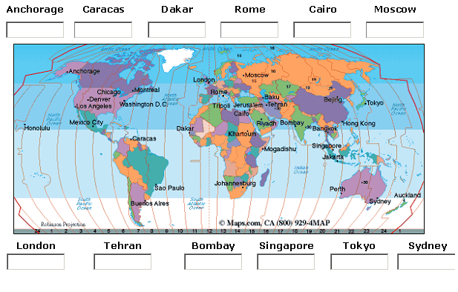

NOTE: For now, use the English names for the cities.
Exercise 5 (Group Exercise)

A. Look at the different pictures of watches and clocks. Take turns giving the time indicated aloud to the class.
Beispiel:
Es ist halb neun. It is half past eight 8:30

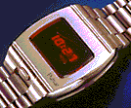  1. | 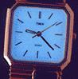  2. | 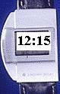  3. | 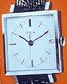  4. | 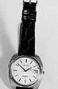  5.

B. Now use other times:
vor = before
nach = after, past
*You may want to refer to the Cultural Notes section.

Examples:
Es ist zehn Minuten vor neun. It is ten to nine 8:50
Es ist zwanzig Minuten vor vier It is 20 minutes to four 3:40
Es ist fünf Minuten nach drei It is five after three 3:05
Es ist dreizehn Minuten nach drei It is thirteen minutes after three 3:13

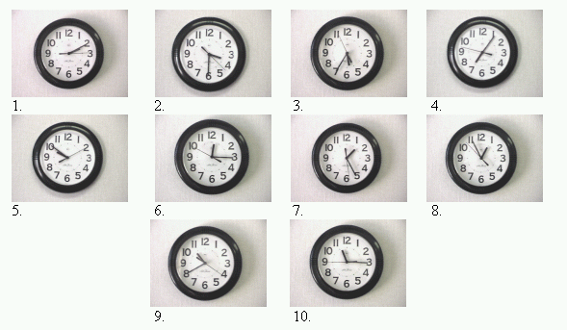
2. Use the Metric System

Exercise 6 (Group Exercise)

The class figures out how tall (meters) and heavy (kilograms) each student is. Then the first student will ask the person next to him/her how tall and how heavy he/she is. That person will answer, and the dialogue continues until the last student has answered.

Exercise 7 (Group Exercise)

Mingle and ask about your classmates’ complete dates of birth, including the year. Further, inquire in what years your classmates’ family members were born. Make sure to write down all the answers and after 15 minutes each student reports on one student and the information he/she received on him/her and his/her family.

NOTE: The number 1995 is written/spoken: → Eintausendneunhundertfünfundneunzig
The year 1995 is written/spoken: → Neunzehnhundertfünfundneunzig

Exercise 8

Study the pictures below and assign the correct measurements to the respective pictures.

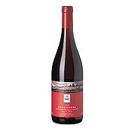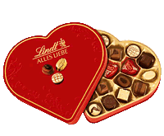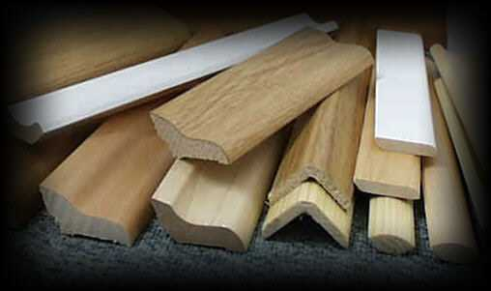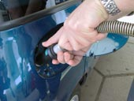
1. 2. 3. 4.

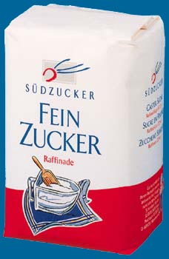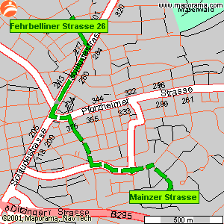
Answer Key:
1b, 2d, 3a, 4f, 5c, 6e
5. 6.

a. 1,50 m b. 0,75 l (Flasche) c. 1 kg (Päckchen) d. 210 g (Schachtel)
e. 8,5 km f. 10 l
Exercise 9 (Pair Exercise)

Imagine that you are at a German department store and you would like to buy a suit, shirt or dress and a pair of matching shoes. Tell the clerk your German sizes and ask how much the items are. Take 15 minutes to create a brief dialogue with you being the customer and your partner being the clerk. Present the dialogue to the rest of the class.

Adverbs of Time

German has many adverbs of time. Some of the most common ones are listed in the table below. One important point to remember is that in German, time comes before place. In English it is the other way around.

Adverbs of Time
Deutsch | Englisch
gestern – heute – morgen | yesterday – today – tomorrow
vorgestern – übermorgen | the day before yesterday – the day after tomorrow
Heute morgen/mittag/nachmittag/abend/ nacht | This morning/noon/afternoon/evening/ night
jetzt – später/nachher | now - later

Modal Verbs

German modal verbs consist of six verbs, which are the equivalent of the verbs “can”, “must” and “will”, etc. in English. They are always used in conjunction with a second verb, which appears in the infinite form. The second verb is placed at the end of the sentence.

Modal verbs
Deutsch | Englisch | Beispielsätze
dürfen | may | Darf ich es anprobieren? (May I try it on?)
können/könnte | can/could | Kann ich Ihnen helfen? (Can I help you?)
mögen | would like | Möchten Sie es kaufen? (Would you like to buy it?)
müssen | must | Ich muß es erst anprobieren. (I have to try it on first.)
sollen | shall/should | Soll ich es anprobieren? (Should I try it on?)
wollen | want | Wollen Sie es anprobieren? (Do you want to try it on?)
NOTE: Some modal verbs can also appear as regular verbs.

Conjugation of Modal Verbs

dürfen ich darf wir dürfen
du darfst ihr dürft
er/sie/es darf sie dürfen
Sie dürfen Sie dürfen
können ich kann wir können
du kannst ihr könnt
er/sie/es kann sie können
Sie können Sie können

mögen ich möchte wir möchten
du möchtest ihr möchtet
er/sie/es möchte sie möchten
Sie möchten Sie möchten

müssen ich muss wir müssen
du musst ihr müsst
er/sie/es muss sie müssen
Sie müssen Sie müssen

sollen ich soll wir sollen
du sollst ihr sollt
er/sie/es soll sie sollen
Sie sollen Sie sollen

wollen ich will wir wollen
du willst ihr wollt
er/sie/es will sie wollen
Sie wollen Sie wollen

Exercise 1

Create six German sentences, each containing an adverb of time.

1. ______________________________________________________________
2. ______________________________________________________________
3. ______________________________________________________________
4. ______________________________________________________________
5. ______________________________________________________________
6. ______________________________________________________________
Exercise 2

Fill in the blanks with the correct modal verb. Pay attention to the conjugations.

1. Wir _____________ (must) heute in die Schule gehen.
2. _____________ (can) du mir bitte das Buch geben.
3. Er _____________ (want) Sabine einen Blumenstrauß kaufen.
4. Ihr ______________ (should) morgen um 12 Uhr im Museum sein.
5. Ich _____________ (would like) dieses Kleid kaufen.

Answer Key:
1. müssen
2. kannst
3. will
4. sollt
5. möchte

ankommen | to arrive
anprobieren | to try on
ansehen | to look at
Armbanduhr, die die Armbanduhren | watch
aufstehen | to get up
deshalb | therefore
Dose, die die Dosen | can
Ei, das die Eier | egg
Entfernung, die die Entfernungen | distance
Entschuldigen Sie bitte! | Excuse me, please!
etwas | something
Flasche, die die Flaschen | bottle
früh | early
geben | to give
genau | exact
Gewicht, das die Gewichte | weight
Gramm, das die Gramm | gram
Größe, die die Größen | size
Höhe, die die Höhen | height
jetzt | now
Kilogramm, das die Kilogramm | kilogram
Kilometer, der die Kilometer | kilometer
Kleidergröße, die die Kleidergrößen | clothing size
kosten | cost, to
Länge, die die Längen | length
Liter, der die Liter | liter
Meter, der die Meter | meter
Milligramm, das die Miligramm | milligram
Milliliter, der die Mililiter | milliliter
Millimeter, der die Milimeter | millimeter
Minute, die die Minuten | minute
nehmen | take, to
Paket, das die Pakete | package
Päckchen, das die Päckchen | small package / parcel
planen | to plan
Schachtel, die die Schachteln | box
Schuhgröße, die die Schuhgrößen | shoe size
Sekunde, die die Sekunden | second
Tonne, die die Tonnen | ton
Umfang, der die Umfänge | circumference
wiegen | to weigh
Zentimeter, der die Zentimeter | centimeter
zurück | back

Supplemental Vocabulary

Ausstellung, die die Ausstellungen | exhibition
Bahnhof, der die Bahnhöfe | train station
behilflich sein | to be of help
Berg, der die Berge | mountain
Erde, die die Erden | earth
Frühstück, das die Frühstücke | breakfast
Gasthof, der die Gasthöfe | guesthouse, restaurant
Hotel, das die Hotels | hotel
Kinofilm, der die Kinofilme | movie
Kleid, das die Kleider | dress
klingen | to sound
Konzert, das die Konzerte | concert
Kunde, der die Kunden | customer
laufen | to walk, to run (movie)
Marathonlauf, der die Marathonläufe | marathon
Mond, der die Monde | moon
passen | to fit
Schaufenster, das die Schaufenster | store window / showcase
Umkleidekabine, die die Umkleidekabinen | dressing room
Wasser, das die Gewässer | water
Wechselgeld, das die Wechselgelder | change (money)
Weitsprung, der die Weitsprünge | long jump
Weltrekord, der die Weltrekorde | world record
Zug, der die Züge | train

German “Time-Keeping”

Germany is famous for its numerous clock towers, which can mostly be found in Southern Germany, and usually date back to the 15th or 16th centuries. One of Germany’s most famous and largest clocks is Munich’s musical clock, which can be found on Munich’s new town hall and dates back to 1908. It consists of 32 copper figures, each approximately 2 meters high.

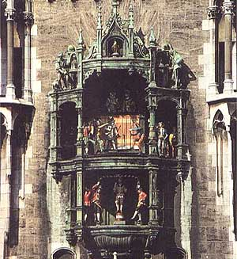

Germans do not always use the 24-hour time system. It is also common for the 12-hour system to be used, in conjunction with the words “morgens” (in the morning), “mittags/nachmittags” (noon/in the afternoon), “abends” (in the evening), or “nachts” (at night). This system tends to be used when talking about full hours and about time in general.
US: German:
Beispiel: 7:00 am 7 Uhr morgens
5:00 pm 5 Uhr nachmittags
8:00 pm 8 Uhr abends
11:00 pm 11 Uhr nachts

BUT: 11:45 pm 23.45 Uhr or dreiundzwanzig Uhr fünfundvierzig
Noon Es ist Mittag
Midnight Es ist Mitternacht

Also: If asked for the current time, and it is obvious what time of the day it is – a.m or p.m – then Germans also sometimes use the 12-hour system without adding the specific time of the day.

Example: One person asking another in the street:
“Entschuldigung, können Sie mir bitte sagen wie spät es ist?”
“Excuse me, could you please tell me what time it is?”
“Es ist ein Uhr zwanzig!”
“It is 1:20 p.m.!”
HOWEVER: The proper way is to use the 24-hour time system!

The constructions required to express minutes "past" and "to" the hour in German are very similar to the English. The equivalent of "past" is "nach" (= after) and "to" is translated by "vor" (= before). The German word for a "quarter" is "das Viertel". The half hour is counted in German in relation to the following full hour, not the preceding hour as in English. Thus "halb elf" is half past ten and not - as you might expect from the English - half past eleven. Think of it as being "half to eleven".

When talking about “a quarter after” and “a quarter ‘till”, colloquial German also uses a similar expression: “viertel nach” and “viertel vor”. For example, 13.15 Uhr can often be heard as “viertel nach eins,” or 13.45 Uhr would be “viertel vor zwei”.

Beware, however, that Southern Germans might confuse you with their unique time system. They will tell you how much time has already passed until the next full hour. So, for example, instead of saying: “Es ist 16.15 Uhr.“ (Es ist sechzehn Uhr fünfzehn) or “Es ist viertel nach vier.“, they will say: “Es ist viertel fünf.” (It is a quarter five). Similarly, for 16.45 Uhr, Southern Germans will often say “Es ist dreiviertel fünf.” (It is three quarters five), instead of “Es ist sechzehn Uhr fünfundvierzig.” or “Es ist viertel vor fünf.”

Although midnight can be expressed in the German 24-hour clock either as null Uhr or vierundzwanzig Uhr, you can only use null Uhr when you need to express that it is a number of minutes past midnight. You cannot, however, say "halb null", just as you cannot say "halb dreizehn", "Viertel nach/vor dreizehn", etc.

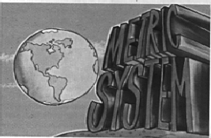
Germans and the

In 1795, the meter was introduced in France and it was defined as the 10millionth part of the distance equator – pole. Germany followed France’s example in 1872 and introduced the metric system. Although to some the metric system might seem just as arbitrary as using yards or miles, the great advantage is, however, that the metric system has a logical sequence, due to the constant factor 10, which is included in all prefixes of the words of measurement – a millimeter is the thousandth part of a meter, one kilometer is 1000 meters, etc.

kilo | km | one thousand | 1000
hecto | hm | one hundred | 100
deka | dam | ten | 10
deci | dm | one tenth | 0,1
centi | cm | one hundredth | 0,01
milli | mm | one thousandth | 0,0001

Since the metric system uses prefixes to indicate units larger or smaller than a given base unit, it is easy to see that each prefix is a multiple of 10 and therefore, changing one unit to another for a given measurement is achieved by simply moving the decimal point.

1. Tell Time

Activity 1

Imagine you are stationed in Germany and your parents are going to visit you for one day. Create a schedule for that day with all the times and the activities you have planned. Report your schedule to the class. You may use your dictionary for help with the activities. Make sure to use full sentences and the proper German times.

Beispiel: Um acht Uhr gehen wir zum Frühstück.
Um neun Uhr dreißig gehen wir in die Stadt.
etc.

Activity 2

What did your daily work schedule look like before you started at the language school? Put together a one-day schedule of a regular military workday, using the German time system. For now, use the English military expressions. Read your schedule to the rest of the class.

Beispiel: Von 6.00 Uhr bis 7 Uhr 30 haben wir PT.
Von 8.00 Uhr bis 9.00 Uhr frühstücken wir.
etc.

2. Use the Metric System

Activity 3

Listen to your instructor read six numbers between 101 and 1,000,000. Write out each number.

1. _______________________________________________________________
2. _______________________________________________________________
3. _______________________________________________________________
4. _______________________________________________________________
5. _______________________________________________________________
6. ______________________________________________________________
Reading and Answer Key:
1. 2519 – zweitausendfünfhundertneunzehn
2. 49.817 – neunundvierzigtausendachthundertsiebzehn
3. 891 – achthunderteinundneunzig
4. 283.471 - zweihundertdreiundachtzigtausendvierhunderteinundsiebzig
5. 9283 – neuntausendzweihundertdreiundachtzig
6. 16.937 – sechzehntausendneunhundertsiebenunddreißig

Activity 4 (Pair Activity)

Imagine you are in a German store. Using the articles and units below, create the following dialogue in German.

A: Say hello. Say that you would like a certain product and mention the amount
(choose from the selection below).
B: Say hello and tell him/her that you do/don’t have that amount of that product.
A: Say that would like to buy the amount he/she has and ask how much it is.
B: Say how much the product is.
A: Give him/her the money, say thank you and good-bye.
B: Say thank you and good-bye.

Produkte: Milch Maßeinheiten: 250 g
Trauben 1,5 l
Schokolade 750 g
Orangensaft 2,50 m
Stoff 1 l

Activity 5 (Group Activity)

Using the table below, ask each other questions about the height or weight of the listed items.
 | Deutsche Einheiten | Amerikanische Einheiten
Entfernung der Erde zum Mond | 385 000 km | 240 000 miles
Umfang der Erde | 40 000 km | 25 000 miles
Höhe des Mt. Everest | 8850 m | 29 035 feet
Länge eines Marathonlaufes | 42,195 km | 26 miles 385 yd
Weitsprungweltrekord | 8,95 m | 29 feet 4.5 in
Gewicht der Erde | 5,975 x 10²⁴ kg | 1.3 x 10²⁵ pounds
Ein Liter Wasser | 1000 g | 2.2 pounds

Activity 6 (Group Activity)

Each student receives three flashcards with each card containing a German shirt size, a suit size, and a shoe size. Each student will then tell the rest of the class his/her (flashcard) sizes. The other students write down the name and the three sizes of each person. In the end, the students will put the names with the sizes in numerical order starting with the smallest number. They will then compare their lists. Make sure to announce your sizes in full sentences.

Beispiel:

Name of Person Suit Size Name of Person Shirt Size Name of Person Shoe Size

Activity 7

Your instructor will read a list of items, the amount, and price of each item she has in her shopping bag. Study the items below and write down the correct amounts next to the items.

1. 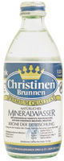 (Mineralwasser) Anzahl: ___________ Preis: ___________

2. (Espresso) Anzahl: ___________ Preis: ___________

3.  (Nudeln) Anzahl: ___________ Preis: ___________

4. 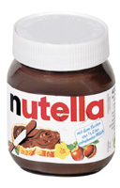 (Nutella) Anzahl: ___________ Preis: ___________

5. 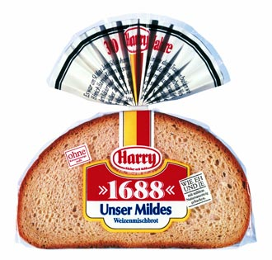(Brot) Anzahl: ___________ Preis: ___________

Reading Key:
Ich habe in meiner Tasche ein 400 g Glas Nutella und ich habe €1,59 bezahlt.
Ich habe in meiner Tasche eine 250 g Dose Espresso und ich habe €5,09 bezahlt.
Ich habe in meiner Tasche einen 500 g Leib Brot und ich habe €2,05 bezahlt.
Ich habe in meiner Tasche eine 0,33 l Flasche Mineralwasser und ich habe €1,05 bezahlt.
Ich habe in meiner Tasche eine 750 g Packung Nudeln und ich habe €2,05 bezahlt.
Answer Key:
1. 0,33 l, €1,05
2. 250 g, €5,09
3. 750 g, €2,05
4. 400 g, €1,59
5. 500 g, €2,05

Activity 8

Figure out the math problems and write out the solutions.

1. fünfhundertsiebenundachtzig + zweitausendsiebenhundertneunundzwanzig
= ____________________________________________________________________

2. siebenundzwanzigtausendachthundertsechsunddreißig + achthundertsieben
= ____________________________________________________________________

3. zweihundertvierundsiebzigtausendzweihundertneunzehn + dreihundertvierzehn
= ____________________________________________________________________

4. dreiundvierzigtausendfünfhundertachtundneunzig + siebentausendeinhundertzwei
= ____________________________________________________________________

Answer Key:
1. dreitausenddreihundertsechzehn (3316)
2. achtundzwanzigtausendsechshundertdreiundvierzig (28643)
3. zweihundertvierundsiebzigtausendfünfhundertdreiunddreißig (274533)
4. fünfzigtausendsiebenhundert (50700)

Activity 9 (Group Activity)

The following map and the numbers next to it show the distance of various cities from the Bavarian town “Ahorn”. The instructor will ask each of the students how far a certain city is from “Ahorn”. Answer in complete sentences.
Entfernungen
Mühlhausen 146 km
Bad Langensalza 126 km
Eisenach 133 km
Gotha 107 km
Erfurt 114 km
Weimar 131 km
Apolda 148 km
Jena 130 km
Bad Salzungen 108 km
Großliebringen 93 km
Suhl 62 km
Saalfeld 82 km
Meiningen 73 km
Lauenstein 63 km
Hildburghausen 36 km
Sonneberg 33 km
Coburg 5 km
Rödental 12 km (Hummel-Figuren- Porzellanfabrik)
Kronach 37 km
Lichtenfels 18 km
Schweinfurt 66 km
Zeilitzheim 81 km
Neuses 88 km
Bamberg 47 km
Buttenheim 58 km
Bayreuth 71 km
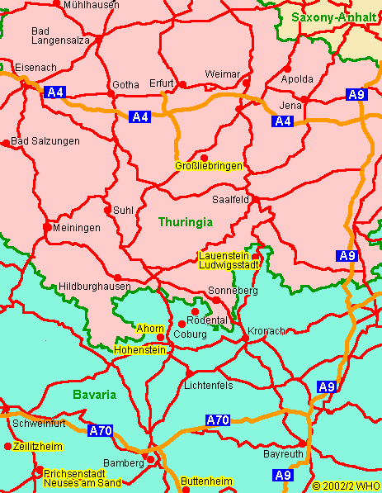

Activity 10

Give the English equivalent of the German clock times below.

- Es ist viertel vor sieben. ____________________________________________

- Es ist dreiviertel acht._______________________________________________

- Es ist genau halb elf.________________________________________________

- Es ist dreiundzwanzig Uhr.__________________________________________

- Es ist vierzehn Uhr einundzwanzig.___________________________________

- Es ist viertel acht.__________________________________________________

- Es ist dreiviertel zehn._______________________________________________

- Es ist halb zwei.____________________________________________________

- Es ist zwanzig vor drei.______________________________________________

10. Es ist vierundzwanzig Uhr.__________________________________________

Answer Key:
1. 6:45 5. 2:21 9. 2:40
- 7:45 6. 7:15 10. 12:00
- 10:30 7. 9:45
- 11:00 8. 1:30

Listen to the instructor randomly read one of each of the following times and determine what the correct answer is.

1. 13:45 2. 24:00 3. 15:50 4. 22:30
13:54 4:20 5:50 2:23
3:54 24:20 10:55 2:30

5. 17:27 6. 13:58 7. 11:21 8. 21:35
7:27 3:50 1:12 21:53
1:17 1:35 11:12 1:23
Answer Key:
Answers may vary.

1. Tell Time

Activity 1 (Pair Activity)

Study the TV guide for the ZDF (Zweites Deutsches Fernsehen) and ask each other questions regarding show times and shows.

Beispiel: Um wie viel Uhr kommt “Löwenzahn”?
Was kommt um 17.05 Uhr?

Sendezeiten | Das ZDF-Programm am 29.06.2002
06.25 | Wo ist Walter?
07.25 | Der Bär im großen blauen Haus
07.50 | Jetzt schlägt's Theo
08.35 | 1, 2 oder 3
11.10 | Löwenzahn
12.45 | Mona der Vampir
13.00 | heute
15.30 | Kaffeeklatsch
16.30 | Junge Herzen - Auf großer Fahrt ins Leben
17.05 | XVII. Fußball-Weltmeisterschaft 2002 in Korea/Japan  Länderspiegel
18.20 | Aus Berlin:  ZDF WM-Studio  Vor dem Finale
19.00 | heute
19.20 | Wetter
20:15 | Der Samstagskrimi  Wilsberg und die Tote im See
22:10 | Standpunkte  Bericht vom Parteitag der CSU in Fürth
23:55 | Heiner Lauterbach: Faust
01:00 | Die Sopranos
01:55 | heute
02:00 | Flucht vom Planet der Affen
03:55 | Boxen  Weltmeisterschaft im Schwergewicht  Wladimir Klitschko - Ray Mercer

NOTE: For now, don’t worry about the exact meanings of the shows.

Activity 2

Your instructor will read a dialogue. Listen carefully and from the information you receive, create a timetable with the correct times and the respective activities.

Reading Key:
Sonja: Hallo Jürgen. Was hast du heute für uns geplant? Es ist jetzt 9 Uhr, sollen wir etwas frühstücken gehen?
Jürgen: Ja, ich habe Hunger. Dann können wir um 10.30 Uhr ins Museum gehen und um 11:30 die Ausstellung ansehen.
Sonja: Das klingt gut. Wir können dann um 12.30 Uhr in den Gasthof “Zum Löwen“
zum Mittagessen gehen.
Jürgen: Genau, und der Kinofilm, den wir sehen wollen, läuft von 14.00 Uhr bis 16.30 Uhr. Um 18.00 treffen wir dann Anja und Lars zum Kegeln.
Answer Key: 9.00 Uhr Frühstück
10.30 Uhr Museum
11.30 Uhr Ausstellung
12.30 Uhr Mittagessen im Gasthof “Zum Löwen”
14.00 bis 16.00 Uhr Kino
18.00 Uhr Kegeln mit Anja und Lars

Activity 3 (Pair Activity)

Ask each other the question “Wie viel Uhr ist es? and use the times below as answers. You may answer with the morning or the evening time.
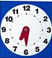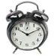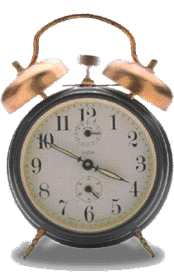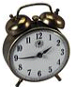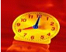

Activity 4

Listen to your instructor read the following dialogue between a customer and a salesclerk and answer the questions below.

1. Wo sieht die Kundin das Kleid?
_________________________________________________________________

2. Welche Größe ist das Kleid, das sie kauft?
_________________________________________________________________

Activity 4 (continued)

3. Welche Farbe ist das Kleid, das sie kauft?
_________________________________________________________________

4. Wie viel kostet das Kleid?
_________________________________________________________________

5. Wie viel Wechselgeld bekommt sie zurück?
_________________________________________________________________

Reading Key:
Sales Clerk: Guten Tag. Kann ich Ihnen behilflich sein?
Customer: Guten Tag. Ja, ich möchte gerne das Kleid dort im Schaufenster anprobieren.
Sales Clerk: Gerne. Welche Größe darf ich Ihnen bringen? Und welche Farbe hätten
Sie gerne? Wir haben das Kleid in rot und in blau.
Customer: Größe 38 und in rot, bitte.
Sales Clerk: Gerne. Sie können es dort in der Umkleidekabine anprobieren.
Customer: Das Kleid paßt sehr gut. Ich nehme es. Wieviel kostet es?
Sales Clerk: Es kostet 39,95 €.
Customer: Hier sind 40,00 €.
Sales Clerk: Danke, und 5 Cents zurück. Einen schönen Tag noch.

Answer Key:
- Im Schaufenster
- Größe 38
- rot
- 39,95 €
- 5 Cents

2. Use the Metric System

Activity 5 (Pair Activity)

Choose several of the following objects and describe each one by mentioning the color, shape, height, and amount. Your partner guesses the described object. Do not mention the name of the object.
Activity 5 (Pair Activity) (continued)

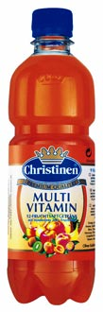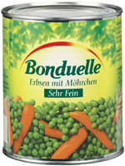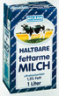
5 kg 35cm 0,5 l 21cm 850 ml 12cm 1 l 25cm
Paket Flasche Dose Tüte
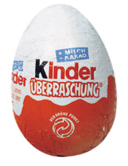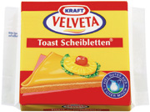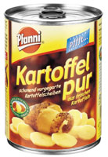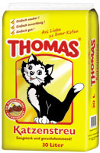
10 g 7cm 200 g 11cm 360 g 14cm 30 l 70cm
Ei Päckchen Dose Paket

Activity 6 (Group Activity)

Each student chooses an object in the classroom and describes it to the rest of the class without naming the object itself. Make sure to mention the shape, color, approximate size and weight. Use German measurements.

Activity 7

Reverse the numbers below and write them out. Read them to the class.

Beispiel: 495823: vierhundertfünfundneunzigtausendachthundertdreiundzwanzig
→ 328594: dreihundertachtundzwanzigtausendfünfhundertvierundneunzig

1. zweihundertdreiundneunzigtausendeinhundertfünf
_______________________________________________________________________
2. neuntausenddreihundertfünfundsiebzig
_______________________________________________________________________
3. achtundvierzigtausendzweihundertneun
_______________________________________________________________________
Activity 7 (continued)

4. einundachtzigtausendachthundertsiebenundvierzig
_______________________________________________________________________
5. zweihundertvierundachtzigtausendfünfzehn
_______________________________________________________________________

Answer Key:
1. 501392: fünfhunderteintausenddreihundertzweiundneunzig
2. 5739: fünftausendsiebenhundertneununddreißig
3. 90284: neunzigtausendzweihundertvierundachtzig
4. 74818: vierundsiebzigtausendachthundertachtzehn
5. 510482: fünfhundertzehntausendvierhundertzweiundachtzig

Activity 8

The instructor will read five math problems. Write down the problems while he/she is reading them to you and figure out the solution. Write the solutions in full words and compare them with the rest of the class.

1. _____________________________________________________________________
=______________________________________________________________________

2. _____________________________________________________________________
=______________________________________________________________________

3. _____________________________________________________________________
=______________________________________________________________________

4. _____________________________________________________________________
=______________________________________________________________________

5. _____________________________________________________________________
=______________________________________________________________________

Reading Key:
1. 483 + 2393=
2. 3840 + 19283=
3. 78319 + 3920=
4. 834173 + 392=
5. 3842 + 7482=
Answer Key:
1. 2876 zweitausendachthundertsechsundsiebzig
2. 23123 dreiundzwanzigtausendeinhundertdreiundzwanzig
3. 82239 zweiundachtzigtausendzweihundertneununddreißig
4. 834565 achthundertvierunddreißigtausendfünfhundertfünfundsechzig
5. 11324 elftausenddreihundertvierundzwanzig

Activity 9 (Pair Activity)

Practice the following dialogue with your partner in German.

A: Ask for his/her name
B: State your name
A: Ask for his/her telephone number
B: State your telephone number
A: Ask for his/her age
B: State your age
A: Ask for his/her height in meters/centimeters
B: State your height
A: Ask for his/her weight in kilograms
B: State your weight

Activity 10 (Group Activity)

Make a list of important events in US history. Your instructor will write the events and the year they took place on the blackboard. Each student will take a turn stating one event and the year it took place. Use the English words for the events

Note to the Instructor:
1776 - Independence Day
1620 - Mayflower
1963 - John F. Kennedy’s Assassination
1775 - Bunker Hill / The Army’s Birthday, etc.

Activity 1

Listen to the following people announce their height, weight, and the year they were born in and write it down below.

1. Bernd: Größe:_________ Gewicht:_________ Geburtsjahr:___________
2. Tina: Größe:_________ Gewicht:_________ Geburtsjahr:___________
3. Sonja: Größe:_________ Gewicht:_________ Geburtsjahr:___________
4. Stefan: Größe:_________ Gewicht:_________ Geburtsjahr:___________

Audio Script:
1. Mein Name ist Bernd und ich bin 1,83 m groß. Ich wiege 92 kg und mein Geburtsjahr ist 1956.
2. Mein Name ist Tina und ich bin 1,71 m groß. Ich wiege 60 kg und mein Geburtsjahr ist 1968.
3. Mein Name ist Sonja und ich bin 1,65 m groß. Ich wiege 52 kg und mein Geburtsjahr ist 1982.
4. Mein Name ist Stefan und ich bin 1,89 m groß. Ich wiege 102 kg und mein Geburtsjahr ist 1971.
Answer Key:
1. 1,83 m, 92 kg, 1956
2. 1,71 m, 60 kg, 1968
3 1,65 m, 52 kg, 1982
4. 1,89 m, 102 kg, 1971

Activity 2

Imagine you are sightseeing in Germany and a German stops you and asks you for the time. Using the clock/watch next to the question, write down the answer you would give the person. Write out the numbers and also write the sentence in the order in which it would be said. Use both the morning and the evening times.
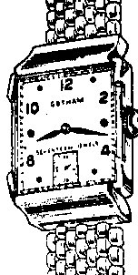

1. “Entschuldigen Sie bitte. Können Sie mir sagen wie spät es ist?”
Answers: _____________________________________________________
_____________________________________________________________
2. “Entschuldigen Sie bitte. Können Sie mir sagen wie spät es ist?“
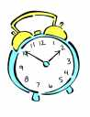
Answers: _____________________________________________________
_____________________________________________________________
3. “Entschuldigen Sie bitte. Können Sie mir sagen wie spät es ist?“
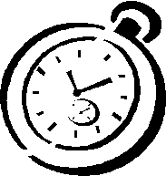
Answers: _____________________________________________________
_____________________________________________________________
Answer Key:
1. Es ist acht Uhr siebzehn. Es ist zwanzig Uhr siebzehn.
2. Es ist ein Uhr fünfzig. Es ist dreizehn Uhr fünfzig.
3. Es ist zehn Uhr fünf. Es ist zweiundzwanzig Uhr fünf.

Activity 3

Listen to the following excerpt of a travel diary and fill in the blanks with the correct measurements and amounts.

Heute sind wir über _______ gefahren. Wir sind um _________ in München angekommen und sind noch _______ bis zum Hotel gefahren. Morgen fahren wir in die Berge. Wir wollen auf einen _________ hohen Berg klettern. Heute Abend findet um ________ hier im Hotel ein Konzert statt. Aber wir müssen morgen früh aufstehen und gehen deshalb früh ins Bett.

Audio Script and Answer Key:
Heute sind wir über 500 km gefahren. Wir sind um 21 Uhr in München angekommen und sind noch 3 km bis zum Hotel gefahren. Morgen fahren wir in die Berge. Wir wollen auf einen 2000 m hohen Berg klettern. Heute Abend findet um 22 Uhr hier im Hotel ein Konzert statt. Aber wir müssen morgen früh aufstehen und gehen deshalb früh ins Bett.

Activity 4
Describe one of your relatives in 10 sentences. Give metric measures for your description of the physical attributes. Be ready to read your description to the class.

Activity 5
Write down a few high mountains, big lakes, long rivers and basketball players’ names in America. Give the approximate size of them in the metric system.

Activity 1

Find out the distances between Fayetteville, NC and the cities below. Convert them into kilometers and complete the map with the distances.

Winston-Salem
Raleigh

Goldsboro

Charlotte
Fayetteville, NC

Hope Mills

Wilmington
Lumberton

Myrtle Beach

NOTE: You may use a map program like www.yahoo.com to find out the distance.

