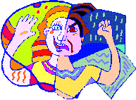

Personal Characteristics

At the end of this lesson you will be able to talk about personal and physical characteristics and emotional states of people. In order to achieve this objective you will:

Identify Physical Traits of People

- Describe characteristics of an individual
- Identify stereotypes of the people in Germany
- Express emotions

Scenario

You have noticed a distinct change in your German counterpart recently. He has a dreamy look in his eyes and smiles a lot!

SSG Chris Johnson: Wolfgang, was hast du?
Feldwebel Hans Huber: Ich bin verliebt, Chris! Sie ist wunderbar.
Chris: Aha! Darum bist du immer fröhlich.
Hans: Sie ist so schön. Sie hat lange braune Haare und grüne Augen.
Chris: Wie heißt sie denn?
Hans: Sie ist nicht zu schlank und nicht zu klein. Sie ist perfekt.
Chris: Ich freue mich für dich. Wie heißt sie?
Hans: Ich bin so verwirrt! Liebt sie mich auch?
Chris: Du bist nett und nicht häßlich. Sie liebt dich!
Hans: Sie heißt Gerda!
-----------------------------------------------------------------------------------------------------------
Identify Physical Traits of People - U.S. versus German mentality

When asked about the typical US and German mentalities, many people consider Americans to have a “naive optimism,” while Germans are said to have a “deliberate, hesitant pessimism.” Of course, this is an extreme simplification and it will be up to you to decide if you agree with this statement or not. Getting to know Germans on a more personal level may give you a completely different impression of the German people.

Gefühle (Emotions)

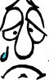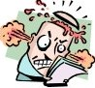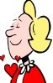
fröhlich traurig wütend verliebt
happy sad mad, angry in love

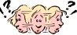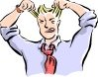
gelangweilt verwirrt ängstlich verzweifelt
bored confused scared desperate

Körperbau (Physique)

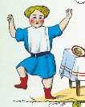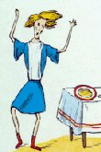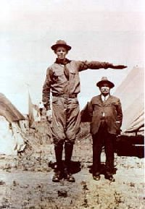

dick (overweight) dünn, schlank groß - klein
(thin, skinny) (tall) (short)
Körpermerkmale (Physical Traits)

A. Haarfarbe (hair color)

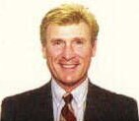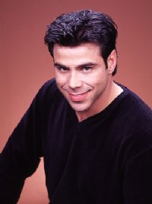
blondes Haar braunes Haar rotes Haar schwarzes Haar kahlköpfig
(blond hair) (brown hair) (red hair) (black hair) (bald)

B. Augenfarbe (eye color)

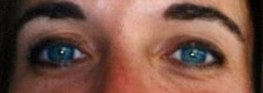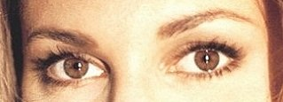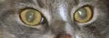
blaue Augen (blue eyes) braune Augen (brown eyes) grüne Augen (green eyes)

B. Gesichtsbehaarung (facial hair)

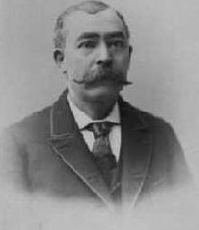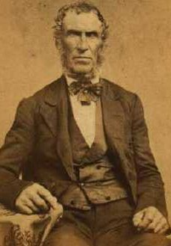
Schnurrbart Vollbart
(mustache) (beard)

C. Andere Besondere Merkmale im Gesicht (Other Important Facial Features)

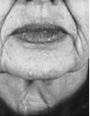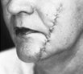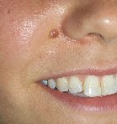
Brille Falten Narbe Muttermal
(glasses) (wrinkles) (scar) (mole)
Exercise 1 (Group Exercise)

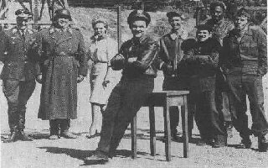
Hogan’s Heroes displays some of the most common ideas and stereotypes Americans have of Germans. As a group, try to list some of the stereotypes from the show.
Make a list of stereotypes that you might have of Germans, and share it with the class.

Exercise 2 (Group Exercise)

Write down a physical description of yourself. The instructor collects all the descriptions and reads them loud in class. Guess which description goes with which student.

Exercise 3 (Pair Exercise)

Try to think of a situation in the past in which you experienced a very strong emotion. Describe this situation to your partner in German and have him/her guess which kind of emotion you felt. Reverse roles.

Exercise 4

Study the pictures below and write down all the possible emotions that might be displayed in each picture.
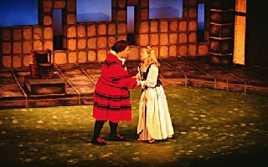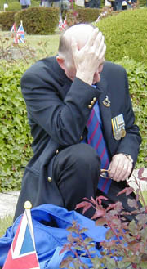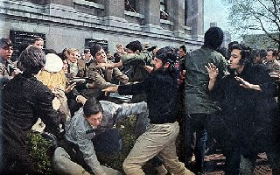

_____________________ ________________ _________________________
_____________________ ________________ _________________________
_____________________ ________________ _________________________

Answer Key:
1. verliebt, fröhlich
2. traurig, verzweifelt, wütend
3. wütend, ängstlich

Exercise 5

Your instructor will read descriptions of three people. Listen carefully to all the details, and write the descriptions down. Compare your notes with those of your classmates.

Reading Key:
1. Der Mann ist sehr klein. Er hat einen dicken Bauch und braune Haare. Er hat einen Schnurrbart und eine Narbe im Gesicht.
2. Die Frau ist sehr dünn und hat schwarze Haare. Sie trägt eine Brille und hat ein Muttermal am Kinn.
3. Der Junge ist sehr groß und schlank. Er hat rote Haare und hat keinen Bart. Er hat eine Narbe im Gesicht.

Exercise 6 (Pair Exercise)

Imagine you have just witnessed a burglary. Your partner, the police officer, asks you about the physical appearance of the burglar. Choose one of your classmates as the burglar and describe him/her in as much detail as possible so your partner can “arrest” the correct person. Use the words below as a guideline for your questioning.

Alter Haarfarbe
groß/klein besondere Merkmale
dick/dünn Augenfarbe

Exercise 7 (Group Exercise)

Form two groups. Each group comes up with six famous people that have exceptional physical traits, e.g. Arnold Schwarzenegger = big muscles, Carrot Top = bright red hair, etc. Describe your celebrities to the other group in as much detail as possible. The group whose description leads to the other group is guessing the correct person gets a point.

Exercise 8 (Group Exercise)

Play charades. The instructor will hand out flashcards expressing different emotions. Each student acts out the emotion shown on his/her card while the other students have to guess the expressed emotion.

Beispiel: Du bist traurig!
Du bist wütend!
--------------------------------------------------------------------------------------------------------
Exercise 9 - Choose the correct word from the jumble box.

1. Wenn mein kleiner Bruder mich irritiert, dann bin ich oft ganz _______________
2. Meine Frau geht 3 Monate nach Korea! Ich bin so ____________________
3. Andreas und Kirsten sind ___________. Sie wollen nächstes Jahr heiraten.
4. Die Kinder sitzen ____________vor dem Fernseher. Sie haben nichts zu tun!
5. Diese Straße heißt Kaiserstraße, nicht Königstraße. Jetzt bin ich ganz____________!
6. Sei nicht so ____________! Der Hund ist nicht aggressiv. Der ist harmlos.
7. Bald beginnt unser Urlaub! Wir können kaum warten! Wir sind so ______________!
8. Du bist so__________und ______________, und dein Bruder ist so groß und dick.

wütend fröhlich

traurig verwirrt klein

gelangweilt ängstlich
dünn
verliebt

Answer Key:

- wütend 5. verwirrt
- traurig 6. ängstlich
- verliebt 7. fröhlich.
- gelangweilt 8. klein, dünn

Prepositions

In Lesson 3 you have already learned some of the most common German prepositions. These prepositions demonstrated the relationship between people and/or things. They also demonstrated the position (local – örtlich), time (temporal – Zeit kennzeichnend), type (modal – Art und Weise kennzeichnend), or reason (kausal – begründend) of a certain activity. As the lessons continue, you will learn more German prepositions. Some of these prepositions are often combined with the article that follows them.

an dem → am Am Montag gehen wir in die Schule.
On Monday we go to school.

bei dem → beim Er ist beim Konzert.
He is at the concert.

in das → ins Wir gehen ins Schwimmbad.
We are going to the swimming pool.

in dem → im Er ist im Garten.
He is in the garden.

durch das → durchs Sie geht durchs Zimmer.
She is going through the room.

hinter dem → hinterm Der Garten ist hinterm Haus.
The garden is behind the house.

von dem → vom Das ist vom Onkel.
This is from the uncle.

zu dem → zum Wir gehen zum Essen in das Restaurant
We are going to the restaurant to eat.

zu der → zur Ihr geht zur Feier.
You are going to the party.

Adjectives

Adjectives describe people and things, and they usually change their cases according to the noun with which they are connected. German grammar has two types of adjectives: Adjectives with weak (non-significant) endings and adjectives with strong (significant) endings. The change of case, therefore, also depends on the type of adjective.

Weak endings

They indicate nothing about the gender or case of the noun the adjective modifies, and they generally appear in the following three instances:

- a definite article precedes the adjective
- a indefinite article with modified ending precedes the adjective
- a pronoun with modified ending precedes the adjective

In which case the adjectives are modified as follows:

 | Masculine | Feminine | Neuter | Plural
Nominative | -e | -e | -e | -en
Accusative | -en | -e | -e | -en
Dative | -en | -en | -en | -en
Genitive | -en | -en | -en | -en

Beispiele:
Der große Mann sitzt im Auto
The tall man is sitting in the car.

Die kleinen Kinder sind auf dem Spielplatz.
The small children are at the playground.

Strong endings

They indicate the gender and case of the noun the adjective modifies, and they generally appear in the following two instances:

- no article, pronoun, or number precedes the adjective
- an indefinite article, pronoun, or number without modified ending precedes the adjective

In which cases the adjectives are modified as follows:

 | Masculine | Feminine | Neuter | Plural
Nominative | -er | -e | -es | -e
Accusative | -en | -e | -es | -e
Dative | -em | -er | -em | -en
Genitive | -en | -er | -en | -er

Beispiele:
Zwei neue Schüler fehlen heute.
Two new students are missing today.
Exercise 1

Replace the following articles and prepositions with the correct article/preposition combination.

1. Sie hat eine Narbe an dem Hals.
_________________________________________________

2. Er ist im Moment bei dem Mittagessen.
_________________________________________________

3. Er hat ein Muttermal in dem Gesicht.
_________________________________________________

4. Er kommt heute zu dem Abendessen.
_________________________________________________

5. Wir gehen durch das Museum.
_________________________________________________

Answer Key:
1. Sie hat eine Narbe am Hals.
2. Er ist im Moment beim Mittagessen.
3. Er hat ein Muttermal im Gesicht.
4. Er kommt heute zum Abendessen.
5. Wir gehen durchs Museum.

Exercise 2

Fill the blanks with the correct adjective endings.

1. Das braun_____ Haus ist neben dem weiß______ Haus.
2. Die groß_____ Schuhe gehören Werner.
3. Eine klein_____ Blume steht an der Straße.
4. Zwei neu_____ Autos stehen vor der Garage.

Answer Key:
1. braune/weißen 2. großen 3. kleine 4. neue

ängstlich | scared
arbeiten | to work
aufgeschlossen | open-minded
Augen, die | eyes
Bauch, der die Bäuche | belly
Bein, das die Beine | leg
blond | blond
Brille, die die Brillen | glasses
dick | corpulent, overweight
dünn | thin
eng | tight, narrow
Falte, die die Falten | wrinkle
fröhlich | happy
Gefühl, das die Gefühle | emotion
gelangweilt | bored
Gesicht, das die Gesichter | face
Haar, das die Haare | hair
Hals, der die Hälse | throat
Hand, die die Hände | hand
häßlich | ugly
immer | always
irritieren / irritierbar | to irritate / irritable
jung | young
kahlköpfig | bald
Kinn, das die Kinne | chin
Körper, der die Körper | body
lang | long
Merkmal, das die Merkmale | feature, trait
muskulös | muscular
Muttermal, das die Muttermale | mole
Narbe, die die Narben | scar
nass | wet
Pferdeschwanz, der die Pferdeschwänze | ponytail
ruhig | quiet
Schnurrbart, der die Schnurrbärte | mustache
traurig | sad
trocken | dry
verliebt | in love
verwirrt | confused
verzweifelt | desperate
Vollbart, der die Vollbärte | beard
wütend | mad, angry, furious

Supplemental Vocabulary

Augenbraue, die die Augenbrauen | eyebrow
Clown, der die Clowns | clown
Diamantene Hochzeit, die die Hochzeiten | diamond wedding anniversary
Fußball, der die Fussbälle | soccer, soccerball
Geldbeutel, der die Geldbeutel | wallet
Gips, der -no plural- | cast
heiraten | to get married
hochstecken | to put up (hair)
Hut, der die Hüte | hat
Kleidung, die | clothing
Kondition, die die Konditionen | condition, shape
Lippenstift, der die Lippenstifte | lipstick
Moment, der die Momente | moment
Museum, das die Museen | museum
nett | nice
Ohrring, der die Ohrringe | earring
Pflaster, das die Pflaster | band-aid
Regen, der die Regenfälle | rain
schon | already
Schuhe, die | shoes
schulterlang | shoulder length
seit | since
Seite, die die Seiten | side
umziehen | to move (from one living area to another)
verlieren | to lose
Zirkus, der die Zirkuse | circus
zu | too

Some of the typical stereotypes of Germans

Lederhosen und Dirndl

When Americans imagine German clothing, they usually think of a typical “Heidi”-scene in which the woman is wearing a Dirndl and the man is wearing a Lederhosen. However, clothing in Germany is very much like that in the US. The typical traditional costumes described above are only worn in Bavaria, which is located in Southern Germany. This type of clothing is usually worn on special occasions or during festivities.

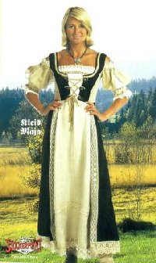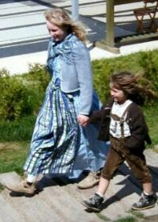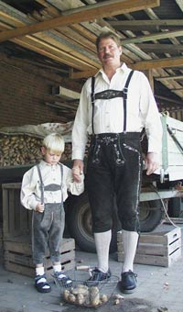

Bureaucracy and Orderliness

German bureaucracy is not a myth. There seem to be rules and regulations for everything and of course, each regulation is implemented by a different department. There seem to be thousands and thousands of bureaus, offices and departments, which all produce a never ending paper trail. However, this thoroughness also means that most things are done properly – the first time around.

Punctuality

In Germany punctuality is considered a virtue. If you have an appointment with a German, you can usually adjust your watch after the appearance time. So, when you invite Germans over to your house, you can expect them to be on your doorstep at exactly the time for which you had invited them. Therefore, make sure to be on time if you get invited. The only place where you might catch a German being late is at the university. All German universities have a time period called “akademische Viertelstunde” (academic quarter), which means that the students are allowed to arrive up to 15 minutes late for the lecture and still be considered to be on time.

Bratwurst and Sauerkraut

Yes, Germans do eat Bratwurst and Sauerkraut, but they do not play as important a role in the German diet as Americans think. Because they are cheap and easy to eat, just like our hot dogs, Bratwürste are usually sold at snack stands or booths during traditional festivities.

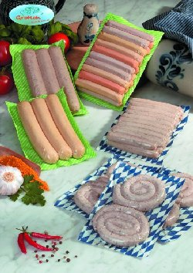

Tip of the Day
Foreigners often get the impression that Germans are rather rude, but actually they are just very direct. A German will usually let you know what he/she thinks either through his/her words or through his/her mannerism. The German language often also sounds very harsh and strict to foreigners, which may also give the impression of rudeness. Once you have mastered the language and personally get to know Germans, you will find out that most of them are very friendly and hospitable people.

Identify Physical Traits of People

Activity 1 (Group Activity)

Each student describes another student from class by describing what he/she is NOT or does NOT look like. The student who first guesses the described person gets to go next. Include the instructor in your description.

Beispiel: Er ist nicht groß.
Sein Haar ist nicht braun oder rot.
Er ist nicht leicht irritirbar.

Activity 2 (Pair Activity)

Imagine you have to meet your German contact in front of the town hall in Munich. It’s a busy place, and you don’t know what he/she looks like, so your superior gives you a description of him/her. One of you plays the role of the superior and chooses one of the pictures below. Describe it to your partner, so he/she can identify his/her counterpart.

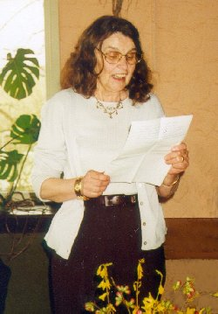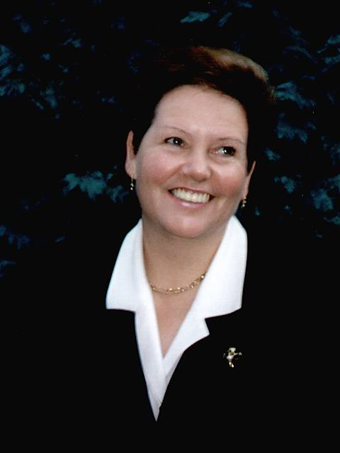

Activity 3

Listen to the descriptions of the three people’s emotional states. Write down what emotions they are feeling and why they are feeling that way.

Karin: _________________________________________________________________
_______________________________________________________________________

Lars: __________________________________________________________________
_______________________________________________________________________

Stefan: _________________________________________________________________
_______________________________________________________________________

Reading Key:
Karin: Karin ist sehr traurig. Ihre Tochter hat geheiratet und ist in die USA gezogen.
Lars: Lars ist sehr wütend. Er hat seinen Geldbeutel verloren.
Stefan: Stefan ist sehr fröhlich. Er hat heute Geburtstag.

Activity 4

Which words (nouns and adjectives) would you associate with each of the pictures below?

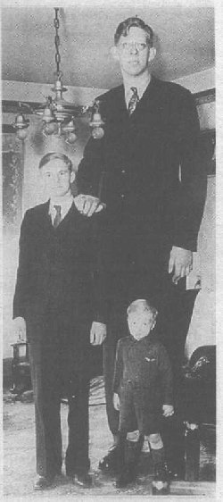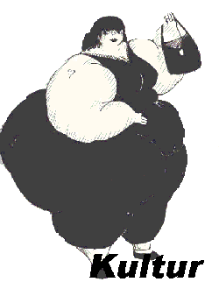

________________ ______________ ____________________
_________________ ______________ ____________________
_________________ ______________ ____________________
_________________ ______________ ____________________

Answer Key:
1. Mann, alt, Schnurrbart, graues Haar
2. Männer, Junge, klein, groß, größer
3. Frau, dick, schwarzes Haar
Answers may vary!

Activity 5 (Group Activity)

Make a list of physical stereotypes that are associated with the following nationalities:
German
American
Italian
French
Discuss your list in class and see if any of the stereotypes overlap. What might be some of the reasons that there are overlapping stereotypes?

Activity 6

Write down the opposites of the adjectives below and build a sentence containing the opposite word.

1. groß _________________________________________________________
2. traurig _________________________________________________________
3. dünn _________________________________________________________
4. alt _________________________________________________________

Answer Key:
1. klein 2. fröhlich 3. dick 4. jung
Sentences may vary!

Activity 7 (Pair Activity)

Describe at least two of your family members to your partner without mentioning the title of the person. Describe them in as much detail as possible (age, facial features, etc) so that your partner can guess which family member you are describing.
Activity 8

Study the newspaper announcement below and choose the matching adjective.

Herzlichen Glückwunsch zur Diamantenen Hochzeit!!

Am 14. September 2001 haben Maria und Franz Müller ihre Diamantene Hochzeit gefeiert. Wir wollen ihnen recht herzlich gratulieren!

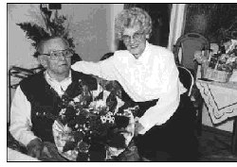

- traurig
- verzweifelt
- wütend
- fröhlich

Answer Key: d

Identify Physical Traits of People

Activity 1 (Pair Activity)

You and your partner play a question and answer game in German. One of you chooses a person in class, which your partner has to ask questions of regarding the person’s physical and mental traits in order to guess the correct person.

Beispiel: A: Hat er rotes Haar? (Does he have red hair?)
B: Nein, er hat kein rotes Haar. (No, he doesn’t have red hair.)

Activity 2 (Group Activity)

Each picture below shows people of different nationalities. Three of the pictures show Germans. Try to figure out which of the pictures display German people and analyze if this identification was made due to a stereotype.

a.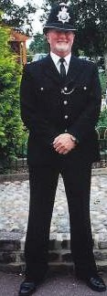 b.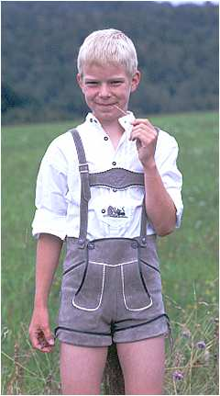 c.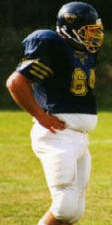 d.

e.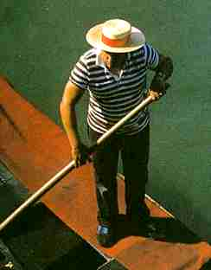 f.

Answer Key: b, d, f
Activity 3

Your instructor will describe the three people below. However, each picture is missing one item mentioned by your instructor. Complete each picture with the additional item.

1. 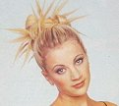 2. 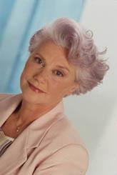 3. 

Reading Key:
1. Frau, jung, blonde Haare, Brille, hochgesteckte Haare
2. Frau, älter, Hut, graue, kurze Haare
3. Mann, jünger, braune Haare

Activity 4

Complete the following sentences with the correct preposition-article contraction.

1. Er hat einen Gips ________ (on the) Bein.
2. Sie hat ein Pflaster ________ (in the) Gesicht.
3. Das Haar ist naß _______ (from the) Regen.
4. Ich bin ______ (at the) Abendessen.

Answer Key:
1. am 2. im 3. vom 4. beim

Activity 5 (Group Activity)

The class is split into two groups and each group must come up with a fictitious suspect. Write down exactly what the suspect looks like, and draw his/her picture on a piece of paper. While you are describing your suspect to the other team, they will have to draw him/her. Compare their finished picture with your drawing.
Activity 6 (Group Activity)

The instructor will hand out flashcards with each of the students’ name. Each student takes on the identity of the student whose name he/she named on his flashcard and gives the rest of the class some information about him/herself.

Activity 7

Listen to the following paragraph and write down as many adjectives as you remember. Afterwards, compare your words with the words the instructor writes on the board.

_____________________________________________________________________
_____________________________________________________________________
_____________________________________________________________________
_____________________________________________________________________

Reading Key:
Holger ist ein großer Mann, aber er hat kleine Füße und kleine Hände. Seine Haare sind sehr lang und sie sind rot. Er trägt enge Kleidung und die Hosen sind immer zu kurz. Er ist sehr fröhlich und arbeitet als Clown im Zirkus.

Activity 8

Give a thorough description of the following picture. Use as many descriptive adjectives as possible. Use your dictionary, if necessary. Compare your description with those of your classmates.

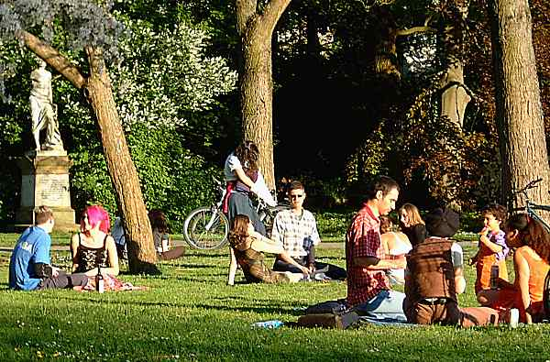

Activity 1

Listen to the two mothers talk about their children and write down their descriptions.

Klaus:
____________________________________________________________________
____________________________________________________________________
____________________________________________________________________
____________________________________________________________________

Claudia:
____________________________________________________________________
____________________________________________________________________
____________________________________________________________________
____________________________________________________________________

Audio Script:
Frau Maier:
“Klaus ist jetzt schon acht Jahre alt. Er ist sehr groß für sein Alter. Er hat kurze braune Haare und trägt in der Schule eine Brille. Er treibt viel Sport und ist sehr muskulös. Er ist sehr ruhig, wie sein Vater. Aber er ist sonst ein sehr fröhlicher Junge.”
Frau Hagen:
“Claudia ist erst sieben Jahre alt. Sie ist seit diesem Jahr in der Schule, ist aber klein für ihr Alter. Sie hat lange blonde Haare und trägt sie oft in einem Pferdeschwanz. Sie hat sehr schöne blaue Augen. Sie hat eine gute Kondition und spielt seit letztem Jahr Fußball. Ihre Lehrerin sagt, dass sie ein sehr aufgeschlossenes Mädchen ist.”

Activity 2

Fill in the blanks with the correct adjectives.

1. Peter hat einen _________ Hund. Er ist nicht sehr klein.
2. Sabine ist sehr _________. Sie ist nicht häßlich.
3. Markus hat ________ Füße. Seine Füße sind nicht groß.
4. Tanja ist sehr ________. Sie ist nicht fröhlich.

Answer Key:
1. großen 2. hübsch 3. kleine 4. traurig

Activity 3

Try to guess the meaning of these phrases.

1. Meine Schwester macht mich oft ganz wütend!

2. Ich bin verzweifelt! Wo ist mein Autoschlüssel?

3. Sie heißt Anja, und mein Bruder ist in sie verliebt!

4. Unsere Lehrerin ist heute sehr traurig! Ihre Großmutter lebt nicht mehr!

5. “Fröhliche Weihnachten und ein glückliches Neues Jahr!”

6. Sein kleiner Bruder wird immer beim Testschreiben sehr ängstlich!

7. Am Wochenende sitzen wir manchmal gelangweilt zu Hause.

Answer Key:

- My sister often aggravates me!
- I am desperate! Where is my car key?
- Her name is Anja and she is in love with my brother.
- Our teacher is very sad today. Her grandmother has passed away.
- Merry Christmas and a Happy New Year!
- His little brother is always afraid of taking tests.
- Sometimes we are bored and sit at home on the weekends.

Activity 4

Listen to the description of the three couples and choose the correct match from column A and B.

A B

1. 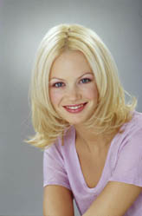 a. 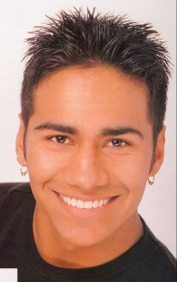

2. 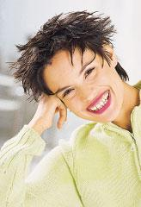 b. 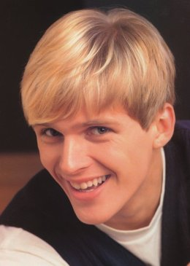

3. 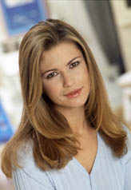 c. 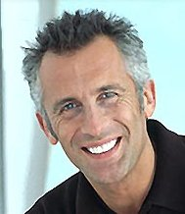

Audio Script:
1. Jutta und Wolfgang sind schon seit acht Jahren verheiratet. Jutta hat kurze schwarze Haare und sehr dunkle Augenbrauen. Sie trägt gerne roten Lippenstift. Wolfgang hatte früher einmal schwarze Haare, aber jetzt sind seine Haare grau an den Seiten.
2. Steffi und Thorsten sind erst ein Jahr verheiratet. Steffi ist sehr jung und hat schulterlange blonde Haare. Thorsten ist auch erst 22 und seine Haare sind ebenfalls blond.
3. Beate und Andreas heiraten nächstes Jahr. Beate hat sehr lange braune Haare und trägt nicht gerne Makeup. Andreas hat sehr kurze schwarze Haare und hat zwei Ohrringe im Ohr.
Answer Key: 1b 2c 3a

Activity 5

Prepare a “Wanted” poster of yourself to post on a board in class. Follow the outline below.

Picture of
yourself
Name:
Hair Color:
Eye Color:
Other facial features:
Stature:
Character Description
Emotion:

