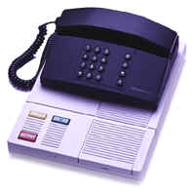
Telephone Conversation
At the end of this lesson you will be able to engage in a telephone conversation. In order to achieve this objective you will:

Engage in a Telephone Conversation

- Talk about common military calls
- Use information and emergency services from a pay phone
- Compare US telephone services / carriers with those in Germany

Use Telephone Services

- Give information where the call can be made
- Make local and long distance phone calls
- Call a person and leave a brief message
- Request assistance to place a long distance call
- Take telephone messages
- Make international calls

Ask for Telephone Numbers

- Request/provide telephone numbers
- Ask the operator for a telephone number

A Telephone Call in Germany

Your German counterpart, Franz Kreuz, tells you how he met his wife Eva during a telephone call mix-up! Listen as he recalls the fateful four phone calls.

Frau Müller: Müller.
Herr Kreuz: Guten Tag. Hier ist Kreuz. Kann ich bitte mit Frau Braun sprechen?
Frau Müller: Tut mir leid. Sie sind falsch verbunden.
Herr Kreuz: Oh, entschuldigen Sie bitte.

(bei Frau Braun zu Hause)
Frau Schmidt: Bei Braun.
Herr Kreuz: Guten Tag. Kreuz hier. Kann ich bitte mit Frau Braun sprechen?
Frau Schmidt: Frau Braun ist nicht hier. Kann ich ihr etwas ausrichten?
Herr Kreuz: Sagen Sie ihr bitte, dass ich angerufen habe. Sie soll mich zurück rufen.

Frau Braun: Guten Tag, mein Name ist Braun. Franz Kreuz bitte.
Herr Kreuz: Am Apparat!
Frau Braun: Guten Tag, Herr Kreuz. Sie wollten mich sprechen?
Herr Kreuz: Ja, Frau Braun. Ich....
Frau Braun: Bitte sprechen Sie etwas lauter. Ich kann Sie kaum verstehen.
Herr Kreuz: Frau Braun? Hallo?

Herr Kreuz: Hallo? Frau Braun?
Frau Müller: Hallo? Was heißt hier „hallo“?
Herr Kreuz: Wer ist am Apparat?
Frau Müller: Sie haben mich angerufen! Wer sind Sie?
Herr Kreuz: Hier spricht Franz Kreuz. Wo ist Frau Braun?
Frau Müller: Sie haben wieder die falsche Nummer.
Herr Kreuz: Oh, nein! Mit wem spreche ich?
Frau Müller: Ich heiße Eva Müller.
Herr Kreuz: Nett, Sie kennenzulernen, Frau Müller.

German Telephone Etiquette

1. How to answer the telephone at home

Frau Müller (answering the phone): Müller.
Herr Kreuz: Guten Tag, Frau Müller. Kreuz hier.

NOTE: In Germany it is considered unusual to answer the telephone with “Hallo!”.
Instead, Germans simply state their last name when answering.

2. How to answer the telephone at someone else’s home

Frau Müller (at Frau Braun’s home): Bei Braun.
Herr Kreuz: Guten Abend. Kreuz hier. Kann ich bitte mit Frau
Braun sprechen?
Frau Müller: Frau Braun ist nicht hier. Kann ich ihr etwas
ausrichten?

3. How to tell someone that he/she has the wrong number

Frau Müller: Müller.
Herr Kreuz: Guten Tag. Hier ist Kreuz. Kann ich bitte mit Frau Braun sprechen?
Frau Müller: Tut mir leid. Sie sind falsch verbunden.
Herr Kreuz: Oh, entschuldigen Sie bitte.

4. Speaking!

Frau Müller: Müller.
Herr Kreuz: Eva Müller bitte.
Frau Müller: Am Apparat!

5. How to tell someone that you are having difficulties hear him/her

Frau Müller: Müller.
Herr Kreuz: Guten Tag, Frau Müller. Hier spricht Franz Kreuz.
Frau Müller: Guten Tag, Herr Kreuz. Bitte sprechen Sie etwas lauter. Ich kann Sie
kaum verstehen.

6. How to tell someone to speak more slowly.

Frau Müller: Müller.
Herr Kreuz: Guten Tag, Frau Müller. Kreuz hier.
Frau Müller: Guten Tag, Herr Kreuz. Bitte sprechen Sie etwas langsamer. Mein
Deutsch ist nicht sehr gut.

1. Engage in a Telephone Conversation
 Tip of the Day
Three tones followed by the sentence “Kein Anschluß unter dieser Nummer!” (No connection under this number) means that the number you are trying to dial does not exist.

Exercise 1 (Pair Exercise)

Pretend you are receiving a telephone call from your German counterpart while you are at work. Use the English example below to create a dialogue in German.

A: Answer the phone with your name and rank and say that this is not a secure line.
B: Say good morning and state your name and rank.
A: Say good morning and ask how you can help him/her.
B: Say that there will be a reception (der Empfang) at the NCO Club at 7pm this evening.
Invite him to the reception.
A: Say that you will be there and ask him what the attire will be.
B: Say that it will be formal attire.
A: Thank him and tell him that you will see him this evening. Say good-bye.
B: Say good-bye.

Exercise 2 (Group Exercise)

Play the German game “Stille Post”. Imagine that your instructor is trying to get a message to the person sitting all the way in the back of the class, but she will have to go through all the students in front of him/her to get the message to him/her. The instructor will whisper a German message to the first student, who will whisper it to the next student, etc. Pass the message on until it has reached the last student, who will announce the message loudly. How much does the received message differ from the original message?

Note to the Instructor:
Repeat this exercise five times and keep the messages brief and simple.

Exercise 3 (Pair Work)

Beispiel der Telefonpreise in Deutschland

 | Grundpreis | City |  | Deutschland |  | USA
Standard-telefon | €13,33 im Monat | Tag  Mo-Fr  9-18 Uhr  6 Cent/  1,5 Min. | Nacht  Mo-So  21-5 Uhr  6 Cent/  4 Min.  Mo-Fr  5-9 Uhr  Sa+So  5-21 Uhr  6 Cent/  2,5 Min. | Tag  Mo-Fr  7-18 Uhr  12,3 Cent/  1 Min. | Nacht  Mo-So  21-7 Uhr  3,1 Cent/  1 Min.  Sa+So  7-21 Uhr  4,6 Cent/  1 Min.  Mo-Fr  18-21 Uhr  6,2 Cent/  1 Min. | 13 Cent/  1 Min.

Imagine that you are the sponsor of a soldier who will be arriving in Germany shortly. He has asked you to give him some information regarding local telephone services. Use the fictitious table of German telephone prices above as a guideline to write him a short message in German, explaining to him what the monthly base price is, and how much local, long distance, and international calls will be. Compare and discuss the tasks with those of your classmates.

_______________________________________________________________________

_______________________________________________________________________

_______________________________________________________________________

_______________________________________________________________________

_______________________________________________________________________

_______________________________________________________________________

_______________________________________________________________________

2. Use Telephone Services
Tip of the Day
Germany is in the process of switching the 0130 toll-free prefix to 0800-numbers, called “Freecall Nummern.” It has recently become possible to call 800 or 888 numbers in the US from Germany, although international rates may be involved.

Exercise 4 (Pair Exercise)

Compare, in German, the “German Telephone Etiquette” mentioned at the beginning in the Introduction with those of the USA.

Exercise 5

Read the following telephone conversation and answer the questions below. Discuss your answer with the rest of the class.

Auskunft: Auskunft!
Frau Walz: Ich hätte gerne die Nummer von Herrn Andreas Bader in Stuttgart.
Auskunft: Ich habe sieben Telefonnummern für Andreas Bader in Stuttgart. Wissen
Sie in welcher Straße er wohnt?
Frau Walz: Ich glaube er wohnt in der Königsstraße.
Auskunft: Danke. Die gewünschte Rufnummer ist: 8 87 47 64. Die Vorwahl für Stuttgart ist: 0711.
Frau Walz: Vielen Dank. Auf Wiederhören.

1. Wen ruft Frau Walz an?
_____________________________________________________________________
2. Welche Information möchte Sie über Herrn Bader?
_____________________________________________________________________
3. Was möchte die Auskunft noch wissen, außer dem Namen und der Stadt?
_____________________________________________________________________
4. Was ist “0711”?
_____________________________________________________________________

Answer Key:
1. Frau Walz ruft die Auskunft an.
2. Sie möchte Herrn Baders Telefonnummer.
3. Die Auskunft möchte wissen in welcher Straße Herr Bader wohnt.
4. “0711” ist die Vorwahl für Stuttgart.

Exercise 6 (Group Exercise)

Wie bedient man ein öffentliches Telefon und wichtige Telefonnummern?

Die Telefonzelle
 | Notruf  110 | Feuer  112 | Arzt  112
1. Hörer abnehmen  2. Geld einwerfen /  Telefonkarte einschieben  3. Nummer wählen  4. Gespräch führen  5. Hörer auflegen | Auskunft  Inland  11833  Ausland  11834 | Vermittlung  11885 | Störung  0800 3 30 20 00  Telegrammaufnahme  0180 5 12 12 10

Each student creates a short scenario, which should lead to calling either the fire department, an ambulance/police, or directory assistance. Explain your scenario to the rest of the class in German and end your description with the question: “Wen muss ich anrufen?” (Whom should I call?). If your description was detailed enough, the students should be able to answer your question and they should also be able to tell you what number to dial. Refer to the table on how to use a public telephone for your answer.

Beispiel: Ich möchte einen alten Freund in den USA anrufen und ich weiß seine
Telefonnummer nicht. Wen muss ich anrufen?

Answer: Sie müssen die internationale Auskunft anrufen. Die Nummer ist
11834.

Tip of the Day
When calling Germany from the United States, the initial 0 needs to be omitted in the area code. Example: 0711-person’s telephone number (within Germany)
011-49-711-person’s phone number (calling from the US)

3. Ask for Telephone Numbers

Exercise 7 (Group Exercise)

Each student writes his/her telephone number in large numbers on a piece of paper and holds it in front of him/her so the other students can see it. Mingle and ask/answer the following questions:

- Wie ist Ihre Telefonnummer?
- Wie ist Ihre Vorwahl?
- Wie ist die Telefonnummer und die Vorwahl von Herrn/Frau ...?

Exercise 8 (Pair Exercise)

Imagine that you would like to call a fellow soldier who is stationed in Heidelberg. You have tried calling him for a couple of days, but you are having difficulties getting through and would now like to try an operator-assisted call. Create a German dialogue with your partner. You may use the English dialogue below as a guideline.

A: Announce that you are the operator.
B: Say that you want to call a friend in Heidelberg but cannot get through (nicht
durchkommen).
A: Tell him/her that there will be a connection fee (Vermittlungsgebühr).
B: Say that you will pay the fee.
A: Ask for the person’s name and telephone number.
B: Give him your friend’s name and telephone number.

Exercise 9

Study the following German cell phone card and discuss the instructions in German.

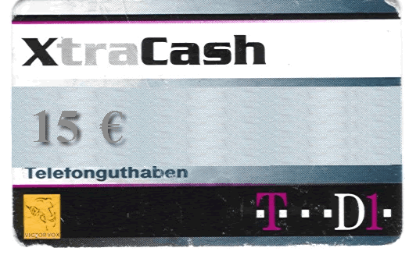

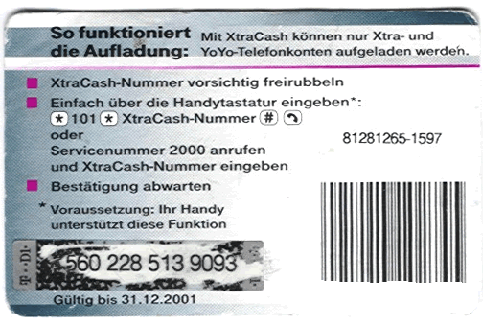

freirubbeln = to scratch off eingeben = to input, key in
aufladen = to reload Bestätigung, die = confirmation
vorsichtig = careful abwarten = to wait for
Tastatur, die = key/number pad Vorraussetzung, die = condition

________________________________________________________________________________________________________________________________________________________________________________________________________________________________________________________________________________________________________________________________________________________________________________________________________________________________________________________________________________________________________________________________________________________________________________________________________________________________________________________________________

Reflexive Verbs

The German language utilizes reflexive verbs much more than the English language does. In most sentences that contain objects, the subject and the object are two different people/things. When reflexive verbs are used, however, the verb’s subject and the verb’s object are the same person/thing. In English, these pronouns always end in –self or –selves. In German, reflexive verbs consist of a simple verb together with the reflexive pronoun in the accusative or the dative case. In the infinitive form, the reflexive pronoun “sich” precedes the verb itself.

Study the table below for the reflexive pronouns, which are used in connection with a verb to create a reflexive verb.

Nominative | Accusative | Dative
ich | mich (myself) | mir (myself)
du | dich (yourself) | dir (yourself)
er/sie/es | sich (himself/herself/itself) | sich (himself/herself/itself)
wir | uns (ourselves) | uns (ourselves)
ihr | euch (yourselves) | euch (yourselves)
sie/Sie | sich (youself/themselves) | sich (yourself/themselves)

Now let’s take a look at a sample of commonly used reflexive verbs. You will not need to know all of these verbs at this time, as many of them will be introduced in later lessons. Some of the verbs below you have already encountered in previous lessons.

sich anziehen | to get dressed
sich ärgern | to be angry, upset
sich beeilen | to hurry
sich duschen | to take a shower
sich entscheiden | to decide
sich erinnern | to remember
sich freuen | to be glad, happy
sich interessieren für | to be interested in
sich rasieren | to shave
sich setzen | to sit down
sich treffen | to meet
sich waschen | to wash (oneself)

NOTE: The verb “treffen” is only used reflexively in the plural.

Beispiele: Sie freut sich über die Blumen. – She is happy about the flowers.
Er ärgert sich über den Unfall. – He is upset about the accident.
Er setzt sich auf die Bank. – He sits down on the bench.
Exercise 1

Read the sentences below and fill in the blanks with the correct reflexive verbs and pronouns.

1. Wir ____________ __________ die Hände. (sich waschen)
2. Er ____________ _________ jeden Morgen. (sich rasieren)
3. Ich ________________ _______ für Musik. (sich interessieren)
4. Ihr _____________ ___________ in der Schule. (sich treffen)
5. Du ____________ ___________ über das Geschenk. (sich freuen)

Answer Key:
1. Wir waschen uns die Hände.
2. Er rasiert sich jeden Morgen.
3. Ich interessiere mich für Musik.
4. Ihr trefft euch in der Schule.
5. Du freust dich über das Geschenk.

Exercise 2

Read the following sentences and write down the infinitive form of the reflexive verbs.

Beispiel: Er beeilt sich jeden Tag.
sich beeilen

1. Sie erkältet sich jeden Winter.
___________________________
2. Die Gruppe bewegt sich sehr langsam.
Answer Key:
1. sich erkälten
2. sich bewegen
3. sich gewöhnen

___________________________
3. Ich gewöhne mich allmählich an das Wetter.
___________________________

Apparat, der (Telefonapparat) die Apparate | telephone
auf Wiederhören | good-bye (on the telephone)
auflegen | to hang up
Auskunft, die | directory assistance
Auslandsgespräch, das die (-gespräche) | international call
ausrichten | can I take a message
außer | besides
billig | cheap
durchkommen | to get through (on the telephone)
einschieben | to insert
einwerfen | to deposit
falsch verbunden sein | to have the wrong number
Ferngespräch, das die (-gespräche) | long-distance call
Feuer, das die Brände | fire
Feuerwehrauto, das die (-autos) | fire engine
Gebühr, die die Gebühren | charge
Gespräch, das die Gespräche | conversation
glauben | to believe
Grundpreis, der die Grundpreise | basic price
Handy, das die Handys | cell phone
Hilfe, die | help
hinterlassen (Nachricht, die) | to leave (a message)
langsam | slowly
Leitung (Telefon-), die (-leitungen) | telephone line
melden | to report
Notruf, der die Notrufe | emergency call
öffentliche Fernsprecher, der / Münzfernsprecher, der die/die | public telephone
Ortsgespräch, das die (-gespräche) | local call
preiswert | cheap
sichere Leitung, die | secure line
Störung (-sstelle), die | repair service (when dialing the number for “Störung”)
Techniker, der die | technician
Telefonanruf, der die Telefonanrufe | telephone call
Telefonhörer, der die | telephone receiver
telefonieren | call on the telephone
Telefonkarte, die die (-karten) | telephone card
Telefonnummer, die / Rufnummer, die (-n) | telephone number
Telefonzelle, die (-zellen) | telephone booth
unterwegs sein | to be on its way
Vermittlung, die | operator
Vermittlungsgebühr, die | connection fee
verstehen | to understand
Vorwahl, die | area/city code
wählen | to dial

Supplemental Vocabulary

allmählich | gradually
Bekleidung, die | attire
finden | to find
Geschenk, das die Geschenke | present
Gruppe, die die Gruppen | group
laut | loud
Nachbar, der die Nachbarn | neighbor
sich bewegen | to move
sich gewöhnen | to get accustomed to
sich erkälten | to catch a cold
Übungsbesprechung, die (-en) | training meeting
Wetter, das | weather

Die Deutsche Telekom

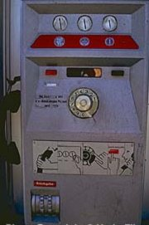

The German deregulation in 1998 has taken phone services out of the hands of the state monopoly phone company. Privatization has enabled more than 250 new phone companies to evolve in the German market and the Deutsche Telekom, which is still the most dominant German phone company, now has to cut prices to remain competitive. Germans usually pay per-minute charges for calls and these include all local calls (das Ortsgespräch), long-distance calls (das Ferngespräche), and international calls (das Auslandsgespräch).

Over 60 million Germans already own one or more cell phones (das Handy) and the number is steadily increasing. Most US cell phones do not work outside of the United States. The only wireless phones that will work are GSM-compatible phones.

However, you can always rely on public phones (die Telefonzelle). Or can you? With the increasing number of Handys flooding the market, the Deutsche Telekom has drastically cut the number of public telephones in Germany. Only 130,000 public telephones are now remaining in Germany and 85% require telephone cards (die Telefonkarte/Smart Card) that can be bought in most stores or at the post office.

Local, long-distance, and international calls can be placed from a public phone. To call Germany from the United States, dial 011, then the country code 49 (die Landesvorwahl), then the area/city code (die Vorwahl) without the zero, and then the person’s phone number. To call the US from Germany, dial 001, followed by the area code, and then the person’s phone number.

Germany’s latest invention in the public telephone sector

The Deutsche Telekom has just recently introduced the “Telekioske”, which, sometime in the not so distant future, are supposed to replace the current public telephones. So far 1,000 Telekioske have been installed, giving the public the opportunity to use the telephone, fax documents, send emails, and surf the Internet, all from a public telephone.

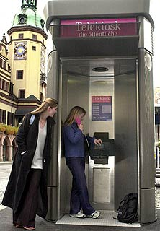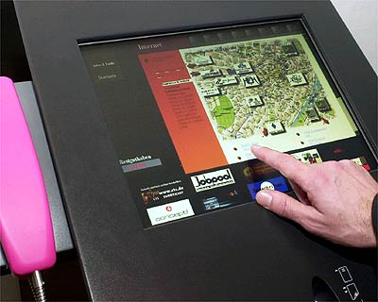

Contacting US phone companies in Germany

If you would rather deal with a US telecommunications company than the German “Vermittlung,” you can always reach AT&T, MCI WorldCom or Sprint through their own toll-free number and speak to a US operator. And of course, all major US telephone cards can be used within Germany as well.

The numbers you will have to dial from Germany are:

AT&T: 0800-2255-288
MCI WorldCom: 0800-888-8000
Sprint: 0800-888-0013

The Deutsche Telekom does, however, have an English-speaking operator, who can be reached at 11837.

1. Engage in a Telephone Conversation

Activity 1 (Group Activity)

This Activity will practice one of the most dreaded military “wake-up” calls – the alert exercise call. Your instructor will start the Activity by “calling” the first student, addressing him/her by his/her proper rank and informing him/her of an alert exercise (die Alarmübung) at 0430 in front of the company building. The instructor will also order the student to call the next person on the alert roster (die Alarmliste). Continue the exercise until every student has been informed.

Activity 2

Read the five telephone-related statements on the left and match them with the statements on the right.

1. Feuerwehr Münster! A. Von der Telefonezelle 3.

2. Ich hätte gerne die Nummer von B. Er ist nicht zu Hause. Möchten Sie
Thomas Maier in Ulm. eine Nachricht hinterlassen?

3. Von welcher Telefonzelle aus C. Ich möchte ein Feuer in der Königstrasse
kann ich telefonieren? melden.

4. Martin Stotz bitte! D. Die Vorwahl ist 089.

5. Wie ist die Vorwahl von München? E. Die Rufnummer ist 39 30 84

Answer Key: 1C, 2E, 3A, 4B, 5D

2. Use Telephone Services

Activity 3
In this Activity you will play the role of an answering machine. Your instructor will “call” you and leave three messages. Make sure to carefully write down each message. Compare your information with that of your classmates.

MESSAGE 1:

MESSAGE 2:

MESSAGE 3:

Reading Key:
Message 1:
Hallo Andrea. Sabine Messer hier. Ich möchte dir alles Gute zum Geburtstag wünschen. Ich habe dein Geschenk vorgestern mit der Post abgeschickt und hoffe, dass du es schon bekommen hast.

Message 2:
Guten Tag, Frau Straub. Hier ist Thomas Mann von der Deutschen Bank. Wir haben ihre Scheckkarte gefunden. Bitte rufen Sie mich an unter: (069) 56 82 01.

Message 3:
Hallo Martin, hier ist Beate. Ich wollte dir nur sagen, dass ich heute Abend nicht zum Essen kommen kann, weil meine Eltern zu Besuch kommen.

Activity 4

Read the following dialogue and answer the questions below. Compare it with the rest of the class.

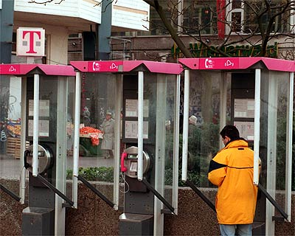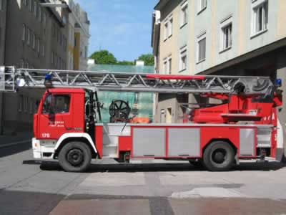
112

Feuerwehr: Feuerwehr Ditzingen.
Herr Bauer: Ewald Bauer hier. Ich möchte ein Feuer melden.
Feuerwehr: Wo ist das Feuer, Herr Bauer?
Herr Bauer: Es ist im Hotel Löwen in der Waldstrasse 23 in Ditzingen. Bitte kommen
Sie schnell.
Feuerwehr: Ein Feuerwehrauto ist schon unterwegs. Es wird in fünf Minuten am
Hotel Löwen sein.

1. Wen ruft Herr Bauer an?
_________________________________________________________________
2. Warum ruft er an?
_________________________________________________________________
3. Wo ist das Feuer?
_________________________________________________________________
4. Wie lange dauert es, bis das Feuerwehrauto am Hotel Löwen ankommt?
_________________________________________________________________

Answer Key:
1. Herr Bauer ruft die Feuerwehr an.
2. Er ruft an, weil er ein Feuer melden will.
3. Das Feuer ist im Hotel Löwen in der Waldstrasse 23 in Ditzingen.
4. Es dauert fünf Minuten bis das Feuerwehrauto ankommt.

Activity 5 (Pair Activity)

You have just arrived in Germany and don’t have a telephone in your home yet. You have called the Deutsche Telekom to get a telephone installed and you also want to know from the person where you can make a phone call in the meantime. Using the English dialogue below as a guideline, create a dialogue in German.

A: I don’t have a telephone, and I would like to call my family in the US. Where can I go
to call them?
B: You can go to the post office to make the phone call.
A: I don’t know where the post office is. Can I make the call from somewhere else?
B: Yes, you can also go to a public telephone.
A: Thank you for your help.

Activity 6

Imagine that you are calling a friend in Germany and he is not at home. The answering machine picks up and you leave a message. Choose one of the three topics below and write down the exact message you are leaving, including the introduction and the good-bye. Compare it with your classmates.

1. Say that you will be arriving in Germany on Monday at 7 pm. Ask him if he can pick
you up and to please return the call.

2. Say that you are having a party tomorrow at 6 pm. Invite your friend and ask him to
bring something to drink.

3. Say that you just bought a new car, and ask him if he wants to drive to Munich with
you this weekend. Ask him to return your call.

3. Ask for Telephone Numbers

Activity 7 (Pair Activity)

You will be moving to Germany shortly and want to make reservations at a local hotel for the first few nights of your stay. Your partner has been to Germany before and knows how the German telephone system works. Request the following information in German:
- What do I have to dial to reach the Hotel Krone in Baumholder?
Your partner will choose one of the two numbers below and will answer:
- You will have to dial the country code …, followed by the area code… and then the number of the hotel…
Switch roles and use the second telephone number.

a. 011-49-67-833947 b. 011-49-67-831840

Activity 8 (Pair Activity)

Imagine that you met a soldier of the Deutsche Bundeswehr at an exercise in the US. He gave you his telephone number, but you have lost it. You are now stationed in Germany and are trying to get his telephone number from the operator. Use Exercise 5 in the Introduction as a guideline to create a dialogue with your partner, the operator. Switch roles after you have received the number.

1. Engage in a Telephone Conversation

Activity 1 (Group Activity)

Pretend that there will be a training meeting at 10 am tomorrow morning, and you are calling all the people who will need to attend the meeting (everyone in the classroom). The first person pretends to call his/her classmate and reminds him/her of the meeting and asks him/her to call the next person. Continue until every person has called someone else. Make sure to properly introduce yourself.

Activity 2

The instructor will give each student a message for one of the other students without any of the other classmates hearing the message. Once every student has received the message, the first student will approach the student for whom the message was intended and relay the message. Continue until every student has received his/her message.

Note to the Instructor:
Prepare as many short messages in German as there are students.

2. Use Telephone Services

Activity 3 (Pair Activity)

Imagine that you are at the post office and want to use a public phone to call your brother in the US. Create a German dialogue with the postal clerk.

Activity 4

Read the following dialogue and answer the questions below. Discuss your answers with those of your classmates.

Sgt. Miller: Ich möchte gerne Sgt. Smith in Stuttgart anrufen.
Sgt. Combs: Wie ist Sgt. Smith’s Telefonnummer?
Sgt. Miller: Seine Telefonnummer ist 48 23 93.
Sgt. Combs: Wenn Sie in Stuttgart sind, müssen Sie nur die Nummer wählen.
Sgt. Miller: Ich möchte ihn aber von München aus anrufen.
Sgt. Combs: Wenn Sie Sgt. Smith von München aus anrufen, dann müssen Sie erst die
Vorwahl 0711 wählen.
Sgt. Miller: Danke für Ihre Hilfe, Sgt. Combs.

1. Wo ist Sgt. Smith?
_______________________________________________________________________

2. Wie ist Sgt. Smith’s Telefonnummer?
_______________________________________________________________________

3. Von welcher Stadt aus möchte Sgt. Miller anrufen?
_______________________________________________________________________

4. Was muss Sgt. Miller wählen, bevor er Sgt. Smith’s Telefonnummer wählt?
_______________________________________________________________________

Answer Key:
1. Sgt. Smith ist in Stuttgart.
2. Sgt. Smith’s Telefonnummer ist 48 23 93.
3. Sgt. Miller möchte von München aus anrufen.
4. Sgt. Miller muss die Vorwahl 0711 wählen.

Activity 5 (Group Activity)

Each student takes a turn asking one of his/her classmates about the telephone number and the address of one of the companies below.

Auto Schmidt GmbH (07 11) 59 66 71 Bernhauser Str. 1
Ballettschule Tanja Schmidt (07 11) 28 00 18
Tränkestr. 13
Brotladen Schmidt (07 11) 36 36 68
Breitscheidstr. 133
Elektro Schmidt (07 11) 40 40 22
Dreifelderstr. 26
Entrümpelungen Schmidt (07 11) 98 73 13
Aspacher Str. 12
Galerie Adriana Schmidt (07 11) 20 55 82
Katharinenstr. 21B
Schmidt Fotografie (07 11) 15 81 29
Schwabstr. 2
Notar Schmidt Siegfried (07 11) 22 05 93
Königstr. 21
Omnibus Schmidt (07 11) 63 61 49
Ludwigsburger Steige 42
Schmidt Rechtsanwalts- (07 11) 27 23 09
und Steuerberaterkanzlei
Kornbergstr. 10
Schmidt – Hausverwaltungen (07 11) 40 05 99
Allgäustr. 12
Schmidt + Co. GmbH (07 11) 47 11 32
Hölderlinplatz 4



Activity 6 (Pair Activity)

Ask and answer each other about German service numbers. Use the public telephone instruction in Exercise 6 of the Introduction as a guideline.
3. Ask for Telephone Numbers

Activity 7

Study the following numbers below and assign the correct words to each of the numbers.

a. (069) 34 28 92 b. 0800 3 30 20 00 c. 001-910-868-4398

d. 110 e. 88 72 82 f. 112 g. 11833 h. 11885 i. 11834

Auskunft (national) Ferngespräch Notruf

Auslandsgespräch Ortsgespräche Feuer/Arzt

Auskunft (international) Vermittlung Störung

Answer Key:
a. Ferngespräch b. Störung c. Auslandsgespräch
d. Notruf e. Ortsgespräch f. Feuer/Arzt g. Auskunft (national)
h. Vermittlung i. Auskunft (international)

Activity 8

Take turns requesting and providing the phone numbers used in the exercise above. Make sure you speak in complete German sentences.

Activity 9

Match the left column with the logical right column answer.

1. Wir gehen zum Nachbar. A. Sie ist einundzwanzig Euro.

2. Verzeihung, ich bin falsch verbunden. B. Die Leitung ist kaputt.

3. Er ist nicht da. Kann ich etwas ausrichten? C. Er hat uns eingeladen.

4. Wie ist die Vorwahl für Berlin? D. Das ist doch ein Ferngespräch.

5. Kann ich eine Telefonkarte benutzen? E. Er soll mich bitte zurückrufen.

6. Wie hoch ist die Gebühr? F. Ich habe warme Kleider.

7. Der Telefonanruf ist sehr teuer! G. Das ist ein Sonderangebot.

8. Ich komme einfach nicht durch! H. Kein Problem. Macht nichts.

9. Bei dem Wetter kann man sich erkälten! I. Die ist null drei null.

10. Der Grundpreis fürs Handy ist billig! J. Natürlich! Es ist sehr einfach!

Answer Key:

1. C 6. A
2. H 7. D
3. E 8. B
4. I 9. F
5. J 10. G

Activity 10

Read the following dialogue and answer the questions.

Person A: Hartmann

Person B: Guten Morgen, hier spricht Julia Olson. Kann ich bitte mit Herrn Hartmann sprechen?

Person A: Tut mir leid. Er ist schon auf dem Weg zur Arbeit.

Person B: Ach, wie schade. Es ist dringend.

Person A: Wollen Sie eine Nachricht hinterlassen?

Person B: Ich habe ein Geschenk in meinem Auto. Das ist für ein Arbeitskollege.
Unser neuer Techniker.

Person A: Wie kann ich Ihnen helfen?

Person B: Ich habe ein Handy gekauft, und unser Arbeitskollege soll nichts davon wissen. Ich wollte Herrn Hartmann heute morgen kurz treffen, und ihm das
Geschenk geben. Aber jetzt ist es schon zu spät.

Person A: Wissen Sie, Fau Olson. Ich kann Ihnen vielleicht helfen. Ich rufe meinen Mann im Büro an, und er soll dann noch einmal in der Mittagspause nach Hause kommen. Bringen Sie mir jetzt das Geschenk, und dann gebe ich es meinem Mann. Geht das?

Person B: Das wäre eine gute Idee! Vielen Dank für Ihre Hilfe. Der Techniker feiert heute seinen dreiundvierzigsten Geburtstag.

Person A: Jetzt ist es zehn vor acht. Mein Mann ist noch unterwegs. Ich rufe jetzt seine Sekretärin an, und richte ihr das aus. Ich glaube sie ist schon im Büro.

Person B: Ja, das stimmt. Frau Lagerfeld ist immer um viertel vor acht da.
Herzlichen Dank, Frau Hartmann. Nun bin ich beruhigt. Auf Wiederhören.

Person A: Nicht zu danken, Frau Olson. Kein Problem. Auf Wiederhören.

Activity 10 (continued)

1. Person A is: a) an office worker
b) Julia Olson’s co-worker
c) Mr. Hartmann’s wife
d) none of the above

2. Person B is: a) the new technician
b) Mr. Hartmann’s wife
c) Mr. Hartmann’s secretary
d) none of the above

3. Ms. Olson has: a) somebody’s cell phone
b) Ms. Lagerfeld’s phone
c) received a gift, because she is the new technician
d) a birthday

4. The secretary is always a) 7:50am
in her office at: b) 8 am
c) 8:45
d) none of the above

5. Julia Olson called: a) too early
b) too late
c) not at all
d) at the right time

Answer Key:

1. c
2. d
3. a
4. d
5. b

Activity 1

Listen to the following conversation and answer the questions below. Be ready to discuss your answers in class tomorrow.

1. Wo ruft Frau Lindt an?
_____________________________________________________________________

2. Was ist mit ihrem Telefon?
_____________________________________________________________________

3. Wie ist die Telefonnummer von Frau Lindt?
_____________________________________________________________________

4. Wen schickt die Störungsstelle?
_____________________________________________________________________

Audio Script:
Störungsstelle: Störungsstelle Stuttgart!
Frau Lindt: Sabine Lindt hier. Die Leitung meines Telefons ist tot. Ich rufe
vom Telefon meiner Nachbarin aus an.
Störungsstelle: Wie ist Ihre Telefonnummer und Ihre Adresse, Frau Lindt?
Frau Lindt: Meine Telefonnumer ist (0711) 83 41 03 und meine Adresse ist
Frankenstrasse 45 in Stuttgart-Feuerbach.
Störungsstelle: Uns ist zur Zeit keine Störung in Feuerbach bekannt, aber wir
schicken heute Nachmittag einen Techniker zu Ihnen.
Frau Lindt: Vielen Dank. Auf Wiederhören.

Answer Key:
1. Frau Lindt ruft bei der Störungsstelle an.
2. Die Leitung ist tot.
3. Die Telefonnummer von Frau Lindt ist (0711) 83 41 03.
4. Die Störungsstelle schickt einen Techniker.

Activity 2

Make a list of all important telephone numbers that you might need when getting deployed to Germany, including numbers of family and friends. Make sure to write down the numbers the way they would be dialed from Germany.
Activity 3

Study the following Deutsche Telekom ad and choose the appropriate description below.

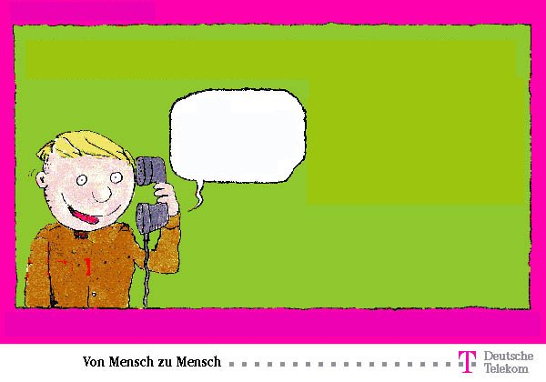
Hallo Werner. Hier ist Stefan.
Was machst du heute?
Melden Sie Sich bei Ihren Freunden für nur 12 Cent für drei Minuten!
Noch nie war Telefonieren so preiswert!
- Es ist sehr teuer die Familie anzurufen.
- Abends ist das Telefonieren am billigsten.
- Es ist sehr billig die Freunde anzurufen.

Answer Key: c

Activity 4

Imagine that you have just witnessed a car accident (der Autounfall) and you are using a pay phone to call the police (use the “Notfall” number). Tell the police your name and location and that you have just witnessed an accident and anything else you would like to add. Be ready to orally report it in class tomorrow.

______________________________________________________________________
______________________________________________________________________
______________________________________________________________________
______________________________________________________________________
______________________________________________________________________

Activity 5

Pretend that you and your classmates are stationed in Germany. Create a dialogue between yourself and a German operator, requesting the telephone number of one of your classmates. Make the dialogue as interesting as possible and play it out the next day with a classmate.

