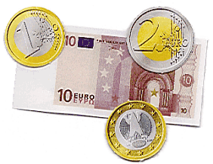
Banking

At the end of this lesson you will be able to get information about banking activities in Germany. In order to achieve this objective you will:

Conduct Daily Business Transactions

- Describe banking activities
- Open a bank account
- Close a bank account
- Deposit money
- Withdraw money
- Engage in office conversation
- Read instructions on standard bank forms
- Identify different services at the bank
- Describe other business activities

Discuss Monetary Units

- Identify the different values of German currency
- Compare US currency to German currency

Discuss the Exchange Rate

- Compare the exchange rate
- Exchange money at the bank

Scenario

Your German counterpart, Michael Hansen, has to run an errand at the bank. He asks you to accompany him.

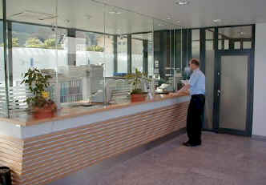

Bankangestellte: Guten Tag, Herr Hansen. Wie geht es Ihnen heute?
Herr Hansen: Gut, danke Frau Schulz. Ich möchte gerne Geld von meinem
Girokonto abheben.
Bankangestellte: Kein Problem, Herr Hansen. Füllen Sie bitte diesen
Auszahlungsschein aus.
Herr Hansen: Ach ja, und ich möchte außerdem noch 100,00 Euro auf mein
Sparkonto einzahlen.
Bankangestellte: Dann müssen Sie bitte noch diesen Einzahlungsschein ausfüllen.
Herr Hansen: Welches Datum haben wir heute?
Bankangestellte: Heute ist der 22. August.
Herr Hansen: Danke. So, hier sind die beiden Formulare und hier sind die 100,00
Euro.
Bankangestellte: Hier sind die 250,00 Euro von Ihrem Girokonto. Kann ich
Ihnen sonst noch behilflich sein, Herr Hansen?
Herr Hansen: Nein, danke Frau Schulz. Das wäre alles für heute. Ich wünsche
Ihnen noch einen schönen Tag.
Bankangestellte: Ebenfalls, Herr Hansen. Bis zum nächsten Mal.

1. Conduct Daily Business Transactions

Exercise 1

After reading the scenario, answer the following questions in German. Discuss the answers with the rest of the class.

1. Was möchte Herr Hansen als Erstes?
______________________________________________________________________
2. Was muss er ausfüllen?
______________________________________________________________________
3. Was möchte Herr Hansen als Zweites?
______________________________________________________________________
4. Was gibt Herr Hansen der Bankangestellten?
______________________________________________________________________
5. Wie viel Geld bekommt Herr Hansen?
______________________________________________________________________

Answer Key:
1. Herr Hansen möchte Geld von seinem Girokonto abheben.
2. Er muss einen Auszahlungsschein ausfüllen.
3. Er möchte 100,00 Euro auf sein Sparkonto einzahlen.
4. Er gibt der Bankangestellten den Auszahlungsschein, den Einzahlungsschein und 100,00 Euro.
5. Er bekommt 250,00.
Der Euro

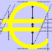
On 1 January 2002, the Euro became the official currency of the member states of
the European Union, including Germany. From then on, the value of the Euro
against the dollar and all other currencies, including those of the four Member States staying out of the euro zone, will fluctuate according to market conditions.
© Paul Joyce 2001

Euro bills are available in 7 denominations and look the same in all euro-zone countries. Each denomination is printed in a different color and size and their designs are based on the architectural styles of 7 periods in Europe's cultural history.
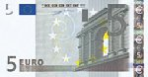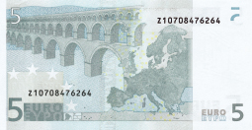 | 5 Euro  Classical
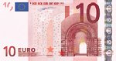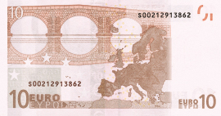 | 10 Euro  Romanesque
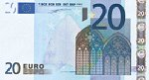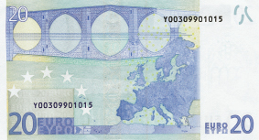 | 20 Euro  Gothic
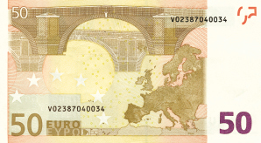 | 50 Euro  Renaissance
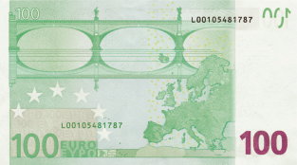 | 100 Euro  Baroque and Rococo
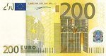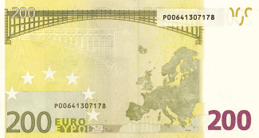 | 200 Euro  19th century Industrial
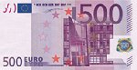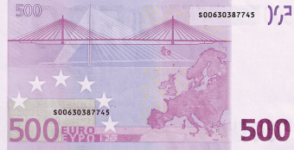 | 500 Euro  20th century Modern
Euro coins are available in 8 denominations and all coins have a European side. This side was designed by Belgian artist Luc Luycx and looks the same in all Euro-zone countries. The second side is a national side, designed by each member country. All coins are valid in all Euro-zone countries.

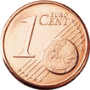 | 1 Euro Cent
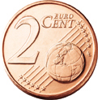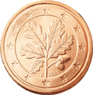 | 2 Euro Cent
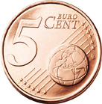 | 5 Euro Cent
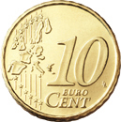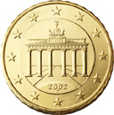 | 10 Euro Cent
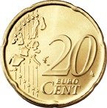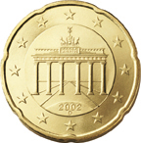 | 20 Euro Cent
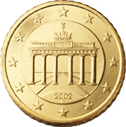 | 50 Euro Cent
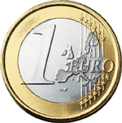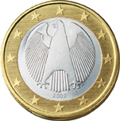 | 1 Euro
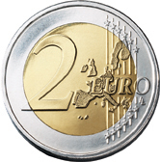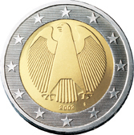 | 2 Euro

 Tip of the Day
In Germany, Euro and Cent are not used in the plural. So in contrast to the United States, where you would spend 25 cents on a piece of gum, in Germany you would spend 25 Cent.

Most commonly used phrases at a bank

Ich möchte gerne ein Girokonto / Sparkonto eröffnen / schließen.

Ich möchte gerne Geld abheben / einbezahlen.j

Ich möchte gerne Geld wechseln.

Bitte füllen Sie den Auszahlungsschein / Einzahlungsschein aus.

Welche Währung hätten Sie gerne?

Exercise 2 (Pair Exercise)

Imagine you would like to open a checking account in Germany. Since each bank offers different Girokonto-packages, you want to ask the bank clerk what services and fees will be involved if you open an account with them. Create a dialogue with your partner, asking him to help you open up an account and requesting information about the different services and fees. Your partner can use the services table in the Introduction as a guideline.
Exercise 3

A check is used very rarely in Germany and in its place transfers are used (for bills, for example). However, checks are used in situations where large amounts of cash have to be transferred immediately, for example, when buying a car with cash. Below is an example of a German check. Study it with your instructor and fill in the blanks.

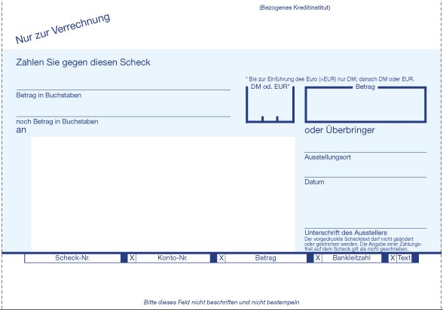

Exercise 4

Read the dialogue and determine what occured here. Then please answer the questions.

Meine Scheckkarte wurde gestohlen!

Frau Stuck: Mir wurde vor einer halben Stunde mein Geldbeutel mit meiner
Scheckkarte gestohlen. Was soll ich nun machen?
Bankangestellter: Das ist kein Problem. Wie ist Ihr Name bitte?
Frau Stuck: Mein Name ist Stuck. Tanja Stuck.

Exercise 4 (continued)

Bankangestellter: Gut, Frau Stuck. Füllen Sie bitte dieses Formular aus.
Machen Sie bitte die folgenden Angaben: Name, Adresse,
Telefonnummer, Zeit und Ort des Diebstahls, und eine genau
Beschreibung des Diebstahls.
Frau Stuck: Was passiert dann?
Bankangestellter: Wir sperren sofort Ihre Scheckkarte, damit niemand anderes sie
benützen kann und innerhalb von zwei Tagen wird Ihnen eine neue
Karte zugeschickt.
Frau Stuck: Gut, dann würde ich gerne 50,00 Euro abheben, damit ich
in den nächsten zwei Tagen wenigstens Bargeld habe.
Bankangestellter: Dann füllen Sie bitte auch noch diesen Auszahlungsschein aus.

1. Was wurde Frau Stuck gestohlen?
_____________________________________________________________________
2. Was soll Frau Stuck ausfüllen?
_____________________________________________________________________
3. Welche Angaben soll sie machen?
_____________________________________________________________________
4. Was passiert nachdem sie das Formular ausfüllt?
_____________________________________________________________________
5. Wie viel Geld möchte Frau Stuck abheben?
_____________________________________________________________________

Answer Key:
1. Ihr wurde der Geldbeutel mit ihrer Scheckkarte gestohlen.
2. Sie soll ein Formular ausfüllen.
3. Sie soll ihren Namen, ihre Adresse, ihre Telefonnummer, die Zeit und den Ort des Diebstahls, und eine genaue Beschreibung des Diebstahls angeben.
4. Die Bank sperrt ihre Scheckkarte und schickt ihr innerhalb von zwei Tagen eine neue Karte.
5. Frau Stuck möchte 50,00 Euro abheben.
Exercise 5

Below are five sentences you might hear when walking into a bank in Germany. Read the sentences and match them up with the descriptions below. Compare your answers with those of your classmates.

1. “Stehen Sie an?”

2. “Sie waren zuerst hier.”

3. “Haben Sie etwas zum Schreiben?”

4. “Wo sind die Bankformulare?”

5. “Ist das der richtige Schalter für ........?”

a) You are looking for the bank forms.
b) You want to make sure you are at the correct counter.
c) You are asking a person if he/she is standing in line.
d) You are looking for something to write with.
e) You are letting someone go ahead of you, who was at the bank before you.

Answer Key: 1c, 2e, 3d, 4a, 5b

Exercise 6 (Pair Exercise)

Imagine that your tour in Germany is over and you want to close your bank account with a German bank. Approach the bank teller (your partner) and create the corresponding dialogue in German. Role-play the situation for the whole class.

A: Say hello and tell the teller that you would like to close your bank account.
B: Ask if it is a savings or a checking account.
A: Say that it is a checking account.
B: Ask for his/her name and account number.
A: State your name and account number.
B: Ask him/her to fill out a withdrawal slip for the amount in the account.
A: Ask how much money is currently in the account.
B: Tell him that he/she has 357,44 Euro in the account. Hand him/her the money and ask if you can help him/her with anything else.
A: Say that this would be all and say good-bye.
B: Say good-bye.

Exercise 7

Study the bank form below and decide which of the three answers is correct. Then fill out the form and ask your instructor for help, if necessary. Compare it with one from your own bank.
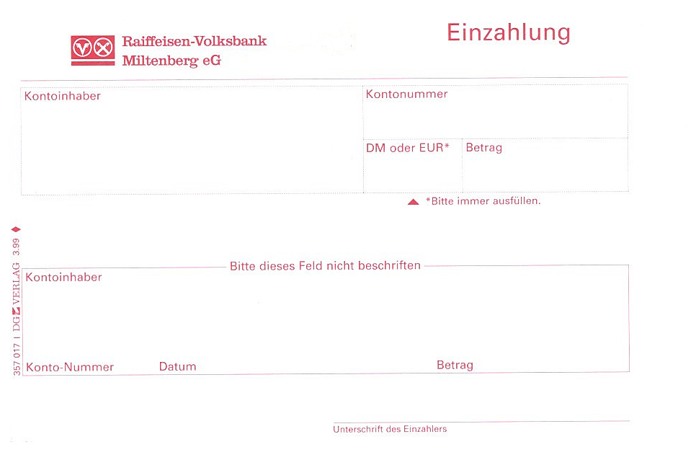
a) transfer slip b) deposit slip c) withdrawal slip

Answer Key: b

Exercise 8

Study the table below and answer the following two questions in German.

- What type of financial transaction can be performed at this location?
- Where is the financial institution?

Raiffeisenbank Ankunftshalle: Tel: 1-7007-33778, Fax: 1-7007-36792
Wechselstube Öffnungszeiten: | Mo, Di, Mi, Fr, Do | 8.00 - 17.30
Erste Bank Abflughalle: Tel: 1-7007-33354, Fax: 1-7007-33832
Wechselstube Öffnungszeiten: | Mo, Di, Mi, Fr, Do | 8.00 - 12.30,  13.30 - 15.00

Answer Key:
- Man kann Geld wechseln.
- Die Wechselstube ist an einem Flughafen.

Exercise 9 (Group Exercise)
Tip of the Day
At German banks a driver’s license is not a valid form of ID. Make sure to bring your military ID or your passport in order to conduct any kind of financial transaction.

Form two teams and each team describes the picture below in as much detail as possible. Compare the descriptions of the two teams.

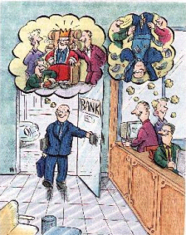
“Wie können Sie mir helfen?” – “Wie können Sie uns helfen?”

2. Discuss Monetary Units

Exercise 10 (Group Exercise)

The instructor asks each of the students how much he/she is depositing into his/her savings account. The students use one of the boxes below to answer the question.

Beispiel: Instructor: Wie viel zahlen Sie auf Ihr Sparkonto ein?
Student: Ich zahle …………. Euro auf mein Konto ein.

Exercise 10 (Group Exercise) (continued)

1. 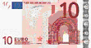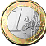 2. 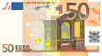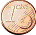

3. 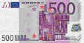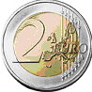 4. 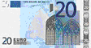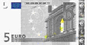

5. 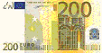 6. 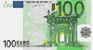

7.  8.

3. Discuss the Exchange Rate

Exercise 11 (Pair Exercise)

Create a dialogue in which you are trying to exchange money at a German bank. Role-play this situation for the whole class.

The Passive Voice

When changing an active sentence to a passive sentence, the direct object becomes the subject of the passive sentence. In an active sentence the subject performs an action, while in the passive sentence the subject is being acted upon.

Romeo loves Juliet. Juliet is loved by Romeo!

In the German passive construction the different tenses are indicated by the auxiliary verb werden. The active verb changes to its past participle form and moves to the end of the sentence. Used as an auxiliary for the passive present perfect, werden uses worden as a participle instead of geworden. In this lesson we will concentrate on the present tense, even though you will have an opportunity to practice the other tenses on the web.

Active: Romeo liebt Julia.
Passive:
Present Julia wird von Romeo geliebt.
Simple Past Julia wurde von Romeo geliebt.
Present Perfect Julia ist von Romeo geliebt worden.
Future Julia wird von Romeo geliebt werden.

NOTE: The passive voice is used much more often in German than in English. It is not considered to be a grammatical mistake to use the passive in formal texts. On the contrary, its primary use is in scientific and academic writing.

Exercise 1

Read the active sentences below and create the correct passive present tense sentences.

Beispiel: Der Mann füllt das Überweisungsformular aus.
Das Überweisungsformular wird von dem Mann ausgefüllt.

1. Der Bankangestellte nimmt das Geld.
____________________________________________________________________
2. Der Bankangestellte ruft den nächsten Kunden.
____________________________________________________________________
3. Der Kunde unterschreibt das Formular.
____________________________________________________________________
4. Der Kunde zeigt den Personalausweis.
____________________________________________________________________

Answer Key:
1. Das Geld wird vom Bankangestellten genommen.
2. Der nächste Kunde wird vom Bankangestellten gerufen.
3. Das Formular wird vom Kunden unterschrieben.
4. Der Personalausweis wird vom Kunden gezeigt.

Exercise 2

Create the correct active sentences from the passive present tense sentences below.

Beispiel: Ein Konto wird von uns eröffnet.
Wir eröffnen ein Konto.

1. Der Schalter wird vom Bankangestellten geschlossen.
____________________________________________________________________
2. Ich werde vom Bankangestellten angerufen.
____________________________________________________________________
3. Die Bankkarte wird vom Dieb gestohlen.
____________________________________________________________________

Answer Key:
1. Der Bankangestellte schließt den Schalter.
2. Der Bankangestellte ruft mich an.
3. Der Dieb stiehlt die Bankkarte.

Exercise 3

Create two simple sentences of your own. Write them first in the active, then in the passive present tense voice. Share them with your partner. Let the instructor check them. If you are adventurous, try to write one sentence each in the other tenses.

abheben | to withdraw
ausfüllen | to fill out
Auslandsüberweisung, die (-weisungen) | wire transfer
Auszahlungsschein, der die (-scheine) | withdrawal slip
Bank, die die Banken | bank
Bankangestellte, der/die die (-angestellten) | bank clerk, teller
Bankleitzahl, die die Bankleitzahlen | bank code number
Bankschließfach, das die (-fächer) | safety deposit box
Bargeld, das | cash
Betrag, der die Beträge | amount
Buchung, die die Buchungen | account entry
Dauerauftrag, der die (-aufträge) | standing order
einbezahlen | to deposit
Einzahlungsschein, der die (-scheine) | deposit slip
eröffnen | to open
Finanzberatung, die (-beratungen) | financial advice
Geld wechseln | to exchange money
Geldautomat, der die Geldautomate | ATM machine
Geldschein, der die Geldscheine | bill (money)
Girokonto, das die Girokonten | checking account
Immobilienberatung, die | property purchasing advice
Konto, das die Konten | account
Kontoauszug, der die Kontoauszüge | statement
Kontoführung, die (-führungen) | running of the account through the bank
Kredit, der | loan, credit
Kreditkarte, die (-karten) | credit card
Monatsgebühr, die (-gebühren) | monthly fee
Münze, die die Münzen | coin
Reisescheck, der die Reiseschecks | traveler’s check
Scheck, der die Schecks | check
Scheckkarte, die (-karten) | debit card
schließen | to close
Sparbuch, das die Sparbücher | savings book
Sparkonto, das die Sparkonten | savings account
Überbringer, der (die) | the delivering person
Überweisung, die (-überweisungen) | transfer
Währung, die | currency
Wechselkurs, der die Wechselkurse | exchange rate
wechseln | to change / exchange
Wechselstube, die (-stuben) | exchange office
Zins, der die Zinsen | interest

Supplemental Vocabulary

Abflugshalle, die (-hallen) | departure section
Angabe, die die Angaben | statement
Ankunftshalle, die (-hallen) | arrival section
anstehen | to stand in line
Ausweis, der | identification
benutzen | to use
beraten | to advise
Diebstahl, der | theft
Eingang, der die Eingänge | entrance
Flughafen, der die Fluhäfen | airport
passieren | to happen
sperren | to block
stehlen | to steal
Termin, der die Termine | appointment
Traum, der die Träume | dream

Der Wechselkurs

Since the world market constantly fluctuates and exchange rates depend on the market situation, you will have to contact your local bank to get an up-to-date exchange rate for the Euro and the US Dollar. You may also access one of the many currency converters online, like www.xe.com, which will give you a quick and accurate exchange rate. At the time of the development of this lesson, the exchange rate for the Euro and the Dollar is approximately 1:1, which will therefore be the base exchange rate for the rest of the Modules. The Exchange offices in airports and large train stations are open both evenings and weekends. Here, you can exchange your own currency and cash travelers’ checks.

Currency exchange sample as of 08/29/02
 | USA | EUR
1 US $ buys: | 1.00 | 1.01647
inverse: | 1.00 | 0.983737
1 EUR buys: | 0.983737 | 1.00000
inverse: | 1.01653 | 1.00000

Deutsche Banken

The major German banks are the Commerzbank, the Deutsche Bank, the Dresdner Bank, the Sparkasse, the Volksbank and the Postbank. All banks, including private ones, are subject to state control. Banks, savings banks, and postal banks offer more or less the same service, but the charges you have to pay for having an account (Konto) in Germany differ from bank to bank. In order to open a current account you will need your passport or identity card.

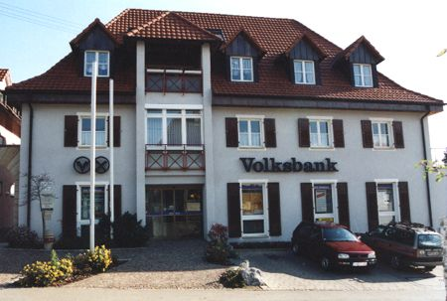
Das Serviceangebot Deutscher Banken

Das Girokonto (checking account)
All German banks require a monthly checking account fee. The following services are usually included:
- Kontoführung (running of the account through the bank)
- Buchungen (account entries)
- Vordrucke / Formulare (bank forms)
- Kontoauszüge (statements)
- Daueraufträge (standing order)
- Guthabenverzinsung (interest)
- Scheckkarten (debit cards)

Das Sparkonto (savings account)
Most German banks require their customers to give a 3-month notice to close a savings account. The customer can keep track of his or her money with his savings book (das Sparbuch).

Kredite, Finanz- und Immobilienberatung (loans, financial and real estate purchasing advice)
In order to be eligible for a loan, most German banks require the customer to be at least 18 years of age and own a checking account at their bank with a minimum monthly deposit. Of course, German banks also offer a great variety of investment options.

Die Überweisung (transfer)
To transfer from one account to another within the same financial institution or a transfer from the customer’s account to an account at another bank, the customer has to fill out an Überweisungsauftrag (transfer form) containing the following information:
- Name und Kontonummer des Empfängers (Begünstigter) (name and account number of the beneficiary)
- Überweisungsbetrag (transfer amount)
- Adresse der Empfängerbank und Bankleitzahl (address of the receiving bank and routing number)
- Name, Kontonummer und Unterschrift des Auftraggebers (name, account number and signature of the ordering customer)
The fee for a transfer varies from bank to bank.

Die telegrafische Geldüberweisung / Auslandsüberweisung (wire transfer)
The fee for a wire transfer varies from bank to bank. The following information has to be supplied when requesting a wire transfer at a German financial institution.

- Betrag und Währung (amount and currency type)
- Name, Adresse und Kontonummer des Auftraggebers (name, address, and account number of the ordering customer)
- Name, Adresse, Kontonummer und Bankleitzahl des Empfängers, Bank- oder SWIFT-Code der Empfängerbank, Zielland (name, address, account number of the beneficiary, bank or SWIFT-Code of the receiving bank, destination country)

Der Reisescheck (traveler’s check)
During the German main travel season, Euro travelers’ checks can be bought at most German banks without a fee. Fees during the rest of the year depend on the banks. Traveler’s checks can be used worldwide and have no expiration date. Lost or stolen checks will be replaced within 24 hours and unused checks can be cashed at any German financial institution.

Der Geldwechsel (money exchange)
Although the exchange rate is the same all over Germany, each bank adds an exchange fee onto the rate. To exchange large amounts of money you might want to call a few days in advance, because most banks only keep a limited amount of foreign currency.

Das Bankschließfach (safety deposit box)
Safety deposit boxes are available at most German banks. The fee depends on the bank.

1. Conduct Daily Business Transactions

Activity 1 (Pair Activity)

Imagine you are at a German bank and want to withdraw money for the first time. You are not sure what the procedures are and ask the bank teller for help. Create a dialogue in German to role-play for the class.

Activity 2

Below are eight questions you might get asked at a German bank. Read the questions and find the matching answers in the right column.

1. Was für ein Konto möchten Sie eröffnen? | a. Den habe ich zu Hause gelassen.
2. Welche Währung möchten Sie? | b. Ja, ich gehe in die USA zurück.
3. Kann ich bitte Ihren Ausweis sehen? | c. Geben Sie mir bitte fünf 100 Euroscheine.
4. Möchten Sie das Geld einbezahlen? | d. Ich möchte ein Sparkonto eröffnen.
5. Möchten Sie das Konto schließen? | e. Ich möchte es auf das Konto meines Bruders überweisen.
6. Wie möchten Sie die 500,00 Euro? | f. Nein, ich möchte es abheben.
7. Wohin wollen Sie das Geld überweisen? | g. Ja, ich möchte mein Geld am Geldautomaten abheben.
8. Möchten Sie eine Scheckkarte? | h. Ich möchte Euro.

Answer Key:
1d, 2h, 3a, 4f, 5b, 6c, 7e, 8g
Activity 3

Study the form and choose the correct description below. Then fill out the form with the help of your instructor.

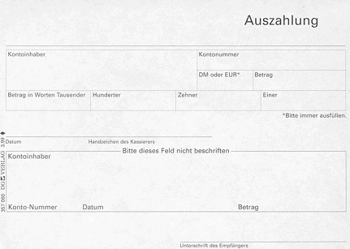

a) transfer money b) deposit money c) withdraw money

Answer Key: c

Activity 4

Study the sign below and describe what is being advertised at this financial institution. Explain how you would improve the ad. Discuss your findings in class.

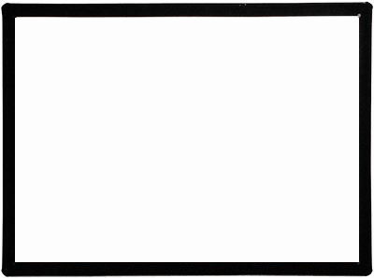
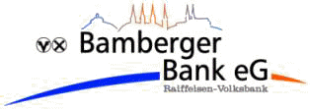
Wollen Sie ein neues Haus oder Auto kaufen? Wir bieten ihnen kostenlose Finanz- und Immobilienberatung.
Machen Sie noch heute einen Termin mit einem unserer erfahrenen Finanzberater!

Activity 5

Below are two signs you might see above a bank teller’s counter. Study the signs and decide which of the following transactions will be handled at which counter.

1. deposit
2. withdrawal
3. wire transfer
4. transfer
5. open/close a bank account
6. traveler’s checks
7. loans
8. financial advice

Schalter 1
Konto eröffnen/schließen
Geld abheben
Geld einbezahlen

Schalter 2
Finanzberatung
Kredit aufnehmen
Telegrafische Geldüberweisung
Überweisung
Reiseschecks

Answer Key:
Schalter 1: open/close a bank account, deposit, withdrawal
Schalter 2: financial advice, loans, wire transfer, transfer, travelers checks

Activity 6 (Pair Activity)

Imagine you walk into a German bank and you are not sure where to find certain items. Create a dialogue with your partner, asking him the corresponding questions below in German. Role-play the situation in class.

Activity 7

What types of services are being offered at this part of the bank? Describe in German each one of the services.

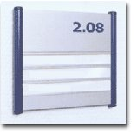
Reiseschecks
Auslandsüberweisungen
Wechselstube

Answer Key:
Traveler’s Checks, Wire Transfers, Exchange Office

Activity 8 (Group Activity)

Mingle and ask each other what type of bank/financial transactions you have recently completed. Describe the transactions in detail.

Activity 9

Your instructor will read announcements you might hear at a German bank regarding the types of transactions handled at the various counters. There are three counters. Listen carefully and write the correct transaction under the corresponding counter. Compare your list with the rest of the class.

Schalter 1

Schalter 2

Schalter 3

Reading Key:
1. Für telegrafische Überweisungen, gehen Sie bitte zum Schalter 3.
2. Für Reiseschecks, gehen Sie bitte zum Schalter 1.
3. Für Überweisungen, gehen Sie bitte zum Schalter 3.
4. Für die Eröffnung von Konten, gehen Sie bitte zum Schalter 2.
5. Für Ein-und Auszahlungen, gehen Sie bitte zum Schalter 2.
6. Für Bankschließfächer, gehen Sie bitte zum Schalter 1.
7. Für Kredite, gehen Sie bitte zum Schalter 3.
8. Für verlorene oder gestohlene Kredit-oder Scheckkarten, gehen Sie bitte zum Schalter 1.

Activity 10 (Pair Activity)

Imagine that you tried getting money out of the ATM machine and the machine took your card and it didn’t give you the requested money. Use the English dialogue below to create a similar dialogue in German with your partner.

A: Say good morning. Tell the teller that you tried getting money out of the ATM
machine and it took your card.
B: Ask where the machine is located.
A: Say that it is the one in front of the bank building.
B: Ask when the card was taken.
Activity 10 (continued)

A: Say that it was yesterday at 7:15 pm.
B: Ask how much money he/she had requested.
A: Say that you had tried to withdraw 50,00 Euro.
B: Ask for his/her account number and ID
A: Give your account number and show your ID.
B: Give him/her the card back and say that you are very sorry.
A: Say thank you and good-bye.
B: Say good-bye.

Activity 11

Imagine that you are sponsoring a soldier who will be arriving in Germany shortly. He wants to know how to conduct a regular transfer within Germany. Briefly describe the transaction in German, using the transfer section in the Introduction as a guideline. Report your instructions to the class.

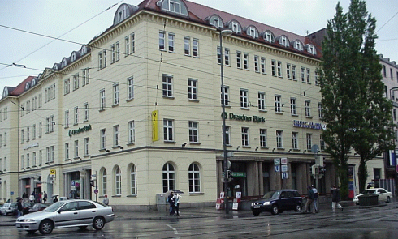

Dresdner Bank in the City Center

2. Discuss Monetary Units

Activity 12 (Pair Activity)

Different banks charge different fees for certain transactions. Below is a list of transactions and the corresponding Euro amount. Start by asking your partner in German how much the first transaction is. He/she will respond that the requested transaction is X amount. You will then switch roles. Continue until you have covered all transactions listed below.

NOTE: The amounts below do not reflect actual fees.

1. Transfer

2. Safety deposit box

3. Traveler’s Checks

4. Exchange money

Entschuldigen Sie bitte. Wie viel kostet es…………?

Answer Key:
1. Entschuldigen Sie bitte. Wie viel kostet eine Überweisung?
Eine Überweisung kostet 3,20 Euro.
2. Entschuldigen Sie bitte. Wie viel kostet ein Bankschließfach?
Ein Bankschließfach kostet 7,70 Euro.
3. Entschuldigen Sie bitte. Wie viel kosten Reiseschecks?
Reiseschecks kosten 13,00 Euro.
4. Entschuldigen Sie bitte. Wie viel kostet es Geld zu wechseln?
Es kostet 7,00 Euro Geld zu wechseln.

3. Discuss the Exchange Rate

Activity 13 (Group Exercise)

Check your wallet and count how much money is in it (come up with a fake amount, if you don’t have any cash on you). The first student turns to his classmate and says in German: “I have _________ dollars. I would like Euro, please.” The second student responds by saying “For __________ dollars you will receive _________ Euro.” He then turns to the third student and tells him the same sentence. Repeat until the last student has answered. Remember the exchange rate for these modules is approximately 1:1.

Activity 14

Match the left words with their correct English equivalents

der Kontoauszug interest

die Monatsgebühr amount

das Girokonto coin

die Bankleitzahl property purchasing advice

die Überweisung arrival section

die Scheckkarte identification

das Sparbuch bank clerk

die Währung safety deposit box

der Wechselkurs traveler’s check

der Betrag departure section

der Bankangestellte statement

der Zins account entry

die Buchung transfer

die Münze bank code number

der Termin savings book

die Ankunftshalle appointment

der Ausweis debit card

die Abflugshalle monthly fee

das Bankschließfach currency

der Reisescheck exchange rate

die Immobilienberatung checking account

Answer Key:

der Kontoauszug interest
die Monatsgebühr amount
das Girokonto coin
die Bankleitzahl property purchasing advice
die Überweisung arrival section
die Scheckkarte identification
das Sparbuch bank clerk
die Währung safety deposit box
der Wechselkurs traveler’s check
der Betrag departure section
der Bankangestellte statement
der Zins account entry
die Buchung transfer
die Münze bank code number
der Termin savings book
die Ankunftshalle appointment
der Ausweis debit card
die Abflugshalle monthly fee
das Bankschließfach currency
der Reisescheck exchange rate
die Immobilienberatung checking account

1. Conduct Daily Business Transactions

Activity 1 (Pair Activity)

Imagine that you want to pay your monthly electric bill directly from your German checking account. You will have to set up a standing order. Conduct the following dialogue in German with your partner and report your findings back to the class.

A: Say hello and say that you would like to pay your electric bill directly from your
checking account every month.
B: Say hello and tell him/her that he/she will have to set up a standing order.
A: Tell him/her your name and account number and show him/her your ID card.
B: Ask him for the bank information of his/her electric company.
A: Give the requested information.
B: Tell him/her that the amount will come out of his/her checking account every first of
the month.
A: Say thank you and good-bye.

Activity 2

Study the bank slip below and choose the correct description. Then fill out the form with the help of your instructor.

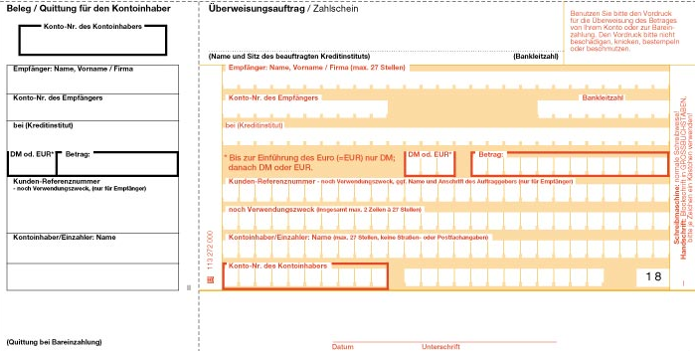

a) transfer money b) deposit money c) withdraw money

Answer Key: a

Activity 3

What is necessary to open an account at a German bank? Choose the correct answer below and explain why?

a) a valid driver’s license
b) a passport or military ID
c) a German ID (Personalausweis)

Answer Key: b

Activity 4

Your instructor will read a dialogue between a bank teller and a customer. Listen carefully and answer the questions.

Auf der Bank

1. Was möchte Frau Maier eröffnen?
____________________________________________________________________
2. Was zeigt sie dem Bankangestellten?
____________________________________________________________________
3. Hat Frau Maier schon ein anderes Konto mit der Bank?
____________________________________________________________________
4. Wie viel zahlt Frau Maier auf das neue Konto ein?
____________________________________________________________________
5. Was bekommt Frau Maier von dem Bankangestellten?
____________________________________________________________________

Reading Key:
Bankangestellter: Guten Tag. Wie kann ich Ihnen behilflich sein?
Frau Maier: Guten Tag. Ich möchte gerne ein Sparkonto eröffnen.
Bankangestellter: Darf ich bitte Ihren Ausweis sehen?
Frau Maier: Natürlich. Hier ist mein Personalausweis.
Bankangestellter: Danke, Frau Maier. Haben Sie schon ein Konto mit uns?
Frau Maier: Ja, ich habe ein Girokonto.
Bankangestellter: Füllen Sie auf diesem Formular bitte Ihren Namen, Ihre Adresse
und Ihre Telefonnummer aus.
Frau Maier: So, bitte sehr.
Bankangestellter: Mit wie viel Euro möchten Sie das Konto eröffnen.
Frau Maier: Ich möchte gerne 200,00 einbezahlen.
Bankangestellter: Hier ist Ihr neues Sparbuch, Frau Maier. Ich wünsche Ihnen noch einen schönen Tag.
Frau Maier: Danke, ebenfalls.

Answer Key:
1. Frau Maier möchte ein Sparkonto eröffnen.
2. Sie zeigt dem Bankangestellten ihren Personalausweis.
3. Ja, sie hat ein Girokonto mit der Bank.
4. Sie zahlt 200,00 Euro auf das Konto ein.
5. Frau Maier bekommt ein Sparbuch.

Activity 5

In German and in your own words, summarize the dialogue you just heard in Activity 4.
Identify the main idea, and discuss it with the rest of the class.

______________________________________________________________________

______________________________________________________________________

______________________________________________________________________

______________________________________________________________________

______________________________________________________________________

______________________________________________________________________

______________________________________________________________________

Activity 6

Below is a bank form requesting a standing order, or requesting the cancellation of a standing order. Study the form with your instructor and fill in the blanks.

Dauerauftrag

Auftraggeber-Kontonummer

Auftraggeber-Name

Hiermit bitte ich Sie folgenden Dauerauftrag auszuführen:

Neuanlage eines Dauerauftrages □
Löschung eines Dauerauftrages □

Ausführung am ………. eines jeden Monats □

erstmals im …………….. letztmals im …………….

Bankverbindung des Empfängers/Zahlungspflichtigen

Name des Empfängers/Zahlungspflichtigen

EUR
Betrag Verwendungszweck

Sie sind berechtigt, den Dauerauftrag zu streichen, wenn er wiederholt mangels Deckung nicht ausgeführt werden kann.

Ort, Datum Unterschrift(en) des/der Kunden

Activity 7 (Group Activity)

The instructor divides the class in two teams. The first team will play the role of bank tellers. The instructor will give each of the students on the first team flashcards with one bank service. The students on the second team, who will play the customers, will receive the same flashcards. The first customer will ask the teller group “An welchem Schalter kann ich (service on the flashcard). The student with the corresponding flashcard will say “An meinem Schalter können Sie (service on the flashcard). The two students will then conduct a short dialogue regarding the service mentioned on their flashcard. Continue the game until all students have participated in a dialogue.

Note to the Instructor:
Make up enough flashcards for different bank services and double the cards for the activity.

Activity 8

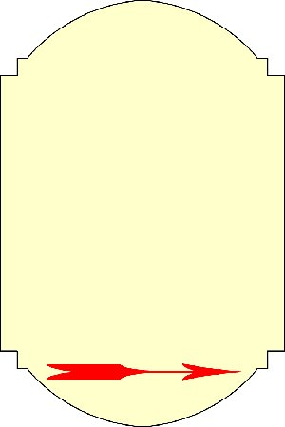

Ein Geldautomat der Deutschen Bank befindet sich direct neben dem Eingang des Restaurants.
What financial service is being mentioned on the sign?

a) Currency exchange
b) Transfer
c) ATM machine
Answer Key: c

Activity 9

The form below is necessary to open an account, or to make changes to an existing account at a German bank. Study the form with your instructor and fill in the blanks.
You will not need to know all the vocabulary on the form. Compare with a form of your own bank.

Kontoeröffnung/-änderung

Kontoart | Konto Nr. | Freist.-Auftr. | Online-Banking
Kontokorrent
Spar
Festgeld

1 Ich/Wir beantrage(n) die ◻ Eröffnung ◻ Änderung der genannten Konten-Depots lautend auf:
Name, Firma, Anschrift (Straße, Haus-Nr., PLZ, Ort), Geburtsdatum, Gründungsdatum

Postfach

ggf. auch Geburtsname | Familienstand
Beruf | Minderjährig
E-Mail
Arbeitgeber
Telefon Rechtsform Staatsangehörigkeit
Branche Register-Eintragung beim Amtsgericht unter der Nr.

◻ selbständig ◻ gebietsfremd ◻ Steuerausländer ◻ Umsatzsteueroption ◻ ja ◻ nein

Name | Zeichnet

Rechnugnsabschluss: ◻ vierteljährlich ◻ halbjährlich
Erstellung der
Kontoauszüge: ◻ bei Umsatz ◻ wöchentlich ◻ monatlich

Zustellungsart: ◻ selbst durch Kontoauszugsdrucker ◻ Schließfach-Nr. ___________ ◻ Bote
◻ Abholer ◻ Zusender ◻ täglich ◻ wöchentlich ◻ monatlich
2
◻ Kündigungsfrist von ______Monaten Depot-Verrechnungskonto für
◻ Kündigungssperrfrist von _____Monaten Ankauf/Verkauf/Gebühren Nr. ___________
◻ Sparvertrag Jahreserträgnisaufstellung ◻ ja ◻ nein
Bemerkungen ________________________________________________________________________
3 Die neu eröffneten Konten werden in ◻ Euro ausgeführt.
Deportabrechnungen und –aufstellungen sollen in ◻ Euro erstellt werden.
4 Die bereits am __________ getroffene Vollmachtsregelung soll auch für die neuen Konten/Depots gelten.
5 Der Konto-/Depotinhaber ist mit der telefonischen Beratung in Geldangelegenheiten durch die Bank
◻ einverstanden. ◻ nicht einverstanden.
6 Kontoeröffnung/-änderungen durch Vertreter

Name, vollständige Anschrift des Vertreters

Exercise 10 (Group Exercise)

Imagine you are working at a large bank and you are joining your colleagues for lunch in the break room. Approach several of your classmates, telling them about some of the bank transactions you have completed today. Choose several of the services discussed in the Introduction.

Exercise 11 (Pair Exercise)

Ask your partner bank-related questions. Ask him/her if she has any checking and/or savings accounts. Ask him/her if he/she pays bills from any of these accounts by check or by transfer. Ask if he/she has ever bought a foreign currency at his/her bank. Ask what the fees are for any transactions.

2. Discuss Monetary Units

Activity 12 (Pair Activity)

Ask each other about the equivalent of a certain dollar amount. Ask your partner about at least five different amounts. Use the 1:1 ratio.

Beispiel: Frage: Wie viel Euro sind $25.84? Antwort: $25.84 sind €25,84.
3. Discuss the Exchange Rate

Activity 13

Study the following sign. From the options below, choose the one that is not mentioned.
Explain in German each one of the different activities.

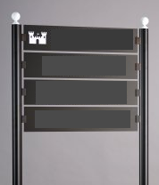

Deutsche Burgbank
Öffnungszeiten:
Mo-Fr 9.00 – 18.00 Uhr
Kontoführung
(Ein-und Auszahlung)
Überweisungen
Finanzberatung
Bankschließfach
Wechselstube

a) deposits
b) currency exchange
c) transfers
d) traveler’s checks
e) safety deposit box

Answer Key: d

Activity 14

Match the correct verb with the noun.

1. Reisescheck = ausfüllen abheben schließen

2. Geld = eröffnen wechseln anstehen

3. Eingang = benutzen stehlen ausfüllen

4. Girokonto = ausfüllen anstehen eröffnen

5. Diebstahl = einbezahlen stehlen wechseln

6. Scheckkarte = abheben anstehen benutzen

7. Bargeld = schließen einbezahlen beraten

8. Ankunftshalle = sperren ausfüllen abheben

9. Wechselstube = eröffnen einbezahlen anstehen

10. Betrag = einfüllen anstehen abheben

Answer Key:

- ausfüllen 6. benützen
- wechseln 7. einbezahlen
- benutzen 8. sperren
- eröffnen 9. anstehen
- stehlen 10. abheben

Activity 1

Study the form below and choose the correct description. Fill out the form. Use your dictionary, if necessary.

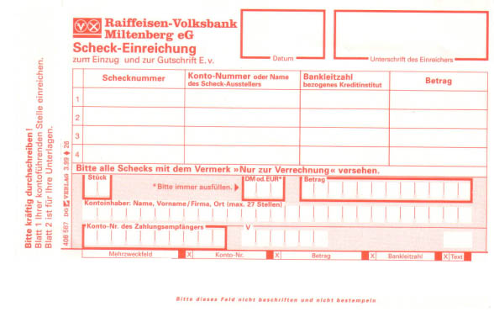
a) withdrawal slip b) check deposit slip c) form to open a checking account

Activity 2

Listen to the following dialogue and answer the questions below. Be ready to defend your answers in class tomorrow.

1. Was möchte die Bankangestellte sehen?
________________________________________________________________________
2. Was für ein Konto möchte die Frau eröffnen?
________________________________________________________________________
3. Wie hoch ist die monatliche Gebühr?
________________________________________________________________________

Audio Script:
Frau: Ich möchte gerne ein Konto eröffnen.
Bankangestellte: Darf ich bitte Ihren Personalausweis sehen?
Frau Was kostet ein Girokonto monatlich?
Bankangestellte: Die Gebühr beträgt monatlich €1,50.
Answer Key:
1. Die Bankangestellte möchte den Personalausweis der Frau sehen.
2. Die Frau möchte ein Girokonto eröffnen.
3. Die Monatsgebühr beträgt €1,50.

Activity 3

For which bank service does the picture advertise? Use your dictionary if necessary.

a) Currency exchange
b) Opening an account
c) Property purchasing advice

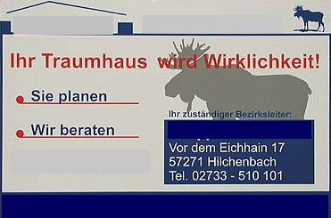
Ihre Sparkasse
Immobilienberatung in Heidenheim.
Rufen Sie uns an:

Answer Key: c

Activity 4

In German, list all the information necessary to conduct a transfer at a German bank. Be ready to discuss it in class tomorrow.

_____________________________________________________________________
_____________________________________________________________________
_____________________________________________________________________
_____________________________________________________________________

Answer Key:
Überweisungsbetrag
Name und Kontonummer des Empfängers
Adresse der Empfängerbank und Bankleitzahl
Name, Kontonummber und Unterschrift des Auftraggebers

Activity 5

Read the three short dialogues below and in English write the corresponding service next to each dialogue.

1. A: Guten Tag. Wie kann ich Ihnen helfen?
B: Ich möchte gerne Geld von meinem Konto abheben.
A: Füllen Sie bitte dieses Formular aus.

2. A: Können Sie mir sagen, welches Formular ich brauche?
B: Was möchten Sie machen?
A: Ich möchte mein Konto schließen.

3. A: An welchen Schalter muß ich für eine Überweisung gehen?
B: Was für eine Überweisung?
A: Eine Auslandsüberweisung.

Answer Key: 1. withdrawal 2. closing an account 3. wire transfer

Activity 6

Fill in the missing German words and write a sentence.

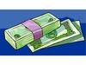
- the cash money 2. the coins
________________ _________________

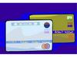
3. the credit cards 4. the savings account
_________________ ___________________

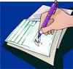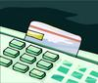

5. the traveler’s check 6. the debit card
__________________ ___________________

Answer Key:

1. das Bargeld 4. das Sparkonto

2. die Münzen 5. der Reisescheck

3. die Kreditkarten 6. die Scheckkarte

Activity 7

Ask for a bank form from your local bank and bring it to class. In class, discuss the German equivalent and translate the requested information on the form.

