SOLT French Module 4 Lesson 7
Student Manual

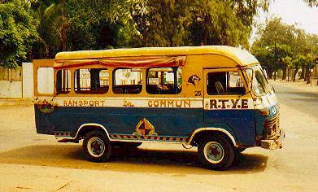

Transportation

At the end of this lesson, you will be able to report on transportation systems.

Identify Means of Transportation

- Identify means of transportation of Francophone Africa
- Discuss fees / rates for the different means of transportation
- Compare means of transportation of West Africa with the United States

Discuss Rental Cars

- Name types of vehicles in West Africa
- Identify car models in Francophone Africa
- Identify various parts of the car in French
- Tell the clerk what type of car you want
- Ask the clerk what type of fuel is required for your car
- Rent a car

Identify Military Vehicles

- Name military vehicles
- Identify vehicle parts

Discuss Motor Pool Activities

- Specify types of vehicles for specific activities
- Discuss vehicle maintenance activities
- Discuss advantages and disadvantages of certain types of military vehicles

Scenario:

À la gare routière

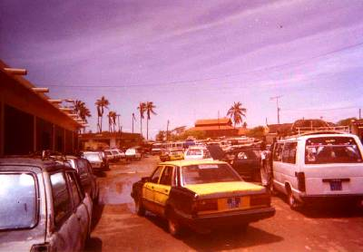
Une gare routière à Saint-Louis-du-Sénégal

Read the following conversation about how to find transportation in a major Senegalese city, Saint-Louis. Once your class has reviewed the new words and pronunciation, work with a partner and practice the dialogue.

John: J’ai besoin d’aller en haut de la colline située à 15 kilomètres au nord du village.

Réceptionniste: Vous pouvez prendre un taxi ou le car si vous voulez.

John: Quelle est la difference?

Réceptionniste: Le car est très bon marché mais il s’arrête souvent. Le taxi coûte un peu plus cher mais il vous conduit directement là où vous voulez aller. Ça depend si vous êtes pressé ou pas.

John: Un peu oui. Je préfère prendre un taxi.

Réceptionniste: Dans ce cas vous aurez le choix. À l’extérieur, il y en a au moins une trentaine qui attendent. Choisissez !

John: Merci et à bientôt!

Identify Means of Transportation

To travel in the country, the public transportation the most frequently used is the bus or the “taxi-brousse”.

To travel between cities is done by “taxi-brousse”-usually a Peugeot 504 Wagon-, mini-buses or big Mercedes buses “Ndiaga Ndiaye”. At the bus station (gare routière), the destinations are indicated on panels and the price depends on the condition of the vehicle and the road. You will also be required to pay a fixed price for your luggage. Change of scene and atmosphere guaranteed.
The famous “car-rapide” Renault assure the urban public transport in the large cities, in competition with the "Dakar Dem Dikk" bus company.

In Dakar, where traffic is infernal, the “cars rapides” (small buses), decorated with words and religious pictures, are often crammed: avoid the peak hours. If you do not know the city, it will be hard to find your destination. The young ticket collector hanging from the rear door, calls out the final destination (Dakar, Dakar, Dakar, Dakar... or Pikine, Pikine, Pikine, Pikine, Pikine, Pikine...) the destination are called out as the car rapid passes, often with an accent perfectly incomprehensible. The stops are done almost anywhere, are brutal and are always noisy. The pulling in and out of traffic are always determinant to double the competitor, unfortunately delayed by a "Mama" that has a problem entering with her basket overflowing with fish... But everything goes well, thanks to god!

Renting a car cost more. You might want to rent a “taxi-brousse” for the day. It will be cheaper (20-50 Euros/day) and you will not be responsible in case of a problem.

Other less common means of transportation include bicycle (Vélo Tout Terrain), Train, boats “chaloupe”, smaller boats “pirogues” on rivers, plane.

Identify means of transportation of Francophone Africa

Exercise 1 (Class Work)

As a class, observe the photos below and match each one with the correct name from the text above. Go over the pronunciation with your instructor.

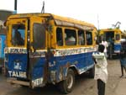 | 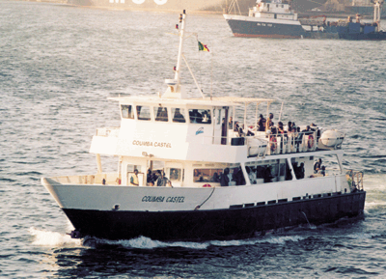 | 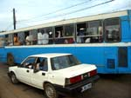
1 | 2 | 3
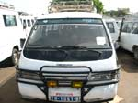 | 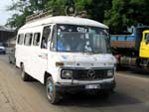 | 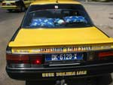
4 | 5 | 6

- car-rapide
- mini-bus
- Dakar-dem-dikk
- taxi
- Ndiaga-Ndiaye
- chaloupe

Discuss fees / rates for the different means of transportation

Exercise 2 (Class Work)
Review the following chart of prices for different destinations from Dakar. You are going to Ziguinchor from Dakar. Your teacher will ask you to choose a mean of tranportation from the chart below and describe your choice to the class; price, pros, cons.
Moyens de transport au Sénégal

 |  |  |  |  | 
Train | Taxi-brousse | Car Rapide et Minibus | Taxi | Aéroport | Bateau

 | Ziguinchor | Kolda | Banjul | Kaolack | Saint-Louis | Kédougou | Tambacounda | Thiès | Mbour
 |  |  |  |  | suspendu |  | 10800-14000 | 6900  7200 | néant
 | 7000 |  | 5000 | 2500 | 2800 | 10.000 | 6500 | 1000 | 1000
 | entre 4500 et 5500 |  |  | 1100  à 1500 | 1800-2000 |  |  |  | 550  à 700
 |  |  |  |  |  |  |  |  | 12000 (à discuter)
 | 58000 A/R | liaisons irrégulières |  | liaisons irrégulières | liaisons irrégulières | liaisons irrégulières | liaisons irrégulières
 | de 3500 à 16000

Compare means of transportation of West Africa with the United States

Exercise 3 (Group Work)

Discuss the differences between what you may encounter on the roads in Sénégal and similar things you have experienced in the U.S.
In addition, talk about the differences regarding the roads in the 2 countries.

LE RÉSEAU ROUTIER
Le réseau routier sénégalais est de bonne qualité (14 600 km de routes carrossables, dont 4 500 km sont bitumées) et vous pourrez aller quasiment partout avec un véhicule ordinaire. Mais restez prudents: la route n'est pas seulement le domaine des véhicules motorisés, mais également des charrettes brinquebalantes, des ânes scotchés au macadam, des chèvres aux allures désordonnées, des moutons aux trajectoires aléatoires. Ralentissez pendant les traversées des villages, faites attention aux camions qui réparent un essieu en haut de côte, restez attentifs aux inégalités du revêtement...
The Senegalese road network is of good quality and you will be able to travel almost everywhere on paved roads. But be careful: the roads is not only the domain for motor vehicles, but also for carts, wagons, donkeys large holes in the pavement, goats taking there time, sheep crossing the roads in all directions. Slow down when you cross the villages, watch out for broke downed trucks doing repair on the roads, stay alert for the deformations in the payment...

Aller quelque part…
  à pied |   à bicyclette / en vélo |   à cheval
  en moto |   en voiture |   en avion
  en bateau |   en car  en bus |   en train

Traverser le fleuve / la rivière…
  à la nage |   en pirogue

Exercise 4

Which means of transportation is the most suited for each of the following situation?

1. You are going from New York to Dakar in 24 hours. En avion
2. You are crossing a wide stream. En pirogue
3. You are going to the baker down the corner. À pied
4. You are going deer hunting in the woods. À cheval
5. You are crossing the Atlantic Ocean in 2 weeks. En bateau

Exercise 5

Discuss with the class the differences between the cost of taking a cab from Dakar and your experience with cabs in the U.S.

Dakar taxi rates
Airport-down town
Day rates: 3 000 F CFA
Night rates: 3 500 F CFA
Taxis in town
Basic rate: 100 F CFA
20 F CFA every 200 m.
The rate is doubled between midnight and six.

Exercise 6 (Group Work)

In groups of 3, decide which means of transport would come under each one of these categories below. Make a list and present them to the class.

- Transports en commun

- Transport maritime

Exercise 7 (Class Work)

As a class, describe this photo with as many vocabulary words for transportation means. Go over the pronunciation with your instructor.
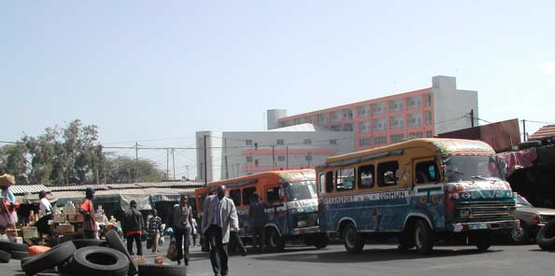

Tip of the day: Leasing airplanes

In Senegal, one can also lease airplanes through Sénégalair-Voyage. The company has a fleet of small airplanes that it rents on reservation. They link Dakar to all the regional capitals and to the Niokoloba Park, which is one of the favorite tourist attractions in Senegal. The airplanes are also available for trips to the West African capitals. However, a delay of 24 hours is required for chartering and other verification routines.

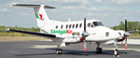 | 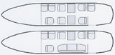  Configuration cabine
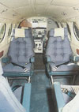 | Bi turbopropulseur pressurisé  Vitesse de croisière : 500 km/h  Altitude de croisière : 9000 m  9 places passagers  Version cargo : 900 kg  2 pilotes  Autonomie : 5 h
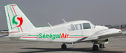 | type : PA 23-238  vitesse de croisière 160 Kt Moteurs 2 x 250 CV  Pilote automatique  Places : 5 + 1  Essence - capacité : 550 kgs consommation : 100 l/H

John asks Amadou about the best means of transportation to Ziguinchor. Read the conversation before practicing with a partner.

John: Je veux visiter l’intérieur du pays. Est-ce qu’il y a un train qui part à Ziguinchor?
Amadou: Oui, il y a un train chaque jour. Seulement les rails sont très vieux et le service peut être lent.
John: Et les bus?
Amadou: Les bus sont vieux également et ils ne sont pas confortables.
John: Alors quel est le meilleur moyen d’y aller?
Amadou: Je recommande le bateau. Il est confortable et tu verras beaucoup de villages de pêcheurs.
John: Ça, c’est une excellente idée. Merci.

Tip of the day: Hiring a driver

In case you need to hire a driver, one can be appointed for you by the car rental agency. For local errands you will pay 4 500 F CFA/day and 6 500 F CFA/day for trips to the interior. For trips outside of Senegal, the rate is 9 000 F CFA. Make sure, however, that yours speaks one of the main languages in your area of destination. This might come in handy.

The system of roads in Senegal is extensive by West African standards, with paved roads reaching each corner of the country and all major towns. They link with the road systems of neighboring countries, and in particular those of western Gambia. The most important Roads are prefixed “N”and numbered from 1 to 7:
- N1: Diourbel – Kaolack – Tambacounda – Kidira – (Mali)
- N2: Kaolack – Thiès – St-Louis – Richard Toll – Ouro Sogui – Kidira
- N3: Thiès – Diourbel – Touba – Linguère – Ouro Sogui
- N4: Kaolack – (Trans-Gambia Highway) – Bignona – Ziguinchor – (Guinea-Bissau)
- N5: Bignona – Diouloulou – (Gambia)
- N6: Tambacounda – Kolda – Ziguinchor
- N7: Tambacounda – Dar-Salam – Niokolo-Koba – Kedougou – Ségou – (Guinea)

Discuss Rental Cars

Name types of vehicles in West Africa

The chart below shows the French equivalents of vehicle types in English.

 | French | English
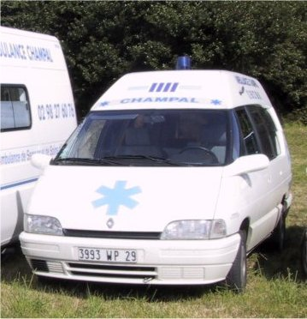 | Ambulance | Ambulance
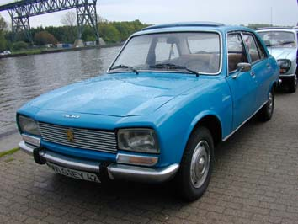 | Voiture | Automobile
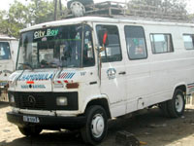 | Bus/Mini-bus | Van (Passenger)
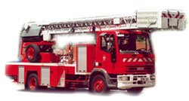 | Camion de pompiers | Firetruck
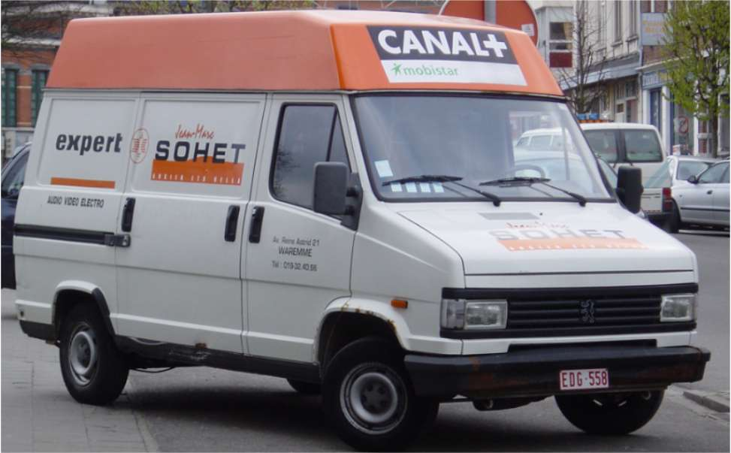 | Camionnette | Truck (Small)
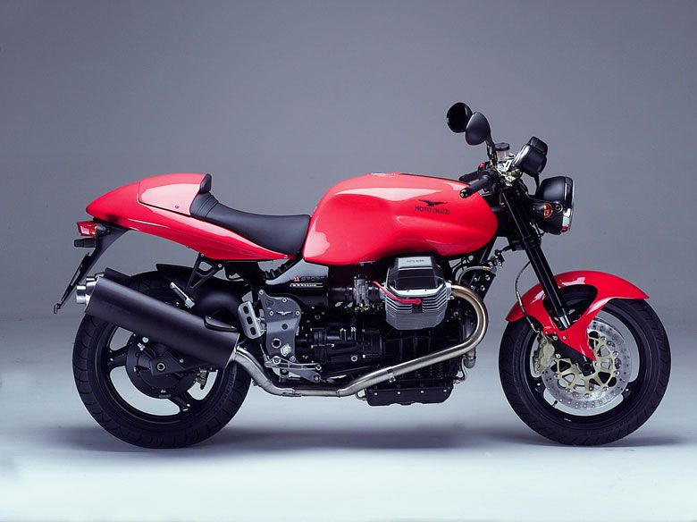 | Moto | Motorcycle
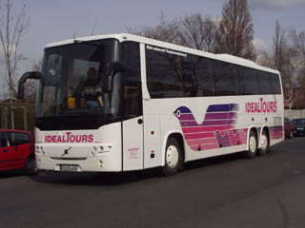 | Car | Bus (Interstate)
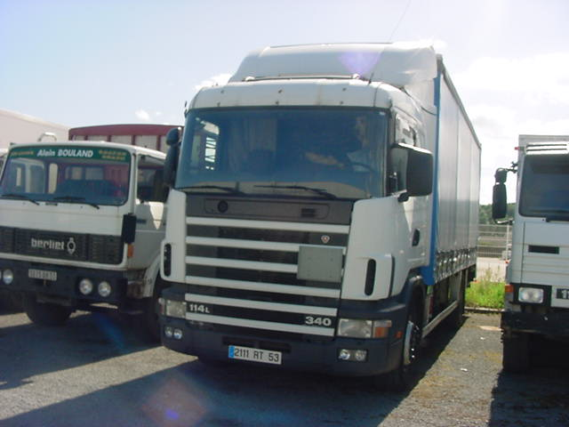 | Camion/Poids-Lourd | Truck(Big)
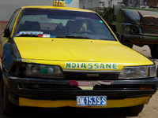 | Taxi | Taxi
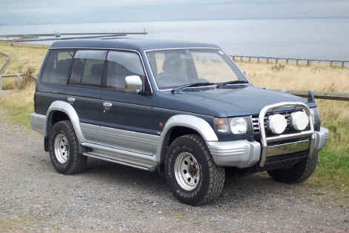 | Tout-Terrain/4x4 | 4-wheel Drive
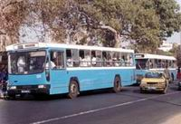 | Bus | Bus (Public transportation)

Exercise 8 (Pair Work)

Use the vocabulary below and match them with their French equivalents. Closely study the table above to master the vocabulary provided.

4-wheel drive, bus (Interstate), firetruck, truck (small), automobile, van (passenger)

 | French | English
1 | Tout-Terrain/4x4
2 | Car
3 | Camion de pompiers
4 | Camionnette
5 | Voiture
6 | Bus/Mini-bus

Identify car models in Francophone Africa

The gender of car makes and models are feminine except for the 4-wheel drive and SUV categories (un Nissan Pajéro, un Hummer, un classe M Mercedes, un VW Touareg, etc)

Une Peugeot Une Renault Une Fiat
Une Citroën Une BMW Une Toyota
Une Mercedes Une Golf Un Land Rover
Une Honda Une Isuzu Une Jaguar
Une Nissan Une Volvo

Read the following dialogue where John asks Amadou about his means of transportation.

John: Est-ce que tu as une voiture?
Amadou: Oui.
John: Qu’est-ce que tu as comme voiture?
Amadou: J’ai une Renault 5. Et toi?
John: Moi, j’ai une moto.
Amadou: Quelle marque?
John: Harley Davidson.

Exercise 9 (Pair Work)

Ask your partner what type of means of transportation he owns and what make it is.

Exercise 10 (Class Work)

Below are the most common types of rental vehicles in Francophone Africa. Pick one and explain your choice to the class (size, mileage, look, etc...)

VÉHICULES DE TOURISME ET STANDING (Marques et Modèles)
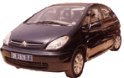   | - CITROEN SAXO  - RENAULT CLIO  - PEUGEOT 306 BERLINE - PEUGEOT 206 XR  - CITROEN XSARA - HYUNDAI ELANTRA  - RENAULT MEGANE CLASSIC  - CITROEN XSARA BREAK - PEUGEOT 306 BREAK  - PEUGEOT 406 SR - RENAULT LAGUNA - CITROEN XANTIA  - RENAULT SAFRANE  - MERCEDES CLASSE E
VÉHICULES TOUS TERRAINS (4x4) (Marques et Modèles)
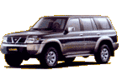 | - MITSUBISHI PICK-UP L200  - MITSUBISHI DOUBLE CABINE PLATEAU L200  - SUZUKI GRAND VITARA CHASSIS LONG 4x4  - LAND CRUISER PRADO LONG 4x4  - MITSUBISHI PAJERO LONG  - LAND CRUISER PRADO TURBO LUXE  - NISSAN PATROL NISSAN LONG 4x4  - MITSUBISHIPAJERO TURBO DIESEL LONG  - MERCEDES ML 270 4x4
BUS ET MINI-BUS (Marques et Modèles)
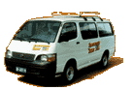 | - MINIBUS TOYOTA - MINIBUS HYUNDAI  - BUS ASIA -COASTER – ROSA  - BUS GRAND TOURISME FR1- BUS MERCEDES 0 303
Identify various parts of the car in French

La voiture:
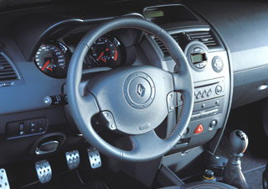
Le compte-tours
Le volant
Le tableau de bord
Le compteur
L’éclairage
L’embrayage
Le frein
Le klaxon
L’airbag
L’autoradio
Le levier de changement de vitesse
Le cendrier
L’allume-cigare
Le siège
L’accélérateur

Le toit
Le pare-brise
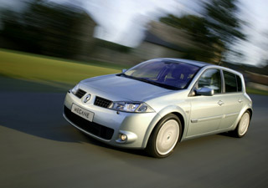
La vitre
Le rétroviseur
La portière
Le capot
Le pare-chocs
Les essuies-glace
Les feux anti-brouillard
Le pneu
Le clignotant

Exercise 11 (Class Work)

Which parts of a vehicle do the following things?
1. Le pare-chocs limite les dégâts en cas d'accident.
2. Le clignotant indique quand on veut tourner à gauche ou à droite.
3. Le volant sert à tourner les roues.
4. On a besoin des essuie-glaces pour voir quand il pleut.
5. On appuie sur l'accélérateur pour rouler plus vite.
Exercise 12 (Class Work)

The table below represents the French equivalents of the various parts of the car. Study the table. Then, the instructor will accompany the students to the parking lot. Point and identify the various parts of the car in French.

French | English
batterie | battery
puissance | horse power (hp)
embrayage | clutch
rétroviseur | rearview mirror
volant | steering wheel
échappement | exhaust
ceinture de sécurité | seat belt
frein | brake
filtre à air | air filter
contrôleur de vitesse de croisière | cruise control
accélérateur | gas pedal
transmission | transmission
levier de vitesse | stick shift
filtre à huile | oil filter

Tell the clerk what type of car you want

Exercise 13 (Pair Work)

Read the following conversation between a customer and a rental car clerk. Compare the dialogue with a similar personal experience.

Agent Avis : Bonjour, comment Monsieur, puis-je vous aider ?
Mr. Assim : Oui, j’ai besoin d’une voiture pour aller à Dakar s’il vous plaît.
Agent Avis : Vous avez une réservation ?
Mr. Assim : Non.
Agent Avis : Ce n’est pas grave, nous avons encore quelques véhicules de disponible. Quel type souhaitez-vous louer ; tout-terrain, berline, cabriolet ?
Mr. Assim : Une berline, diesel de préférence.
Agent Avis : Je suis désolé Monsieur, tous nos véhicules diesel sont loués.
Mr. Assim : Est-ce que vous auriez une petite économique à la place ?
Agent Avis : J’ai une petite Citroën Saxo de disponible, qui fonctionne au Super sans plomb 95. La location est à partir de 21200 FCFA par jour.
Mr. Assim : D’accord, je la prends.

Ask the clerk what type of fuel is required for your car

Exercise 14 (Class Work)

Now that you have practiced the dialogue, focus on specifics and answer these questions about types of fuel and reservations.

1. What type of vehicle does the customer want to rent?
2. Does he/she have a reservation?
3. Is he/she able to get that diesel vehicle?
4. What type of vehicle does the customer get at the end?
5. What type of gas is needed for the vehicle?

Rent a car

Une voiture…
Avec un autoradio tape player
Avec une boîte automatique automatic transmission
Avec une boîte à vitesse manual transmission
Avec la climatisation A/C
Avec la direction assistée power steering
À quatre portes 4 doors
À quatre roues motrices (4Χ4) 4 wheel drive

John wants to rent a car.

John: Je voudrais louer une voiture pour une semaine.  L’agent: Quelle sorte de voiture?  John: Une voiture automatique, avec climatisation et direction assistée.  L’agent: Malheureusement nous n’avons pas de voitures automatiques ici. Voulez-vous une voiture à vitesse?  John: D’accord.  L’agent: Est-ce que vous voulez une marque particulière?  John: Une Toyota.  L’agent: Le forfait pour une semaine coûte 108 500 F, kilométrage illimité inclus. Voulez-vous une assurance tous risques? C’est un supplément de 3 000 F par jour.  John: Non, c’est trop cher.  L’agent: Puis-je voir votre permis de conduire?  John: Le voici.  L’agent: Signez ici. Voici les clefs.  John: Est-ce que je dois mettre de l’essence ordinaire ou du super dedans?  L’agent: De l’ordinaire. | Kind  Brand  Package  Unlimited mileage  Comprehensive  Keys

True or false?

1. John wants to rent a car for a week T/F
2. The rental company also has automatic cars T/F
3. Customers cannot choose the model or make of the car they are renting T/F
4. The customer chooses comprehensive coverage T/F
5. Customers do not have to show their driver’s license T/F
6. The car runs on regular unleaded T/F

Exercise 15 (Pair Work)

Discuss with your partner what is required to rent a car in Dakar. After you go through the conditions, create a brief dialogue where you rent a car from your partner. Make sure to include the type of vehicle and the category of vehicle; low to high $.

Conditions pour louer un véhicule :
- Avoir au moins 25 ans.
- Avoir le permis depuis plus de 2 ans.
- Disposer d'une carte de paiement (non débitée)ou d'espèces pour la caution.
Le véhicule est fourni avec le plein de carburant et doit être restitué avec le plein. Le carburant manquant sera facturé au tarif en vigueur.
Les pneumatiques, roues et glaces ne sont pas garantis par l'assurance et restent à la charge du client en cas de déterioration.
En cas de sinistre (vol, accident, etc...) une franchise reste due par le client en fonction de la catégorie de véhicule. Cette franchise n'est pas applicable si vous avez souscrit à l'option "suppression de franchise".
Exercise 16 (Pairs)

Look at this table of Renault rental cars and mark the options each car has.
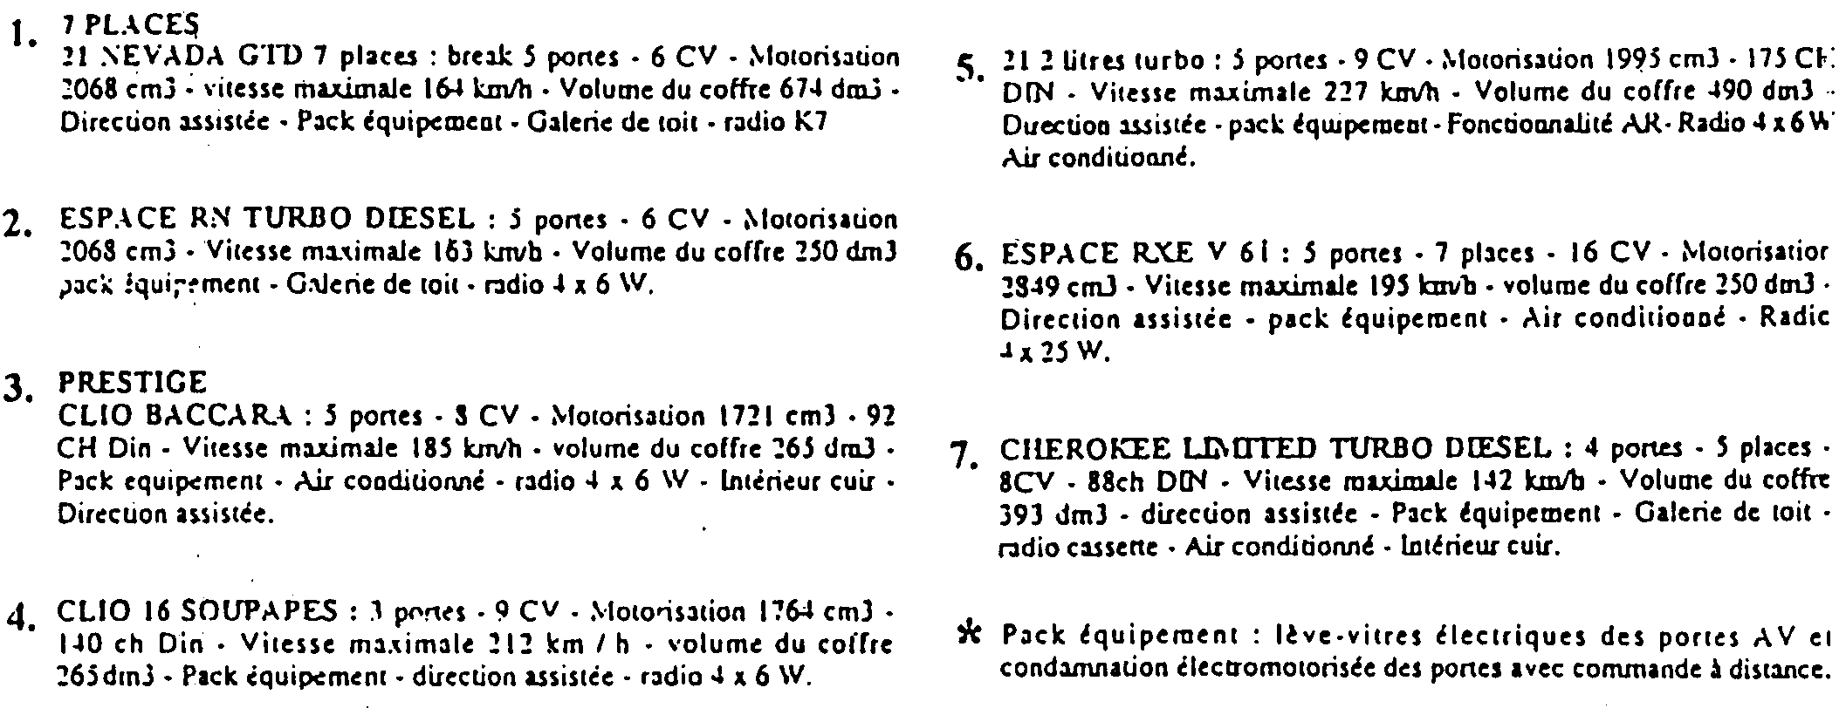

 | Largest trunk | Power steering | Luggage rack | Radio | Radio-cassette | Air conditioning | Leather seats
1 | X | X |  | X
2 |  |  |  | X
3 |  | X |  | X |  | X | X
4 |  | X |  | X
5 |  | X |  | X |  | X
6 |  | X |  | X |  | X
7 |  | X |  |  | X | X | X

Identify Military Vehicles

Name military vehicles

Here are some combat vehicles that you might recognize. Review the photos and compare your knowledge of military vehicles before learning the French names.

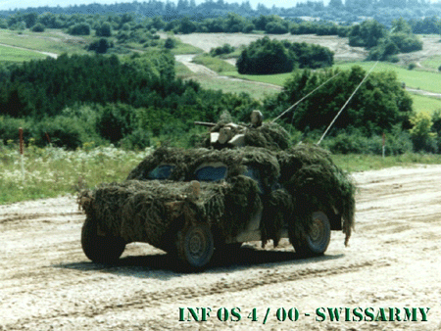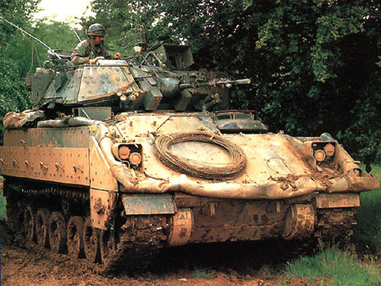
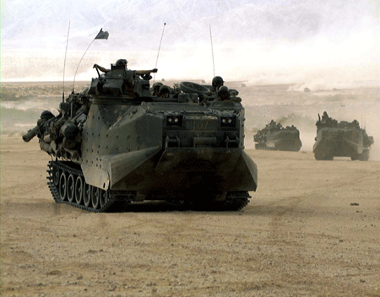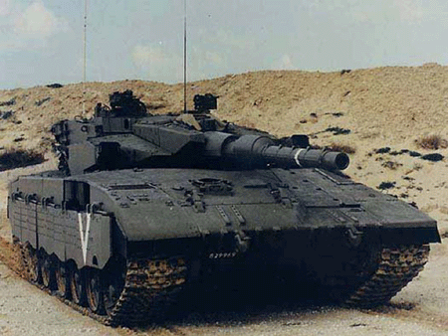
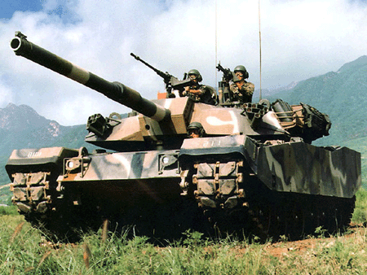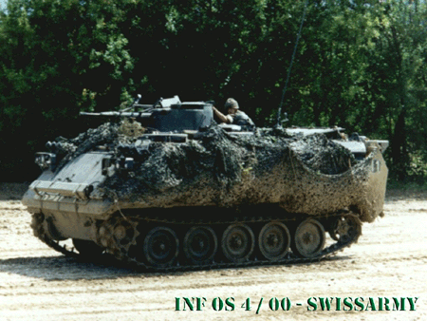

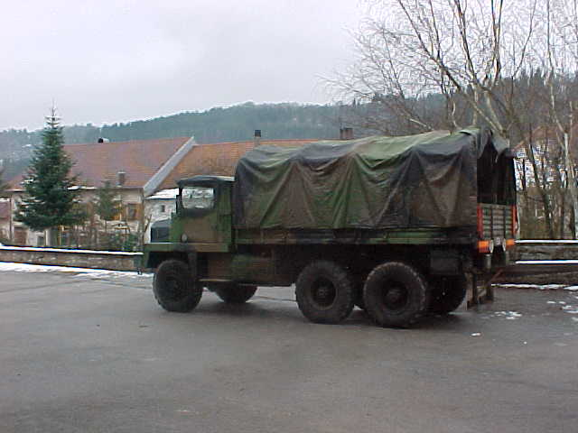  un camion | 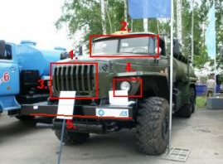  un camion citerne
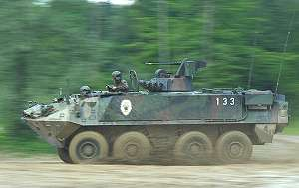  un véhicule de combat de l'infanterie mécanisée | 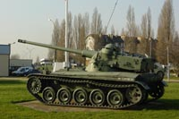  un char de combat
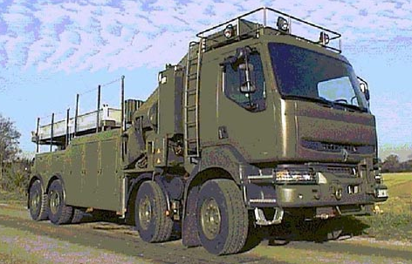  une dépanneuse | 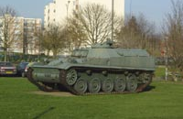  un transport de troupes blindé

Exercise 17

Which of the above vehicles do you need for the following situations?

1. You need to transport fuel from the base to a camp. Un camion citerne
2. Your car broke down on the highway. Une dépanneuse
3. You need a protected fighting vehicle. Un char de combat
4. You need to move your troops through a war zone. Un transport de troupes blindé
5. Your combat tank got stuck in the field. Un char de dépannage
Exercise 18 (Pair Work)

The instructor will read the names of military vehicles above in French and the class will repeat after her/him. With your partner, practice all of these common military vehicle names and their pronunciation in French.

Identify vehicle parts

The list below includes the basic list of vehicle parts in French and some additional parts that are not mentioned earlier in the lesson. Study the vocabulary list very carefully and try to learn the spelling and pronunciation after your instructor reads all of them to the class.

French | English
alternateur | alternator
sans plomb | unleaded fuel
bougies | spark plug
châssis | wheelbase
diesel/gasoil | diesel
airbag | airbag
carburateur | carburetor
pot catalytique | catalytic converter
pneu | tire
moteur | engine
capot | hood
pare-brise | windshield
cylindre | cylinder
ressort | spring

Exercise 19 (Group Work)

Each group will select some of the vocabulary mentioned above and try to write a small paragraph about a specific vehicle including any interesting facts known about it.

Discuss Motor Pool Activities

Specify types of vehicles for specific activities

Exercise 20 (Class Work)

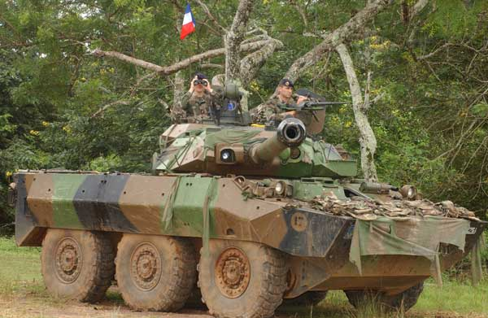 | L'AMX 10 RC est un engin de reconnaissance puissamment armé, doué d'une très bonne mobilité sur route et en tout chemin, amphibie (sauf avec surprotection), protégé contre les armes légères d'infanterie. Il est apte au combat en atmosphère contaminée et aérotransportable sur C130 après préparation.

1. This tank :
a. is protected against light infantry weapons. T / F
b. can be transported by air T / F
c. can always go in the water T / F

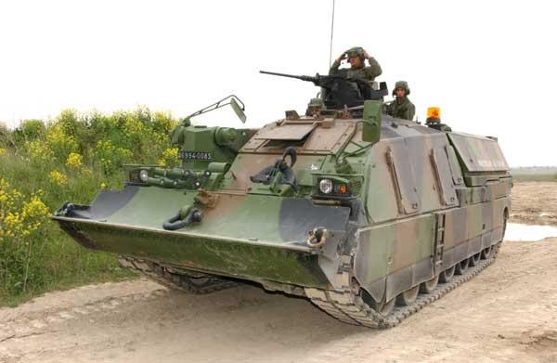 | Le dépanneur de chars LECLERC est un blindé lourd conçu pour récupérer et évacuer les chars de plus de 50 tonnes. Son équipement lui permet de participer aux opérations de maintenance lourde, d'assurer la sécurité des franchissements et d'aménager sommairement le terrain.

2. a. This tank is designed to clear mine fields T / F
b. It can tow away other tanks T / F
c. It should not be used for clearing obstacles T / F

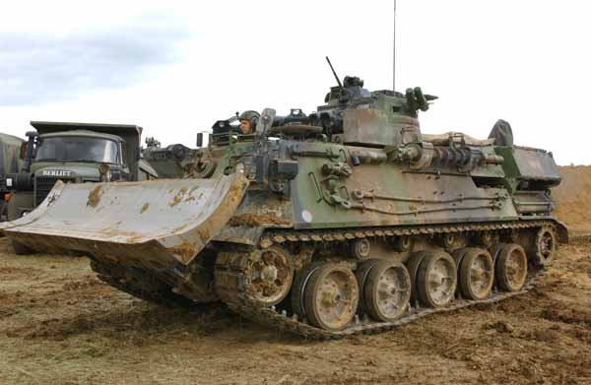 | Dérivé de l'A.M.X 30 B2, l’Engin Blindé du Génie (EBG) est destiné à remplir un grand nombre de missions de contre-mobilité: ouverture de passages sommaires, dégagement d'obstacles, aménagement de gués et de berges, réalisation rapide de petites zones minées et d'abattis, participation à l'organisation de terrain et au camouflage. Il est capable de traverser les zones contaminées et de franchir les cours d'eau en submersion.

3. a. This is a multi-purpose tank T / F
b. It would break down if used in water operations T / F
c. It is designed to carry personnel T / F

Discuss vehicle maintenance activities

L’entretien d’un véhicule:

bougies spark plug
freins brakes
plaquettes de frein brake pad
vidange oil change
courroie belt
amortisseur suspension
filtre filter
Balais d'essuie-glace blades
The chart below gives a brief guideline on how to maintain a vehicle properly.

Remplacer
 | 7500  km | 10000  km | 20000  km | 30000 km | 40000 km | 50000 km
Plaquettes de freins AV |  |  |  | x
Plaquettes de freins AR (selon équipement) |  |  |  | x
Courroies d'accessoires |  |  |  |  |  | x
Bougies d'allumage (moteur essence) |  |  | x
Bougies de préchauffage (moteur diesel) |  |  |  |  | x
Amortisseurs AV et AR |  |  |  |  |  | x
Faisceau d'allumage |  |  |  |  |  | x
Courroie de distribution (essence) |  |  |  |  |  |  | 100000  km
Courroie de distribution (diesel) |  |  |  |  |  |  | 80000  km
Filtre à huile (moteur essence) |  | x
Filtre à huile (moteur diesel) | x
Filtre à air |  |  | x
Filtre à essence |  |  |  |  | x
Filtre à gasoil |  |  | x
Balais d'essuie-glace |  | 1 fois  par an

Avant de prendre un départ
Si vous n'avez pas fait plus de 5 000 km depuis la dernière vérification de votre voiture, les quelques contrôles suivants seront suffisants. Sinon, n'hésitez pas à confier votre véhicule à un professionnel une semaine avant le départ.
Les points à vérifier :
-Le système de freinage (plaquettes, étanchéité des flexibles, équilibrage entre l'avant et l'arrière...).
-Le niveau d'huile
-Le niveau de liquide de refroidissement
-Le niveau de liquide de frein
-Le niveau de lave-glace (comportant un anti-gel)
-La pression des pneumatiques
-L’usure des pneumatiques
-Le bon état des amortisseurs, des rotules et des bras de suspension
-La direction (absence de jeu)
-Le réglage des feux de croisement

Et aussi...
-Si vous n'avez pas encore fait votre vidange, c'est le moment !

Exercise 21 (Class Work)

Read the text above “Avant de prendre un départ” and initiate a discussion about the tips and suggestions that are mentioned in the text. Next, after discussing the tips, the class will divide into two groups and classify the tips in order of importance. The instructor will write the numbers of the tips on the board as students from each group list them in their chosen order so the order can be compared and discussed by the whole class.

Exercise 22 (Group Work)

Identify the following car problems as a group. Next, match each problem with its cause and share your results with other groups.

1- Il n'y a pas d'étincelle aux bougies A- Fuite au niveau du radiateur
2- Ma voiture tire à droite ou à gauche B- Manque de liquide de
refroidissement dans le circuit
3- Mon moteur consomme de l'eau C- Les bougies sont encrassées
4- Le voyant d'eau reste allumé D- Manque d'huile, faire l'appoint
5- Le voyant d'huile reste allumé E- Parallélisme à régler
6- Le voyant des freins reste allumé F- Manque de liquide de frein, faire l'appoint

Exercise 23 (Class Work)

Check which of the following car maintenance and repairs can be done at this mechanic shop with no appointment.

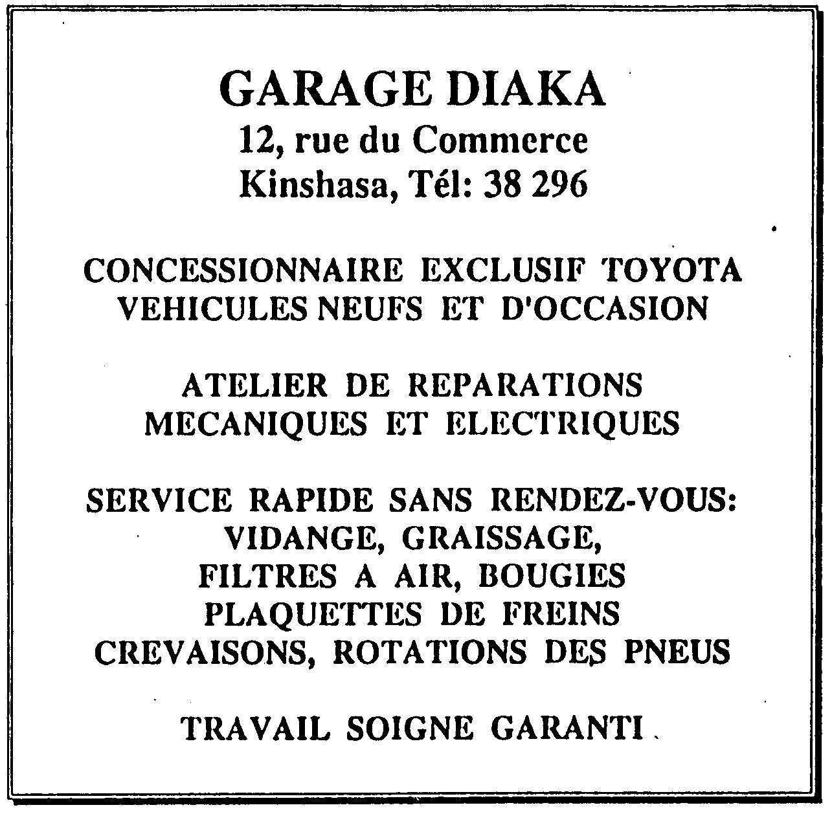

Brake fluid  Tire rotation  Electric repairs  Oil change | Transmission fluid  Air filter  Spark plugs  New tires | Brake pads  Tire repairs  Steering fluid

Accélérateur (n.m)  Assurance (n.f)  Atelier de réparation (n.m)  Bateau (n.m)  Boîte à vitesses (n.f)  Boîte automatique (n.f)  Camion (n.m)  Camion citerne (n.m)  Capot (n.m)  Chaloupe (n.f)  Changer les bougies (verb)  Char de combat (n.m)  Char de dépannage (n.m)  Cheval (n.m)  Clef (n.f)  Climatisation (n.f)  Confortable (adj.)  Dépanneuse (n.f)  Direction assistée (n.f)  Embrayage (n.m)  Escale (n.f)  Essence sans plomb (n.f)  Essuie-glace (n.m)  Forfait (n.m)  Frein (n.m)  Horaire (n.m)  Lent (e) adj.  Mitraillette (n.f)  Moteur (n.m)  Pare-brise (n.m)  Permis de conduire (n.m)  Phare (n.m)  Pirogue (n.f)  Plein (n.m)  Pneu (n.m)  Portière (n.f)  Rail (n.m)  Remplacer les plaquettes de frein (verb)  Réservoir (n.m)  Tomber en panne (verb)  Transport de troupes blindé (n.m)  Véhicule de combat de l’infanterie mécanisée (n.m)  (Faire le) Vidange (n.f)  Volant (n.m) | Accelerator  Insurance  Mechanic’s shop  Boat  Manual transmission  Automatic transmission  Truck  Tank truck  Hood  Ferry  To change the spark plugs  Combat tank  Recovery tank  Horse  Key  Air conditioning  Comfortable  Recovery vehicle, towing vehicle  Power steering wheel  Clutch  Stopover  Unleaded gas  Windshield wiper  Flat rate, set price  Brake  Schedule  Slow  Submachine gun  Engine  Windshield  Driver’s license  Headlight  Canoe, pirogue  Full tank  Tire  Door (car)  Rail  To replace the brake pads  Tank  To break down  Armored Personnel Carrier  Mechanized infantry combat vehicle  Oil change  Steering wheel

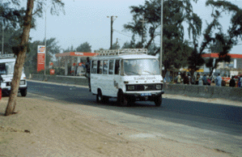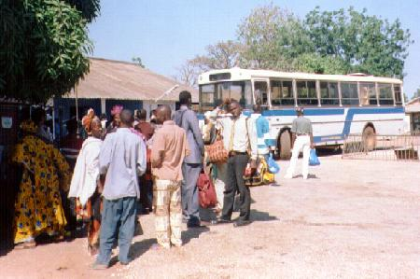
Les cars et les bus sont en général très vieux et très lents

Means of transportation

The train is not a popular means of transportation in Senegal. However, two lines are regularly served: Dakar-Saint Louis and Dakar-Bamako (Mali). Thus, it is possible to go by train to cities like Thiès, Kaolack, Tambacounda, Louga, Diourbel, Kaffrine, and so on. Even though a pleasant way to travel, the train in Senegal is mostly used for freight and it is slower and a little bit more expensive than the “bush taxi” (mostly station wagon cars used for interurban transportation and known as taxi de brousse or taxi brousse). The main problem with the train service in Senegal is that breakdowns and accidents are frequent due to aging fleet and tracks. Consequently, it is not a very reliable means of transportation as an article by the daily Walfajiri of August 8, 1999 indicates:

The railway traffic between Mali and Senegal has been interrupted this week due to the collapse of the Samé Bridge located at about 20 kilometers of the Malian city of Kayes (500 km east of Bamako and 700 km of Dakar). The bridge gave in under the pressure of heavy rains that fell in the locality of Samé last Sunday. According to the technicians, there will be at least three weeks before the service, through which most of the Malian freight via Dakar port transits, could resume. The railway linking Mali to Senegal is 70 years old and is judged timeworn and causes a great deal of annoyance to its riders. “It will take a Marshall plan to make the railway functional” said a half joking and half serious Lassana Koné, director of the Malian railways.

Source: www.senegalaisement.com

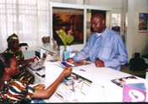
Une agence de location à Dakar

Renting a car

In general, car rental companies in Senegal have a good reputation and they propose a variety of makes and models for deals ranging from a day to a month. In addition to French cars, which form the bulk of the country’s inventory, customers can also rent Japanese and German cars from every category. American cars have not penetrated the West African market yet and, therefore, are not featured.

With 16 000 F CFA, you can rent a compact but be aware of the distance you are covering. With certain rental agreements, you only have limited mileage (100 km) per day and will be assessed for the additional kilometers. As a general rule, you should rent cars from rental companies only for local errands (covering 100 km a day in African cities is not a common occurrence). If you are planning to go the interior of the country and do not need a car during your stay there, you can rent a bush taxi for the duration of the trip and ask them to come back for you on the desired day. Some car rental companies might accept similar deals with their SUVs because they are not rented as frequently as the other car categories.

Rented cars can be taken out of the country on condition that the rental company is advised of it to issue the mandatory insurance for such a trip. Failure to do that will likely land you in big trouble in the country of destination as cars are systematically checked at border crossings. Agreements with most car rental companies in Senegal cover theft, fire and accidents caused to a third person provided these accidents are not the result of dangerous driving or a violation of the country’s driving code, ant that they have been reported to the police. Additional insurances are available but not required.

In order to be eligible to rent a car, one must be at least 23 years old, have at least two years of driving experience and show a proof of his or her current address. A deposit is always required and it can be made by credit card (Visa, American Express, Diner's club, MasterCard, Eurocard), traveler’s checks, cash, or certified money order. The final bill can also be paid through these means. Gas is paid for by the customer and is available almost everywhere in Senegal even though prices are a little bit higher in the countryside.

Dealing with traffic agents

Not all streets in Dakar are equipped with traffic light signals. Consequently, uniformed policemen man some of the town’s busiest intersections. The police force in Senegal is known to be extremely corrupted; therefore, you might be stopped at any time for a traffic violation you know you have not committed. It is a swindle they use to make extra cash. The best way is to avoid stopping. However, nowadays you might be obliged to pull over because the solution they found against the repeated non-compliance to their requests is to stand in front of your car with stretched arms trying to occupy the whole lane and to prevent you from proceeding (imagine the number of casualties if this were to happen in the U.S.). If you look like a high risk for evasion, the policeman will remain in that position until a partner takes seat in your car. Only then will they pull you to the side and talk to you.

If a policeman stops you, try a few strategies. First, give the impression that you are an important personality (don’t worry! it is morally o.k. to do so in the African context) by suggesting something like: he is delaying you from a meeting with a minister or the director of a big company, or by talking him down (i.e. giving the impression that you do not need to deal with him to settle this problem, that you will deal with his superiors). However, do not overplay it. If you sense that he is backing off, keep up with the strategy, if not, try to be more reconciliatory. If he still insists on you paying a fine you can negotiate it if you are in a hurry. If he refuses, ask him to write the ticket and give you a receipt. This will make him want to negotiate because it means that the money will go to the state coffers rather than to his pockets.

Because the uniformed men at intersections lack the equipment to pursue or track down violators, most drivers in Africa often ignore their orders. However, one should be very careful in Senegal where the gendarmes man certain crossroads. This corps is generally more equipped and better trained than the Police. The gendarmes are known for their strictness and toughness. Do not try to disregard them: they will take it personally and are said to rough people up sometimes.
The best strategy of all, however, is to befriend the policemen that are on duty in the intersections you use the most. An occasional wave or shake of hands will establish an amicable relationship. They might come to you from time to time for assistance. Believe me: this is a small price compared to the hassle and worries they might otherwise give you, and you can be certain that they will come through for you in a lot of ways when you need them.

Mechanics

Given the bad condition of most roads in Africa and the nature of town driving, one should expect car breakdowns from time to time. If you happen to be in a rural area, you might have to bring a mechanic from a nearby town (for a minimal fee), car-towing being almost non-existent. In an urban center, however, you will be faced with the dilemma of choice. Car repair shops abound in cities and most of them are open 7 days a week. Most mechanics in Africa do not go to vocational schools to get a degree and a certification. Rather, they learn through apprenticeship and guidance from a senior mechanic. The sight of kids ten years old or even younger in greased uniforms working in a garage might be unusual in the U.S. In Africa, however, it is commonplace. In fact, car repair shops absorb the majority of children who have dropped out of primary school or who simply have not had the opportunity to go to school.

The reliability of repairs depends mostly on one’s budget. If you want a quick and cheap repair, African mechanics are experts at “bricolage” (local people call bad mechanics bricoleurs). Auto parts being expensive in Africa, part of a mechanic’s skills is to be able to manufacture or alter car components to make repairs. On the other hand, if you are ready to buy the required parts, you can be back on the road in no time. Be warned however that some mechanics might replace your new brand part for a used one. In general, mechanics are not known there to recommend unnecessary repairs. If you are in doubt of a diagnostic, you can get second opinions at any garage without paying a penny.

Finally, if you own a car that is not common in the country, you should exercise extreme care as to who should repair it. Most mechanics would not admit not knowing how to repair a given make or model. They acquired their skills through trial and error and they will try to work on your car with the same attitude.

Activity 1

Read the schedule of the shuttle boat that goes from Dakar to the Gorée Island and answer the questions that follow.

Gorée
Horaires & tarifs de la Chaloupe
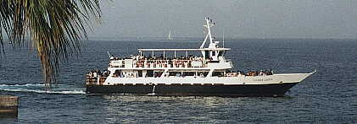
la nouvelle chaloupe "Coumba Castel", mise en service en 1999
Horaires en semaine
Départ Dakar  06 h 15  07 h 30  10 h 00  11 h 00  12h 30  14 h 30  16 h 00  17 h 00 (sauf samedi)  18 h 30  20 h 00  22 h 30  23 h 30 (vendredi uniquement)  00 h 45 (samedi uniquement) |  | tarifs de la Chaloupe A/R  Adultes 3 000 CFA  Enfants 1 500 CFA  Non-résidents 2 000 CFA  Résidents Afrique 1 000 CFA  Résidents Sénégal 1 000 CFA  500 CFA | Départ Gorée  06 h 45  08 h 00  10 h 30  12 h 00  14 h 00  15 h 00  16 h 30  18 h 00 (sauf samedi)  19 h 00  20 h 30  23 h 00  00 h 00 (vendredi uniquement)  01 h 15 (samedi uniquement)
Horaires Dimanches et Jours Fériés
Départ Dakar  07 h 00  09 h 00  10 h 00  12 h 00  14 h 00  16 h 00  17 h 00  18 h 30  20 h 00  21 h00  22 h 30  23 h 30 | tarifs de la Chaloupe A/R  Adultes 3 000 CFA  Enfants 1 500 CFA  Non-résidents  Résidents Afrique 2 000 CFA  1 000 CFA  Résidents Sénégal 1 000 CFA  500 CFA |  |  | Départ Gorée  07 h 30  09 h 30  10 h 30  12 h 30  14 h 30  16 h 30  17 h 30  19 h 00  20 h 30  21 h 30  23 h 00  00 h 00
http://www.senegal-online.com/senega00.htm

1. The first time schedule is valid Monday through Friday. T / F
2. The second time schedule is in effect on Sundays and holidays. T / F
3. The rates quoted are for a one-way ticket only. T / F
4. The rates vary according to one’s country of residence. T / F
5. Residents of Mali pay more than residents of the USA. T / F
6. Children pay half the adults’ fare. T / F
7. The last ferry on Sundays leaves Gorée at midnight. T / F
8. The last ferry on Mondays from Dakar is at 9.30 pm. T / F
9. The last ferry on Saturdays from Dakar is at 11.30 pm. T / F
10. The word chaloupe is an equivalent of ferry. T / F

Activity 2

John got the following information about a means of transportation to Ziguinchor. Choose the statements that correctly finish each sentence.

Le Kassoumay Kep  A destination de la Casamance et/ou de Banjul (Gambie), ce superbe catamaran tout neuf est vraiment le summum du confort. Un bar, les télévisions avec vidéo de tous les côtés, un design moderne avec un personnel (hôtesses et stewards) bien formé. On peut désormais relier Dakar à Ziguinchor en 8 heures dans un confort digne de la « business class ». Le prix est plus que raisonnable pour une prestation de ce type:  DAKAR-ZIGUINCHOR : Adulte 14000 pour la classe éco (déjà très luxueuse) et 25000 CFA pour la première classe.  7200 pour les enfants et 2400 pour les bébés.  DAKAR-BANJUL ou BANJUL-ZIGUINCHOR :  12000 pour les adultes (20000 en 1ère classe), 6000 pour les enfants, 3500 pour les bébés. | 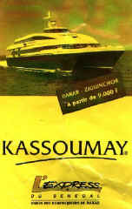
Le Joola (le Diola)
C'était jusqu'il y a un an le seul bateau assurant la liaison Dakar-Ziguinchor. La liaison dure tout de même 16 heures dans le meilleur des cas. Cet immense bateau est vraiment le mode de transport populaire entre la Casamance et le Nord. Toute une fourchette de prix est proposée en fonction du budget et du confort demandé.
Cabine individuelle (douche, WC, télé, vidéo, couchette): 28 000 CFA
Cabine double (idem avec deux couchettes) : 15 000CFA
Cabine quadruple (idem avec 4 couchettes): 12 000CFA
2ème classe : 8000 CFA (fauteuil)
3ème classe: 3500 CFA (bancs de bois très inconfortables mais parfait pour les petits budgets et pour rencontrer des Casamançais rentrant au pays)
Possibilité d'embarquer une voiture pour 18000 CFA
Un bar-restaurant propose casse-croûte, repas (2000CFA), boissons (500CFA) et petits-déj.
Départ de Dakar les mardi et vendredi à 20h00 (soyez sur place 1 heure avant et réservez vos billets la veille si vous voulez être sûr d'en avoir) et arrivée à Ziguinchor le lendemain vers 12h00
départ de Ziguinchor les jeudi et dimanche vers 12h00 (achetez les billets en avance) et arrivée le lendemain à Dakar vers 6h00.
Possibilité de descendre ou monter à Karabane. Acheter un billet nécessite une pièce d'identité.
http://www.multimania.com/soumaway/index.htm

1. Le Diola a. is the only boat to go from Dakar to Ziguinchor
b. was the only boat to go from Dakar to Ziguinchor until a year ago
c. is a catamaran
2. The trip from Dakar to Ziguinchor a. takes at least 16 hours with the Diola
b. takes less than 8 hours with the Kassoumay
c. takes 12 hours round trip
3. The least expensive adult fare for Dakar-Ziguinchor
a. in the Kassoumay costs 7 200 CFA
b. in the Diola costs 8 000 CFA
c. in the Diola consists of an uncomfortable wooden bench
4. Food is available a. on both boats
b. on the Diola (breakfasts and snacks only)
c. in a self-service cafeteria on the Kassoumay
5. Amenities include a. showers in second class on the Diola
b. televisions on the Kassoumay
c. service by stewardess on the Diola

Activity 3
Read the following ad for a car rental agency and check whether the statements that follow are true or false.

COSELOC, le même service 24h/24 partout au Sénégal
Des véhicules neufs
Des véhicules climatisés
Un service VIP avec chauffeur
Accueil et transfert : séminaristes, congressistes et particuliers
Des forfaits incluant : la location, le kilométrage, l'assurance et la TVA
Location de téléphones portables
Des privilèges en plus

1. The services of the Coseloc agency are available during regular business hours. T / F
2. This agency can provide you with a driver. T / F
3. Cell phones are available free of charge with each rental car. T / F
4. Coseloc has packages that include insurance and taxes. T / F
5. Coseloc doesn't have air-conditioned vehicles available at this time. T / F

Activity 4

You will hear 10 sentences, each mentioning one of the labeled car parts from the drawing below. Write the number of the sentence in which the part is mentioned next to each label.

Script:

- L’ampoule du clignotant gauche est grillée.
- Les freins sont en bon état.
- La roue de secours est petite.
- Le pare-brise est cassé.
- Les essuie-glace sont usés.
- Les pneus sont neufs.
- Le réservoir est plein.
- Les feux arrières sont allumés.
- Le moteur est vieux
- L’embrayage est bien serré.

a) Moteur b) Embrayage c) Pare-brise
d) Ampoule du clignotant e) Réservoir f) Feux arrières
g) Roue de secours h) Essuie-glaces i) Freins j) Pneus

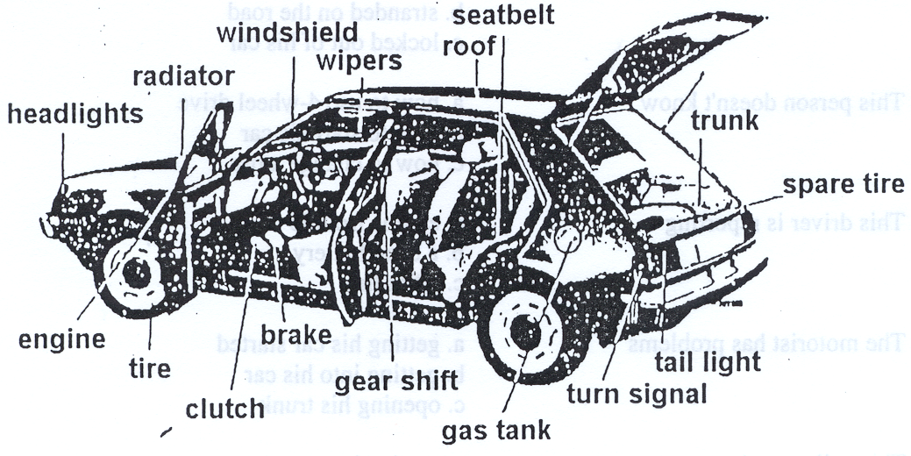

Activity 5

Look at this table of convertible cars and select one. Explain your choice.

Photo | Modèle | Marque | Vitesse max (en km/h) | 0 à 100 km/h (en sec.) | Prix TTC en € (à partir de) | Emission de Co2 (en g/km) | Notation crash test Euro NCAP
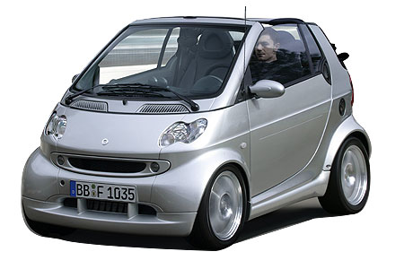 | For Two Cabrio & Pure softip | Smart | 135 | 13.5 | 12070 | 113 | *****
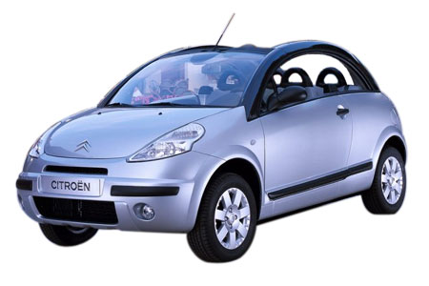 | C3 Pluriel 1.4i | Citroën | 160 | 13.9 | 15350 | 163 | *****
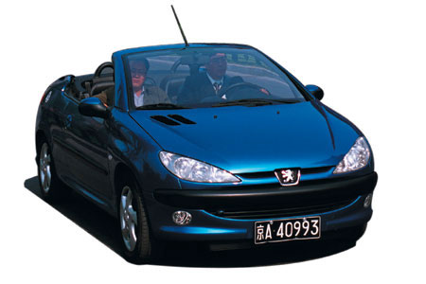 | 206 CC 1.6 16v | Peugeot | 194 | 10.7 | 17550 | 166 | Non testé
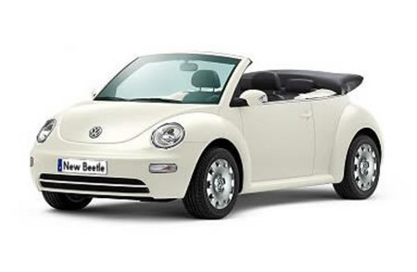 | New Beetle Cabriolet 1.4 | Volkswagen | 161 | 15.6 | 20010 | 170 | Non communiqué
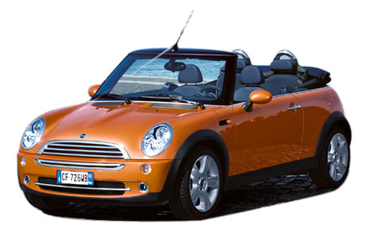 | Mini Cooper Cabrio | Mini | 193 | 9.8 | 21500 | 175 | Non communiqué. Le modèle est sortie fin 2004 donc il n'est certainement pas testé.
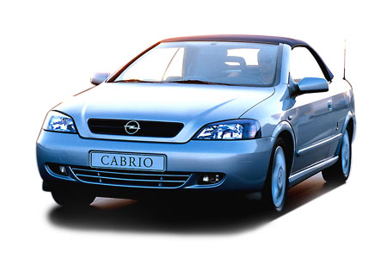 | Astra Bertone 1.6 Twinport Cabrio | Opel | 190 | 13 | 22230 | 161 | Non Communiqué
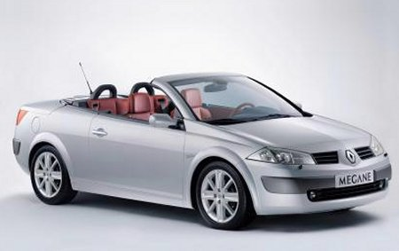 | Mégane CC Confort | Renault | 186 | 13.6 | 22300 | 164 | *****

Activity 6

Read the excerpt from a document about the means of transportation in La Mauritanie and discuss in class.

Les transports à l’intérieur de la ville répondent à des règles différentes. La variété des moyens de déplacement est calquée sur les disparités de revenus, et sur les organisations très diverses des quartiers. En périphérie, l’espace habité est très semblable à un campement. A côté des baraques on plante la Khaïma, tente traditionnelle des maures. On amène ses chèvres, on ajoute parfois un arbre. Il n’existe pas de titre de propriété, ni de limites matérielles à la parcelle habitée. Le processus d’intégration à la vie urbaine est lent. Les habitants des villes sont toujours un peu des nomades et d’ailleurs, nombreux sont les fonctionnaires de la capitale qui possèdent leur groupe de chameaux, en brousse. Cela explique que les paysans soient plus nombreux que les urbains, pourtant majoritaires : les deux catégories s’entrecoupent. Mis à part au centre-ville, l’espace n’a pas d’organisation définie. La périphérie est une interminable succession de cabanes plantées sur du sable, formant un réseau chaotique, qui se faufile entre les habitations. Ca et là, on trouve des petits marchés qui sont les centres de gravité des quartiers. Pour les besoins quotidiens, le citadin doit se déplacer. Souvent le chef de famille est le seul à être salarié. C’est lui qui sera amené à se déplacer quotidiennement le plus loin. Mais la plupart des autres membres de la famille travaillent aussi, en général de manière informelle, irrégulière et à temps partiel. L’offre des transports est adaptée à cette demande aux exigences et aux revenus différents. Le moyen le plus économique demeure la marche.

Activity 7

In groups of 3, discuss the previous article and the image below. Find different sentences in the text that explain or somehow relate to this image. First work on the caption.

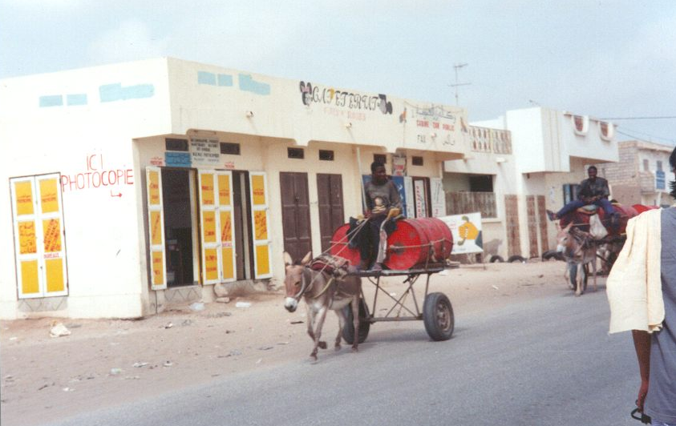
Transport d’eau et boutiques dans le centre de Nouakchott
Read about some of the vehicles of the French army and check whether the statements that follow are true or false.

1.
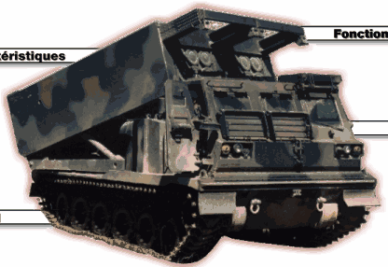 | Le système d'armes Lance-Roquettes Multiple (LRM) est un ensemble complet comprenant un lanceur, des munitions appropriées, des systèmes de gestion et de transmission de données, ainsi que des moyens d'acquisition spécifiques. Le LRM est destiné à détruire les cibles adverses blindées, à ralentir l'adversaire, à neutraliser les forces d'appui et de soutien, et à arrêter le deuxième échelon.

a. This tank is a rocket launcher T / F
b. It can destroy armored vehicles T / F
c. It is not equipped to transmit information T / F

2.
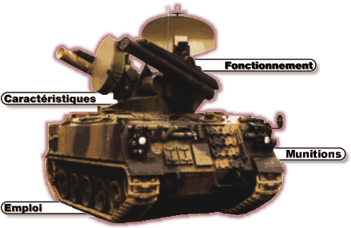 | Le système d'arme ROLAND2 est destiné à la défense antiaérienne des unités blindées et mécanisées du corps de bataille contre des aéronefs volant à près de Mach 1,5 et des hélicoptères en vol stationnaire. Le ROLAND est généralement employé :  - soit en complément de la couverture HAWK (défense de zones et couloirs non défendus par le HAWK)  - soit en prolongement du HAWK vers l'avant
Une section ROLAND assure la défense de l'ensemble d'une zone de 100 km² face à une menace constituée par une patrouille de 4 avions ou par 2 patrouilles agissant à plus de 20 secondes d'intervalle

a. The Roland 2 system is an anti-air defense system T / F
b. It is not linked to the HAWK system T / F
c. It can defend against four airplanes T / F

Activity 8

Listen about some of the vehicles of the French army and check whether the statements that follow are true or false.

3.
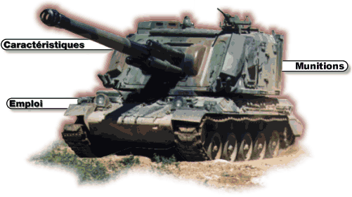

a. This tank is a personnel carrier T / F
b. It is specifically used by the combat engineers T / F
c. It is used by the artillery T / F

4.
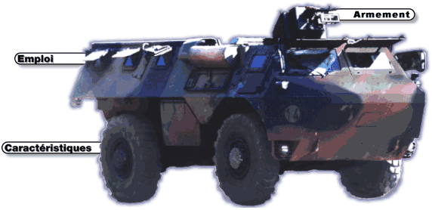

a. This vehicle is an integral part of the artillery T / F
b. It is very mobile T / F
c. It can be carried by plane T / F

5.
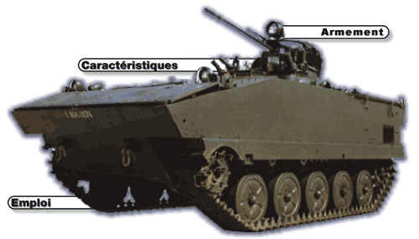
Pictures and texts taken from http://www.defense.gouv.fr/terre/equip/index3.html.

a. This vehicle is not used by the infantry T / F
b. It is an armored vehicle T / F
c. It can destroy light armored vehicles T / F

Activity 9

Fill in the blanks with the following words and give oral answers.

Louer, sans plomb, voiture, plein, vidange, clignotant

1. Je mets de l’essence sans plomb dans ma voiture.
2. Le clignotant de gauche marche-t-il bien?
3. Il faut faire la vidange tous les 5 000 km.
4. Le week-end je lave ma voiture.
5. Bonjour Monsieur! Le plein, s’il vous plaît.
6. Pendant combien de temps voulez-vous louer la voiture?

Activity 1

Pair activity. The table below shows the rates and vehicles available from the Coseloc agency. Decide which vehicle is most suitable for each of the following situations, and estimate your bill. Be ready to share your results with the rest of the class.

CATEGORIE | Modèles | Par Jour | Km. supp. | Forfait  Week-end  avec  200 KM | Forfait  3 jours  avec  350 Km | Forfait  7 jours  avec  750 Km | Forfait  15 jours  avec  1 600 Km | Forfait  1 mois  avec  3 500 Km
Economique | Peugeot 106  Renault Clio  Toyota Starlet  Citroën Saxo 1,4 l. | 16 000  "  "  18 000 | 140  "  "  160 | 65 000  "  "  75 000 | 125 000  "  "  145 000 | 275 000  "  "  305 000 | 550 000  "  "  625 000 | 1 050 000  "  "  1 220 000
Tourisme | Citroën Xsara  Peugeot 306  Renault Mégane  Toyota Tercel | 20 000 | 180 | 85 000 | 155 000 | 340 000 | 690 000 | 1 350 000
Affaires | Honda Civic Ex I  Hyundai Elantra  Mitsubishi Lancer GLX  Toyota Corolla | 22 000 | 200 | 93 000 | 173 000 | 370 000 | 750 000 | 1 485 000
Confort | Citroën Xantia 1,8 l.  Honda Accord  Hyundai Sonata  Peugeot 406  Renault Laguna | 32 000 | 300 | 135 000 | 250 000 | 535 000 | 1 050 000 | 2 145 000
Luxe | Mercedes E 220  Peugeot 605  Renault Safrane | 37 000 | 350 | 155 000 | 285 000 | 610 000 | 1 240 000 | 2 450 000
4x4 Junior | Honda CRV  Sportage KIA  Toyota RAV 4 | 31 000 | 290 | 130 000 | 240 000 | 510 000 | 1 050 000 | 2 075 000
4x4 Senior | Mitsubishi Pajero GL  Toyota LJ 79  Mitsubishi Pajero Turbo  Nissan Patrol  Toyota Land Cruiser Prado  Toyota J 80 Luxe | 33 000  "  37 000  "  "  " | 310  "  350  "  "  " | 140 000  "  155 000  "  "  " | 255 000  "  285 000  "  "  " | 545 000  "  610 000  "  "  " | 1 100 000  "  1 240 000  "  "  " | 2 195 000  "  2 455 000  "  "  "
Utilitaires | Toyota Pick-up Dble Cabine  Minibus 15 places  Minibus 30 places | 29 000  29 000  50 000 | 270  270  480 | 124 000  124 000  212 000 | 225 000  225 000  380 000 | 485 000  485 000  815 000 | 980 000  980 000  1 640 000 | 1 950 000  1 950 000  3 250 000

Activity 2

Pair activity. One student is looking to purchase his partner’s classic car. Go over each part mentioned below to ask if everything is in working condition. Take notes so you can decide whether or not the car is a lemon. Then switch roles.

Example: Est-ce que les essuie-glace marchent?
Est-ce que les freins marchent bien?
Les pneus sont en bon état?

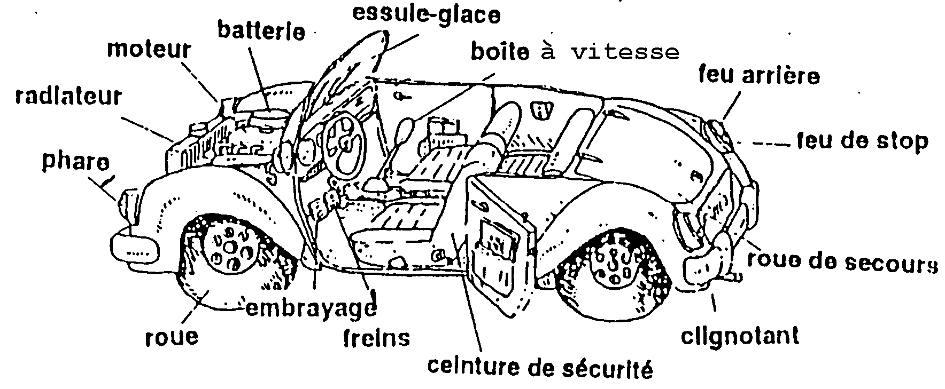

Pair Activities, Student A.

Activity 3

The (incomplete) table below contains the schedule for the Kassoumay, the boat described in the preceding exercise. Take turns asking questions to fill in the missing information.

Départ |  |  | Escale |  | Arrivée
Ville | Jour | Heure | Ville | Heure | Ville | Heure
Dakar |  | 9h00 | Banjul | 12h à 13h | Ziguinchor
Ziguinchor | mercredi et dimanche | 10 h00 | Banjul | 1400 à 15h00
Banjul |  | 15h00 |  |  | Dakar | 18h00
Banjul |  | 12h00 |  |  | Ziguinchor | 17h00

Activity 4

You work for an apartment complex and you have to reassign the parking spaces. Reconstitute the list of vehicle makes and their owners. Your partner has the information you are missing and vice versa.
Example: Qui a une Renault?
M. Fall a une Renault.

M. Fall |  | M. et Mme Diouf |  | M. Dieng |  | M. et Mme Diop
 |  |  |  |  |  | 

Activity 5

Below is an incomplete table of the rates of the Coseloc agency. Take turns asking questions to fill in the information you are missing.

Compagnie Sénégalaise de location: Coseloc
145, Rue Moussé Diop BP 21832 DAKAR PONTY
CATEGORIE | Modèles | Par Jour | Km. supp. | Forfait  Week-end  avec  200 KM |  | Forfait  3 jours  avec  350 Km | Forfait  7 jours  avec  750 Km | Forfait  15 jours  avec  1 600 Km | Forfait  1 mois  avec  3 500 Km
Economique | Peugeot 106  Renault Clio  Toyota Starlet  Citroën Saxo 1,4 l. |  | 140  "  "  160 |  |  | 125 000  "  "  145 000 |  | 550 000  "  "  625 000
Tourisme | Citroën Xsara  Peugeot 306  Renault Mégane  Toyota Tercel | 20 000 |  | 85 000 |  |  | 340 000 |  | 1 350 000
Affaires | Honda Civic Ex I  Hyunday Elantra  Mitsubishi Lancer GLX  Toyota Corolla |  | 200 |  |  | 173 000 |  | 750 000
Confort | Citroën Xantia 1,8 l.  Honda Accord  Hyundai Sonata  Peugeot 406  Renault Laguna | 32 000 |  | 135 000 |  |  | 535 000 |  | 2 145 000

Activity 6

You need to rent and car and want to shop around. Call the directory assistance and ask for the phone numbers of Avis, Budget, Touba Location, and Hertz.

Activity 7

You work for a car rental agency at the Kinshasa airport. You receive a phone call from a person who wants to reserve a rental car. Using the chart below, help the customer. Make sure you agree on the make of the car, the options, the duration of the rental, and the price. Don’t forget to get your customer’s name and credit card number.

Voitures disponibles | Prix par jour
Renault Clio RL 1.1 – 4 C.V.  Renault Safrane RN CA auto-radio cassette  Peugeot Junior diesel, 5 portes, 5 vitesses  Peugeot 405 GR, 5 vitesses, climatisation  Citroën XM Ambiance, automatique, climatisation  Citroën XM break turbo automatique | 5 500 Zaïres  7 500 Z  4 500 Z  8 500 Z  9 000 Z  9800 Z

Pair Activities, Student B

Activity 3

The (incomplete) table below contains the schedule for the Kassoumay, the boat described in the preceding exercise. Take turns asking questions to fill in the missing information.

Départ |  |  | Escale |  | Arrivée
Ville | Jour | Heure | Ville | Heure | Ville | Heure
Dakar | mardi et samedi |  | Banjul | 12h à 13h |  | 17h00
Ziguinchor | mercredi et dimanche |  |  | 1400 à 15h00 | Dakar | 18h00
Banjul | lundi, mercredi, vendredi et dimanche | 15h00 |  |  | Dakar
Banjul | mardi et samedi | 12h00 |  |  | Ziguinchor

Activity 4

You work for an apartment complex and you have to reassign the parking spaces. Reconstitute the list of vehicle makes and their owners. Your partner has the information you are missing and vice versa.

Example: Qui a une Renault?
M. Fall a une Renault.

M. Fall | Mlle Niane |  | Mme Sembène |  | Mme Bâ

Activity 5

Below is an incomplete table of the rates of the Coseloc agency. Take turns asking questions to fill in the information you are missing.

Compagnie Sénégalaise de location: Coseloc
145, Rue Moussé Diop BP 21832 DAKAR PONTY
CATEGORIE | Modèles | Par Jour | Km. supp. | Forfait  Week-end  avec  200 KM |  | Forfait  3 jours  avec  350 Km | Forfait  7 jours  avec  750 Km | Forfait  15 jours  avec  1 600 Km | Forfait  1 mois  avec  3 500 Km
Economique | Peugeot 106  Renault Clio  Toyota Starlet  Citroën Saxo 1,4 l. | 16 000  "  "  18 000 |  | 65 000  "  "  75 000 |  |  | 275 000  "  "  305 000 |  | 1 050 000  "  "  1 220 000
Tourisme | Citroën Xsara  Peugeot 306  Renault Mégane  Toyota Tercel |  | 180 |  |  | 155 000 |  | 690 000
Affaires | Honda Civic Ex I  Hyundai Elantra  Mitsubishi Lancer GLX  Toyota Corolla | 22 000 |  | 93 000 |  |  | 370 000 |  | 1 485 000
Confort | Citroën Xantia 1,8 l.  Honda Accord  Hyundai Sonata  Peugeot 406  Renault Laguna |  | 300 |  |  | 250 000 |  | 1 050 000

Activity 6

You work at the directory assistance. Below are the phone numbers of car rental agencies in Senegal. Help the caller who wants the phone numbers of car rental agencies.

DAKAR AUTO SERVICE 221.821.59.15  AFRICAR 221.22.18.50 221.821.06.90  AVIS SENEGAL 221.823.33.18/ 221.821.21.83  BUDGET 221.822.25.13/ 221.822.25.06  EUROPCAR 221.821.38.49  HERTZ 221.821.56.23 / 221.821.17.21  NOPROLA 221.821.73.11 / 221.822.01.39 | SAHEL AUTO 221.22.85.88  SARR & FRERES 221.20.17.34  SENECARTOURS 221.22.94.54 221.21.83.06  SENEGALAUTO 221.22.53.96 221.21.21.83  SOTRICA 221.22.89.35  TERANGA LOCATION 221.21.75.23  TOUBA LOCATION 221.21.59.09

Activity 7

Before flying into Kinshasa, you want to call ahead to arrange for a rental car at the airport. Call an agency to reserve a car. Inquire about models, options, and rental rates. Some popular brands in the Democratic Republic of Congo are Renault, Peugeot, and Citroën.

Phrases needed: Je voudrais réserver une voiture de location.
Je vais la prendre à l’aéroport à … heures
La voiture est-elle climatisée?
Est-ce que vous acceptez la carte de crédit Visa?

Activity 8

Listen to the following sentences (read by your instructor) and write down what type of transportation is used to travel.
Use this space for any notes.

Answers:

Activity 1 Track 58

CD. Listen to the following sentences and connect the names with the make of the vehicle they own.

Mariama  Mamadou  Penda  Khady e  Pape  Coumba | - Peugeot  - Toyota  - Nissan  - Renault  - Jaguar  - Mercedes

Script:
Mamadou a une vieille Peugeot qui tombe toujours en panne.
Mariama a une Mercedes toute neuve.
Penda met de l’essence sans plomb dans sa Toyota.
Khady conduit une belle Jaguar.
Pape a une Nissan rouge.
Coumba n’aime pas sa Renault.

Activity 2

Read the following ad and answer the questions.
Avec le magasin pièces de rechange BOSCH, la large gamme de pièces et produits couvre 95% des besoins du parc automobile, ce, en une seule marque, et dans les domaines suivants :
- freinage
- filtration (huile, carburant, air, habitacle)
- batteries pour véhicules, engins et motos
- électronique de confort
Contact
Km 2,5 bd du Centenaire de la commune de Dakar
Tél. : (221) 849 38 02
Fax : (221) 849 38 01

- démarreurs et alternateur
- injection diesel
- injection essence
- éclairage et signalisation
- balais d’essuie-glace
- courroies et kits de distribution
- bougies d’allumage
- bougies de préchauffage
- petits accessoires électriques : relais - fusibles - fils

- What is the purpose of this ad?
- What kind of products can be found here—name at least 5 categories of the car parts?
- How many rental locations are listed in this ad?
- What address would you use to send a letter to this agency?

Activity 3 Track 59

CD. Listen to a conversation at a car rental agency and check whether the statements are true or false.

Script:
Client: Je voudrais louer une voiture.
Réceptionniste: Pour combien de jours, Monsieur?
Client: Pour cinq jours.
Réceptionniste: La location est de 15 500 F par jour.
Client: C’est trop cher.
Réceptionniste: Si vous prenez la voiture pour une semaine, vous aurez un forfait à 92 500 F.
Client: Je n’ai besoin d’une voiture que pour 5 jours.
Réceptionniste: Dans ce cas, c’est le tarif normal.
Client: Je n’ai pas le choix. Je prends le tarif normal.
Réceptionniste: Est-ce que vous voulez une assurance tous risques?
Client: Non.
Réceptionniste: J’ai besoin d’une avance de 38 750 F et de faire une copie de votre permis international.
Client: Le voici.
Réceptionniste: Signez ici s'il vous plaît. Voici les clefs.

1. The clerk suggests a weekly package. T / F
2. The customer declines comprehensive insurance. T / F
3. He has to make an advance payment of 38 000 F. T / F
4. He has an international driver’s license. T / F
5. He signs the rental agreement. T / F

Activity 4 Track 60

CD. Listen to the conversations between a clerk from a towing company and a caller. Take notes so you can give information to the tow truck driver.

Appel numéro 1:
Motoriste: Bonjour Madame. J’ai des ennuis mécaniques et je voudrais qu’on m’envoie une dépanneuse.
Dépanneur: Quel genre d’ennuis?
Motoriste: Le moteur fume.
Dépanneur: Vous êtes où?
Motoriste: Je suis sur la route de l’aéroport.
Dépanneur: Quel type de voiture avez-vous?
Motoriste: Une Nissan rouge.
Dépanneur: Une dépanneuse sera là-bas dans 45 minutes.

Call 1:
Nature of the problem:
Location of the vehicle:
Description of the vehicle:
Waiting time:
Activity 5

Answer the questions based on the following vehicle sales pitch.

Les travaux à la vigne exigent de transporter beaucoup de matériaux. C’est pourquoi j’ai opté pour un 4x4 Toyota Hilux 2.4 TD qui est bien plus robuste que d’autres marques. Très pratiques en hiver, les quatre roues motrices permettent de se déplacer quelque soit la situation extérieure.
La boîte de vitesse est facile à enclencher autant pour les petits que les grands rapports. Le moteur diesel est très souple et la consommation correcte. Depuis trois ans que je le possède, je n’ai pas eu de frais d’entretien sur ce véhicule. Le pont est en aluminium et ne rouille pas. Ceci prouve que ce modèle est très solide.
Le confort est très appréciable. Mon épouse s’en sert souvent et l’apprécie beaucoup pour sa maniabilité. Autant pour les chargements que pour la montée, le véhicule n’est ni trop haut ni trop bas.
En somme, c’est un très bon véhicule pour les entreprises moyennes.

1. This vehicle is most likely a a. truck
b. luxury motorcar
c. bus

2. It is easy to drive because of its a. small size
b. overall quality
c. low suspension

3. The vehicle won’t operate in a. mud
b. sand
c. rivers

4. It has a spacious a. trunk
b. passenger area
c. driver’s cab

Activity 6

You need to give a briefing about the pros and cons of certain routes in Mauritania. Look at the map below and write a few sentences for each means of transportation to present in class.
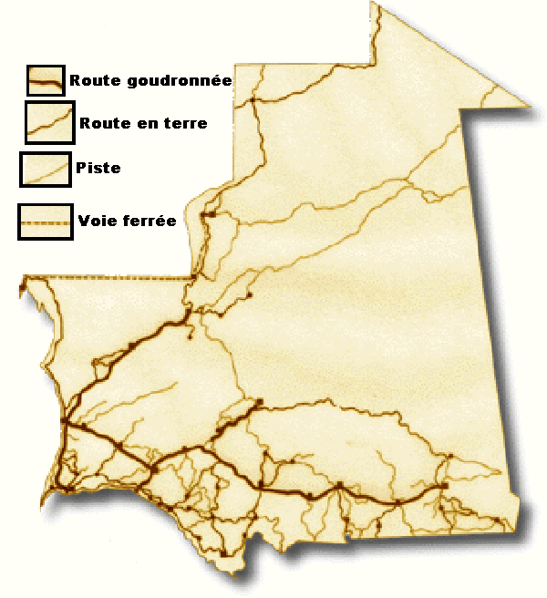Réseau de route et de voies ferrées du pays

Activity 7

You want to sell your car. Write a short ad (to present) detailing the features of your car.

Activity 8

Prepare at least 5 sentences for calling a taxi service in Dakar. Use the following information to help you get started.

ALLO TAXI
Km 1 Avenue Cheikh Anta Diop, Dakar
Tél. : 823 44 04
Fax : 823 00 51
DAKAR TAXI
Boulevard Général de Gaulle, BP 21 475 Dakar
Tél. : 823 48 38
AIRPORT LIMOUSINE SERVICE
Tél. : 820 11 74,
822 20 16
Fax : 821 17 21

Activity 9

Read the following text about forms of transportation in La Mauritanie and find the meanings for key words in bold. Be prepared to share them in class.
Une partie des marchandises arrive en Mauritanie par avion. Vide et plat, le pays se prête très bien à la construction de pistes d’aviation, mais le trafic aérien est limité, du fait de la faible demande. Le marché local n’offre pas beaucoup de débouchés, aussi bien en terme de marchandises que de voyageurs. En effet, rares sont les Mauritaniens qui ont les moyens de s’offrir un billet d’avion, et le tourisme n’existe quasiment pas. Les aéroports de Nouadibou et Nouakchott peuvent accueillir des appareils de grande taille. Les compagnies étrangères qui desservent le pays sont Air Afrique, Air France, Royal Air Maroc et Iberia. Vingt pays étrangers sont desservis, Paris et Dakar sont les destinations les plus fréquentes. La compagnie nationale Air Mauritanie possède deux Fokker F-28 de 80 places, destinés aux liaisons internes vers la quinzaine d’aérodromes du pays, ainsi qu’aux vols vers Dakar et Las Palmas de Majorque. Elle a fait l’acquisition l’année dernière (1999) d’un Airbus A300 pour répondre à la demande croissante du pèlerinage de La Mecque. Cette évolution est encourageante pour ce pays qui a des potentialités naturelles évidentes pour le tourisme.

