SOLT French Module 3 Lesson 7
Student Manual

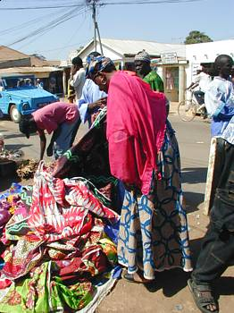

Bargaining

At the end of this lesson, you will be able to bargain for merchandise.

Bargain for Merchandise

- Negotiate the price in a store
- Talk about prices of different merchandise
- Discuss acceptable bargaining techniques

Tip of the day: Clothing sizes

In Lesson 6, you learned about size conversion and expressions to use when asking about clothing. Most West African francophone countries use French sizes. Activity 5 in the skill enhancement applications section will provide you with approximate equivalents to US sizes.

Scenario:
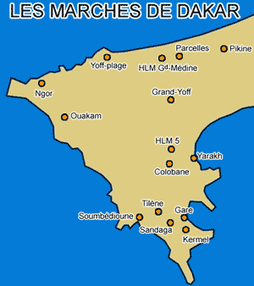
Read the conversation below with another classmate and underline words that specify clothing items. Check your vocabulary list for meaning of expressions for bargaining.

John and Amadou run into each other on the streets of Dakar. John has been shopping around the major marchés and Amadou is helping his uncle sell some clothes.

John: Salut Amadou, comment ça va ce matin ?
Amadou: Bien et toi ?
John: Pas mal. J’ai besoin d’une chemise et de tee-shirts.
Amadou: Quelle taille ?
John: Taille large et en couleur si tu as.
Amadou: Regarde cette chemise hawaïenne, elle te plait ?
John: Oui, ça devrait aller. Et pour les tee-shirts ?
Amadou: Je viens juste de recevoir ces paquets de 5 tee-shirts blancs. C’est de la super qualité.
John: Tu n’as pas de tee-shirts colorés ?
Amadou: Non, mais c’est une bonne affaire car ils ne coûtent que 5300 Francs les 5.
John: Que 5300 Francs ? Sans la chemise ? Tu plaisantes, c’est bien trop cher. Je te donne 5000 pour le tout.
Amadou: Non, 6000 pour le tout. Il faut bien que je vive mon ami.
John: 5500 pour le tout ou je vais voir chez tes collègues à côté :
Amadou: D’accord, donne-moi 5500 Francs.
John: Voilà, je te remercie, et à bientôt.
Amadou: A bientôt mon ami.

Exercise 1 (follow-up)

Answer the following questions and discuss your answers in class.

- Besides the fact that Amadou and John are used as characters for your text, how do you know that they know each other?
- What is John looking for?
- What does Amadou say to persuade John that he is getting a good deal?
- Why is a Hawaiian shirt mentioned in the conversation?
- Would this happen in the U.S.? Do you bargain for clothes in a store or a market? How about online (an auction site)? How does our culture differ from this one?

Tip of the day: Dakar marchés
Dakar has two major markets. Marché Kermel, east of the Place towards the port, burnt down in 1993, so now the stalls are out in the surrounding streets, selling mainly fruit, clothing, fabrics and souvenirs. The larger Marché Sandaga has more fruit and fewer souvenirs, but for visitors the sheer choice of fabric is a real draw.

Talk about prices of different merchandise

John decides to go and shop for a few gifts for his family. He sees a beautiful piece of clothing that he wants to buy for his mother. Read over the short conversations below.

John: Est-ce que je peux voir cette jupe?  La marchande: Laquelle? La jupe bleue?  John: Non. La rose.  La marchande lui apporte la jupe.  John: Combien coûte-t-elle?  La marchande: Celle-ci coûte 12 000 Francs. Mais si tu veux la jupe à plusieurs couleurs, je peux te la laisser à 10 000 Francs.  John: Non. J'aime mieux cette jupe. Voici ton argent.  La marchande: Merci. C'est ta première fois au Sénégal?  John: Oui.  La marchande: Passe d'agréables moments ici.  John: Merci.  John rencontre Amadou dans la rue.  John: Amadou, regarde la bonne affaire que je viens de faire! Cette jupe pour 12 000 francs seulement!  Amadou: 12 000 francs! Mais c’est hors de prix! Tu t’es fait avoir! | Your first time  Have a good time here  Good bargain  Exorbitant / You’ve been ripped off!

Exercise 2 (Pair Work)

Compare the opening dialogue with this one. Select one portion of the second dialogue above and act it out for the class. Add at least four new exchanges after reviewing the vocabulary list. Create a surprise ending.

Tip of the day: How to bargain in Sénégal

In order to get the best deal on an item, bargain with a vendor until he or she refuses to lower the price anymore. Then, tell him or her that the price is interesting but you will shop around to check if other vendors will give you an even better price. When you deal with the next merchant, start bargaining from where you left off with the first vendor. Without fail, this bargaining technique will guarantee you the best deals in Senegal.
You may hear the word, “bana-bana” or in standard French, marchand ambulant/street vendor.
The first objective of bargaining is not to reduce the price. It acts above all to create an exchange. Take your time, talk of other things, and clearly express yourself.

*partial information taken from: www.senegalaisement.com

Negotiate item prices at a store or in the market

John is not sure how he should negotiate items in the market. Amadou takes John to the nearby markets to teach him how to bargain. Read their conversation and then go to the next exercise on bargaining techniques.

Amadou: Combien coûte ce tee-shirt?
Le marchand: Combien tu peux payer?
Amadou: Dis-moi un prix.
Le marchand: Sept cent cinquante francs.
Amadou: C’est trop cher. Je t’offre quatre cents francs.
Le marchand: Ce prix est trop bas. Mais comme tu es mon premier client ce matin, j’accepte.

Discuss acceptable bargaining techniques

Bargaining and technique when it comes to bargaining is a major part of the West African culture. Bargaining is a part of life, not only in Senegal but in other places such as Tunisie, Mali, and La Côte d’Ivoire. Here is one description of how to “marchander” in la Tunisie. Read the description and ask your instructor for help with certain words or expressions. You are not expected to understand all of the text—only the key words and given context for this lesson.

Marchander = to haggle

Savez vous marchander? Pour certains, c'est un loisir et une passion, pour d'autres c'est plus difficile. Mais de toute façon on est obligé de passer par là en Tunisie, c'est ce qui fait le principal attrait des souks. Vous verrez la mine réjouie que vous aurez quand vous aurait fait baisser le prix d'un souvenir. La plupart d'entre vous n'ont jamais essayé (vous vous voyez marchander aux Etats-Unis?) alors voici pour ne pas se faire arnaquer les prix réels de certains objets:

Bien entendu, les vendeurs détectent les têtes de touristes (si si :) et vous invite à visiter leur boutique. Suivez les. Faites mine que vous vous intéressez à un objet tout en ayant la tête de quelqu'un qui trouve l'objet trop cher (je suis sûr que vous pouvez le faire !!). Demandez au vendeur le prix qu'il peut vous faire. Si l'objet est trop cher, proposez lui un prix assez bas (en bluffant) ou qui vous semble juste. S'il ne descend pas, commencez à rebrousser chemin en quittant la boutique et là, Miracle! le prix va commencer à baisser à une vitesse folle (normallement :) c'est là tout l'art !!! Sinon faites un tour dans le souk pour connaître le prix que vous font les autres vendeurs. Revenez sur la place de la boutique, et comme les propriétaires sont souvent dehors ils vont vous reproposer un autre prix beaucoup plus attractif!!!

L'autre moyen s'adresse plutôt à des jeunes. Après que le vendeur est proposé un prix, dites lui que vous n'avez que _ F CFA. Bien entendu il refusera, mais quittez la boutique, il va peut-être faire baisser le prix énormément.

Exercise 3 (Group Work)

Read this excerpt from a travel journal and discuss with your classmates. Highlight information that will help you bargain in Francophone Africa. Are there points you agree (disagree) with? In groups of 3, make a clear argument that agrees or disagrees with this advice. In French, write out your main ideas to present to the other groups.

I initially felt rather apprehensive about having to bargain for (almost) everything in Senegal. I mean surely they vendors would trick me into paying higher prices. Would they also be dishonest with me but less so for local habitants? Well, yes they do charge a slightly higher price for toubabs (foreigners) but the difference is generally negligible. And besides, bargaining is an art so if you're not ready to chit chat, you are not ready to bargain!
Tips: 1) Always try to bargain. This is not disrespectful, it's just the way business is done here. 2) Find a style that's you. The vendors always will match your attitude. 3)Cut everything in two.
Exercise 4 (Pair Work)

Discuss these two bargaining cases in Dakar. Which “style” do you prefer? Do you think the first or second case is the best “technique” for bargaining based on your personal experiences and what you have learned about the culture? After a short discussion, select one of the situations and create a short dialogue (using the other scenarios and conversations in this lesson). Your instructor will ask each pair to present in front of your classmates.

Case #1

My friend has a bargaining style that is very much his own. Hecomes up to the stall and asks for the price. Then he groans and grunts and starts with: “why are you charging this ridiculously high price? I'm not a tourist so don't give me toubab prices. Why do you have to be so dishonest?? You give me an unreasonably high price so let me give you an unbelievable low price! What, you think I am rich? I am just a volunteer!”
This session starts out on an irritated tone and quickly escalates to a shouting match. The vendor matches the intensity and anger of my friend’s tone and finally, after much arguing, they agree on a mutually acceptable price. When the item is purchased, he and the seller are the best friends in the world and civilly ask each other what they are planning to do for the rest of the day.
Case #2
On the other hand, I am rather more calm. I stroll to a stall, hesitate and greet the vendor with a smile. When she tells me the price, I always nod and say that the item is very nice but really too expensive, could you give me another price? A little bit of chit chat back and forth allows us to arrive to a decent price.
*In both cases each buyer ends up paying the same prices.

The verb mettre (to put, to put on)

This verb is irregular and is conjugated as follows:

Je mets  Tu mets  Il/elle/on met | Nous mettons  Vous mettez  Ils/elles mettent

Verbs that follow the same conjugation are: promettre to promise
permettre to permit

Exercise 1

Fill in the blanks with the appropriate forms of mettre, promettre, or permettre.

- Aujourd’hui, je mets un pull car il fait froid.
- Tu me promets d’arriver à l’heure.
- Ils ne permettent pas à leurs enfants de regarder la télévision.
- Nous mettons nos livres sur la table.
- Il lui promet la lune (moon), et elle le croit!

The verbs plaire à (to please, to be pleasing to) and aller à (to fit)

- Remember the expression for “please” in French? S’il vous plaît is one way to use the verb plaire. The verb plaire à is used in the same way as the verb to like. The present tense of plaire:
Je plais | Nous plaisons
Tu plais | Vous plaisez
Il/Elle/On plaît | Ils/Elles plaisent

- Plaire à requires an indirect object. The subject in French is the object in English:

La chemise plaît à Julie. Julie likes the shirt.
La chemise lui plait. S/he likes the shirt (literally, the shirt is pleasing to him/her; the shirt pleases him/her).

- The verb aller, which you already know in the sense of to go, and in the phrase aller bien à (to be well, fine), can also mean to fit when used in a construction similar to the one with plaire:

Ce pantalon va bien à John. The pants fit John well.
Ce pantalon lui va bien. The pants fit him well.

Exercise 2

Write whether these clothes fit the person or not.
Exemple: Est-ce que ce pantalon vous va? Oui, il me va.

- Est-ce que la casquette va à John? Oui, elle lui va.
- Est-ce que le boubou va à Aminata? Non, il ne lui va pas.
- Est-ce que la chemise te va? Non, elle ne me va pas.
- Est-ce que les pantalons vont à Mike et Paul? Oui, ils leur vont.
- Est-ce que les chaussures vous vont? Oui, elles me/nous vont.

Exercise 3

- Qu'est-ce qui vous plaît dans votre métier ?
- Qu'est-ce qui ne vous plaît pas dans [...] ?
- Qu'est-ce qui vous déplait ?
Aller à qqn. (bien)  Blouson (n.m)  Bon marché (adj.)  Chausser (verb)  Chaussettes (n.f.pl)  Chaussures (n.f.pl)  Chemise (n.f)  Cher (e) adj.  Chercher (verb)  Comme  Court (e) adj.  Costume (n.m)  Coton (n.m)  Coûter (verb)  Cravate (n.f)  Cuir (n.m)  Donner (verb)  En dessous  En dessus  Épais (se) adj.  Essayer (verb)  Être serré (e)  Gant (n.m)  Jupe (n.f)  Laisser (verb)  Large (adj.)  Long –ue (adj.)  Maillot de bain (n.m)  Manteau (n.m)  Mettre (verb)  Pantalon (n.m)  Plaire à (verb)  Slip (n.m)  Taille (n.f)  Trop (adverb)  Vendre (verb) | To go well, to fit somebody (clothes and shoes)  Jacket  Cheap  To wear (shoes)  Socks  Shoes  Shirt  Expensive  To look for  Like, as, since  Short  Suit (men’s)  Cotton  To cost  Tie  Leather  To give  Underneath, below  On top, above  Thick  To try  To be tight  Glove  Skirt  To leave, to let go, to drop  Wide, broad, full, big  Long  Swimming suit  Coat  To put  Trousers  To please  Underwear  Size, waist  Too, too much  To sell

À (au) rabais (n.m)  Argent (n.m)  Bonne affaire (n.f)  Boubou (n.m)  Création (n.f)  Dépense (n.f)  Dernier (ière) adj.  Diminuer (verb)  Foulard (n.m)  Léger (e) adj.  Hors de prix  Imperméable (n.m)  Imprinco  Marchand (e) noun  Marchander (verb)  Marché (n.m)  Pagne (n.m)  Pardessus (n.m)  Patron (ne) noun  Permettre (verb)  Raisonnable (adj.)  Réduction (n.f)  Rémise (n.f)  Robe (n.f)  Sac à main (n.m)  Salopette (n.f)  Solde (n.f)  Souk (n.m)  Veste (n.f) | At a discount  Money  Good deal, good bargain  Long traditional African gown  Design, creation (clothes)  Expense  Last  To diminish  Head scarf  Light  Overpriced  Raincoat  A quality of cloth dye  Merchant  To haggle  Market  Loincloth  Coat  Boss  To allow  Sensible  Reduction, discount  Discount  Dress  Handbag  Overalls  Sale  Souk is the Arabic word for market  Jacket

Clothing and Cultural Significance

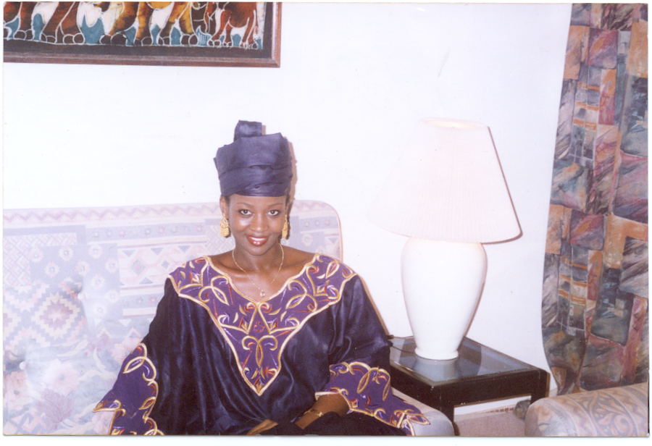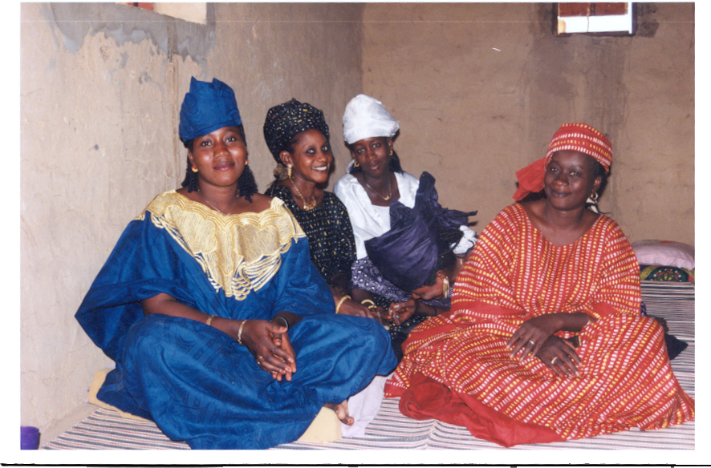
Mauritanian women wearing traditional boubous: the design patterns reflect exceptional creativity

While an increasing number of Africans are wearing Western style attire, traditional African clothes still occupy a special place in most of Africa, especially in the Western part of the continent where the traditional fabrics and designs have known a phenomenal resurgence lately. Unlike the Western style of garment, most African traditional clothes are very gender specific and it is very rare to see a unisex item. African traditional clothes are very diverse and depending on cultures, they might convey a special meaning or reflect the wearer’s status or social standing. Among the Pulaar society of the Senegal River valley, for instance, certain design patterns and dying colors have a symbolic meaning, as they are worn only by new brides.

In most African countries, the western style outfit has asserted itself as the preferred form of attire at workplaces and for various activities, reportedly for practical purposes. Indeed, many people feel that most traditional clothes are not well suited to the hustle and bustle of everyday life. Consequently, they only wear them on special occasions and or for symbolic reasons. Recently, the Mauritanian government has gone as far as to prohibit employees in the public sector from wearing traditional clothes at work. However, this ban was not successful due to the cultural symbolism attached to the act of wearing traditional outfits in that country. In Conakry, Guinea, for example, one can easily tell a Friday from any other day by the sheer number of people in traditional clothes who wear them for the one o’clock congregational prayer. There, as in many other cities, the general impression is that traditional clothes are more appropriate for praying and, therefore, should be worn on Fridays, the Muslim holy day.

In the face of the relentless assault of the Western style of attire, Africans have found creative ways of adapting to the new situation. Not only have they been particularly successful in designing patterns and fabrics that appeal to a wide range of tastes and demands within Africa and abroad, but they also have innovated clothing styles that are midway between the traditional and the Western styles. In the process, Africans have been able to popularize their outfits and put their imprints on the world of fashion everywhere.

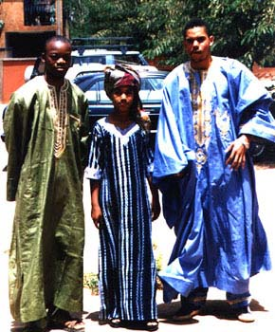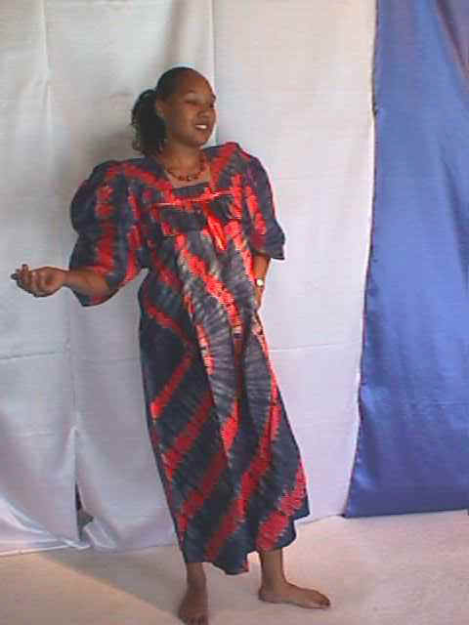
Mali Style
Senefou Grand Boubou

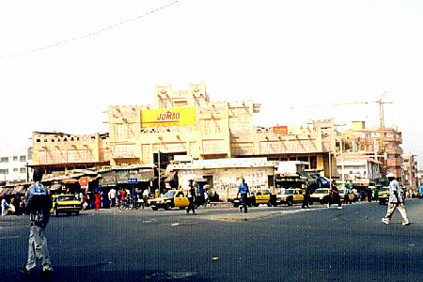
Le marché Sandaga est le marché le plus populaire à Dakar.

Bargaining in Senegal

Perhaps more than in any other country, bargaining is a way of life in Senegal and foreign visitors should sharpen their bargaining skills before or upon arrival to the country. Senegalese vendors have the dubious reputation of taking advantage of the unprepared buyers, a label that they vehemently dispute because to them an item is only worth what the purchaser is willing to give. While almost everything can be subjected to haggling in Senegal, there are, however, certain items that cannot be bargained. Prices of some industrial items in shops (cookies, toothpaste, cooking oil, soap, sugar, coffee, etc.) cannot be negotiated because they are determined either by the state (sugar, oil, rice) or by supply and demand. Rates for public transportation are also fixed and cannot be bargained.

These categories excepted, everything else ranging from shoes, clothes, art objects, fruits and vegetables or electronic items to taxi fares can be negotiated in Senegal. Even a police ticket can be bargained. In low season, it is also possible to haggle for rates of car rentals. Learning how to bargain therefore constitutes a survival kit in Senegal and it is extremely important to realize that an item is sometimes worth 1/4 or 1/5 of the initial price. Requesting a straightforward and final price of an article from a vendor in hope of saving time and sparing oneself the hassle of bargaining is not usually honored. One is obliged to bargain if one wants to avoid being had.

For those who cannot “deal” with this national hobby, as one visitor remarked, there are always professional bargainers who will trail you the minute you enter the Sandaga Market. They offer their services for a minimal fee. However, one should be aware that a number of them are in connivance with some shop owners and might strike a deal for you that is not to your advantage. The safest way is to enlist the help of a Senegalese friend who will bargain for you.

*Most of this information is drawn from: www.senegalaisement.com.

Activity 1

Find the opposite of each adjective and say one sentence that uses both (the opposites). Articles of clothing, certain objects, etc. can be used for your sentences.

- serré e  - grand d  - court b  - léger a  - cher c | a. épais  b. long  c. bon marché  d. petit  e. large

Activity 2

Fill in the blanks in the dialogue with words from the following list. Practice the conversation with your partner and share your answers with the class.

serré essayer monsieur blanche taille pantalon la en dessus

- Bonjour Monsieur. Vous désirez?
- Je cherche un pantalon beige et une chemise blanche en coton.
- Quelle est votre taille?
- 34.
- Est-ce que je peux les essayer?
- Bien sûr, la cabine d’essayage est là-bas.
- Est-ce que cela vous va?
- La chemise me va très bien. Je la prends. Mais le pantalon est un peu trop serré. Vous avez la taille en dessus?

Activity 3

Nobody seems to be finding clothes that fit today. Look at the pictures and say what is wrong with each item. Then think about how you could use these adjectives for a bargaining technique. Discuss with your classmates.
Example: Est-ce que la casquette vous va? Non, elle est trop grande.

- La robe lui va-t-elle? Non, elle est trop serrée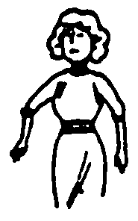
- Le pantalon lui va-t-il? Non, il est trop long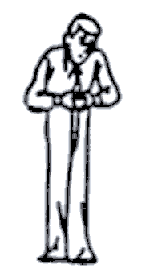
- Le pardessus vous va? Non, il est trop court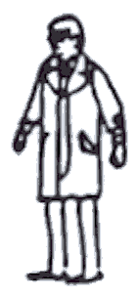
- Est-ce que le veston vous va? Non, il est trop grand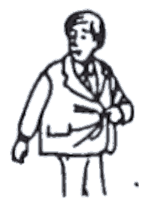
- Le chemisier vous va t-il? Non, il est trop serré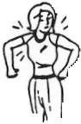

Activity 4

Reconstitute the dialogue that takes place in a store by putting the sentences in the right order. Choose someone to partner up with and role-play the conversation without referring to your notes. Take a few minutes to practice and ad-lib where appropriate.

A: Quelle taille faites-vous? 3
A: En voilà une en 44. Elle vous va? 9
A: En voilà une en 42. Vous voulez l'essayer? 5
A: Bonjour Monsieur 1
A: Est-ce qu'elle vous va? 7
B: Oui, elle me va très bien. Combien coûte-t-elle? 10
B: Du 42. 4
A: 7 500 F CFA. 11
B: Elle est un peu trop petite. Vous avez la taille en dessus? 8
B: Ce n'est pas cher. Je la prends. 12
B: Oui, bien sûr. 6
B: Bonjour. Vous avez des chemises blanches? 2

Activity 5

What do the following people want? Look at the pictures and answer the question.

- Elle veut une robe et des chaussures.
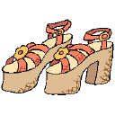

- Il veut un pantalon et une veste.

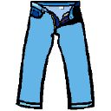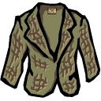
- Elle veut une jupe et un pull.

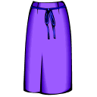
- Il veut une casquette et une chemise.


- Il veut des gants et un t-shirt.



Activity 6

Pair activity. Role-play the following dialogues.
Situation 1
At a menswear shop. A: customer, B: salesperson
A: Greet the salesperson.
B: Greet the customer.
A: Explain what you are looking for.
B: Ask what his size is.
A: State your size.
B: Ask what color he would like.
A: Choose a color.
B: Show some item and ask if he would like to try it on.
A: Say yes and ask for the price.
B: Quote a high price.
A: Say it is too expensive. Thank the salesperson and leave.
Situation 2
At a clothing issue point. A: recruit, B: supply sergeant
A: Greet the sergeant.
B: Greet the soldier. Ask what he needs.
A: Name several uniform items.
B: Ask for his size.
A: Specify size for each item you are getting.
B: Name each item you are bringing out.
A: Try on the first item and complain about the fit.
B: Say that you don't have his size.
A: Tell the sergeant that you will take the item but that you don't like the color.
B: Say that camouflage is the color one wears around here and terminate the conversation.
Activity 7

Read the following joke and answer the questions that follow. Discuss your ideas with the class.

C'est le général des forces de l'ONU qui inspecte les rangs. Il s'approche du soldat russe qui est au garde à vous raide comme un piquet. Il prend sa Kalachnikov et lui met un grand coup dans le dos. Le soldat ne bronche pas et le général lui demande :  - Tu as mal ?  - Niet camarade général (oui cette blague est assez vieille).  - Pourquoi tu n'as pas mal ?  - Parce que les soldats russes ne craignent pas la douleur.  Il s'approche alors de l'Américain. Il prend son colt et lui met un grand coup sur la tête. Le soldat ne bronche pas et le général lui demande :  - Tu as mal ?  - No mon général.  - Pourquoi tu n'as pas mal ?  - Parce que les soldats américains ne craignent pas la douleur.  Il s'approche alors du Français, prend son fusil à baïonnette (je vous avais prévenu c'est une vieille blague) et la lui plante dans le pied. Le soldat ne bronche pas et le général lui demande :  - Tu as mal ?  - Non mon général.  - Pourquoi tu n'as pas mal ?  - Parce que je chausse du 39 et ces imbéciles de l'intendance m’ont donné du 44. | stands at attention  blow in the back  budge  Does it hurt?  joke  are not afraid of pain  rifle (I have warned you / sticks it in his foot  gave me

1. What are the nationalities of the three soldiers? Russian, American, and French.
2. What does the general do to each soldier? He hits them with their weapon.
3. The first two soldiers have the same reaction. What do they answer to the general’s question? It does not hurt them because Russian and American soldiers are not afraid ofn.
4. Why doesn’t the third soldier feel any pain? He was given shoes too big for him and therefore was not hurt.

Activity 8

Fill in the blanks with the following words and practice each part. Your instructor will select a few students to role-play the short scene.

foulard, boubou, coton, 15 000 F, 18 500 F, coûte, préfère

A: Vous avez ce boubou en rouge et bleu?
B: Oui, en voilà un.
A: Combien coûte-t-il?
B: 20 000 F, il est en coton.
A: 20 000 F! C’est trop cher!
B: Voilà un boubou en Imprinco. Il coûte 15 000 F.
A: Je préfère celui en coton. Je vous donne 13 500F
B: 18 500 F, c’est mon dernier prix.
A: Bon, 18 500 F avec un foulard.
B: D’accord, 18 500 F pour le boubou et le foulard.

Activity 1

You are working at a mail-order business. Listen to the customer's order (read by your instructor), and fill in the missing parts of the form to process his order. Review sizing information in Lesson 6 if necessary.

Bon de commande

Article | Numéro | Taille | Couleur | Prix
costume | 345b | 34 | Gris | 40 000 F
Tee-shirt | 7283 | 52 | Blanc | 12 500 F
cravate | 632t | -- | Rouge / Noir | 7 800 F
chemise | 832C | 52 | Blanche | 15 300 F
jean (2) | 921S | 44 | Noir / Bleu | 15 800 F

Activity 2

Pair activity.
Student A. You want to buy a pair of pants, a tee shirt, and shoes. You only have 24 250 F. Go to a store and explain the items, colors, and size you need, ask to try them on. Then bargain on the price of the items you want to buy.
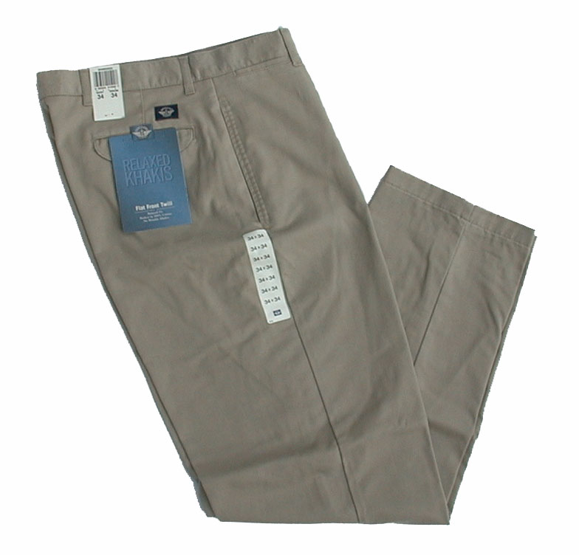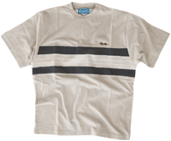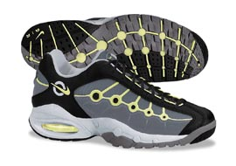

10 000 F 3 500 F 12 000 F

Student B. You are a clothes merchant. You are currently advertising for some specials. Help the customer.

Activity 3

Pair activity (review).Take turns naming the items with their colors in a random order. One student names an item and its color without pointing it out, the other crosses it out, and so on until all items have been crossed out.

Example: des chaussettes blanches

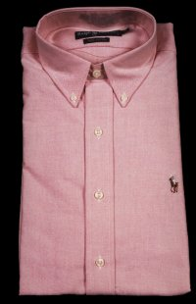 |  | 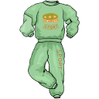 | 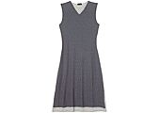 | 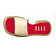
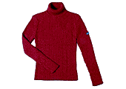 |  |  |  | 
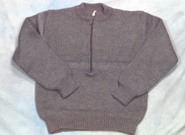 | 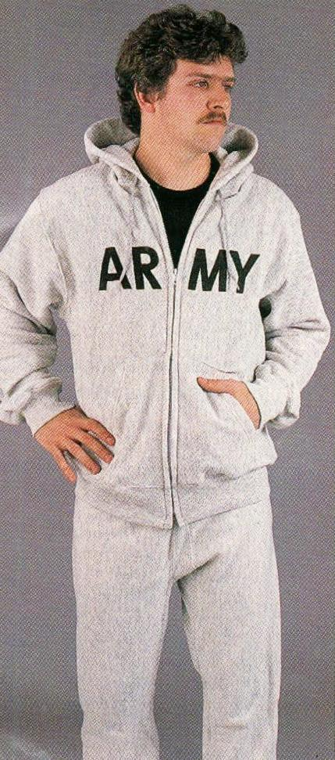 | 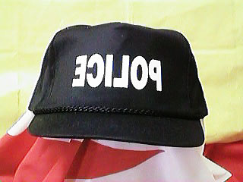 | 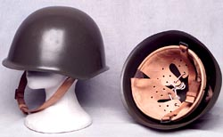 | 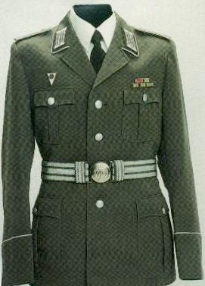
 |  |  | 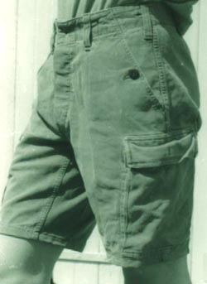 | 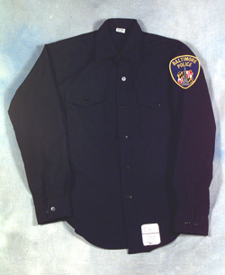
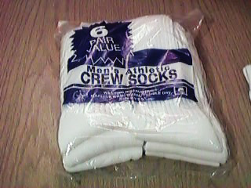 | 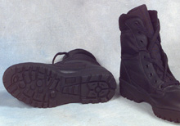 |  | 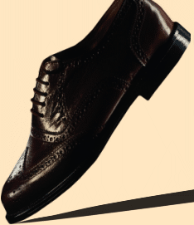 | 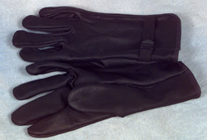

Activity 4

Pair activity (review).You have just received a 2 000 F gift certificate to buy clothing from a French mail-order catalog. Look at the specials on the next pages and decide what to buy to come as close as possible to the amount of the gift certificate. Include something for your mother, wife, girlfriend, or daughter. Fill out your order form. Then call in your order to your partner, who will write it down and read it back to check for accuracy. Then switch roles.
Exemple: je voudrais un tee-shirt, taille 34, à 35 F.

Vous voulez:
article | taille | couleur | prix

Votre partenaire voudrait:
article | taille | couleur | prix

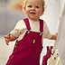  La robe-salopette DDP  à partir de 199 F | 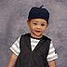  L'ensemble ELIANE ET LENA  à partir de 119 F |   La salopette longue ACTIVE WEAR  à partir de 99 F
  Le pull marin EDEIS  à partir de 139 F | 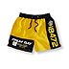  Le boxer-short  à partir de 69 F | 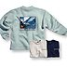  Le sweat ras de cou QUIKSILVER  à partir de 249 F

  Le soutien-gorge à froufrous CHANTAL THOMASS  340 F |   La culotte à froufrous CHANTAL THOMASS  235 F

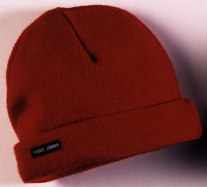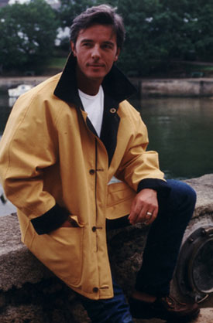
Pull Marin homme: 485,41 Frs. Bonnet breton: 45 Frs. Veste:1 567, 74 Frs.

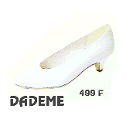 | 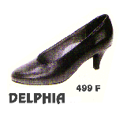 | 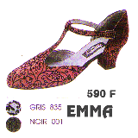

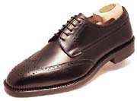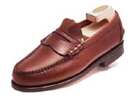
Chaussures Paterson: 576, 92 Frs. Chaussures oxford: 409, 7 Frs.

Activity 5

Imagine that you tour the markets in West Africa. Fascinated by the bright colors and diversity of the clothing of the natives, you venture into a small store and discuss the clothing with your partner. Look at these traditional clothing items to make your description. What would you bargain for? A gift to send home? Something unique for yourself?

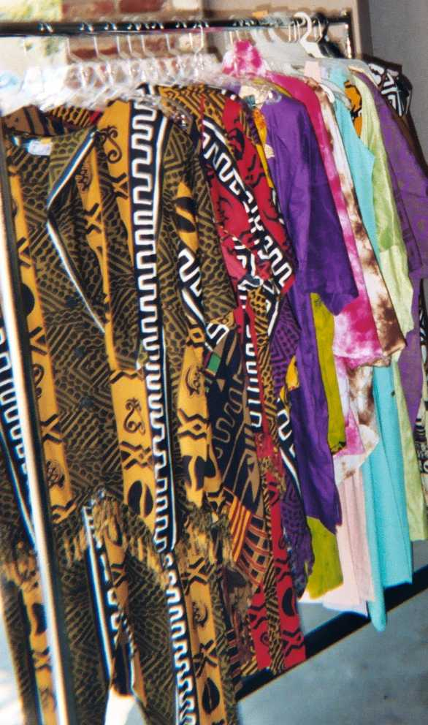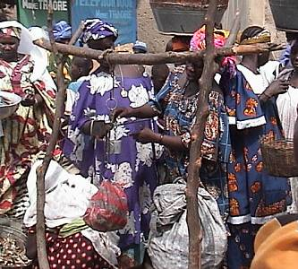

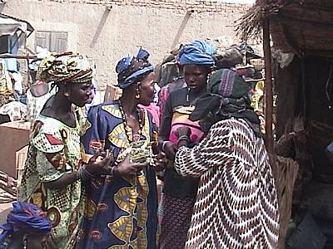

Activity 6

Student A. You are in a store in Dakar and want to purchase various articles of clothing for family and friends. Ask the salesperson what are the size equivalents that you need. Alternate the roles with your partner. Review the Introduction section in Lesson 6 for sizing information.

Modèle:
Client: Quelle taille correspond à la taille US 32 pour les pantalons pour hommes?
Vendeur: 42.

Shoe Sizes
Les chaussures d’homme | USA | Les chaussures de femme | USA
39 | 6.5 | 35 | 6
40 | 7 | 36 | 6.5
41 | 7.5 | 37 | 7
42 | 8.5 | 38 | 7.5
43 | 9 | 39 | 8
44 | 10 | 40 | 8.5
45 | 11 | 41 | 9
46 | 12

Shirts Male
USA | 14 |  | 15 |  | 16 |  | 17
France |  | 46 |  | 50/52 |  | 56
Pants/Trousers Male
USA |  | 32 |  | 36 |  | 40
France | 40 |  | 44 |  | 48
Pants/Trousers Female
USA |  | 6 |  | 10/12 |  | 16
France | 36 |  | 40 |  | 44

Note to the instructor: ask students how they could bargain with the salesclerk. Prompt the students by asking how these “store” techniques could be used in the market.
Activity 6

Student B. You are in a store in Dakar and want to purchase various articles of clothing for family and friends. Ask the salesperson what are the size equivalents that you need. Alternate the roles with your partner. Review the Introduction section in Lesson 6 for sizing information.

Modèle:
Client: Quelle taille correspond à la taille US 32 pour les pantalons pour hommes?
Vendeur: 42.

Shoe Sizes
Les chaussures d’homme | USA | Les chaussures de femme | USA
39 | 6.5 | 35 | 6
40 | 7 | 36 | 6.5
41 | 7.5 | 37 | 7
42 | 8.5 | 38 | 7.5
43 | 9 | 39 | 8
44 | 10 | 40 | 8.5
45 | 11 | 41 | 9
46 | 12

Shirts Male
USA |  | 14.5 |  | 15.5 |  | 16.5
France | 44 |  | 48/50 |  | 54 |  | 58
Pants/Trousers Male
USA | 30 |  | 34 |  | 38
France |  | 42 |  | 46 |  | 50
Pants/Trousers Female
USA | 4 |  | 8/10 |  | 14
France |  | 38 |  | 42 |  | 46

Activity 7

Read the following dialogue and answer the questions.

Benoît is a tourist from France visiting Senegal for the first time. On his second day in Dakar, he goes to Marché Sandaga to buy a few items. Even though he had been advised to bargain for everything he might want to buy in Senegal and that he had observed his friend do the same with African vendors on the streets of Paris, nothing prepared him for what he is going to experience. Benoît, walking past a few vendor stands exhibiting African art objects, is bombarded by vendors from almost everywhere.

Premier marchand: Mosieur, venez ici.
Deuxième marchand: Mosieur venez voir, c'est bon qualité et bon prix.
Benoît (finally stopping at a stand): Combien coûte cette poupée?
Le marchand: Ça c'est vraiment bon poupée, hein. La semaine passée j'avais plus de cinquante. Mais tout est parti. Touristes américains aiment ça beaucoup. D'ailleurs...
Benoît: D'accord, mais dis-moi combien ça coûte maintenant.
Le marchand: Combien tu veux acheter?
Benoît: Non, dis-moi combien tu vends ta poupée.
Le marchand: Combien tu peux donner?
Benoît: Si tu ne veux pas me dire, je vais aller voir les autres.
Le marchand: Doucement, Patron. Faut pas presser. Dis-moi juste ton prix.
Benoît: 25 francs.
Le marchand: Mais patron, qu'est-ce qu'on peut avoir avec 25 francs dans ce monde maintenant? Il faut dire un prix raisonnable et on parle.
Benoît exasperated by this waste of time decides to leave. But the merchant grasps him by the hand.
Le marchand: Il ne faut pas partir, patron. Allah sait je veux vendre ça. Je n'ai pas encore donné de dépenses à ma famille. Dis-moi juste ton vrai prix.
Benoît draws his hand back and tries to move away. But he is held again by the merchant.
Le marchand: Bon, maintenant, donne-moi 25 000 Francs.
Benoît: 25 000 Francs? Laisse-moi partir.
Le marchand: (still holding on to his hand) Ne pars pas. Dis-moi ton prix.
Benoît: Ça c'est trop.
Le marchand: Tu vois maintenant. Combien tu peux?
Benoît: Il faut diminuer.
Le marchand: Mais combien tu peux? C'est maintenant toi qui ne veux pas parler.
Benoît: (Remembering the advice of his friends, mentally cuts the price to 1/3) Je la prends ça 8 000 Francs.
Le marchand: Patron, vas-y voir dans tout le marché. Si tu vois une poupée comme ça à 8 000 Francs moi-même je vais payer.
Benoît: Je vais ajouter 500 Francs.
Le marchand: Patron, tu sais bien que cette poupée vaut plus que 8 500 Francs.
Benoît: C'est tout ce que je peux te donner. C'est à prendre ou à laisser.
Le marchand: D'accord. Je te donne ça pour 8 500 francs. Mais ne dis pas à personne. Je l'ai fait pour que tu sois mon client et tu amènes tes amis ici.
Benoît: Merci. Voici ton argent.
Le marchand: Merci beaucoup patron. Si tu as besoin de quelque chose il faut revenir ici. Tu es mon ami maintenant.
Benoît: Au revoir.
Le marchand: A bientôt.

1. Which tourists, according to the merchant’s claim, bought all of his dolls? Americans
2. What is the first offer that Benoît gives? 25 F
3. What is the merchant’s counter offer? 25 000 F
4. How much is Benoît’s second offer? 8 000 F
5. How much does Benoît finally pay for the doll? 8 500 F
Activity 8
After you go over these specific questions, take some time to think about your past experiences with merchants or salespeople. Have you had an experience like this one? Have you been persuaded to buy an item and later regretted it? Begin your discussion in English with at least 5 French sentences that detail your personal experiences.

Activity 1

Read the following description about the male and female versions of the boubou. What information can you extract from this short depiction? Be prepared to discuss your ideas with the class.

Chez les femmes, le boubou a la forme d'une tunique largement ouverte sur les côtés, avec une encolure assez généreuse qui tend à glisser sur l'épaule. Selon le tissu utilisé, le boubou peut se porter aussi bien comme un vêtement ordinaire, de tous les jours ou bien comme une tenue d'apparat pour les fêtes. Ces boubous peuvent être brodés. On retrouve des broderies au niveau de l'encolure et du dos ainsi que sur les poches des boubous masculins.
Chez les hommes, le boubou diffère au niveau de l'encolure, laquelle est triangulaire alors qu'elle est ronde chez les femmes.

Activity 2 Track 45

CD. Listen to the following conversation and answer the vrai / faux statements.

- The man does not know his wife’s dress size. V / F
- The man’s wife likes to wear blue. V / F
- He buys a green skirt. V / F
- The garment was on sale. V / F
- This dialogue takes place in the USA. V / F
- Do you buy clothes for your family (wife, children, and siblings)? When? Where? Be prepared to elaborate in class tomorrow.
Activity 3

Be prepared to describe what you and others around you are wearing on a non-uniform day. Write down a list of items to bargain for in the local market.

Activity 4

Describe these two gentlemen and the boubous that they are wearing.

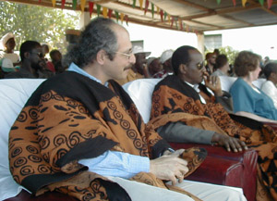
www.usaid.gov

There are many standard French words that have been modified or “détournés” in French-speaking Africa. For example in Sénégal, the adjectives, « long » and « court » have taken the place of the standard, grand and petit. If a French speaker from Sénégal says that someone is “long” that means he or she is tall (French “grand”). Other examples include: linger / faire la lessive (to do the laundry), descendre / terminé sa journée au travail (finish one’s day at work), and gâter / corrompre (corrupt). Many colloquial expressions in West Africa have altered the standard French expression. The original meaning no longer exists and has taken a life of its own –a phenomenon that occurs as a people adapts the word or expression to its own culture. Words or expressions indicate a lot about the culture itself. Vulgar or derogatory terms related to women may for example, stress a culture’s sense of oppression related to a certain group.

In the same way, standard French (spoken in and outside of Francophone Africa) has taken or borrowed many words from Africa as the two places came into contact with one another (from the early days of colonization until today). French students who study abroad or West Africans who travel to France for an internship transfer their native language, words, etc. Look at the following list of some French words that originated from Sénégal. Note that each of these words may have developed from an individual ethnic group in Sénégal such as the Wolofs or the Manjaks, the Mankagnes, etc:

Sénégal | French  *not necessarily used by the French speaker from France.
tubabu | *toubab
bubu | boubou
tara | tara
tapalé | tapalé
tata | tata

*If you hear the word, “too-bah-boo” in la Côte d’Ivoire, it is intended for a white person or perhaps an African-American. It is in no way derogatory.

With language and interference comes custom and adaptation to the standard. Traditional forms of greetings and language fuse as new forms of language are created. For example, in Sénégal, it is important to meet the eyes of whomever you speak to as you introduce yourself in French while in Mali, eye contact is frowned upon—even children do not make eye contact and it is not considered disrespectful. Also, English words or expressions can be adapted to a particular group or region. In the Anglophone section of Cameroon, you could hear some standard French paired with, “You are there!” meaning bonjour! A few minutes later, the dialect could crop up with new words and colloquial phrases. It is extremely important to recognize and adjust to the overall variation of the standard and to understand how each Francophone country relates a particular word to a convention or common implication about a person or a group within that area.

Monsieur: The merchant’s speech is transcribed as you would hear it, keep in mind that it does not strictly conform to the grammatical rules of standard French.
doll
everything’s gone
voir les autres: see the others

