SOLT French Module 3 Lesson 6
Student Manual

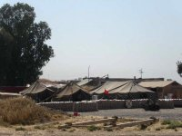
Setting up a Base Camp

At the end of this lesson, you will be able to describe supplies needed to set up a base camp and learn new French words to identify the accommodations at a military installation. You will also be able to identify common articles of military clothing as well as civilian clothing, and get familiar at where to obtain supplies for missions.

Plan to Set up a Base Camp

- List items for setting up a base camp
- Identify and describe one’s surroundings in this environment
- Identify the accommodations at a military installation

Discuss Work Attire

- State military clothing needs
- Describe civilian and military clothing
- Select weather appropriate clothing
- Discuss common articles of clothing for men and women
- Compare clothing and shoe sizes in the US with sizes in French-speaking West Africa
- Describe seasonal clothes
- Discuss preference in style, color, and material

Get Supplies

- Identify supplies
- Select supplies for your mission
- Ask and answer questions about supplies and where to get them on post
- Discuss specific supplies required by team members
- Buy supplies
Scenario:
Pour établir un camp de base
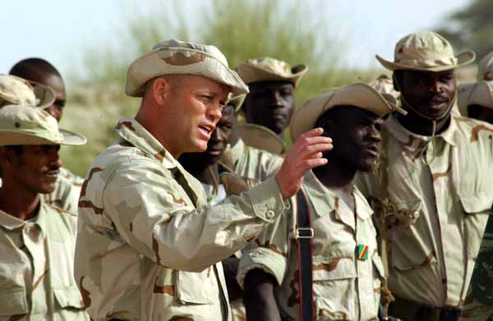
Read the conversation about setting up camp and future training in Bamako between the Lt. Col. and the Corporal (a Malian). Go to the follow-up exercise and discuss new words, meanings, context with your class.

Lt. Col.: Caporal Barizamega!
Caporal: Oui mon Colonel?
Lt. Col.: Nous allons établir le campement ici. Rassemblez vos hommes et formez des équipes; une pour monter le réfectoire là-bas, près des rochers; une autre pour s’occuper du centre de transmissions à droite; à gauche, on mettra l’infirmerie et au bout de cette allée, près des arbres, vous planterez la tente pour le poste de commandement.
Caporal: Et pour le dortoir?
Lt. Col: Dîtes aux hommes de sortir leur pelle et de creuser un trou pour y passer la nuit. On verra ça demain. Et dîtes-leur également de se dépêcher, la nuit va bientôt tomber. C’est compris?

Caporal: Oui mon Colonel!

Exercise 1 (Pair Work)

The class will be divided into pairs for this exercise. Working with a partner, read the scenario again. Pay attention to underlined phrases.

A. Write the English equivalent of the phrases.
B. Talk about similarities and differences in comparison to your base camp preparations.
A class discussion will follow.

A base camp

The essentials: items needed to establish a base camp:

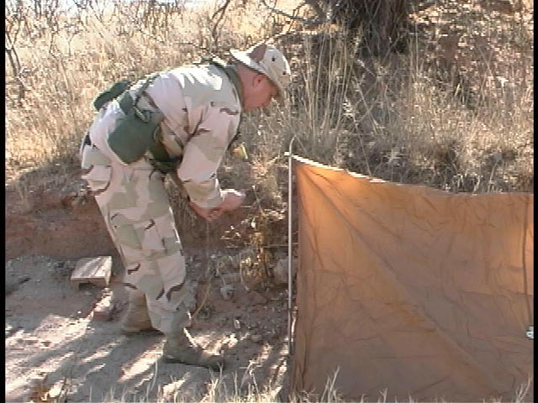  une tente | 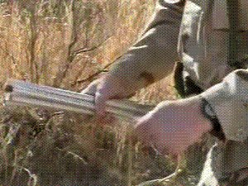  des mâts | 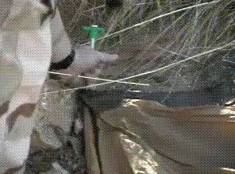  des piquets | 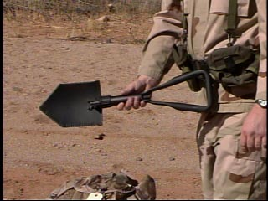 une pelle
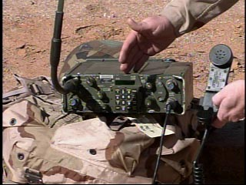  un poste émetteur | 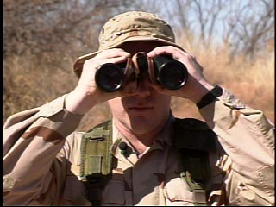  des jumelles | 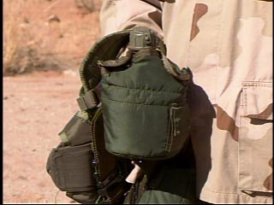  une gourde

Exercise 2 (Pair Work)

With the basic vocabulary given above and prepositions of place below, write in French the steps necessary to set up a tent in the correct order.

To express location: devant
derrière
à côté de
à gauche de
à droite de
en face de
entre

Exercise 3 (Class Work)

Review the prepositions of location. Your instructor will describe where students are located. Depending on class size, your instructor may describe objects. Place yourself where you should be so that your instructor’s statement is accurate. After a few sentences, your instructor will ask a couple of students to follow the model and change student (object) arrangement in the classroom.

Example: Your instructor says: John est derrière Matt. Matt est à côté de Paul. Then John stands behind Matt and Matt stands next to Paul.

À vous maintenant...

Le camp:
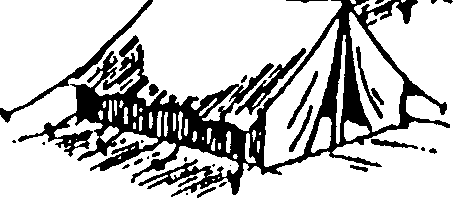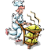  La cuisine roulante  field kitchen | 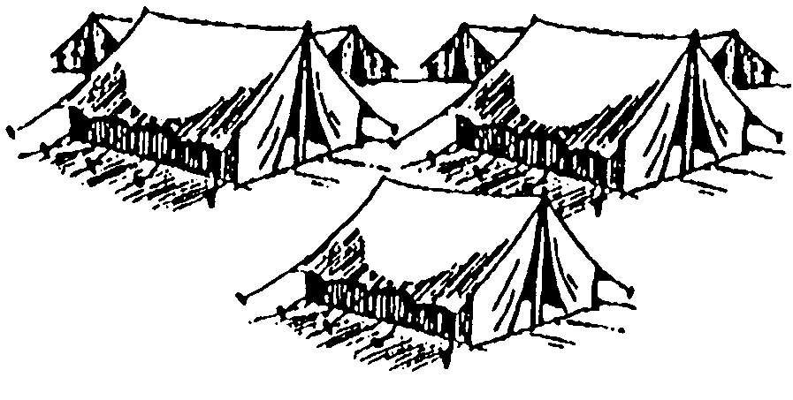  La tente-dortoir  sleeping tent | 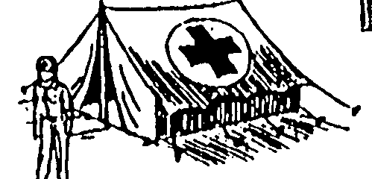  Le poste de secours  first-aid station
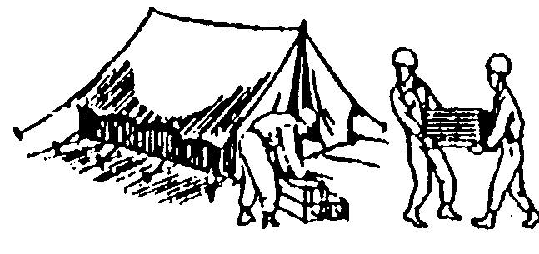  Le dépôt  depot |  |   Le centre de transmissions  communication center
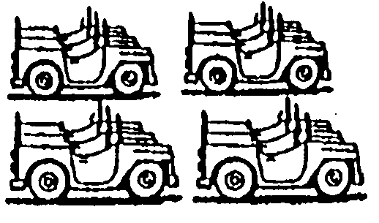  L’aire de stationnement et d’entretien  motor pool | ENTRÉE |   Le poste de commandement command post

Exercise 4 (Pair Work)

Fill in the blanks with the proper direction (placement) and then tell your partner where each base camp location is situated.

Example: Le poste de secours est derrière le centre de transmissions.

- La cuisine roulante est à gauche de la tente-dortoir.
- Le poste de secours est à droite de la tente-dortoir.
- Le dépôt est devant la cuisine roulante.
- Le centre de transmissions est entre le poste de commandement et le poste de secours.
- Le dépôt est en face du centre de transmissions.

Exercise 5 (Class Work)

Discuss and list the important accommodations for a simple base camp other than the one given earlier. Write them on the board and classify them according to their importance.

Exercise 6 (Pair Work)

Working with a partner, analyze the following schema which depicts a general base camp. Write French meanings of them on the table below. Compare your answers with those of your classmates.

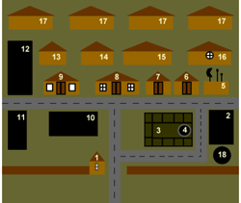

Exercise 7 (Pairs)

Imagine that you are at a Senegalese military post. Answer the questions below after your instructor reviews the key vocabulary.

- Your friend is slightly injured. Where does he need to go to get medical treatment?

- You would like to buy a pack of cigarettes. Where would you go?

- You will observe the military training tomorrow. Where will this training most likely take place?

- Where would you report a disturbing military message?

- You are looking for Captain Fall. He is on lunch break. Where do you think he is most likely to be found?

Articles of clothing

Vêtements pour hommes:
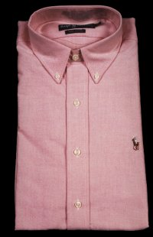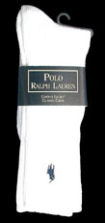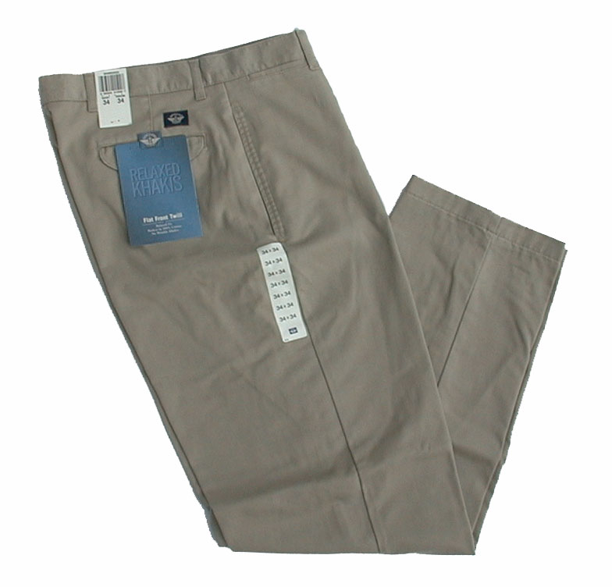
une chemise des chaussettes un costume un pantalon

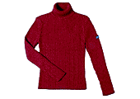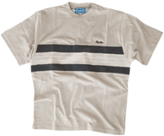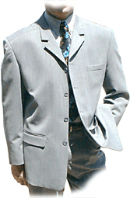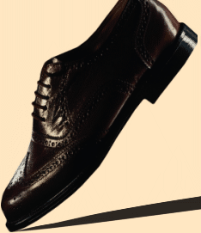
un pullover un T-shirt une veste des chaussures une cravate

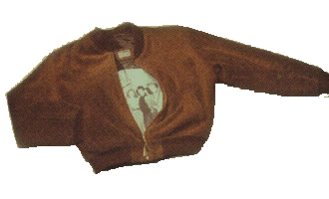
un blouson (cuir) des tennis un short

Vêtements pour dames / femmes:
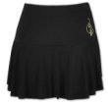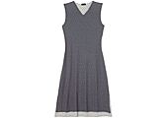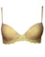
une jupe un maillot de bain une robe un soutien-gorge

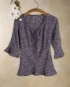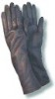
un chemisier des gants

Here are some more clothing words that are common but can be very tricky. For example, some are gender specific or may be singular in French but plural in English.

- bien habillé (e)
- *un calçon = boxer shorts

une ceinture
- *une culotte = sous-vêtement féminin
- enfiler sa robe
- des fringues = clothes / gear
- un imperméable

*un jean = jeans / plural in English, singular in French

un manteau
- *mettre = to put on
- *porter = to wear / [er] verb
- *s’habiller = to dress (oneself) / reflexive verb

*les sous-vêtements = underwear
- *un survêtement = jogging suit / sweatsuit
While this lesson deals more with military clothing in the vocabulary section, Lesson 7 will introduce you to more clothing vocabulary and verbs to use for bargaining. Look ahead for further explanation and additional words to include in the exercises to follow.
Exercise 8

Pack your suitcase for a vacation! What would you bring to wear for each of the following destinations?

- une semaine à la plage à Hawaii
- une semaine de ski au Colorado
- une semaine à Paris au printemps
- deux semaines à New York en hiver
- trois semaines de vacances à votre endroit préféré

Exercise 9 (Pair Work)

Describe one of the images given below. Your partner should guess which image you are describing by pointing to it and indicating that this is the right article / image. If his guess is right then it is his turn to describe another image.


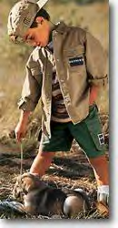
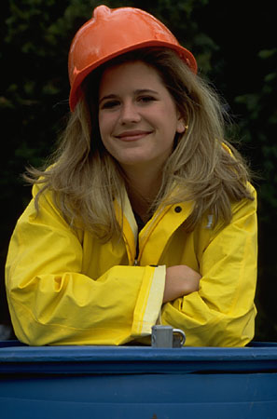

Modèle: Cette personne porte...

Exercise 10 (Pair Work)

Discuss with your partner where you usually buy the articles of clothing introduced on the previous page and say which item you would like to have. Make a list as you tell your partner.

State clothing needs

Les tailles—to talk about size:

La taille size (clothes)
Je fais du 38. I’m a size 38.
Je porte du 38.
Je cherche un 40. I’m looking for a size 40.
Une chemise taille 15 a size 15 shirt
La pointure size (shoes)
Un pair de chaussures en 42 a size 42 pair of shoes
Je chausse du 39. I’m a size 39 (shoes)
Ça me va bien. It fits me well.

C’est trop serré. It’s too tight.
⇨ trop grand. …too big.
⇨ trop court. …too short.
⇨ trop long. …too long.
Il me faut la taille en dessus I need the next size up.
⇨ la taille en dessous …next size down.
Matériaux: (en) cuir leather
(en) coton cotton
(en) laine wool

Quelle taille faites-vous? What size are you?
Quelle pointure faites-vous? What size shoe do you wear?
Avez-vous une taille 40? Do you have a size 40? (app. 30/men, 8/women)
Avez-vous ce modèle en 40? Do you have the same thing in a size 40?
Avez-vous ce modèle en plus grand / plus petit ? Do you have the same thing in a larger / smaller size?
Exercise 11 (Pairs)

A. Formulate questions about the size and color of a certain article of clothing using the cues. Take turns and write the questions in the blanks provided. Number 1 has been done for you as an example.

1. in black/my Vous avez ma taille en noir?

2. in white/his _________________________________________
3. in gray/her _________________________________________
4. in brown/his _________________________________________
5. in khaki/my _________________________________________
6. in blue/her _________________________________________
7. in green/my _________________________________________
8. in yellow/her _________________________________________
10. in orange/my _________________________________________
11. in red/his _________________________________________

B. With your partner, use your written questions from Part A. and now use other expressions to ask about size. Be more specific with sizing and/or material. Your partner will answer with a “yes” or “no” answer.
Example: Ce n’est pas à ma taille […]. Avez-vous une taille […] en noir? Non, nous avons votre taille en bleu.
Men’s Suits & Overcoats |  | Men's Trousers
USA | France | US | France
36 | 46 | 28 | 71
38 | 48 | 30 | 76
40 | 50 | 32 | 81
42 | 52 | 34 | 87
44 | 54 | 38 | 97
 |  | 42 | 107
 |  | 44 | 112
Men's Shirts: Collar size
14.5 | 37
15 | 38
15.5 | 39
16 | 41
16.5 | 42
17 | 43
17.5 | 44
18 | 46

Military clothing

TENUES DE COMBAT

Casque
Ceinturon
Pantalon de treillis
Brodequins

Veste de combat

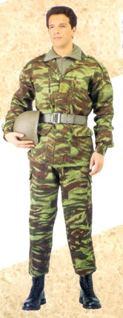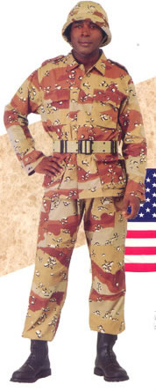

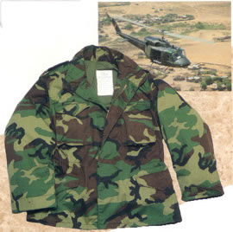

TENUE DE SORTIE
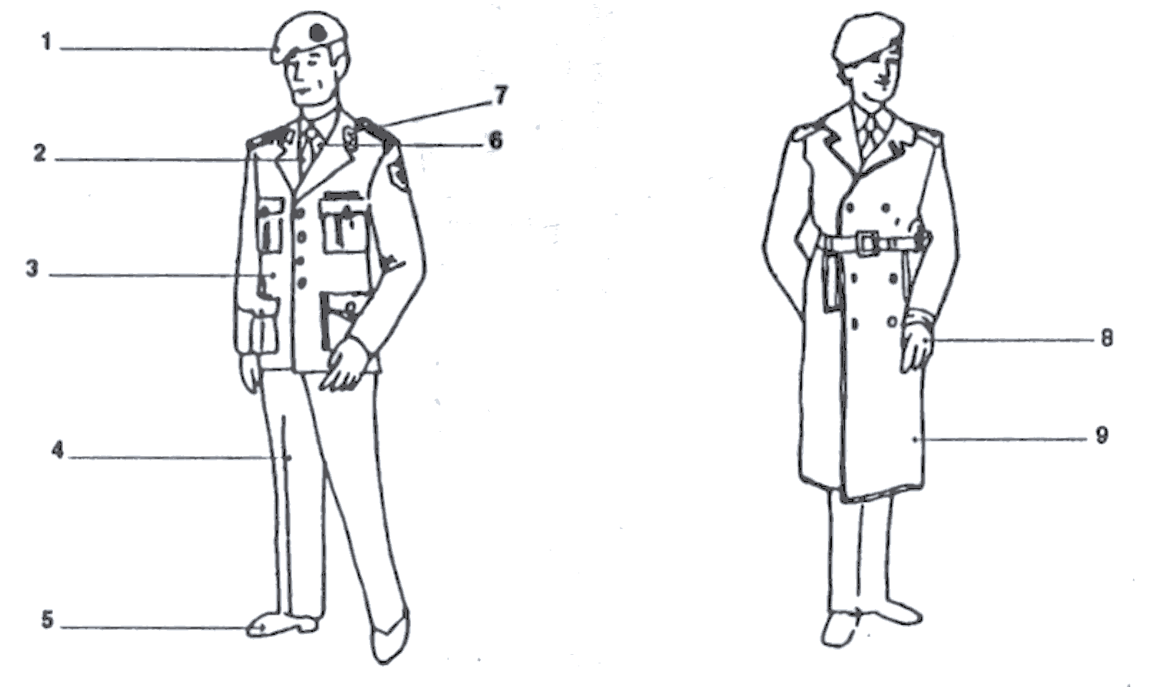

Pantalon 4 Béret 1 Imperméable 9 Insigne 7 Gants 8
Chaussures 5 Veste 3 Chemise 6 Cravate 2

Exercise 12

What do the following soldiers need? Look at the pictures and answer the questions.

1. Il a besoin d’un béret et d’un ceinturon.

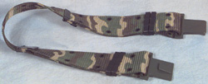

2. Il a besoin d’un casque et d’une veste de treillis.
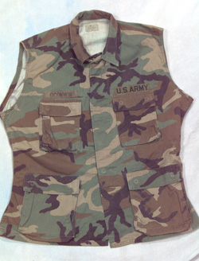

3. Il a besoin de brodequins et d’une insigne.

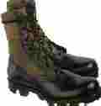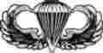
- Il a besoin d’une cravate et d’un pantalon de treillis.
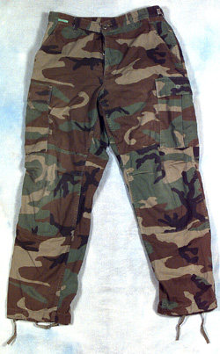
- Il a besoin d’une tenue de sortie.

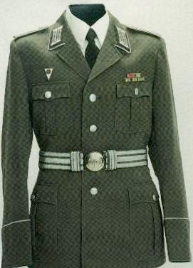

Exercise 13 (Pair Work)

Each one of you will write key words under each image below. Once you are done, you will compare it with your partner by asking each other how you described a certain image (use the key words to form a full sentence). Remember to use colors, sizes, and textures.

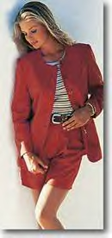
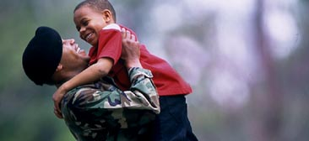

_________________ _________________ _________________
_________________ _________________ _________________
_________________ _________________ _________________
_________________ _________________ _________________

Supplies

Qu’est-ce que nous emportons en mission?

Des provisions:
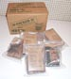  des vivres |   des médicaments | 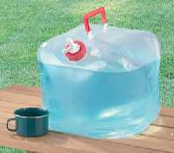  de l’eau potable | 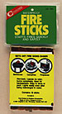  des torchères
de l’équipement:
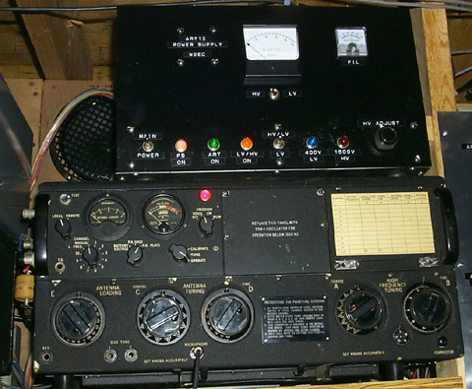  des postes émetteurs | 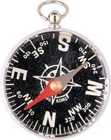  une boussole | 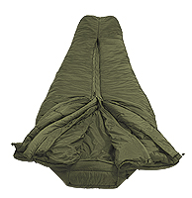  un sac de couchage | 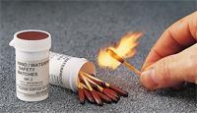  des allumettes
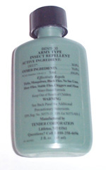  de l’insecticide | 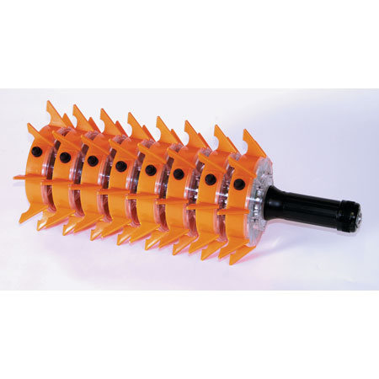  une fusée éclairante | 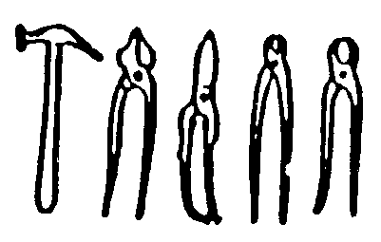  des outils | 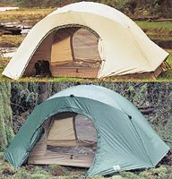  des tentes
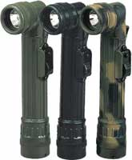  des torches électriques | 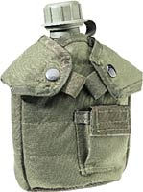  une gourde/un bidon | 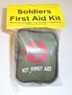  une trousse de premier secours | 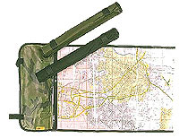  une carte
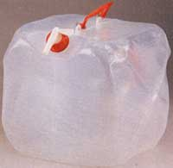  un cubis/un bidon | 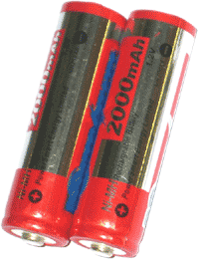  des piles | 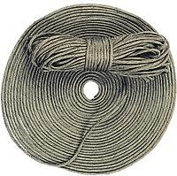  des cordes | 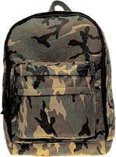  un sac à dos
des armes: |   des explosifs | 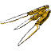  des couteaux |   des munitions
Exercise 14 (Class Work)

Indicate with a number the category that each item belongs to.

1 = provisions 2 = équipement 3 = armes

eau potable  munitions  postes émetteurs  boussoles  sac de couchage  allumettes  insecticide  fusées éclairantes  explosifs  outils  tentes | 1  3  2  2  2  2  2  2  3  2  2 | piles électriques  bougies  trousse de premiers secours  cartes  médicaments  couteaux  piles  cordes | 2  2  2  2  1  3  2  2

Exercise 15 (Pair Work)

You are preparing for a mission. Tell each other the things you will need by pointing at the following ten things and saying what they are. Begin with: On a besoin de…
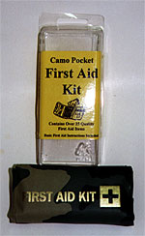
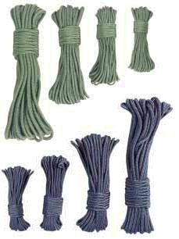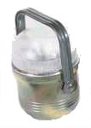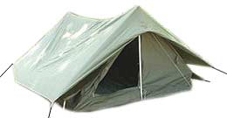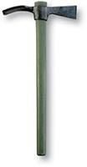

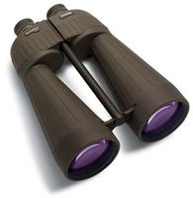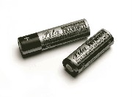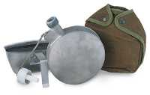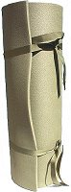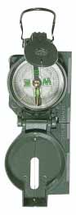

Tip of the day: Poisson d’avril

The French came to call April 1 Poisson d'Avril, or “April Fish.” French and francophone children sometimes tape (very discreetly) a picture of a fish on the back of their schoolmates, crying “Poisson d'avril” when the prank is discovered. There are of course adult adaptations of poisson d’avril shenanigans. For example, the media may announce an outlandish report and later reveal the truth.
For Homework Activity 4 think about how the tricks played on American April Fool’s Day are similar to “Poisson d’avril.”

Exercise 16 (Class Work)

Your unit is sponsoring a summer camp for Senegalese children ages 6 through 12. Your task is to set the kids up with camp essentials. Pretend that the parents are present and hold a group discussion. For the English topics listed below, conclude with a logical answer. Follow the French model to begin.
- Discuss the items they need to bring: Les enfants doivent apporter …

- They will be provided with some basics at camp: Les enfants vont recevoir…

- Some items are definitely not to be used: Les enfants ne doivent pas utiliser…

Exercise 17

Match each term with its sigle (acronym). Be logical and use any and all terms to help you figure it out! Share your answers with the class.

- Poste de commandement P.C. | P.M.F
- Ration de Combat Individuelle Réchauffable R.C.I.R. | P.C.
- Véhicule Léger V.L. | P.I.F.
- Appareil Normal de Protection à Visière Panoramique: un masque à gaz A.N.P.V.P. | R.C.I.R.
- Point à atteindre - Itinéraire – Formation P.I.F. | B.A.B.
 | V.T.L.R
 | A.N.P.V.P.
 | V.L.

Prepositions of place
Remember that prepostions like devant or entre are invariable (one form) with the exception of contractions with à and de. When prepositions contract with articles like le, la, l’, or les, the main word remains the same—only the preposition à or de changes depending on the noun that follows.
Examples: Le café est en face de la poste. BUT L'épicerie est juste à côté de l'école. Many prepositions of place will not require a contraction: La place est entre le café et la poste.
Exercise 1

Find the matching squares.

en face de | of / from | near | de
behind | sans | envers | without
facing / opposite of | devant | près de | in front of
derrière | toward | on | sur

Answers: derrière → behind, sur → on, devant → in front of, de → of / from, en face de → facing / opposite of, près de → near, sans → without, envers → toward.
The verb porter (to wear)

This verb is regular and is conjugated as follows:

Je porte  Tu portes  Il/elle/on porte | Nous portons  Vous portez  Ils/elles portent

Exercise 1

Take a few minutes to read the following passage about how to dress for an interview. As you read, practice difficult sounds such as, “rend” or “habillée” and underline words that use “porter”. Your instructor will ask someone to read this passage aloud and discuss the advice given.

Tout le monde se demande ce qu'il faut mettre pour se présenter à un entretien d'embauche. Faut-il impérativement que vous endossiez le costume-cravate, alors que vous n'en portez pour ainsi dire jamais ?
Quelle que soit la tenue que vous portez, pensez à vous sentir à l'aise dans vos vêtements. Si porter une cravate vous rend fou, abandonnez l'idée et portez simplement une chemise habillée.

Aire de stationnement et d’entretien (n.f)  Allumette (n.f)  Approvisionnement (n.m)  Arme (n.f)  Bidon (n.m)  Bottes (n.f.pl)  Bougie (n.f)  Boussole (n.f)  Brodequins (n.m.pl)  Casque (n.m)  Ceinture (n.f)  Ceinturon (n.m)  Caisse de munitions (n.f.pl)  Carte (n.f)  Centre de transmission (n.m)  Corde (n.f)  Couteau (n.m)  Cuisine roulante (n.f)  Dépôt (n.m)  Emporter (verb)  Équipement (n.m)  Explosif (n.m)  Fusée éclairante (n.f)  Infirmerie (n.f)  Insecticide (n.m)  Jumelles (n.f)  Lampe électrique (n.f)  Mât (n.m)  Médicament (n.m)  Munitions (n.f.pl)  Outil (n.m)  Pile (n.f)  Piquet (n.m)  Poste de commandement (n.m)  Poste de secours (n.m)  Poste émetteur (n.m)  Provision (n.f)  Sac à dos (n.m)  Sac de couchage (n.m)  Taille (n.f)  Tente (n.f)  Tenue de combat (n.f)  Tenue de sortie (n.f)  Trousse de premier secours (n.f)  Véhicule (n.m)  Vivres (n.m.pl.) | Motor pool  Matchbox, matchstick  Supply, provision  Weapon  Can, Bottle, flask  Boots  Candle  Compass  Boots  Helmet  Belt  Uniform belt  Ammunition crate  Map  Communications center  Rope  Knife  Field kitchen  Depot  Bring along  Equipment  Explosive  Flare  Infirmary  Insecticide  Binoculars  Flashlight  Mast, pole  Medication  Ammunition  Tool  Battery  Post, picket, tent pole  Command post  First-aid station  Transmitter, transmitting set  Provision  Backpack  Sleeping bag  Size, waist  Tent  Combat uniform  Dress uniform  First-aid kit  Vehicle  Food, supply

Ajouter (verb)  Arbre (n.m)  Armurier (n.m)  Béret (n.m)  Camion (n.m)  Camouflage (n.m)  Camp de base (n.m)  Camp d’entraînement (n.m)  Cantonnement (n.m)  Cantonner (verb)  Casquette (n.f)  Constater (verb)  Constituer (verb)  Désordre (n.m)  Dormir (verb)  Dortoir (n.m)  Endroit (n.m)  Gourde (n.f)  Malade (adj.)  Matelas (n.m)  Mission (n.f)  Moisir (verb)  Mouiller (verb)  Ombre (n.f)  Ordre (n.m)  Paillasse (n.f)  Papier hygiénique (n.m)  Pardessus (n.m)  Pelle (n.f)  Pluie (n.f)  Porter (verb)  Protéger (verb)  Ranger (verb)  Rendre Compte (verb)  Réquisitionner (verb)  Sol (n.m)  Tente-dortoir (n.f)  Torche de poche (n.f)  Veste de treillis (n.f) | To add  Tree  Gunsmith, armourer  Beret  Camion  Camouflage  Base camp  Training (boot) camp  Stationing, quartering, billet  To station, to quarter  Cap  To notice, to come to one’s attention  To constitute  Disorder, disorganization  To sleep  Sleeping quarters  Place  Flask  Sick  Mattress  Mission  To mould  To wet, to moisten  Shadow, shade  Order  Straw mattress  Toilet paper  Overcoat  Shovel  Rain  To wear  To protect  To put away, to tidy  To report  To requisition  Ground  Communal sleeping tent  Flashlight  Combat jacket

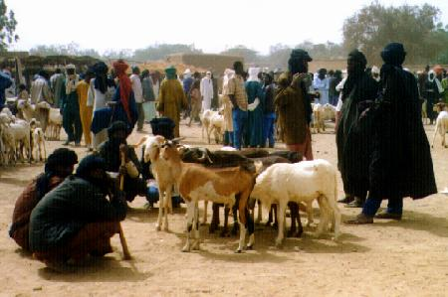
A cattle market

Livestock markets

While markets in Africa are a mixture of vendors displaying all sorts of goods, livestock markets are the exception and are highly specialized. Livestock markets usually feature goats, sheep and cattle. Even though chickens and other birds are classified as livestock, they are not sold in livestock markets. Livestock markets are usually situated on the outskirts of towns and villages or in a big open space within the city where the livestock can be accommodated, especially on the eve of certain holidays, such as Tabaski, when the number of livestock increases.

As in a regular market, there is a head of a livestock market, elected by his peers, who is in charge of managing the everyday issues facing his community. He also serves as a liaison between the sellers and the municipal authorities. Livestock markets are less stable than ordinary markets in terms of sellers and how often the seller attends the market. Most of the people who bring their animals to the livestock markets are not regular sellers. They are present once in a while and then go back to their farms or ranches. However, there are middlemen who are regular faces in the market and who try to make a living out of negotiating a price for buyers for a fee. These middlemen may take advantage of a desperate seller who had only come to town for the day and wants to get rid of his animals to return home. Often middlemen offer to buy stock or crops at prices far lower than they would get if the farmers traveled to market themselves. Because of this, both buyers and sellers hate the middlemen who are exploitative. Consequently, many sellers come to the livestock markets only when they are desperate and cannot find buyers elsewhere. Sometimes, buyers try to intercept sellers on their way to town before the latter are appraised of the ongoing price in the local market and before market fees drive the prices higher. Since most municipalities confine the selling of animals in designated livestock markets, the middlemen, in their turn look for violators and report them to the competent authorities. New technology such as the cell phone help collectors who can log market prices for farmers that have no way of finding out the prices before they travel to the market, or even if their crop is in short supply at a particular place.
Activity 1

In which facilities are the following pictures taken?

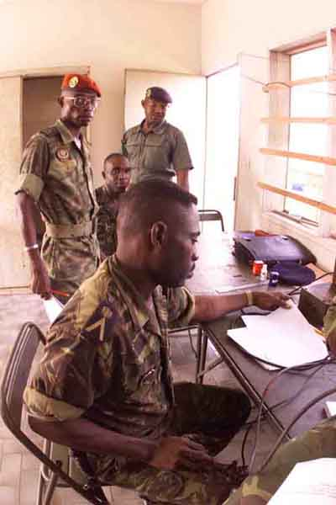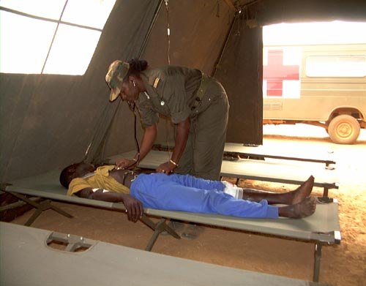
un centre de transmissions un poste de secours

Activity 2

Your instructor will read aloud either a sentence or a question, each of which contains a new word from this lesson. Mark the correct English equivalent for each of them and share your answers with the class.

1. a. supply room
b. communication center
c. command post

2. a. motor pool
b. training area
c. classroom

3. a. mess hall
b. hospital
c. barracks

4. a. field kitchen
b. vehicles
c. provisions

5. a. radio equipment
b. sleeping bag
c. ammunitions

Activity 3

Listen to the following questions (read by your instructor) and mark the most appropriate answer to each of them. Be prepared to repeat the question.

1. Quand est-ce que le détachement A a besoin de fusées éclairantes?
- when wanting to signal its location
- when trying to read a map at night
- when celebrating the birthday of an officer

2. Quand est-ce que le détachement A a besoin d’un poste émetteur?
- when looking for entertainment
- when setting up camp
- when relaying a message

3. Quand est-ce que le détachement A a besoin de cordes?
- when roping down
- when doing the laundry
- when marking a campground

4. Quand est-ce que le détachement A a besoin d’une trousse de premier secours?
  - when visiting someone in the hospital
  - when they have run out of water
  - when helping an injured soldier

5. Quand est-ce que le détachement A a besoin d’allumettes?
- when lighting a fire
- during a cease fire
- when they are under fire

6. Quand est-ce que le détachement A a besoin d’une carte?
- when evading the enemy
- when provisions are not readily available
- when they are lost

Activity 4

Your instructor will choose one person to play Amadou and another to act as John. The rest of the class will listen to their classmates as they discuss mission supplies. Fill in the blanks in the transcript.
A: Alors, tu emportes des munitions, des explosifs, et des fusées éclairantes?
J: Oui, et des allumettes et une boussole aussi. Et toi, qu’est-ce que tu emportes?
A: Moi, j’emporte des piles et de l’eau potable. De quoi d’autre avons-nous besoin?
J: D’une trousse de premiers secours et d’une carte.

Activity 5

Fill in the blanks with the proper vocabulary. Prepare oral responses.

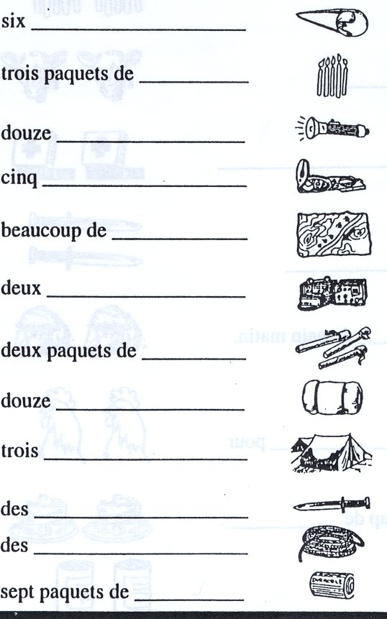

Activity 6

What are the Senegalese soldiers pictured below setting up? Answer with a complete sentence in French. Ils établissent un camp/ils dressent une tente. Next describe the scene for the class with at least 7 sentences. Talk about attire, setting, etc.

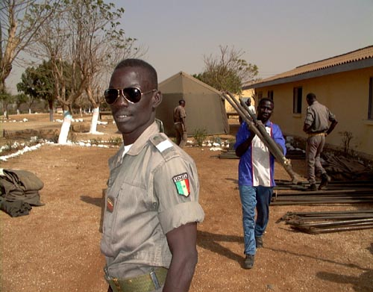

Activity 7

Pair activity. Civilian Clothing. Take turns in describing what one of the following people is wearing. Your partner has to guess which picture you are talking about. Don’t forget to mention the colors. For a more comprehensive vocabulary list, look ahead at Lesson 7. Brief the class about your findings with respect to each one of the pictures. Be creative!
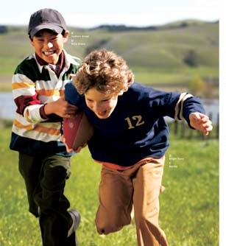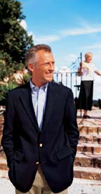

Activity 8 (Pair Work)

Look at the following list of supplies and together with your partner decide which team member uses which item. Write the number of the team member in the blank space next to the item. If an item is used by the entire team, write T next to it. Discuss your findings with the class.
eau potable  munitions  poste émetteur  boussoles  sacs de couchage  allumettes  insecticide  cartes  médicaments  couteaux  trousse de premiers secours  fusées éclairantes  explosifs  outils  tentes  torches électriques  bougies  piles  cordes  bidons | - chef de détachement  - technicien et sous-chef de détachement  - sergent des opérations  - premier spécialiste en armement  - sergent des renseignements  - second spécialiste en armement  - infirmier-chef  - spécialiste en transmissions  - sapeur-chef  - infirmier  - radio  - sapeur

Activity 1

Read the following note from John to Amadou to prepare for a mission. Then list which items they already have or can readily obtain (ils ont déjà) and which ones they still need to obtain (ils ont besoin).

Amadou,
Nous avons déjà beaucoup d’équipement: nous pouvons nous procurer une tente et des sacs de couchage à l’approvisionnement, et des médicaments et une trousse de premiers secours aussi. Peux-tu réquisitionner des piles? (Sinon, nous devons acheter des torches). Je dois toujours trouver des outils. J’ai déjà un poste émetteur et des explosifs. Nous pouvons acheter de la viande dans une ferme. Peux-tu emporter de l’insecticide, des cartes, et une boussole? Merci.
John.

Ils ont déjà…. Ils ont besoin de…
une tente, des sacs de couchage, des medicaments, une trousse de premiers secours
des piles électriques, des outils, de l’insecticide, des cartes, et une boussole

Activity 2

Pair activity. You are about to go on a mission with your partner. You are restricted to three items each from the following. Decide what items you will take along and explain why.
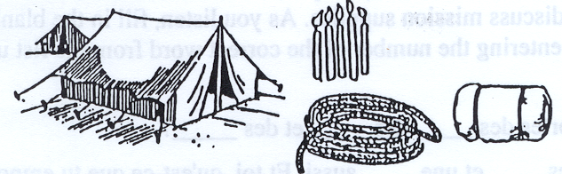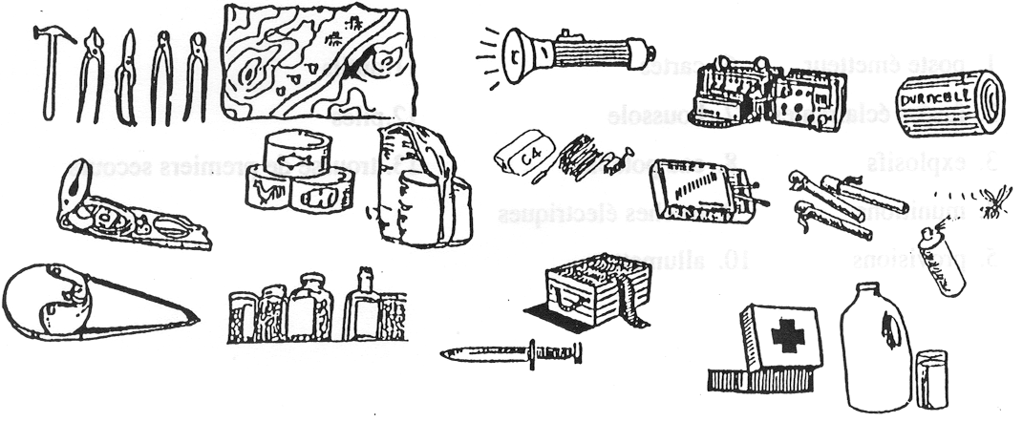

Activity 3

Pair activity. Work with your partner to find the logical connection between the supplies listed under A and the additional items listed under B needed to operate or make use of them.
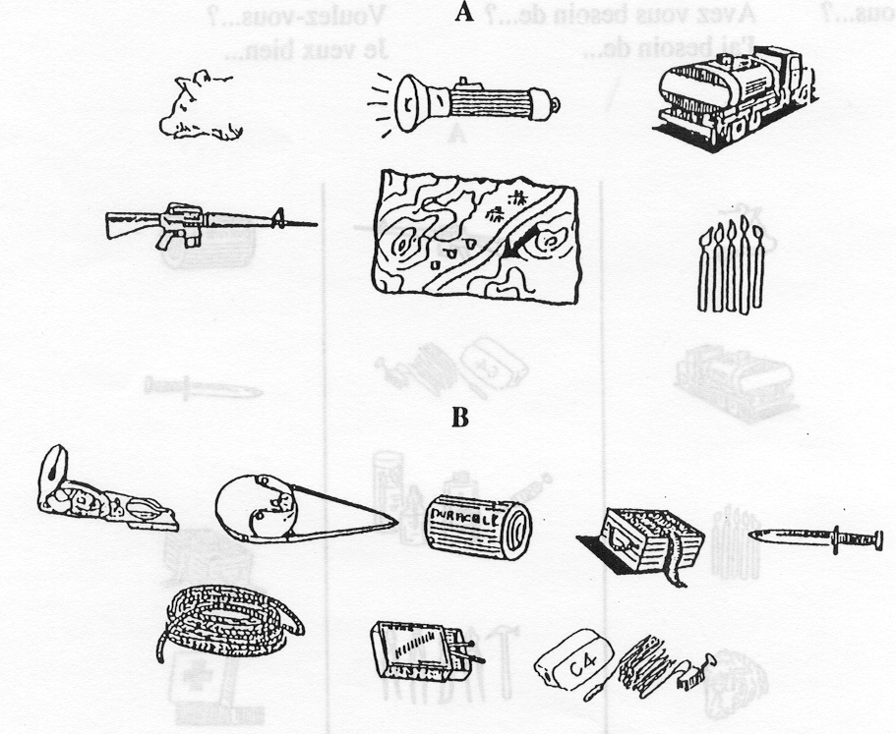

Activity 4

Pair activity. The lieutenant gives an order to the sergeant on where to set up camp facilities in relation to each other. The sergeant draws a map as the lieutenant describes how he wants the camp set. Role-play the situation for the whole class.

Pair Activities, Student A

Activity 5

You and your partner are in charge of getting the items you need to set up the base camp. This is what you already have. Check what your partner has, and make a list of what you are missing.

Activity 6

You are the driver of a supply truck. Since you are not certain about the destination, ask the person in charge [your partner] where to go and name at least 3 items for each destination.
Model:
Driver: Il faut apporter des couteaux au poste de secours? = Should / must we bring the knives to the first aid station?
Soldier: Non! On doit en apporter à la cuisine roulante!

- à l’aire de stationnement et d’entretien

à la cuisine roulante
- à la tente
- au centre de transmissions
- au dépôt de munitions
- au poste de commandement
- au poste de secours

Pair Activities, Student B

Activity 5

You and your partner are in charge of getting the items you need to set up the base camp. This is what you already have. Check what your partner has, and make a list of what you are missing.

Activity 6

You are in charge of directing the supply trucks to their destination at the base camp. Use the following checklist to answer the driver’s questions [your partner] who will name at least 3 items for each destination.
Model:
Driver: Il faut apporter des couteaux au poste de secours? = Should / must we bring the knives to the first aid station?
Soldier: Non! On doit en apporter à la cuisine roulante!

- à l’aire de stationnement et d’entretien

à la cuisine roulante
- à la tente
- au centre de transmissions
- au dépôt de munitions
- au poste de commandement
- au poste de secours

*Note to the instructor: Have students formulate questions as a class activity before partner exercise. Comment on article usage like: on doit y aller / on doit en/les apporter.

Activity 1 Track 42

CD. You will hear soldiers come into the supply room to pick up or exchange various uniform items. Write the number of the item and the correct size for each rank.

Grade | Uniform | Taille/Pointure
lieutenant | 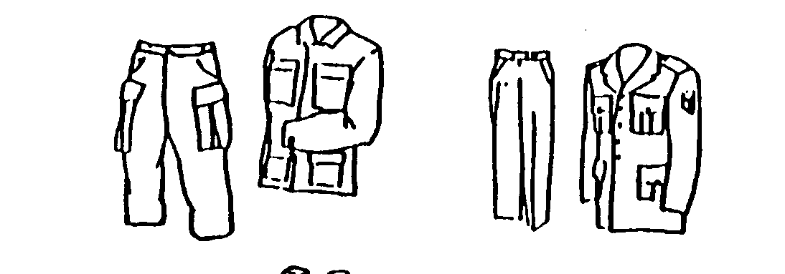 | 60, 52
capitaine | 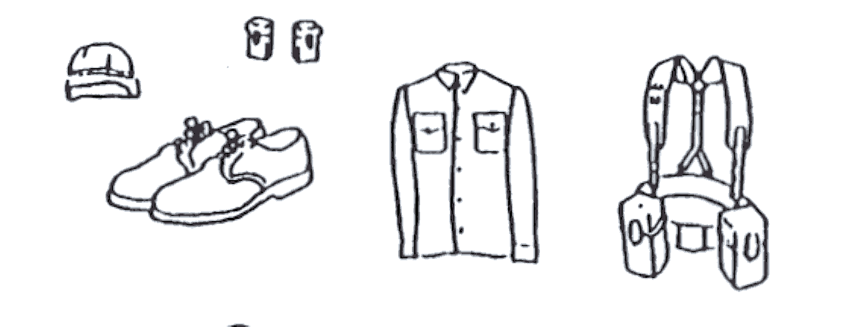 | 41, 58
commandant | 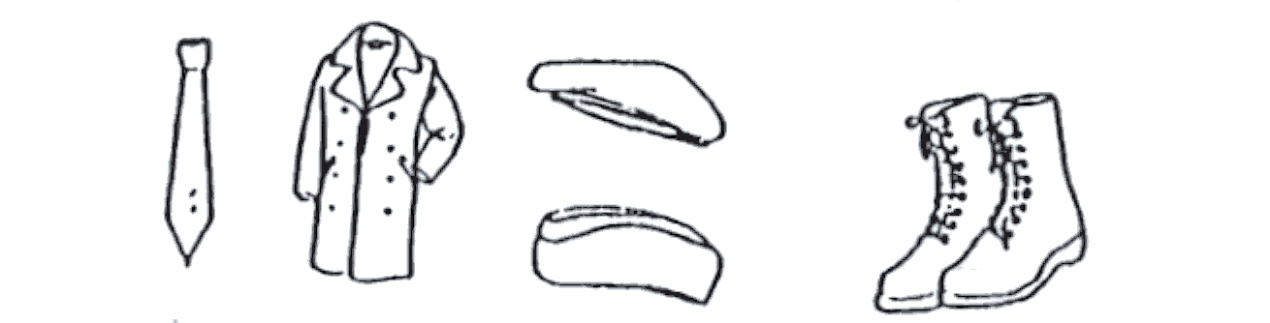 | 41.5
sergent | 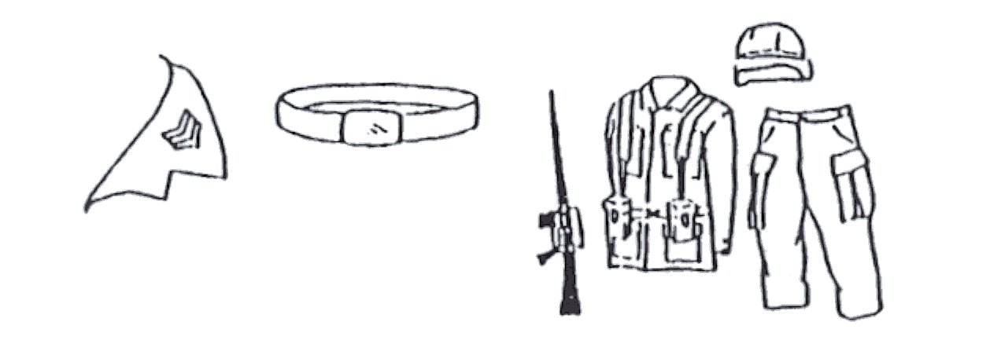 | 56, 48

Activity 2

Read the following excerpt from a letter describing a base camp and answer the questions.

from Les Commandos de France, by Maja Destrem. Paris: Fayard, 1982.

1. Quels sont le grade et la spécialité de Dubard? Capitaine, médecin
2. Combien de tentes y a t-il dans le cantonnement? 80
3. Est-ce qu’il y a des arbres au cantonnement? Non
4. Combien de mètres y a-t-il entre chaque tente? 1
5. Est-ce qu’il fait froid ou chaud dans les tentes? Chaud et humide
6. Comment sont les mattes et les paillasses? Mouillées et moisies
7. Est-ce que la cuisine est en bon état? Non

Note to the instructor: Before students read this document, you may want to review terms such as nattes versus mattes (en botanique).

Activity 3 Track 43

CD. Listen to Khady describing a base camp and sketch it. Label the buildings and place of each one. Use your vocabulary list to help you. Be prepared to discuss in class the next day.

Activity 4 Track 44

CD. Some jokers set up camp on April 1st, and nothing is where it is supposed to be. Listen to the report and match each item with its present location by drawing a line.

1. Telephone g  2. Food supplies a  3. Ammunition crates f  4. Sleeping bags c  5. Radio equipment d  6. Medical supplies  7. Toilet paper b  8. Fuel e | a. Command post  b. Field kitchen  c. Depot  d. Sleeping tent  e. Communication center  f. First-aid station  g. Latrine  h. Pool

Activity 5

Your team is getting ready to go on a mission. Make a list for your Senegalese colleague of the supplies you need to set up a base camp and mark the items that are of primary importance. As you scan the list, highlight any items that may not be readily available based on past conversations with your colleague. Prepare a few short sentences in French to demonstrate what you have learned from your Senegalese colleague. For example, how much new information did you learn about the mission terrain? What difficulties are you and your team likely to encounter as you set up the base camp?
Activity 6

Match the photo with the correct vocabulary word dealing with essential supplies.

Chargeur piles
Lampe Torche | 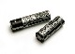
Piles | 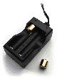
Pochette pour lampe torche | 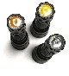
Led pour lampes torches | 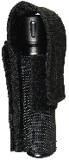
Réflecteur | 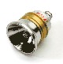

Activity 7

Be ready to order from the Senegalese army’s supply room what you need to set up a base camp. Remember greetings and how to address someone before you place your order.

Activity 8

In English, make a detailed list of the pros and cons of civilian and military clothing. For example, seasons affect both military and civilian clothing needs. Choice is a pro for most civilians but lack of choice (already decided for you) could be a pro listed under military clothing. After you have completed the list, write 3 French adjectives or nouns next to each pro and con. Be ready to discuss your list and opinions in class.

Activity 9

Look over each coat of arms pictured below. How are they similar? And/or different? Do you recognize any words from other lessons? The first bearing represents what country? Write a few French sentences that describe each of these and in English, give your assessment of the importance of each item. Be prepared to share your findings with the class.


