SOLT French Module 1 Lesson 5
Student Manual

signes particuliers :
un gros pif, barbu,

des cheveux blancs,

très optimiste

Personal Characteristics

At the end of this lesson, you will be able to talk about personal and physical characteristics and emotional states.

Describe Physical Traits of People

- Describe characteristics of an individual
- Identify stereotypes of the people from French-speaking Africa
- Express emotions

Scenario:

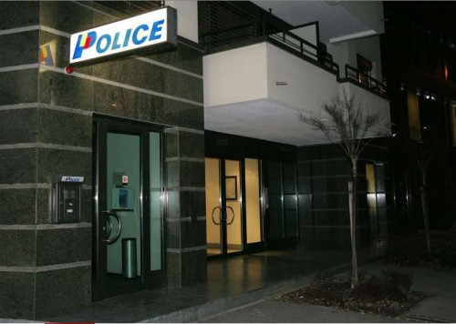

Amadou gives a physical description of a thief who snatched his wallet. Read his account to the local police and look up the italicized words or expressions. For verbs, only look up the infinitive forms for meaning. Be prepared to summarize what happened to Amadou and what the thief looks like. Your instructor will ask 2 students to role-play the scenario.
*Note to the instructor: write out meanings for the imperfect and explain to the students that this will be studied later. This scenario is for comprehension of physical attributes.

Policier: Bonjour Monsieur, puis-je vous aider?
Amadou: Oui, je viens de me faire voler mon portefeuille.
Policier: Est-ce que vous avez vu le voleur?
Amadou: Oui, c’était un jeune homme d’une trentaine d’année, avec un survêtement bleu marine et des lunettes.
Policier: Etait-il blanc, noir? avec des signes particuliers?
Amadou: Il était blanc, avait une barbe noire et des cheveux blonds. Je n’ai pas vu ses yeux à cause des lunettes. Il avait également une cicatrice sur le front. C’est tout ce dont je me souviens.
Policier: Je vois, celà correspond à un voleur qui nous a été déjà signalé. Je vais voir ce que je peux faire. Restez-là, je vais chercher un album photos des criminels que nous avons déjà arrêtés. Peut-être reconnaîtrez-vous le vôtre?
Amadou: D’accord. Je vous attends.

Tip of the day: the Toucouleurs

In general rule, it is easy to distinguish one ethnic group in Africa from another by the physical characteristics of its members. During the colonial period French authorities in West Africa had relied on these external features, with great accuracy, to identify their subjects. However, they were unable to categorize the Pulaar ethnic group because of the diversity in complexion, height, and corpulence that characterizes these people. Faced with that bafflement, the French decided to give them the name Toucouleur (all colors in French) to express their inability to identify them by their complexion. This name is still being used in present independent Africa to refer to some members of the Pulaar ethnic group even though most natives prefer to be called Fulbe or Pulaar.

Part of being fluent in a culture is being able to discern not only the personal and physical traits of the people in the host culture, but also being able to know how they describe themselves. Physical stereotypes have been with us for a long time and regardless of their subjective nature, form part of the way we portray others and ourselves. This lesson introduces you to words and expressions that are used to describe an individual’s physical traits as well as emotional states in French.

Describe Characteristics of an Individual: what they look like

Here are different ways to describe people and their physical traits. Pay close attention to the use of the verbs avoir and être.
- In French the definite article (le, la, l’, les) is generally used with parts of the body.
- In English, we use possessive adjectives.
Elle a les yeux bleus. = She has blue eyes. → Her eyes are blue.

LES CHEVEUX
*The noun “hair” is masculine plural in French and this is difficult for non-native speakers (we often hear native French speakers say, “hairs” when speaking in English!) and the adjective must agree:
- Il/elle a les cheveux bruns, blonds, noirs, roux, *châtain (brown/chestnut-haired)
*adjective châtain is invariable
- Il/Elle a les cheveux longs, courts (short), lisses (straight), bouclés (curly), frisés (wavy/frizzy)
- Il/Elle est brun (e) ou blond (e), roux (rousse). = He/She is a brunette, a blond, a redhead/redheaded

LES YEUX
- Il/Elle a les yeux noirs ou bleus, verts, noirs, gris, *marron
*adjective marron is invariable

LA TAILLE / LE POIDS La taille = height / Le poids = weight
- Il/Elle est grand (e), petit(e), de taille moyenne. Je mesure 1 mètre 75. = I am five feet 10 inches tall. Je pèse 65 kilos. = I weigh 143 pounds.

SIGNES PARTICULIERS
Il/Elle porte (wears) des lunettes ou des lentilles (de contact).
Il est chauve, est barbu, a une barbe, a une moustache, a une cicatrice (scar).
Il a les cheveux en brosse (crew cut).
Il a une brosse américaine. He’s got/he has a flattop.
Elle a un grain de beauté (beauty mark).
Il/Elle a des tâches de rousseur (freckles).

L’APPARENCE GENERALE
Il/Elle est mince (thin), maigre (skinny), gros (se) (fat/heavyset), faible (weak), fort (e) costaud (well-built), athlétique

 | 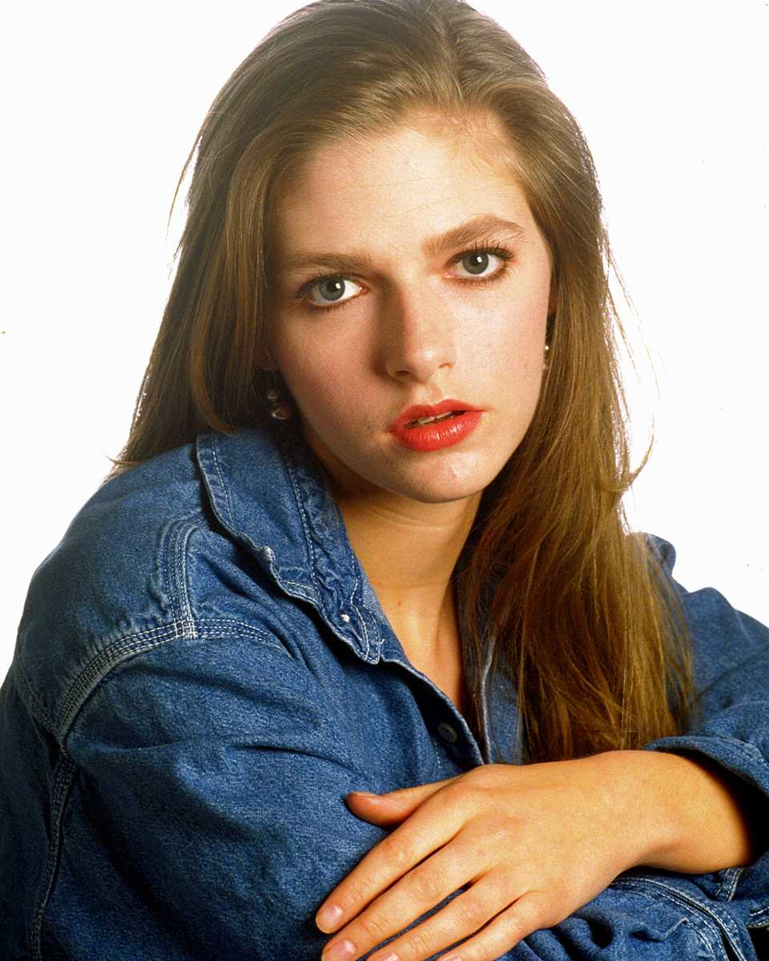 | 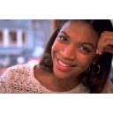
Elle a les cheveux blonds et les yeux bleus. | Elle a les cheveux châtain et les yeux verts. | Elle a les cheveux noirs et les yeux noirs.

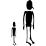 |  | 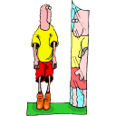
petit / grand | de taille moyenne, mince | mince / gros

Signes particuliers:
 | 
Il a une barbe et une moustache. | Il porte des lunettes.

Exercise 1

Give your auto-portrait with as much detail as possible about your physical appearance. Present your portrait to the class.

Exercise 2 (Pairs)

A friend (your partner) has invited you to go out with someone he has met recently. You want more details about this person. Find out more information from your partner. Role-play the situation for your class.

Exercise 3

Discuss the meaning of this French proverb: “Tu coupes les cheveux en quatre”. Is there an English equivalent? Hint: your partner in Exercise 3 could say this to you after you ask a lot of (too many) questions about your date. Discuss with your classmates.
You’re very finicky; you are splitting hairs.

Exercise 4 (Pair Work)

Describe the other members of your family to your partner, comparing yourself to them. Make sure to include physical appearance as well as personality traits.
Sample sentences: Mon frère, il est plus intelligent que moi. Mon fils, il est plus sportif que moi. Je suis plus actif que mes sœurs.

Exercise 5 (Pairs)

Show your partner a picture (real or imaginary) of someone. Identify that person (name, age, etc.) Describe his/her personality. Give a physical description as well.
Examples:
Il est vilain. Elle est agréable. Ils sont ridicules, etc.

Exercise 6 (Group Work)

Describe your 3 favorite people and your 3 least favorite people. Your instructor will move around the room quickly asking for your descriptions.
Tip of the day: How to make a question with avoir expressions
To ask a question with an avoir expression like “avoir besoin de” use the question word (interrogative pronoun) De quoi (est-ce que): De quoi as-tu besoin? De quoi est-ce que tu as besoin? Literally, of what do you have a need? = What do you need?
A simple, “what” doesn’t work in French since the preposition de/d’ must be included somewhere→avoir besoin de/d’.

Express Emotions, Needs, and Wants

John is homesick.

 | J’ai le mal du pays. J’ai envie d’un hamburger. J’ai honte, car j’ai besoin de parler à ma mère tous les jours. J’ai du mal à m’adapter au climat, j’ai chaud, j’ai sommeil, et j’ai soif. J’ai envie de rentrer à la maison. J’ai peur des hyènes. Je suis malheureux. | homesick  some trouble / a hard time adapting (myself)  go (back) home  hyenas
Vrai ou Faux?

1. John est très heureux en Afrique. F John est malheureux
2. Il aime les hamburgers. V/T
3. Il aime beaucoup le climat du Sénégal. F Il a du mal à s’adapter au climat

Read over these common ways to express emotions, needs, and wants. Your instructor will ask you to conjugate the infinitive forms; je suis impatient mais ma femme est très patiente. See the grammar section for more information.
être impatient(e) to be impatient
être content(e) to be happy
être heureux(/se) to be happy
être ravi(e) to delighted
être étonné(e) to be surprised
être mécontent(e) to be unhappy
être malheureux(/se)
avoir peur to fear
être triste to be sad
être surpris(e) to be surprised
Exercise 7 (Pairs)

Find a partner and fill in the chart below for him/her. Your partner will need to fill in or write down his own information beforehand. Share your “portraits” with the class.

CARACTÉRISTIQUES DU PERSONNAGE
Caractère | Qualité (s) et défaut (s) | Goût (s)
Apparence | Signes particuliers | Intérêts
Identify Stereotypes of the People from Africa

The following dialogue, in which two friends are talking about someone’s family, illustrates various stereotypes of members of a respected family. First read the dialogue to yourself and then practice it with your partner. Answer the 2 questions and discuss in groups of 4 or 5.
Ibou: D’où viens–tu Samba?  Samba: Je viens de chez Dieynaba.  Ibou: Tu connais donc Dieynaba?  Samba: Oui, je la connais très bien.  Ibou: Est-ce qu’elle est sérieuse?  Samba: Oui, c’est une fille très sérieuse.  Ibou: Est-ce que tu es familier avec son père?  Samba: Oui, c’est un homme très intègre.  Ibou: On dit qu’il est sévère.  Samba: Non. Il est très sympathique. Seulement il n’est pas bavard.  Ibou: Est-ce qu’il est pieux?  Samba: Il est très pieux.  Ibou: Comment est sa mère?  Samaba: C’est une femme très gentille.  Ibou: On dit qu’elle cuisine bien.  Samba: Oui, c’est une excellente cuisinière.  Ibou: On dit que son grand frère est brillant à l’école.  Samba: Oui, il est très intelligent et très studieux.  Ibou: Comment est son petit frère?  Samba: Il est paresseux et impoli.  Ibou: On dit qu’il n’étudie pas.  Samba: C’est un enfant gâté. | Know  People say  talkative  Pious  Nice  Cooks  Lazy / impolite  spoiled

Exercise 8

1. From the dialogue above, which qualities are valued in a man and in a woman?

2. How do younger siblings differ from the elder children in a typical family?

Avoir expressions
The verb avoir is used in the following expressions instead of the verb “to be.” French speakers also use avoir to ask and answer questions about someone’s age (see M1L6).
Words following “avoir” are nouns, not adjectives.

Avoir→How to say what someone or something looks like
Avoir l’air + adjective
Il a l’air fatigué. = He seems tired.
Tu as l’air malade. = You look sick.
*After “avoir l’air”, the adjective usually agrees with the subject: Marie a l’air heureuse.
BUT l’air is masculine singular.

Avoir→How to describe certain feelings and states
Avoir faim/soif
Avoir chaud/froid
Avoir raison/tort
Avoir peur
Avoir sommeil
Avoir de la chance

Avoir→How to describe needs and desires
Avoir besoin de + noun or infinitive
Avoir envie de + noun or infinitive

Être:

être malheureux (euse) être en colère être heureux (euse)
être triste être content (e)

Avoir:

 | 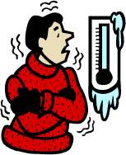 | 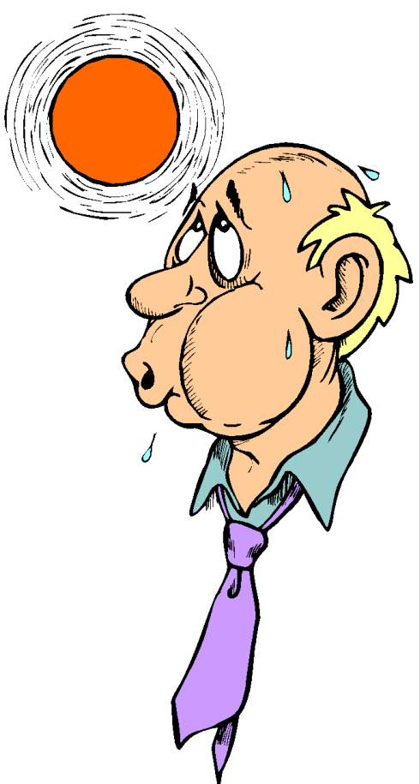 |  | 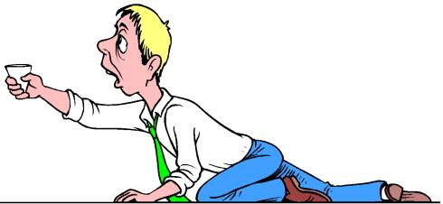
avoir peur | avoir froid | avoir chaud | avoir faim | avoir soif

Exercise 1

Fill in the blanks with the verb être or avoir.

- Elles sont heureuses.
- Jacques a peur dans le noir.
- Je/J’ai sommeil le soir.
- Nous avons soif et chaud dans le désert.
- Vous êtes en colère.
- Tu as froid en Alaska.

Exercise 2

Match the following pictures with the sentences that describe them.
1.2.  3. 4. 5.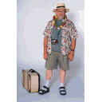 6. 7. 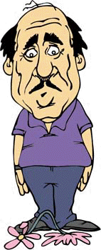

- J’ai les yeux bleus et les cheveux blonds. 2
- J’ai les cheveux noirs et je porte des lunettes. 3
- Je suis blonde, grande, et mince. 1
- J’ai une barbe. Je suis petit et gros. 5
- J’ai les yeux bleus et les cheveux bruns. 4
- Je suis de taille moyenne. J’ai les cheveux noirs et une moustache. 7
- J’ai les yeux noirs et les cheveux noirs. 6

Adjectives that precede AND follow the noun

In Lesson 3, you learned about adjectives that usually follow the noun they modify (une chaise noire, un livre intéressant, une femme américaine, etc.). You also learned about 10 adjectives like beau or bon that precede the noun. Other preceding adjectives include: long (ue) long, autre other, chaque each/every, and gros (se) fat, large.

*Here are some adjectives that can precede or follow the noun and can be used to describe people or things:
un certain regard/une victoire certaine a certain look/a certain victory
un brave homme/un homme brave a decent man/a brave man
un grand écrivain/un écrivain grand a great writer/a tall writer
le même jour/le jour même the same day/the very day
un cher ami/un livre cher a dear friend/an expensive/pricey book

Adverbs of frequency

Here are some common adverbs to indicate frequency:
toujours always quelquefois sometimes
souvent often rarement rarely

They usually go right after the verb in the present tense (except quelquefois).

Adverbs of Negation

You have learned to negate a sentence with the words ne…pas. Other phrases that express negation and that are constructed as ne…pas (that is, surrounding the conjugated verb) are:

- Ne jamais = never;
Je ne vais jamais au cinéma. I never go to the movie theater
- Ne pas encore = not yet;
Il n’est pas encore ici. He’s not here yet.
- Ne pas du tout (not at all) used frequently both in conversation and in writing;
Je n’aime pas du tout les carrottes. I don’t like carrots at all.
- Ne plus = no more, not anymore;
Je ne travaille plus à Raleigh. I don’t work in Raleigh anymore.
Je ne vais plus au restaurant. I don’t go to restaurants anymore.
- Ne pas toujours = still not;
Tu ne parles pas toujours ton cousin? You still don’t talk to your cousin?
- Ne que = only (can be used instead of “seulement”). It looks negative but doesn’t have a negative meaning:
Je n’ai que 2 stylos. I have only 2 pens.
Il n’y a que 4 portes. There are only 4 doors.

Exercise 2

Negate the following sentences with one of the negations listed above.

- Je vais souvent au cinéma. Je ne vais jamais au cinéma.
- Elle va toujours au restaurant le midi. Elle ne va jamais au restaurant
- Nous allons en mission au Sénégal. Nous n’allons pas (en mission) ...
- Tu aimes bien le lait. Tu n’aimes pas du tout le lait.
- On parle 3 langues. On ne parle que 3 langues.
- Il habite toujours à San Francisco. Il n’habite plus à SF.
- Maintenant, vous adorez les tomates. Vous n’adorez plus les tomates. Vous

n’adorez pas toujours les tomates.
Avoir besoin + de  Avoir chaud  Avoir du mal (à + verb)  Avoir envie + de  Avoir faim  Avoir froid  Avoir honte + de  Avoir le mal du pays  Avoir peur + de  Avoir soif  Avoir sommeil  Barbe (n.f.)  Bavard (e) adj.  Blond (e) adj.  Brun (e) adj.  Châtain (adj.)  Cheveux (n.m.p.)  Être arrogant (e)  Être athlétique (fort)  Être content (e)  Être en colère  Être heureux (euse)  Être gai (joyeux)  Être malheureux (euse)  Être triste  Gâté (e) adj.  Grand (e) adj.  Gros (se) adj.  Impoli (e) adj.  Lunettes (n.f.pl.)  Maintenant (adv.)  Maigre (adj.)  Mince (adj.)  Moustache (n.f.)  Moyen (ne) adj.  Ne…jamais (adv.)  Ne...pas du tout (adv.)  Ne...pas encore (adv.)  Ne...pas toujours (adv.)  Ne...que (adv.)  Ne…plus (adv.)  Oeil (n.m., pl: yeux)  Pieux (euse) adj.  Petit (e) adj.  Porter (verb)  Quelquefois (adv.)  Rarement (adv.)  Rentrer (verb)  Roux (rousse) adj.  S’adapter à (verb)  Studieux (euse) adj.  Taille (n.f.)  Talent d’artiste (n.m.) | To need  To be hot  To have trouble (in) doing. . .  To feel like/ want  To be hungry  To be cold  To be ashamed/embarrassed  To be homesick  To be afraid/scared  To be thirsty  To be sleepy  Beard  Talkative  Blond  Dark-brown  Light-brown  Hair  To be arrogant  To be athletic  To be happy  To be angry  To be happy  To be cheerful  To be miserable  To be sad  Spoiled  Tall  Big/Fat  Impolite  Glasses  Now  Skinny  Lean  Moustache  Middle (height)  Never  Not at all  Not yet  Still not  Only  Not…anymore/no more  Eye  pious  Small  To wear/To carry  Sometimes  Rarely  To go back (home)  Red (hair)  To adjust  Studious  Height  Artistic ability (gifted)

Stereotypes about Africa

Many Americans have perceptions about Africa that are not often flattering. This is mainly due to the way Africans and their continent are depicted in the national media. Africa commands little news coverage in America, and when it does, it is often about a human or natural disaster of catastrophic proportions. As a result, many uninformed Americans can only make judgments about what they see. The graphic images of famine in Ethiopia in the mid-1980s, and the civil wars in Rwanda and Burundi in more recent history have left many negative perceptions of Africa in the minds of many Westerners.

In the absence of any background information about these famines and wars, Africans have been seen, in the eyes of many people in America, as incapable of feeding themselves and/or living peacefully with each other, like any other civilized community. One often hears that African countries are very prone to ethnic and tribal conflicts due to matters that most nations in the world have overcome. Not only are such assertions false, as the cases of former Yugoslavia and Russia (situated in the heart of modern Europe) show, but they also ignore the social stability that most African countries such as Senegal, Tanzania or Botswana have been enjoying. Many African countries are unknown to Americans because they are relatively stable and therefore do not make headlines. In Tanzania, for instance, over 126 languages are spoken yet despite its language diversity, the country has been very cohesive socially.

Another common misconception is that Africa is homogenous. African people are very different linguistically, culturally and physically and these differences are easily noticeable by Africans and people who have lived among them. During the civil war in Rwanda, the protagonists have been able to identify each other through somatic (bodily) features rather than language or culture. Questions such as “how do Africans do this or that?” are often answered through generalizations (as in this course) because there isn’t one dominant linguistic or cultural entity. Linguistic or cultural predominance varies according to regions.

A little known fact about Africa is the size of the continent. Its area is twice that of the United States and is made up of deserts, savannas, jungles, forests and so on. Consequently, there is the assumption that Africans live in jungles, next to wild animals. There are regions in Africa where it is almost impossible to find wild animals because the physical environment is so barren that they cannot survive there. Furthermore, there is a large number of Africans who have always lived in cities (some as big as Miami, Atlanta or Memphis) and who have never been in the countryside to be in contact with wild animals. Africa, therefore, has modern cities with many amenities, like those in the United States, even though they are not always as readily available as they are in America or other countries.
Very often, African cultures are depicted as primitive and in a condescending manner in the West. Western reporters who go to Africa to shoot documentaries often become impressed with some aspects of African cultures, which, although very important in their own right, nevertheless do not reflect the continent's predominant modern reality. Rather than covering Africa's many facets, these reporters focus on qualities that seem to be exotic and sensational to them. Thus, most documentaries about the continent depict half-naked Africans in a tropical forest, dancing around a fire, and oblivious to the changes taking place in the world and around them. A tourist who sets out to look for these scenes will likely be disappointed for these portrayals are no longer a dominant reality in Africa. Africans are being swept by the winds of globalization and the information revolution and they are doing their best to cope with the changing times.

Identification cards

The national Identification Card (carte nationale d’identité) constitutes the main identification document in most African countries and is required of all citizens over 18 years of age. Identification Cards are used for voting, cashing checks, and traveling within one’s own country or to countries where visas are not required. Presentation of Identification Cards is also mandatory for sitting in certain exams or applying for certain jobs.

While the form, size, and color of Identification Cards vary from one country to another, all Identification Cards contain the following information: the name of the issuing country, first and last names of the Identification Card holder, date and place of birth, sex, address and occupation, parents’ first names, the administrative region that issued the Identification Card and the date it was issued. In addition to the holder’s small size picture, Identification Cards also contain his or her fingerprint (thumb) and have to be signed in front of the issuing authority in order to be valid. In general, Identification Cards have to be renewed every ten years. On the next page is a carte d’identité from Senegal.

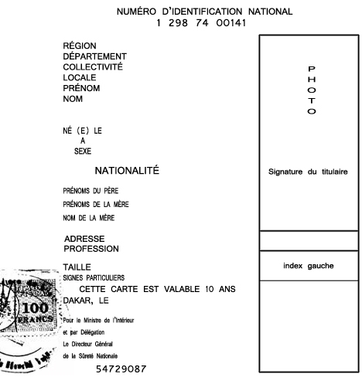
Activity 1

Class activity. Your instructor will assign you a partner to glance at quickly. Take a mental note of his/her physical features. How does he/she stand out? Would you be able to describe him/her accurately? After a few minutes, your instructor will ask you to describe your partner to the class.

Activity 2

Class activity. Your instructor will describe someone from the class. Listen carefully and guess who is being described. The first student to guess will then describe someone else for the class to guess.

Activity 3

Pair activity. Take turns describing an unforgettable celebrity or a well-known public figure. Your partner will listen and correct the description if he disagrees.

Activity 4

Pair activity. Ask each other the following questions. Feel free to add your own.

- Tu as souvent le mal du pays?
- Tu as envie d’un hamburger maintenant?
- En général, tu es heureux(euse) ou malheureux(euse)?
- Tu as besoin de téléphoner à ta mère tous les jours?
- Tu as peur des scorpions?
- Tu es en colère quelquefois? Après qui (with whom)?

Activity 5

Describe the emotions displayed in the pictures below.

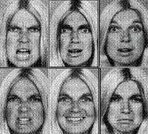

Activity 1

Class activity. Play Pictionary. Divide the class into two teams. Your instructor will give you cards with phrases that indicate emotions, needs, and wants. The teams take turns in having a member draw to let his teammates guess the phrase within the allocated time. If the phrase is not guessed correctly, the other team gets the chance to do so and get the point.

Activity 2

Class activity. Write a short paragraph on a card where you describe your physical traits. Your instructor will collect and redistribute the cards randomly. Read the card your instructor gave you and return it to the person it describes.

Activity 3

Pair activity. Pick two famous people and write a description of them. Include as much information as you can, but do not mention their names.

Activity 4

Group activity. Join another pair of students. Take turns in reading your descriptions of celebrities, and guessing the names.

Activity 5

You are applying for an ID card. Fill in the missing information. Don’t forget to sign.

Activity 1

Choose one of your favorite pictures of your family. Write a physical description of yourself and the members that appear on the picture. Include the picture for presentation.

Activity 2 Track 16
CD. Listen to the dialogue and choose the correct answers.

Script:
A : Sergent Thompson, avez-vous vu le colonel Lukombo? B : Je ne sais pas, mon lieutenant. Comment est-il?
A : Il est assez grand, il a les cheveux gris et les yeux noirs.
B : Est-ce qu’il porte des lunettes?
A : Oui.
B : Alors je crois qu’il est à la cafétéria.

- Lieutenant Harkin is looking for…
a. Colonel Lukombo
b. Major Lukombo
c. Lieutenant
- Sergeant Thompson
a. knows Lukombo
b. does not know Lukombo
- Lukombo is…
a. tall
b. short
c. of medium height
- He has…
a. grey hair and black eyes
b. brown hair and blue eyes
c. black hair and green eyes
- He…
a. wears glasses
- has a tattoo
c. has a scar .

Activity 3

Be prepared to describe (out loud and without notes!) yourself to your instructor and to the class. Use Exercise 1, page 121 as a guide. Give more detail this time and concentrate on pronunciation.

Activity 4 Track 17

CD. Listen to the descriptions of people and write the corresponding number next to the names, physical traits, emotions, needs and wants that you hear. There are more items listed than you will hear.

Lieutenant Harkin 3 grande 1 avoir peur
Mariama 1 petit 3 être heureuse 1
Sergent Reagan de taille moyenne avoir envie de rentrer 2
Mamadou 2 gros 3 avoir du mal à s’adapter 3
mince 1 avoir chaud 3
les yeux bleus 3 avoir froid 2
les yeux marron avoir sommeil 1
les yeux noirs 1 être malheureux 2
les cheveux blonds 3
les cheveux gris
les cheveux noirs 1

Script:
1. Voici Mariama. Elle est grande et mince, elle a les cheveux et les yeux noirs. En général elle est heureuse. Maintenant, elle a sommeil.
2. Mamadou est malheureux. Il étudie dans le Michigan, et il a le mal du pays. Il a toujours froid, et il a envie de rentrer au Sénégal.
3. Le lieutenant Harkin est en mission à Dakar. Il est petit et gros, il a les cheveux blonds et les yeux bleus. Il a souvent chaud et il a du mal à s’adapter au climat.

Activity 5

For each of the following situations, use a negative adverb (ne jamais, ne plus, ne pas du tout) to express what each person does not do. Prepare your written answers orally.
- Le week-end, je . . .
  - étudier?
  - retrouver (meet) mes copains?
  - rester (stay) à la maison?
- Mon copain/Ma copine (Mon mari/Ma femme) . . .
  - parler espagnol?
  - danser bien?
  - jouer souvent au tennis?
- À la maison, je . . .
  - téléphoner toujours (à qui)?
  - préparer le dîner?
  - travailler?

Activity 6

Look at the sample ID card below and give the appropriate answer for each question or statement.

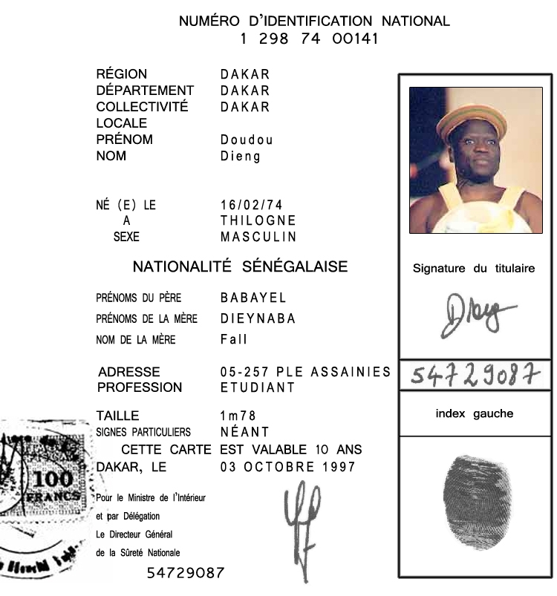
- How long is the card valid? 10 years
- Mother’s maiden name is? Fall
- Give this person’s birthdate. February 16, 1974
- Give the birthplace. In Thilogne

