SOLT French Module 5 Lesson 4

Instructor Manual

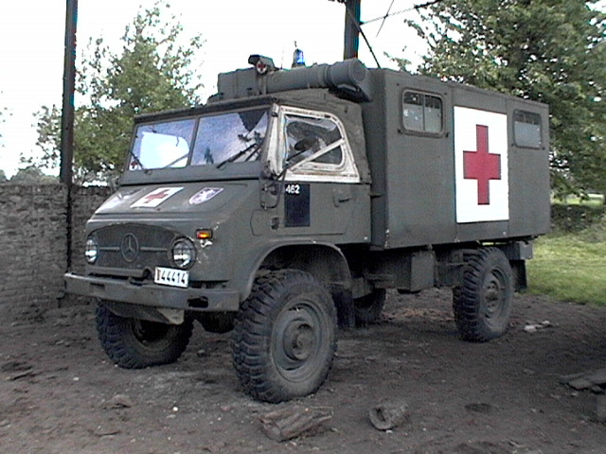

Medical Emergencies

At the end of this lesson you will be able to talk about health matters such as medical emergencies and discuss injuries and how to treat them.

Discuss Medical Emergencies

- Call for assistance
- Report an accident
- Discuss the scene of an accident
- Interpret in emergency situations

Discuss his / her Injury

- Make a doctor’s appointment
- Discuss medical treatment
- Request medication at the doctor’s office
- Discuss a healthy diet
- Ask / respond about the state of an illness and recovery from an illness
Scenario:
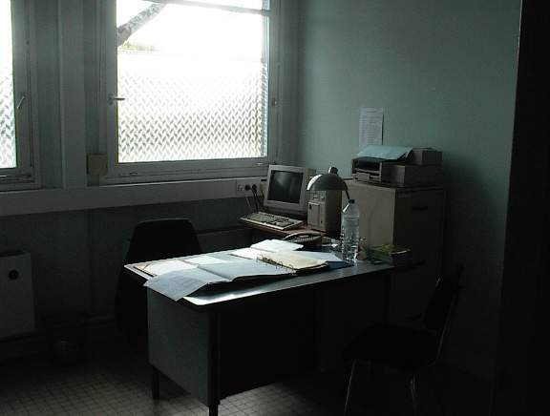

John calls a doctor in Dakar to make an appointment. At first there is no answer and then, the receptionist, Madame Ndiaye, answers the phone. Go over the conversations below and look up new vocabulary words.

John: Allô?
Réceptionniste: Cabinet du docteur Daff, bonjour.
John: Bonjour. Je voudrais prendre rendez-vous le plus tôt possible. Je me sens très mal.
Réceptionniste: Pouvez-vous venir cet après-midi à quinze heures trente?
John: D'accord.

Now John sees the Doctor in person [...] who is making in the hospital. Continue reading with his visit to the doctor’s office in town:

Chez le médecin:

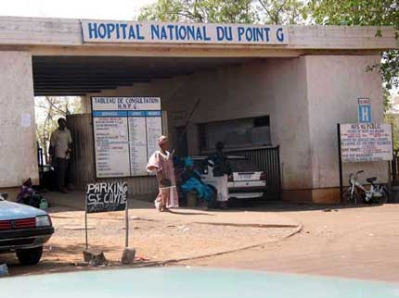
Médecin: Bonjour Monsieur.
John: Bonjour Docteur.
Médecin: Alors, qu'est-ce qui ne va pas?
John: J'ai de la fièvre, je tousse, et j'ai mal à la tête.
Médecin: Je vais vous examiner. Je vais prendre votre tension et votre température. Nous allons aussi faire une analyse de sang. Je crois que vous avez la grippe.

Vrai ou Faux?

Answer the following questions in class and prepare correct answers for any “faux” sentences.

1. John is talking to Docteur Daff on the phone. V / F
2. John called to reconfirm an already scheduled appointment. V / F
3. John will see Docteur Daff at 4:30 p.m. V / F
4. John has a combination of fever, coughing and headache. V / F
5. The docteur will take John’s blood pressure V / F
6. Docteur Daff is 100% sure that John suffers from the flu. V / F
Discuss Medical Emergencies

Emergency situations

Carefully read over the different ways to talk about an emergency. Notice the difference between certain expressions + avoir and others that use a form of être. Certain verbs are used for specific conditions; respirer, souffrir, etc.

- Une noyade → Il / elle se noie.
- Il a une insolation.
- Elle a une fracture au bras.
- Il vomit.
- Il s’est fait mordre par un serpent.
- Il a un traumatisme crânien.
- Elle a des lésions internes.
- Il a une crise cardiaque.
- Elle s’est blessée à la tête.
- Elle s’est brûlée au deuxième/troisième degré.
- Elle s’est fait piquer par un scorpion.
- Elle respire difficilement.
- Elle souffre d’hypothermie.

Next, practice how to use a command when asking for someone to send a medical item / service:

- Envoyez un brancard!
- Envoyez une ambulance!
- Envoyez un hélicoptère!
- Envoyez un médecin d’urgences!

*Note to the instructor: Ask students to brainstorm and find other command forms that would be appropriate. For example, Trouvez... Appelez…
Tip of the day: Ambulance services in Africa

Because of cuts in hospital budgets and the financial collapse of many African cities, the ambulance services throughout the continent are very poor. Most hospitals have discontinued their ambulance services altogether because of their inability to fund the operations. So, in case of a medical emergency, it is always preferable to rent a taxi and go the nearest hospital. The phone book (see http://www.yellowpagesofafrica.com) will list numbers for hospital ambulances. Chances are that you will experience a longer delay than if you had requested a taxi.

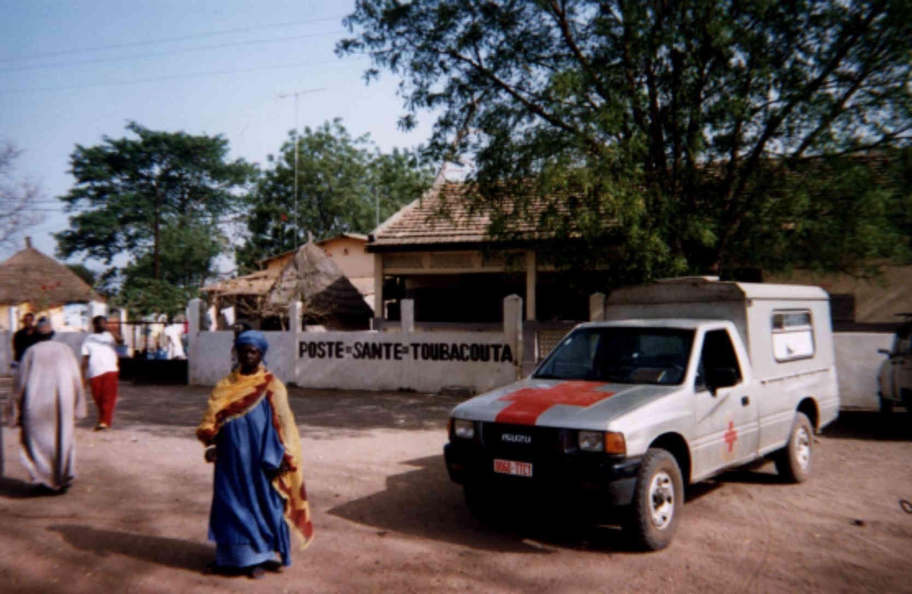
Une ambulance en milieu rural au Sénégal

Exercise 1 (Pair Exercise)

What will you tell an emergency service in the following situations to explain what is happening?

1. A baby is crying; next to it is a snake.
2. A body is floating in a swimming pool.
3. A motionless skier is “hugging” a tree.
4. A child pulled a pot of boiling water on himself.
5. A man is holding his chest and appears to be in great pain.
6. A woman is found delirious in the mountains. It is 30°C and her water canteen is empty.

Exercise 2 (Pair Work)

The class will be divided into pairs for this exercise. One of you will call for assistance and the other will assume the role of the operator and will get information about an emergency situation. Reverse roles so each student gets a chance to practice calling for assistance.
Answer Key: Answers may vary.
Suggested situations:
Your roommate slipped and fell unconscious in the shower.
Your child fell from the stairs and is unconscious.
Your spouse has difficulty breathing because of asthma.
You fell and unable to move because of possible broken leg.

Report an accident

Amadou calls to report an accident he saw on the way home. Read his conversation with the operator. Your instructor will ask a few pairs to read the dialogue aloud.

Opératrice: Ici la police routière. Comment puis-je vous aider?

Amadou: Je voudrais signaler un accident qui a eu lieu sur la route de Thiaroye. Il y a un blessé grave. Un homme a perdu connaissance, et un enfant est en état de choc. On a besoin d'aide. Envoyez une ambulance.

Exercise 3 (Pair Exercise)

Your instructor has been in an accident. Listen while your instructor describes his/her injuries. Then do the same, working with a partner. If you have never been in an accident, create a hypothetical accident.

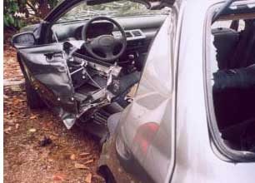

Note to the instructor:
Prepare an imaginative or true story of an accident you may have had. Tell the story to the class.

Exercise 4 (Pair Exercise)

With your partner, take turns describing the scene of an accident. Be sure to include the kind of information essential for rescuers to locate the scene, and also be prepared to give first aid to victims, such as address, phone number, number of people who are in trouble, description of the scene of the accident, etc. One student plays the role of a witness, the other a member of an emergency medical response team en route to the site.

Exercise 5 (Pair Exercise)

Practice this dialogue about an accident with a partner. Take turns playing different parts.

Clerk: Identify yourself as a hospital desk clerk.
Patient: Say that you want to report an accident.
Clerk: Ask the caller for the location of the accident.
Patient: Tell him / her that the accident is on the main road going south, about 15 miles out of town.
Clerk: Find out what type of injuries the patient (s) has (have).
Patient: Say you believe there is some internal bleeding and that the patient (s) is / are unconscious.
Clerk: Inquire if someone is giving first aid.
Patient: Say no. Say victims are trapped in a truck.
Clerk: Tell the caller that help is on the way.

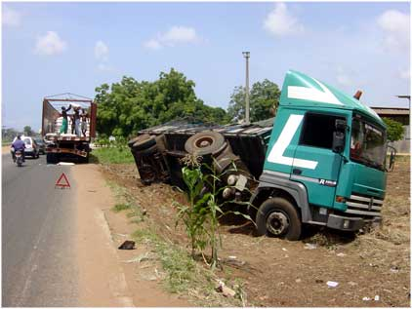

Exercise 6 (Pair Exercise)

Practice this dialogue about an accident with a partner. Take turns playing different parts.
Médecin-major?
Infirmier: Tell the victim you are a medic and will help. Ask where she/he is injured?
Patient: Tell him/her you think the arm is broken and that a leg is bleeding.
Infirmier: Tell the patient not to move the arm and that you are going to apply pressure to the wound and bandage it.
Patient: Tell the medic that you are diabetic and that there is a shot of insulin in your car.
Infirmier: Say the ambulance has just arrived and that the patient will be transported to the hospital. Explain the whole situation to the paramedic.

Discuss his / her Injuries

Find the English equivalent for the following expressions:

L’examen médical
Faire une radiographie
Un test de dépistage du SIDA
Une analyse d'urine / de sang / des matières fécales
Une prise de sang
Prendre le pouls / la tension (artérielle) / la température

Le diagnostic
examen médical

Un rhume
La grippe
Une grippe intestinale
un ulcère à l'estomac
Une inflammation de la gorge
Une bronchite
Une crise d'appendicite
Une intoxication alimentaire
Une allergie alimentaire
Une hernie
Des calculs biliaires
Des calculs du rein
De l'asthme
Des rhumatismes
Une éruption cutanée
Une maladie vénérienne

Exercise 7 (Class Work)

Fill in the blanks with the health problems that are being described.

- Ça arrive subitement. Tout d'un coup on ne peut plus respirer. C'est probablement une crise d'asthme.
- C'est une inflammation de la peau. Ce n'est pas beau à voir. C'est une éruption cutanée.
- Tu as mal dans le bas ventre. C'est peut-être une crise d'appendicite.
- C'est quelque chose qui vient avec l'âge, quand on a mal aux articulations. Ce sont des rhumatismes.
- On a des boutons rouges partout sur la peau. C'est une éruption cutanée.

Le traitement:

Now, practice saying how to treat a problem that has been diagnosed by a doctor:

Je vais vous prescrire une diète légère / le repos complet / des antibiotiques.
Vous devez suivre → un régime sans sel / sans matières grasses / végétarien.
un régime riche en protéines et en vitamines.
un régime pauvre en calories et en glucides.

Exercise 8 (Class Work)

Tell your class: Qu'est-ce qui est riche en protéines (P)? En glucides (G)? En lipides (L)? Qu'est-ce qui contient beaucoup de vitamines (V)?

Pomme  Pain  Melon  Fromage  Oeufs  poisson | V, G  G  V  P, L  P  P | Carottes  Lait  Poulet  Spaghettis  Saucisses  fraises | V  P  P  G  P, L  V

Exercise 9 (Pair Exercise)

Set up a military clinic in your classroom. The medical officer médecin militaire / traitant (your instructor) is in charge. Each student attends the clinic with a problem, and the officer suggests appropriate first-aid.

Example: Patient:
Médecin:

Exercise 10 (Pair Exercise)

Make an appointment at a Senegalese doctor’s office. You are the patient and your partner is the receptionist. Due to your non-translated foreign documents, your request is denied – rejeté. Think up a strong medical reason that would push office personnel hard by using patterns from the scenario as a model. Switch roles when you feel confident enough to survive this situation in the real world. Use these verbs:
fixer le / un rendez-vous
prendre rendez-vous

Exercise 11 (Pair Exercise)

It is very important to check whether a particular patient is allergic to any medicine before medication. But also, away from home, certain cravings can become quite outspoken, bodily and emotionally. Working with a partner, practice asking and answering questions concerning a patient’s allergic or emotional responses to a particular medication or food or lack thereof.

Exercise 12 (Pair Work)

The class will be divided into pairs for this exercise. What type of medication would you ask for in the following instances? Working with your partner, decide on the medication. Next, assume the role of a doctor and a patient. State the symptoms then request the appropriate medication from your doctor. Reverse roles so both of you has a chance to request medication.

- You have a rash.
_____________________________________________________________________
- You have a cough.
_____________________________________________________________________
- You have a terrible headache.
_____________________________________________________________________
- You have an ear infection.
_____________________________________________________________________

Tip of the Day: Emergency services

SUMA Assistance SOS Médecin
Av.Cheikh Anta Diop Rue Parent
Tel.: 824 24 18 Tel.: 821.32.13

Exercise 13

With your classmates, decipher the steps to follow before calling an emergency number. Could you answer all of these questions. How would you react?

Assurez-vous de posséder les réponses aux questions suivantes qui vous seront posées par le répondant médical d'urgence :
Quelle est l'adresse ?
Quel est le numéro de téléphone ?
Quel est le problème ?
Est-ce un homme ou une femme ?
Quel âge a la personne ?
Est-elle consciente ou non ?
Respire-t-elle ou non ?
Il est important pendant l'appel de :
rester calme
répondre clairement
ne pas raccrocher le téléphone avant qu'on vous dise de le
faire
suivre les directives de premiers soins

Answer Key: Answers may vary.

The imparfait

Another tense that is used to talk about past events is the imparfait. It is usually not interchangeable with the passé composé. The imparfait is used to describe a scene, feelings, as well as habitual actions in the past. Meaning of the imperfect varies. Three possible translations include: was / were + ing (I was doing…), regular past meaning as in –ed such as I talked, or I used to talk. The “used to” is an indicator for habitual or repeated actions, stressed by the imperfect tense. Other clues like adverbs (souvent, toujours, etc.) will help you distinguish between the passé composé and the imparfait.

To form the imparfait, use the first person plural (nous) form of the present tense (without the ending -ons) as a stem and add the following endings:

Example: avoir present: nous avons

Imparfait of avoir

J'avais  Tu avais  Il/elle avait | Nous avions  Vous aviez  Ils/elles avaient

Irregularities:

- Être has an irregular stem (ét):

J'étais  Tu étais  Il/elle était | Nous étions  Vous étiez  Ils/elles étaient

- Verbs ending in ger and cer add an e after the g and a cedilla respectively, except for the nous and vous forms to maintain a consistent pronunciation.
*Reminder: in the present nous mangeons (keep the e before o/a for the soft –g sound).
Examples: je mangeais nous mangions
Tu commençais vous commenciez

Use the imparfait to describe:

- Conditions in the past: Elle s'appelait Khady.
Elle habitait dans un petit village.

- Feelings in the past: Elle aimait aller à l'école.

- Habitual past actions: Chaque matin, elle faisait trois kilomètres pour aller à l'école. Elle se levait de bonne heure.

Exercise 1

The following paragraph was written by John to describe his daily routine 10 years ago. Now many changes have happened, so put all verbs in the past. Read the paragraph aloud in the present tense and then in the imperfect tense. Your instructor will explain differences in meaning between the imperfect and the passé composé. This information is explained in detail later in the Module.

For example, Je suis allé au parc / J’allais au parc.

Le matin, je me réveille à 6 heures. Ma mère prépare le petit déjeuner. Ma sœur et moi mangeons. Je prends le bus à 7 heures. Je vais au lycée toute la journée. L’après-midi, je rentre chez moi. D’abord, je fais mes devoirs. Ensuite, mes amis viennent me chercher pour jouer au basket dehors.

réveillais, préparait, mangions, prenais, allais, rentrais, faisais, venaient

*Note to the instructor: inform students of the passé composé mix with the imperfect. For this lesson, the imperfect should be used BUT make them aware that adverbs of sequence such as puis, ensuite, and time indicators could use the passé compose. List some of the above sentences with the correct forms of the p.c.

Exercise 2 (Pair Work)

Take turns telling each other what your daily routine used to be during your training to join the SF. Present your partner’s routine to the class.
Allergie alimentaire (n.f)  Analyse d’urine/des matières fécales/de sang (n.f)  Asthme (n.m)  Bilan (n.m)  Brancard (n.m)  Bronchite (n.f)  Cabinet (n.m)  Calcul du rein (n.m)  Chariot (n.m)  Commémorer (verb)  Crise cardiaque (n.f)  Crise d'appendicite (n.f)  Déraillement (n.m)  Écraser (verb)  Éruption cutanée (n.f)  Étranger (n.m)  Évacuer (verb)  Examiner (verb)  Fondateur (n.m)  Grossesse (n.f)  Guérir (verb)  Gynécologie (n.f)  Intoxication alimentaire (n.f)  Maladie vénérienne (n.f)  Matière grasse (n.f)  Médecin d’urgences (n.m)  Ophtalmologue (n.m)  Pédiatre (n.m)  Pèlerin (n.m)  Piéton (n.m)  Podologue (n.m)  Police routière (n.f)  Prendre d’assaut (verb)  Prompt rétablissement (n.m)  Radiographie (n.f)  Renverser (verb)  Rhumatisme (n.m)  Surcharger (verb)  Témoin (n.m)  Tension artérielle (n.f)  Test de dépistage de Sida (n.m)  Toit (n.m)  Transporter (verb)  Ulcère à l’estomac (n.m)  Urologue (n.m) | Food allergy  Urine / stool / blood analysis  Asthma  Results  Stretcher  Bronchitis  Office (lawyer, M.D)  Kidney stone  Cart  To commemorate  Heart attack  Appendicitis attack  Derailment  To crush  Skin eruption  Abroad/foreigner  To evacuate  To examine, consult  Founder  Pregnancy  To heal  Gynecology  Food poisoning  Venereal disease  Fat (food)  Emergency doctor  Eye doctor  Pediatrician  Pilgrim  Pedestrian  Foot doctor  Traffic police  To take by storm  Speedy recovery  X-ray  To run over  Rheumatism  To overload  Witness  Blood pressure  Aids screening  Roof  To carry  Stomach ulcer  Urologist

S’abstenir (verb)  S’avouer (verb)  Banlieue (n.f)  Bondé (adj.)  Boutons (n.m.pl)  Clamer (verb)  Colère (n.f)  Contenter (verb)  Croire (verb)  Dehors (n.m) (adv.) (adj.)  Épine (n.f)  Épuiser (verb)  Esprit (n.m)  Hernie (n.f)  Hors de portée (loc)  Intolérance alimentaire (n.f)  Gingivite (n.f)  Malédiction (n.f)  Mort (n.f)  Ossements (n.m.pl)  Ouïe (n.f)  Peau de bête (n.f)  Persuader (verb)  Peser (verb)  Plume (n.f)  Porc-épic (n.m)  Préservatif (n.m)  Prodiguer (verb)  Recherche et sauvetage (SAR)  Sauvetage (n.m)  Subitement (adv.)  Sucreries (n.f. pl)  Tout d’un coup (loc.) (adv.)  Se vêtir (verb)  Vue (n.f) | To abstain / to keep off  To say to oneself  Suburb  Full  Rash/pimples  To claim loudly  Anger  To please  To believe  Outside, outdoors, out  Thorn, prickle  To tire out/to exhaust  Spirit, mind, sense, wit  Hernia  Out of reach  Food allergy  Gum disease  Curse  Dead, death  Bones  Hearing  Animal skin  To convince  To weigh  Feather  Porcupine  Condom  To give  Search and Rescue  Rescue  Suddenly  Sweets  All of a sudden  To wear  Sight

Medical Emergencies

There are separate emergency numbers for police, fire and ambulance services. Each hospital usually has its own number for calling an ambulance. When in doubt, call the operator by dialing “12,” and they will make sure to contact the closest healthcare facility.

Several hospitals and clinics in Dakar can treat major and minor injuries and illnesses. There is inadequate in-patient psychiatric care, though there is very good office-based psychiatry. Public hospitals do not meet U.S. standards, but several private clinics are at the level of small European hospitals, and even approach U.S. community hospital standards. The Embassy maintains a list of physicians and other health care professionals who may see U.S. citizen patients. The Embassy does not guarantee their services or recommend any of the physicians.

Medical facilities outside Dakar are limited. French medications are more readily available than American drugs, and the limited selection of American drugs in stock are often listed under the French trade name. Medications may be obtained at pharmacies throughout Dakar and in other areas frequented by tourists, and are usually less expensive than those in the U.S. Travelers should carry a supply of any needed prescription medicines, along with copies of the prescriptions, including the generic name for the drugs, and a supply of preferred over-the-counter medications.

For a review of important numbers in case of a medical emergency, here are the ambulance numbers:
Ambulances
Sapeurs pompiers / fire department (downtown)
Tel.: 18
Service ambulancier de l'Hôpital Principal
Av. Nelson Mandela
Tel.: 839 50 50
Activity 1

Read the following report and select the appropriate statements.

Accident de train : 12 morts et 210 blessés

DAKAR, 22 mai (AFP) - 19h28 - Douze personnes ont été tuées et deux cent dix autres blessées à la suite du déraillement d'un train lundi à Diamniadio à une quarantaine de km de Dakar, a-t-on appris auprès des services de secours.
Des wagons bondés de passagers se sont renversés à la suite du déraillement écrasant de nombreuses personnes, indique-t-on de même source.
Le train transportait des milliers de pèlerins vers Touba, capitale du mouridisme (une des grandes confréries musulmanes sénégalaises) qui commémore mardi le départ en exil de son fondateur, Cheikh Ahmadou Bamba.
Les services de secours, selon lesquels ce bilan n'est pas définitif, s'activaient encore en milieu d'après-midi à évacuer les blessés vers les hôpitaux de la capitale.
Le renversement des wagons sur certains passagers rendait très difficile les opérations de secours, selon des témoins, qui soulignent que les wagons étaient surchargés.
Les raisons exactes de cet accident ne sont pas encore connues, mais habituellement, pendant la période du "Magal" (pélerinage à Touba), le train spécial à destination de Touba utilise des wagons de marchandises pour transporter les pèlerins. Ce train est toujours pris d'assaut par plusieurs milliers de jeunes qui voyagent parfois sur les toits des wagons.
Les ministres de l'intérieur et de la santé se sont rendus sur les lieux de l'accident pour superviser les opérations de secours auxquelles participent un hélicoptère de l'armée française ainsi qu'une dizaine d'ambulances et des grues prêtées par des entreprises privées.
De nombreux accidents de voiture sont souvent enregistrés sur les routes menant à Touba pendant la période du "Magal" en raison du non-respect des normes de sécurité.
Plus de deux millions de pèlerins sont attendus à Touba pour cet évènement majeur de la communauté mouride du Sénégal et de l'étranger.

http://www.seneweb.com

- This is about
  - a plane crash
  - a train derailment
  - car accidents

- This accident occurred in
  - Touba
  - Dakar
  - Diamniadio

- The casualties so far are
  - 2 killed and ten injured
  - 12 killed and 210 injured
  - 10 killed and 200 injured
- Victims are being taken to hospitals in
  - Touba
  - Dakar
  - Diamniadio

- Which of the following is lent by the French army for rescue operations?
- ambulances
- a helicopter
- a crane

Activity 2

You will hear several passages (read by your instructor) describing an emergency situation. Listen and check whether the following statements are true or false.

Script:
1: Il y a une noyade à la plage Soumboudioune. La femme saigne du nez. Il y a un secouriste qui lui fait du bouche-à-bouche.
2: Il y a un accident sur la Place de l’Indépendance. Un chauffeur vient de renverser un piéton et la victime est inconsciente.
3: L’enfant a des brûlures au deuxième degré. Il souffre beaucoup. Envoyez une ambulance rapidement.
4: Allô, ici le restaurant Keur Samba. On a un client qui transpire et vomit beaucoup. Il semble avoir une allergie. Il a aussi des difficultés à respirer.
5: Allô, nous avons besoin d'une ambulance au supermarché Supersam. Un enfant est tombé du chariot la tête la première. Il est inconscient.

1. a. Someone is reporting a car accident. T / F
b. The victim has internal injuries and a broken arm. T / F
c. The victim has an allergy. T / F

2. a. The accident happened on the highway. T / F
b. The victim is not responding when spoken to. T / F

3. a. A child was pulled from the water. T / F
b. An ambulance is requested. T / F

4. a. The victim has an allergic reaction. T / F
b. The victim has trouble breathing. T / F

5. a. The emergency happened in a department store. T / F
b. A child is injured. T / F

Activity 3

Complete each sentence with the most appropriate word from the right column.

1. Les pommes de terre sont riches en…d  2. Le jus d'orange a beaucoup de …f  3. Le porc est … e  4. Le poulet contient peu de …c  5. La pizza est riche en … b  6. Le poisson est riche en … a | - protéines  - calories  - matières grasses  - glucides  - gras  - vitamines

Activity 4

Select the appropriate answer for each sentence. After you go over each answer in class, prepare 1-2 sentences as a logical conclusion or response to what is already given.

1. Je vous souhaite un prompt rétablissement. a. Non merci.
b. Merci.
c. De rien.

2. Votre tension artérielle est très élevée. a. Oui, ça saigne.
b. Je suis très stressé en ce moment.
c. Ça ne saigne plus.

3. La coqueluche est-elle une maladie vénérienne? a. Non, c'est une maladie du coeur.
b. Non, c'est une maladie du foie.
c. Non, c'est une maladie infantile.

4. Que faites-vous pour rester en forme? a. Je mange beaucoup de chips.
b. Je bois un litre d'alcool par jour.
c. Je prends des vitamines.
Activity 5

Look at the directory of doctors, and decide which doctor each person should go to. Give the full name and address for each answer.

Cabinet Medical Dr Ali Badreddine
Médecin Pneumologie Allergies Respiratoires
60, Rue Carnot BP 2731 Dakar

DR ERICK GBODOSSOU
Médecin Généraliste
Thiaroye Gare n° 49/A Tally Diallo BP 6134 Dakar
CABINET HANEDERMA
DERMATOLOGIE- MEDECIN-DERMATOLOGUE
12, Rue Jules ferry DAKAR

DR FALILOU MBACKE FAKHRY
Médecin Généraliste Sexologie
108, Av Lamine Guèye 1er Etage BP 7916 Dakar

Medecins Ophtalmologue- Dispensaires
Rue Ahmadou Malick Gaye BOPP BP 5070 Dakar

Cabinet Pediatrie Docteur Marième Soumaré Ndiaye
Pédiatrie
93, Rue Amadou Assane Ndoye Dakar
CABINET DENTAIRE DR HABIBOU SY
Chirurgien Dentiste
Grand Yoff Face Poste BP 13251 Dakar

DR ALSEYNI DANSOKHO
Gynécologie Obstétricien Gynécologue
Plles Assainies U. 14 n° 350 BP 1156 Dakar

- Une femme a une maladie vénérienne.
- Tu as une fièvre élevée.
- Ta cheville gauche te fait mal.
- Ta fille a la varicelle.
- Il vous faut un examen de la vue.
- Vous avez besoin d’un examen de l’ouïe.
- J’ai une gingivite.
Activity 6

Your instructor will read a conversation between a doctor and his patient. You will only hear the patient begin with his medical issues. Then the doctor will continue with advice and treatment. Listen carefully and then mark the correct ending to each statement.

Instructor’s Reading:

P : J’ai des douleurs dans le dos. Il m’est très difficile de m’asseoir pendant un long moment. J’ai besoin de me coucher toutes les 30 minutes.
D : Est-ce que vous êtes actif? Vous devriez faire beaucoup de sport. Je vais vous montrer quelques exercices qui vont vous aider.
D : En attendant, vous allez passer une radiographie. Je crois que vous n’avez pas besoin de faire une analyse d’urine pour le moment.
D : Les résultats de la radiographie montrent qu’il y a un petit problème au niveau d’un de vos reins. Je vais prescrire des médicaments qui vont vous soulager bientôt.
D : D’abord, prenez les médicaments régulièrement et abstenez-vous des excitants comme l’alcool.

First visit:

1. Mr. Diouf is complaining about pains in his a. back
b. chest
c. stomach

2. The doctor is asking about his a. workload
b. workout habits
c. weight maintenance

3. At the end of the exam, the patient is a. being X-rayed
b. put on the scale
c. asked for a urine sample
Second visit:

4. Mr. Diouf finds out about his a. heart condition
b. stomach ulcer
c. kidney problem

5. The doctor prescribes a. bed rest
b. rehabilitation at a spa
c. abstaining from alcohol

Activity 7 (Pair Work)

Read the text about actions to take after you call an emergency line and create a dialogue for your class.
Après l'appel, préparer à l'intention des techniciens ambulanciers:
la carte d'assurance maladie
les médicaments de la personne
la carte de l'hôpital s'il y a lieu
De plus, pour faciliter la tâche aux techniciens ambulanciers :
allumer la lumière extérieure
dégager les escaliers et le vestibule
envoyer quelqu'un pour guider les techniciens ambulanciers
si possible
attacher le chien ou le chat s'il y a lieu
rappeler si l'état de la personne s'aggrave
Activity 8

Read the following article and write down, in English, four suggestions to help improve your skin. Change each command to a form of “devoir” or “il faut”. Do not translate the French word for word.

Example: Il faut boire beaucoup de liquides.
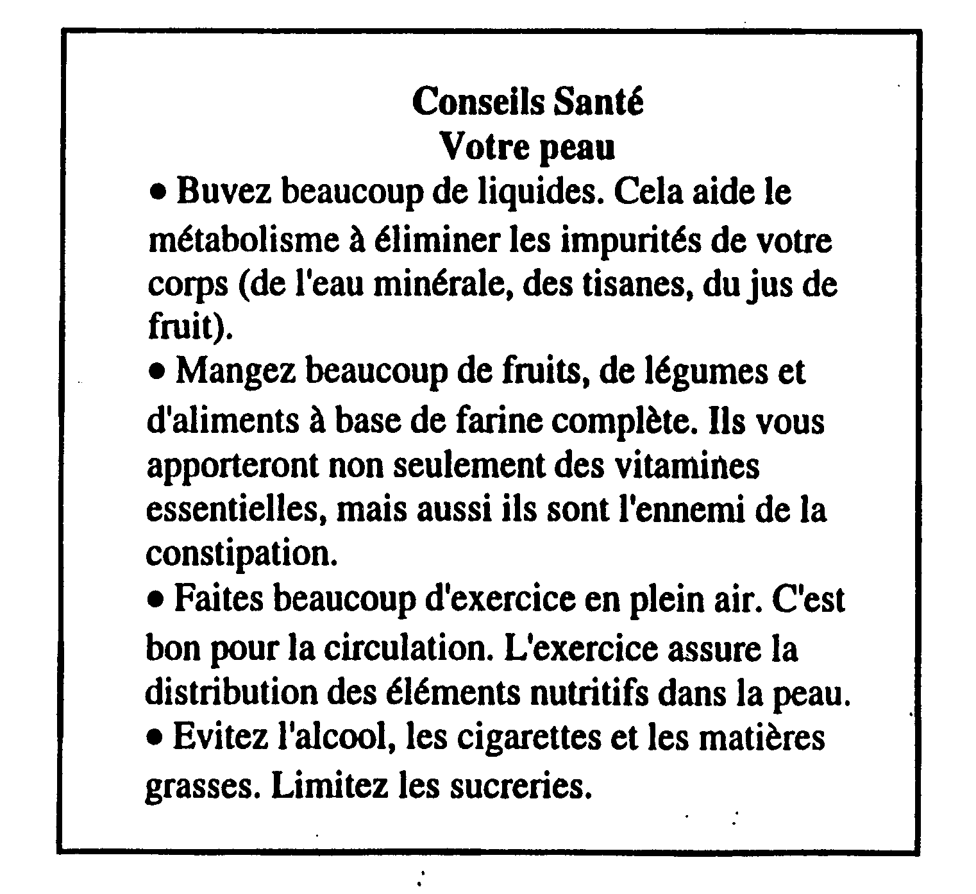

Activity 9

Listen to various doctors (your instructor) explaining which diagnostic tools they plan to use and mark them on the chart below.

Script 1: Je vais faire une radiographie pour m’assurer si c’est une foulure ou une fracture que vous avez à la jambe.
Script 2: Je crois qu’il est bon de faire un test de grossesse à la fin du mois.
Script 3: Votre tension artérielle est normale. Continuez à faire des exercices.
Script 4: A la naissance, on fait passer à l’enfant un examen de l’ouïe et un examen de la vue.
Script 5: La température de son corps est très élevée. Il doit avoir de la fièvre.
Script 6: Le docteur recommande une analyse de sang et une analyse des matières fécales.

*Note to the instructor: read the first script and then allow 4 or 5 students to continue the readings.
 | 1 | 2 | 3 | 4 | 5 | 6
Examiner
Peser
Radiographie | X
Examen de l’ouie |  |  |  | X
Examen de la vue |  |  |  | X
Test de grossesse |  | X
Dépistage du Sida
Analyse d’urine
Analyse de sang |  |  |  |  |  | X
Analyse des matières fécales |  |  |  |  |  | X
Pouls
Tension artérielle |  |  | X
Température |  |  |  |  | X
.

Activity 10


Suppose that you are in a doctor’s office for an appointment with your doctor. You explain to him that the medication that he has prescribed has worked either well or poorly and ask for a new prescription or a refill for the previous prescription, explaining your current condition or symptoms. Role-play the situation with your partner.

Activity 11 (Pair Activity)

Listen to your partner trying to make or cancel appointments with different specialists, and correct him. Then you get to make the next appointment.

- You want to cancel your appointment with Dr. Thiam.
- You want cancel your appointment with Dr. Mourad on Wednesday.
- You want to schedule an appointment either with Dr. Mourad or Dr. Faye.
- You want to cancel his appointment with Dr. Thiam and get another appointment with Dr. Mourad.
- You want to schedule an appointment with Dr. Kassé and Dr. Mbaye who work in the same building.
- You want to get an appointment with any doctor on Thursday.

Activity 12

Read the following texts – one with a health concern and the other about what to do (not do). Summarize the advice given in the second paragraph and in your own words, share the remedy with the rest of the class. Explain the final argument given for the flu vaccination.
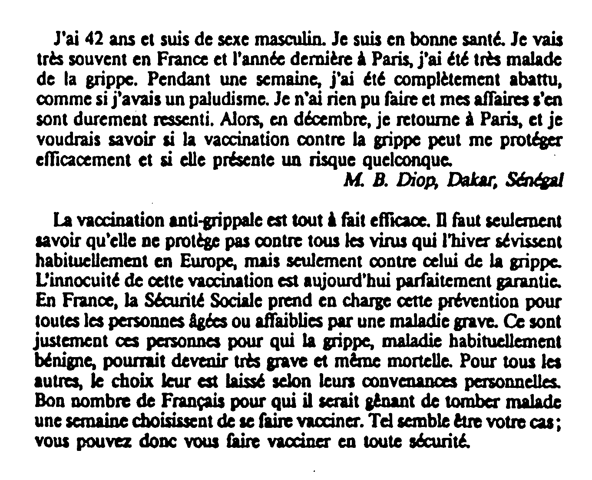

Activity 1 (Class Work)

Students circulate around the room to ask each other what kind of accidents they have been in and what injuries they have sustained. Beside each injury, write names after the colon. Formulate different ways to ask and answer about each injury.

- Trouvez quelqu'un qui a eu…
…une jambe cassée:
…une cheville foulée:
…un accident de la route:
…un accident du travail:
…une brûlure au deuxième degré:
…une brûlure au troisième degré:
…une crise cardiaque:
…une insolation:
…un traumatisme crânien:

- Trouvez quelqu'un qui s'est fait…
…piquer par un scorpion:
…mordre par un serpent:

Activity 2 (Pair Work)

Role-play the following situation with your partner. Next, switch roles and present to the class.

A: emergency operator B: accident witness

B: Tell the operator you want to report a car accident. Say that two people have been injured, and request that an ambulance be sent.
A: Ask the caller for the location of the accident.
B: Name the location
A: Find out what kind of injuries the victims have.
B: Explain that the driver has a head injury and is in shock. The woman with him is unconscious.
A: Check if anybody is administering first aid.
B: Tell the operator that a medic just arrived and started administering first aid.
A: Inform B that an emergency doctor will be dispatched immediately. Tell him to secure the accident site and to stay there until the police arrive.

Activity 3 (Pairs)

You are taking an injured soldier who does not speak a word of French to the emergency room. Speak on his behalf to the male nurse who will admit him.

A: nurse B: interpreter

A: Tell the patient you are a nurse and that you will examine him. Ask where his injury is.
B: Explain that the injured person doesn't speak French and that you will translate for him. Tell the nurse that his leg hurts and might be broken.
A: Ask about the medical history of the patient including the year of his last shots, any allergy or chronic illness, current medication (if any), and if he has health insurance.
B: Answer that he is current on his shots, doesn't have any allergy, suffers occasionally from asthma, and has health insurance.
A: Say that the doctor will be in soon and that in the meantime they will take x-rays of the leg.

Activity 4 (Pairs)

Role-play the following dialogue taking place at the doctor's office.

A: receptionist B: patient

A: Greet the patient.
B: Greet the receptionist.
A: Ask if B has an appointment.
B: Say that you don't, but explain that you are feeling a lot of pain and give a list of symptoms.
A: Tell B to come back at 1:45 pm. Ask for his name.
B: Answer and verify the time of your appointment.
A: Confirm the appointment and close conversation.

Activity 5 (Pairs)

Student A: You are making an emergency call. You were driving on the Corniche highway when you saw a car accident. There is an injured man with a fractured arm and possible internal injuries. You have given first aid and you know that the injured is allergic to penicillin.

Student B: You take emergency calls to dispatch assistance. Enter the information needed to send an ambulance.

Nom:
Lieu de l'accident:
Nombre de blessés:
Blessures:
Premiers soins donnés:
Allergies:

Activity 1

Read the text and check whether the statements that follow are true or false. Share your answers in class.
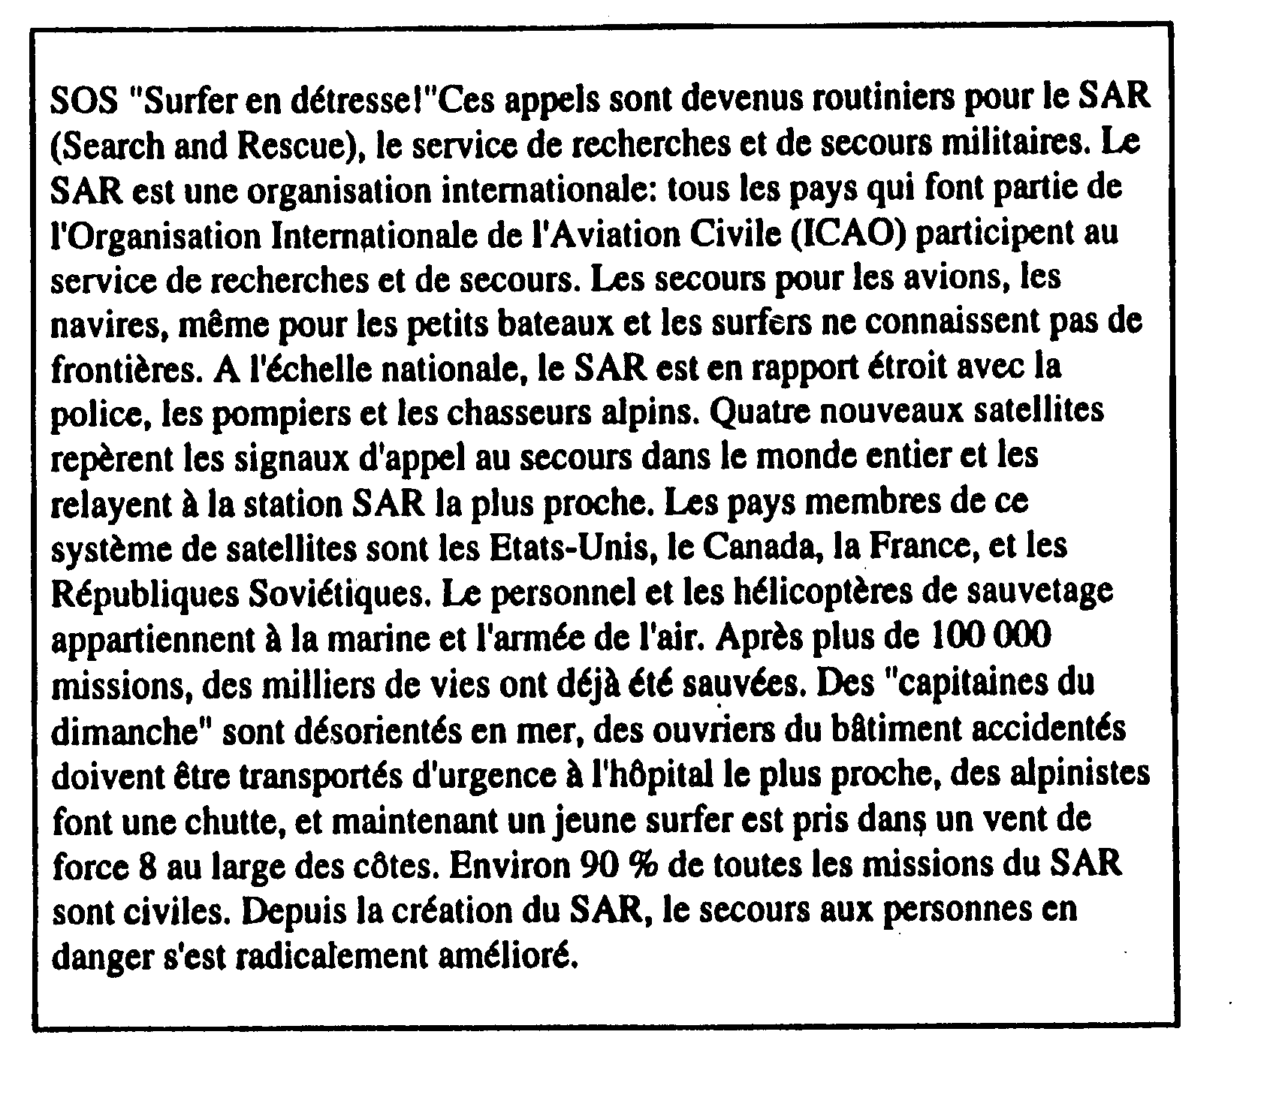
1. SAR is an international organization comprised of members of ICAO. T / F
2. SAR does not involve local police or firemen. T / F
3. Equipment and personnel for SAR comes from all branches of the Army. T / F
4. Most of SAR’s missions involve civilians. T / F

Activity 2

You stopped by the scene of a car accident and have to write a report about what you saw. Write a description of the scene of the accident. Remember to use the imparfait when necessary.
Activity 3 Track 67

CD. Listen to four short dialogues and check whether the following statements are true or false.

Script 1: Votre garçon souffre d’une infection au niveau des oreilles. C’est très courant à son âge. Heureusement, il y a des médicaments efficaces pour ça.

1. a. This conversation takes place at a pediatrician's office. T / F
b. The patient is a little girl. T / F

Script 2: Je suis diététicienne. Votre médecin vous a prescrit un régime très strict que je vais vous expliquer. Vous avez un ulcère à l'estomac, il faut donc faire très attention à ce que vous mangez.

2. a. This conversation takes place at a dietician's office. T / F
b. The patient has cancer T / F

Script 3: Je ne vois aucun problème avec vos yeux. Vous avez une très bonne vue. Je vous recommande cependant de porter des lunettes de soleil pour vous protéger.

3. a. This conversation takes place at an ophthalmologist’s. T / F
b. This patient is a diabetic. T / F

Script 4:
A: Bonjour Madame!
B: Est-ce que Monsieur Dieng est ici?
A: Non, il est en pause.
B: Je crois que je me suis foulé la cheville et je voudrais qu’il m’examine.
A: Asseyez-vous, il ne va pas tarder à revenir.

4. a. This conversation takes place at Dr. Dieng’s office. T / F
b. The patient has a sprained ankle. T / F

Activity 4
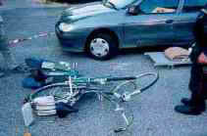

While driving home you encounter the scene above. Call 911 and explain the situation.
Activity 5 Track 68

CD. You will hear short sentences concerning either a medical condition or a medical treatment. Listen and mark each item with a C (condition) or a T (treatment).

- T / C
- T / C
- T / C
- T / C
- T / C
- T / C
- T / C

Script:
1. J’ai la peau qui me gratte.
2. Sa cheville est enflée.
3. Il a mis de la glace sur son genou.
4. Il prend des antibiotiques pour sa gorge.
5. Il tousse beaucoup et sa température est élevée.
6. Il a des douleurs au ventre.
7. Il porte des verres correcteurs.

Activity 6

Read about a telephone system when you call a doctor’s office and check if the statements are true or false. Share your answers in class and be prepared to discuss the context / meaning of this description.

Répondeur (aussi appelé Système de réponse automatisée)
Service de téléréponse électronique qu'utilisent un grand nombre d'entreprises pour diriger votre appel vers la personne ou le service approprié et de plus en plus de bureaux de professionnels et de médecins pour attribuer les rendez-vous. La plupart vous présentent un menu à partir duquel faire un choix en appuyant sur les touches de votre téléphone. Ce système ne fonctionne pas avec les téléphones à cadran.

1. This is about a very personal answering service provided in some companies. T / F
2. Most Americans are familiar with this type of service. T / F
3. This reading refers to how to call the doctor’s office to cancel an appointment. T / F

Activity 7

Read the following article in French about a devastating malady konzo in the Congo. Pay attention to the key words listed below and be able to share your ideas in class. Begin with the first section (3 parts) and then continue with the conclusion and results of the study.

Mots clés:
manioc, konzo, paraparésie spastique aigue, substances cyanogènes

Description:
Le Konzo est une paraparésie spastique permanente, à début
brutal, associée à la consommation de manioc insuffisamment traité
avec une alimentation pauvre en acides aminés soufrés.
Objectif:
Déterminer si une épidémie de paraparésie spastique en République Démocratique du Congo était compatible avec le konzo.
Methode: Un dépistage des cas de konzo a été effectué au moyen des critères de l' OMS. Des interviews ont été réalisées sur l'alimentation et la maladie. Les taux sériques de préalbumine, albumine et thiocyanate furent mesurés ainsi que ceux de linamarine, thiocyanate et sulfate dans les urines. Les serums furent testés pour HIV 1-2 (Behring ELISA) et HTLV I-II (ELISA/Wellcome).

Resultats:
Sur 2.723 habitants, 55 étaient affectés par le konzo, soit une prévalence de 20 pour mille. Le symptôme majeur était une paraparésie spastique permanente à début brutal ou une tétraparésie dans les cas sévères, le manioc amer était l' aliment de base. Il y avait une importante exposition aux substances cyanogénétiques: concentration moyenne (± écart-type) de thiocyanate sérique
502 (±153) mmol/L, de linamarine urinaire 482 (±322) mmol/L, de thiocyanate urinaire 1128 (±670) mmol/L. La concentration moyenne (± écart-type)
de sulfate urinaire était 4.0 ± 3.3 mmol/L. En majorité, le taux des protéines sériques était en dessous de la normale:
sur 38 sujets, 37 et 28 l'avait pour l'albumine et la préalbumine respectivement. Tous les 38 serums collectés étaient négatifs aux rétrovirus
testés.

Conclusion:
Cette épidémie était compatible avec le konzo. Ameliorer le traitement du manioc peut prevenir la maladie.

English (for class discussion):
Konzo is an acute non-progressive spastic paraparesis associated with a consumption of insufficiently processed bitter cassava, and a low intake of sulfur amino acids.

Method:
To determine whether an outbreak of spastic paraparesis in the Democratic Republic of Congo was compatible with konzo, we surveyed and screened the population in the affected area by using the WHO criteria. Interviews and focus group discussions were done on diet and the occurrence of konzo. Serum samples were analyzed for prealbumin, albumin and thiocyanate; urine samples for linamarin, thiocyanate and sulfate. Serum samples were tested for HIV 1-2 (Behring ELISA) and HTLV I-II antibodies (ELISA/Wellcome).

Results:
Of 2,723 inhabitants, 55 were affected by konzo i.e. a prevalence of 20 per thousand.
The main symptom was a sudden onset of a non-progressive spastic paraparesis or
a tetraparesis in severe cases. Bitter cassava was the staple diet. We found high exposure to cyanogenic compounds i.e., mean (± SD) concentration of serum thiocyanate 502 (±153) mmol/L, of urinary linamarin 482 (±322) mmol/L, and urinary thiocyanate 1128 (±670) mmol/L. The mean (± SD) urinary sulfate concentration was 4.0 ± 3.3 mmol/L. Most subjects had low proteins concentration in serum: of 38 subjects 37 and 28 were below the albumin and prealbumin reference values respectively. All 38 blood samples were negative to the tested retroviruses.

Conclusion:
This outbreak was compatible with konzo. Improving cassava processing might prevent the disease.

Key words: acute spastic paraparesis, cassava, cyanogens exposure, konzo.

