Special Operations Language Training

French (African)

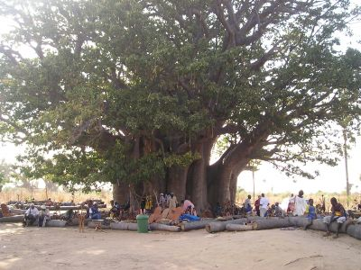
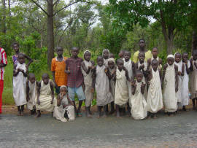
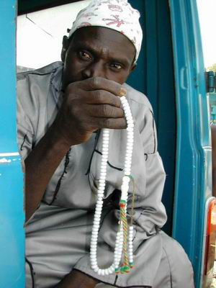

Student

Supplementary Listening Comprehension Workbook
Modules 4-6

Module 4 Lesson 1

Audio Clip 1 Track 1

Listen to a telephone conversation and fill out the chart below. Use the blank space to write any notes.

Who is calling whom (names)?
When are the two speakers planning to meet?
Day of the week
Time

Audio Clip 2 Track 2

Listen to a conversation in which someone is giving directions. Take notes. You may have to listen several times.
A. First, listen once for the general information.
B. Listen again and write down answers to the following questions:

1. Where does the person want to go?
2. What are the directions to this place?
3. Why does the person have to give up on going to this place?
4. Where is the person advised to go and how do you get there?

Audio Clip 3 Track 3

Listen and take notes about the speaker's schedule. You may have to listen several times.
When does he wake up? When does he eat breakfast? When does he go to work? How long does he work? When does he get home? When does he eat supper?

Answers

1.
2.
3.
4.
5.
6.

Audio Clip 4 Track 4

First, read over the statements below. Next, listen at least two times to a conversation between two friends.
A. The first time, listen for the general information.
B. The second time, listen for specifics: Who said what? Write down F for the Female Speaker and M for Male Speaker next to the statement.

Answers
F | Reads
F | Gets up around 8 a.m.
M | Goes to a discothèque
F | Runs
M | Sleeps in
M | Visits with friends

Audio Clip 5 Track 5

Listen to a segment of a lecture about the Pentagon in French and take notes as needed.

A. Read over the text with the missing numbers.
B. Before you hear the large numbers on audio, estimate the numbers that would logically fit in the text. Imagine the extent or size of each area and how French numbers are expressed. For example, is it, “mille” ou “million”?
C. Listen and fill in the numbers.

Au Pentagone: Le rez-de chaussée est de ___________________ m2, la zone commerciale occupe une superficie de _________________ m2.

Module 4 Lesson 2

Audio Clip 1 Track 6

General Scenario. You are participating in a geography training session about the target region conducted by a native instructor. Before listening to the training material, review the map of West Africa below.

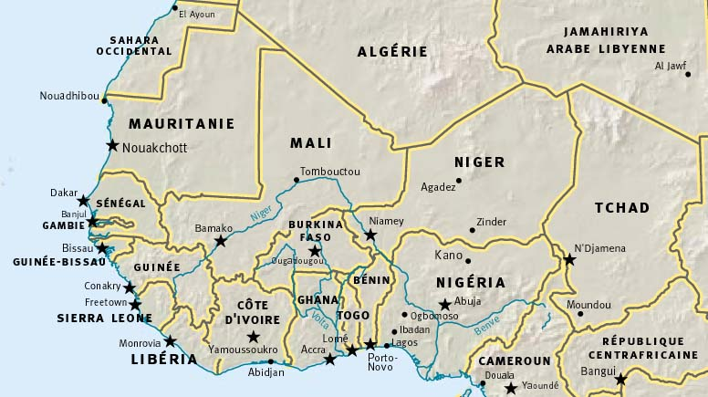

Listen to the passage as many times as you need to answer the questions.

- What is the name of the country that is the topic of this passage?
Answer: Ivory Coast.

- List the names of the countries that border the country under discussion.
Answer: Маli, Guinea, Liberia, Ghana, Burkina Faso.

- What is the area of the country in discussion? Choose the correct response:
  - 167 100 km²
  - 322 460 km²
  - 320 460 km²

- What is the area of the agricultural land in the country? Choose the correct response:
  - 1 60 700 km²
  - Over 170 000 km²
  - 167 100 km²

- Which ocean has been mentioned?
  - The Atlantic Ocean
  - The Pacific Ocean
  - The Arctic Ocean

- How many climatic zones are there in the country?
  - 3 climatic zones
  - 4 climatic zones
  - 2 climatic zones
  - climatic zones

Audio Clip 2 Track 7

Listen and choose the correct response.

- According to the passage Togo is situated:
  - in the Golf of Guinea.
  - around the Golf of Guinea.
  - away from the Golf of Guinea.

- The cultivated area in Togo is:
  - 60 % of the country’s area
  - 41% of the country’s area
  - 25% of the country’s area

- Population density in the maritime region is:
  - 71 inh/km²
  - 170 inh/km²
  - 20 inh/km²

Nota Bene : Le PIB = Produit Intérieur Brut (gross domestic product)

Audio Clip 3 Track 8

In this recording the geography instructor is discussing an important geographical feature in the Democratic Republic of Congo. Follow the steps below.

- Read the list of the geographical terms below.

- Listen to the recording and put a check mark next to the terms mentioned in the recording.

- A number of Congolese cities will be mentioned in the passage. Listen to it again. Look at the map on the following page and identify them. Describe their locations to your classmates.

  - river
  - peninsula
  - tributaries
  - strait
  - bay
  - archipelago
  - islands
  - sea
  - peak
  - cape
  - estuary
  - lake
  - rapid
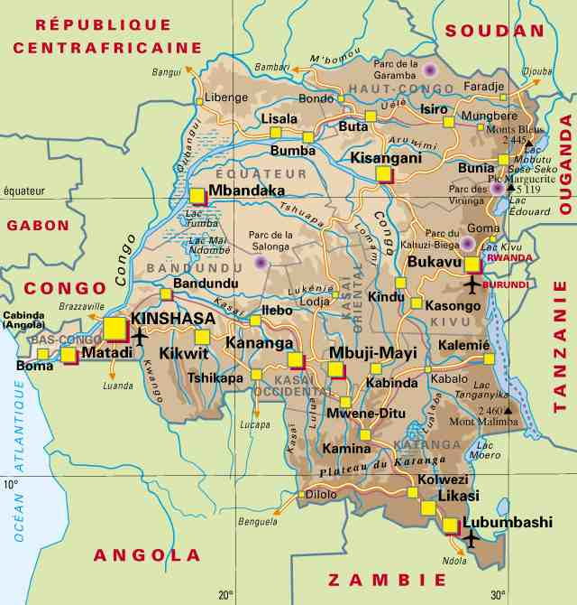

Audio Clip 4 Track 9

A. Read the list of the main ethnic groups in Senegal below, then listen to the recording and put a check mark next to the ethnic groups mentioned.

Sérères | Notes:
Yoruba
Bambara

Wolof

Peuls
Bété

Lébou
Touaregs

Saracolés

Mandingues
Toma

Bassaris
Igbos

Toucouleurs
Soussous

Diola
Hausa

B. Listen again and choose the correct response.

According to the passage:
a. The Peuls are only in Senegal.
b. The Peuls are all over West Africa.
c. The Peuls are relatives to the Mandingues.

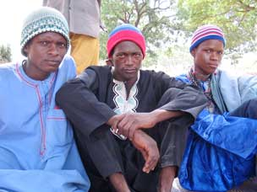

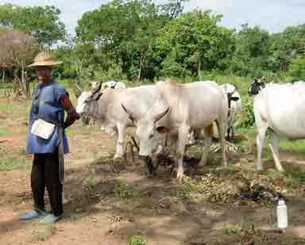
Audio Clip 5 Track 10

Challenge. A classmate was taking notes about some African countries. However, he forgot to indicate the names of the countries on which he was reporting. Look at the map and his notes to see if you can help him identify the countries based on the audio. He only wrote partial information for the neighboring countries because he wasn’t sure about the spelling. Fill in the missing segments.

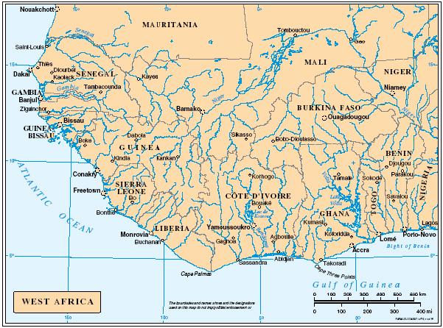

Module 4 Lesson 3

Audio Clip 1 Track 11

Listen to a conversation. A visitor is asking a passer-by for directions to the Central Market. Read the statements below and choose the correct response.

According to the passage:

a. The Central Market is three blocks ahead.
b. The Central market is three blocks back on the left side.
c. The visitor has to go back three blocks, turn left and walk 150 meters.
d. The visitor has to walk back 150 meters.

Audio Clip 2 Track 12
Listen to a conversation. Read the statements below and choose the correct response.

1. According to the passage the visitor is looking for:
a. a hotel
b. a department store
c. a supermarket
d. an office

2. According to the passage:
a. The visitor should go up to the third floor.
b. The visitor should go down to the third floor.
c. The place the visitor is looking for is across from the elevator.
d. The place the visitor is looking for is across the receptionist’s desk.

Audio Clip 3 Track 13

Listen to a conversation. A tourist is asking for directions and a passer-by is giving directions. Read the statements below and choose the correct response.

According to the passage:

a. The tourist has to walk straight until he reaches the square he is looking for.
b. The tourist has to walk straight and then make a left.
c. The tourist has to take a 10-15 minute bus ride to get to his destination.

Audio Clip 4 Track 14

Listen to a conversation. A soldier is asking for directions and a local resident is giving him the way to go. Read the statements below and choose the correct response.

In order to get to Séno Palel, you should:

a. Go around the lake until you reach a small village, drive through, turn right by the river and you will find yourself in Séno Palel.
b. Take the road going south, go around the millet fields, turn left by the hill and you will see the first houses of Séno Palel.
c. Go south across the millet fields, until you see the first houses of the village.

Audio Clip 5 Track 15

Someone gave you incomplete directions. Read the text, then listen to the recording and fill in the missing parts (10 total).

Mon village est situé entre 4 montagnes. Chaque montagne a une hauteur d’au moins 600 mètres. Pour aller à mon village, tu traverses d’abord une forêt très dense avec des arbres très épais. Ensuite, tu traverses une petite rivière à l’aide d’une grande pirogue. Puis, tu prends un chemin très étroit qui longe les champs de mil et de maïs. Ensuite tu verras un ruisseau clair à ta droite entre deux montagnes. Mon village se trouve au fond de la vallée
*NB: standard French pronunciation for corn = [mais] with the –s sound.

Module 4 Lesson 4

Audio Clip 1 Track 16

Listen to the recording at least three times. Follow these steps:
A. Listen for general information.
B. Listen again and choose the correct response to complete each portion of the sentence below.

According to the passage, the interviewed person is ________________, has served ________________, and ________________.

  - an NCO
  - an officer
  - the commander in chief

  - in France
  - in Atar
  - in Rosso

- has been a capitaine in the army for ten years
- has been a capitaine for three years
- has attempted a coup

C. Listen again to verify the information.

Audio Clip 2 Track 17

A. Listen to a new recording and choose the correct response to complete the sentence below:

- The person interviewed stated that he
  - is in the army’s Intelligence Service.
  - is a commando.
  - is a military police.

- He
- has a lot of enthusiasm for his service.
- is no longer enthusiastic about his service.
- is bored by his service.

B. Listen again and verify your answers.

Notes:

Audio Clip 3 Track 18

Listen to the conversation about mission plans and answer the questions.

1. What kind of action is being discussed? | Answers  A sabotage operation of a rebel camp in Guinea-Bissau
2. Types of weapons to be used? | Explosives, anti-personal mines, automatic light weapons
3. When will the operation begin? | Tonight at 11 p.m.

Notes:

Audio Clip 4 Track 19

Listen to an interview and choose the correct response to complete the sentence below:

The person interviewed provides the following two facts about himself:

a. He is a mechanic in the Army.
b. He was initially trained as a mechanic and as a weapon specialist in the air force.
c. He is a weapons specialist serving in the motor pool division as a disciplinary measure.

Audio Clip 5 Track 20

Listen to a segment of authentic radio news. Follow these steps.

A. Listen first for the general information. Pay special attention to cognates.
B. Listen again and choose the correct response.

According to the footage:
a. The airplane was shot by Iraqi terrorists.
b. The plane was partially damaged.
c. The plane failed to return to its base.
d. The plane crashed into the USS Cole.

Module 4 Lesson 5

Audio Clip 1 Track 21

Listen to a segment of a lecture about physical diversity of Africa. You will listen three times. Then read the list of geographical terms below, listen to the recording again and underline those mentioned:

Lake
River
Desert
Rapids
Shoreline
Shore
Mountain
Beach
Coast
Relief
Ocean
Peninsula
Plains
Sea

*Please note that when you hear, “sa géologie” the speaker mistakes this for “géographie” or the physical characteristics, especially the surface features, of an area.

Notes:

Audio Clip 2 Track 22

Read the statements below, then listen to the recording and put check marks next to any that are true.

1. The Kilimanjaro stretches over both Tanzania and Kenya.
2. The Kilimanjaro is always covered with snow.
3. The Kilimanjaro is an active volcano.

Audio Clip 3 Track 23

Listen to a quick presentation of the natural landscape, fauna and flora of Tanzania.

- Read the list of the geographical and animal terms, listen to the recording again and put a check mark next to those mentioned:

Oiseaux Hippopotame
Acacia Forêt
Rhinocéros Rivière
Chèvre Buffle
Éléphant Gazelle
Cheval Zèbre
Lion Végétation
Léopard Hyène
Âne Giraffe
Guépard

- Read the multiple-choice question below and choose the correct response.

According to the footage:

a. Most of the country is covered with scarce vegetation.
b. The environmental degradation in Tanzania is alarming.
c. A quarter of the country’s area is made up of parks and reserves.

- Look at the images below and write down as many words as you can that apply to each photograph underneath, using the vocabulary from the recording.

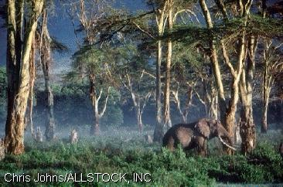 | 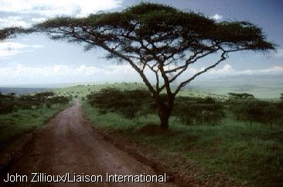

Audio Clip 4 Track 24

Listen twice to a segment of a lecture about another interesting aspect about the physical environment in Tanzania.

As indicated by the recording:

a. Lake Tanganyika is next to Lake Baikal.
b. Lake Tanganyika is deeper than Lake Baikal.
c. Lake Tanganyika is the longest sweet water lake in the world.

Notes:

Audio Clip 5 Track 25

Listen to an authentic segment of a lecture for military students.

- Choose the correct response based on the information in the recording.

a. Mali is twice as big as Mauritania.
b. Mali’s area is 1 240 000 m2.
c. Mali is the biggest country in Africa.
d. Mali is the biggest country in West Africa.

- Read the list of countries below. Then listen to the recording again and put a check mark next to those that share a border with Mali.

Ivory Coast  Libéria  Guinea  Sierra Leone | Niger  Algeria  Chad  Senegal | Mauritania  Burkina Faso  Nigeria  Togo

Module 4 Lesson 6

Audio Clip 1 Track 26

A. Read the list of geographical terms and then listen to the recording and put a check mark next to those that you heard:

forêt dense
patûrage
savane

désert
steppe nordique
plaine
climat côtier
prairie de montagne
brousse

B. Listen again and choose the correct response.

According to the recording:

a. The climate of Cameroun is mostly continental and there is no variety.
b. Cameroun is next to the equator and Chad.
c. Cameroun has dense forests as well as savannas.

Audio Clip 2 Track 27

First read the short paragraph that introduces the audio portion. Next, listen and answer the following questions:

Reading:
Pays continental et enclavé, limitrophe de la Libye au nord, du Niger et du Nigéria à l'ouest, du Cameroun au sud-ouest, de la R.C.A. au sud et du Soudan à l'est, le Tchad s'étend sur un territoire de 1 284 000 km² .

1. What are the main climatic zones in Chad?
Answer: The Saharian zone, The Sudanian and Sudano-guinean zone, and the Sahelo-Saharian and Sahelian zone.

2. From where does Lake Chad get its waters?
Answer: From the overflooding of the plains of Chari and Logone Rivers.

3. What is the measure of the precipitation in Sudanian and Sudano-Guinean zone? Answer: 600 mm.

Audio Clip 3 Track 28

Listen to a weather report and choose the correct response.

a. A hot and dry wind is blowing over the central part of the country.
b. Tomorrow’s weather report is simlar to today’s report.
c. There has been some rain in the southwestern part of the country.
d. The west is covered by a thick sand storm.

Audio Clip 4 Track 29

Listen to a disaster report and fill out the chart below.

 | Answers
Type of disaster | floods
Area/country | Northern Senegal
The number of casualties | 3
Destruction | 15 houses destroyed
Other countries affected | Mauritania

Audio Clip 5 Track 30

Listen to a segment of radio news and fill out the chart below.

According to the weather report:

a. The rainfall in the month of June has been very low in all of the Sahel.
b. Burkina Faso has had adequate rainfall in June.
c. Certain parts of Senegal, the Gambia and Mauritania got their first rains only in June.

Module 4 Lesson 7

Audio Clip 1 Track 31

Listen to a commercial and find out the topic of the ad:

a. car sales
b. trips abroad
c. car rental
d. favorable insurance rates

Audio Clip 2 Track 32

Listen to a conversation about car rentals and find out the following information:

a. The price of a 5 day rental. Answer: 12.550 F for a Renault.
b. For how long is the tourist planning to rent a car. Answer: For a week.
c. What car did he rent; the cheaper one or a more expensive one? Answer: The cheaper one.

Audio Clip 3 Track 33

Listen to a description of a new weapon in South Africa and choose the correct answer among the alternatives given below:

a. The South African authorities have released a new weapon in the market.
b. The new weapon is solidly built but hard to manipulate.
c. The new weapon is easy to maintain and costs half the price of a K-47.
d. The K-47 is not widely used in African conflicts.

Audio Clip 4 Track 34

Listen to the announcement about cars.

A. Listen once for general information. Pay special attention to cognates.
B. Listen again and mark the statements below as either true or false.

T/F
F | The Mitsubishi cars produced for export do not show any technical problems.
F | Mitsubishi cars dominate the small cars market in Africa.
T | The Mitsubishi 4X4Pagero dominates the African 4X4 market.

Audio Clip 5 Track 35

Listen to a segment of an authentic radio news report. Read the following three summaries in English and choose the most accurate one.

- The plane crash of Zambian football players happened at 11:30 am.

- The crash was due to technical difficulties.

- It is confirmed that the crash was caused by bad visibility.

Module 4 Lesson 8

Audio Clip 1 Track 36

Listen to a commercial and fill out the chart below. You may have to listen several times.

 | Answers
Destination | Senegal
Type of accommodations | Hotels built as huts
Places to visit | Gorée Island, Pink Lake, Niokoloba Park
Main cities to visit | Dakar, M’Bour

Audio Clip 2 Track 37

Help! Someone spilled a drink on the Script of a radio commercial.

A. Read the Script with the missing parts and try to predict what is missing.
B. Listen to a previous recording and reconstruct the transcript. Write in the missing parts.
C. Listen again and check your work.

Depuis plus d’un quart de siècle, Mauritanie-Voyage s’est imposée comme la compagnie principale de _____________ en Mauritanie. Fort d’un personnel _________ et dévoué, Mauritanie-Voyage met à la ____________ de ses clients une gamme variée de services et d’expertise dans le domaine du tourisme. Vous avez soif d’une _________ dans le désert, laissez les guides de Mauritanie-Voyages vous amener dans des excursions inoubliables à travers le Sahara à dos de ____________, d’ânes, ou par voiture ou avion. Ou bien si vous voulez aller seul, on peut vous trouver les meilleurs prix sur les voitures de ___________.
Si c’est l’extérieur qui vous intéresse, confiez-nous vos plans et nous vous trouverons les meilleurs tarifs dans vos companies __________ préférées et les meilleurs hôtels pour votre ___________.

Audio Clip 3 Track 38

A tourist is asking about the schedule of buses to the village of Pirogovo and Komarovo in the information booth. Listen and provide the following information. You may have to listen several times.

a. When does the bus leave for Boki Diawé? Answer: no departure time. It leaves whenull.
b. How long does it take to get to Boki Diawé? Answer: 6 hours.

c. Are there stopovers between here and Bokidiawé? Answer: one-hour stopover in N’Dioum.
d. What time does the last bus leave for Boki Diawé? Answer: 6 p.m. at the latest.

Audio Clip 4 Track 39

A. Read a Script of one side of the telephone conversation between a tourist and travel agent -- the travel agent's part. Try to see if you can predict, at least partially, what the tourist said.
B. Then listen to a recorded memo of the conversation and fill in the missing lines of the dialogue -- the tourist part.

Reading / Script

- “Togo Voyage Express”, comment puis-je vous aider?
- _____________________________________.
- Quand est-ce que vous voulez partir?
- _____________________________.
- Quand est-ce que vous voulez revenir?
- ___________________________________.
- Le billet aller-retour Lomé-Paris-Lomé du 15 Novembre au 20 Décembre va coûter 400.500 FCFA par Air Afrique, et 450.800 FCFA par Air France.
- Faites-moi une réservation avec Air France s’il vous plaît.
- C’est fait. Vous avez une réservation sur Air France.

Audio Clip 5 Track 40

Bayal is a young schoolboy who loves to go on vacation at his grandma’s. Listen to the text about his vacations and answer the questions.

1. Where does Bayal spend his vacations in general? In Guédé.
2. How far is Guédé from Dakar? 7 hours.
3. Why is Guédé a lively place during the school break? Students come back to visit with families and to help in agricultural chores.
4. Why does Bayal always have good time in Guédé? Because he gets together with many children of his age.
5. According to Bayal, where is the best place to spend one’s vacation in Senegal? Guédé.

Module 5 Lesson 1

Audio Clip 1 Track 41

Listen to the recording and mark whether the following statements are true or false.

 | T/F
1. The patient has cut his finger.  2. It’s a minor cut.  3. The nurse is going to put a bandage on the cut.  4. The procedure is painful.  5. The nurse told the patient to come back after tomorrow. | T  F  T  T  F

Audio Clip 2 Track 42

Listen to the following first-aid instructions and mark whether the following statements are true or false.

 | T/F
1. This is about symptoms and the first-aid remedy for fainting.  2. The symptoms are cold sweats and pallor.  3. One should keep the person upright.  4. One should wrap the person in a blanket.  5. If the person is diabetic and feels hungry, give him/her sugary things to consume. | T  T  F  F  T

Audio Clip 3 Track 43

Listen to the recording and underline the first aid items that were not mentioned in the dialogue.

thermometer, cotton balls, aspirin, sterile bandages, burn ointment, ice pack, laxative, safety pins, blanket, scissors

Audio Clip 4 Track 44

Listen to the recording about hemorrhages and answer the questions.

1. How many types of hemorrhages are there?
2. The first-aid should consist of what procedure?
3. What amount of blood loss is life-threatening?
4. What type of hemorrhage can be stopped safely?

Audio Clip 5 Track 45

Listen to the first aid advice to stop a hemorrhage and check whether the statements that follow are true or false.

1. One should not put one’s finger directly on the wound under any circumstances. T / F
2. One should sit a person whose leg is bleeding. T / F
3. One should not remove the injured person’s clothing. T / F
4. The injured should lie down. T / F
5. One should keep an eye on the injured person’s vital signs. T / F

Module 5 Lesson 2

Audio Clip 1 Track 46

Listen to the recording and underline the names of the organs mentioned in the dialogue.

tongue, intestine, liver, heart, abdomen, thyroid gland, kidneys

Audio Clip 2 Track 47

Listen to the dialogue and mark if the following statements are true or false.

1. What is the text about? a. the reproductive system
b. the respiratory system
c. the digestive system

2. Which of the following organs is mentioned? a. kidneys
b. intestines
c. stomach

Audio Clip 3 Track 48

Listen to the recording and complete the sentences below.

1. The percentage of water that composes the human body is

- 51 %
- 56 %
- 62 %

2. There are approximately how many cells in the human body?

- 65 billion
- 75 billion
- 65 million

3. Which of the following govern our external appearance? Underline all that apply.

- body fat
- skin color
- hair color
- bone size
- musculature
- cardio-vascular capacity

Audio Clip 4 Track 49

Listen to the recording and underline the words that were NOT mentioned in the dialogue.

1. How does the nervous system compare with the other systems of the body? It is the most complex
2. Where are unconscious functions such as thirst and hunger controlled? In the hypothalamus
3. What is the name of the bone structure that contains the bone marrow? La moëlle épinière
4. Which of the following words were not mentioned in the recording?

Nerf
Yeux
Cerveau
Cortex
Tête
Thalamus
Moëlle épinière
Colonne vertébrale
Neurones
Crâne

Audio Clip 5 Track 50

Listen to a recording about the respiratory system and answer the following questions.

1. How much oxygen does the human body need per day? 250 g
2. What are the four parts of the respiratory system? List them.

1) les voies aériennes supérieures
2) les poumons,
3) le diaphragme et
4) le système nerveux

3. What other function unrelated to breathing does the respiratory system fulfill? Provides the air needed for the vocal cords

Module 5 Lesson 3

Audio Clip 1 Track 51

Listen to the recording and choose the correct endings for the sentences below.

1. The patient has a problem with his | a. hip  b. foot  c. knee
2. The injury started hurting | a. a week ago.  b. two weeks ago.  c. a couple of months ago.
3. The doctor thinks that the patient should | a. be hospitalized  b. have an x-ray  c. do more exercise.

Audio Clip 2 Track 52

Listen to the descriptions of symptoms and select the name of a disease or sickness.

1. a. allergie
b. grippe
c. grippe intestinale

2. a. constipation
b. grippe intestinale
c. indigestion

3. a. otite
b. sinusite
c. rhume

Audio Clip 3 Track 53

Listen to the recording and choose the correct endings for the sentences below.

1. Mamadou has | a. a flu  b. appendicitis  c. pneumonia
2. Mamadou is now | a. at home  b. at the University  c. at the hospital
3. In two days Mamadou will | a. be hospitalized  b. return home  c. have a surgery

Audio Clip 4 Track 54

Listen to a piece of news and answer the questions.

1. What does Salvador fear after the earthquake? Epidemics (poor sanitary conditions)
2. How many people are left homeless? 45, 000
3. What do the hospitals lack? Emergency materials, blood and drinkable water

Audio Clip 5 Track 55

Listen to a French pediatrician’s explanation of an illness in infants and answer the questions.

1. What is the name of the disease? Is it viral or bacterial? (Acute Viral) Bronchiolitis, viral
2. At what time of the year does it strike? From November - February
3. What are the symptoms? The infant develops a minor fever, cough, wheeze and shortness of breath. There is a possible link with (later) asthma (symptoms are similar).

Module 5 Lesson 4

Audio Clip 1 Track 56

Listen to the recording and mark whether the following statements are true or false.

 | T/F
1. A man was hit by a car.  2. The casualty is unconscious.  3. The casualty is being assisted by four people.  4. The ambulance car will arrive soon.  5. The casualty should not be moved. | T  F  F  T  T

Audio Clip 2 Track 57

Listen to the recording and choose the correct endings for the following sentences.

1. The man’s wife | a. was injured.  b. is bleeding.  c. fainted.
2. The man’s wife is | a. without insurance.  b. without signs of life.  c. unconscious.
3. The nurse tells him | a. to bring the wife to the emergency room.  b. that an emergency car is on the way.  c. to give her aspirin.

Audio Clip 3 Track 58

Listen to the recording and fill out the chart below.

1. Food intoxication occurs when:  2. Germs are:  3. Symptoms of food intoxication are: | We have eaten in which the toxin liberated by bacteria has multiplied.  Carried and spread by human beings.  Nausea, vomiting, diarrhea, stomach cramps, headaches, and fever.

Audio Clip 4 Track 59

Listen to the recording and choose the correct conclusions for the following sentences.

1. In the mouth there are | a. 5 000 bacteria.  b. 50 000 bacteria.  c. 50 000 000 bacteria.
2. According to the text, to keep the teeth healthy one should | a. brush one’s teeth and floss every day.  b. brush one’s teeth twice a day and floss twice a week.  c. eat less sweets.

Audio Clip 5 Track 60

Here is an authentic segment of radio news. Follow the steps below:

A. Listen once for general information.
B. Listen for the second time and try to notice as many cognates as possible.
C. Listen for the third time and answer the questions.

Script:

Les armes chimiques et biologiques n’ont heureusement pas encore été utilisées dans les conflits en Afrique. Mais cela pourrait changer très bientôt. Les armes biologiques et les armes chimiques sont relativement faciles à faire. Leur fabrication ne demande pas de connaissance scientifique approfondie et aujourd’hui il est facile de recruter des professionnels qui s’y connaissent. Espérons que les parties en conflit en Afrique s’abstiendront d’utiliser ces armes redoutables.

Questions | Answers
1. What is the article about? | Biological and chemical weapons
2. Are these weapons used in Africa? | No.
3. Is it difficult to make biological weapons? | No. It is relatively easy.
4. Does making chemical and biological weapons require deep scientific knowledge? | No. It does not.

Module 5 Lesson 5

Audio Clip 1 Track 61

Listen to the recording and underline the medications that were not mentioned in the dialogue.

heart medication, nose drops, Nyquil, tablets, an ointment for burns, cough medicine, eye drops, syrup

Audio Clip 2 Track 62

Listen to the recording and say whether the following statements are true or false.

 | T/F
1. The customer wants to buy eye drops.  2. The customer could not afford the medication.  3. The pharmacist let him have the medication for 525 F. | F  T  T

Audio Clip 3 Track 63

Listen to the recording and mark whether the following statements are true or false.

 | T/F
1. The child is four weeks old.  2. The child was vaccinated against tetanus.  3. The child hurt himself. | F  T  T

Audio Clip 4 Track 64

Listen to the recording and choose the correct endings for the sentences below.

1. The customer needs | a. ointment for burns.  b. ointment for rashes.  c. ointment for wounds.
2. The ointment should be applied | a. every three hours.  b. every four hours.  c. three to four times a day.
3. The customer also wants to buy | a. aspirin, gauze and cotton.  b. bandages, cotton and aspirin.  c. bandages, liquid medicine and cotton.

Audio Clip 5 Track 65

Listen to the recording and answer the questions.

 | Answers
What geographical area is being discussed? | The Sahel
What kind of illness is being reported? | Malaria
What population stratum is the most affected? | Children
To what extent have the cases of this illness increased in the past ten years? | Doubled
What is believed to be the reason for the increase in malaria cases? | The building of hydraulic dams

Module 5 Lesson 6

Audio Clip 1 Track 66

Listen to the recording and fill out the chart below.

1. The ophthalmologist’s business days are?  2. The ophthalmologist’s business days hours are?  3. Date of the patient’s appointment is?  4. Time of the appointment: | Monday, Tuesday, Friday  9:00am-3:00pm  August 18th  9:00am

Audio Clip 2 Track 67

Listen to the recording and choose the correct conclusions for the following sentences.

1. The patient has a problem with her | a. hand.  b. toe.  c. foot.
2. The doctor suggests that the patient | a. has an x-ray.  b. does more physical exercise.  c. starts taking prescription medicine.

Audio Clip 3 Track 68

Listen to the dialogue and mark whether the following statements are true or false.

 | T/F
1. Amadou had his tooth removed.  2. His friend had his tooth removed, too.  3. Amadou and his friend have the same dentist. | T  F  T

Audio Clip 4 Track 69

Listen to the recording and mark if the following statements are true or false.

 | T/F
1. The hospital was built 3 years ago.  2. There are eleven departments in the new hospital.  3. It took a long time to equip the hospital.  4. The medical equipment was bought in Switzerland. | T  F  T  F

Audio Clip 5 Track 70

Listen once for general information and answer the questions.

 | Answers
1. Who is Diyé Bâ? | Health minister
2. What problem is she talking about? | Aids
3. Through what medium did she address it? | A press conference

Module 6 Lesson 1

Audio Clip 1 Track 71

Listen to the dialogue between the two friends and fill out the chart below.

1. The name of the movie that Penda went to see  2. The name of the movie director  3. John is planning to see the movie on  4. The title of another movie from the same director | “Le Camp Thiaroye”  Sembène Ousmane  Wednesday  “Le Mandat”

Audio Clip 2 Track 72

Listen to the announcement and mark if the following statements are true or false.

1. The Paris-Dakar Rally is held twice every year.  2. Only French and African cars participate in the race.  3. Paris-Dakar is a test of technology and nerves.  4. The motorcycle crossing of the desert is one of the  highlights of the race. | F  F  T  T

Audio Clip 3 Track 73

Listen to the recording and choose the correct endings for the sentences below.

1. The movie theatre is located | a. in the center of the city.  b. near the central market.
2. The Reubeus shows | a. African movies.  b. American movies.
3. The price of a ticket is | a. 150 F CFA.  b. 25 FCFA

Audio Clip 4 Track 74

Listen to the recording and mark if the following statements are true or false.

 | T/F
1. Thione Seck is a singer.  2. Thione Seck is only known in Senegal.  3. Thione Seck plans to produce ten albums.  4. Thione Seck is removed from the social problems that Senegal confronts. | T  F  F  F

Audio Clip 5 Track 75

Listen to a segment of radio news and fill out the chart below.

Name: | Baye Yéli
Profession (type of art): | Actor
Age the artist died: | 45
Senegalese group he performed with: | Daaray Kocc

Module 6 Lesson 2

Audio Clip 1 Track 76

Listen to the recording and fill out the table.

1. Name: | Roger Milla
2. Profession: | Soccer Player
3. Country of origin: | Cameroon
4. Countries in which he performed his talent: | Cameroon and France
5. Record set in a World Cup | Old player to score a goal
6. Place of residence after retirement | Cameroon
7. Current plans | Write his memoirs

Audio Clip 2 Track 77

Listen to the recording and mark if the following statements are true or false.

 | T/F
1. The African Nations Cup took place in March 2000.  2. Cameroon won the Olympic gold medal in soccer over Nigeria.  3. Nigeria had lost against Brazil during the Olympic games in Atlanta.  4. Africa is a back-to-back Olympic champion in soccer. | T  F  F  T

Audio Clip 3 Track 78

Listen to the recording and check whether the statements below are true or false.

- The soccer game is between Senegal and Guinea.  - Tomani Keita wants supporters to pay a fee of 12 000 F.  - Tomani Keita is the president of Senegalo-Guinean soccer federation.  - There is no charge for watching the game at the stadium. | T/F
T
F
F
T

Audio Clip 4 Track 79

Clip 1
Listen to the recording and answer the questions.

1. What happened this morning in Nouakchott?
2. What personalities were present at the event?
3. Who is Diallo?
4. What is the goal of the academy?
5. How many youngsters will be trained on a yearly basis?

Clip 2
Listen to the segment of radio news and choose the correct response.

A. A Romanian gymnast lost her gold medal because a trace of an illegal substance was discovered in her organism.
B. A Romanian gymnast will sue the Olympics Committee to allow her to keep her gold medal which she lost due to the presence of an illegal substance in her body.
C. Because of the circumstances, a Romanian gymnast was allowed to retain her gold medal even though she tested positive for an illegal substance.
D. A Romanian gymnast will be given back her gold medal after it was taken from her on charges of testing positive for an illegal substance.

Module 6 Lesson 3

Audio Clip 1 Track 80

Listen to the dialogue and mark if the following statements are true or false.

 | T/F
1. John and Amadou are discussing about what to do for the New Year’s celebration.  2. Yéro suggests that they go to M’Bour.  3. Going to a nightclub was not considered.  4. John wants a private house party. | T  T  F  T

Audio Clip 2 Track 81

Listen to the dialogue between husband and wife and choose the correct endings for the sentences below.

1. The couple will go to | a. an uncle’s house  b. the firemen’s festival  c. the flower festival
2. One of the activities at the festival will be | a. book signing  b. a rock concert  c. games for the children

*Note speakers may use the future: Il y aura or conditional aurait for will be / would be.

Audio Clip 3 Track 82
Listen to the dialogue between the two friends and fill out the chart below.

1. Name of the holiday the friends are talking about is  2. What does the second speaker usually do? | the Lovers’ Holiday (Valentine’s Day)  Take his girlfriend to a restaurant and give her flowers

Audio Clip 4 Track 83
Clip 1
Listen to the dialogue between two friends. Read the list below and underline the food items that were mentioned in the dialogue.

carrots, milk, chips, meat, hotdogs, onions, beverages, fruit, dessert

Clip 2
You will now listen to an authentic news segment from the Burkinabe television. Listen and determine the name of the holiday being discussed, and choose the correct response:

The reporter describes the holiday as:

A. the most important holiday in Islam.
B. the second most important holiday for Moslems
C. the favorite holiday in Senegal.

Module 6 Lesson 4

Audio Clip 1 Track 84

Listen to the recording and mark if the following statements are true or false.

 | T/F
1. The “maison des esclaves” is on the Gorée Island.  2. Gorée Island is in Cape Verde  3. The “maison des esclaves” has been declared a world heritage | T  F  T

Audio Clip 2 Track 85

Listen to the recording and choose the correct endings for the sentences below.

1. The building the friends are talking about is a | a. palace  b. cathedral  c. shopping center
2. Pierre Fakhoury was | a. an architect  b. a friend of Houphouët-Boigny  c. the founder of the project

Audio Clip 3 Track 86

Listen to the recording and choose the correct endings for the sentences below.

1. The friends are talking about | a. a museum  b. a theatre  c. a concert
2. Peter Gabriel is a | a. sculptor  b. singer  c. soccer player
3. Peter Gabriel and Youssou N’Dour: | a. play in the same band  b. are acquaintances  c. have produced an album together

Audio Clip 4 Track 87

Clip 1
Listen to a dialogue and mark if the following statements are true or false.

 | T/F
1. John went to church on Easter.  2. Céline and her brother visited John.  3. John ate at Ibou’s place.  4. John and his brother visited Ibou. | T  F  F  F

Clip 2
Listen to an authentic segment of the radio news.
A. Listen once for the general meaning.
B. Listen for the second time and determine the occasion being reported. Choose the most accurate response.

A. The organization of a peace prayer.
B. The opening of new mosques.

C. The celebration of the Muslim New Year.

Module 6 Lesson 5

Audio Clip 1 Track 88

Listen to a passage about Samba’s plans and fill out the chart.

1. The city where Samba’s parents live is:  2. The country where Samba’s friends are from is | Diourbel  The United States

Audio Clip 2 Track 89

Listen to the recording and mark if the following statements are true or false.

 | T/F
1. Ibou and Sokhna’s wedding is on the 9th of June.  2. The religious ceremony will take place at 11 o’clock.  3. Big festivities will take place afterwards.  4. Family members will be at the religious ceremony | F  F  T  T

Audio Clip 3 Track 90

Listen to the recording and choose the correct endings for the sentences below.

1. The participants of the dialogue are in | a. Paris  b. Dakar  c. Kaolack
2. The couple will go to the museum | a. in the afternoon  b. in the evening  c. in the morning
3. Afterwards the couple wants to go to | a. the movie theater  b. the theater  c. a restaurant

Audio Clip 4 Track 91

Clip 1
Listen to the following recording and fill out the chart below.

1. People who introduced yam in the Ivory Coast  2. The Yam holiday is:  3. Number of Akan tribes  4. What happens to the offerings | The Akan people  In February  11  One part will be burned, the other distributed among participants

Clip 2
Hors d’oeuvre
Listen to a segment about some important Senegalese heroes and match the birth dates of each personality on the left with the information on the right by drawing the connecting lines.

1797 | Former parliamentarian in the constitutional assembly, he became the first president of independent Senegal.
1906 | A second World War veteran, he is an autodidact who worked odd jobs in Paris before launching a prolific career as a writer and movie producer.
1923 | Led the resistance to the colonial penetration in West Africa. Fought the French until his death.

Module 6 Lesson 6

Audio Clip 1 Track 92

Listen to the recording and perform the tasks.

1. Underline the correct name of the singer mentioned in the dialogue | Gawlo  Coumba Gawlo  Coumba
2. Underline the name of the concert hall where the friends are going | La Maison des jeunes  Au stade  A la plage
3. Underline the correct date of the concert | Le 19 août  Le 13 août  Le 26 août
4. Underline the correct time when the concert starts | 17:00  19:00  14:00

Audio Clip 2 Track 93

Listen to the dialogue between a bank clerk and a customer and choose the correct endings for the sentences below.

1. The current exchange rate is | a. 2,500 Guinean Francs for one French Franc  b. 2,500 French Francs for one Guinean Franc  c. 3,000 French Francs for one Guinean Franc.
2. The customer is traveling to | a. France  b. Senegal  c. Guinea
3. The customer wants to: | a. sell Guinean Francs  b. buy French Francs  c. buy Guinean Francs

Audio Clip 3 Track 94

Listen to the dialogue between Koffi and his friend and choose the correct endings for the sentences below.

1. Koffi plans | a. to go to the polling station to vote  b. to go to a concert  c. to go to a political rally
2. The leader of the Parti Démocratique Républicain is | a. Laurent Gbago  b. Alassane Traoré  c. Konan Bedié

Audio Clip 4 Track 95

Clip 1
Listen to the dialogue between Amadou and John and answer the questions.

Script:

– Je voudrais aller au “Cocody” ce week-end. Ça t’intéresserait de venir?
– C’est quoi le “Cocody”?
– C’est une grande boîte de nuit qui vient d’ouvrir au centre-ville. On y joue toutes sortes de musiques.
– Quand est-ce que tu voudrais y aller?
– Je ne suis pas encore sûr. Quel est le meilleur jour pour toi?
– Je préfère le vendredi soir car je suis de garde le dimanche.
– A quelle heure dois-je venir te prendre?
– Je serai prêt à 21 heures.
A. Où est-ce que Amadou et John veulent aller ce week-end? Au “Cocody”
B. Où se trouve le “Cocody”? Au centre-ville
C. Quel genre de musique joue-t-on au “Cocody”? Toutes sortes de musique
D. Pourquoi John a-t-il choisi d’aller le vendredi soir ? Il est de garde le dimanche

Clip 2

Listen to the segment of radio news and choose the best response to complete the sentences below.

According to the passage, the meeting concerned ?

A. the changing weather patterns in the area of the Pacific Ocean.
B. excessive fishing in the European part of the Atlantic Ocean.
C. possible reasons for the decrease of fish supply.
D. the increasing level of pollution of the ocean waters.

The Senegal River:
A. is common to Mali and Senegal and is an important source of livelihood for the majority of the population of these countries.
B. is common to Mauritania, Senegal and Mali but does not constitute an important source of livelihood for the majority of the populations of these countries.
C. is common to Mauritania, Mali and Senegal.
D. belongs to Senegal alone.

Module 6 Lesson 7

Audio Clip 1 Track 96

Listen to the dialogue between John and Penda and mark if the following statements are true or false.

 | T/F
1. Penda will give John gloves for his birthday.  2. Amadou has already bought a present for John.  3. Penda thinks that John will like an all-paid trip to the M’Bour beach. | F  F  T

Audio Clip 2 Track 97

Listen to the dialogue between Amadou and Penda and choose the correct ending for the following sentences.

1. Amadou is going to have a birthday party for  John | a. this Saturday.  b. next Saturday.  c. this Sunday.
2. The party will start at | a. 1:00 p.m.  b. 3:30 p.m.  c. 3:00 p.m.
3. Penda volunteered to | a. cook the food.  b. buy all the drinks for the party.  c. invite guests.

Audio Clip 3 Track 98

Listen to the dialogue between Doudou and Koffi and fill out the chart below.

 | Doudou | Koffi
1. Name of the school they apply to | École des journalistes de CESTI | Medical School
2. Exams they are going to have | French, History, Sociology, Geography | Math, Natural Sciences, Chemistry and French
3. Dates of the first exams | September 13th | August 29th

Audio Clip 4 Track 99

Clip 1
Listen to the conversation between Amadou and Penda and choose the correct endings for the sentences below.

1. Friday is | a. the 19th  b. the 9th  c. the 10th
2. Penda suggested that the party be on | a. Friday  b. Saturday  c. Sunday
3. Penda wants the party to start at | a. 7: 30 p.m.  b. 2:30 p.m.  c. 8:30 p.m.

Clip 2
Listen to the authentic segment of radio news and choose the best response.

The passage is about:

A. The new budget proposal.
B. The reduction of the external debt.
C. A meeting held in the Ministry of Finance on August 17th.

