SOLT French Module 3 Lesson 1
Instructor Manual

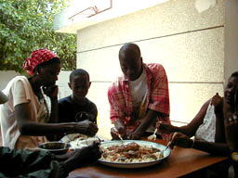
Food and Drink

At the end of this lesson, you will be able to talk about West African food and drinks.

Offer Food and Drink

- Invite somebody to dinner at your house
- Plan a dinner party
- Plan a picnic
- Compare different types of food in the US and Francophone Africa
- Talk about table manners in Francophone Africa

Discuss Quality and Quantity of Food Items

- Specify the meal times for breakfast, lunch, and dinner
- Discuss dishes and utensils

Order a Meal in a Restaurant

- Identify food items and beverages
- Make a restaurant reservation
- Talk about cafeteria and fast foods
- Read and ask about items on the menu
- Talk about the variety of ethnic dishes

Shop for Goods/Services

- Plan the grocery list
- Shop for groceries
- Recognize types of packaging used in the markets
- Purchase items at the butcher shop, bakery, grocery store, open-air market, and a supermarket
- Purchase personal items
- Purchase fuel
- Purchase water
- Purchase wood for construction

Like many other places in the world, in Senegal, there are 3 main meals: breakfast, lunch and dinner. There are usually specific dishes for each mealtime. Breakfast is less formal than the other two main meals in that it does not require people eating together at the same time. It usually consists of having something as simple as a cup of coffee and a slice of bread or having a bowl of one of the many local puddings. Following the French, lunch represents the most important meal of the day. Family members and guests usually converge at home around noon to share their meal together. Chances are that you will have Thiébou Diène as a lunch meal in ninety-nine percent of Senegalese households. For some Senegalese, there is just not lunch without Thiébou Diène. Yassa and Maffé are also popular lunch meals and, if prepared by an expert, they can also be a delight. Dinner is the second most important meal in Senegal. In urban centers, it is gaining in importance because of the long working hours. Dinner usually consists of Thiéré (made of sorghum or millet grain) and meat. Read the scenario below and have a class discussion about cultural traditions and invitations to dinner.
Scenario:
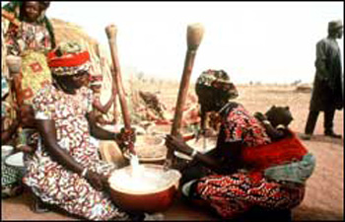

A Dinner Invitation
Amadou invites John to dinner for a local meal prepared by his wife.

Amadou: Est-ce que tu es libre demain soir?
John: Oui, pourquoi?
Amadou: Je t’invite à manger chez moi. Ma femme est une
excellente cuisinière. Elle va préparer un plat typique Cook / dish
du pays.
John: D’accord. A quelle heure?
Amadou: A six heures et demie.

Exercise 1 (Class Work)

Go over the following questions with your class for a group discussion. Share ideas about meals and invitations. For example, do we follow a standard practice when inviting someone to eat at our place?

- What is the most important time for a meal in your household?
- Would you invite someone over early before the meal to have a drink? How much earlier?
- When you invite someone to dinner, is it more common to go out or stay at home for a home-cooked meal?
- Would you have a formal or an informal dinner the first time you invite someone over or to go out and eat?

To extend an invitation for a meal:
Practice these ways of inviting someone to dinner. Follow your instructor’s model.

Formally: je vous invite à manger.
Informally: je t’invite à manger.

Exercise 2 (Pairs)

Invite your partner to eat dinner at your place. Begin the dialogue with the expressions above and decide between an informal or formal invitation. Continue your conversation and be ready to present.

Plan a dinner party

Amadou’s wife is making a list of things to do for the dinner party.
Demain matin, je dois d’abord faire le ménage. Ensuite, je vais faire les courses, puis la cuisine. Je vais cuisiner du *Thiébou Diène. Après, je vais mettre la table.

*Thiéboudienne—au Sénégal, ce plat traditionnel est généralement composé de poisson et de légumes.
Spelling of names for special regional dishes like thiéboudienne or maffé may vary.

Exercise 3

Put in the right sequence the steps that Penda will follow. Next, list the adverbs of sequence and their English equivalents.

Cook 3 do the house work 1 set the table 4 do the shopping 2

d’abord (first/firstly), ensuite (next/then), puis (next/then), après (afterwards/after)

Exercise 4 (Pair Work)

Answering the following questions in French should give you an idea on how to plan a dinner party. Once you have answered these questions get with a partner and invite him/her to your party.

- Why are you planning this party?
- What do you want to celebrate?
- When and where is the party going to take place?
- At what time is it going to be?
- What are you going to cook? Is someone going to give you a hand?
- Who are you going to invite?

Answer Key: Answers may vary.

Exercise 5 (Pair Work)

You and your partner/roommate are inviting a friend for a meal at your house. You are also inviting two other classmates, for a total of five people. Make a list of the items you need, as well as a to-do list to get everything ready. Your partner has already made a list of ingredients. Begin with his or her command and present to the class:

Fais ton menu avec les ingrédients listés ci-dessus:
After making your list, have a class discussion and answer the questions below:

1. Compare the the party list with what you buy when you go grocery shopping.
2. What types of food do you like and dislike from the list you compiled?
3. What are the items you regularly buy from this list?
4. Add an item to a list that represents a regular shopping list for language school students.

Answer Key: Answers may vary.
Plan a picnic

Listen as your instructor review the names for each picnic item below. Practice saying each item in the singular and plural. Your instructor will ask a few students to read aloud.

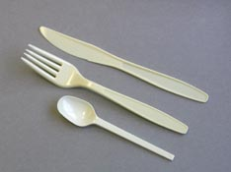
couverts plastique
goblet transparent

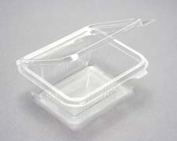
barquette avec couvercle

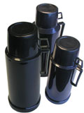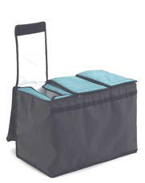
bouteille thermos
glacière
Read the following dialogue and answer the questions to follow.

Julie is making plans to take her family for a picnic.

Julie: Les enfants, qu’est-ce que vous voulez emmener pour le pique-nique demain?  Isabelle: Moi, je veux des chips et un sandwich au fromage.  Julie: Et toi, Mike, qu’est-ce que tu veux?  Mike: Moi, je veux un sandwich au jambon.  Julie: Et en dessert?  Isabelle et Mike: Un gâteau au chocolat!  Julie: Bon. Nous allons emmener des boissons fraîches et un thermos de café. Je vais préparer des sandwichs et des chips. Je vais faire un gâteau au chocolat. Nous allons aussi emmener des fruits et des goblets. Vous apportez une glacière et aussi des couverts. | Bring  Cheese  Ham  Cake  Cold drinks

Vrai ou Faux?

1. Ils vont faire un pique-nique aujourd’hui F demain
2. Mike va manger un sandwich au jambon. V
3. Ils vont manger des sandwichs, des chips, du gâteau et des fruits. V

Exercise 6 (Pairs)

You and a classmate are planning a picnic for four to six people. Discuss what type of food and drinks you want to prepare and/or buy and who should bring what. Include paper plates, cups, plastic utensils, and condiments to your list. Here are some food items mentioned in the dialogue above. Use these to get started.

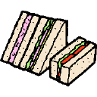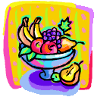
des sandwichs une boisson fraîche des chips des fruits un gâteau

Basic Dishes and Utensils:
La Table
une assiette

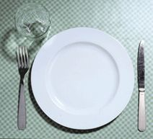
un verre
une fourchette
un couteau

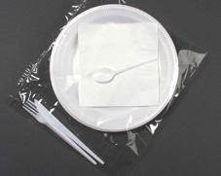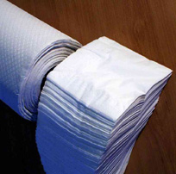
une tasse
diverses vaisselles en plastiques
serviettes (sets de table)

Exercise 7 (Pairs)

All of the dishes are dirty! Use the plastic silverware to describe how you will set the table. Take turns adding to the setting. Begin with: Je vais mettre la table.
Je vais mettre la table avec … 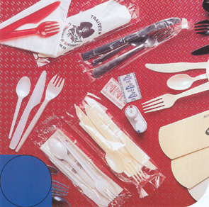
couverts
Tip of the day: Eating habits in West Africa

In West Africa, eating with your hands is a very common practice, especially in predominantly Muslim countries. Usually people share their meals together around a big bowl after washing their hands with soap and clean water. The practice is to eat with the right hand. If you are left handed, you should try and practice using your right hand before you get in a real life situation. If you have trouble, your hosts would be glad to teach you the intricacies of this “art” and they will certainly get a kick out of it. Africans appreciate anyone who tries to adapt to their culture and regional or local customs. Eating with your hands as you dine with the local people is certainly the ultimate proof of your willingness to accept their way of life.

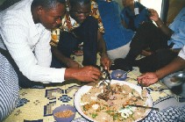
Senegalese meal seated on the floor and serving from the common platter

Food in West Africa

Read as Amadou talks about his eating habits and a speciality of Senegal.

Amadou:  Je prends le petit-déjeuner à sept heures. Je bois du café et je mange du pain avec de la confiture. Je déjeune à midi. Au déjeuner, je mange du Thiébou Diène (du riz au poisson). Ensuite, je bois un verre de thé à la menthe. Le soir, je dîne vers huit heures. Je mange du Thiéré (du couscous) et de la viande. | Have breakfast/drink  Have lunch (verb)

*Note to the instructor: select one student to read each part text aloud. Text continues on the next page.
John is curious about the dish Amadou talked about. He asks what it is made of and Amadou continues to explain:
Amadou:
Au Sénégal, ce plat traditionnel est généralement composé de Tiof, un poisson local. Le colin est le poisson qui lui ressemble le plus mais on peut aussi lui substituer un poisson maigre tels marlu, aiglefin, dorade, congre, etc.

Exercise 8 (Group Work)

In groups of 3, discuss the speciality Amadou describes. Look up each new vocabulary word such as ingredients and be prepared to have a discussion with your opinions about the meal.

Meal times

Le petit déjeuner 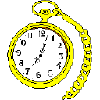 | Le déjeuner   | Le dîner  

Exercise 9

Your instructor will start a chain by asking À quelle heure est-ce que tu prends le petit déjeuner? Each student answers, and then asks a similar question to another student. Ask about all meals of the day. Have your answers ready to present. Also, think of using expressions with nous, on, etc. Examples: Chez moi, nous mangeons / dinons vers 19h. Mais, Paul et sa famille mangent vers 20h le soir.

Compare different types of food in the US and Francophone Africa

Exercise 10 (Class Work)

Go over the “breakfast philosophy” and a breakfast menu. Discuss differences between this style and an American breakfast. Be prepared to present your answers.
Breakfast philosophy: eat what you might for dinner, only earlier, when you need the most energy.
A protein-packed power breakfast menu: Juicy fried chicken spiked with loads of black pepper and garlic, served with salad and a hefty spoonful of mayonnaise, and sautéed kidneys and onions with petits pois.

Petit-déjeuner américain |  | Petit-déjeuner (afrique)
PROS | CONS | PROS | CONS

Food preparation

MAFFE AUX CACAHUETES
Découper le boeuf (ou le poulet) en morceaux d'environ 50g. Dans une cocotte, faire chauffer l'huile et bien dorer les morceaux de viande. Retirer.
Mettre dans la cocotte les oignons émincés et faire blondir doucement. Ajouter les tomates pelées, épépinées et concassées.
Remuer et faire cuire pendant cinq minutes. Mouiller, ajouter les légumes, le sel, le poivre et couvrir. Laisser mijoter très doucement pendant trente minutes. Ajouter la viande et la pâte d'arachides diluée dans un peu d'eau.
Couvrir et servir après 1/2 heure avec du riz créole (cuit à la vapeur).

Exercise 11

The recipe above is approximately translated below, but the various steps are not in the right order. Reconstitute the correct order.

a. Put the onions in the pot and cook till golden. Add the tomatoes. 2
b. Cover and serve 30 minutes later with steamed rice. 4
c. Cut the meat in small pieces. Warm the oil in a pot and cook the meat until brown. Put aside. 1
d. Stir and cook for 5 minutes. Add water, the vegetables, salt, pepper, and cover. Simmer for 30 minutes. Add the meat and the peanut paste diluted with a little bit of water. 3

Exercise 12 (Class Work)
Your instructor will ask a student to read the excerpt below. Discuss the following menu that describes a traditional Senegalese dish. Share your opinions about the ingredients. Would you like to try this dish? Why or why not?
Yassa au poulet
C'est le parfum du citron vert, de l'ail, et du clou de girofle.
On le sert généralement sur un lit de riz dans un grand plat de service placé au centre de la table et les convives le dégustent ... avec les doigts.
Au Sénégal, on a l'habitude de battre chaque morceau avec un couperet pour l'attendrir avant de le déposer dans sa marinade.
Exercise 13 (Pair Work)
Now that you know what Yassa is made up of, read the steps for preparation. With your partner, go through each step and be prepared to act out a couple of steps in front of the class.
Préparation
- déposer le poulet dans la marinade: jus des 10 citrons verts, l'oignon et le piment coupés en lamelles; assaisonner (sel, poivre, thym, laurier) et laisser mariner 12 heures;
- retirer le poulet de la marinade; éponger; faire griller sur le gril ou dans un four bien chaud pendant 45 à 60 min.;
- pendant ce temps, préparer la sauce: chauffer l'huile dans une casserole; ajouter les oignons, la marinade préalablement passée au chinois et porter à ébullition;
- ajouter le poulet et laisser mijoter 15 min.;
- servir avec du riz.
Food items and beverages

  du lait | 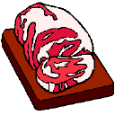  de la viande |   du poisson |   du fromage
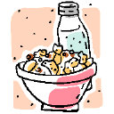  des céréales | 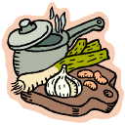  des légumes | 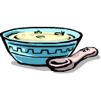  de la soupe |   du jus d’orange
  de l’eau | 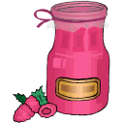  de la confiture |   du vin | 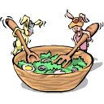  de la salade
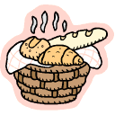  du pain |   de la bière | des fruits | 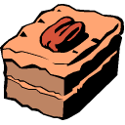  du gâteau

Viandes |  | Légumes |  | Fruits
  du poulet |  | 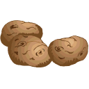  des pommes de terre |  |   des pommes
  du bœuf |  |   des haricots verts |  | 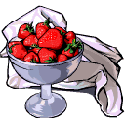  des fraises
  du veau |  |   des petits-pois |  |   des poires
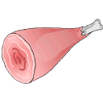  du porc |  |   des tomates |  |   de la pastèque
  des concombres | 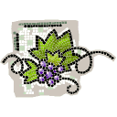  du raisin
Tip of the day: the Cola Nut, Goro
After a copious meal, especially during holidays and ceremonies, a cola nut is used to complete the meal. The cola nut is broken into small pieces and shared between family and friends.
The cola nut has a very special meaning in West African Cultures. It is used to seal agreements and contracts. For example it is widely distributed at weddings, naming ceremonies, and conflict mediation.

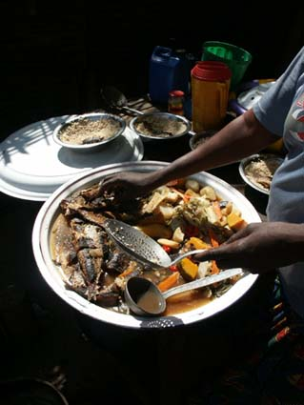

Exercise 14 (Group Work)

In groups of 3, describe the picture above. Imagine three large platters of rice, vegetables and fish for two euros. With your group discuss lunch dishes and preference. Present your description to the class.
Types of packaging (food shopping)

With a partner, practice the mini-dialogues where you use expressions for food shopping at the marché. First, review different types of quantity expressions such as:

  une boîte de conserve |   une bouteille de vin | un pot de confiture à la fraise |   un paquet de biscuits

Exercise 15 (Pair Work)

Vous désirez?
un kilo = 1000 grams
une livre = 500 grams
Je voudrais | un kilo de tomates.
| une livre de carottes.
une douzaine = a dozen

Et avec ça? {Anything else?}

Donnez-moi aussi une douzaine d’œufs.

C’est tout? (Is that all?)

Oui, c’est tout.

Ça fait combien? (How much is it?)

Alors ça fait trois mille francs (CFA).

Shop for groceries

Read Penda’s shopping list:

- 3 litres d’eau
- 1 litre de jus de fruit
- 1 poulet
- 2 kilos de tomates
- un paquet de riz

Amadou adds a few items that Penda has forgotten for the meal and some important information about how long it will take, if it will cost a lot, etc.:

- 200 g de patates douces
- 200 g de carottes

Temps de préparation: moins de 30 min.
Temps de cuisson: environ 1H15
Coût: raisonnable

Exercise 16 (Pair Work)
Tell your partner information about a meal you like to make or one you like to eat. Do you know how long it takes to prepare? To cook? How much it costs? If it is easy or hard to make? Fill in the chart:
Temps de préparation:

Temps de cuisson:

Coût:

Difficulté:

Where will Penda go to do her shopping? Your instructor will ask a few students to read the following sentences about stores where you can buy different food items.

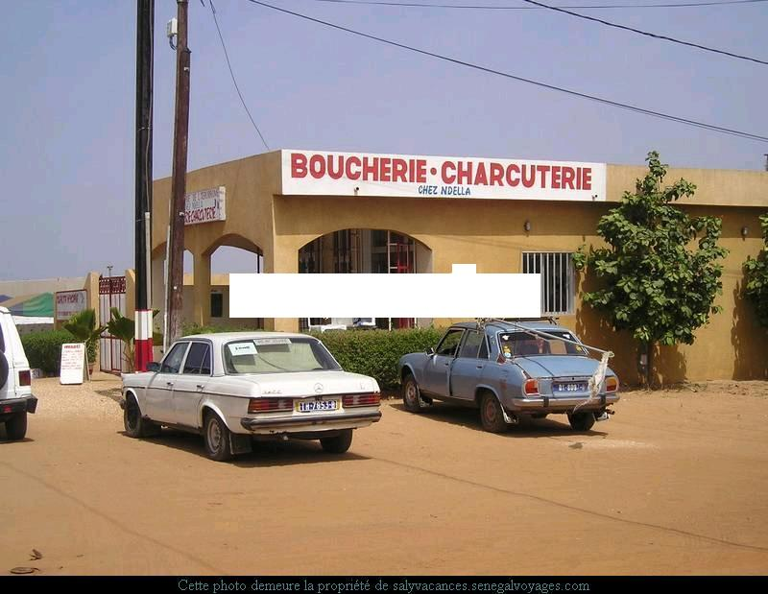
On va à la boucherie pour acheter de la viande.

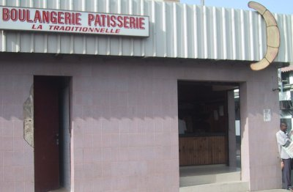
On va à la boulangerie pour acheter du pain.
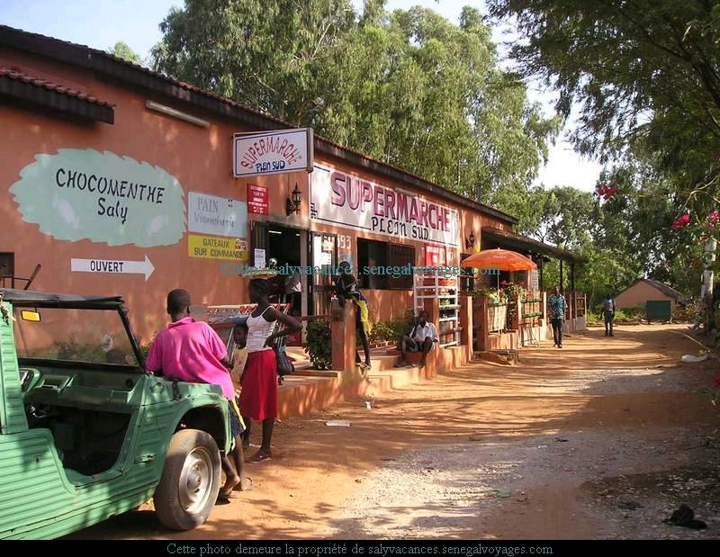
On va au supermarché ou à l’épicerie pour acheter ...
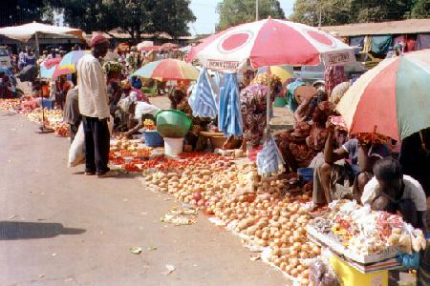
On va au marché pour acheter des légumes et des fruits.

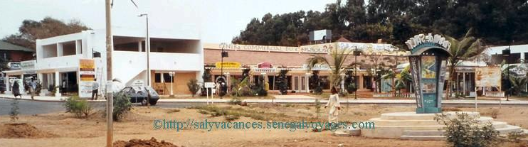
Ou on va au centre commercial.
Exercise 17 (Pairs)

Correct your partner’s errors in the following sentences: C’est faux, on va à la, au, à l’ [...] pour acheter [...]. Tell him where he goes (should go) to buy certain foods.

1. On va à la boulangerie pour acheter un poulet. boucherie
2. On va à l’épicerie pour acheter du sel. (ou au …)
3. On va à la boucherie pour acheter du pain. boulangerie
4. On va au marché pour acheter des pommes. (ou au …)
5. On va au marché pour acheter du Coca. supermarché / centre commercial
Exercise 17 (Class Work)
Take turns asking your partner about running errands. Begin with: Où est-ce que tu vas pour faire les courses? Continue the conversation naming at least 3 stores you like to shop in.

Answer Key: Answers may vary.
Tip of the day: Best places to eat in Africa.

While almost all types of restaurants serve traditional food, it is generally admitted by the local population that the best cuisine is found not in high standing restaurants but in those situated in popular neighborhoods. In order to have the best Athiéke or Poisson Braisé, for instance, Ivorians of all social or economic standing, rush to the Maquis (neighborhood restaurants/bars often run by a family or a single owner. Maquis are the most lively places in the Ivory Coast) to satisfy their craving because of the home cooking “feeling” they get out of eating in these places.

Restaurant reservations

Read the scene where John makes a reservation to have dinner in a restaurant. Your instructor will ask 2 students to role-play the situation in front of the class.

Réceptionniste: Restaurant Keur Samba, je vous écoute.
John: Bonjour Madame. Je voudrais réserver une table pour trois personnes pour dîner ce soir.
Réceptionniste: A quelle heure?
John: A 19 heures.
Réceptionniste: Votre nom, s’il vous plaît.
John: John Ryan.
Réceptionniste: Bien. J’ai donc une réservation pour trois personnes à 19 heures sous le nom de John Ryan. A ce soir, monsieur.
John: Merci. Au revoir.

Make a restaurant reservation

Exercise 18 (Pair Work)

Imagine that your best friend has just married and you want to celebrate this happy event in a restaurant. To do that you need to reserve a table for four people. You also would like to try some traditional dishes.
Prepare a simple telephone conservation between the restaurant manager and you. Then read your script in front of the classroom.
Mention:
(The day) le jour (time) l’heure (number of people) nombre de personnes

Exercise 19 (Pair Work)

In this exercise, prepare a telephone conversation to invite your friends mentioned above to explain your dinner plan. Read your script with your partner.

Answer Key: Answers may vary.

Talk about cafeteria and fast foods

Fast food is taking a large place in traditional restaurants.

Exercise 20 (Pair Work)

Fast food restaurants, many of which belong to multi-national American companies like Coca Cola or KFC, are becoming increasingly popular in Francophone countries. Practice some expressions that may be used in those restaurants with your partner.

Examples:
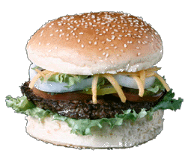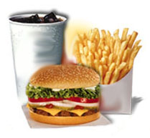 | 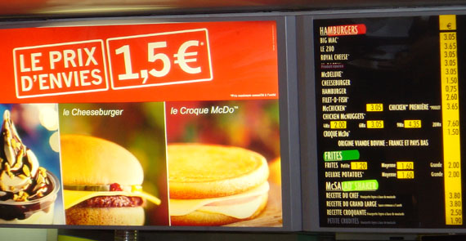 | 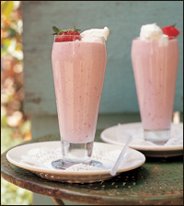
Menu Best of | Le Croque | Dessert (milk-shake)

*Super size = Menu maxi best of

Answer Key: Answers may vary.

Exercise 21 (Class Work)

How do you think you would translate a slogan like “I’m loving it?” Would the slogan be completely different in another country? Would it be word for word? What do you think about the fast-food invasion?

*Note to the instructor: write the slogan on the board after a discussion: C’est tout ce que j’aime.

Tip of the day: Bills and tips in restaurants

Even though people bargain for almost everything in Africa, it is not customary to haggle over prices in restaurants. A regular customer might be allowed to pay lower that the running prices. However, this would be more of a social gesture than a usual business practice.
Furthermore, bills handed at the end of meals do not include tips. Even though there is not a fixed amount, most servers expect tips from their customers and, in general, they expect fatter tips from their Western guests than from local diners.

To ask for the bill: L’addition, s’il vous plaît!

Ordering a meal

John, Amadou, and Penda are looking at a menu. Three students will role-play the scene for the class.

Menu | Prix
Omelette | 200 F
Yassa | 300 F
Poulet | 750 F
Maffé | 275 F
Thiébou Diène | 300 F
Steak | 800 F
Poisson grillé | 500 F
Chawarma | 600 F
Couscous marocain | 700 F
Thiakri | 150 F
Bissab | 150 F
Coca | 200 F
Lait caillé sucré | 250 F

Serveur: Bonjour.
Penda: Bonjour. Nous sommes ici avec notre ami John. On voudrait lui faire goûter quelques plats sénégalais.
Serveur: Nous avons une grande variété ici. Préfère t-il de la viande ou du poisson?
John: En réalité, ça m’est égal.
Serveur: Peut-être un Yassa au poulet serait un bon choix.
Amadou: Il peut aussi essayer le Maffé.
John: Je crois que je vais prendre du Thiébou Diène.
Penda: C’est un bon choix. Moi, je prends du Yassa. John, qu’est-ce que tu aimerais comme boisson?
John: J’ai assez bu de coca dans ma vie. Je vais prendre un Bissab.
Penda et Amadou: Nous aussi.
Amadou: Je n’ai pas trop faim. Je vais prendre un Thiakri.
Serveur: D’accord. Merci beaucoup. Vos plats et vos boissons seront là dans un instant.

Discuss Items on a Menu

Exercise 22 (Pair Work)

Discuss with your partner what you want to order for a dinner meal. Prepare a take out food order for your whole family.

Exercise 23

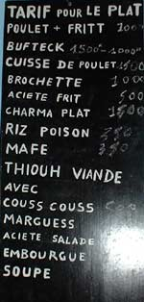
Look at the menu from a local restaurant. What food items do you recognize? What words are unfamiliar and perhaps, specialities of the region? Try to find the meanings for words that are new.

http://www.au-senegal.com

Personal items (Articles de toilette)

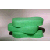  du savon |   du dentifrice |   une brosse à dents |   une brosse à cheveux
  un peigne |   du déodorant |   du fil dentaire |   un rasoir

de la mousse à raser

Exercise 24

What toiletries do you need to …? Prepare oral responses.

- shave?
- take a shower?
- brush and clean your teeth?
- smell nicely?
- groom your hair?

Purchasing fuel and water

John inquires about the drinking water.

John: Est-ce que l’eau du robinet est potable?  Amadou: Ça dépend. Il vaut mieux boire de l’eau minérale, c’est plus sûr. Tu peux l’acheter au supermarché.  John: Je dois y aller de toute façon. Je n’ai plus de dentifrice. Amadou: Allons-y. Mais d’abord, je dois faire le plein d’essence. | Drinkable  It depends. It’s better to / it’s safer  Fill the gas tank

Vrai ou Faux?

1. Amadou a besoin de dentifrice. F John a besoin de dentifrice
2. Amadou veut faire le plein d’essence. V
3. Amadou et John vont aller au supermarché. V

Exercise 25 (Pair Work)

Re-read the dialogue and create a similar situation with your partner. Be prepared to present it in front of the classroom.

Flavors and Specialties How to indicate flavored with or containing

To talk about flavors, use the preposition à followed by the definite article and the noun.
Quelque chose de salé: Something salty
Un sandwich au fromage a cheese sandwich
Une omelette aux fines herbes an omelette with mixed herbs, spices

Quelque chose de sucré: Something sweet
Une glace à la vanille vanilla ice cream
Un gâteau au chocolat a chocolate cake
Une tarte aux fraises a strawberry tart

Note the use of both à and de in describing foods:
- à / flavored with: un sandwich au jambon, une glace à la vanilla, une pizza aux anchois
- de / made from, consisting (entirely of): un jus d’orange, une salade de tomates

Exercise 1

Ask your partner the following questions. Be ready to report his or her answers to the class. Add one sentence for each question that explains why s/he likes or dislikes certain foods.

- Tu préfères la glace au chocolat ou la glace à la vanille?
- Est-ce que tu manges souvent de la tarte aux fraises?
- Tu fais souvent des gâteaux au chocolat?
- Quel est ton dessert préféré?
- Tu préfères les sandwichs au jambon ou au poulet?

Exercise 2

What are the meanings for the foods below?
- Un pain aux raisins
- Un croissant aux amandes
- Une tartelette aux fraises
- Un chausson aux pommes

The verb prendre (to take, to have)

The verb prendre means to take, but it can also mean to have / to take in (a meal, a drink). It is irregular. Some verbs that are conjugated like prendre are comprendre (to understand) and apprendre (to learn).
Je prends ds Nous prenons
Tu prendsds Vous prenez
Il/elle/on prend d Ils/elles prennent *n sound

The verb boire (to drink)

The verb boire is irregular and is conjugated in the present tense as follows:
Je bois [bwa] Nous buvons
Tu bois Vous buvez
Il/elle/on boit Ils/elles boivent [bwav]

The verb manger: –ger types

Reminder: Verbs ending in –ger keep the e when it comes before the vowels a and o. In the present tense, manger is conjugated like other –er verbs except for the nous form:
Je mange Nous mangeons
Tu manges Vous mangez
Il/elle/on mange Ils/elles mangent

Exercise 3

Fill in the blanks with the verbs boire, comprendre, prendre, or apprendre.

- Nous apprenons le français à Fort Bragg.
- Elle boit du thé au petit-déjeuner.
- Vous êtes de Russie? Alors, vous comprenez le russe, n’est-ce pas?
- Qu’est-ce que tu prends au petit-déjeuner?
- Elles boivent de l’eau minérale.

Exercise 4

Fill in the missing information with the correct form of prendre.

Qu’est-ce que Samba prend d’habitude au café ? (un café noir)

Et vous deux? (une limonade)

Et les autres? (un / des coca –s)

The partitive article

As all articles, the partitive has to agree in gender with the noun it precedes. Like the indefinite article, the partitive becomes de in a negative sentence.

 | Masculine | Feminine | With a noun starting with a vowel
Affirmative | Je mange du poulet | Je mange de la viande | Je bois de l’eau
Negative | Je ne mange pas de poulet | Je ne mange pas de viande | Je ne bois pas d’eau

The partitive article is used:

- With noncountable or mass nouns such as viande (meat), sel (salt), eau (water). While in English, some or any is optional, the partitive article in French has to be used:
Je mange de la viande au déjeuner I eat (some) meat for lunch
Je ne bois pas de café au petit-déjeuner I don’t drink (any) coffee for breakfast
- To express part of a whole:
Je mange un poulet I eat a chicken (the whole bird)
Je mange du poulet I eat some chicken (part of a chicken)

Exercise 5

Fill in the blanks with the right form of the partitive article.

Au petit-déjeuner, je bois du café et je mange du pain avec de la confiture. Je ne prends pas de lait avec mon café. A midi, je mange souvent du poisson avec de la salade et je bois du jus de fruit. Le soir, je mange de la viande, en général du poulet, et je bois de la bière. Je ne bois pas de vin et je ne mange pas de fromage.

The partitive OR the definite article?

- With verbs that indicate consumption (such as boire, manger, acheter, prendre), use the partitive or the indefinite article (because you refer to a limited quantity).
Je bois de l’eau I drink some water
Nous mangeons des fruits.
Il prend du sucre avec son café.
Au marché, achétez-vous du poisson?

- With verbs that indicate preferences (such as aimer, préférer, adorer, détester) use the definite article (because you refer to a category with le, la, l’, les).
J’aime l’eau. I (really) like water.
Je préfère les pommes. (In general), I prefer apples.
*Je n’aime pas le lait. I don’t like milk.

*The definite article does not change in a negative sentence.
*Pay attention to: beaucoup de / d’ versus beaucoup as an adverb / j’aime beaucoup…

Exercise 6

Fill in the blanks with the partitive or the definite article. Prepare oral answers.

Le matin, je bois du jus d’orange. Je ne bois pas de boissons chaudes, je déteste le café et le thé. Je n’aime pas la viande rouge, alors le midi, je mange du poulet avec de la salade. J’adore le fromage, et je mange souvent du brie (m) et du fromage de chèvre (goat). Je bois du vin avec le fromage. En dessert, je prends du gâteau au chocolat. J’aime beaucoup le chocolat!

Exercise 7

Fill in the blanks with the partitive or definite article.

A: Aimez-vous le poulet?
B: Oui, j’aime beaucoup le poulet. Je vais prendre du poulet rôti avec du riz.
A: Et les enfants?
B: Ils n’aiment pas la viande. Ils vont prendre des pâtes avec des légumes.
A: Et en dessert? Je recommande le gâteau au chocolat. Il est excellent.
B: Je préfère les fruits. Et les enfants vont prendre de la glace.
A: Et comme boissons?
B: de l’eau minérale pour moi et du coca pour les enfants.

Exercise 8 (Pair Work)

With a partner, take turns and indicate your preferences for each suggestion below:
Use je préfère...
- pour le petit dejeuner ? une orange ou un pamplemousse ?
- apres le dejeuner ? une pomme ou une poire ? des fraises ou des cerises ?
- avec le poulet ? des haricots verts ou des petits pois ?
- avec le bifteck ? des pommes de terre ou des carottes ?
- comme salade ? une salade de tomates ou une salade de concombre ?
- pour le dessert ? une tarte aux pommes ou une tarte aux poires ?
- comme glace ? une glace à la fraise ou une glace à la vanille ?
Phrases to indicate quantity

Phrases that indicate a quantity are followed by the preposition de (or d’ when followed by a vowel) and the noun with no article in between: une bouteille de vin, une bouteille d’eau, un kilo d’oranges.
Use ⇨ expression of quantity + de + noun
  Un verre |   Une cuillère |   Une tranche, une part de (pizza) |   Un morceau

un peu de  assez de  beaucoup de  trop de | A little bit of  Enough of  A lot of  Too much of | une cuillère de  une tranche de  un morceau de  un paquet (pack/package)  un pot (jar)  un sac (bag)  une boîte  une bouteille | A spoon of  A slice of  A piece of  Types of Packaging
Reminder:
- un litre is slightly less than a quart
- une livre = 500 grammes (1.1 us pounds)
- un kilo = 1 000 grammes (2.2 us pounds)

Other words to express quantities
Here are some basic words that can also indicate quantity: (un/une) autre, quelques, d’autres, plusieurs.
Examples: d’autres sandwichs, un autre croissant, etc.
A combination of more than one expression is another way to indicate amount or quantity. French may use one word like beaucoup whereas English uses two:
- beaucoup = very much
- trop = too much
- Combination: beaucoup trop = much too much

Exercise 9

Fill in the blanks with an appropriate phrase of quantity.

1. Je voudrais une cuillère de sucre dans mon café, s’il vous plaît.
2. Je voudrais quatre tranches de jambon fumé.
3. Il reste un morceau de gâteau. Qui le veut?
4. Attention! Tu verses trop d’eau! Le verre déborde!
5. C’est délicieux, je vais prendre encore un peu de riz, mais pas beaucoup, car je n’ai plus faim.

Exercise 10

Make a list of food and beverages in your refrigerator at home. Give at least one quantity, and 6 individual items: Example: Dans mon réfrigérateur (mon frigo), il y a…
deux bouteilles de lait, six tranches de jambon, une douzaine d’oeufs, une livre de beurre, un sac de pommes, deux pots de yaourts

The definite article and prices

Unit prices are expressed by placing the definite article before the unit in question:
Example: six francs la livre 6 CFA / livre
trente francs le kilo 30 CFA / kg

Exercise 11

You are opening a store and have to write price tags for each item. Follow the model given in the preceding grammar note to write tags. Next, think about how to say each tag label: per pound, per gram, etc. Prepare oral answers.

1. treize francs cinquante le kilo 13,50 CFA/kg
2. cinq francs la livre 5 CFA / livre
3. douze francs le kilo 12 CFA / kg

The partitive and indefinite articles

Partitive articles are used to refer to a certain quantity of a certain amount of something.
While the words “some” or “any” are often omitted in English the articles du and de la must be used in French.

Look at the following examples + indefinite articles:

- un poulet = an entire / a whole chicken
- un melon = a whole melon
- une salade = a whole salad

In certain contexts, you may use either the partitive or the indefinite article with the same noun. Consider the following examples:

1. Je voudrais du Coca. I’d like some Coke.
2. Je voudrais un Coca. I’d like a Coke.

In example 1, you are ordering some Coke, whereas in example 2, you are ordering a serving of Coke (it is implied that you mean a glass, bottle or can of Coke). Example 2 is more likely to be used when ordering in a restaurant or café.

Exercise 12 (Pairs)

Look at the following menu and, with your partner, alternate role-playing a customer and a waiter. Order a complete meal. Then get the bill and leave a tip. Present to your classmates.

Item | Price
Omelette | 200 F
Yassa | 300 F
Poulet | 750 F
Maffé | 275 F
Thiébou Diène | 300 F
Steak | 800 F
Poisson grillé | 500 F
Chawarma | 600 F
Couscous marocain | 700 F
Thiakri | 150 F
Bissab | 150 F
Coca | 200 F
Lait caillé sucré | 250 F
Café au lait | 100 F
Thé à la menthe | 150 F
Lipton | 100 F

Addition (n.f)  Assiette (n.f)  Bœuf (n.m)  Boire (verb)  Boisson (n.f)  Boucherie (n.f)  Bouillir (verb)  Boulangerie (n.f)  Bouteille (n.f)  Café (n.m)  Comprendre (verb)  Cuillère (n.f)  Cuisiner (verb)  Déjeuner (n.m)  Délicieux (euse) adj.  Dentifrice (n.m)  Désirer (verb)  Dessert (n.m)  Dîner (n.m)  Eau (n.f)  Épicerie (n.f)  Essence (n.f)  Fourchette (n.f)  Frites (n.f.pl)  Fromage (n.m)  Fruit (n.m)  Gâteau (n.m)  Jamais  Jambon (n.m)  Jus de fruit (n.m)  Lait (n.m)  Légume (n.m)  Manger (verb)  Marché (n.m)  Morceau (n.m)  Oignon (n.m)  Pain (n.m)  Paquet (n.m)  Petit déjeuner (n.m)  Poisson (n.m)  Poulet rôti (n.m)  Réservation (n.f)  Sandwich (n.m)  Verre (n.m)  Viande (n.f) | Bill  Plate (container)  Beef  To drink  Drink  Butcher’s shop  To boil (faire bouillir)  Baker’s shop  Bottle  Coffee  To understand  Spoon  To cook  Lunch, to have lunch  Delicious  Toothpaste  To desire  Dessert  Dinner  Water  Grocery shop  Gas (car)  Fork  Fries  Cheese  Fruit  Cake  Never  Ham  Fruit juice  Milk  Vegetable  To eat  Market  Piece  Onion  Bread  Packet  Breakfast  Fish  Roasted chicken  Reservation  Sandwich  Glass  Meat

Alcool (n.m)  Arachide (n.f)  Beurre (n.m)  Bière (n.f)  Boisson gazeuse (n.f)  Boîte (n.f)  Carotte (n.f)  Céréale (n.f)  Concombre (n.m)  Confiture (n.f)  Crevette (n.f)  Cuisine (n.f)  Douzaine (n.f)  Faire le plein d’essence (verb)  Four (n.m)  Fraise (n.f)  Glace (n.f)  Goûter (verb)  Haricot vert (n.m)  Huile (n.f)  Menthe (n.f)  Pâtes (n.f.pl)  Pâtisserie (n.f)  Petits pois (n.m)  Poire (n.f)  Poivre (n.m)  Pot (n.m)  Pomme (n.f)  Pomme de terre (n.f)  Pourboire (n.m)  Raisin (n.m)  Restaurant (n.m)  Riz (n.m)  Salade (n.f)  Sel (n.m)  Service compris  Serviette (n.f)  Souvent  Sucre (n.m)  Table (n.f)  Terminer (verb)  Tomate (n.f)  Tranche (n.f) | Alcohol  Peanut  Butter  Beer  Soda  Box, can  Carrot  Cereal  Cucumber  Jelly  Shrimp  The kitchen  Dozen  To fill up with gas  Oven  Strawberry  Ice-cream  To taste  Green bean  Oil  Mint  Pasta  Pastry/ pastry shop  Peas  Pear  Pepper  Jar  Apple  Potato  Tip  Grape  Restaurant  Rice  Salad  Salt  Service included  Napkin  Often  Sugar  Table  To finish  Tomato  Slice

West African foods

African culinary repertoire is very diverse and, in many regards, very different from the types of foods that are common in America. Almost every ethnic group has its own specialty but depending on the region, some dishes are more predominant than others. While it not possible to talk about a dish that is commonly consumed by all Africans because of taste, the presence or absence of some ingredients in certain areas and so on, there are, however, some types of foods that are recognized as national dishes because their consumption has spilled over ethnic or regional boundaries. In general, there are one or two dishes that impress themselves at the national level in every country. Thus in the Ivory Coast, Athiéké (made of yam roots and served with grilled chiken or fish) has become the most popular and favorite meal of Ivorians. Guineans everywhere relish their national “sauce au poisson fumé” (steamed rice served with smoked fish in a delicious sauce) or their “sauce aux feuilles de patate” (sauce made of potato leaves and served with steamed rice) In Senegal, the famous “Thiébou Diène” (fish and rice prepared with a lot of vegetables) has reached endemic proportions as some Senegalese claim to have an addiction to it, and therefore, need to take their daily intake to feel their best. The Yassa (fish or chicken cooked in a thick onion sauce) and, to a certain extent, the Maffé (peanut sauce served with steamed rice) also have national recognition in Senegal but they lag far behind the specialty of Saint Louis (the Saint Louisiens are said to be the best in preparing “Thiébou Diène) in the eyes of many Senegalese.

Some dishes, such as fried plantain bananas, are popular in many parts of West and Central Africa, and no one country can claim to have popularized the dish. Mauritanians, on the other hand, profess having introduced Méchoui (lamb or goat meat grilled in a special way) to the rest of West Africa. However, it seems that every country
has adapted it so well to its own preferences that the result is a differently tasting meal depending on where you are.

Fast food chains such as McDonalds or Burger King have not invaded African markets yet, and it is very unlikely that they will succeed in doing it in the predictable future. The majority of Africans relish their traditional food, and even as expatriates, they make sure that they can get it. Paris is one of the cities where you can eat any African dish of your choice with unbelievable ease, as traditional restaurants are set up in different Foyers (low-income housing in France). The same kind of setup is slowly taking place in certain areas of New York.

So if you are a hamburger junky, do not expect to satisfy your craving everywhere in Africa. Even though hamburger places exist, they are very different from McDonalds and might not be available everywhere. The solution is to try every African dish you can lay your hands on, and very likely you will find one or two that will gratify and maybe temporarily calm your craving for juicy McDonald hamburgers.

Drinks and desserts

Even though most of the drinks commercialized in the West are also available in Africa, Senegalese are very fond of their local drinks and are proud to serve them to their most honored guests. Among the drinks that the Senegalese enjoy the most, is Bissab (made of hibiscus juice), which is certainly their favorite and their most popular beverage outside the country. Bissab has won many hearts over and is praised for its quenching ability and health benefits. Touffam (mixture of buttermilk, sugar and water) is the only drink that rivals Bissab in popularity. Indeed, in certain regions of Senegal, Touffam is more consumed than the Bissab, and many neighboring countries have their own adaptation of the Touffam.
Another popular Senegalese beverage is the Bohé juice (made of baobab fruits, locally known as pain de singe). While the Bohé drink is well liked by most of the population, its strenuous preparation has limited its popularity. Ginger juice is also another local beverage that Senegalese love very much. However, like the Bohé juice its preparation is not a simple process and the produce is available only seasonally.
Desserts are not commonly featured in Senegalese regular meals. In most cases, a meal consists of a main course and a round of tea. While a number of fruits are available in the country (the most abundant being mangoes), desserts are not viewed as integral parts of meals. Most poor Senegalese see desserts as an indulgence that they cannot afford. A Thiakri, often taken as dessert, is a form of local couscous served with sweetened buttermilk.

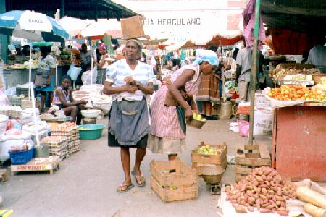

A market in Gambia

Outdoor markets and supermarkets

The overwhelming majority of markets in Africa are outdoor markets, and despite the apparent anarchy, they are well regulated and function according to well-established rules. Who sells where and what is not determined on a first come first serve basis. Rather, new sellers have to be given permission (mostly verbal agreement) to occupy a spot by previously established neighboring vendors. In certain instances, there is an elected head of the market in charge of assigning stalls and making sure that the market functions smoothly. He is also in charge of solving any problems that might arise among fellow sellers.

There are a few advantages in having outdoor markets from both the sellers and the buyers’ perspectives. While the local government levies a daily tax on the vendor in outdoor markets, it is very minimal compared to that imposed on merchants in a well-built marketplace, for example. Consequently, people with little or almost no operating capital can set up in these markets and sell whatever it is they are trying to sell. It is therefore not surprising that most of the vendors are poor women trying to sell their products to make ends meet. In this regard, outdoor markets help vendors who cannot afford renting shops.

Outdoor markets are usually set up in popular neighborhoods where access to a central market might create problems for some of the residents. People around the outdoor market can thus purchase the items they need at any time of the day. In countries where grocery shopping is done on a daily basis, outdoor markets become, therefore, a source of great convenience.

Even though supermarkets exist in Africa, they are mostly confined to the affluent areas of urban centers. Indeed, supermarkets in Africa, most often, cater only to the needs of expatriate clientèle or to those of the local moneyed class. They usually carry imported items that are not commonly used by most of the population. As a result, prices in supermarkets tend to be extremely high compared to those in outdoor markets. Consequently, most indigenous people prefer to shop in outdoor markets for their grocery needs.

Cafeteria and fast food stands

Cafeterias and fast food places, as known and run in the West, are growing steadily in Africa, especially in downtown areas. However, they have not been able to take away the clientèle from the traditional fast food places and cafeterias. Part of the reason is that, in general, prices in modern fast food stands are a lot higher than those in the traditional fast food places.

Traditional eating-places, called Tanganas, are often set in open air or in an old barrack where coffee, bread, and Méchoui are served all day long. In Senegalese Tanganas, for instance, one is sure to get something whatever his budget, even if it means cutting in half or third the quantity of the normal serving. This sort of flexibility is not available in fast food restaurants in Africa. In addition, the type of socialization taking place in the Tanganas is so special that most people prefer to go back every time they can to catch up with every kind of gossip and rumor.

Activity 1

What items do you need for each of the following situation?

1. You need to shave.
2. You need to brush your teeth.
3. You need to take a shower.
4. You need to comb your hair.
5. You have sweated a lot after running but have no time for a shower.

Activity 2

Read the small text about les fast-food and be ready to give a summary with your opinions.

Activity 3
Les fast-food
Quand ils ont faim, les jeunes vont souvent dans un fast-food. Ces restaurants simples et bon marché, servent des repas à l’américaine: salades, poulet ou hamburgers, frites…

Determine which category the following foods belong to by writing the right number next to each item.

1. boisson 2. viande 3. légumes 4. fruits

bière 1  haricots verts 3  pommes de terre 3  coca 1  petits-pois 3  poulet 2  thé 1  veau 2 | café 1  barottes 3  bœuf 2  porc 2  vin 1  jus de fruit 1  eau 1

Activity 4

Listen to several sentences, each containing information about either weight, measure, or packaging. Write the number of each sentence under its appropriate drawing.

5 | 2 | 4 | 1 | 3 | 

Script:
1. J’ai besoin d’un kilo de pommes de terre pour faire de la purée.
2. Nous allons acheter deux bouteilles d’eau minérale.
3. Est-ce que tu as besoin d’un morceau de fromage?
4. Elle va chercher une boîte de haricots verts pour ce soir.
5. Je vais emporter un paquet de gâteaux secs.

Activity 5

Read the recipe for one of Senegal’s specialty and check whether the statements that follow are vrai or faux. Correct the ones that are faux.
YASSA AU POULET
INGREDIENTS : (pour 4 personnes) - 1 poulet - 4 citrons - 4 gros oignons
- 4 cuillères à soupe d'huile d'arachide - 250 g de riz - sel - poivre - 1 piment - eau
Coupez votre poulet en morceaux et le faire macérer pendant 2 heures avec l'huile, le jus et l'écorce des citrons, les oignons émincés, le piment coupé en morceaux, le sel et le poivre.
Bien remuer les morceaux de poulet pour qu'ils soient imprégnés de la marinade. Egouttez les morceaux de poulet, les faire griller de tous les côtés.
Faire revenir les oignons égouttés dans leur cocotte avec l'huile d'arachide, laisser cuire doucement.
Rajouter la marinade et les morceaux de poulet grillés et mouiller avec de l'eau. Laisser mijoter 3/4 d'heure et servir avec du riz.

1. This recipe gives you proportions for 6 people. V / F
2. You need 4 teaspoons of peanut oil. V / F
3. The chicken should be marinated for 2 hours. V / F
4. This dish is served with rice. V / F

Activity 6

Choose the most appropriate answer to each of the questions. Next, act out each scene, adding to the conversation.

1. Vous désirez?
- Non, merci.
- Un kilo
- Un morceau de fromage, s’il vous plaît.
2. Vous avez des légumes frais?
a. Oui, nous avons des fraises.
b. Oui, des haricots verts et des pommes de terre.
c. Oui, des croissants.
3. Combien coûtent les bananes?
a. Trois francs le kilo
b. C’est pas cher.
c. Deux francs la bouteille.

Activity 7

Pair activity. Take turns role-playing the following situation:

A: Enter the store and greet the salesperson
B: Greet the customer and ask what s/he would like
A: Ask for several food items
B: Ask him/her if s/he needs anything else
A: Decline and ask how much you owe
B: State the total

Activity 8

You overhear someone making a purchase in the market. Reconstruct the dialogue by putting the following sentences in the right order.

- 2 500 Francs. 1. i
- Bon appétit! 2. g
- Qu’est-ce que vous avez comme jus de fruit? 3. d
- Et comme boisson? 4. c
- Un jus de goyave, s’il vous plaît. 5. f
- Bonjour Madame. Qu’est-ce que vous prenez? 6. a
- Nous avons du jus d’orange, du jus de pomme et du jus de goyave 7. e
- Merci. Combien je vous dois? 8. h
- Je voudrais une omelette au fromage et une salade de tomates. 9. b

Activity 9

Pair activity. You and your partner are going to a buffet. One of you will eat everything in the odd-numbered squares, while the other will gobble up the food in the even-numbered squares. Take turns stating what you eat and how it tastes.

1  croissant | 2  banane | 3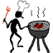  Barbecue | 4bière
5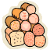  Jambon | 6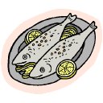  Poisson | 7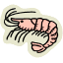  Crevettes | 8  Glace
9  Poulet | 10Pomme | 11  Gâteau | 12  Melon
13  Thé | 14  Café | 15  des oeufs | 16  eau

2. Il n’y a plus rien. Que faites-vous ?

Suggestions : Vous allez prendre a. un taxi
b. un Alka-Seltzer
c. une bière au bar
d. autre ?

Activity 10

Listen to some prices and circle the one you hear.

1. 1 400,80 F 4 000, 90 F 40 000, 40 F
2. 313,60 F 1 300, 70 F 3 000, 16 F
3. 660, 13 F 1 600, 30 F 616, 03 F
4. 8 900, 99 F 9 800, 80 F 980, 90 F
5. 780, 70 F 870, 80 F 970, 90 F
Activity 11

Determine in which category these foods and drinks belong and enter the appropriate number next to each item.

Entrée: 1 plat principal: 2 dessert: 3 boisson: 4

Poisson 2  Poulet 2  Bière 4  Haricots verts 2  Coca 4  Glace 3  Petits-pois 2  Salade de tomates 1 | Café 4  Agneau 2  Bœuf 2  Riz 2  Frites 2  Pâtes 2  Gâteau 3  Œufs mayonnaise 1 | Vin rouge 4  Jus de fruit 4  Concombre 1  Soupe 1  Thé 4  Eau minérale 4  Tarte aux fraises 3

Activity 12

Find the most appropriate answer for each of these questions. There is one answer that does not fit anywhere.

A: Vous avez de la soupe de poisson? 3 1. Oui, surtout les haricots verts.
B: Tu aimes les légumes? 1 2. 1 200 F
C: C’est bon? 5 3. Non, mais nous avons de la soupe à l’oignon.
D: Ça fait combien? 2 4. Non, c’est du veau.
E: C’est du bœuf? 4 5. Oui, c’est délicieux.
F: Vous voulez du thé ou du café? 7 6. Nous avons des fruits, de la glace, et de la tarte aux pommes.
G: Qu’est-ce qu’il y a comme dessert? 6 7. Du café, s’il vous plaît.
H: Tu veux un fruit? 9 8. Encore un peu, s’il vous plaît.
9. Je veux bien du raisin.
Activity 13

Find the word that does not belong in each group.

quiche  omelette  petit pois  fromage | bière  coca  jus de fruit  eau minérale | ketchup  moutarde  mayonnaise  pêche | ananas  citron  orange  carotte | confiture  croissant  gâteau  tarte
lait  yaourt  fromage  pomme | steak haché  poulet  porc  dinde | porc  poisson  poulet  boeuf | dessert  entrée  pain  plat | café  jus de pomme  limonade  jus d’orange

Activity 14

Listen to the conversation between a waitress and a customer and answer the following questions:
*Note: Have 2 students read the script aloud while others answer the questions. Allow students to read over the script and practice once beforehand.

Script:

Serveuse: Bonjour Monsieur. Vous voulez une table?
Ibou: Oui, Madame. Et j’aimerais quelque chose à boire.
Serveuse: Nous avons de l’alcool, des boissons gazeuses, et du Bissab.
Ibou: Est-ce que vous avez des jus de fruit?
Serveuse: Nous n’avons que du jus d’ananas.
Ibou: J’aimerais un verre de jus d’ananas, s’il vous plaît.
Serveuse: Ça va faire 400 F.
Ibou: Voici 500 F. Gardez le reste pour votre pourboire.
Serveuse: Merci beaucoup Monsieur.

- What kind of drink does the customer order? Pineapple juice
- How much was the check? 400F
- How much tip did he leave? 100F

Activity 15

You will hear short sentences read by your instructor. Mark the correct statement.

1. John is a. hungry Je voudrais un Coca, s’il vous plaît
b. thirsty
c. broke
2. The customer is looking for a. mayonnaise Vous avez de la mayonnaise?
b. mustard
c. ketchup
3. The couple is having a. breakfast Tu veux encore des céréales?
b. lunch
c. dinner
4. He is ordering his coffee a. black Je voudrais un café-crème, s’il vous plaît
b. with cream
c. with cream and sugar
5. The customer is asking for a. some water Vous avez de la bière?
b. a soft drink
c. an alcoholic drink
6. The dessert in this restaurant is a. very good En dessert, je vous recommande la
b. not good tarte aux pommes. Elle est délicieuse
c. inexpensive

Activity 16

Read the ads for restaurants in the Dakar area and answer the questions that follow.

Le Big Five, rue Mohammed Cinq, dans un cadre très "savane africaine", les meilleurs plats de viandes de la capitale vous attendent. Très bon accueil dans une salle climatisée et un jardin tropical (il y a même des caïmans...). Comptez minimum 10 000 CFA/personne. 24, rue Victor Hugo, Tél: 822.08.17
**CHEZ LOUTCHA: La meilleure cuisine Capverdienne du Sénégal. Accueil chaleureux. Très bon marché. 101, rue Moussé Diop (821.03.02)
***LE DAGORNE: Tenu par des Français (M. et Mme Michel CHILLOU, la qualité de l'accueil est sans faille, le service est rapide. Prix raisonnables. Fermé le lundi. 11, rue Dagorne (822.20.80)
***AUBERGE DES 4 VENTS: restau-hôtel entre Dakar et Rufisque dans une zone très tranquille au carrefour de Mbao. Plats à 2 000 CFA à toute heure.

1. Where will you eat the best meat dishes in Dakar? Le Big Five
2. Which restaurant is owned by French people? Le Dagorne
3. Which restaurant is closed on Mondays? Le Dagorne
4. In which restaurant can you eat for 2,000 CFA at any time of the day? L’Auberge des 4 Vents

Activity 17

Put the following sentences in the right order and then role-play the scene with a classmate.

4 a. Je voudrais du poulet rôti et ma femme va prendre un steak.
9 b. Ça fait 2 300 F. Le service est compris.
2 c. Garçon! La carte, s’il vous plaît.
10 d. Ce restaurant est formidable.
6 e. Une bouteille d’eau minérale.
1 f. Une table pour deux personnes s’il vous plaît.
8 g. L’addition, s’il vous plaît.
3 h. Vous désirez?
5 i. Et comme boissons?
7 j. Bon appétit.

Activity 18

Listen to the following exchanges, and check the correct answer. Note: Have 6 different students read sentence scripts for 1-6 (volunteers or selected).

1. The customer is ordering a. his first drink
b. his second drink
c. his dessert
Mademoiselle, je voudrais encore un Coca s’il vous plaît

2. The customer is ready to a. order
b. reorder
c. pay
L’addition, s’il vous plaît

3. Both customers ordered a. a main course
b. a dessert
c. the same thing
Et pour monsieur? Une tarte aux pommes. Et madame? Moi, je vais prendre une glace à la vanille, s’il vous plaît.

4. This man is being served by a. a waiter
b. a waitress
c. his wife
Madame, apportez-moi un verre d’eau, s’il vous plaît

5. This customer is ordering a. an alcoholic drink
b. a soft drink
c. a hot drink
Je voudrais un café, s’il vous plaît

6. This customer a. loves the dessert
b. declines the dessert
c. complains about the dessert
Monsieur, vous avez aimé le gâteau au chocolat? Ah oui, merci, c’était délicieux !

Activity 19

Listen to this announcement for supermarket specials. For each item, write down what is being offered and at what price. *Note: Split up script between 2 or 3 students, give them a copy and ask them to read aloud while others answer.

Script:
Aujourd’hui nous avons des promotions exceptionnelles au rayon boucherie. Le kilo de bœuf est à 475 F CFA. Le kilo de poulet est à 620 F CFA. Nous avons également de grandes réductions dans d’autres secteurs. Le litre de lait frais est à 200 F CFA. La douzaine d’œufs vaut 150 F CFA. Les oignons sont à 130 F le kilo. La bouteille de Coca de deux litres est à 490 F CFA. Dépêchez–vous, car cette offre n’est valable que pour 3 jours !

- bœuf: 475 F CFA/kg.
- poulet: 620 F CFA/kg.
- lait frais: 200 F CFA/lt.
- œufs: 150 F CFA/dz.
- oignon: 130 F CFA/kg.
- coca: 490 F CFA/b.

Activity 20 (Pair Work)

Role-play. Purchase fuel. In this activity, one student will play the role of an SOF soldier and the other an attendant at a service station. The situation is that you need to buy fuel both for vehicles and for the generators. Fortunately, they both use diesel! Your partner will ask how much you need and tell you the price. Role-play the situation to the class. Your classmates will give you a feedback.
Activity 1

Pair activity. Your partner and yourself plan to have a party. Decide when to have the party, whom to invite and what to offer to eat and drink. One of you takes notes. Be ready to report to the class.

Activity 2

Pair activity. Divide the shopping chores. Refer to the list you drew of the items you need for the party you are preparing and take turns stating where you will go to buy each item.

Activity 3

Pair activity. Ask your partner about his food habits for breakfast, lunch and dinner. Take notes. After you have interviewed each other, write a paragraph with complete sentences to describe what your partner eats. Do not mention his/her name.

Activity 4

Class activity. Your instructor will collect and randomly redistribute the paragraphs written during the previous activity. Find out whose food habits it describes by going around the room and asking questions such as, Est-ce que tu bois du lait au petit-déjeuner? or Qu’est-ce que tu bois au petit-déjeuner?

Activity 5

Pair activity. With your partner, decide on a dish, dessert or cocktail, and then write the recipe with the approximate amounts needed to prepare it. Example: on a besoin d’une cuillère de…

Activity 6

Class activity. Each pair of students read their recipe to the whole class without saying the name of the dish. The class has to guess what the recipe is for.

Activity 7

Group activity. The class will be divided in groups of three or four. One student plays the role of the waiter/waitress while the others order dinner. The customers will have to change their choices since most of their first choices are not available anymore today.
Activity 8

Class activity. Following the format in the previous activity, compose what would, to you, be the ideal menu for the mess hall. Your instructor will collect all the menus and redistribute them randomly. Find out whose menu you have by asking questions such as Tu aimes…?

Activity 9

Pair activity. Your partner and yourself would like to have a snack, but you are a little short and have only 1 700 F between the two of you. Look at the following menu of a fast food stand and find something to drink and eat for both of you within your budget. Report what you will order to the class.

Item | Price
Hamburger | 600 F
Chawarma | 600 F
Omelette | 200 F
Pizza | 450 F
Sandwich | 250 F
Coca | 250 F
Glace | 175 F

Pair activities, Student A

Activity 10

One student looks at chart A while the other looks at chart B. Find out who is having the food items that are listed with no name next to them. Make sure you use the right form of the partitive article. Example: Qui mange du poulet?

A
 | poulet
 | salade
 | gâteau
 | eau
Boubacar | fromage
Anta | jus d’orange
Mamadou | viande
Aïssatou | poisson

Activity 11

You have one half of the weekly mess hall menu and your partner has the other half. Take turns asking for the information you need to fill out your half.
Example: Qu’est-ce qu’il y a au petit déjeuner samedi?
A
 | lun | mar | mer | jeu | ven | sam
Petit déjeuner |  | Lait  Croissants | Chocolat  Pain  Confiture |  |  | Chocolat  Croissants
Déjeuner |  | Salade de tomates  Steak-frites | Soupe de poissons  Omelette |  |  | Poulet  Haricots verts
Dîner |  | Spaghettis  Salade  Pomme | Steak au poivre  Légumes |  |  | Poisson  Pommes de terre

Pair Activities, Student A

Activity 12

Find the missing prices on the bill by taking turns asking questions such as Combien coûte…? Then total the bill and see if you come up with the same number as your partner.

Facture de restaurant A

Restaurant le Teranga

Facture
Plat | Prix
 | 200 F
Yassa | 300 F
Poulet
Maffé | 275 F
Thiébou Diène
Steak | 800 F
Poisson grillé
Chawarma
 | 700 F
Thiakri | 150 F
Bissab | 160 F
 | 220 F
 | 250 F
Café au lait | 100 F
Thé à la menthe
Lipton | 100 F

Pair Activities, Student B

Activity 10

One student looks at chart A while the other looks at chart B. Find out who is having the food items that are listed with no names next to it. Make sure you use the right form of the partitive article. Example: Qui mange du poulet?

B
Amadou | poulet
Mariama | salade
Aminata | gâteau
Amin | eau
 | fromage
 | jus d’orange
 | viande
 | poisson

Activity 11

You have one half of the weekly mess hall menu and your partner has the other half. Take turns asking for the information you need to fill out your half.
Example: Qu’est-ce qu’il y a au petit déjeuner samedi?
B
 | lun | mar | mer | jeu | ven | sam
Petit déjeuner | Thé  Pain  Beurre |  |  | Café  Pain  Beurre | Céréales  Lait
Déjeuner | Soupe aux lentilles  Pizza |  |  | Saucisses  Pommes de terre | Poisson  Petits-pois  Fraises
Dîner | Sandwich au jambon |  |  | Soupe à la tomate  Poire | Brochettede boeuf  Gâteau

Pair Activities, Student B

Activity 12

Find the missing prices on the bill by taking turns asking questions such as Combien coûte…? Then total the bill and see if you come up with the same number as your partner.

Facture de restaurant B

Restaurant le Teranga

Facture
Plat | Prix
Omelette | 200 F
 | 300 F
Poulet | 750 F
Maffé
Thiébou Diène | 320 F
Steak
Poisson grillé | 500 F
 | 600 F
Couscous marocain | 700 F
 | 150 F
Bissab
Coca | 220 F
Lait caillé sucré | 250 F
Café au lait
Thé à la menthe | 155 F
Lipton

Activity 1

Write a paragraph in which you describe your food preferences. State the beverage, meat, vegetable, fruit, and dessert you like; then explain how often or when you eat these items.

Activity 2 Track 31

CD. Listen to a conversation between 2 friends who are planning a party. Underline the items they decide to buy on the list below.

Riz  Sel  Tomates  Piment  Lait caillé  Arachide  Huile  Choux  Oignons | Menthe  Poisson frais  Sucre  Poisson séché  Café  Eau  Aubergines  Lait  Carottes

Script: Nous allons faire du Thiébou Diène. Est-ce qu’on a encore du riz? Non, on en n’a plus. Est-ce qu’il y a des tomates? Oui. Et l’huile? Il en reste un peu. Nous n’avons plus de choux. Il nous faudra également des carottes. Samba a amené du poisson frais hier, mais on aura besoin de poisson séché et d’aubergines. Tu peux aussi acheter un peu de sel.

Activity 3 Track 32

CD. Listen to four short dialogue excerpts and decide in what type of store they took place. Numbers one and four include 2 speakers.

- la boulangerie
- la boucherie
- l’épicerie
- le marché

Script:
1. A: Bonjour Monsieur. Vous désirez? B: Je voudrais une baguette, s’il vous plaît.
2. Je voudrais un rôti de veau et un poulet, s’il vous plait
3. Bonjour madame. Vous avez du Coca?
4. A: C’est combien, le kilo de petits-pois? B: 750 F le kilo, c’est pas cher : Regardez comme ils sont frais et beaux !

Activity 4

Read the following ads and answer the questions.

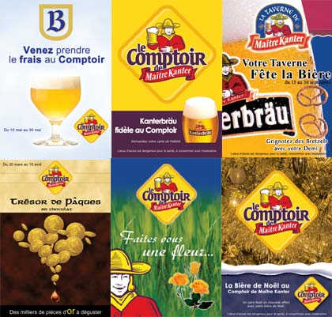 |  | This firm is a food and beverage distributor. T / F
 |  | The word four most likely means  - flour  - oven  - financial aid
  
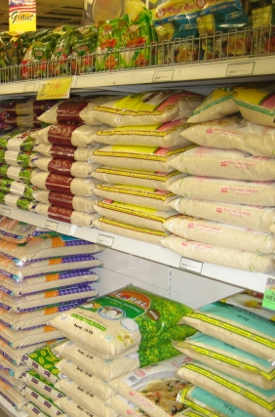 | One can expect to find fresh vegetables here. T / F

Activity 5

Be prepared to order a complete meal and a drink at a restaurant. You can prepare an order by phone or in person.

Activity 6 Track 33

CD. Listen to the following dialogue in which Amadou and Penda discuss what food should be bought for a party. Look at the shopping list, check off the food items mentioned and write in the amounts given.

Farine (2 kilos)  Œufs (une douzaine)  Poisson  Pain  Raisin | Viande  Oranges  Huile  Fraises  Sel | Moutarde (un pot)  Oignons  Carottes  Vinaigre (1 bouteille)  Haricots

Script:
Amadou: Qu’est ce qu’on doit acheter pour notre soirée?
Penda: On a besoin de deux kilos de farine et d’une douzaine d’oeufs.
Amadou: Combien coûte un kilo de farine?
Penda: Un kilo est à 175 F.
Amadou: Et les œufs?
Penda: La demi-douzaine coûte 350 F.

Amadou: Est-ce qu’il manque autre chose?
Penda: Oui. On a besoin d’un pot de moutarde et de deux bouteilles de vinaigre pour la viande.
Amadou: Combien vaut un pot de moutarde?
Penda: Ça vaut 430 F.
Amadou: Et la bouteille de vinaigre?
Penda: 750 F.
Amadou: C’est trop cher, ça. Prenons donc un pot de moutarde et une seule bouteille de vinaigre.

Activity 7

Read the conversation between a waitress and Amadou and Penda and mark the following statements as vrai ou faux.

Serveuse: Est-ce que je peux vous servir quelque chose?
Penda: Je voudrais des pâtes, s’il vous plaît.
Amadou: Moi, j’aimerais avoir des côtelettes de veau.
Serveuse: Je suis désolée, mais nous ne servons pas de pâtes ici. Ensuite, nous n’avons plus de côtelettes de veau.
Penda: Qu’est-ce que vous avez donc?
Serveuse: Nous avons du riz à la viande, du poulet et du Thiébou Diène.
Penda: Je vais prendre du riz à la viande et une glace à la vanille.
Amadou: Je vais prendre du poulet.

1. Amadou wants to order veal. V / F
2. He orders chicken. V / F
3. The restaurant is out of rice. V / F
4. Penda wants to order pasta V / F
5. Penda orders chocolate ice cream. V / F

