SOLT French Module 2 Lesson 2
Instructor Manual

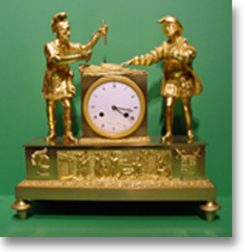
Time and Measurement

At the end of this lesson, you will be able to understand and use French for time and measurements, including the metric system.

Tell Time

- Ask the time (conversational time)
- Tell military official time
- Use the 12-hour system for telling time
- Ask and answer questions about clock times

Use the Metric System

- Use numbers from 101-1, 000,000
- Compare metric system with the English system
- Tell distance in metric system
- Recognize and use metric system weights and measures
- Recognize types of packaging used in the French-speaking markets

Scenario:
Au guichet de la gare

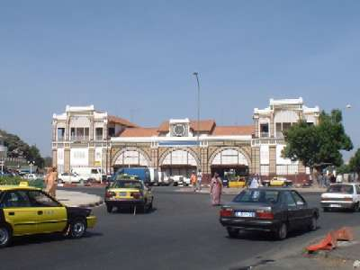

Read the following scenario with conversational time and jump to the vocabulary list for all of the underlined words. Your instructor will ask two students to role-play the scene after you have discussed the comprehension questions on the next page.

Amadou: Excusez-moi Monsieur, À quelle heure arrive le train pour Bissau?

Un passant (passer-by): Le train rentrera en gare à 11 heures 45. C’est à dire dans 20 -25 minutes environ.

Amadou: Donc il doit être 11 heures et quart, onze heures vingt maintenant, c’est ça?

Un passant : Oui, Monsieur.

Amadou: J’ai le temps de manger un morceau avant de partir. Est-ce qu’il y a un restaurant dans la gare?

Un passant: Oui, sur votre gauche, il y a une petite brasserie, mais dépêchez-vous car elle ferme à 11 heures et demie et ne sert que le petit-déjeuner.

Amadou: Très bien, je vous remercie!

Un passant: Je vous en prie. Bon voyage!

*Note to the instructor: go over meaning of some of the words and expressions before the role-play.
Exercise 1 (follow-up)

Answer the following questions to get a better understanding of the conversation at the train station.

- Why does Amadou need to find out about the train schedule?
He is leaving for Bissau and doesn’t know what time it leaves.
- Where will Amadou eat his lunch?
In a restaurant at the station.
- How much time before the train for Bissau arrives?
20 – 30 minutes; the train returns then and will depart immediately.
- Does Amadou have a watch?
If he does, it must not work!
- What does 11 heures et quart mean?
11:15 a.m.

Tip of the day: Asking for the time / Politeness formulas

To stop people in the street and ask for some information such as the time, say, Pardon Monsieur / Mademoiselle / Madame, or Excusez-moi Monsieur / Mademoiselle / Madame. Remember to thank the person (Merci Monsieur / Mademoiselle / Madame). A few ways to say, “You’re welcome” are Il n’y a pas de quoi, De rien or Je vous en prie. De rien (don’t mention it) is considered more informal than Je vous en prie that includes “vous”.

Exercise 2 (Pair Work)

With your partner, practice this conversation where Amadou stops a lady in the street.

Amadou: Pardon Madame, quelle heure est-il s’il vous plaît?
What time is it?
La femme: Il est deux heures et quart.

It’s 2:15
Amadou: Merci Madame.
La femme: De rien.
You’re welcome
Amadou (To himself): Zut! Je suis en retard!
Darn! I’m late

Exercise 3 (Pair Work)

You have an appointment and noticed that your watch does not work. It is very important that you are on time. You see a passer-by who looks friendly. Ask for the time along with the appropriate greetings and expressions of gratitude. Your partner will answer you with the time (use both dialogues as a guide).
Ask the Time

Quelle heure est-il?

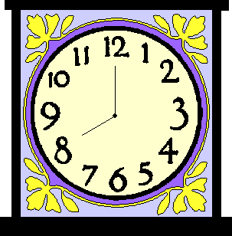 | 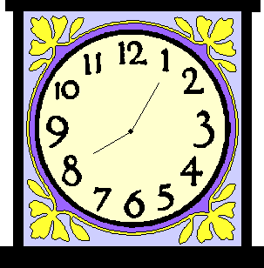 | 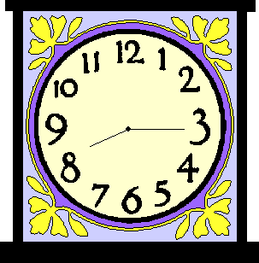 | 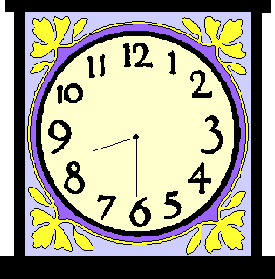
Il est huit heures | Il est huit heures cinq | Il est huit heures et quart | Il est huit heures et demie

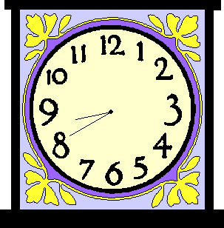 | 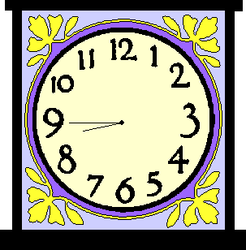 | 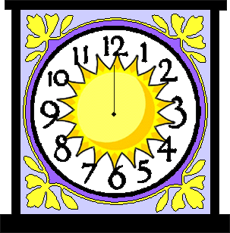 | 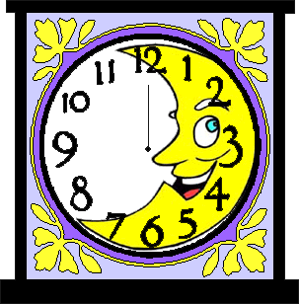
Il est neuf heures moins vingt | Il est neuf heures moins le (un) quart | Il est midi | Il est minuit

*There are specific words to use for conversational time:

Le midi / Il est midi. Noon / It’s noon. Il est minuit. It’s midnight.
Et quart = (and) plus fifteen Il est huit heures et quart / It’s 8:15
Moins le (un) quart = minus fifteen Il est neuf heures moins le quart / It’s 8:45
Et demie = and 30 / + one half Il est huit heures et demie / It’s 8:30
Since “midi” and “minuit” are masculine, no –e is added when demi (e) follows these two expressions: Il est minuit et demi.

To indicate a.m. / p.m. in French, use:
Du matin (from 1 to 11 a.m.) → In the morning
De l’après-midi (from 1 to 5 p.m.) → In the afternoon
Du soir (from 6 to 11 p.m.) → In the evening

*Note that le temps is time (duration) or used for weather expressions. Clock time is indicated by the word, “heure”. Examples: Je n’ai pas le temps (I don’t have the time…) versus Quelle heure est-il ? What time is it ? or A cette heure du jour = At this time of day.
Exercise 4 (Pairs)
Working with a partner, match the pictures with the times listed below.
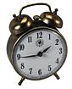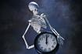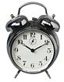 A B C D E
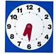 F G H I J

- Il est midi moins cinq. 7. Il est onze heures cinq. B
- Il est sept heures et demie. F 8. Il est quatre heures dix.
- Il est huit heures. C 9. Il est dix heures dix. H
- Il est deux heures moins le quart. J 10. Il est neuf heures vingt-cinq. E
- Il est quatre heures. A 11. Il est cinq heures et quart. D
- Il est cinq heures moins vingt-cinq. I 12. Il est minuit. G


À quelle heure est-ce que tu fais tes devoirs de français?
Je fais mes devoirs de quatre heures jusqu’ à six heures.

The preposition à is used to ask and answer about the time when something occurs: À quelle heure = at what hour (time). When someone asks, “A quelle heure...?” the response requires either the prepositon à (exact time) or vers (approximate time).
J’arrive (vais arriver) chez moi à 9h. I’ll arrive at 9.
J’arrive (vais arriver) chez moi vers 9h. I’ll arrive around 9.

- To ask someone when something occurs, you can also use quand: Quand est-ce qu’on va au café?
- To indicate that something happens between two times, use either “entre...et” or “de...jusqu’ à”. The construction de…à is used to express start and finish times; de (from) ... jusqu’à (until).

Q : Quand est-ce que tu fais ton français?
R : Je fais mon français entre 8h et 9h. I do my French work between 8 and 9.
Q : Quand est-ce que tu travailles?
R : Je travaille de 4h jusqu’à minuit. I work from 4 until midnight.

Military Time

In Francophone Africa, a 24-hour clock is widely used for schedules and timetables. Electronic devices usually show the time with the 24-hour system. The official time uses numbers only.

A.M. / P.M. | 24-Hour Clock / Official Time | Official Time (written form)
2:45 p.m. | 14:45 | Il est quatorze heures quarante-cinq
5:50 p.m. | 17:50 | Il est dix-sept heures cinquante
10:15 a.m. | 10:15 | Il est dix heures quinze
12:30 p.m. | 12:30 | Il est douze heures trente
12:10 a.m. | 00:10 | Il est zéro heure dix

Look at the following examples that show the differences between conversational time and official time and repeat after your instructor:

Conversational Time: Official Time :
10 a.m. dix heures du matin → Il est dix heures.
1 p.m. une heure de l’après-midi → Il est treize heures.
9 p.m. neuf heures du soir → Il est vingt et une heures.
12:30 p.m. midi et demi → Il est douze heures trente.
*Note that the word for hour, heure is feminine. It agrees with the number of hours given (dix heures = 10 hours).
Exercise 5 (Group Work)
Match the following times. Your instructor will call on a few students to give their answers.

- 10:25 3 1. Il est vingt heures quarante.
- 13:30 6 2. Il est vingt-trois heures cinquante.
- 16:15 4 3. Il est dix heures vingt-cinq.
- 20:40 1 4. Il est seize heures quinze.
- 22:05 5 5. Il est vingt-deux heures cinq.
- 23:50 2 6. Il est treize heures trente.

Exercise 6 (Class Work)

Listen to the instructor as s/he reads the times. Tell the time in another way according to the example.
Example: Il est deux heures et demie de l’après-midi. Il est quartorze heures trente.

You hear: | Another way to tell the time:
- Il est midi et demi.
- Il est huit heures du soir.
- Il est minuit moins dix.
- Il est deux heures et quart du matin.
- Il est trois heures de l’après-midi.
- Il est dix heures moins vingt du soir.

Answer Key: Answers may vary.
Use Numbers from 100 through 1,000,000

Practice the numbers with your instructor

100 | cent
101 | cent un
200 | deux cents | cent takes an s in the plural, except when
210 | deux cent dix | followed by another number
300 | trois cents
562 | cinq cent soixante-deux
1 000 | mille | French uses a coma for the decimal and a space for 3 unit digits, except for dates: 10 décembre 1999
2 000 | deux mille | mille is invariable
1 000 000 | un million | million should be followed by de + a plural noun: un million de dollars
3 456 789 | trois millions quatre cent cinquante-six mille sept cent quatre-vingt-neuf

Exercise 7 (Group Work)
Listen to your instructor and circle the number you hear in each set. Be prepared to give your answer orally.

a. 224 284 240 j. 848 884 874
b. 543 453 413 k. 999 989 949
c. 823 283 328 l. 1 850 1 085 805
d. 444 414 404 m. 2 783 2 873 2 860
e. 545 514 554 n. 45 623 54 623 45 723
f. 399 319 389 o. 78 117 68 116 68 117
g. 781 741 791 p. 902 402 902 432 902 232
h. 212 222 202 q. 321 689 321 699 301 689
i. 912 972 962 r. 884 701 894 601 804 711
s. 1 732 946 1 630 946 1 702 956
t. 10 385 927 11 382 928 11 985 928

Exercise 8 (Class Work)

Listen to your instructor and repeat the following numbers after him/her. Your instructor will ask a few students to repeat individually.

1,670 4,897,429 387 2,650,000
10,487 645 3,478 105
478,829 90,736 4,500 444
998,372 100,000 3,300,000 89,300

Exercise 9 (Pair Work)

Working with a partner, match the numbers with their written form.

56,802 | cinq cent soixante sept mille huit cent soixante douze
546,622 | cinq mille neuf cent quatre vingt deux
5,762 | cinq mille cinq cent soixante deux
53,622 | cinq cent quarante six mille six cent vingt deux
523,072 | cinquante trois mille six cent vingt deux
5,982 | cinquante six mille huit cent deux
5,562 | cinq mille sept cent soixante deux
567,872 | cinq cent vingt trois mille soixante douze

56,802 | cinquante six mille huit cent deux
546,622 | cinq cent quarante six mille six cent vingt deux
5,762 | cinq mille sept cent soixante deux
53,622 | cinquante trois mille six cent vingt deux
523,072 | cinq cent vingt trois mille soixante douze
5,982 | cinq mille neuf cent quatre vingt deux
5,562 | cinq mille cinq cent soixante deux
567,872 | cinq cent soixante sept mille huit cent soixante douze
Tip of the day

Here are some tips to make rough approximations when you don’t have a calculator handy:
-1 meter equals 3 feet
-1 meter is 1 yard
-1 kilometer is ½ mi
-1 kilogram equals 2 lbs.
-1 liter equals 1 quart
-1 liter is ¼ gallon

The Metric System

The metric system is the most prevalent measurement system in the world. It is based on the decimal system, therefore multiples and submultiples are always related to powers of ten. For example, kilo means one thousand times, thus one kilometer equals 1,000 meters and one kilogram equals 1,000 grams. Note that the coma is used to mark the decimal: 1 kilomètre = 0,625 miles, and is read virgule.

1Lb = 454g | 1 livre = 500g
Une livre américaine est égale à 454 grammes | La livre métrique est égale à 500 grammes

Length: 1 inch = 2.54 centimeters (cm) Weight: 1 ounce = 28.35 grams (g)
1 foot = 30.48 cm 1 pound = 0.4536 kilograms (kg)
1 yard = 0.914 meter (m) 1 quart = 0.946 liter (l)
1 mile = 1.609 kilometer (km) 1 gallon = 3.785 liters
1 km = 0.62 mi.
1 m = 3.28 feet = 1.09 yard
1 cm = 0.394 inch

Approximate conversion factors between inch-pound units and the metric system:
From US to metric | From metric to US
inches to cm: multiply inches by 2.54 (this conversion factor is exact) | cm to inches: divide by 2.54
feet to meters: multiply feet by 0.305 | m to feet: divide m by 3.3  m to yards: divide meters by 0.91
mi to km: multiply miles by 1.6 | km to mi: multiply kilometers by 0.62
lb to kg: multiply pounds by 0.453 | kg to lb: multiply kg by 2.2
oz to grams: multiply ounces by 28 | g to oz: divide grams by 28
fl. oz to milliliters: multiply fluid ounces by 30 | ml to fl. oz: divide ml by 30
gallons to liters: multiply gallons by 3.78 | liter to gallon: multiply liters by 0.26
*Note about Temperature Conversion

You will learn later about temperature and expressions for weather. For now, note that in Francophone countries, Celcius is commonly used to measure temperature. The following are the conversion formulas for Celcius and Fahrenheit:

From Fahrenheit to Celsius C = (F – 32) x 5/9 → (59-32) x 5/9 = 15˚ C
From Celcius to Fahrenheit F = (C x 9/5) + 32 → (20x9/5) + 32 = 68˚ F

Exercise 10 (Class Work)

Convert your weight in pounds into kilograms. This is done by dividing your weight in pounds by 2.2. So, using the example of a 220 person:
220/2.2 = 100 kilograms

Exercise 11 (Pair Work)

Using the conversion table section, work with your partner to convert the following mileage speed into kilometers.

20 mph | 50 mph | 60 mph | 75 mph | 86 mph | 140 mph
40 mph | 55 mph | 65 mph | 90 mph | 100 mph | 150 mph

Answer Key:
12.4 km | 31 km | 37.3 km | 46.6 km | 53.4 km | 87 km
24.8 km | 34.2 km | 40.3 km | 56 km | 62.3 km | 93 km

Exercise 12 (Group Work)

Working in groups of four, ask each other about your weight and height and convert them to the metric system.

Answer Key: Answers may vary.

Exercise 13 (Class Work)

Use the Tip of the day to decide which of the numbers is the closest approximation of the distance or weight given. Do not use calculators or pens and paper for this exercise and be prepared to share your answers with the class.

1. 100 meters a. 100 feet b. 100 yards c. 150 feet
2. 55 kilograms a. 110 lbs b. 100 lbs c. 90 lbs
3. 80 km a. 120 mi b. 40 mi c. 70 mi
4. 15 liters a. 3 gallons b. 6 gallons c. 8 gallons

Tip of the day: Marking Time in Pulaar (Senegal)
Telling time by the hour and the minute is something which you probably won't have much use for in Pulaar. However, people mark the times of the day either by noting the position of the sun or by the five Muslim prayers which are called out from the mosque. In addition to gnalowma e jamma, day and night, the times of day are divided as follows:
During the day time: Subaka (morning), fegnange (mid-day), kikidhe (late after noon)
At night: kikidhe jamma (evening), nder Jamma (middle of the night), weendogo (dawn).These are the units of time more or less measured by the position of the sun. Other units are: weeti ,day time, hiiri, evening time, nange fudhi sun rise, nange muti, sun set . The subsequent cardinal directions are: fut nange, east, the direction from which sun rises and hirr nange, the west, where the sun sets. In the specific case of Fuuta Toro, rewo is the north and worgo the south. It is these factors that divide everyone's day, and people make their plans accordingly.

Tell Distance

Combien de kilomètres y a-t-il jusqu’à Dakar? How many kilometers are there to Dakar?
Il y a 50 km. There are 50 km

Exercise 7

Listen to the statements about how much the following people drive per week, month, or year. Then write the correct distances and frequency next to each name. Compare answers with those of your classmates and say how much you drive daily, weekly, on the weekends. Reasons?

Model: You hear: Aminata fait 50 kilomètres par semaine.

Noms distances fréquence

Aminata 50 km semaine

Mariama 890km mois

Amin 15500km an
Birago 33km jour

Mamadou
Aissatou 40250km an

Script: Amin fait 15500 km par an. Mariama fait 890 km par mois. Birago fait 33 km par jour. Mamadou et Aïssatou font 40250 km par an.

Exercise 10 (Pair Work)

Ask and answer questions with your partner about the distances between the following cities. Be ready to read them in class.

Exercise 11 (Pair Work)

Say the lengths of the borders, which Senegal shares with the following countries. Then listen to your partner for the same task.

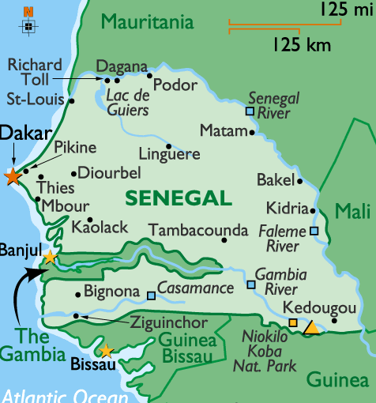

Gambia: 740 km
Guinea: 330 km
Guinea-Bissau: 338 km
Mali: 419 km
Mauritania: 813 km
Exercise 12 (Class Work)

With your classmates, go over some of the distances (from small village to city) shown in this table for Senegal. Practice saying the numbers aloud. Your instructor will ask some students to write out the answers on the board.

 | Dakar | Bakel | Bissau | Diouloulou | Diourbel | Kaolack | Matam | M'bour | Oussouye | St. Louis | Thiès
Dakar | 0 | 705 | 550 | 476 | 146 | 189 | 716 | 83 | 493 | 266 | 70
Bakel | 705 | 0 | 757 | 683 | 580 | 516 | 141 | 622 | 700 | 591 | 656
Banjul | 299 | 626 | 252 | 84 | 174 | 110 | 767 | 216 | 195 | 446 | 289
Bignona | 423 | 630 | 127 | 53 | 318 | 234 | 771 | 340 | 70 | 570 | 413
Bissau | 550 | 757 | 0 | 180 | 445 | 361 | 898 | 467 | 143 | 697 | 540
Bandafassi | 710 | 489 | 762 | 742 | 585 | 521 | 632 | 627 | 705 | 857 | 661
Cap Skiring | 525 | 732 | 175 | 155 | 420 | 336 | 873 | 442 | 32 | 672 | 515

Recognize Types of Packaging

Here are some terms used for specific quantities, weights, and measures for package labels (products such as foods, supplies, etc.). Go over these terms as your instructor reads them aloud.

Note that all of these expressions must be followed by de + noun without the definite or partitive article. For example, a kilogram of apples = un kilo (gramme) de pommes, NOT un kilo des pommes. You will learn more about food items and expressions quantity in Module 3.

Materials: | Plastique / Métal / Verre / Papier et carton
une boîte de | can, box, tin
une bouteille de | bottle
un brique | carton (of milk, juice)
l’emballage | packaging (type)
un kilogramme de  un kilo de | kilogram
un litre de | liter
une livre de | pound
un pot de / pots en verre | jar, cup (glass)
un pouce | inch
un sac / sachet de | small bag or sachet
une tasse de | cup
un verre de | glass

Exercise 13 (Pair Work)

Based on the pictures in the left column of the table below and the package type names, converse with your partner using the following sentences as examples:

 | Package type names
  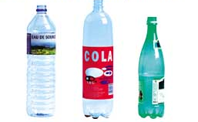
Les bouteilles
(transparentes)
 | Un paquet (de cigarettes)
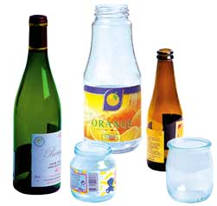 | Les emballages  (en verre)
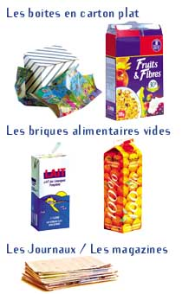 | Les boîtes en carton plat
 | Les emballages (opaques)
 | Les briques

*Note to the instructor: explain to the students that these expressions are used throughout the lessons. For now students should practice basic terms for packaging for recognition of package types.
Adverbs of sequence (a series of events / actions)

You can also mark time with particular adverbs of sequence. Many of these are used in everyday conversation. Read over the following words and the dialogue that follows:

D’abord first
Puis then
Ensuite then
Après after
Enfin finally

 | Isabelle : D’abord, le matin, je vais à l’école. Puis, l’après-midi, je rentre à la maison. Ensuite, je fais mes devoirs. Après, je regarde la télé. Enfin, je vais au lit. | go home  to bed
Exercise 2

Put the activities mentioned above by Isabelle in the right order. Be prepared to answer orally.

Watch TV 4 go to school 1 go to bed 5 do homework 3
Go home 2

Exercise 3
Pair activity. Take turns telling your daily schedule using adverbs of sequence. For certain events, include the times when these actions usually happen. Use the present tense to indicate frequency of these actions.
The verb ouvrir (to open)

Although the verb ouvrir does not end in er, it is conjugated like er verbs:
J’ouvre nous∪ouvrons
Tu ouvres vous∪ouvrez
Il/elle/on ouvre ils/elles∪ouvrent

The verbs couvrir, offrir, souffrir and their compounds are conjugated in this way: j’offre, tu offres, il/elle/on offre, etc.

Exercise 1

Fill in the blanks with the proper forms of the verb ouvrir.

1. Aujourd’hui le restaurant ouvre à midi.
2. En semaine, nous ouvrons à huit heures.
3. A quelle heure ouvrez-vous le jeudi?

-ir verbs—second group

You have learned the conjugation for regular verbs that end in er. You will now learn the conjugation of second group verbs that have their infinitive ending in ir. To obtain the stem, omit the ir ending of the infinitive. Then add the proper endings (to the stem) as shown in the examples below:

FINIR

Je finis Nous finissons
Tu finis Vous finissez
Il/elle/on finit Ils/elles finissent

CHOISIR (stem = chois)

Je choisis Nous choisissons
Tu choisis Vous choisissez
Il/elle/on choisit Ils/elles choisissent

There are about 300 verbs ending in –ir that are conjugated in this way. Some verbs that follow this pattern are:

grossir to gain weight maigrir to lose weight

grandir to grow up choisir to choose
*réussir à to succeed in/at *obéir à to obey
*réfléchir (à /sur) to ponder, to consider, to reflect,
to think (about something)

*Examples:
Je réussis toujours aux examens. I always pass the tests.
Tu obéis à tes parents? Do you obey your parents?
Il réfléchit à votre proposition. He’s thinking about your suggestion / proposition.

Exercise 2

Fill in the blanks with verbs from the following list.

Grossir, maigrir, grandir, choisir, réussir, obéir, réfléchir, finir

- Les sergents obéissent aux lieutenants.
- On grossit quand on mange beaucoup.
- Elles font un régime (diet) et elles maigrissent.
- Les enfants grandissent vite.
- Est-ce que vous finissez toujours vos devoirs?
- Tu réussis toujours à tes examens.
- Je réfléchis à ce problème.
- Vous préférez aller au cinéma ou au café?
- Nous choisissons d’aller au café.

Après-midi  Avec  Commencer (verb)  Cours (n.m)  De rien  Déjeuner (n.m)  Devoirs (n.m.pl)  Difficile (adj.)  Distance (n.f)  En général  Être en avance  Être en retard  Examen (n.m)  Excuser (verb)  Finir (verb)  Grandir (verb)  Gratuit (e) adj.  Grossir (verb)  Horloge (n.f.)  Informations (n.f. pl.)  Itinéraire (n.m)  Je vous (t’) en prie  Journal (n.m)  Kilomètre (n.m)  Livraison (n.f)  Maigrir (verb)  Marque (n.f)  Match (n.m)  Médecin (n.m)  Mètre (n.m)  Minuit  Nouvelles (n.f.pl.)  Obéir à (verb)  Once (n.f.)  Pardon  Pied (n.m.)  Pouce (n.m.)  Préférer (verb)  Quelle heure est-il?  Regarder (verb)  Rendez-vous (n.m)  Rentrer à la maison  Réunion (n.f)  Sortie (n.f)  Sortir (verb)  Vite | Afternoon  With  To commence, to start  Course, class  You are welcome  Lunch  Homework  Difficult  Distance  In general  To be early  To be late  Exam  To excuse  To finish, to end  To grow up  Free  To put on weight  Clock  News, information  Itinerary  You are welcome  News (on TV or radio), newspaper  Kilometer  Delivery  To lose weight  Brand  Game  Doctor (M.D)  Meter  Midnight  News (TV or radio)  To obey someone or something  Ounce  Pardon  Foot  Inch  To prefer  What time is it? Il est…  To watch / to look at  Appointment / date  To go home  Meeting  Departure / Exit / Show (movie), Outing  To go out  Quickly, rapidly

Brique (n.m.)  Causerie (n.f)  Centimètre (n.m.)  Choisir (verb)  Convertir (verb)  Chômeur (n.f)  Dieu (n.m)  Emballage (n.m.)  Film d’action (n.m)  Film d’amour  Fin (n.f)  Heure (n.f.)  Kilogramme (n.m.)  Mesure de longueur (n.f.)  Mètre carré (n.m.)  Mètre cube (n.m.)  Mile (n.m.)  Montre (n.f.)  Opaque (adj.)  Paquet (n.m.)  Réel (le) adj.  Réfléchir à (verb)  Réussir à (verb)  Rougir (verb)  Santé (n.f)  Série (n.f)  Soldes (n.f.pl.)  Soninké  Supérieur (n.m)  Taille (n.f.)  Téléphoner (verb)  Transparent (e) adj. | Carton  Talk  Centimeter  To choose  To convert  Unemployed  God  Packaging  Action movie  Romance movie  End  Time (by clock)  Kilogram  Linear measure  Square meter  Cubic meter  Mile  Watch  Opaque (solid, not clear)  Pack  Real  To think (about)  To succeed  To blush  Health  Series  Clearance sales  An ethnic group in West Africa  Superior  Height  To phone  Transparent

Being on time

The problem of unpunctuality is one of the major issues an American visitor has to face when in Africa. Africans in general are very flexible about time, and this, unfortunately affects their dealings with foreigners. In Africa, it is expected to be 45-minutes to one-hour late whenever an appointment is set. Despite a lack of strict adherence to the clock, there are many other factors that might contribute to frequent tardiness. In most African urban centers, transportation is a nightmare. It is very common to stand on the side of a road for more than an hour looking for a ride. Furthermore, one can receive unannounced visits even as he or she is ready to leave for an appointment—remember the cultural importance of being a good host. Since the social decorum prescribes that guests be given due time and attention, this might be a factor in explaining some cases of tardiness.

For single men, don’t be frustrated or discouraged if a date does not show up on time or at all. Many young girls have to take care of family chores before they are allowed to go anywhere. These household tasks might be overwhelming on the day of the date and might cause them to be late. Moreover, the dating rule in most African countries dictates that women be late for their date, for fear that they could be branded as “easy” and perhaps more interested in the relationship itself than the men who have asked them out in the first place. For this reason most dates arrive deliberately late to their social engagements.

In any event, chances are that in Africa, people will not show up precisely on time but this should not be a reason for you to be late as well. To their credit, many Africans change their time habits when dealing with Westerners to avoid frustrating them, and this, fortunately, has become a growing trend.

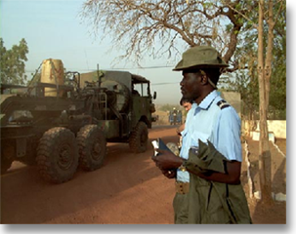
Senegalese gendarme timing the movement of his troops

Activity 1

Pair activity. Role-play the following situation with your partner, and then invert the roles. You have a meeting with your instructor at 3pm. Your watch is broken. Stop someone in the street and ask for the time. Depending on the time said, conclude by Zut! Je suis en retard or Je suis en avance (I’m early). Act out the scene in front of your classmates.

Activity 2

Role-play the following dialogue.

A: Ask when the cafeteria opens.
B: Say it opens at 11am today.
A: Ask what time it is.
B: Say it is 10.45am.

Activity 3

Look at the following breakdown of the prices at a movie theater and answer the questions dealing with clock time.
MELIES
38 RUE GAMBETTA - 42000 SAINT ETIENNE
08.36.68.03.62
TN: 44 F. TR: 35 F.: mercredi, mardi à
partir de 20h, du dimanche 20h au vendredi 18h
pour les étudiants, chômeurs, familles nombreuses...
25 F.: -13 ans tlj. 19 F.: groupes. Abonn.: 300 F./10 pl. ou 160 F./5 pl.
1. A partir de quelle heure commence le tarif réduit (TR) le mercredi? 20 heures
2. A quelle heure finit la période de tarif réduit le vendredi pour les étudiants? 18 heures
Activity 4

Read the following advertisement and check the correct statements.

 | The store will open Wednesday:  a. from 9.30am to 7pm  b. from 10am to 7pm  c. from 8am to 8 pm  On Friday, the store:  a. opens during lunch  b. is closed during lunch  c. closes at 8pm.  The store will:  a. open on weekends  b. open on Saturday  c. open on Sunday  During the weekend:  a. it will be open until 11pm.  b. it will be open until 7pm.  c. it will close at 10pm.
  Des horaires d’ouverture exceptionnels
  
  Printemps ouvrira exceptionnellement dès 8 heures le mercredi 12 janvier et fermera ses portes à 20h00. Un timing idéal pour dénicher la bonne affaire avant ou juste après les horaires de bureau !
  Le magasin sera ouvert de 9h35 à 22h00 le jeudi 13 janvier, de 9h35 à 20h00 les 14 et 15 janvier et le dimanche 16 janvier de 10h00 à 19h00.

Activity 5

You are asked to give a quick approximation of the following measures and distances. Use paper and pencil. Round the numbers down.

1. 100 km = 62 mi 6. 100 kg = lb 220
2. 50 km = 31 mi 7. 55 kg = lb 121
3. 500 km = 310 mi 8. 3 kg = lb 6
4. 84 km = 52mi 9. 12 l = 3 gallons
5. 530 km = 328 mi 10. 2 l = ½ gallon

Activity 6

Write your schedule for a typical week. Indicate the times you perform various activities using the 12-hour system.

Activity 7

Ask each other the following:

- Est-ce que tu grossis après Thanksgiving?
- Quand est-ce que tu maigris?
- Est-ce que tu réussis toujours à tes examens?
- Finis-tu toujours tes devoirs de français?
- Est-ce que tu obéis toujours à tes supérieurs?
- Est-ce que tu rougis (blush) quelquefois? Pourquoi?
- Quand tu vas au cinéma, tu choisis les films d’action ou les films d’amour (love)?
- Est-ce que notre professeur choisit des exercices difficiles?

Activity 8

Class activity. Up for bid are items with an allotted amount of time. Transform your classroom into a live auction house. Each student has a total budget of $1,500,000. Your instructor will ask a student to conduct the auction. Bid by shouting out your offer.

Items to bid on:
- Michael Jackson’s diary—2 hours of reading
- 15 minutes on American Idol (your chance at fame)
- McGuire’s homerun record ball—a day in the park
- Round-trip on the Concorde (its last flight) to your choice location—one full day.
- 20 minutes with your favorite sports icon—on his/her turf.
- A week with Michael Jordan’s Chicago Bulls shirt and a signed copy to keep.
- An afternoon in the company of Heidi Klum (or Brad Pitt, depending on preference)
- A day with Donald Trump
- A 1 hour ride with a professional driver in a Formula 1 or Nascar
- (Your suggestion)

Activity 9

Class activity. Play clock bingo! Your instructor will give you a card with clocks indicating various times. S/he will then announce different times. Check the ones that are on your card as they are announced. The first student whose card is completely checked shouts “bingo” and assumes the role of the announcer.

Activity 10

Listen to the short dialogues (read by your instructor), and fill in the blanks. When you have finished, practice each with a partner.

1. A: A quelle heure est-ce que la cafétéria ouvre le samedi?
B: Elle est ouverte (open) de neuf heures du matin à dix heures du soir.

2. A: A quelle heure est-ce que les restaurants ouvrent aujourd’hui?
B: Ils ouvrent à cinq heures de l’après-midi.

3. A: A quelle heure ouvrez-vous votre restaurant?
B: En général, nous ouvrons à midi.

4. A: A quelle heure ouvres-tu le samedi?
B: Je/J’ouvre de huit heures et quart du matin à cinq heures et demie.

5. A: La cafétéria est ouverte de neuf heures du matin à onze heures du soir.
B: A quelle heure ouvre-t-elle le dimanche?
A: A onze heures et quart.

Activity 11

Mark the correct time for each sentence you hear and share your answers with the class.

1. 10h50 10h11 11h10 Il est dix heures onze
2. 7h45 7h56 8h15 Il est huit heures moins le quart
3. 4h45 5h00 5h15 Il est cinq heures et quart
4. 20h40 20h30 20h15 Il est vingt heures quarante
5. 17h20 17h40 17h50 Il est dix-sept heures cinquante
6. 11h47 11h30 12h13 Il est onze heures et demie
7. 5h10 10h05 9h55 Il est dix heures moins cinq
8. 3h30 4h00 4h30 Il est quatre heures
9. 6h45 7h00 7h15 Il est sept heures quinze
10. 14h30 14h35 4h05 Il est quatorze heures trente-cinq

Pair Activities, Student A

Activity 1

Reconstitute Julie’s schedule. Your partner has the information you need and vice versa. Take turns asking questions such as: à quelle heure a-t-elle une réunion avec M. Dubois lundi? Your partner will answer: elle a une réunion à…/de … à
A
 | lundi | mardi
matin | 8.00-9.00: réunion avec M. Dubois | téléphoner à  M. Dubois
 | réunion avec Mme Blanchot | rendez-vous chez le dentiste
après-midi | 12.05: déjeuner avec Marie | 12.00: déjeuner avec Marie
 | 5.15-6.05: classe d’aérobic
soir |  | 7.30-8.45: cours de marketing
 | cinéma

Activity 2

You want to go to the movie theater. Look at the movie schedule and alternate with your partner in asking and answering questions in order to fill in the missing information.
Example: A quelle heure y a-t-il une séance pour le film … lundi?
Il y a une séance à une heure et à trois heures.

- NADIA ET LES HIPPOPOTAMES
séances: MER - JEU 14H05 18H05 - VEN - SAM 14H05 18H05 - DIM 16H05 20H05 - LUN 16H05 20H15 + DEBAT

- FISH AND CHIPS
film en VO sous-titré -
séances: MER 14H - JEU 20H - VEN 14H - SAM 18H - DIM 20H - LUN - MAR 18H

- LA COUPE
film en VF -
séances: MER - JEU 16H05 20H05 22H - VEN 14H05 18H05 22H - SAM 16H05 20H05 22H - DIM - LUN 14H05 18H05 - MAR 16H05 20H05 22H
Pair Activities, Student A

Activity 3

You and your partner each have a list of cities and their distances in kilometers from Dakar and Libreville. You each have information that the other needs to complete the tables. Take turns asking questions (combien de kilomètres /miles y a-t-il de … à …? to complete the tables.

 | Nouakchott | Yamoussoukro | Tombouc-tou | Lomé | Libreville | Djibouti | Kinshasa
Nouakchott
Yamoussoukro | 1058 miles  1702 km
Tombouctou |  | 701 miles  1128 km
Lomé | 1421 miles  2287 km | 450 miles  724 km | 785 miles  1264 km
Libreville | 2095 miles  3372 km | 1093 miles  1759 km |  | 675 miles  1086 km
Djibouti | 3953 miles  6362 km |  | 3101 miles  4991 km | 2877 miles  4630 km | 2434 miles  3916 km
Kinshasa | 2641 miles  4250 km | 1625 miles  2616 km | 1925 miles  3098 km |  | 546 miles  878 km | 2190 miles  3524 km
Dakar |  | 993 miles  1597 km | 974 miles  1568 km | 1403 miles  2259 km | 2074 miles  3338 km | 4070 miles  6550 km | 2614 miles  4206 km

Pair Activities, Student B

Activity 1

Reconstitute Julie’s schedule. Your partner has the information you need and vice versa. Take turns asking questions such as: à quelle heure a-t-elle une réunion avec M. Dubois lundi? Your partner will answer: elle a une réunion à…/de … à
B

 | lundi | mardi
matin | 8.00-9.00: réunion avec M. Dubois | 9.00: téléphoner à M. Dubois
 | 10.00-10.30: réunion avec Mme Blanchot | 10.00: rendez-vous chez le dentiste
après-midi | déjeuner avec Marie | déjeuner avec Marie
 | classe d’aérobic
soir |  | cours de marketing
 | 9.00: cinéma

Activity 2

You want to go to the movie theater. Look at the movie schedule and alternate with your partner in asking and answering questions in order to fill in the missing information.
Example: A quelle heure y a-t-il une séance pour le film … lundi?
Il y a une séance à une heure et à trois heures.
- NADIA ET LES HIPPOPOTAMES
séances: MER 14H05 20H05 - JEU 14H05 18H05 - VEN 16H05 20H05 - SAM 14H05 18H05 - DIM - LUN 16H05 20H15 + DEBAT

- FISH AND CHIPS
film en VO sous-titré -
séances: MER 14H - JEU - VEN 14H - SAM - DIM 20H - LUN 14H - MAR 18H

- LA COUPE
film en VF -
séances: MER 16H05 18H05 22H - JEU - VEN 14H05 18H05 22H - SAM 16H05 20H05 22H - DIM 14H05 18H05 22H - LUN 14H05 18H05 - MAR
Pair Activities, Student B

Activity 3

You and your partner each have a list of cities and their distances in kilometers from Dakar and Libreville. You each have information that the other needs to complete the tables. Take turns asking questions (combien de kilomètres /miles y a-t-il de … à …? to complete the tables.

 | Nouakchott | Yamoussoukro | Tombouc-tou | Lomé | Libreville | Djibouti | Kinshasa
Nouakchott
Yamoussoukro | 1058 miles  1702 km
Tombouctou | 859 miles  1382 km | 701 miles  1128 km
Lomé | 1421 miles  2287 km | 450 miles  724 km | 785 miles  1264 km
Libreville |  | 1093 miles  1759 km | 1392 miles  2241 km | 675 miles  1086 km
Djibouti | 3953 miles  6362 km | 3310 miles  5326 km | 3101 miles  4991 km | 2877 miles  4630 km
Kinshasa | 2641 miles  4250 km | 1625 miles  2616 km |  | 1220 miles  1963 km | 546 miles  878 km | 2190 miles  3524 km
Dakar | 252 miles  406 km | 993 miles  1597 km | 974 miles  1568 km |  | 2074 miles  3338 km | 4070 miles  6550 km | 2614 miles  4206 km

Activity 4

Take turns in telling Julie’s schedule using adverbs of sequence.

Activity 5

Look at the chart on the following page and contrast the time in two cities using the 24-hour clock.

Example: A: A Paris, il est une heure. Quelle heure est-il à New York?

B: A New York, il est sept heures.
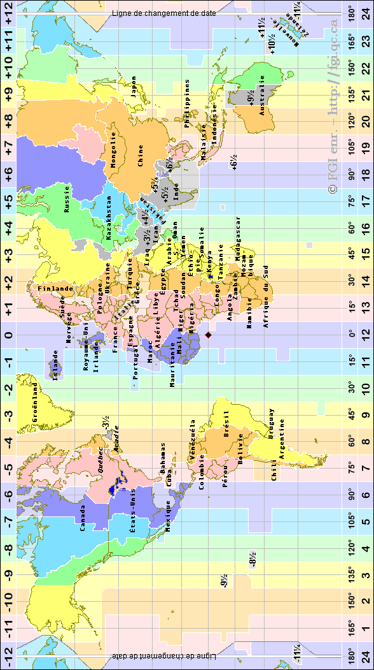
Activity 1

Be prepared to ask and answer questions about clock times.

Activity 2

Imagine that you just won $10,000,000 at the lottery and you are busy spending it. You are writing checks and need to write the following numbers in letters.

- 103 cent trois
- 567 cinq cent soixante-sept
- 800 huit cents
- 4078 quatre mille soixante-dix-huit
- 98 200 quatre-vingt-dix-huit mille deux cents
- 539 054 cinq cent trente-neuf mille cinquante-quatre
- 3 485 945 trois millions quatre cent quatre-vingt-cinq mille neuf cent quarante-cinq

Activity 3 Track 23

CD. The sentences you will hear each contain an official time. Write the time in numbers.

Script:
1. Je vais au cinéma le lundi soir à vingt heures trente. 20.30
2. Nous avons un match de basket-ball samedi à quinze heures. 15.00
3. Patricia a rendez-vous chez le médecin demain à seize heures quinze. 16.15
4. Tu vas au restaurant tous les jours à douze heures cinq. 12.05
5. Vous êtes en classe de français jusqu’à dix-sept heures vingt-cinq. 17.25

Activity 4

Here is a train schedule. Answer the questions to find out about the arrival times of trains leaving from Cergy to Dammartin. Write those times in official time and using am/pm.

H. Dép.  H. Arr. | Départ  Arrivée | Durée | Changements) | Mode(s)
15:47  17:15 | CERGY PREFECTURE GARE  DAMMARTIN JUILLY ST MARD GARE | 01h28 | 2 | Détail de  l'itinéraire
16:21  17:44 | CERGY PREFECTURE GARE  DAMMARTIN JUILLY ST MARD GARE | 01h23 | 2 | Détail de  l'itinéraire
17:11  18:32 | CERGY PREFECTURE GARE  DAMMARTIN JUILLY ST MARD GARE | 01h21 | 2 | Détail de  l'itinéraire

1. A quelle heure le train de 16:21 arrive-t-il à Dammartin? 17:44 - 5.44pm
2. A quelle heure le train de 17:11 arrive-t-il à Dammartin? 18:32 - 6.32pm
3. A quelle heure le train de 17:15 part-il de Cergy? 15:47 - 3.47pm

Activity 5 Track 24

CD. You will hear questions and answers about the distance in kilometers between two cities. Write down the distance in the table.
Model: Combien de kilomètres y a-t-il de Niamey à Dakar? Il y a 2122 km.

Villes africaines | Dakar | Script:
Niamey | 1318 miles  2122 km | 1. Combien de km y a-t-il de Djaména à Dakar? Il y a 3533 km.
Ouagadougou | 1087 miles  1749 km | 2. Combien de miles y a-t-il de Douala à Dakar? Il y a 1996 miles.
Djaména | 2195 miles  3533 km | 3. Combien de miles y a-t-il de Ouagadougou à Dakar? Il y a 1087 miles.
Kigali | 3454 miles  5559 km | 4. Combien de km y a-t-il de Bujumbura à Dakar? Il y a 5542 km.
Bujumbura | 3444 miles  5542 km | 5. Combien de km y a-t-il de Kigali à Dakar? Il y a 5559 km.
Douala | 1996 miles  3211 km | 5. Combien de km y a-t-il de Kigali à Dakar? Il y a 5559 km.

Activity 6
Read the TV program for Monday and answer the questions.

Radiodiffusion Télévision sénégalaise
Lundi
12H00 : Télé services
12H10 : Magazine- Diaspora
12H45 : Journal
13H00 : Magazine- Le journal de l'Afrique
13H133 : Série - Le Coupable ( rediffusion)
14H18 : Documentaire
15H30 : Cinéma ( rediffusion)
17H00 : Jeunesse- Les jules
17H24 : Jeunesse- Urmel
17H50 : Nouvelles en Soninké
18H00 : Annonces + Magazine
18H30 : Causeries sur le Ramadan
18H50 : Nouvelles en wolof
19H00 : Magazine- Santé Vision
19H26 : Série- Tendresse et passion
20H00 : Journal
21H00 : Cinéma
22H41 : Annonces + Magazine + Télé foot
23H51 : Dernières infos
00H06 : Série- Riviera
01H00 : Fin du programme

1. At what time(s) can one watch children’s programs? 17h, 17h24
2. At what time(s) can one watch the news? 12h45, 17h50, 18h50, 20h, 23h51
3. At what time is there a program in Wolof? 18h50
4. At what time is there a program on a religious holiday? 18h30
5. At what time can one watch a program about sports? 22h41

