SOLT French Module 1 Lesson 6
Instructor Manual

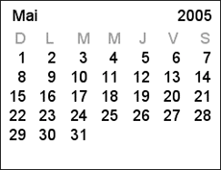

The Calendar

At the end of this lesson, you will be able to talk about family activities and events.

Express Numbers 21-100

- Provide your home address
- Provide the age of your family members
- Request the price of merchandise
- Buy merchandise

Identify Days of the Week

- Recognize days of the week
- Pronounce days of the week
- Name different activities you perform on different days of the week

Identify Months

- Recognize months
- Pronounce months
- Provide your and your family members’ birthdays
- Discuss military activities for the month

Recognize Dates

- Write the dates for personal/military activities
- Name the dates of holidays in French-speaking Africa
- Identify family celebrated dates
- Talk about specific holiday activities
- Identify important family dates
Scenario:


Read the following dialogue where John and Amadou discuss upcoming family events and certain dates.

John: Tiens Amadou, t’as pensé à ce que tu allais faire pour le 31 décembre?

Amadou: Non, pas encore. Je dois déjà m’occuper de l’anniversaire de mon neveux. L’un est le 19 septembre et celui des 2 jumeaux tombe le 28 octobre.

John: Ça fait beaucoup de cadeaux à preparer!

Amadou: Oui, pas mal. J’essaie de leur offrir 2 ou 3 cadeaux chacun, étant donné que le 25 décembre arrive peu de temps après.

John: Tant que tu y es, pense à moi, mon anniversaire, c’est le 10 novembre.

Exercise 1 (follow-up)

Share your ideas with the class. What new expressions do you see? What words are new or seem different as they are presented here?

*Note to the instructor: review some terms beforehand: penser à (to think about something), use of imperfect with aller: allais faire, I must: Je dois, Tant que tu y es: idiomatic usage here.

Exercise 2 (Pair Work)

Before you learn about Francophone celebrations, discuss your own family traditions. How do you prepare for an upcoming family event? Are there some celebrations that your family makes more important than others?
Tip of the day: Numbers 70-99

It might make it easier for you to remember that …
- numbers 70-79 are sixty (+) ten (= seventy), sixty( )+ eleven, etc.
- numbers 80-99 are four (×) twenty (= eighty), four (×) twenty (+) one (= eighty-one), four (×) twenty (+) ten (= ninety), four (×) twenty (+) eleven (= ninety-one), etc.

Whatever our worldview and/or place of residence, we go about life using time as a reference to structure our activities. How we talk about the past, the present or the future is very culture-specific and many people around the world use various concepts and notions, based on their belief systems, to mark the events taking place in their lives. As an expatriate, your adaptation to the new culture will depend largely on you knowing what is important in the lives of your hosts so that you can fit in culturally and socially. This lesson deals with how the societies in West Africa divide, use, and celebrate their time. Expressing numbers in French will help you provide information such as your address, understand and ask about prices, say dates, and describe or relate to cultural events / holidays.

Express Numbers 21-100

You have studied the basics of counting in Module 1 Lesson 3. Follow along as your instructor goes over the numbers below. Numbers from 20 to 69 follow the same pattern:

- vingt et un 40 quarante
- vingt-deux 41 quarante et un
- vingt-trois 42 quarante-deux
- vingt-quatre 50 cinquante
- vingt-cinq 51 cinquante et un
- vingt-six 52 cinquante-deux
- vingt-sept 60 soixante
- vingt-huit 61 soixante et un
- vingt-neuf 62 soixante-deux
- trente
- trente et un
- trente-deux

Note that for 21, 31, 41, etc. the word and, “et” is placed between the number group and one, literally 20 and one: vingt-et-un, trente-et-un, etc. Stress the –s sound of the x in soixante. In the numbers from 21-29, the –t of vingt is always pronounced; vingt-cinq.

Numbers from 70 to 79 have soixante as a base and add the numbers 11-19 (up to 79):

- soixante-dix (sixty + ten) 77 soixante-dix-sept
- soixante et onze 78 soixante-dix-huit
- soixante-douze 79 soixante-dix-neuf (sixty + nineteen)
- soixante-treize
- soixante-quatorze
- soixante-quinze
- soixante-seize

Numbers from 80 to 99 have quatre-vingts (literally four twenties) as a base and add the numbers 1-19:

80 quatre-vingts –s used for 80
81 quatre-vingt-un
82 quatre-vingt-deux
83 quatre-vingt-trois
- quatre-vingt-dix
- quatre-vingt-onze
- quatre-vingt-douze
- quatre-vingt-treize
- cent

The word “et” is omitted in 81 and 91.
The –t in quatre-vingts and quatre-vingt-un is not pronounced.
The –s is dropped from quatre-vingts in 81-99.
The –t in cent is silent before a consonant (cent places), and pronounced before a noun beginning with a vowel sound; cent ans.
Don’t insert “et” in the number cent un. There is no liaison between cent and un.

Exercise 3

Circle the number you hear (read by your instructor) in each row.

a. 22 32 42 g. 55 45 95
b. 68 78 58 h. 80 60 90
c. 44 84 94 i. 78 99 69
d. 29 39 36 j. 47 87 97
e. 61 81 71 k. 79 99 89
f. 93 83 73 l. 100 20 40

Provide your home address

John: Où habites-tu?
Amadou: Au quartier Diakhssawo, à la villa 326.

Exercise 4 (Class Work)

Start a chain. The first student asks the student next to him where he lives, that student answers, then asks the student next to him, and so on until the question comes back to the first student.

Exercise 5 (Pairs)

With a partner, practice asking for the correct telephone number in French. Begin with:
Allo? Est-ce que je suis au…?
- 42.67.96.08
quarante-deux, soixante-sept, quatre-vingt-seize, zéro huit
- 48-84-94-13
quarante-huit, quatre-vingt-quatre, quatre-vingt-quatorze, treize
- 46.01.00.16
quarante-six, zéro un, zéro zéro, seize

Exercise 6 (Pair Work)

Quel est le numéro? Ask your partner the following numbers. Take turns for each one. Ex. Quel est le numéro de ta carte d’étudiant?
C’est le trois deux sept...

- son numéro de sécurité sociale
- son adresse
- le numéro de son permis de conduire
- son code postal
- le numéro de téléphone d’un ami (e)

Provide the ages of your family members

Read the text to follow as Julie talks about her birthday and the birthdays of some of her closest family members.
L’anniversaire
Julie: Mon anniversaire est le quinze septembre. Ma fille a dix ans. Son anniversaire est le douze août. L’anniversaire de mon mari Patrick est le deux juillet.

Vrai ou Faux? The following dates are given in English. Check if they are V/F and correct if false. Give the French date.

- Isabelle’s birthday is 8/13. F 8/12 (le douze août; 12/08)
- Patrick’s birthday is 2/7. F (le deux juillet; 2/07)
- Julie’s birthday is 9/15. V 15/9 (le quinze septembre

Exercise 7 (Group Work)

Tell the class about your birthday and at least 2 people in your immediate family.

Exercise 8 (Pairs)

As a review, ask your partner how many people there are in his/her families and then ask for more details such as ages and addresses:
Find out their names.
Find out how old they are.
Find out where they live.

Now, present your partner to the class.

Sample Answer:
David, il a deux frères qui s’appellent John et Fred. Fred a 17 ans et John a 23 ans. Les deux frères habitent à Raleigh.
Tip of the day: Prices and the Monitary unit→Franc CFA (communauté Financière Africaine franc)
Eight French-speaking countries in West Africa already use a common money, the CFA Franc.
Members of the West African Franc: Mali, Burkina Faso, Ivory Coast, Guinea-Bissau, Senegal, Niger, Benin, Togo.
There are several common ways of writing prices in French:
quarante-huit (francs) cinquante =
48F50
48, 50
48, 50 Frs.
48 FRS 50
48ff50

Requesting and Buying Merchandise

To buy merchandise: Je voudrais… I would like…

Combien coûte(nt)… How much is (are)…

Expressions—Use these expressions to request and buy different types of merchandise:

La marchandise est...
- bon marché / meilleur marché (cheap / good deal)
- en solde / en promotion (on sale)
- de bonne / meilleure / mauvaise qualité (of the best quality)

Le prix est...
- trop élévé (too high) / raisonnable / avantageux / intéressant (low)
- imbattable (unbeatable)

Verbs—Practice these verbs to use for buying or asking about merchandise:
- garder / demander / montrer le reçu ou la facture (too keep / ask for / show the receipt or bill)
- rapporter / échanger (une chemise) qui a un défaut = to take back / exchange (a shirt) that has a fault.

After you have reviewed these expressions as a class, read the dialogue to practice buying merchandise.
Tip of the day: The French use the comma (virgule) in decimal numbers only: 3, 25.
There may be a blank space where English uses a comma. Un point (a period) is sometimes also used.
For example: 2 250 or 2. 250.

John buys some stationary to write to his family and asks the merchant about prices. Practice the dialogue with a partner.

John: Combien coûtent ces enveloppes? How much are these envelopes?
Marchand: Elles coûtent 400 F. They cost
John: Et ce stylo? Combien coûte-t-il?
Marchand: 150 F.
John: Ça fait combien en tout? How much is it all together?
Marchand: 550 F.
John: Voilà 600 F.
Marchand: Voilà votre monnaie. Here is your change

Vrai ou Faux?

1. John achète un stylo et des enveloppes. V
2. Le stylo et les enveloppes coûtent six cents francs. F, 550 F

Exercise 9 (follow-up)

Ask the price for the following objects. Your partner will answer you.
Example: combien coûtent les balles de tennis?
Elles coûtent 32 francs.
Ce n’est pas trop cher (c’est trop cher).

- planche à voile 3 300 F
- raquette de tennis 650 F
- skis 975 F
- mobylette 4 250 F
- balles de tennis 32 F
- ballon de football 160 F

Exercise 10 (Group Work)

Les promotions
You are going shopping in a frozen food store. Most words to look for will be cognates or easy to recognize. You will buy the main dish, some vegetables and a dessert. Look online for 4 sale items for “les produits surgelés”. What will you choose?
Sample items to select:

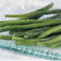
1 KG HARICOTS TRES FINS
83015 - l'unité 1,93 € 1,70 €
(le kilo 1,93 - 1,70 €)

1 KG MACEDOINE DE LEGUMES T
83105 - l'unité 1,80 € 1,62 €
(le kilo 1,80 - 1,62 €)

1 PIZZA ROYALE X 480 G
82411 - l'unité 4,68 € 3,74 €
(le kilo 9,75 - 7,79 €)

10 BEIGNETS POMMES + 2 GRATUIT
89681 - l'unité 4,52 € 4,52 €
(le kilo 5,02 - 5,02 €)
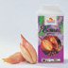
100 G ECHALOTE
83316 - l'unité 1,62 € 1,46 €
(le kilo 16,20 - 14,60 €)

Now calculate the real price of what you will buy, the sale price and how much you save (économiser). Use the chart to track your findings:

Items | prix avant | prix en promotion | différence de prix
Item 1
Item 2
Item 3
Item 4
Totale:

Give your results to the class. Who made the most expensive menu, the most original? Who saves the most?

Exercise 11 (Pair Work)

Ask your partner the following questions. Be prepared to discuss your ideas with the class. Give simple sentences for each using the information below and expand on your answers in English (for class discussion). What did you learn about each other?

- Quand vous achetez quelque chose, quelles caractéristiques sont les plus importantes?
le prix
l’apparence de l’objet (la taille, la couleur, le matérial
la qualité
la marque
l’origine (fabriqué aux Etats-Unis, au Japon , etc.

- Est-ce que l’importance de la qualité est différente selon l’objet que vous achetez? Expliquez.

Les jours de la semaine

lundi Monday

mardi Tuesday

mercredi Wednesday
jeudi Thursday
vendredi Friday
samedi Saturday
dimanche Sunday

To ask about the day:

Quel jour sommes-nous aujourd’hui? What day are we today?

Quel jour est-ce aujourd’hui? What day is it today?
On est quel jour aujourd’hui? What day are we today?

Possible replies: Nous sommes mardi. C’est mardi. On est mardi.

Note that the first day of the week in French is Monday. The days of the week and months are not capitalized in French. Days of the week are masculine: le lundi.

Exercise 12

Look at the calendar below and answer the questions.

1. Quel jour est le treize? Un lundi 6. Quel jour est le cinq? Un dimanche
2. Quel jour est le trente? Un jeudi 7. Quel jour est le dix? Un vendredi
3. Quel jour est le sept? Un mardi 8. Quel jour est le premier? Un mercredi
4. Quel jour est le vingt-neuf? Un mercredi 9. Quel jour est le vingt-trois? Un jeudi
5. Quel jour est le dix-huit? Un samedi 10. Quel jour est le treize? Un lundi

lundi | mardi | mercredi | jeudi | vendredi | samedi | dimanche
 |  | 1 | 2 | 3 | 4 | 5
6 | 7 | 8 | 9 | 10 | 11 | 12
13 | 14 | 15 | 16 | 17 | 18 | 19
20 | 21 | 22 | 23 | 24 | 25 | 26
27 | 28 | 29 | 30 | 31

Activities you perform on different days of the week

Julie, John’s sister, talks about a typical week.

Du lundi au vendredi, je travaille. Je suis secrétaire. Le mardi, j’étudie le marketing. Mon mari fait la cuisine et la vaisselle ce jour-là. Il déteste ça! Le mercredi après-midi, je fais du sport. Le soir, les enfants font leurs devoirs, puis nous regardons la télé. Le vendredi soir, je fais les courses. J’aime le week-end. Le samedi, j’emmène mes enfants au parc. Nous jouons au ballon, et nous faisons un pique-nique. Ils adorent ça. | Work  Study/does the cooking and dishes/hates  Do sports/homework  Watch/evening/shopping  Take/play ball
*Note the use of jouer + à + le ballon.

Vrai ou Faux?

1. Julie travaille le lundi et le vendredi. Julie travaille du lundi au vendredi
2. Julie étudie le marketing le samedi. Julie étudie le marketing le mardi
3. Son mari fait la cuisine tous les jours. Il fait la cuisine le mardi
4. Les enfants regardent la télé, puis ils font leurs devoirs. Ils font leurs devoirs, puis ils regardent la télé
5. Les enfants aiment faire un pique-nique. V

Les mois de l’année

- janvier  - février  - mars  - avril  - mai  - juin | - juillet  - août  - septembre  - octobre  - novembre  - décembre

Les saisons

Le printemps (m.) Spring
L’été (m.) Summer
L’automne (m.) Autumn / Fall
L’hiver (m.) Winter

Remember that the –h is silent: hiver = hiver. Use the preposition, en (in) with months or seasons: en hiver, en janvier, etc. Au printemps (In spring) is the only exception; à + le printemps = au printemps.

Exercise 13

Write in French the months during which the following holidays occur.

- Christmas décembre 6. Memorial Day mai
- Halloween octobre 7. Valentine’s Day février
- Thanksgiving novembre 8. Labor Day septembre
- New Year janvier 9. Father’s Day juin
- Easter avril 10. Independence Day juillet

Exercise 14

- Name the winter months. décembre, janvier, février
- Name the summer months. juin, juillet, août
- Name the spring months. mars, avril, mai
- Name the fall months. septembre, octobre, novembre

Activities for the months

 |  |  | 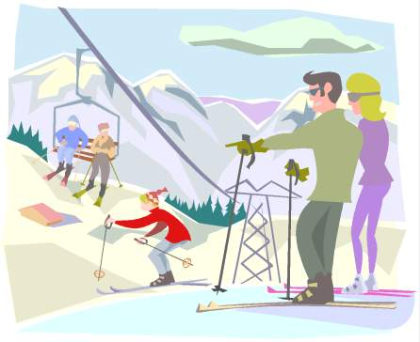
En avril, je fais des randonnées. | En août, je vais à la mer. Je nage et je fais de la planche à voile. | En septembre, je fais de la bicyclette. | En février, je vais à la montagne. Je fais du ski.

Exercise 15 (Pair Work)

Tell your partner about 3 different activities you know how to do well and what month you like to do them. Use the captions above to help you give a detailed answer.
Exercise 16

Make an engagement calendar (use the activities above to help you get started) for whatever month and year it is now. Write out each day’s date (le premier, le deux, le trois, etc.) French calendars start with lundi. Days and months are not capitalized. Place le premier in the small block directly beneath whatever day of the week the first falls on in the month, and then continue numbering. List only major verbs on the day: vendredi le 2 juillet / aller à la montagne avec Jim et Tom.

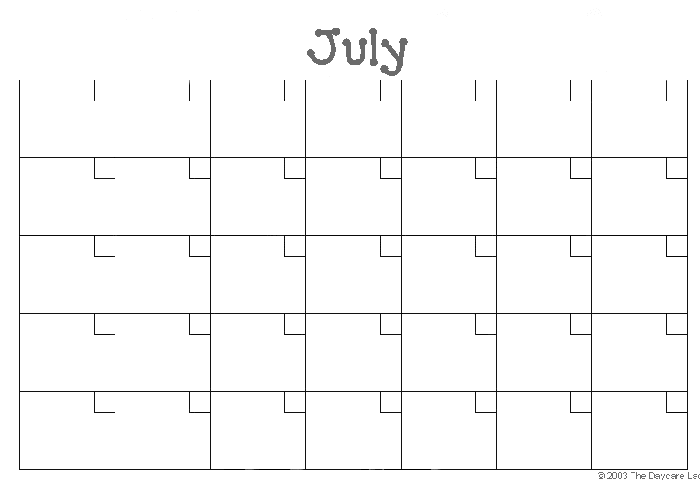
Tip of the day: Dates in numerals

When writing the dates in French in numerals, the day comes before the month. Thus,
2/12 is December 2nd, not February 12th!

The date

 | Quelle est la date d’aujourd’hui?  Aujourd’hui, nous sommes (c’est/on est) le 30 octobre.

To give the date in French, use the cardinal numbers except for the first of any month, in which case you need to use the ordinal: c’est le premier juillet→ It’s the first of July.

*Note to the instructor: from now on, start each class by asking students the date and day.

Exercise 17 (Pairs)

Questions personnelles: Practice these questions with your partner.
- Quel jour est-ce aujourd’hui?
- Quel est ton jour préféré?
- Quel est ton mois préféré?
- Quand est-ce ton anniversaire?
- Quand est-ce, l’anniversaire de ton meilleur copain ou ta meilleure copine?

Exercise 18

Write out the following dates according to the French system and share your answers with the class.

a. 11/10 le onze octobre h. 7/2 le sept février
b. 4/1 le quatre janvier i. 30/4 le trente avril
c. 1/8 le premier août k. 9/3 le neuf mars
d. 21/11 le vingt et un novembre l. 27/7 le vingt-sept juillet
e. 17/5 le dix-sept mai m. 15/6 le quinze juin
f. 12/9 le douze septembre g. 3/12 le trois décembre

Holiday activities

Read the following texts that describe francophone holidays and family events. The first one is very general and the second text is a more personalized version (Julie’s narrative). With your class, discuss unique aspects of your family activities during the holidays.
Les fêtes
Anniversaires, Noël, … sont des fêtes familiales, réunissant toutes les générations. Les repas (déjeuner ou dîner) sont généralement longs. (Il ne faut pas oublier que les français aiment bien manger et bien boire, et les fêtes permettent de profiter des " plaisirs " de la table).

Julie talks about her plans for the coming Christmas holiday.

Pour Noël, ma famille et moi, nous allons (aller) chez mes parents. Nous allons prendre l’avion le vingt-quatre décembre. Le soir, nous allons manger et parler. Le lendemain, je vais faire la cuisine avec ma mère. Puis, nous allons ouvrir les cadeaux. Les enfants vont faire un bonhomme de neige, et nous allons regarder la télévision. Et vous, qu’est-ce que vous allez faire? | Christmas  Take the plane  Open the gifts  snowman

Vrai ou Faux?

1. Julie va prendre l’avion le 24 décembre. V
2. Ils vont ouvrir les cadeaux le vingt-cinq décembre. V
3. Les hommes vont faire la cuisine. F les femmes vont faire la cuisine.

Exercise 19 (Pairs)

Place these holiday (family) celebrations in order of importance for you.
Le 1er janvier: jour de l’An, La fête des Mères, fête des Pères, et les anniversaires, les fêtes, les fiançailles et mariages.

Exercise 20 (Pair Work)

Tell your partner how you normally celebrate New Year’s Eve or New Year’s Day with your family. Ask your partner how s/he usually celebrates the occasion. Share your ideas with the class.

Tip of the day: Tabaski

Tabaski is the most popular holiday of the Moslem community in Senegal. It is celebrated almost identically in all of the country’s different communities. The day starts early because everybody has to dress up for the occasion. At 9:00 am, the men go to pray either at the mosque or at a designated public place, and upon their return, they slaughter sheep or lambs for the day’s feast. During the day, people move a lot, visit and wish each other a happy holiday and ask forgiveness of each other for whatever might have happened between them during the course of the year. After most visits are over, people get together by age group and spend the whole day barbecuing and playing cards.
Children also get together by age group and run from one family to another to collect money gifts known as Ndewenal. In the afternoon, people go out to see soccer games or traditional dance parties organized in the neighborhood on the occasion of this holiday. This outing is usually an opportunity for women, particularly, to show how well they are dressed and how nice their braids are, since most of them have spent the day cooking for their families.

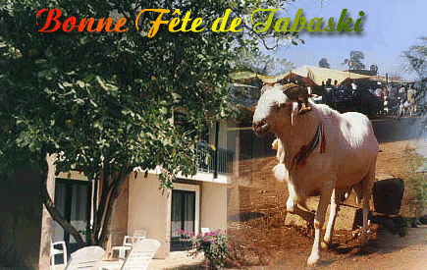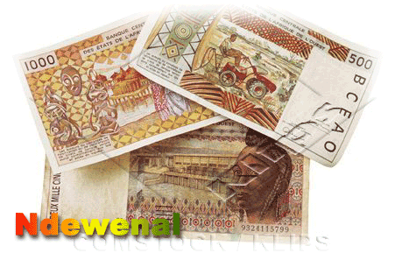

Age

To ask about or say someone’s age in French, use the verb avoir:
Quel âge as-tu? How old are you?
J’ai vingt ans. I have ten years (of age) → I am 20 years old.
Elle a trente ans. She is 30 (years old).

Note: When talking about age, the word ans is not optional.

Demonstrative adjectives

As all adjectives in French, demonstrative adjectives agree in gender and number with the noun they accompany.

Masculine singular | Masculine noun starting with vowel or mute h | Feminine singular | Plural
ce stylo  this pen | cet homme  this man | cette femme this woman | ces enveloppes these envelopes

Exercise 1

Fill in the blanks with the proper form of the demonstrative adjective.

1. Je vais acheter ces livres.
2. Combien coûte cette table?
3. Est-ce que ce stylo est à toi?
4. Qui est cette femme? Et qui sont ces enfants?
5. Cette maison est très belle.
6. Elle aime beaucoup ces couleurs.
7. Ces étudiants sont très intelligents.
8. Cet homme est mon frère.

Exercise 2

Your classroom was hit by a tornado and you are sorting things out. Fill in the blanks with the proper form of the demonstrative adjective.

Ce livre est à Jim. Ces cahiers sont à George. Ce stylo et cette chaise sont au professeur.

Definite article + days of the week

When a day of the week is preceded by the definite article, it indicates something that happens every week on that day. When a day of the week has no article, the coming day is what is being referred to. Example: le lundi: on Mondays
lundi: this Monday
The definite article can also be used with parts/times of the day: le matin (in the mornings), le soir (in the evenings), etc.

Exercise 3

Circle the words that translate the sentence accurately.
1. Mercredi, je travaille. I work this Wednesday / on Wednesdays

2. Elle fait la cuisine le vendredi soir. She cooks on Fridays / this Friday

3. Nous jouons au football le dimanche. We play soccer this Sunday / on Sundays

The verb faire (to do, to make)

The verb faire (to do, to make) is used with idiomatic phrases that indicate household chores and playing/practicing certain sports. Its conjugation is irregular.
je fais nous faisons
tu fais vous faites
il/elle/on fait ils/elles font

How to talk about activities one is engaged in:
Faire + du, de la, de l’, des + subject
+ sport or pastime
Examples:
Nous faisons de l’anglais.
Mes amis font du ski.
Il fait de la photo.

In negative sentences, faire du, de la, de l’, des become de/d’:
Vous faites de la natation aujourd’hui? Are you going to swim today ?
Non, nous ne faisons pas de natation.

How to talk about many common activities: Look at the pictures below to identify how some expressions with faire are used.
- Faire la vaisselle
- Faire le ménage
- Faire la lessive
- Faire la cuisine
- Faire de la bicyclette/du vélo
- Faire de la natation
- Faire ses devoirs
- Faire une promenade = to take a walk/to go on a walk
- Faire les courses = to go shopping

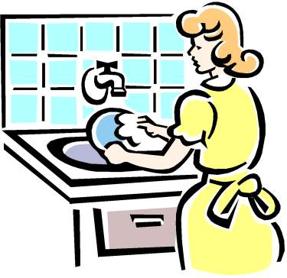 | 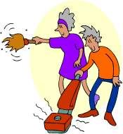 |  | 
faire la vaisselle | faire le ménage | faire la lessive | faire la cuisine
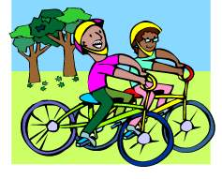 |  | 
faire de la bicyclette/du vélo | faire de la natation | faire ses devoirs

The verb aller (to go)

The verb aller has an irregular conjugation. Here are its forms in the present tense:

Je vais | nous allons
Tu vas | vous allez
Il/elle/on va | ils/elles vont

Exercise 4

Fill in the blanks with the right forms of aller.

- Ton frère va à Disneyland.
- Mes amies vont à la discothèque.
- Je vais à Paris.
- Nous allons au restaurant.
- Tu vas à Dakar.
- Vous allez aux Champs Elysées.

Exercise 5

Ask your partner→ où est-ce que tu vas...
- in the summer?
- in the winter?
- for Thanksgiving?
- on the weekends (le week-end)?

Aller + infinitive = le futur proche

The verb aller followed by the infinitive of a verb is the construction used to express an event or an action that is going to take place in the near future (i.e. the term futur proche). It is similar to the English expression “going to” followed by an infinitive.

Examples: Je vais faire la cuisine I am going to do the cooking
Tu vas aller à la maison You are going to go home
In a negative sentence, ne…pas and other negations surround the conjugated verb:
Nous n’allons pas habiter à Toronto.
Il ne va jamais être content.

Note the expression: aller chercher (to go get): Il va chercher son cousin à l’aeroport.
OR to pick up: Je dois (must) aller chercher un livre a la bibliothèque.
Adorer (verb)  Août  Après  Après-midi  Avril  Beaucoup (adv.) / + de (quantity)  Coûter (verb)  Date (n.f.)  Décembre  Détester (verb)  Dimanche  Faire des courses  Faire des randonnées  Faire du sport  Faire de la bicyclette/du vélo  Verbs  Faire la cuisine  Faire la grasse mâtinée  Faire la lessive  Faire de la natation  Faire le ménage  Faire ses devoirs  Fête (n.f.)  Février  Janvier  Jeudi  Juillet  Juin  Lundi  Mai  Mardi  Mars  Matin  Mercredi  Novembre  Octobre  Pour  Prendre (verb)  Puis  Quand  Samedi  Septembre  Soir  Vendredi | To adore/ To love  August  After  Afternoon  April  A lot/Many/Much  To cost  Date  December  To Hate/Detest  Sunday  To run errands/to shop for groceries  To go hiking  To exercise  To bike  To cook  To sleep in late  To do laundry  To Swim  To do the housework  To do one’s homework  Holiday  February  January  Thursday  July  June  Monday  May  Tuesday  March  Morning  Wednesday  November  October  To/In order to/For  To take/to drink or eat  Then/Next  When  Saturday  September  Evening  Friday

Autre  Bain (n.m.)  Ballon (n.m.)  Chacun (e) (adj., pron.)  Économiser (verb)  Emmener (verb)  Faire du ski  Le lendemain  Manger (verb)  Mer (n.f.)  Monnaie (n.f.)  Montagne (n.f.)  Nager (verb)  Noël  Partir (verb)  Pendant  (Faire) de la planche à voile  Ramadan/Korka  Regarder (verb)  Revenir (verb)  Se lever (reflexive verb)  Tam Kharit/Harane  Taske/Tabaski  Télé (n.f.)  Tout le monde (pronoun)  Tôt  Rendre visite (à + person)  Visiter (verb)  Vivre (verb)  Voisin (e) | Other  Bath  Ball  Each  To Save  To bring  To ski/to go skiing  The following day  To eat  Sea  Change  Mountain  To swim  Christmas  To leave  During  Windsurfing  Fasting month for Moslems  To look/Watch  To return/To go back  To Get up  1St night of the Islamic year  Biggest Moslem holiday  Television  Everybody/Everyone  Early  To give a visit to/to visit someone  To visit a place, monument  To live  Neighbor

Numbers 70-99

In Belgium and Switzerland, other words are used for numbers 70 through 99. Some African countries (former Belgian colonies), such as the Democratic Republic of Congo (formerly Zaïre), also use these numbers. The French system is taught in schools and is widely used by the younger generation, but the Belgian system is still used by the older generation. We provide them for recognition only:
- septante
- septante et un
72 septante-deux
80 octante
- nonante
- nonante et un
- nonante-deux

Holidays

Whether it is a religious, national or family holiday, Africans love to celebrate the events in their lives with big festivities. With the exception of birthdays, holidays are usually celebrated publicly with family members and non-family members alike. Consequently, they are attended by a great number of people and constitute a good opportunity for socialization. Holiday celebrations may include offering prayers, or participating in some games such as card playing (most popular game), but eating, drinking and dancing are usually the most common and popular activities, and the success of a holiday celebration largely depends on how well these three activities are featured.
West African countries such as Senegal, Mauritania, Guinea, the Ivory Coast, and Mali celebrate many holidays. Some of these days are religious while others are national or family holidays. Senegal, for instance, is an overwhelmingly Islamic country (92% Moslem), but minorities such as Christians (2%) and practitioners of indigenous beliefs (6%) enjoy complete religious freedom. Senegal is one of those countries where differences in religious beliefs have fostered understanding and mutual appreciation, rather than dividing people. One has to be in Dakar or any other Senegalese town on Christmas Eve to witness the fervor with which Senegalese of all creeds celebrate this Christian holiday. The same thing could be said of the coming of the Taske (most important Moslem holiday) during which some Senegalese Christians also slaughter sheep, a sacrifice only imposed on Moslems.
Even though national holidays are important, they do not command as much celebration and enthusiasm as religious or family holidays. The Senegalese are deeply religious and religious matters occupy a central place in their lives. Unlike Christian holidays, Islamic holidays are based on the lunar calendar (i.e. on the sighting of the moon). Consequently, they do not fall on fixed dates as Christian holidays do. For example, the start of the month of Ramadan moves forward by eleven days each year. Because the moon is not always visible from everywhere at the same time, some countries celebrate the holidays one day earlier or one day later than others. Except for Tam Kharit, which is mostly a night-time celebration, all the religious and national holidays are off days in Senegal. The following is a list of the most popular holidays in the country.

Religious Holidays
- Moslem Holidays
Tabaski or Taske: 10th of El Hijja, the most important holiday in Senegal and other Moslem countries. It celebrates the sacrificial lamb that was offered when Ibrahim (Abraham) was asked to kill his son as a proof of his submission to the commands of Allah. When Ibrahim showed his resolve to carry out the orders given to him by his creator, Allah substituted a sheep for the killing of his son. Tabaski is in reality a 3-day long celebration but the first day is usually the most celebrated one. It is the children's favorite because, in addition to the delicious food and drinks provided during that holiday, they get new clothes and shoes and collect money from the families in the neighborhood. After their return from the 9:00 am prayer that is specific to Tabaski and Ramadan Holidays, most adult people spend their time eating and playing cards.
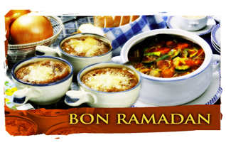Korka or Ramadan: celebrates the end of the fasting month known as Ramadan. Here too, people slaughter sheep or cows to feast. As in Tabaski, children get new clothes and also monetary gifts from adults in the neighborhood. The Ramadan Eid (holiday) is a culmination of thirty days of fasting during which Moslems are required to abstain from food, drink and sexual gratification from sunset to sundown. At night, however, Moslems are allowed to resume all the activities listed above. In most households, the nights are spent eating and drinking to make up for the meals of the day. Moslems take advantage of this month to be even nicer to their relatives and neighbors. In Guinea, for instance, people prepare their best dishes to feed the poor or elderly relatives. La Korité is a celebration for the end of Ramadan.
Tam kharit or Harane: 1st day of the Islamic calendar. It is believed that on this day, Allah determines who will live or die for the year to come. Children are told that whoever goes hungry that night will be counted among the people who will die that year. Consequently, lavish dinners are prepared for people to eat.
Maouloud: Celebrates the anniversary of the birth of the Prophet Mohammed. It is a nightly celebration and the main activities are reciting the Koran in mosques (Moslem worshipping places), and making the praises of the Prophet Mohammed all night long. Tivaoune, a city north of Dakar, organizes each year the biggest Maouloud celebration in Senegal.
- Christian Holidays
Christmas
New Year’s Eve
The Assumption Day: August 15, people gather that night on the Hydrobase Beach in Saint Louis. It is one of the most popular celebrations among the young people.
Popenguine (in April)
Easter

National Holidays
April 4: Independence Day
Mai 1: Labor Day. Like much of the rest of the world, Senegal celebrates Labor Day on Mai 1st.

Activity 1

Class activity. Your instructor will start a chain. The class will count from 1 to100, count 10 by 10, count 5 by 5, and count even numbers, odd numbers.

Activity 2

Class activity. Play bingo. Listen to the numbers, repeat them, and cross them out. The first student to get a bingo takes over the instructor’s role. You get a bingo when you line up 5 numbers horizontally, vertically, or diagonally.

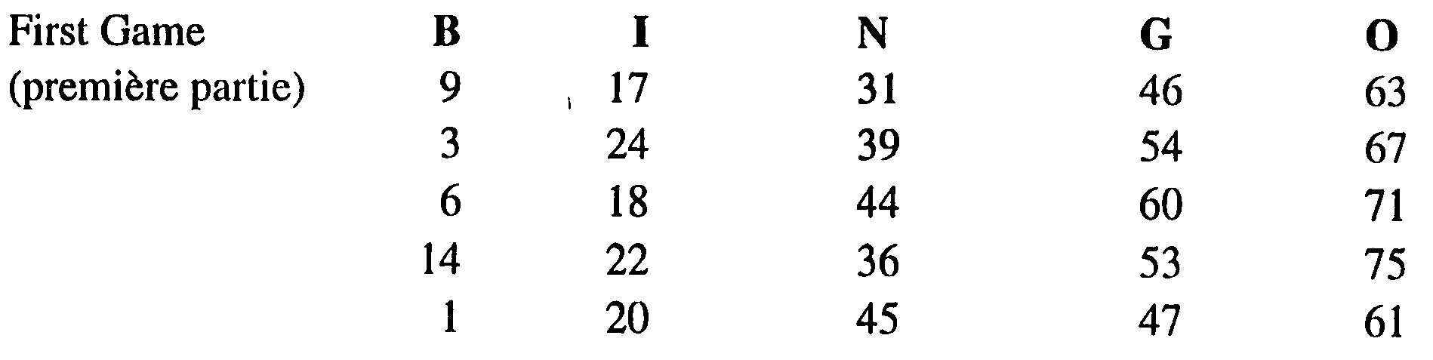

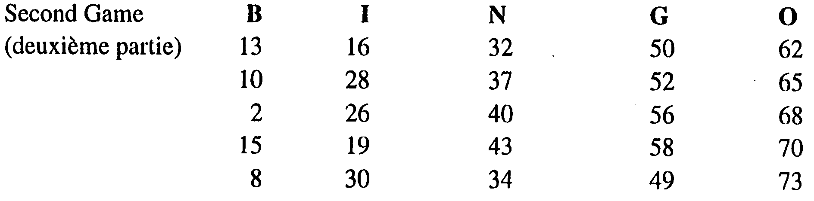

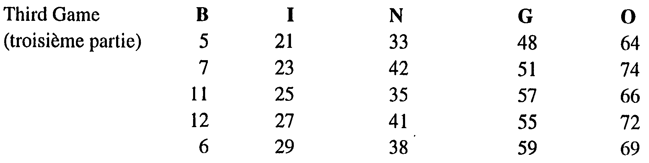

Activity 3

Class activity. Your instructor will randomly collect some classroom objects from different students (notebooks, pens,…) and gather them on his/her desk. S/he will then call out à qui est ce livre? When an item belongs to you, answer ce livre est à moi, and go pick it up. After you have identified your object (s), tell how much it costs.
Activity 4

Your instructor will start a chain by asking a student quel jour est le …? The student will answer (le … est un…), then ask a new question to another student, and so on until all students have asked a question. Refer to the calendar below to answer the questions.

lundi | mardi | mercredi | jeudi | vendredi | samedi | dimanche
 |  | 1 | 2 | 3 | 4 | 5
6 | 7 | 8 | 9 | 10 | 11 | 12
13 | 14 | 15 | 16 | 17 | 18 | 19
20 | 21 | 22 | 23 | 24 | 25 | 26
27 | 28 | 29 | 30 | 31

Activity 5

Reorder the days of the week according to the French custom.

- vendredi 1. lundi
- dimanche 2. mardi
- mardi 3. mercredi
- jeudi 4. jeudi
- lundi 5. vendredi
- samedi 6. samedi
- mercredi 7. dimanche

Activity 6

Write a short paragraph in which you describe where you (and your family) go and what you do in which season of the year. Which ones are more interesting for you? Share the information with your classmates.

Activity 7

Write the months you associate with each picture. Why?

1. décembre |   2. avril |   3. février |   - octobre
  5. juillet |   6. mars |   7. novembre | 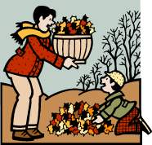  8. septembre

Activity 8

Find the French words for the months of the year.
Z | E | X | A | J | U | I | L | L | E | T | O | L
M | N | T | J | A | N | V | I | E | R | Z | S | Q
B | O | Y | G | O | W | O | R | M | B | N | E | X
C | V | U | X | U | O | B | A | L | O | X | P | F
N | E | R | P | T | M | A | R | S | T | Y | T | M
S | M | A | I | E | Z | J | L | J | C | Y | E | F
A | B | A | T | R | T | L | U | U | O | W | M | G
O | R | P | E | R | A | V | R | I | L | G | B | F
F | E | V | R | I | E | R | M | N | N | X | R | Z
S | M | O | F | D | E | C | E | M | B | R | E | Y

Activity 9

Write a short paragraph where you mention a minimum of 5 of your family members’ ages and birthdays. Share the information orally with your class.

Activity 10

Write the date of the following holidays in French. For those that vary, look up the date on this year’s calendar.

1. Christmas Eve. Le vingt-quatre décembre 6. Veteran’s Day. Le onze novembre
2. New Year’s Day. Le premier janvier 7. Memorial Day.
3. Independence Day. Le quatre juillet 8. Labor Day.
4. Christmas. Le vingt-cinq décembre 9. Easter.
5. Valentine’s Day: le quatorze février 10. Halloween

Activity 11

Ask your partner the following questions and then brief the class:

1. If he always does his French homework.
2. If he swims.
3. If he does the dishes on Sundays.
4. If he bikes on weekends.
5. If he often does the housework.
6. If he cooks on Mondays.
7. If he does the laundry on Saturdays.
Activity 12

Describe what the following people are doing.

1 Elle fait la cuisine

2. Ils font le ménage

3. Nous faisons du vélo/de la bicyclette

4. Tu fais de la natation
5. Je fais mes devoirs
6. Vous faites la lessive

Activity 13

Fill in the blanks with a verb from the list below:
faire regarder travailler aimer

1. Nous aimons le week-end parce que nous ne travaillons pas.
2. Je travaille du lundi au vendredi.
3. Tu regardes trop souvent la télé.
4. Elle fait la cuisine et il fait la vaisselle.
5. Nous faisons nos devoirs le soir.
7. Ils font la lessive le vendredi.

Activity 14

Here is Amadou’s family tree with every member’s birthday added. Fill in the blanks with the correct dates. Example: l’anniversaire de son père est le 2 janvier. How do you think each person would celebrate his / her birthday? Compare your ideas with the class.

1. L’anniversaire de sa mère est le 3 juillet.
2. L’anniversaire de son grand-père est le 25 juin.
3. L’anniversaire de sa femme est le 17 avril.
4. L’anniversaire de son fils est le 12 juin.
5. L’anniversaire de son beau-frère est le 24 mai.
6. L’anniversaire de son père est le 2 janvier.
7. L’anniversaire de sa grand-mère est le 24 décembre.
8. L’anniversaire de sa sœur est le 13 août.

Guéda Samba

24/12 25/6

Sokhna Ousmane
(3/7) (2/1)

Tapha Khady Rose Amadou Penda
24/5 13/8 13/12 17/4

Fama (F) Abou (M)
18/11 12/6

Pair Activities, Student A

Activity 1

The pictures below illustrate the items you want to buy and the money you have to spend. Explain to the merchant what you are looking for, ask for prices, decide on what to buy, give money and get your change if necessary.

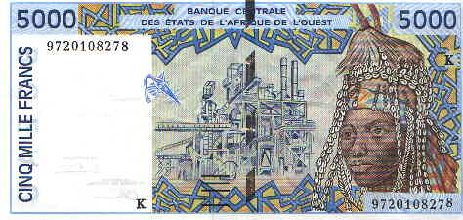

Activity 2

You and your partner each have half of the information necessary to reconstitute Julie’s family’s full schedule for next week. Ask your partner questions using the following example: qui fait la vaisselle mardi?

Schedule A
lundi | mardi | mercredi | jeudi | vendredi | samedi | dimanche
_____ joue au tennis  Isabelle et Mike font leurs devoirs | Isabelle fait de la natation  ______  étudie le marketing  Patrick fait la cuisine | ________  ________ regardent la télé  Mike fait la vaisselle  _______ fait de l’aérobic | Mike joue au foot  _____ fait la vaisselle | ____ fait les courses  Mike et Isabelle jouent au ballon | Julie fait la lessive  _____ fait le ménage | ______ font la grasse mâtinée  Julie, Patrick et les enfants font un pique-nique

Pair Activities, Student B

Activity 1

You are a merchant. The following is the type and price of items you sell. Help the customer.


1 500F 250F 370F 1 220F 20 400F 720 000F 125F

Activity 2

You and your partner each have half of the information necessary to reconstitute Julie’s family’s full schedule for next week. Ask your partner questions according to the following example: qui fait la vaisselle mardi?

lundi | mardi | mercredi | jeudi | vendredi | samedi | dimanche
Patrick joue au tennis  ______  ______ font leurs devoirs | ______  fait de la natation  Julie étudie le marketing  _____ fait la cuisine | Mike et Isabelle regardent la télé  _____ fait la vaisselle  Julie fait de l’aérobic | _____ joue au foot  Isabelle fait la vaisselle | Julie fait les courses  ______  ______ jouent au ballon | ____ fait la lessive  Patrick fait le ménage | Julie et Patrick font la grasse mâtinée  _______  _______  _______ font un pique-nique

Activity 3

Ask your partner for the following information. Write it down in the following format:
Example: quel âge as-tu? Quel âge a ta mère? How old are you? How old is your mother?
Age:
Age de la mère:
Age du père:
Age des frères et sœurs:
Age des enfants:

Activity 4

Class activity. Your instructor will collect and randomly redistribute the cards from the previous activity. Find whose card you have by going around the classroom and asking other students questions. Example: Tu as 30 ans? /Quel âge a ta mère?

Activity 5

Pair activity. Look at the calendar and take turns asking your partner questions. Example: Quel jour est le 12 avril ? Le 12 avril est un mercredi.

janvier février mars
L | M | M | J | V | S | D |  | L | M | M | J | V | S | D |  | L | M | M | J | V | S | D
 |  |  |  |  | 1 | 2 |  |  | 1 | 2 | 3 | 4 | 5 | 6 |  |  |  | 1 | 2 | 3 | 4 | 5
3 | 4 | 5 | 6 | 7 | 8 | 9 |  | 7 | 8 | 9 | 10 | 11 | 12 | 13 |  | 6 | 7 | 8 | 9 | 10 | 11 | 12
10 | 11 | 12 | 13 | 14 | 15 | 16 |  | 14 | 15 | 16 | 17 | 18 | 19 | 20 |  | 13 | 14 | 15 | 16 | 17 | 18 | 19
17 | 18 | 19 | 20 | 21 | 22 | 23 |  | 21 | 22 | 23 | 24 | 25 | 26 | 27 |  | 20 | 21 | 22 | 23 | 24 | 25 | 26
24 | 25 | 26 | 27 | 28 | 29 | 30 |  | 28 | 29 |  |  |  |  |  |  | 27 | 28 | 29 | 30 | 31
31

avril mai juin
L | M | M | J | V | S | D |  | L | M | M | J | V | S | D |  | L | M | M | J | V | S | D
 |  |  |  |  | 1 | 2 |  | 1 | 2 | 3 | 4 | 5 | 6 | 7 |  |  |  |  | 1 | 2 | 3 | 4
3 | 4 | 5 | 6 | 7 | 8 | 9 |  | 8 | 9 | 10 | 11 | 12 | 13 | 14 |  | 5 | 6 | 7 | 8 | 9 | 10 | 11
10 | 11 | 12 | 13 | 14 | 15 | 16 |  | 15 | 16 | 17 | 18 | 19 | 20 | 21 |  | 12 | 13 | 14 | 15 | 16 | 17 | 18
17 | 18 | 19 | 20 | 21 | 22 | 23 |  | 22 | 23 | 24 | 25 | 26 | 27 | 28 |  | 19 | 20 | 21 | 22 | 23 | 24 | 25
24 | 25 | 26 | 27 | 28 | 29 | 30 |  | 29 | 30 | 31 |  |  |  |  |  | 26 | 27 | 28 | 29 | 30

juillet août septembre
L | M | M | J | V | S | D |  | L | M | M | J | V | S | D |  | L | M | M | J | V | S | D
 |  |  |  |  | 1 | 2 |  |  | 1 | 2 | 3 | 4 | 5 | 6 |  |  |  |  |  | 1 | 2 | 3
3 | 4 | 5 | 6 | 7 | 8 | 9 |  | 7 | 8 | 9 | 10 | 11 | 12 | 13 |  | 4 | 5 | 6 | 7 | 8 | 9 | 10
10 | 11 | 12 | 13 | 14 | 15 | 16 |  | 14 | 15 | 16 | 17 | 18 | 19 | 20 |  | 11 | 12 | 13 | 14 | 15 | 16 | 17
17 | 18 | 19 | 20 | 21 | 22 | 23 |  | 21 | 22 | 23 | 24 | 25 | 26 | 27 |  | 18 | 19 | 20 | 21 | 22 | 23 | 24
24 | 25 | 26 | 27 | 28 | 29 | 30 |  | 28 | 29 | 30 | 31 |  |  |  |  | 25 | 26 | 27 | 28 | 29 | 30
31

octobre novembre décembre
L | M | M | J | V | S | D |  | L | M | M | J | V | S | D |  | L | M | M | J | V | S | D
 |  |  |  |  |  | 1 |  |  |  | 1 | 2 | 3 | 4 | 5 |  |  |  |  |  | 1 | 2 | 3
2 | 3 | 4 | 5 | 6 | 7 | 8 |  | 6 | 7 | 8 | 9 | 10 | 11 | 12 |  | 4 | 5 | 6 | 7 | 8 | 9 | 10
9 | 10 | 11 | 12 | 13 | 14 | 15 |  | 13 | 14 | 15 | 16 | 17 | 18 | 19 |  | 11 | 12 | 14 | 15 | 16 | 17 | 18
16 | 17 | 18 | 19 | 20 | 21 | 22 |  | 20 | 21 | 22 | 23 | 24 | 25 | 26 |  | 19 | 20 | 21 | 22 | 23 | 24 | 25
23 | 24 | 25 | 26 | 27 | 28 | 29 |  | 27 | 28 | 29 | 30 |  |  |  |  | 26 | 27 | 28 | 29 | 30 | 31
30 | 31

Activity 6

Class activity. Write your birthday in French on a small card. Your instructor will collect the cards and redistribute them randomly. Find whose birthday you have by asking: ton / votre (if addressing your instructor) anniversaire est le …?

Activity 7

Pair activity. Tell your partner your schedule for the coming week. He will take notes. Then switch roles. When you both have each other’s schedule, find a day when you can both go out for coffee. Share your findings with the class.

Use the following words: matin morning
après-midi afternoon

soir evening

Activity 1 Track 18

CD. Write the numbers you hear in numerals. You will hear each number twice. Then write each numeral in letters.

1.quatre-vingt-onze 2. soixante-seize 3. quarante-trois
4. trente et un 5. soixante-dix-neuf 6. cinquante-cinq
7. soixante-quatre 8. quatre-vingt-sept 9. quatre-vingt-un

Activity 2

Here is Amadou’s family tree with the age of each member. Write complete sentences to indicate the age of each member. Write the numbers in letters.

Guéda Samba

70 75
|________________|
|
Sokhna Ousmane
45 50

Tapha Khady Rose Amadou Penda
27 22 13 24 21

Fama Abou
3 8 mois

Activity 3

Cette semaine...lundi, mardi, mercredi, jeudi, vendredi, samedi, et dimanche
In complete sentences, give at least 7 things that you (and/or your friends/family) are going to do this week. To mark the time of day or when, include vocabulary words like puis, le lendemain, (ce) matin, soir, etc. Make sure to orally prepare your written answers and be prepared to share your answers with the class.

Activity 4

In the following paragraph, Amadou explains how he and his family celebrate Tabaski. Read the passage and answer the questions in French. You will compare your answers with the class the next day.

Le jour de la Tabaski, je me lève très tôt le matin pour me coiffer . Mon voisin Ibou me coiffe toujours pendant les fêtes. Après cela, je prends mon bain et porte mes habits neufs. A neuf heures moins le quart, tout le monde est prêt. On va à la mosquée à pied. Quand on revient, on égorge le mouton et on fait de la grillade. Après, je pars rendre visite à mes amis qui vivent dans un autre quartier. Le soir, je rentre à la maison.

- Who is Ibou?
C’est le voisin d’Amadou.
- What does Amadou wear for the celebration?
Il porte ses habits neufs.
- Where is the first place the family goes on Tabaski?
Elle (la famille) va à la mosque.
- Does the family prepare the meal in advance?
Non, elle l’égorge (le prépare) quand elle revient à la maison.

Activity 5

Be prepared to orally explain your activities for a typical week. Remember to specify on which day each activity takes place.

Activity 6 Track 19

CD. Listen to the following statements about the days on which dates fall, and write the days and dates on their proper place on the calendars.

1. Le treize est un jeudi, le quinze est un samedi
lundi | mardi | mercredi | jeudi | vendredi | samedi | dimanche
10 | 11 | 12 | 13 | 14 | 15 | 16
2. Le vingt-deux est un dimanche, le vingt est un vendredi
lundi | mardi | mercredi | jeudi | vendredi | samedi | dimanche
16 | 17 | 18 | 19 | 20 | 21 | 22
3. Le premier est un lundi, le quatre est un jeudi
lundi | mardi | mercredi | jeudi | vendredi | samedi | dimanche
1 | 2 | 3 | 4 | 5 | 6 | 7

Activity 7 Track 20

CD. Listen to following passage in which Demba explains some events that he has planned for the coming month. Write the dates next to each activity.

Script: le premier décembre, je vais aller chez le dentiste pour me faire soigner une carie. Le douze décembre, ma femme et moi allons au restaurant et à l’opéra pour regarder Le Fantôme de l’Opéra. Le vingt décembre, je vais prendre l’avion pour aller chez mes parents. Mes parents vont venir me chercher à l’aéroport. Le vingt-cinq décembre, mon oncle et ma tante vont venir pour fêter Noël avec nous. Nous allons manger de la dinde et de la bûche de Noël.

L | M | M | J | V | S | D
 |  | 1 | 2 | 3 | 4 | 5
6 | 7 | 8 | 9 | 10 | 11 | 12
13 | 14 | 15 | 16 | 17 | 18 | 19
20 | 21 | 22 | 23 | 24 | 25 | 26
27 | 28 | 29 | 30 | 31

1. fêter Noël
2. aller au restaurant et à l’opéra
- aller chez le dentiste
- prendre l’avion

French is the official language in the following nine countries in West Africa. In addition to the greetings and expressions you learned in Lesson 2, you may hear some of these place-specific African languages:

Benin
Fon:
Good morning AH-fon GHAN-jee-ah
Good evening KOU-doh BAH-dah
How are you? AH-doh GHAN-jee-ah
Thank you AH-wah-nou
Good-bye OH-dah-boh

Burkina Faso
Moré (the language of the Mossi people):
Good morning YEE-bay-goh
Good evening NAY-zah-bee-ree
How are you? lah-fee-bay-may
Thank you un-POS-dah BAR-ee-hah

Guinea
Susu:
Good morning tay-nah-mah-ree
Good evening tay-nah-mah-fay-yen
How are you? oh-REE toh-nah-moh
Thank you een-wah-lee
Good-bye une-GAY-say-gay

Ivory Coast
Dioula [(JOU-lah) the market language in most of West Africa]:
Good morning e-nee-SOH-goh-mah
Good evening e-nee-WON-lah
How are you? e-koh-kay-nay-WAH
Thank you e-nee-chay
Good-bye khan-bee-ah-FOH
*Other common languages in the Ivory Coast:
Yacouba, Senoufo, Baoulé, Agni

Mali
Bambara (the most widely spoken African language, especially around Bamako; almost identical to Dioula):
Good morning e-nee-SOH-goh-mah
Good evening e-nee-WON-lah
How are you? e-koh-kay-nay-WAH
Thank you e-nee-chay
Good-bye khan-bee-ah-FOH

Mauritania
Hassaniya (Berber-Arabic dialect, everyday language of the Moors):
Good morning sah-LAH-mah ah-LAY-koum
Good evening mah-sah el-HAIR
How are you? ish-TAH-ree
Thank you SHOE-kran
Good-bye mah-sah-LAM
*Both French and Arabic are official languages in Mauritania.

Niger
Hausa (the most widely spoken African language):
Good morning ee-nah-KWA-nahlah-HEE-yah-low
Good evening ee-nah-EE-neelah-HEE-yah-low
How are you? BAR-kah
Thank you nah-GOH-day

Senegal
Wolof (principal African language in Senegal):
Good morning ya-MAN-gah fah-NIN
Good evening ya-MAN-gah YEN-lou
How are you? nang-gah-DEF
Thank you jair-ruh-JEF
Good-bye mahn-gah-DEM

Togo
Ewe
Good morning mou-DOH-boh-no nee-fon
Good evening mee-LIE-nee-ah
How are you? nee-FOH-ah
Thank you mou-DOH ack-pay-noh
Good-bye mee-AH-gah-DOH-goh

