SOLT French Module 1 Lesson 3
Instructor Manual

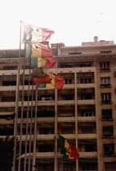
Describe Your Surroundings

At the end of this lesson, you will be able to describe surroundings including color and quantities up to 20.

Express Quantities Up to 20

- Count from 0 to 20
- Number the objects in the classroom
- Tell your SSN
- Count currency
- Tell your license plate number

Identify Colors of Objects

- Name the colors of different objects
- Ask simple questions about objects
- Answer simple questions about objects

Describe One’s Surroundings

- Describe a place or location
- Describe a building structure
- Name pieces of furniture
- Describe styles, size, and colors

Scenario:
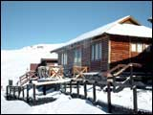

Amadou has just told a few American buddies a story about his cousin who went skiing with a friend over a break a couple of years ago (in June!) in South Africa. Most of the Americans don’t think of Africa and snow but at certain times of the year, there are winter sports near Cape Town, the southern tip of the continent. Amadou’s cousin, Babu, was amazed at the beauty around him and the differences in African regions. Below is a portion of the dialogue Amadou talked about when he told his story. Read over the following scene as a class.

Babu: Quel temps superbe, le ciel est bleu, la neige est blanche, le temps est parfait pour faire du ski.

Jean: Regarde à droite, on dirait qu’il y a trois ou quatre nuages au-dessus des montagnes. Je pense qu’on devrait rester en bas, dans la vallée.

Babu: Tu as raison. Tu as vu au loin, à gauche, tous ces sapins verts sur la colline; on dirait des petits triangles. Il y en a des dizaines.

Jean: Babu, regarde ces oiseaux gris là-haut, ils font des ronds dans le ciel. Et là-bas, on aperçoit la ligne blanche d’un avion à travers les nuages.

Babu: C’est si beau ! Allez, rentrons maintenant. Il me reste 102 ZAR (8 266/ CFA Franc / 15 US dollars) en poche. Je t’offre un café au “Carré d’as”?

Jean: Volontiers, allons-y!

Exercise (follow-up)

Next, with a partner, practice each part without being too concerned about meaning. Check the vocabulary list for meaning for new words. Be prepared to discuss new words in class.
Tip of the day: Floors

Unlike in the US, one doesn’t include the first floor when counting the number of floors (étage) of a building in French. Thus a two-story home will be une maison à un étage.

Getting lost in a foreign country is easy to do, so it becomes imperative that you be able to describe your surroundings in the target language. However, it goes far beyond just describing one’s surroundings, for example you must know the compass directions, be able to read a foreign map, and be able to describe landmarks and building structures, all in the target language. Additionally, you must be able to identify the color of objects, and express quantities up to 20. Many of these things you will learn in succeeding lessons. So for now, we will start with expressing quantities up to twenty.

Express Quantities: Numbers 1-20

un 11 onze
- deux 12 douze
- trois 13 treize
- quatre 14 quatorze
- cinq 15 quinze
- six 16 seize
- sept 17 dix-sept
- huit 18 dix-huit
- neuf 19 dix-neuf
- dix 20 vingt

When a number precedes a noun beginning with a vowel or silent h, liaison occurs and the final consonant is pronounced: cinq∪étudiants. In liaison, x and s are pronounced as z: deux [z] appartements, trois [z] amis, dix [z] omelettes. The final sounds of six, huit, and dix are silent before a consonant. However, many speakers pronounce the [k] of cinq even before a consonant. The t of vingt is not pronounced except in liaison: vingt livres, but vingt∪étudiants.

Exercise 1

Count from 11 to 20, 20 to 11, 0 to 20, 20 to 0.
*Note to the instructor: these exercises are for pronunciation of numbers; spelling rules to be reviewed and practiced later.

Exercise 2

Alternating with your partner, count from zéro to dix. Begin with zero, your partner says un, you say deux, etc. Then count in reverse.
Exercise 3 (Pair Work)

Solve the two math equations below and write out your answers. After you have written your answers, ask a partner the first equation and he will ask you the other. As you ask each other, pronounce the numbers as your instructor modeled.
*The verb faire is used below for how much does ___ and ___ make (equals)?
Example: Combien font deux et onze? Deux et onze font treize.

1. Combien font dix et dix? Dix et dix font vingt.
2. Et combien font trente moins quinze ? Trente moins quinze font quinze.

Exercise 4 (Class Work)

Complete the series.
1. neuf, sept, cinq neuf, sept, cinq, trois, un
2. zéro, trois, six zéro, trois, six, neuf
3. zéro, deux, quatre zéro, deux, quatre, six, huit, dix
Number the Objects in the Classroom

Before you go over objects and colors / shapes in the classroom, go over these terms with the class and differentiate between un and une [n] sound. Begin with the question and answer below.

Combien de stylos y-a-t-il dans la salle? How many pens are there in class?
Il y a 10 stylos dans la (notre) salle. There are 10 pens in the (our) class.

un (deux, trois, quatres, etc.) stylo a (2, 3, 4, etc. ) pen –s
un crayon a pencil
un drapeau a flag
un livre a book
un cahier a notebook
un tableau a chalkboard
un bureau a teacher's desk
un pupitre a student desk
une règle a ruler
une gomme a pencil eraser

Exercise 5 (Pairs)

With a partner, change a few of the objects above to a different number. Use the graphic below to help you get started. For example, Il y a une gomme et quinze cahiers …

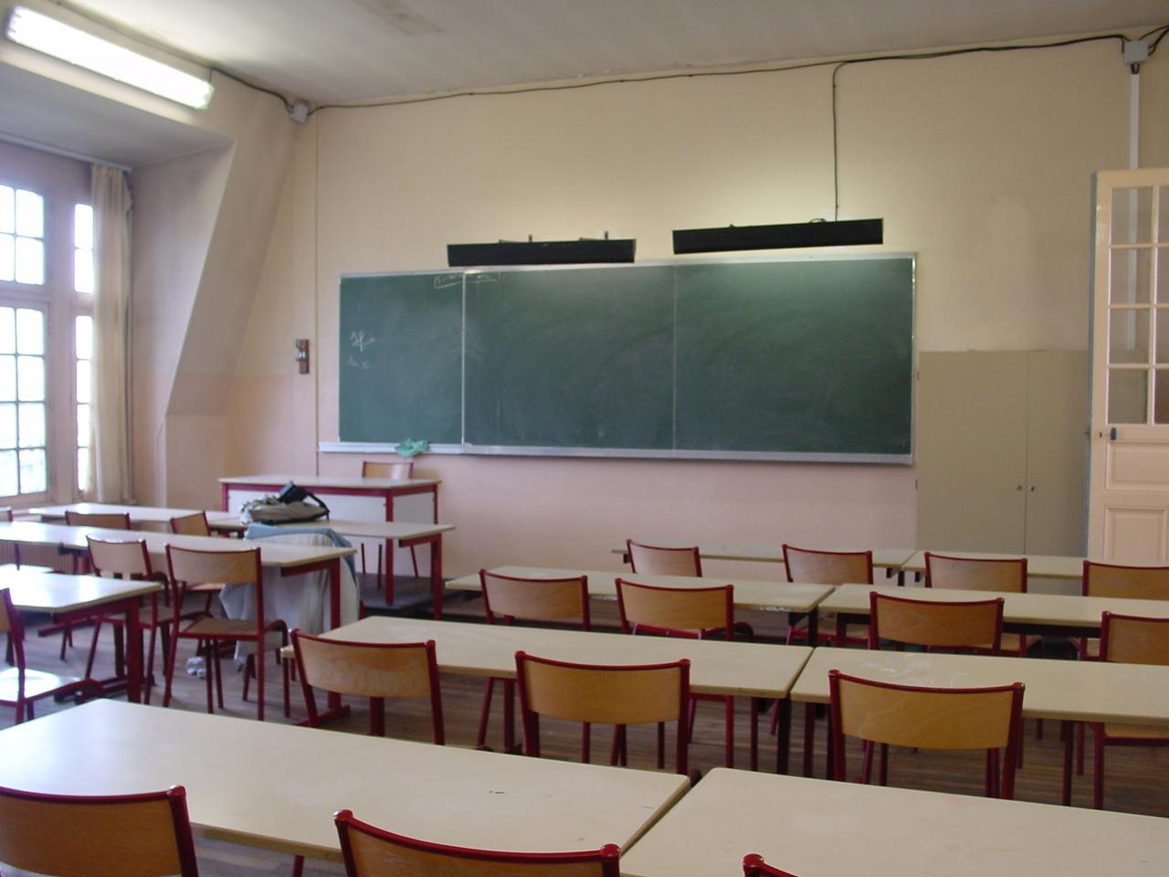
Tell Your Social Security / License Plate Number

Read this form where John fills out an application for a parking permit.

Nom: Ryan last name
Prénom: John first name
Lieu de naissance: Phœnix birthplace
Numéro de sécurité sociale: 123-45-6789 SSN
Plaque d’immatriculation: DK 2398 S license plate
Adresse: Camp de Thiaroye. Dakar

Exercise 6 (Pair Work)

Give your classmates your social security number in French.



Example: Mon numéro de sécurité sociale est 378-47-5331

*Note to the instructor: For student comprehension, write out on the board how to indicate three hundred and seventy eight. Inform students of how this will be covered in later lessons.

Exercise 7 (Pairs)

Write out your license plate number and hand it to your partner. He or she will verify that you say it correctly.

Exercise 8 (Class Work)

Read the following description about license plates in Sénégal. Begin by looking up the underlined words. Share your ideas with the class.

Les plaques sont bleues avec des lettres blanches.
Le sénégal est divisé en régions. Les plaques sont composées (depuis 1978) de deux lettres indiquant la région, d'un tiret, d'un numéro de série en quatre chiffres, d'un autre tiret et d'une lettre de série.
Tip of the day: Counting Money

The money used in West Africa is called the CFA Franc or just plain CFA.

CFA= Communauté financière d'Afrique (The African Financial Community) The base denomination is Francs and subdivided into Centimes (cents) 100 centimes = 1 Franc. The CFA is broken up into a West African CFA and a Central African CFA. The West African CFA can be used in all former French colonies in West Africa such as Benin, Togo, Niger, Mali, Senegal, Cote d’Ivoire, and Burkina Faso. It makes traveling very convenient because you don't have to exchange money at the border, however each former English colony its own currency and CFA is not accepted. The Central African CFA is used in Cameroon, Gabon, Chad, Congo, and other countries. You will learn more about West African currency in Module II.

Exercise 9 (Group Work)

Go to a currency converter online and convert the U.S. dollar into CFA Franc or vice versa. For example, 20 CFA Franc (XAF) is approximately .036 dollars. Practice using numbers 1-20 ans you look up different conversions (at least 3).

Exercise 10 (Pair Work)

You would like to use a cyber café and have only 10 U.S. dollars to spare. How do you explain to the clerk that you cannot go above this amount? Keep in mind that you pay about $1.00 per hour to surf the Internet. Tip: The West African currency is cfa and the exchange rate fluctuates around 500 cfa per dollar. Role-play the scene with your partner.


Identify Colors of Objects

Colors

Blanc(he) | White
Noir(e) | Black
Rouge | Red
Bleu(e) | Blue
Orange | Orange
Marron | Brown
Jaune | Yellow
Gris(e) | Gray
Violet(te) | Purple
Vert(e) | Green
Rose | Pink


De quelle couleur est le tableau? De quelle couleur est le cahier?
Il est noir. Il est gris.
The colors blanc and violet have irregular forms: une chaise blanche, une fenêtre violette
Other colors like marron, orange do not change in the feminine and plural forms (invariable).
Note that all colors are masculine singular when used as a noun: J’aime beaucoup le vert (le rouge, le bleu, le rose, le jaune, etc.)

Exercise 11

Go around the room and ask at least 4 people in the class what color he/she associates with the following nouns. Some of these words are cognates and others are new vocabulary. Show gender agreement when necessary. To begin, use the question: De quelle couleur est. . . ?

- ciel (sky) Le ciel est bleu.
- soleil (sun) Le soleil est jaune, orange.
- herbe (grass) L’herbe est verte.
- feu (fire) Le feu est orange, rouge et jaune.
- tomate La tomate est rouge.
- neige (snow) La neige est blanche.
- pomme La pomme est rouge.
- banane La banane est jaune.
- soir Le soir est noir.
- plante La plante est verte.
Exercise 12

Describe to your partner any objects that you own or can see that are red, yellow, green, blue, black, gray, and white.

Ask and answer simple questions about objects

Dans la salle de classe:
Il y a / On trouve…
Il y a simply states that something exists or tells how many there are:
Il y a un livre sur la table.
Il y a cinq filles et deux garçons.
*Do not use de if il n’y a pas is followed by a number : il n’y a pas trois filles. il y a cinq filles. See more about « il y a » in the grammar section.

Un tableau

Un livre

Un bureau
Une chaise
Un cahier

Qui sont-ils? Who are they? | Qui est-ce? Who is this? | Qu’est-ce que c’est? What is this?
Ce sont des étudiants  These are students | C’est un professeur It’s a professor | C’est un livre It’s a book

Quelques objects (some objects):

Go over this list of some objects that could be used everyday:
un ordinateur = a computer
un appareil-photo = a camera
un disque = a disk
un vélo = a bike
une table = a table
une affiche = a poster
une télé = a television
une voiture = a car
une montre = a watch
une chaîne stéréo = a stereo

Exercise 13 (Pair Work)

Use the objects on the previous page to ask/answer simple questions about your belongings. You will see more vocabulary about lodgings in Module 3.
Qu’est-ce qu’il y a dans votre maison ? appartement ? dans votre chambre ? votre garage ?

Example: Il y a une radio, une stéréo, un fauteuil, un chat, un sofa, un chien, un lit, une chaise, un ordinateur, un bureau, etc.

Exercise 14 (Group Work)

Your instructor will ask students questions about the names and colors of basic objects that are in your classroom. Answer when your turn comes. Be prepared to give a number also. Example: C’est un livre rouge. [...] Il y a douze livres dans la salle de classe.

Exercise 15 (Pair Work)

Find out if your partner has a refrigerator in his/her room.
Find out if s/he has a TV. in his / her room.
Try to find one additional item which your partner has and one item s/he does not have.
Turn to another person and gossip about your partner. Tell what you found out.

Exercise 16

Pair activity. Look at the picture below and write a description of the classroom.

Describe one’s surroundings

Place or Location: prepositions of place (derrière / devant, entre, sous / sur, à côté de)
Prepositions are words which link two related parts of a sentence. They are placed in front of nouns in order to indicate a relationship between that noun and the verb, adjective, or noun that precedes it (see Grammar Notes). Certain prepositions of place help you describe a location and are very common in everyday language:

La maison est derrière les arbres. La maison est entre les arbres.
Les arbres sont devant la maison.

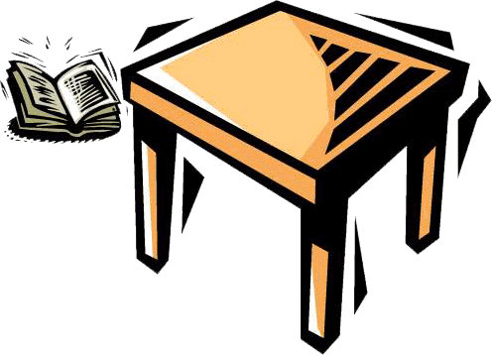
Le livre est sous la table Le livre est sur la table. Le livre est à côté de la table.

Building Structures:


Voici une maison. Elle a Voici un bâtiment à trois étages. Voici des gratte-ciel
une porte et six fenêtres. C’est la tour Eiffel. (n.m.invariable). Il y a un arbre derrière C’est la ville de New
la maison. York.

Vrai ou Faux?

1. La maison a deux portes et six fenêtres. La maison a une porte et six fenêtres.
2. Il y a une voiture à côté du bâtiment. Il y a une voiture devant le bâtiment.
3. La pomme est au-dessous des gratte-ciel. La pomme est au-dessus des gratte-ciel.

Describe styles, sizes, and colors

Styles / Sizes

Review different the following words for describing the style, size and material of an object. A good idea to learn these are by opposites. For example, vide (empty) + plein (full).

La forme: carré, plat, rectangulaire, pointu, triangulaire, courbé, rond, circulaire, droit, ovale, ondulé
- Les dimensions: court, long (ue), grand, haut, élévé, petit, bas (basse), mince, épais, étroite, large, gros, énorme, massif (ive), petit, miniscule
- Le poids: lourd, léger (légère),
- La capacité: vide, plein
- La température: chaud, froid, tiède
- La consistence: dur, mou (molle), flexible
- L’état, l’apparence, la condition: solide, sec, lisse, poli, neuf (neuve), fragile, terne (dull)

En quoi est-ce cet objet? Il est en plastique. It is made of plastic.
Most of the words below are cognates. Check the vocabulary list for words that are trickier.
  - Le papier
  - Le coton
  - Le plastique
  - Le bois
  - La pierre
  - Le verre, la brique, le fer, le plomb, le cuivre, l’acier, le carton

Exercise 17

Below are pictures of modern buildings in Dakar. Describe the buildings you see on each picture. Share your descriptions with the rest of the class.

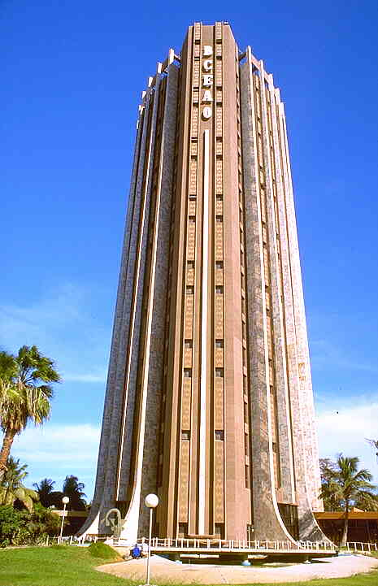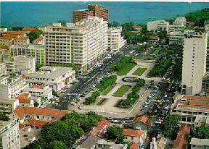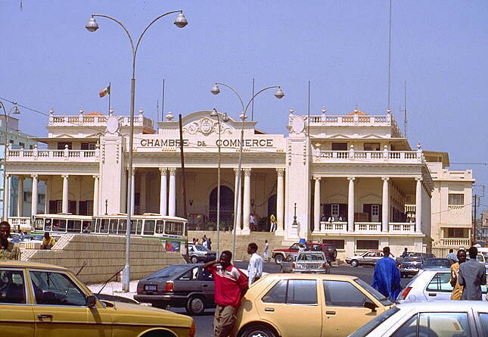
The Chamber of Commerce The BCEAO Building A Modern Neighborhood
in Dakar in Dakar in Dakar
Exercise 18

Fill in each sentence below with a word from the list. See vocabulary list.
mou | vide | chaud | lourd | rond
triangulaire | rectangulaire | froid | droit | dur

- Le fer est __________, alors que le chewing gum est __________.
dur, mou
- Une pomme est __________, un crayon est __________.
rond, droit
- Le café est __________et la glace est __________.
chaud, froid
- Le plomb est plus __________ que (more than) la plume.
lourd
- Il faut remplir (must fill up) le réservoir d’essence quand il est __________.
vide
- La carte d’identité est __________et la pyramide est __________.
rectangulaire, triangulaire

The Indefinite Article

Masculine singular | Feminine singular | Plural
un livre a book | une chaise a chair | des stylos (some) pens

Note that in English the plural indefinite article can often be omitted, but not in French.
Un and une, meaning a or an are gender determiners: un garçon but une fille.
Des means some or any: As-tu des amis = Do you have (any) friends?
Un, une and des become de/d’ after a negative verb: As-tu un stylo? Non, je n’ai pas de stylo.
*Because être does not take a direct object, the indefinite article does not change after the verb être (see next section on C’est and Ce sont).
Most nouns form their plural by simply adding an s which is not pronounced.

Gender and Plural of Nouns

For some nouns that refer to people, you can obtain the feminine by adding an e to the masculine form: un étudiant (a male student) / une étudiante (a female student).

Note that:
- Nouns that already end with an e stay the same: un /une artiste.
- Some nouns have only one gender: une personne a person (male or female)
- Many professions have only a masculine form, because these positions were traditionally held by men only: un médecin, un écrivain.
- Most nouns form their plural by simply adding an s: un homme, des hommes. Nouns that end in s, x, and z in the singular stay the same:
Example: une souris – a mouse, des souris – mice

Exceptions:

Nouns ending in | plural
-al un journal a newspaper | -aux des journaux
-eau un gâteau a cake | -eaux des gâteaux
-ieu un milieu an environment | -ieux des milieux
-ail un travail a work, task, job | -aux des travaux

Exercise 1

Fill in the blanks with the feminine of each noun.

- Un ami et une amie
- Un dentiste et une dentiste
- Un étudiant et une étudiante

4. Un américain et une américaine
C’est / ce sont

Use qu’est-ce que c’est when asking about objects and things, qui est-ce when asking about a person. Use c’est/ce sont to answer both questions. The plural of c’est or ce n’est pas is ce sont or ce ne sont pas:
C’est un stylo → ce sont deux stylos c’est une femme → ce sont des femmes
Est-ce un médecin? Non, ce n’est pas un médecin.
Note that with the expressions c’est and ce sont, un(e) is used before names of professions: Voici Monsieur Bertier. Il est __ professeur? Non, c’est un avocat (lawyer).

Exercise 2

Describe the pictures below using c’est / ce sont.

1. | 2. | 3. | 4.

- Ce sont des étudiants.
- C’est une chaise.
3. Ce sont des livres.
4. C’est un professeur.

Il y a

Il y a is an invariable phrase that means there is / there are. Il y a is an example of an expression that uses the verb avoir where the verb “to be” is used in English. It can be followed by singular or plural nouns:
Dans la salle de classe, il y a un professeur. There is a professor in the classroom
Dans la salle de classe, il y a quinze étudiants. There are 15 students in the classroom
The negative of il y a is il n’y a pas and the inverted form is y a-t-il (is there? are there?):
Y a-t-il une table? Y a-t-il des chaises?

Adjectives

There are two rules about French adjectives that set them apart from the usage of adjectives in English:
- Adjectives always agree in gender (masculine/feminine) and number (singular/plural) with the noun they modify
- They usually follow the noun they modify

Gender Agreement

If the masculine form ends in e, the feminine form is the same.
You usually add an e to the masculine form to make an adjective feminine. Example: un livre noir, une chaise noire.

Exceptions:

masculine ending in | masculine | feminine
-if | actif | active active
-eux  -eur | heureux  travailleur | heureuse happy  travailleuse hardworking
-il | gentil | gentille nice
-el | exceptionnel | exceptionelle exceptional
-ien | canadien | canadienne canadian

Number agreement

Add an s to the singular form (this will not affect pronunciation). If the adjective already ends with an s or x, it remains the same. Example: un livre gris, des livres gris

Exercise 3

Make the adjectives agree in gender and number with the nouns.

1. une porte (orange) orange
2. des tables (jaune) jaunes
3. un livre (noir) noir
4. des arbres (vert) verts
5. une voiture (violet) violette
The verb avoir (to have)

Like the verb être, the conjugation of avoir is irregular.

J’ai I have nous avons we have
Tu as You have vous avez you have
Il / elle a S/he has ils/elles ont they have

Note z sound between nous, vous, ils, elles and plural forms of avoir. Remember linking causes the t to occur in inverted questions: Marie a-t-elle une place (a seat)?
There are many avoir expressions that will be presented later in the Module. These expressions use the verb avoir and have unique English equivalents. For example, avoir besoin de = to have need of/to need. J’ai besoin d’un stylo = I need a pen.
Again, there are other expressions that use avoir where “to be” is used in English (il y a or avoir ___ ans: j’ai 20 ans = I have 20 years→I’m 20).

Exercise 4

Replace the subject in italics and make the necessary changes.
1. Luc a deux stylos. Alex/nous/je/Claude et Nathalie/tu/ils
2. Est-ce que Jean a un crayon? tu/Madeleine/vous/on/André ou Didier
3. Ils n’ont pas de gomme (eraser). Elle/tu/nous/je/on/elles/Sandrine

The preposition de + the definite article

Just as the preposition à contracts with certain forms of the definite article, so does the preposition de.

masculine singular | feminine singular | plural
de + le = du  à côté de le professeur  du  de l’  en face de l’arbre | de la  en face de la maison  de l’  en face de l’ | de + les = des  en face de les voitures  des

Many prepositions of place are followed by de. This de follows the usual rules for contractions: La voiture est en face de la maison. Here are common prepositions of place used in this lesson:
près de, loin de, à côté de, en face de, au bout de (at the end of), au coin de (at the corner of)

Exercise 5

Some of the following sentences are incorrect. Identify and correct them.

- La maison est en face de les arbres. des
- Nous sommes de le Canada. du
- Le parking est à côté de le restaurant. du
- Il y a un gratte-ciel à côté de la maison.
- Les enfants sont à côté de l’homme.
- Il est de les Etats-Unis d’Amérique. des
- J’habite en face de l’Arc de Triomphe.
- Est-ce que tu es de le Mali? du

Adjectives

Some very common adjectives do not follow the same placement rule as most other adjectives. The following adjectives precede the noun they modify:

Adjectives that precede the noun: | These adjectives indicate:
joli (pretty), beau (beautiful, handsome) | Beauty
jeune (young), vieux (old), nouveau (new) | Age
bon (good), mauvais (bad) | Quality
grand (tall, big), gros (big, fat), petit (small, little) | Size

Some of these adjectives have irregular forms.

masculine singular  followed by consonant | masculine singular followed by vowel or mute h | feminine singular  *-s for fem. plural | masculine plural
beau  un beau bâtiment | bel  un bel homme | belle  une belle femme | beaux  de* beaux enfants
vieux  un vieux livre | vieil  un vieil arbre | vieille  une vieille maison | vieux  de* vieux amis
nouveau  un nouveau stylo | nouvel  un nouvel ami | nouvelle  une nouvelle amie | nouveaux  de* nouveaux livres
* The indefinite article des becomes de when followed by an adjective. This rule is often unobserved in daily conversations.
*The alternate form for these adjectives does not exist in the plural and is only used for the singular (noun followed by a vowel or mute –h): un bel arbre/de beaux∪arbres, un vieil apartement/de vieux∪apartements. In the plural, x links up with the following vowel or h of another word: c’est un vieil hôtel → ce sont de vieux [z] hôtels.

Exercise 6

Rewrite the following sentences, making sure articles, adjectives, and nouns agree.

- Voici / un / beau / femme. Voici une belle femme.
- Ce sont / un / vieux / hommes. Ce sont de(s) vieux hommes.
- C’est / un / nouveau / étudiant. C’est un nouvel étudiant.
- Ce sont / un / vieux / femme. Ce sont de(s) vieilles femmes.
- C’est / un / beau / arbre. C’est un bel arbre.

Exercise 7

For each sentence, give the appropriate form of the adjective in parenthesis. Compare your answers with those of your classmates.

1. Les Etats-Unis sont un pays (nouveau)
Les Etats-Unis sont un nouveau pays.
2. Claudine habite dnas un appartement (vieux)
Claudine habite dans un vieil appartement.
3. Marthe adore les maisons (vieux)
Marthe adore les vieilles maisons.
4. Tu parles avec un homme (beau)
Tu parles avec un bel homme.
5. Voilà une idée (nouveau)
Voilà une nouvelle idée.

A côté de  A droite  A gauche  Adresse (n.f.)  américain(e)  Arbre (n.m.)  Au-dessous  Au-dessus  Bâtiment (n.m.)  Beau (bel, belle)  Blanc(blanche)  Bleu(e)  Bureau (n.m.)  Cahier  canadien(ne)  Chaise (n.f.)  Couleur  Derrière  Devant  En face (de)  Entre  Étage (n.m.)  étudiant (e) noun  Fenêtre (n.f.)  français(e)  Gratte-ciel (n.m.)  Gris (e)  Jaune  Joli (e) adj.  Livre (n.m.)  Marron  mexicain(e)  Noir(e)  Nom (n.m.)  Nouveau (nouvel, nouvelle)  Numéro (n.m.)  Numéro de sécurité sociale  Orange  Porte (n.f.)  Prénom (n.m.)  Professeur (n.m.)  Rose  Rouge  Rue (n.f.)  Sous  Stylo (n.m.) | Next to  To the right/On the right  To the left/On the left  Address  American  Tree  Below/Under/Beneath  On top/Above  Building  Beautiful  White  Blue  Desk  Notebook  Canadian  Chair  Color  Behind  In front  Facing/In front of /Opposite  Between  Story  Student  Window  French  Skyscraper  Gray  Yellow  Pretty/Lovely  Book  Brown  Mexican  Black  Name (last)  New  Number  Social security number  Orange  Door  First name  Professor  Pink  Red  Street  Under  Pen

Ami (e) noun  Anglais (e)  Bas (basse)  Carré  Chaud  Chinois (e)  Circulaire  Courbé  Droit (e)  Dur (e)  Élévé  Énorme  Épais  Étroite  Froid  Grand (e)  Gros (se)  Haut  Italien (ne)  Japonais (e)  Large  Long (ue)  Massif (ive)  Mince  Miniscule  Mou (molle)  Ondulé  Ovale  Petit (e)  Plaque d’immatriculation (n.f.)  Plat  Pointu  Pomme (n.f.)  Rectangulaire  Rond  Russe  Suisse  Sur  Table (n.f.)  Triangulaire  Vieux (vieil, vieille)  Ville (n.f.)  Violet (te)  Voiture (n.f.) | Friend  English  Low  Square  Hot, warm  Chinese  Circular  Wavy, curved  Strait  Hard  Raised  Enormous  Thick  Narrow  Cold  Tall  Huge  High  Italian  Japanese  Wide  Long  Massive  Thin  Miniscule  Soft, mushy  Wavy  Oval  Small  License plate  Flat  Pointy  Apple  Rectangular  Round  Russian  Swiss  On/Upon  Table  Triangular  Old  City  Purple  Car

Buildings

Habitat in Africa is as diverse as the people who inhabit the continent, and varies significantly according to ecological zones. Because locally obtained items used to make up the bulk of the building material, buildings tended to be more or less the same in similar ecological zones. Recently, however, with the development of roads and the means of transportation, this uniformity is changing rapidly, as it has become easier to import building material from other regions of Africa or even abroad. Today, there are some neighborhoods in some African cities, such as Nouakchott or Abidjan, that look like any upper class neighborhood in America in terms of architecture as well as infrastructure.

While the great majority of Africans still live in traditional or semi-traditional houses, the reality is that the process of housing modernization is taking a fast pace, even in remote villages. In rural Senegal, for instance, concrete buildings are mushrooming due to the immigration of most of its youth to the West and the remittances they send to build more durable and modern housing. Senegalese young migrants are mostly evaluated according to how big and beautiful the house they have built is. This has triggered some competition among village migrants, and as a result, the face of the village architecture, as traditionally known, is rapidly changing in Senegal.

Buildings in Africa, therefore, range from the most modern to the most traditional stylistically speaking. In humid parts of Africa, traditional buildings are mostly made of standing wood pillars woven with tree leaves (such as palm tree leaves). In more austere environments, such as the Sahel, houses are built traditionally with brick or mud walls covered with thatched roofs. People who are still involved with nomadism prefer to use tents because of their constant mobility.

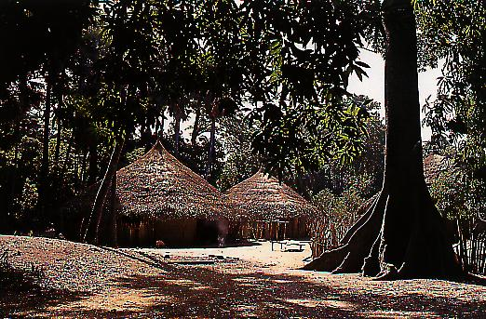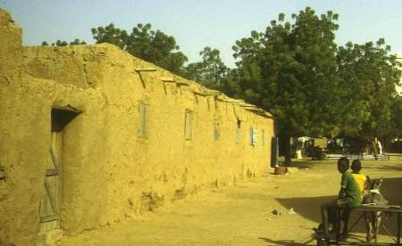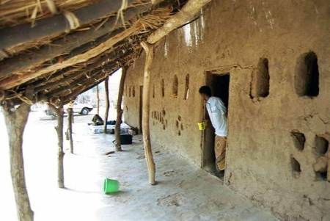
Typical Housing in the Middle Senegal Valley

Activity 1

Class activity. Learn to count while staying fit! Students can take turns in suggesting and leading various exercise activities for the whole class to do while counting. Do aerobics, push-ups, sit-ups, jump rope, march, etc. and try not to get breathless! If your classroom is too small, go outside and get some fresh air while exercising (weather permitting, of course).

Activity 2

Class activity. Your instructor will start a chain to let the class count from 1 to 20 (each student says a number). Once the class successfully counted to 20, your instructor will start a new chain to count odd numbers only, then even numbers.

Activity 3

Class activity. Play bingo. Your instructor will give you a card with three numbers on it. S/he will then call out numbers randomly. When your numbers are called out, make a mark. The first student whose numbers are all marked gets to be the one calling out the numbers.

Activity 4

Class activity. You will count the objects and the people in your classroom. Your instructor will ask questions such as : Il y a combien d’étudiants dans la classe? You and your classmates will count while your instructor points at objects / people counted. Then one student will be asked to report: Il y a cinq étudiants dans la classe.

Activity 5

Class activity. Guessing game. Your instructor will ask questions about the colors of various objects in the classroom. Answer with the proper form of the adjective. Example: qu’est-ce qui est noir? Le tableau est noir.

Activity 6

Class activity. Your instructor will start a chain by asking a student a question about an object or a person’s location. Example: où est le prof? Il est derrière le bureau. Or: le bureau est sur le prof? Non, le bureau est devant le prof.

Activity 8

Class activity. Play Jacques a dit (Simon says). Your instructor will give commands that include prepositions of place (example: Allez (go) derrière le professeur). Obey only if they are preceded by Jacques a dit! The last student left will take over the role of the instructor.

Activity 9

Class activity. Your instructor will start a chain by asking you if you own certain objects. Example: Tu as une voiture? Tu as un livre? You will answer and then say the location and a brief description of the object.

Activity 1

Pair activity. Take turns asking and answering questions about the objects pictured below. Use Qu’est-ce que c’est and C’est/ce sont.

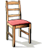



Activity 2

Use the pictures of the activity above and describe each object’s size and color.

Activity 3

Pair and class activity. Ask your partner how many items s/he has (books, pens, cars, etc.). Then your partner will ask you the same questions. Then, write individually a short paragraph detailing what you have, what your partner has, and what both of you have. Be ready to report to the class, listen to others’ reports, and answer questions about their possessions.

Pair Activities, Student A

Activity 1

Play the game la bataille navale. Draw your ships on the grid below, then take turns with your partner calling out grid coordinates to locate and destroy each other’s ships. The first one to find all of his/her partner’s ships wins.

Ships: XXXX XXXX X X
XXXXXXX XXXXXXX
X X

 | A | B | C | D | E | F | G | H | I | J | K | L | M | N | O | P | Q | R | S | T | U | V | W | X | Y | Z
1
2
3
4
5
6
7
8
9
10
11
12
13
14
15
16
17
18
19
20

Pair Activities, Student A

Activity 2

One student looks at chart A, the other at chart B. Take turns asking each other questions to complete the list of hotels in Kinshasa.

Example: l’adresse de l’hôtel X? Le numéro de téléphone de l’hôtel Y?

Nom de l’hôtel | adresse | téléphone
Afrique Hôtel | ___, avenue Colonel Mpia | 13191
Hôtel Astoria | 3, avenue du Commerce
Hôtel Continental | __, place Madrandele Tanzi
Intercontinental | 18, avenue Batela | 114180
Hôtel Matonge | __, avenue du Stade | 18166
Hôtel Okapi | 17, avenue de l’Okapi

Pair Activities, Student B

Activity 1

Play the game la bataille navale. Draw your ships on the grid below, then take turns with your partner calling out grid coordinates to locate and destroy each other’s ships. The first one to find all of his/her partner’s ships wins.

Ships: XXXX XXXX X X
XXXXXXX XXXXXXX
X X

 | A | B | C | D | E | F | G | H | I | J | K | L | M | N | O | P | Q | R | S | T | U | V | W | X | Y | Z
1
2
3
4
5
6
7
8
9
10
11
12
13
14
15
16
17
18
19
20

Pair Activities, Student B

Activity 2

One student looks at chart A, the other at chart B. Take turns asking each other questions to complete the list of hotels in Kinshasa.

Example: l’adresse de l’hôtel X? Le numéro de téléphone de l’hôtel Y?

Nom de l’hôtel | adresse | téléphone
Afrique Hôtel | 1106, avenue Colonel Mpia
Hôtel Astoria | ___, avenue du Commerce | 12187
Hôtel Continental | 7, place Madrandele Tanzi | 17137
Intercontinental | ___, avenue Batela
Hôtel Matonge | 2, avenue du Stade
Hôtel Okapi | ___, avenue de l’Okapi | 18144

Activity 1

Describe your classroom orally.

Activity 2 Track 12

CD. Listen to the description of a classroom and determine which classroom is being described. Then, write a short paragraph to describe the other classroom.

1. 2.

Script: Dans la salle de classe, il y a une porte et un tableau noir. Il y a un professeur et six étudiants. Il y a un bureau, six tables et sept chaises.

Activity 3 Track 13

CD. Listen to the description of a classroom, and draw it. Pay attention to the numbers and colors. Label your drawing.

Script: Voici ma salle de classe. Il y a deux tableaux noirs, quatre chaises marron, et un bureau gris. Il y a quatre personnes: un professeur et trois étudiants. Il y a aussi trois livres rouges, quatre stylos bleus, et deux cahiers verts sur le bureau.
Activity 4

Answer the following questions about the picture (école peule) below.

- Combien d’étudiants y a-t-il dans la salle de classe? Il y a 7 étudiants dans la salle.

- Où est le professeur? On ne sait pas!

- Quels objets sont présents? (Il y a un tableau noir, etc.)

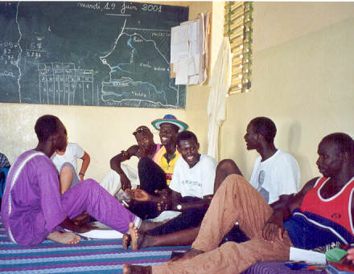

Activity 5

Prepare a few sentences that describe what you see in the photo. Be prepared to discuss your ideas in class.

