Course Overview

As students you will need new insights and comprehensive cross-discipline skills to meet the increasingly complex issues, assignments and challenges of the global conflicts you may find yourself in.
As Special Operations soldiers you need an intensive language program that accelerates your multi-language requirements that in turn, enhances your career to match the rapid speed of changes.
This language program can help you gain the added credentials and valuable learning that you need to advance in your career and provide the specializations needed which can immediately put your learning on the fast track and could save your life.
This language course will be taught by leading faculty members who explore the latest concepts and best practices available (anytime, anywhere in the world) in interactive multimedia instruction (IMI) or distributed distance learning (DL).
The course focuses on learning how to effectively use what you have learned in the previous lesson and the ability to build upon and use the knowledge in each lesson as the class progresses. You can also explore online tools, such as electronic publications and web sites, with particular focus placed on how technology can support multiple modes of learning.
The target language you are about to study has been developed and delivered by highly skilled academic designers, integrating technology in the instructional curriculum. Cognition and technology-based instructions and imperatives are explored in relation to programming for varied learning and motivational styles.

Module I

Student Learning Strategies

As a language student, it is extremely important that you familiarize yourself with the course and strategies to be successful.

- Learning a language is an active and performative phenomenon. Language itself is indescribable and evolves frequently. Anyone who learns a new language should expect changes and challenges—especially as adult learners.
- This course is designed to guide you through the language learning process. Activities move from simple to more difficult and overlap to enhance communication. Module I highlights critical and basic functions of communication.
- Each lesson presents functions (or tasks) and provides activities in which students practice performing them.
- For each task listed before a lesson, the student will find exercises or activities that highlight the steps to meet every lesson objective.
- These creative activities emphasize communication, pair and group-work, and learning in context.
- Exercises may be developed and enhanced by the instructor to incorporate various critical tasks or underline a specific task that may be unusually challenging for each group of students.
- Class exercises or activities are designed to review lesson material immediately after instruction. In class language practice is an important element of successful language comprehension and students will use new information for active and effective language communication.
- Students should always practice pronunciation—especially words or language cases that are difficult for non-native speakers. Use the language in and outside of the classroom. Ask questions about complex material during class and your instructor will guide you with more examples.
- Students should read over lesson material before engaging in an activity. The instructor will review necessary lesson information before assignments are given.
- Learn about the culture of your language. Culture shapes language. It affects changes in the language and helps the student understand particularities of the foreign language. Most importantly, culture helps the student understand the similarities in language and how to adapt to new forms or structures.
- As a language learner, the student will regularly participate in language exchange—you contribute as a listener and speaker. Active listening is a part of class learning and participation while non-participatory listening is an individual step that happens primarily outside of class as students go through various activities and exercises for homework, on the web, etc.
- Students will relate sounds to the individual words in each lesson.
- Students will use new vocabulary words within a cultural context.
- Students will recognize grammatical concepts that match communicative functions.
- Exercises within the lesson as well as the Application and Skill Enhancement Activities stress all 4 skills: listening, reading, writing and speaking.
- These are activities through which students can further develop their grammatical control of the language with minimal intervention on the part of the instructor.
- Students will work with and learn from their partners in small group and role-play activities, summarize and share information that they learn from their partners.
- The homework section of each lesson is a follow-up for the lesson of the day. In the homework students will practice new expressions, grammatical concepts that fulfill lesson tasks.
- At the end of each lesson, the student will incorporate listening, reading, writing and speaking skills to perform comprehensive activities.

Instructional Technique

The instructor will incorporate various activities within one language exercise or activity. For example, a role-play activity may be expanded to include a feedback or discussion forum where students give personal opinions and ideas. Depending on class size and level of proficiency, the instructor can rearrange and adapt a particular activity as follows:

IN THE TARGET LANGUAGE / INSTRUCTOR AS GUIDE

- Activity Explanation ⇨ Language Tips ⇨ Vocabulary in Context ⇨ Student Questions

- ⇨ Class Brainstorming ⇨ Group / Pair Brainstorming ⇨ Group / Pair Practice

- ⇨ Performance of Activity (Situation or Scenario)

- ⇨ Expansion of Activity (Homework / Class Discussion / Cultural - Related Topics)

This type of step by step process where the difficulty level increases for each performance stimulates language comprehension.

The lessons presented in this Module include elements from the standard and non-standard French that you will likely encounter in a francophone region like l’Afrique francophone. Language components such as basic vocabulary and grammar information involve the standard French, that is, what is considered the linguistic “norm,” spoken by many different groups. Spoken French varies from region to region within France itself and outside of Europe. For instance, French regional varieties or dialects found in francophone West Africa may differ only slightly from the standard or common language used in France. Knowledge of the central French implies that there is intercomprehension among speakers. On the other hand, spoken varieties may vary from place to place or individual to individual and in many ways, deviate somewhat (or highly) from the standard.
The French language serves as a medium in many African countries and it may or may not have been acquired formally. French is the official language of nineteen (19) African nations with over 42 million speakers: Benin, Burkina Faso, Burundi, Cameroon, Central African Rep., Chad, Congo, Dem. Rep. of Congo (Zaire), Côte d’Ivoire, Djibouti, Gabon, Guinea, Madagascar, Mali, Mauritania, Niger, Rwanda, Senegal and Togo. It is also widely spoken in the Maghrib (Morocco, Algeria, and Tunisia) with over 40 million.
The African population is composed of a great number of tribes who speak different dialects. Each of the former colonies has many ethnic groups, each with its own language that the others may perhaps not understand. For example, in the Ivory Coast, with approximately sixty different ethnic groups, you may hear baoulé or dioula. Since certain former colonies like Cameroon and the Ivory Coast (in West Africa) have kept close economic and cultural ties with France, French is the official language, taught in schools, read in newspapers, heard on radio and television and used in administrative circles. This common language draws different African countries together into one large cooperative group. Understanding and speaking French facilitates communication between tribes and promotes national unity. Although the young learn standard French in school, the ability to communicate in French may belong to an educated minority, depending on the locale. Some members of the population may only practice what is considered a form (a type that may have evolved significantly) of standard French. French in Africa has been influenced by the people who have adopted and learned to speak it. Language distinctions are found in vocabulary, accent, and intonation.
Many speakers understand and communicate in the standard but may also use another dialect or a completely different language at home, with friends or in their community. It is important to understand that you could hear many different varieties of French but that the standard will guide you and serves as a foundation—a strong linguistic base. Vocabulary specific to a certain area is also a possibility. However, the key vocabulary presented in this Module targets critical communicative functions used by the majority of francophone speakers. Listening exercises that complement the text are devised to prepare you for comprehension of different types of French speakers. Do not be surprised to hear diverse accents within one listening activity. The more speakers you hear, the more prepared you will be for real situations.
Cultural Notes presented in the following lessons include material such as common African names, local customs or family traditions found in (francophone) places other than France. Additional regional vocabulary may be incorporated into the cultural notes as you complete the Module.
SOLT French Module 1 Lesson 1
Instructor Manual

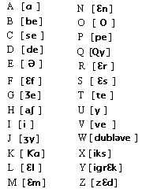
The Alphabet

At the end of the lesson, you will be able to produce letter sounds.

Identify the Alphabet

- Recognize each letter of the French alphabet
- Identify French letter characters by name
- Pronounce the characters phonetic sound
- Write the characters on a scratch piece of paper

Produce Vowel Sounds

- Recognize vowels
- Produce vowel sounds
- Recognize the vowel positions in the writing system
- Identify the acceptance of irregularities of certain vowels
- Identify short vowels and long vowels
- Produce vowel-consonant combinations

Produce Consonant Sounds

- Recognize consonants
- Pronounce aspirated and non-aspirated consonant sounds
- Identify consonants in an alphabetical order and by group
- Write letters, connectors, syllabification, and non-connectors
- Apply the rules for the consonants when reading and writing

Recognize Cognates

- Identify cognates
- Pronounce cognates
- Write cognates

Identify Special Cases

- Identify consonant clusters
- Identify consonant groupings
- Identify consonants having double functions
- Identify symbols with consonant and vowel functions
- Recognize irregular lengths of the vowel symbols

Produce Stress and Intonation

- Contrast stress and intonation
- Pronounce stress and intonation
Scenario:

You are about to go to a briefing and overhear a soldier ask a Francophone visitor to the base who he is (what’s his name). Read over the following dialogue before learning the French alphabet. Your instructor will guide you on the meaning and pronunciation.

John: Bonjour. Tu me permets ? (Do you allow me / to sit down).
Themdo: Oui, bien sûr.
John: Comment tu t’appelles?
Themdo: Themdo.
John: Comment?
Themdo: Themdo, t, h, e, m, d, o.
John: Moi, je m’appelle John.

It is important to be well grounded in the grammar and all other facets of your language before you embark on a journey into the French language. This journey begins with the alphabet. You will start by identifying the letters of the alphabet and the sounds those letters represent, writing the French alphabet, producing vowel and consonant sounds, identifying special cases and proper word intonation.
The French alphabet has 26 letters, just as the English alphabet does.

The Alphabet

Letter | Approximate Pronunciation | Letter | Approximate Pronunciation
A  B  C  D  E  F  G  H  I  J  K  L  M  N | ah (as in father)  bay  say  day  as in bird  eff  j (without the initial d)  ash  ee (as the English letter e)  gee (without the initial d)  kah  ell  emm  enn | O  P  Q  R  S  T  U  V  W  X  Y  Z | oh  pay  koo (but with lips very  advanced and rounded)  err  ess  tay  oo (but with lips very  advanced and rounded)  vay  doobl vay  eeks  ee grayk  zayd
Letter | French Name | Letter | French Name
A  B  C  D  E  F  G  H  I  J  K  L  M | a  bé  cé  dé  e  effe  gé  hache  i  ji  ka  elle  emme | N  O  P  Q  R  S  T  U  V  W  X  Y  Z | enne  o  pé  ku  erre  esse  té  u  vé  double vé  iks  i grec  zède

Speaking French requires a more active and energetic use of the lips, tongue, and jaw than speaking English. The facial muscles are tenser when one speaks French.

Be careful not to confuse the letters e and i, g and j. The vocabulary you encounter in the
following tasks is for pronunciation practice only.
Tip of the day

The French equivalent of hum, which people say when they are thinking about what to say, sounds like the French vowel e, and is written euh. Remember you can use it in the coming weeks when your instructor asks you a question and you need to think a little before answering.

Exercise 1

Practice spelling these words with your instructor.
1. bateau 4. couture 7. œuf 10. voiture 13. auditif
2. beige 5. cœur 8. grise 11. jolie 14. heureux
3. sympathique 6. amour 9. koala 12. wagon 15. zigzag

Exercise 2

You will hear some letters of the French alphabet. Circle the ones you hear.

1. g i j 8. b p d
2. a e i 9. y x i
3. h k q 10. a r l
4. v w f 11. o u e
5. c s z 12. a h f
6. e i u 13. j g h
- m n l 14. u y e

Produce vowel sounds

You will notice quickly that what you see in French doesn’t sound like what you expect and vice versa! The guidelines in this task and the next will help you pronounce new words correctly.
In the following list, the English equivalent is a close approximation. There are no diphthongs in French; vowels are more clipped (shorter) than in English.

A like alligator Adam, Alain
E, eu, oeu early le, Jeudi, nœud
Ei, ai bet seize, mai
I, y ear Michelle, Yves
O, eau, au order Sophie, auto, beau
O office Christophe, téléphone
U Tip: say the English letter e, then without moving
your tongue purse your lips and say the letter u tu, Ursule
Ou boot bonjour, amour
Oi watt moi, Antoinette

A final e is not pronounced (except in one-syllable words such as le, me); but it causes the preceding consonant to be pronounced: contrast port / porte.

Exercise 3

Focusing on the vowels, guess the pronunciation of these words.
1. bateau 3. œuf 5. voiture 7. cœur 9. auditif 11. maison
2. couture 4. ordinateur 6. amateur 8. me 10. beige 12. grise

Nasal vowels

Certain combinations of vowels with the consonants n or m are nasal. To obtain a correct nasal vowel, open your mouth as in saying the French vowel and simultaneously lower the soft palate so that the sound can pass through the mouth and the nasal cavity at the same time (you can lay a finger under your nose to feel if some air is passing through your nasal cavity). The letters n and m are not pronounced.

An, am, en, em, aon enfant, chambre, temps, paon
On, om maison, nombre
In, im, ain, aim, yn, ym, ein, un, um vin, simple, américain, faim, syntaxe, sympathique, plein, lundi, parfum

Note: if the consonant is doubled it is pronounced regularly: contrast bon / bonne.
Exercise 4

Practice the pronunciation of the following words with your instructor.
a. mignon d. mignonne g. enfantine j. français m. pleine p. coquin
b. française e. enfantin h. border k. plein n. chinois q. américaine
c. bord f. chinoise i. américain l. porter o. coquine r. port

Rules and exceptions
You will often see the phrase “most of the time” next to pronunciation guidelines. For instance, the combination of consonants ch is pronounced like sh in sheep, most of the time. This means there are exceptions (such as the name Christophe where ch is pronounced as a k), and you can expect that there are often exceptions to the rules that govern the French language.

Consonant sounds

Most consonants are pronounced as in English, but are more clipped. Note the following:

C like see when followed by e, I, y ceci
C like k when followed by a, o, u, or a consonant classe, cacao
Ch like sheep (most of the time) chinois
G like pleasure when followed by e, I, y général
G like gag when followed by a, o, u or a consonant gare, grand
Gn like canyon ignorer
H never pronounced hôtel, cathédrale (th sounds like a t)
Qu like k (most of the time) qualité
R gargle and you’ll make a French R rare
S like z between 2 vowels (see below) poison
W like v wagon
Y like yet yaourt, yeux

There are two different kinds of the consonant h: the mute h and the aspirate h.
As a general rule, final consonants in French are silent. The consonants c, r, f, l (remember them as the consonants of the word careful) at the end of a word are often pronounced: professeur, chef, avec, national. This rule does not apply to the infinitives of –er verbs: parler, chanter, etc.

The French consonant s is pronounced s or z depending on its position in a word. The s sound occurs when it is followed by a consonant (artiste), it is doubled (dessert, assez), or when it begins a word (seize, sac).

Note that p, b, d, g, k, t are not aspirated in French.
Exercise 5

Practice the pronunciation of the following words with your instructor.
a. beaucoup d. queue g. dangereux j. quatre m. sympathique
b. reine e. menthe h. temps k. rentrer n. peigne
c. Peugeot f. homme i. cigare l. gentille o. capitaine

Accents

Accents are an integral part of the spelling system and are not optional. Some give a different sound to the vowel.

Accent aigu é. The vowel e with an acute accent is similar to the a in the English word age. Infinitive er and present tense ending ez are also pronounced with this e.

Accent grave à, è, ù. The accent on the letter a (à) does not affect pronunciation. È sounds like the e in the English word bet or the ai as in the word air.

Accent circonflexe â, ê, î, ô, û. Ê is pronounced as è, the accent on the other vowels does not affect pronunciation.

Tréma ë, ï, ü. It causes the vowel to be pronounced separately from the preceding vowel. Contrast mais / maïs

The cedilla (cédille)

Written under the letter ç, it causes it to be pronounced as s in front of the vowels a, o and u. Contrast: cacao / français
chocolat / garçon
cube / reçu

Exercise 6

Practice the pronunciation of the following words with your instructor.
1. porte / porté 3. zaire* / Zaïre 5. mémé / mèmè*
2. maçon / Macon 4. françois / francois* 6. pépé / pèpè*

Cognates

What is the place where one eats out called? Un restaurant. Where do you sit at to have your meal? Une table. As you will see, you already know a lot of French vocabulary. That is because French and English share many cognates, which are words that are very similar and have the same meaning in both languages. The following adjectives are cognates and you don’t need a translation to understand them: américain, irrésistible, moderne, optimiste, simple.
Some cognates have the same spelling in both languages (distance, possible); others differ slightly in the spelling. Among the latter, those that differ in the endings tend to follow certain patterns:

Most French words ending in correspond to the English words ending in
-ance/-ence tolérance, compétence -ance/ence, -ency
-eur danseur -er/-or
-ie (noun) psychologie -y
-isme optimisme -ism
-ité activité -ity
-ain africain -an
-aire secrétaire -ary/-ar
-ien canadien -ian
-ique économique -ic/-ical
-eux curieux -ous
-if actif -ive
-ier (verb) simplifier -y
-ir finir -ish
-iser/yser organiser, analyser -ize/yze

The above chart is provided as a tool for recognition and is not to be memorized.

Some words look the same but have different meanings; these are called faux-amis (literally, false friends). Here are examples of faux-amis: librairie: bookstore
sensible: sensitive
pain: bread

Exercise 7

Refer to the cognates chart; guess the French equivalents of the following English cognates.

philosophy ie Mexican ain logical que dangerous eux
tourisme musician en multiply ier utilize ser
possibility ité actor eur accomplish ir popular aire
Stress

In English, certain syllables are stressed within a word. In French, however, all syllables are pronounced evenly, except for the last one, which is slightly lengthened.

Contrast the following cognates: English French
madam madame
restaurant restaurant
decision décision

Exercise 8

Refer to the section on pronunciation and try to guess the French pronunciation of these cognates.

1. restaurant 6. importance 11. éducation 16. dentiste
2. croissant 7. absence 12. négation 17. nourrir
3. café 8. créateur 13. culture 18. punir
4. italien 9. industrie 14. humain 19. indiquer
5. orange 10. gouvernement 15. musique 20. géographie

Linking (liaison)

As discussed in the previous section, many consonants in final position are not pronounced (chocolat, français). However there is a phenomenon called linking (which we will represent by the symbol ∪) which causes otherwise silent end consonants (usually s, x, t) to be voiced when the word that follows start with a vowel or a mute h (see below). This phenomenon can make it hard for a beginner to distinguish one word from another. The final x and s will be pronounced as a z in linking. Contrast: comment / comment∪allez-vous? (the t is voiced and linked with the a)
je suis / je suis∪étudiant
elle est / elle est∪intelligente

The mute h is silent and causes a liaison to be made between the following vowel and the last consonant of a preceding word: l’homme man. The aspirate h is also silent but linking does not occur: la halle market, le hibou owl.

Some liaisons are compulsory, some are optional, and some are forbidden. For example, liaisons are required with certain fixed expressions such as avant-hier or when you have a pronoun + verb: vous∪avez. However, linking is forbidden after the conjunction et (and): un garcon et une fille. You will learn when to make (and avoid) linking as you progress in the study of the French language.
Exercise 9

Listen to the following sentences and mark the liaisons you hear with the symbol ∪.

- Les∪étudiants sont∪intelligents.
- Les∪hommes ont beaucoup∪aimé les beaux∪oiseaux.
- Mes∪enfants sont∪adorables.
- Guillaume∪est∪un∪enfant.
- La voiture∪arrive∪au premier∪arrêt.

Simple Sentences
Simple sentences are made up of two or more groups, or phrases. Each group has a particular job or function in the sentence. In the following table, the examples of the functions are shown in red.
The usual order of these elements in English and French is Subject + Verb + Object. When the subject comes after the verb, this is called Inversion.
Normal word order in French and English requires that the subject be placed before the verb:

Le chien mord son maître.

The dog bites his master.
Simple sentences have only one conjugated verb. All verbs have forms that agree with the subject. The different verb forms that go with different subjects make up the conjugation (conjugaison) of the verb. For example, in English the verb to be is conjugated: I am, you are, he or she is, etc.
We speak about inversion, when, for whatever reason, the subject comes after the verb. This happens in both English and French, but it is far more common in French, and can lead to serious misunderstandings.
English uses inversions for questions with just a few common little verbs:

Do I?

Have you?
but not:

*Eats he?

*Rings the phone?
In French, inversion in questions affects all verbs. If the subject is a Pronoun, things are simple,

Parlez-vous français? Do you speak French ?

You will learn more about subject pronouns, questions and word order in the lessons to follow.
The Francophone world

As you can see on the map below, French is not only spoken in Europe, but also in Africa, Asia, and the Americas. The term francophone refers to countries where French is spoken, in most cases because they used to be French or Belgian colonies. Even though these countries have achieved political independence, French maintains some status, whether as the administrative, official, or teaching language.
A recent political move by France has been to consolidate French influence and leadership through the organization of the Sommet de la Francophonie. Held bi-annually, and alternatively in France and in another member state, the Francophonie summit aims at coordinating efforts in French-speaking countries in order for the member states to reach a common platform in the face of the swift political, linguistic and economic changes taking place around the world. The Francophonie wishes to facilitate economic, cultural and linguistic exchanges among its members.
Even in countries where French is no longer the official language, such as Mauritania, it is, however, widely used by the local populations and there are no signs of this trend changing very soon. It is also important to notice that French is spoken in other African countries as well, such as Cameroon and Angola. Francophone Sub-Saharan African countries are very diverse. In this course, we will focus on West Africa.

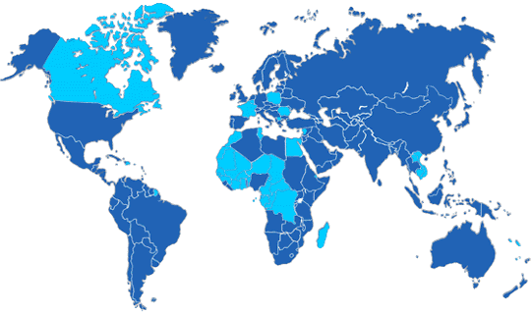
Copyright : Organisation internationale de la Francophonie
Activity 1

Class activity. Below is the song sung by French children when they learn their abc’s. Sing or recite your ABC’s in French. The class will recite or sing the alphabet (each student says or sings one letter). The whole class says or sings the last sentence together.
A b c d e f g
H i j k l m n o p
Q r s t u v
W x y z
Moi je sais mon alphabet
La la la la la la la

Activity 2

Class activity. Your instructor will distribute cards (each card has one letter) among the students. Depending on the number of students, you might have more than one letter. The class will recite the alphabet (each student will say the letter(s) they have according to the alphabetical order).

Activity 3

Class activity. Your instructor will distribute cards (each card has one letter) among the students. Depending on the number of students, you might have more than one letter. The class will spell the following words (each student will say the letter(s) when needed to spell the words).

1. bateau 4. couture 7. œuf 10. voiture 13. auditif
2. beige 5. cœur 8. grise 11. jolie 14. heureux
3. sympathique 6. amour 9. koala 12. wagon 15. zigzag

Activity 4

Have fun in trying to pronounce each student’s first name with a French accent! Your instructor will help you when needed.

Activity 5

Group activity. In small groups, play the hangman. One student chooses a word among the words that you have encountered as pronunciation examples, the others take turns in proposing letters. Alternate until each student proposed a word.

Activity 6

Paying attention to the stress, try to guess the French pronunciation of these cognates.

1. Lion  2. table  3. bicyclette | 4. lampe  5. professeur  6. madame | 7. président  8. république  9. démocratie

Activity 7

With your partner, create a short dialogue with the image below. How would the conversation begin based on the scenario at the beginning of this lesson? Have one soldier spell his name for the West African in French. Concentrate on how troops are building rapport with the locals in Djibouti.

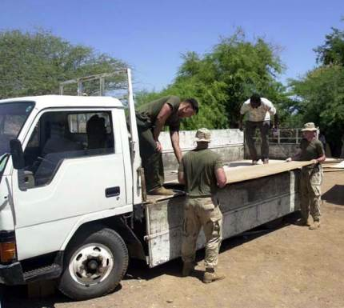
Activity 1

Find a partner and spell your name. He will write it down as you spell it, so you can make sure it is correct.

Activity 2

Pair activity. You go and apply for your own parking permit. The clerk is asking and writing down the information. Spell your name to avoid any mistakes. Role-play the dialogue with your partner, and then switch roles.

Clerk: Nom?
You: Hernandez.
Clerk: Comment?
You: Hernandez. H E R N A N D E Z.
Etc.

Activity 3

Pair activity. On the next page is an excerpt of The Bourgeois Gentilhomme, a comedy written by the famous XVII th century French playwright Molière. In this scene, Monsieur Jourdain, a new-rich bourgeois who aspires to become an aristocrat, has hired various tutors to educate him. The following scene, where M. Jourdain takes his first lesson with his maître de philosophie, his philosophy tutor, highlights the idiocy of the bourgeois. (A translation in English follows).
Your instructor will assign each pair of students a few of the verses in which the bourgeois and his tutor are practicing the pronunciation of vowels. Practice them with your partner, and then each pair will role play their part for the whole class.

Activity 4

Class discussion. In small groups, discuss individual portions (that your instructor will assign) of this comedy piece. What happens in the selected passage? Who is having difficulty with the alphabet? Why? Do you recognize any language similarities? Would this be as funny in English? Make an outline in English of your ideas and share those with the class.

*Note to instructor: role-play activity is designed for pronunciation of letters of the French alphabet. Discussion activity is to be conducted in English to promote student opinions and class discussion. Assign small portions to individual groups / pairs.

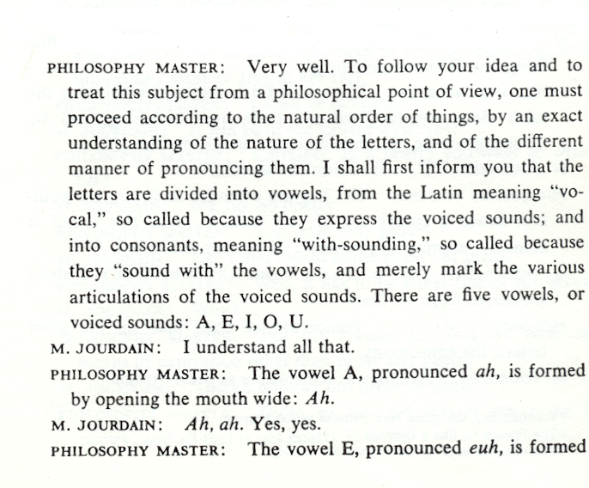
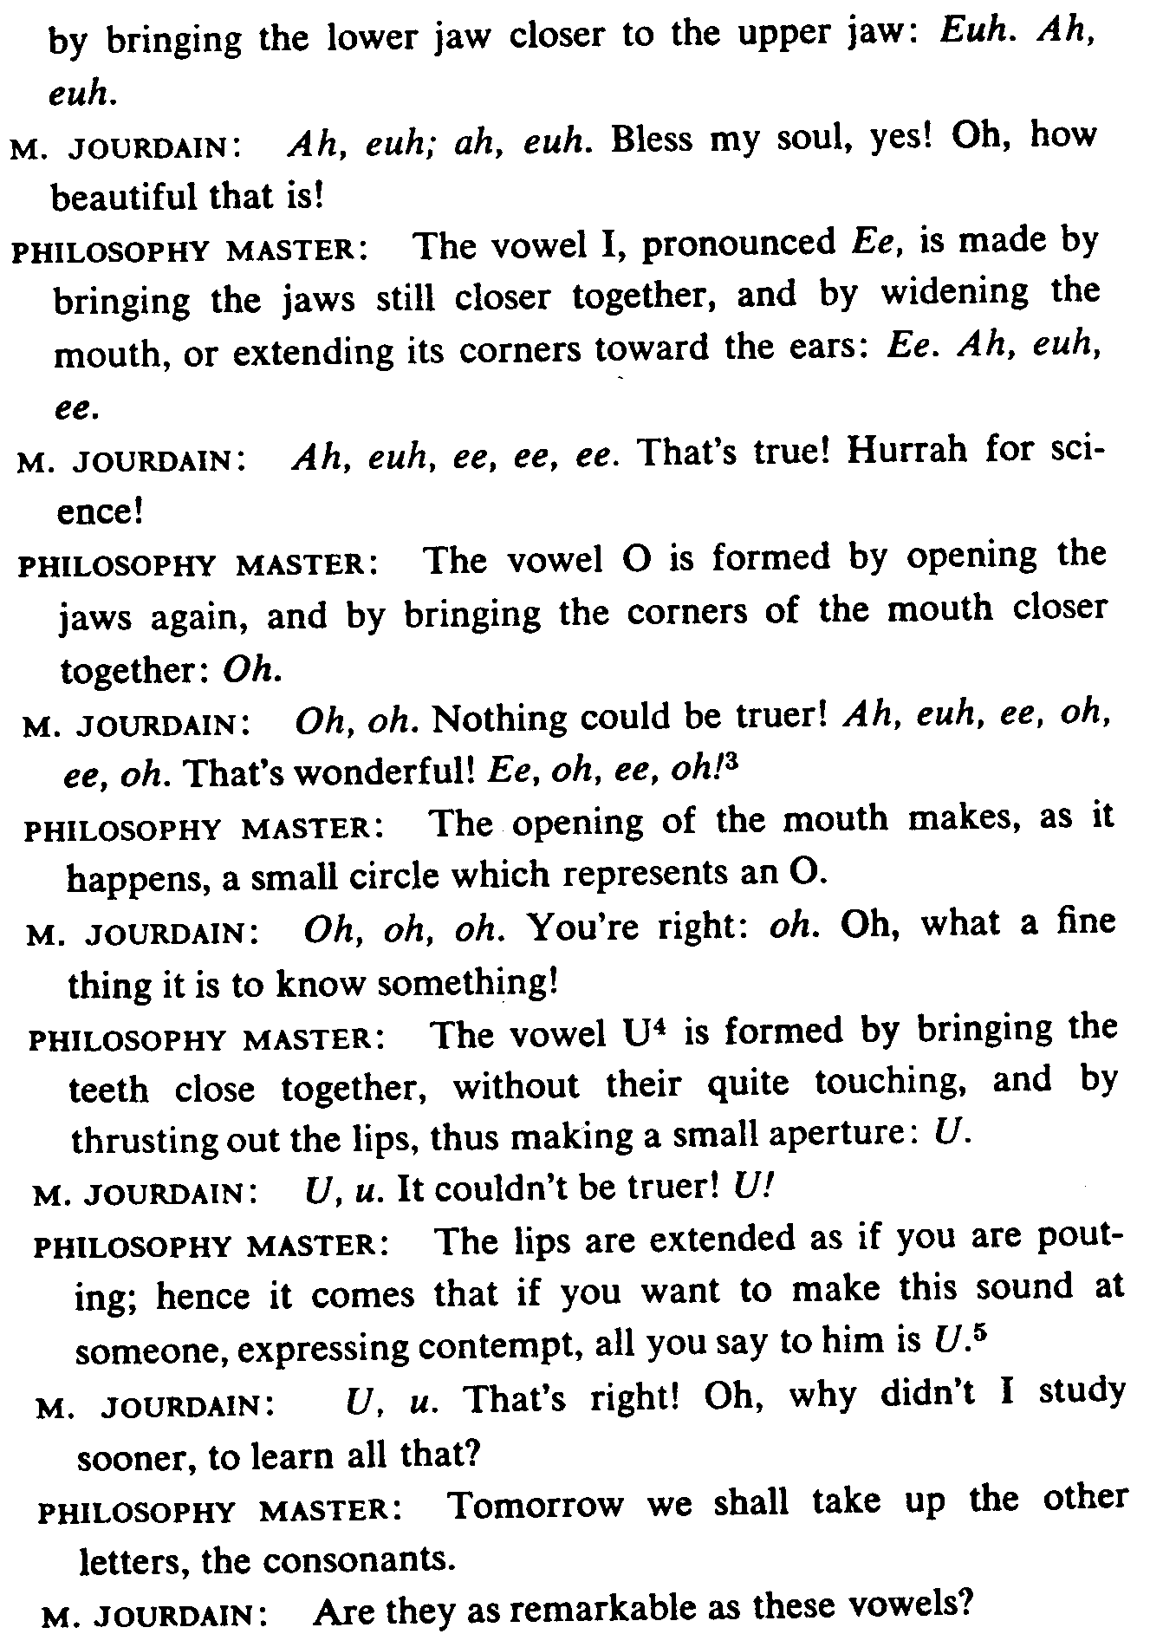
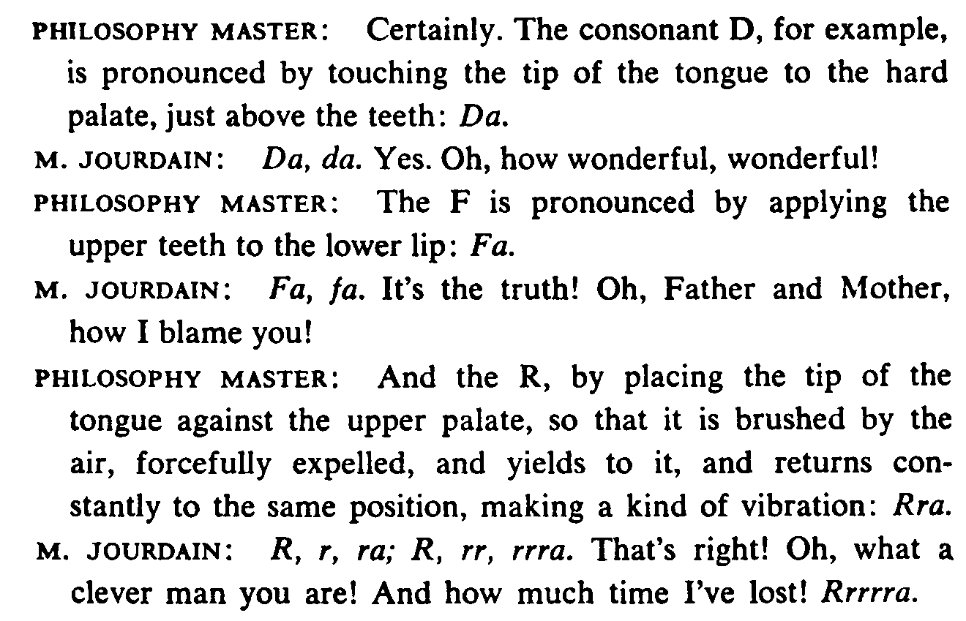

Activity 1 Track 1

CD. You will hear French words spelled. Write the letters as you listen.

philosophie mexicain restaurant dangereux

Activity 2 Track 2

CD. Circle the word you hear in each pair.

1. mignon / mignonne 4. enfantin / enfantine 7. français / française
2. bord / border 5. plein / pleine 8. chinois / chinoise
3. port / porter 6. américain / américaine 9. coquin / coquine

Activity 3 Track 3

CD. Circle the words you hear.

1. porte / porté 3. zaire* / Zaïre 5. mémé / mèmè*
2. maçon / Macon 4. françois / francois* 6. pépé / pèpè*

* These aren’t French words and have been invented for auditory discrimination practice.

Activity 4

Read this excerpt from a French magazine, and answer the following questions.

Au lieu de regagner Kinshasa après le sommet de l’OUA, le président de la République démocratique du Congo, Laurent-Désiré Kabila, a passé deux jours à l’hôpital militaire d’Alger pour y subir une série d’examens médicaux.
L’Express International no. 2508, semaine du 29 juillet 1999

- What is the date? July 29, 1999
- What is the title of the magazine? L’Express International
- Congo is a monarchy / a democracy.
- The name of Congo’s president is Kabila / Kinshasa.
- He was admitted in a civil / military hospital.
- He was in the hospital for medical examinations / surgery.
Activity 5

Which of the following African countries can you visit with this travel agency?

1. Algeria
2. Morocco
3. Kenya
4. Mauritania
5. Tunisia
6. Libya
7. Niger
8. Mali

Activity 6 Track 4

CD. Listen to the following sentences and mark the liaisons you hear with the symbol ∪.

- Vous∪attendez les∪anciens∪élèves.
- Elle est∪assise sous∪un∪arbre.
- Nous∪allons à la mer en∪été.
- Leurs∪amis sont très∪intéressants.
- Ils∪ont quarante-deux∪ans.

Activity 7

Practice spelling your first and last names in French.

Activity 8 Track 5

CD. Listen to the sentences and circle all cognate words. Don’t worry about the other words. Remember that the cognates will be spelled identically with different pronunciation.

- Je suis absent tous les jours 6. C’est une belle kitchenette.
- J’aime beaucoup la mayonnaise. 7. Quelle est la date ?
- As-tu une mission ? 8. Le danger est évident.
- Au mariage, il nous offre un toast. 9. Il a assez d’endurance.
- Elle a beaucoup de patience. 10. Le médicament attaque le virus.

Activity 9

Read over the following list of faux amis and then write down the English equivalent (have your dictionary handy).
- sensible 4. robe 7. raisin 10. collège
- crayon 5. libraire 8. chair
- entrée 6. voyage 9. grosse

